Node port: when we want to access the app in the pod from internet we use service named nodeport

vi mydeploy.yml

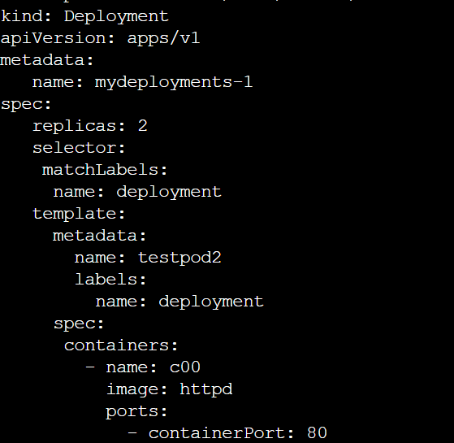



kind: Deployment

apiVersion: apps/v1

metadata:

name: mydeployments-1

spec:

replicas: 2

selector:

matchLabels:

name: deployment

template:

metadata:

name: testpod2

labels:

name: deployment

spec:

containers:

- name: c00

image: httpd

ports:

- containerPort: 80

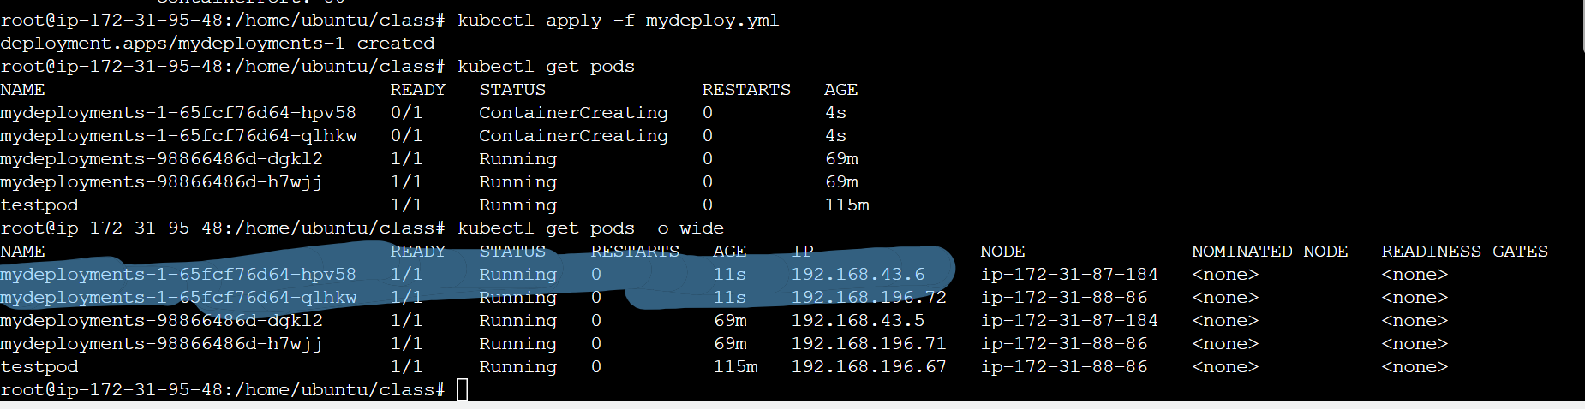

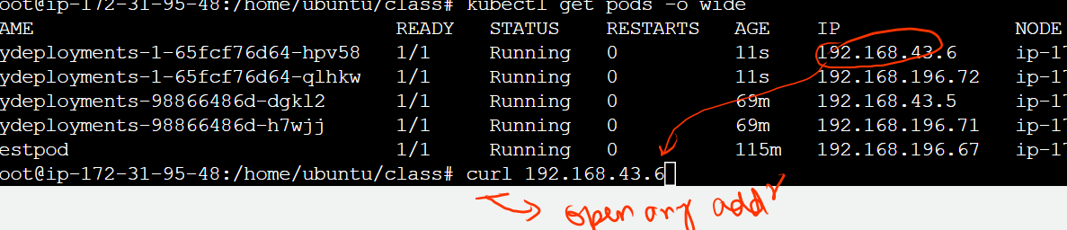

But the problem is if I try to open this ip address from outside the network it will not work

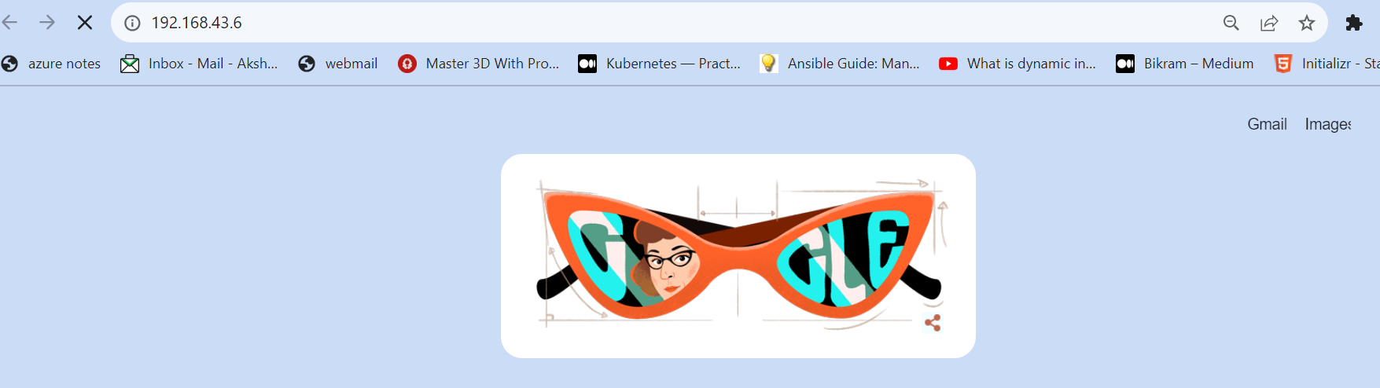

Not opening

But I need to access it from internet ….so here we will use node port

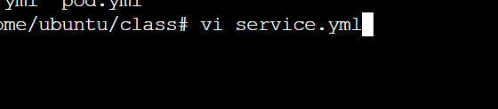

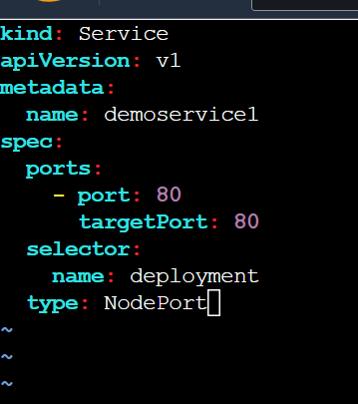

kind: Service

apiVersion: v1

metadata:

name: demoservice

spec:

ports:

- port: 8080

targetPort: 80

selector:

name: deployment

type: NodePort

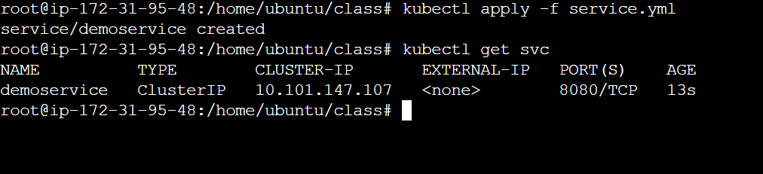







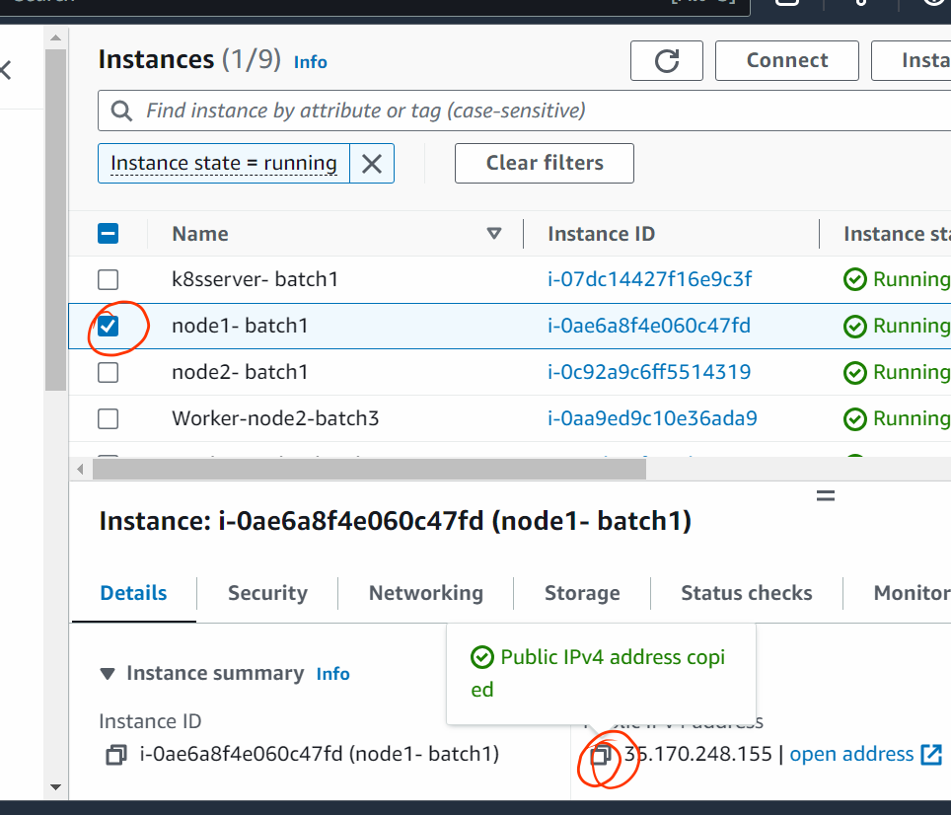



Paste it in browser…..DO NOT CLICK ON OPEN ADDRESS

In both the nodes o/p would be there on ip

