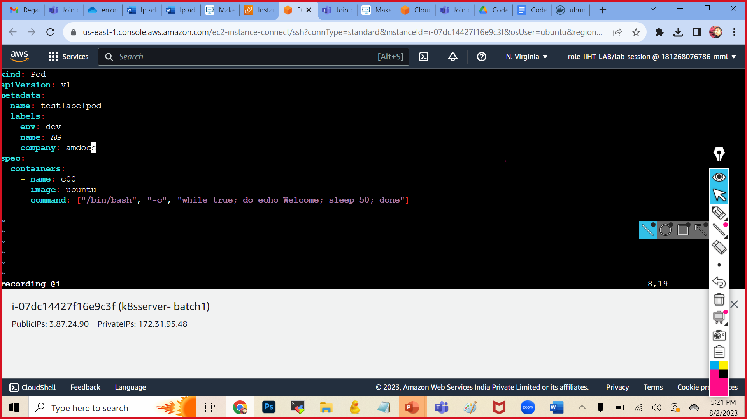

kubectl apply -f podlabel.yml

kubectl get pods

kubectl get pods -o wide

kubectl get pods --show-labels

kubectl label pods multiconpod env=prod

kubectl get pods --show-labels

kubectl label pods multiconpod env=test #error will come in this ..it will ask to overwrite

kubectl label pods multiconpod env=test --overwrite

kubectl get pods --show-labels

kubectl get pods -l env=test

kubectl get pods -l name=AG

kubectl get pods -l env=dev