**Lesson 04 Demo 02**

**Building a Multi-Panel Dashboard in Grafana**

**Objective:** To demonstrate the process of configuring Prometheus in Grafana and creating   
a dashboard for comparing resource utilization across different servers using Node   
Exporter metrics

**Tools required:** Linux operating system

**Prerequisites:** Refer to Demo 02 of Lesson 01 for installing Prometheus, Demo 01 of Lesson 02 for installing and configuring Node Exporter, and Demo 01 of Lesson 04 for installing Grafana

Steps to be followed:

1. Configure Prometheus as a data source in Grafana
2. Create a dashboard in Grafana for visualizing Prometheus metrics

STEP 0: Setup node exporter in Prometheus

**Step 1: Configure Prometheus as a data source in Grafana**

1. Log in to the Grafana server from a browser using the URL **http://localhost:3000**

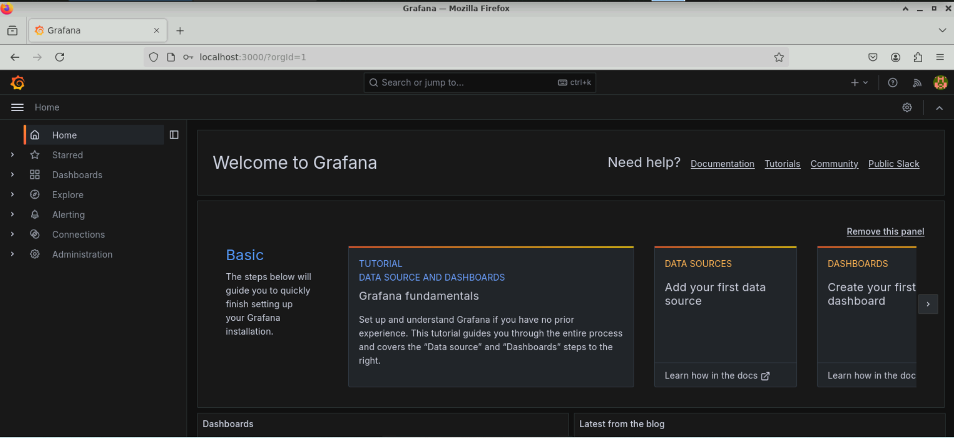

**Note:** Ensure that Prometheus and Node Exporter are installed and running before starting the Grafana server

1. In the Grafana dashboard, select **Connections** and then **Data sources** from the menu on the left side. Then, select **Add data source**

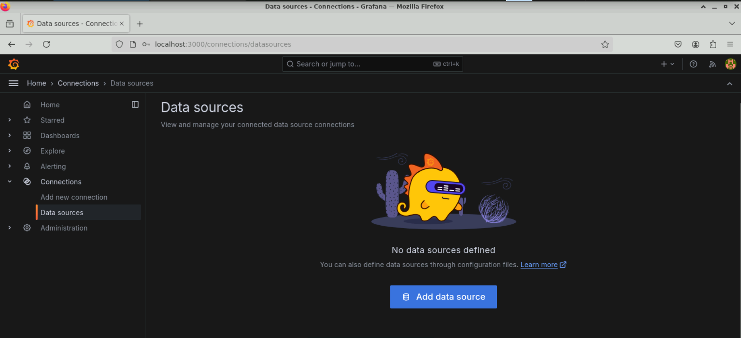

1. Choose **Prometheus** as the data source from the list

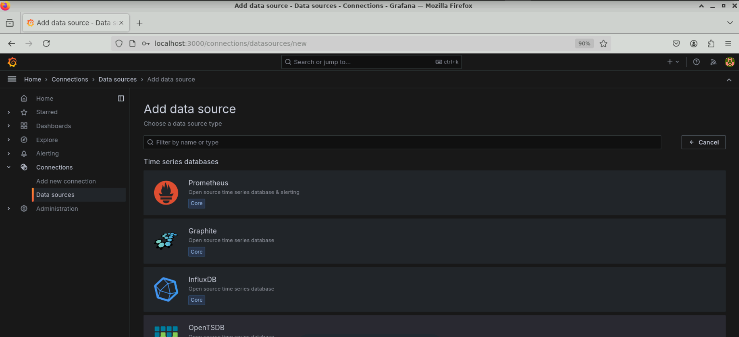

You will see the following interface:

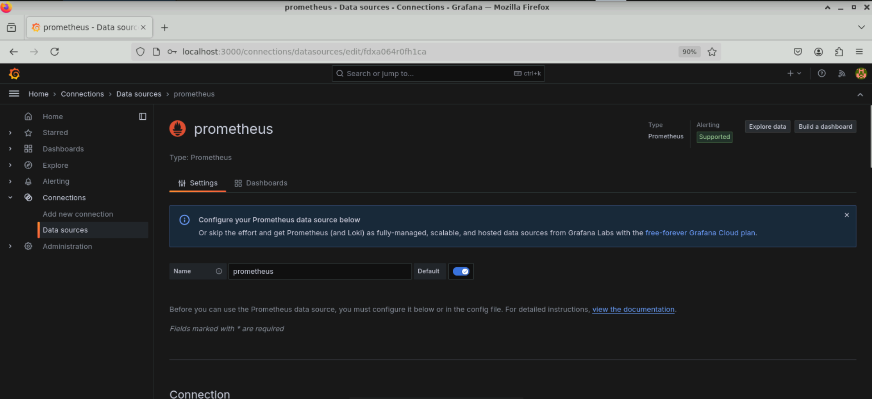

1. Navigate to the **Connection** section in the Prometheus settings and set the **Prometheus server URL** to **http://localhost:9090**

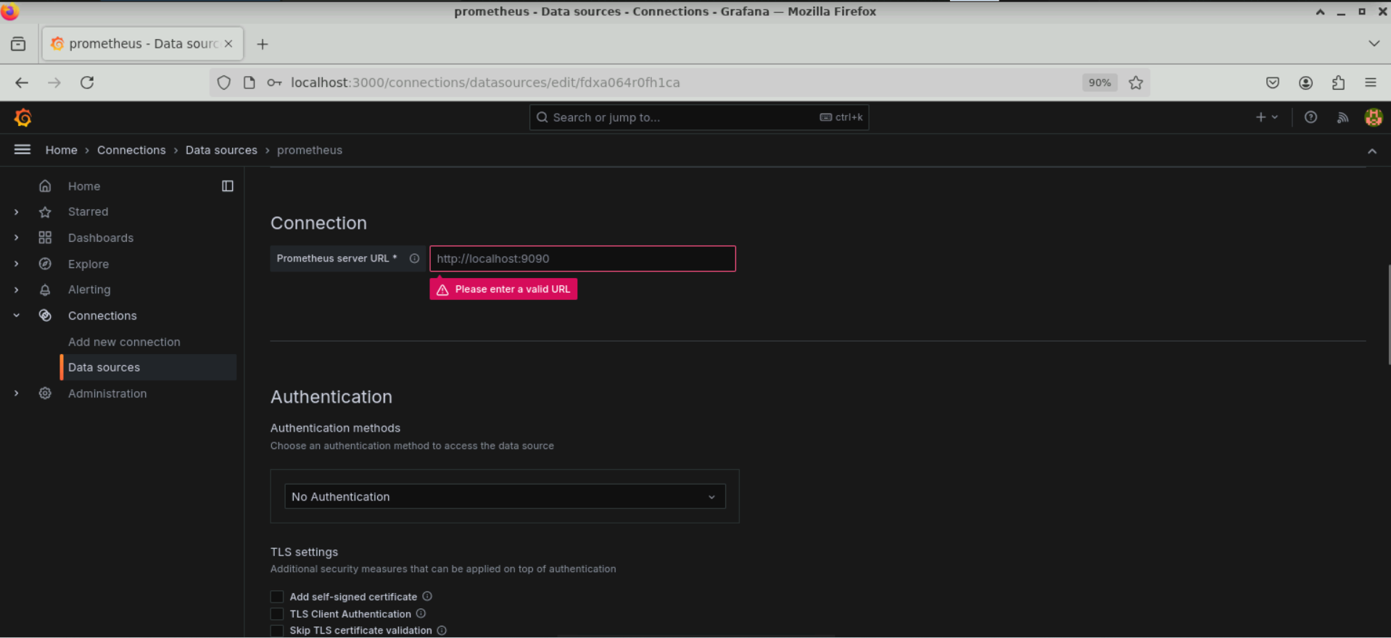

1. Scroll to the bottom of the page and click **Save & test**

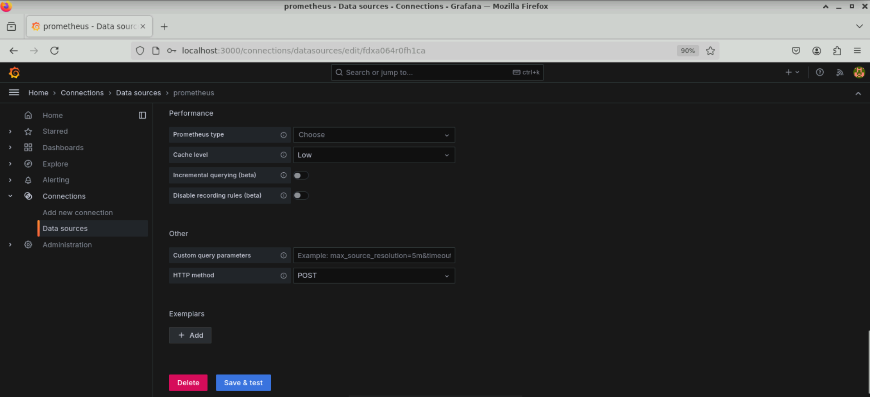

The Prometheus data source configuration in Grafana is successfully saved as shown below:

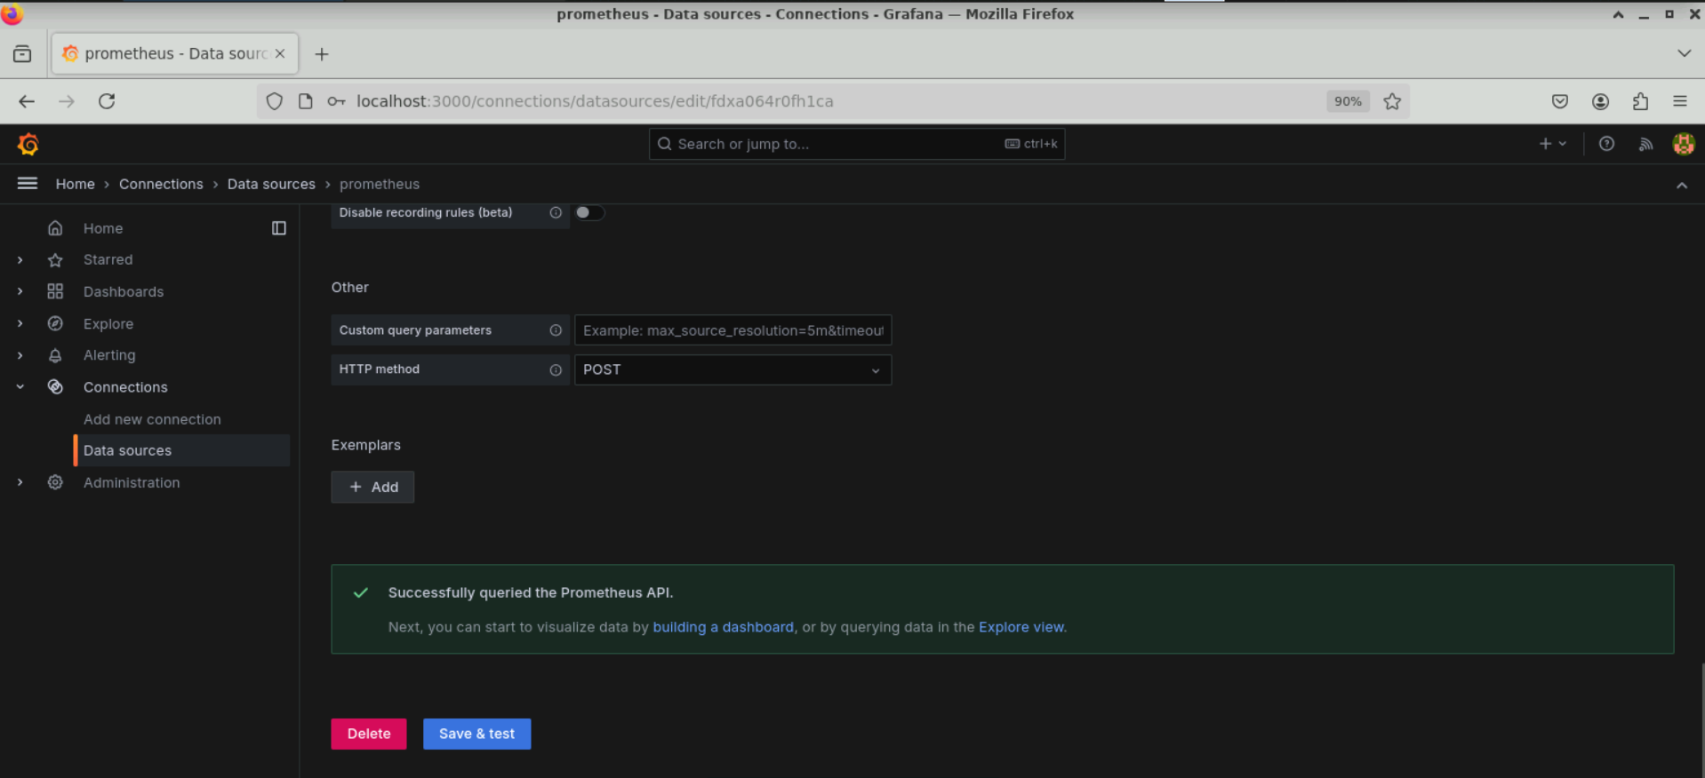

**Step 2: Create a dashboard in Grafana for visualizing Prometheus metrics**

1. Select **Dashboards** from the left-side menu and click **Create dashboard**

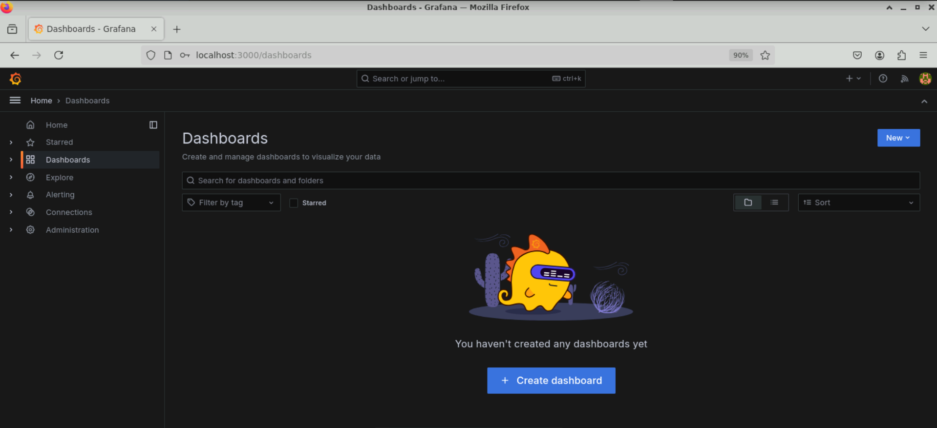

1. Choose the **Import dashboard** option

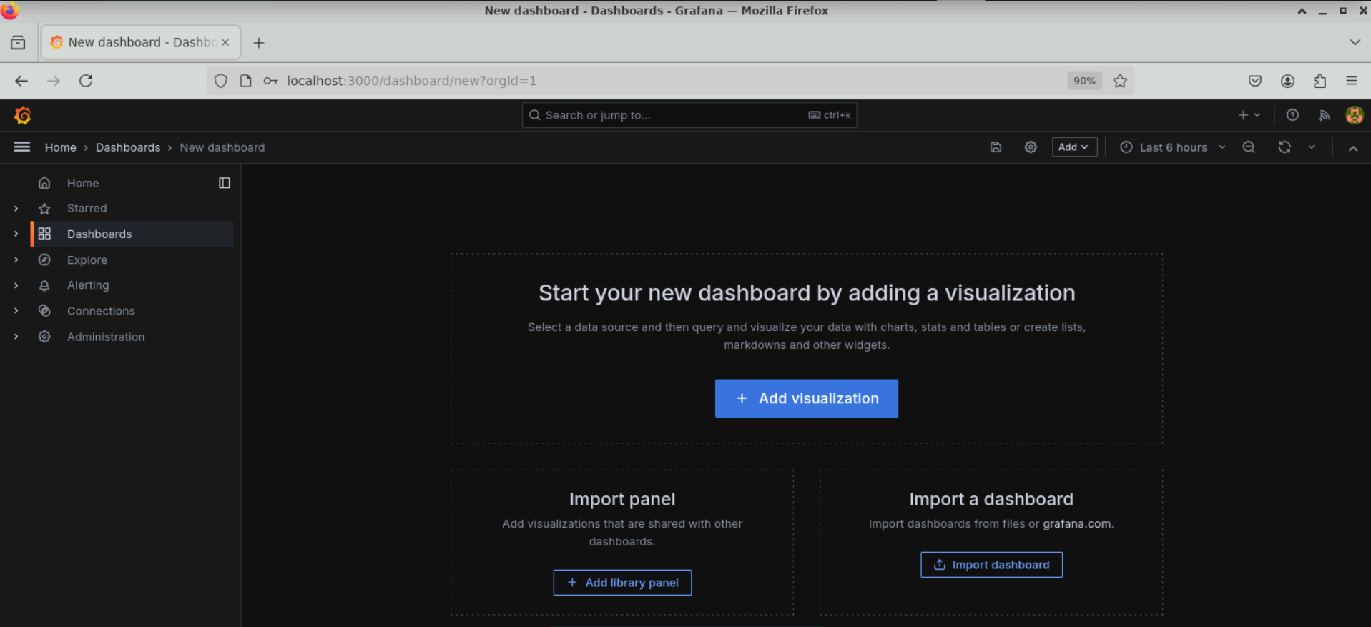

You will see the following interface:

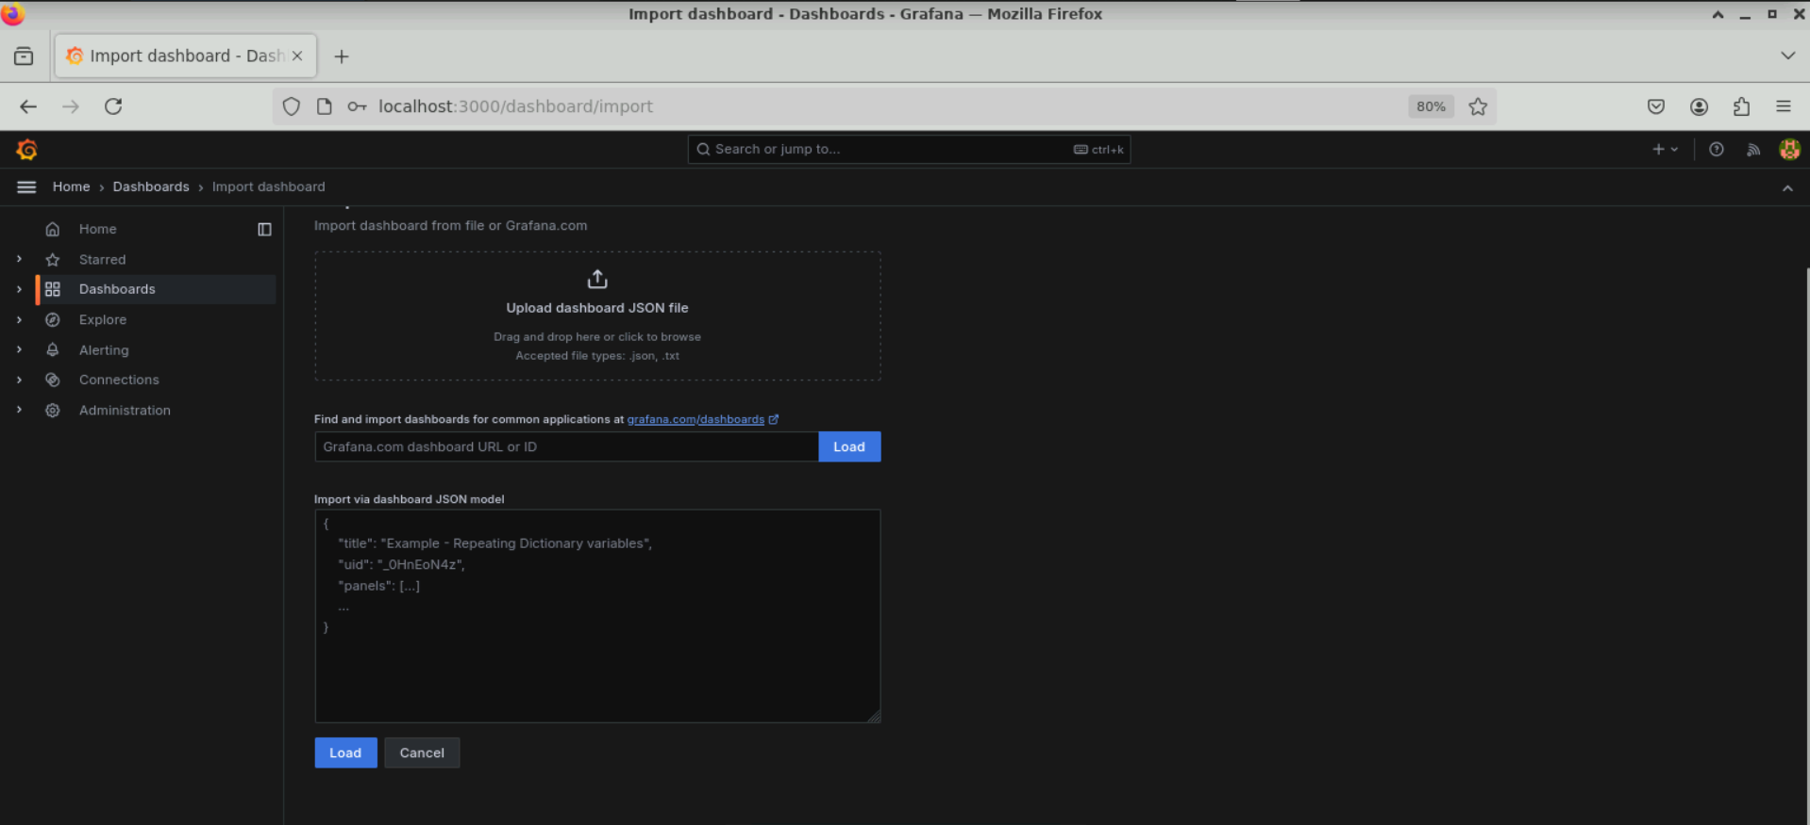

1. Under **Find and import dashboard for common applications**, enter **1860** and then click **Load**

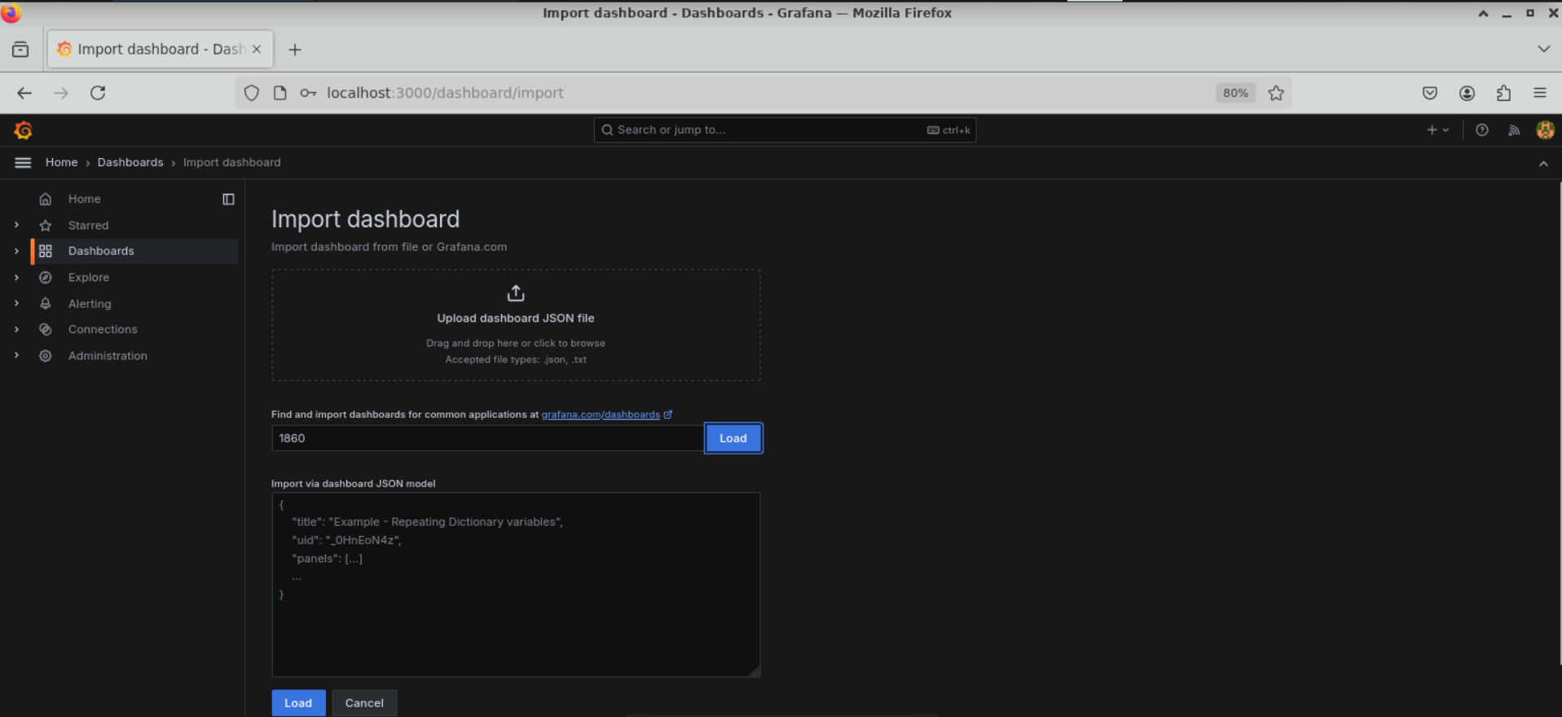

1. Click **Select a Prometheus data source** under **Prometheus**

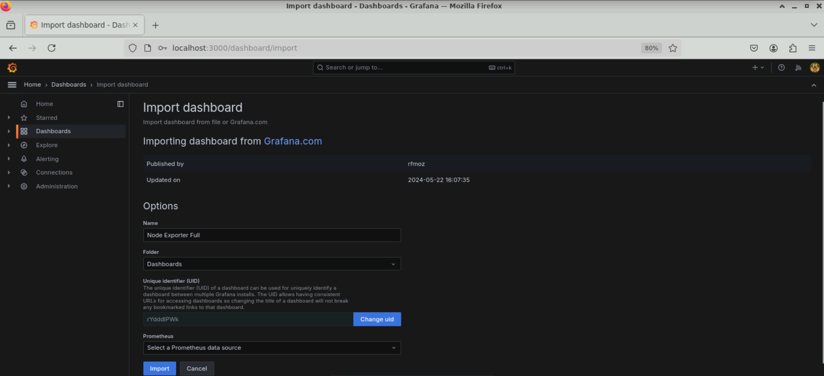

1. Select **prometheus** and then click **Import**

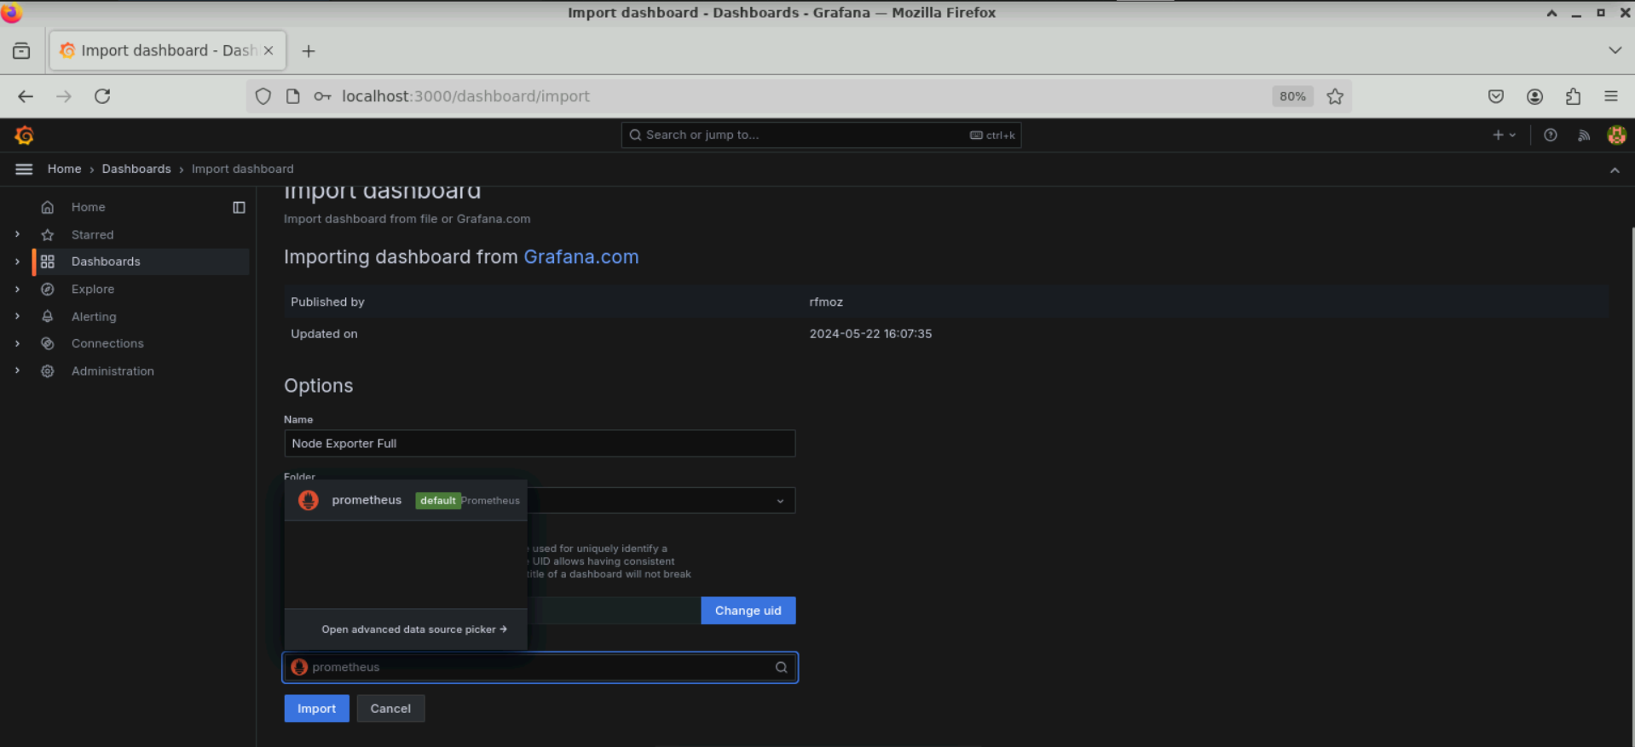

Multiple panels are created under the dashboard, showing different resource metrics as shown below:

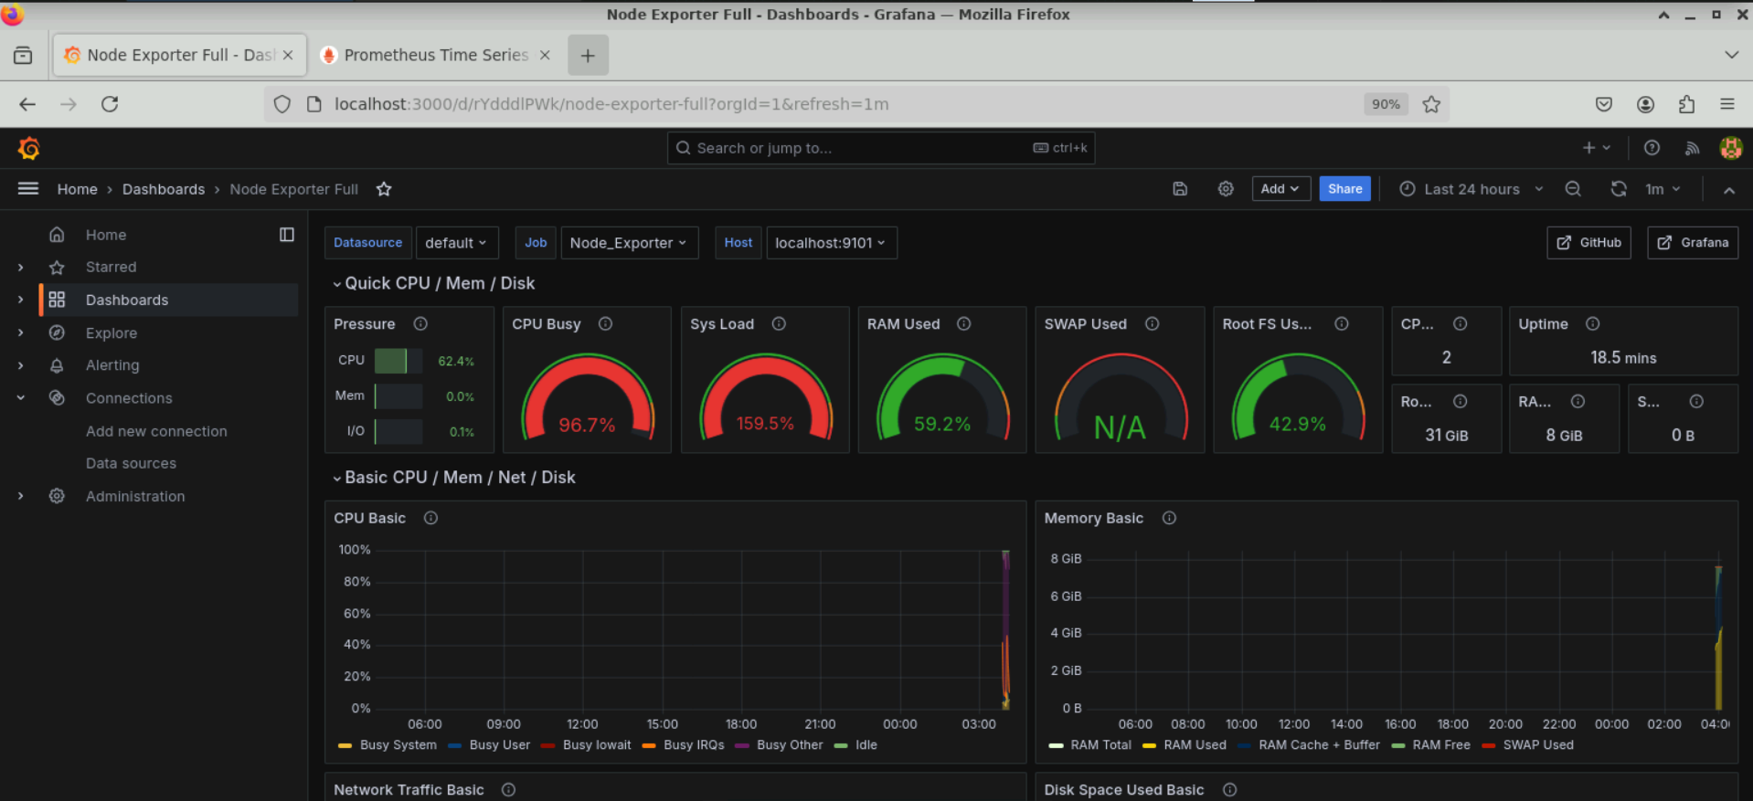

1. Expand each of the panels to view the metrics

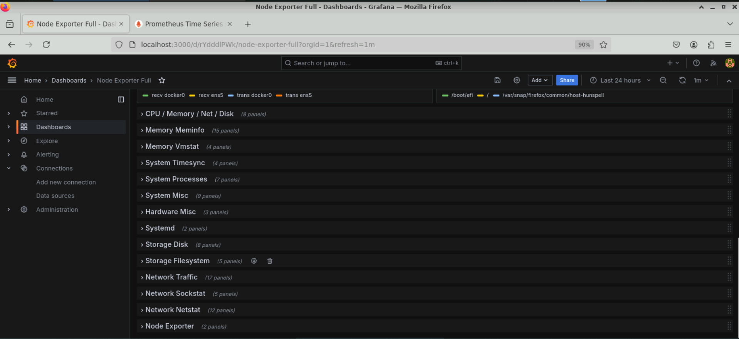

The following shows the expansion of **Memory Meminfo** panel:

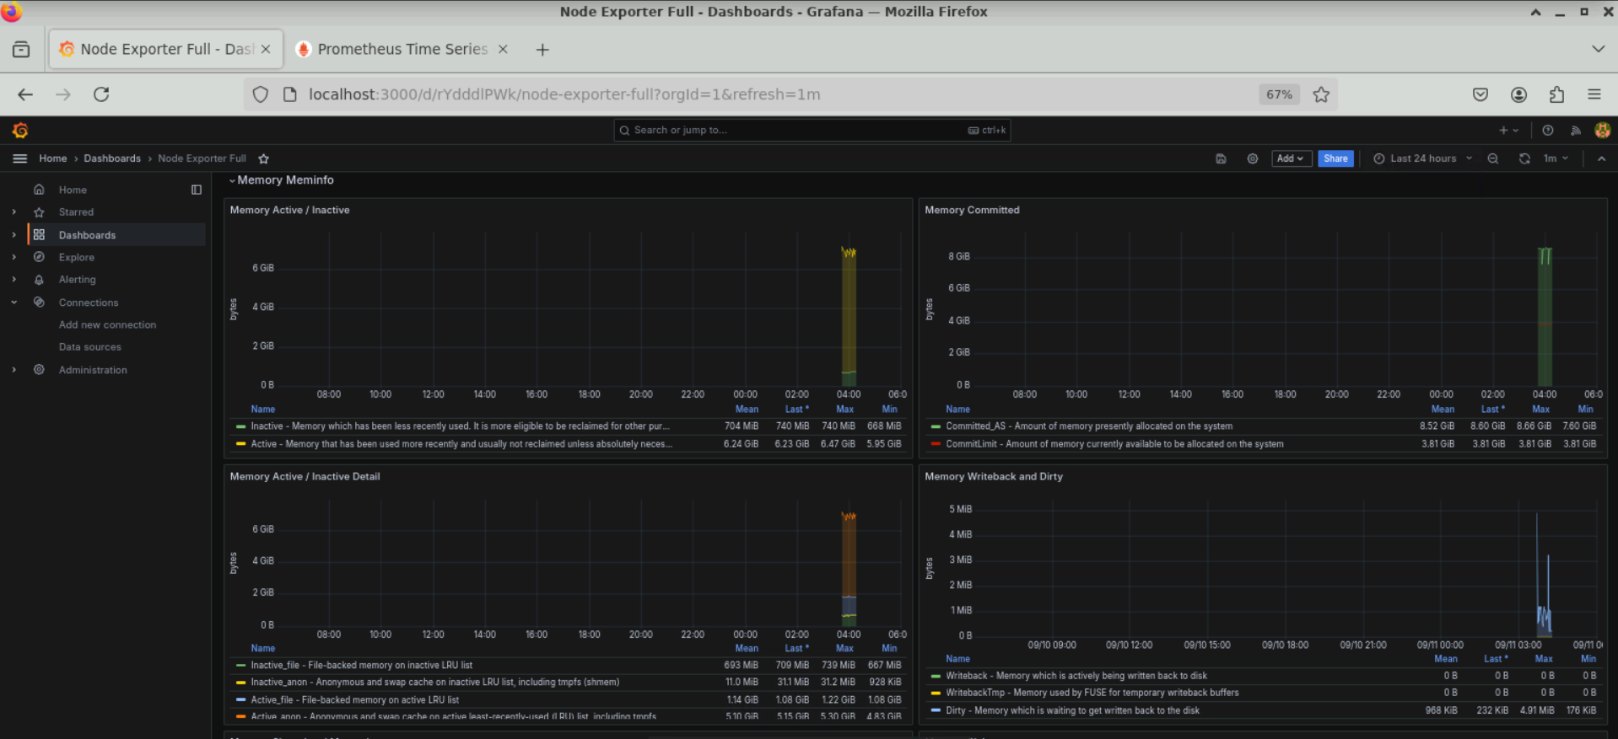

By following these steps, you have successfully connected Prometheus as a data source in Grafana, imported a pre-defined dashboard, and visualized resource metrics across different servers for monitoring and comparing resource utilization.