Cloud computing

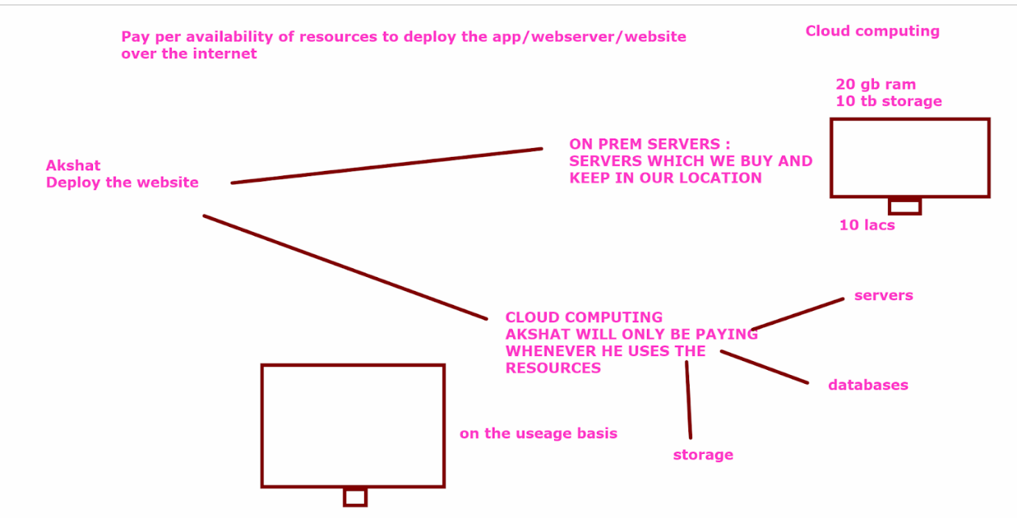

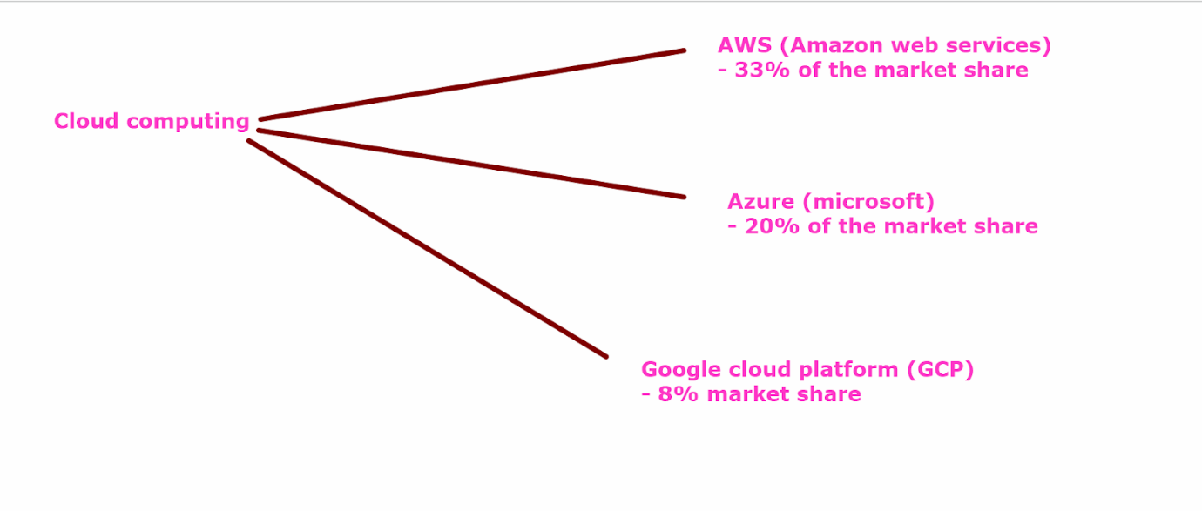

##Create a ubuntu machine and launch a static website in that machine

Launch a machine

Go to aws account

Search for ec2

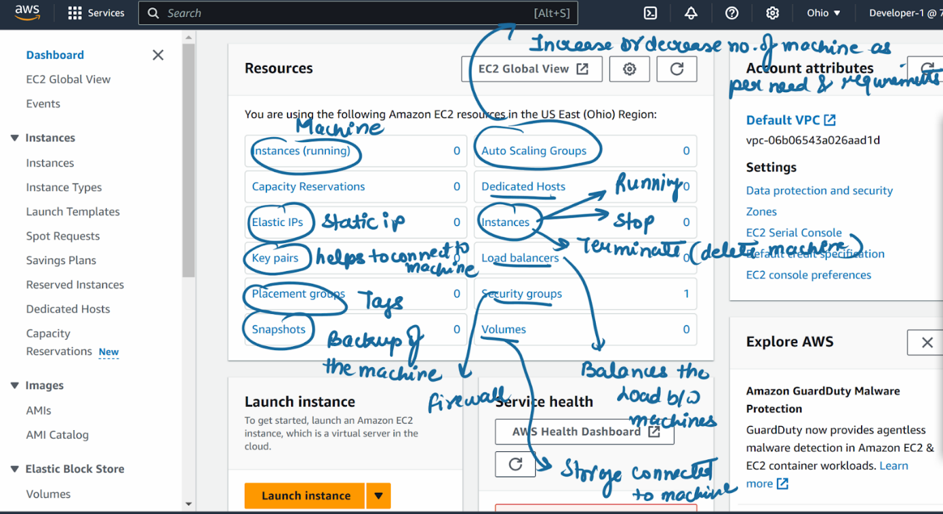

Cick on instances

Launch instances

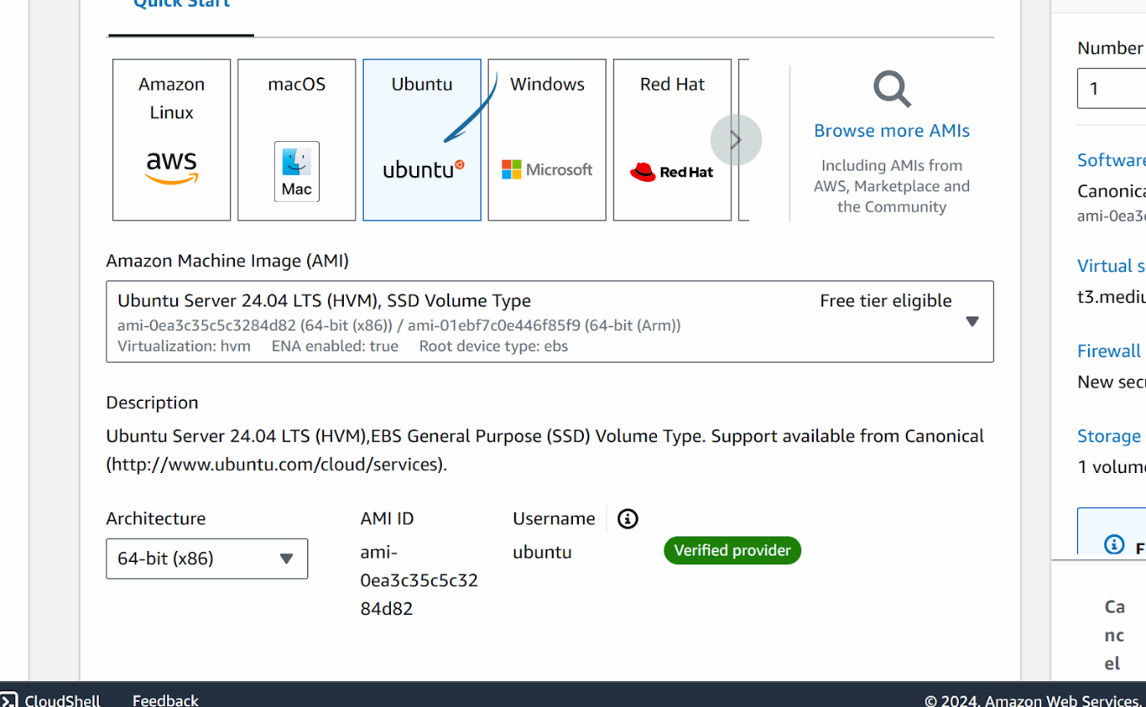

Instance type : t3.medium

Create a new key

Create key

(you will see that key is downloaded in ur laptop)

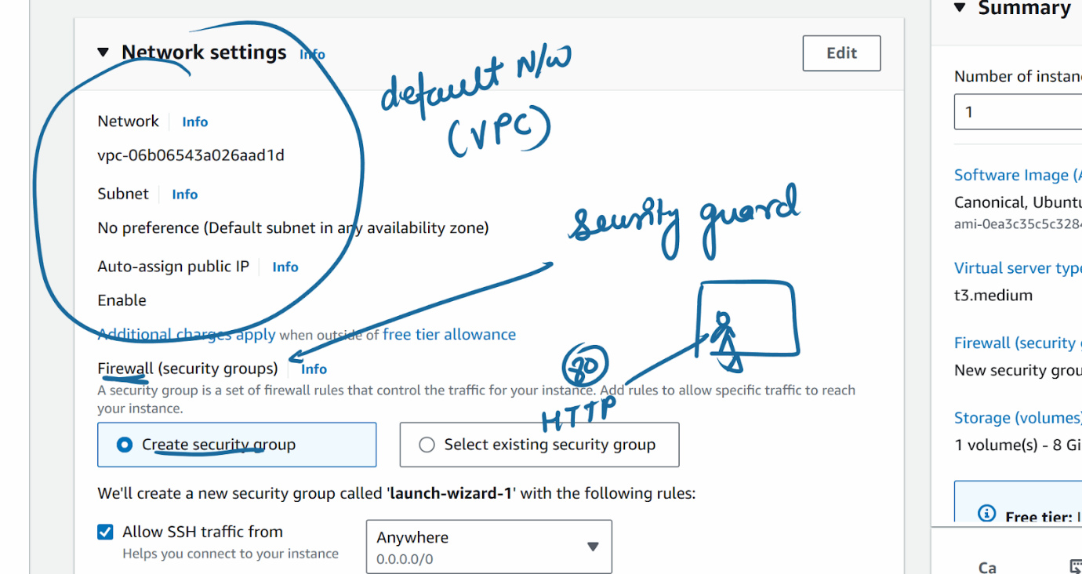

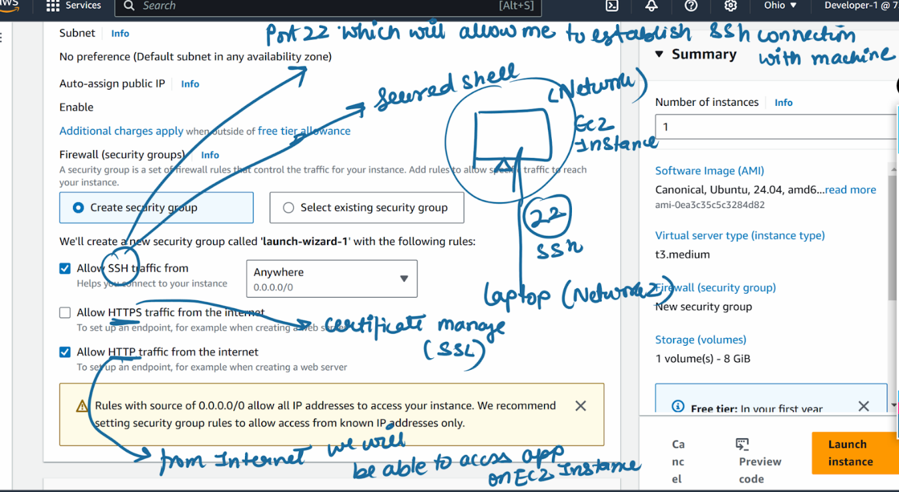

Launch instance

After the instance is launched

**Now we will see some methods via which we can connect to the machine**

1. Browser based connect

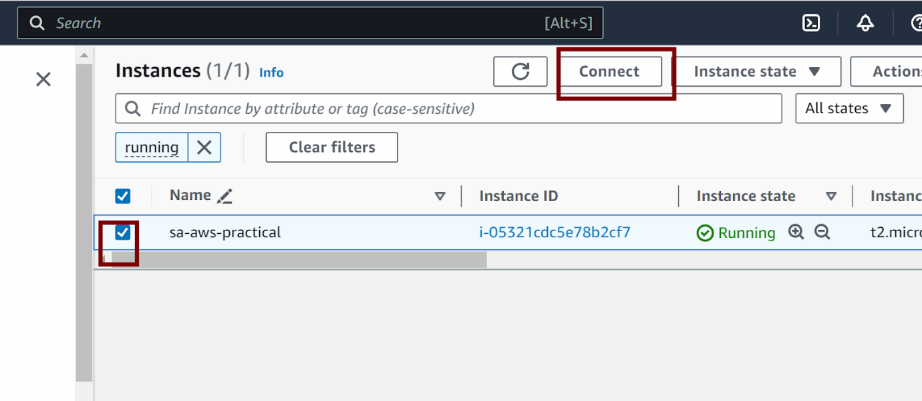

Ec2 instance connect tab

Click on connect

1. Via ssh connection

Click on connect -> click on ssh client

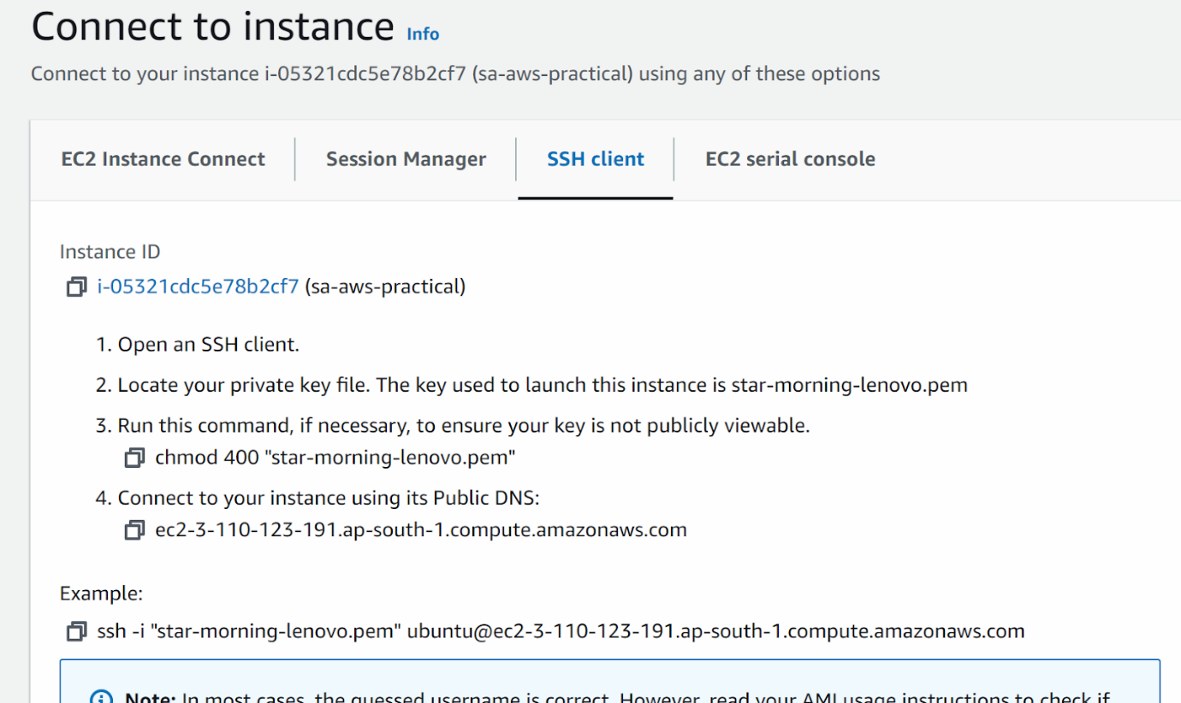

Copy the command

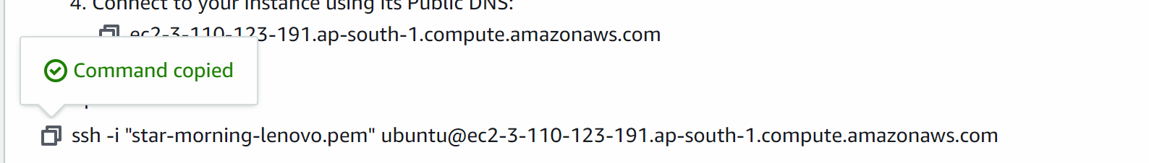

Go to the location where pem key is present

Write cmd on the top of the file manager

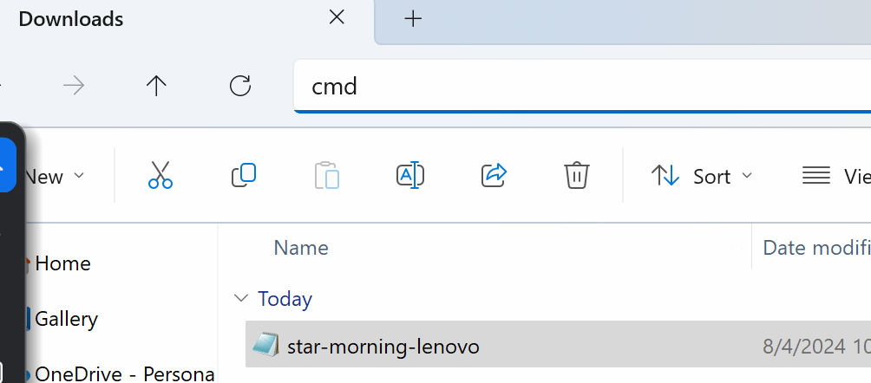

Now command prompt will open

Copy paste that command

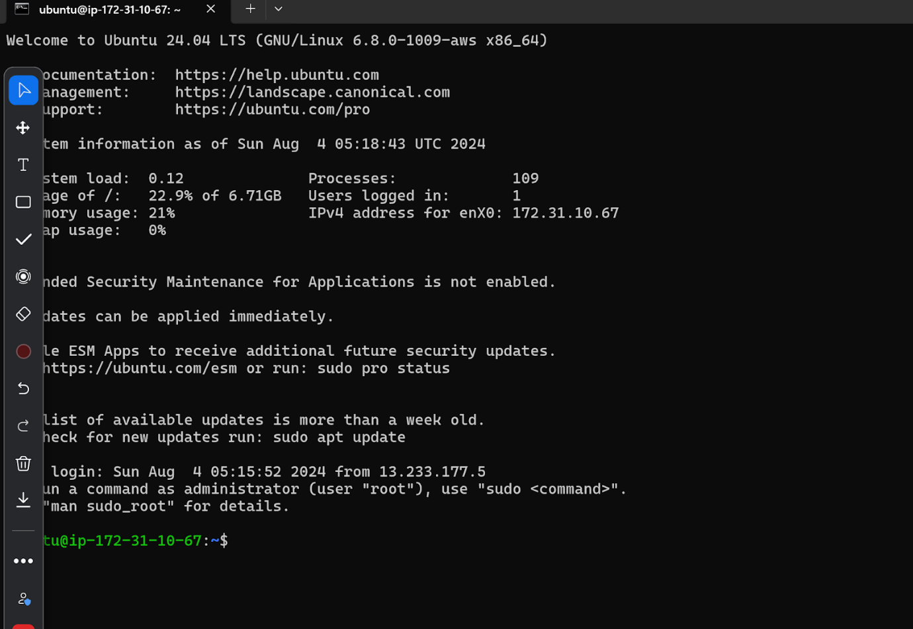

1. Use mobaxterm

Mobaxterm is a software which we use to connect to the machine

https://mobaxterm.mobatek.net/download-home-edition.html

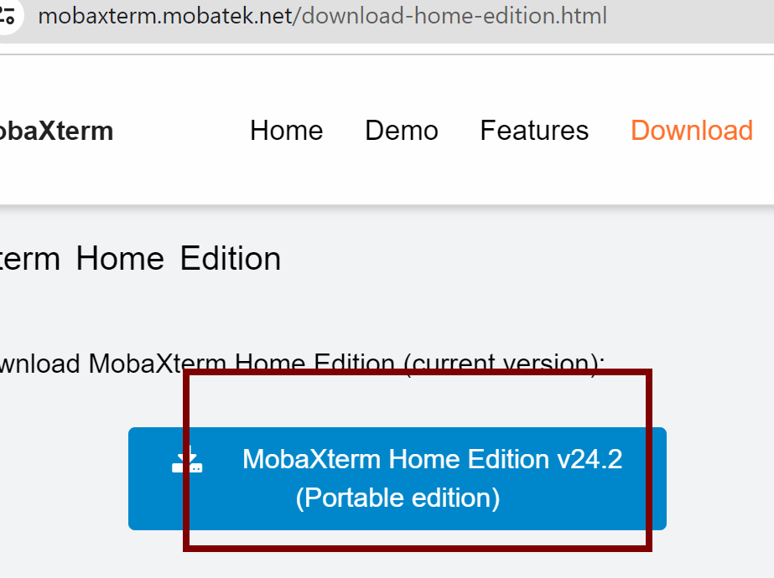

Zip file would be downloaded which can be unzipped in the desktop

You can open mobaxterm file to open the exe file

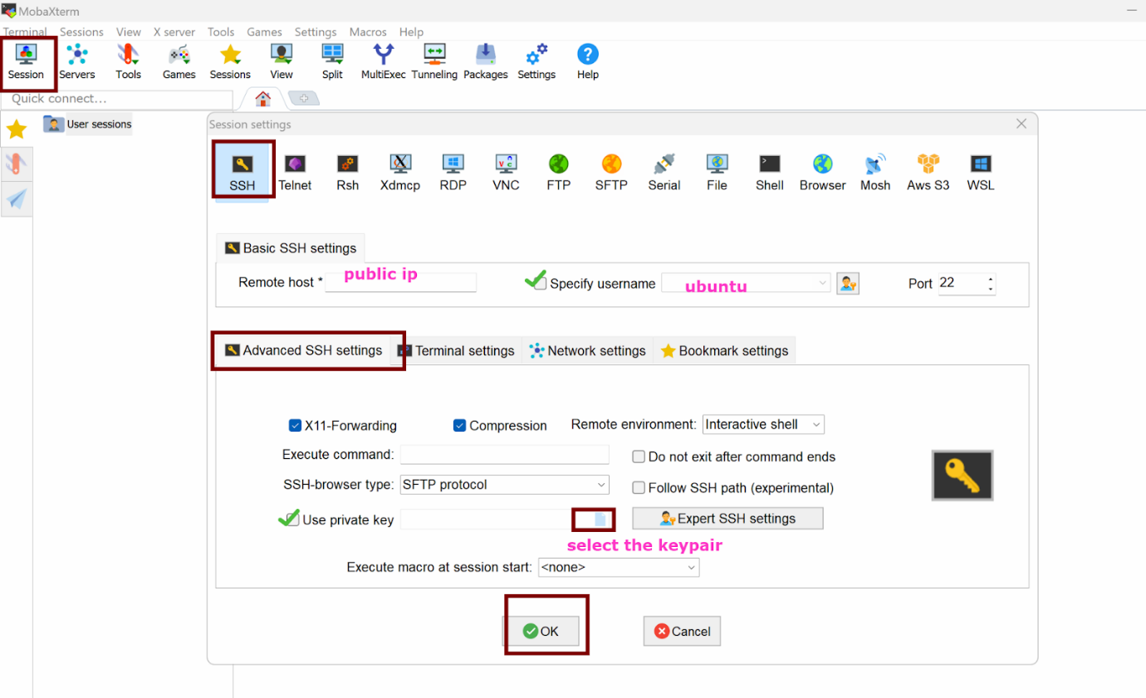

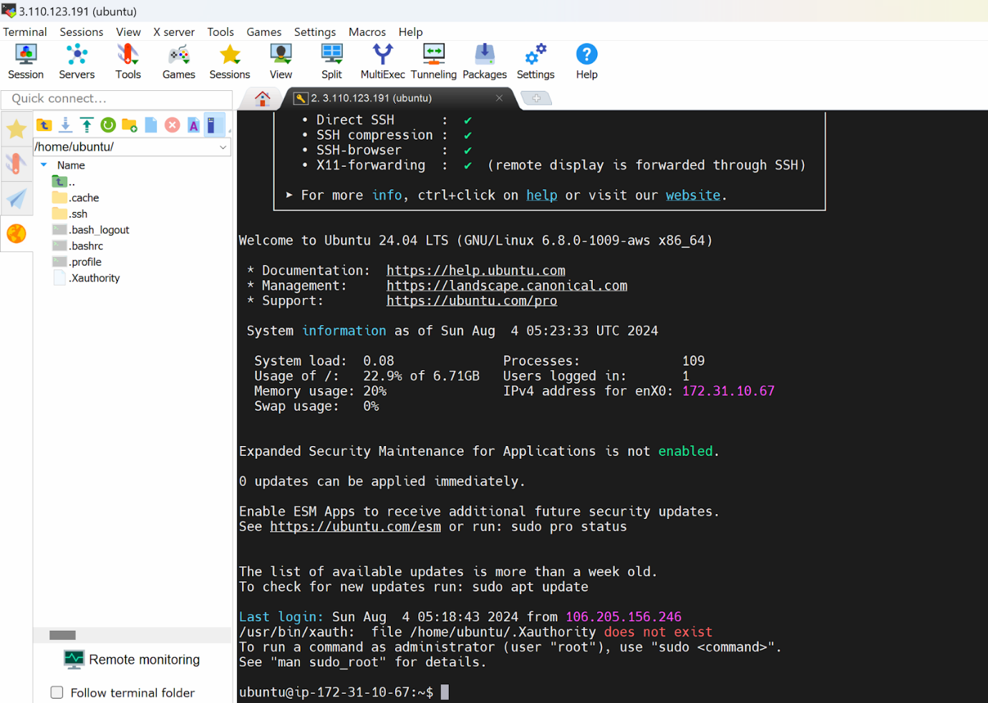

#####################

Lets install a webserver and  website in the machine

sudo su

