**Blog Creator Web Application**

***Wireframe Documentation***

**Home tab**

**I** have divided Blog Creator Application Homepage into Two Sections: -

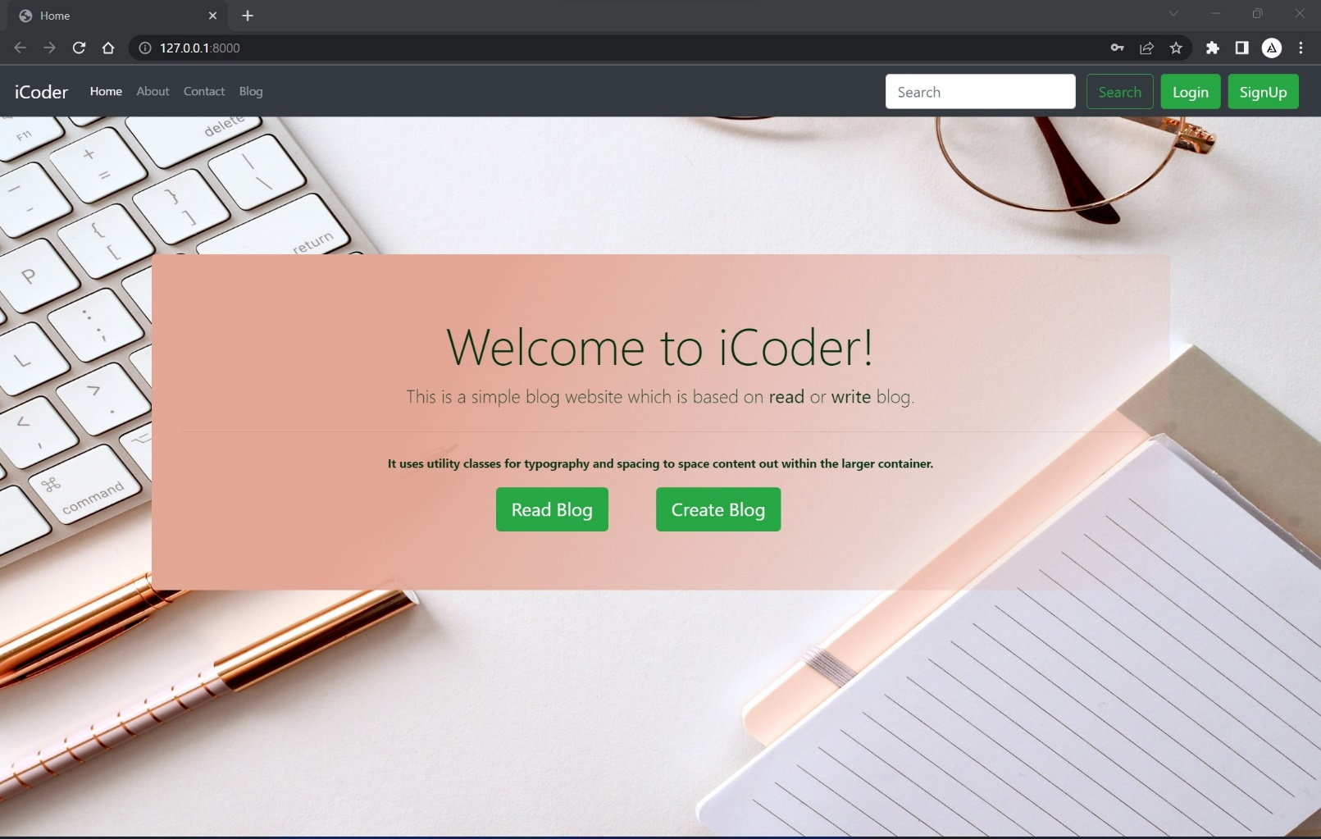

**1*.*** First thing is **Read Blog** by clicking on this button user can enters in Blog page where he finds all Blogs.

**2.** Second thing is **Create Blog** by clicking on this button user can enters in Create page where user can create **Blog.**

**About tab**

In **About page** I discuss about myself and what things I’m using in this web application and little bit define these things

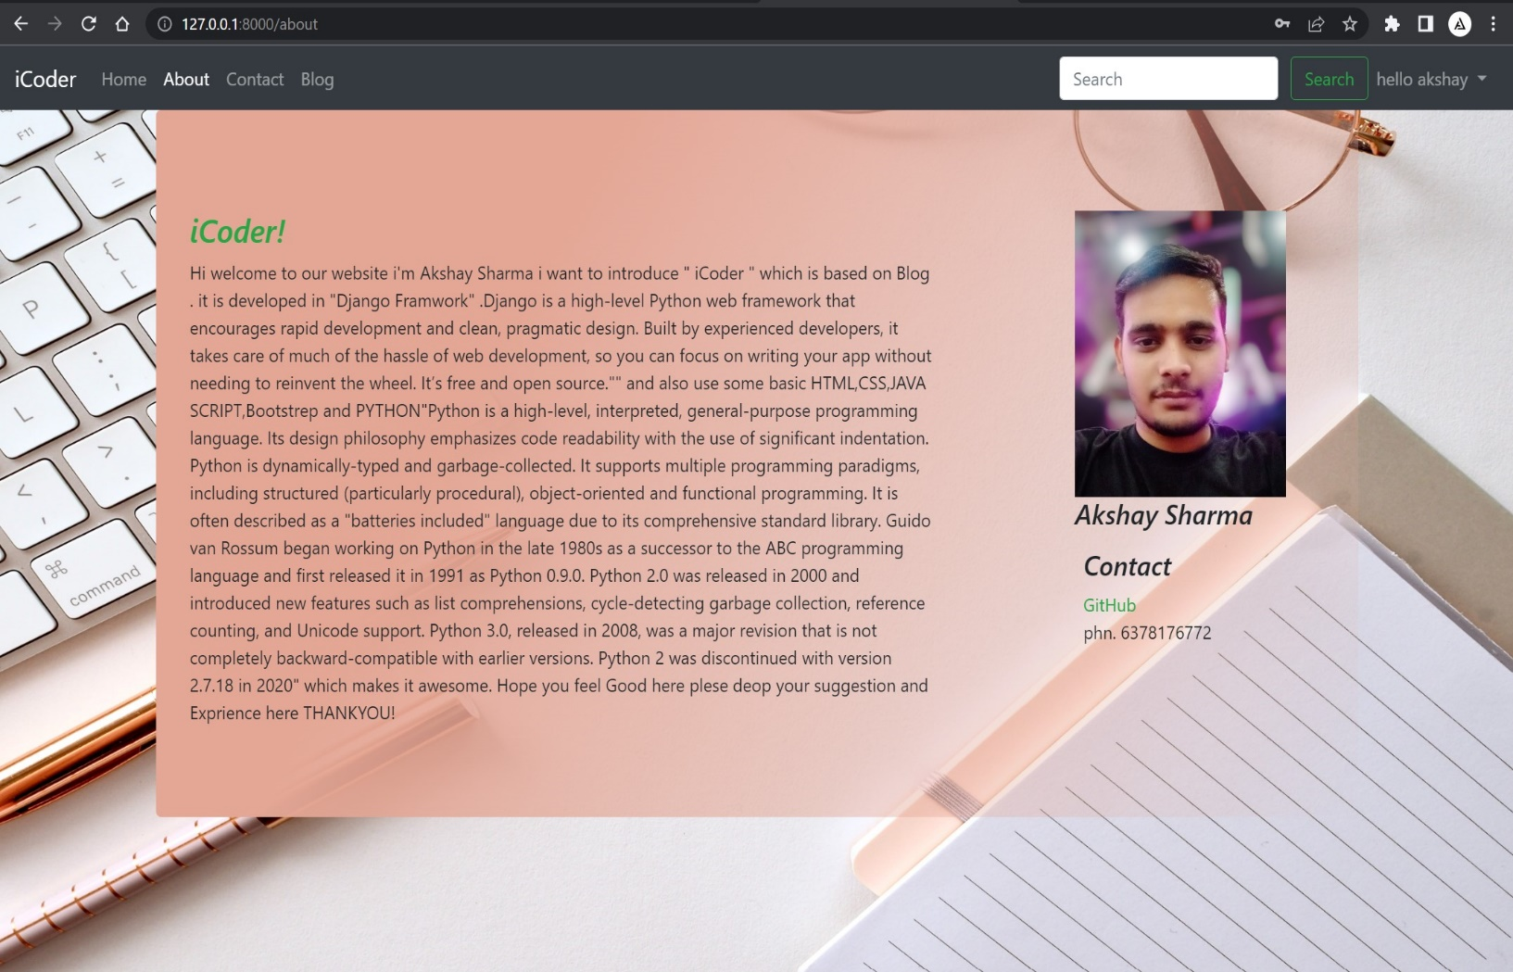

**Contact tab**

In **Contact page** user can drop the message to admin and can share the experience with admin.

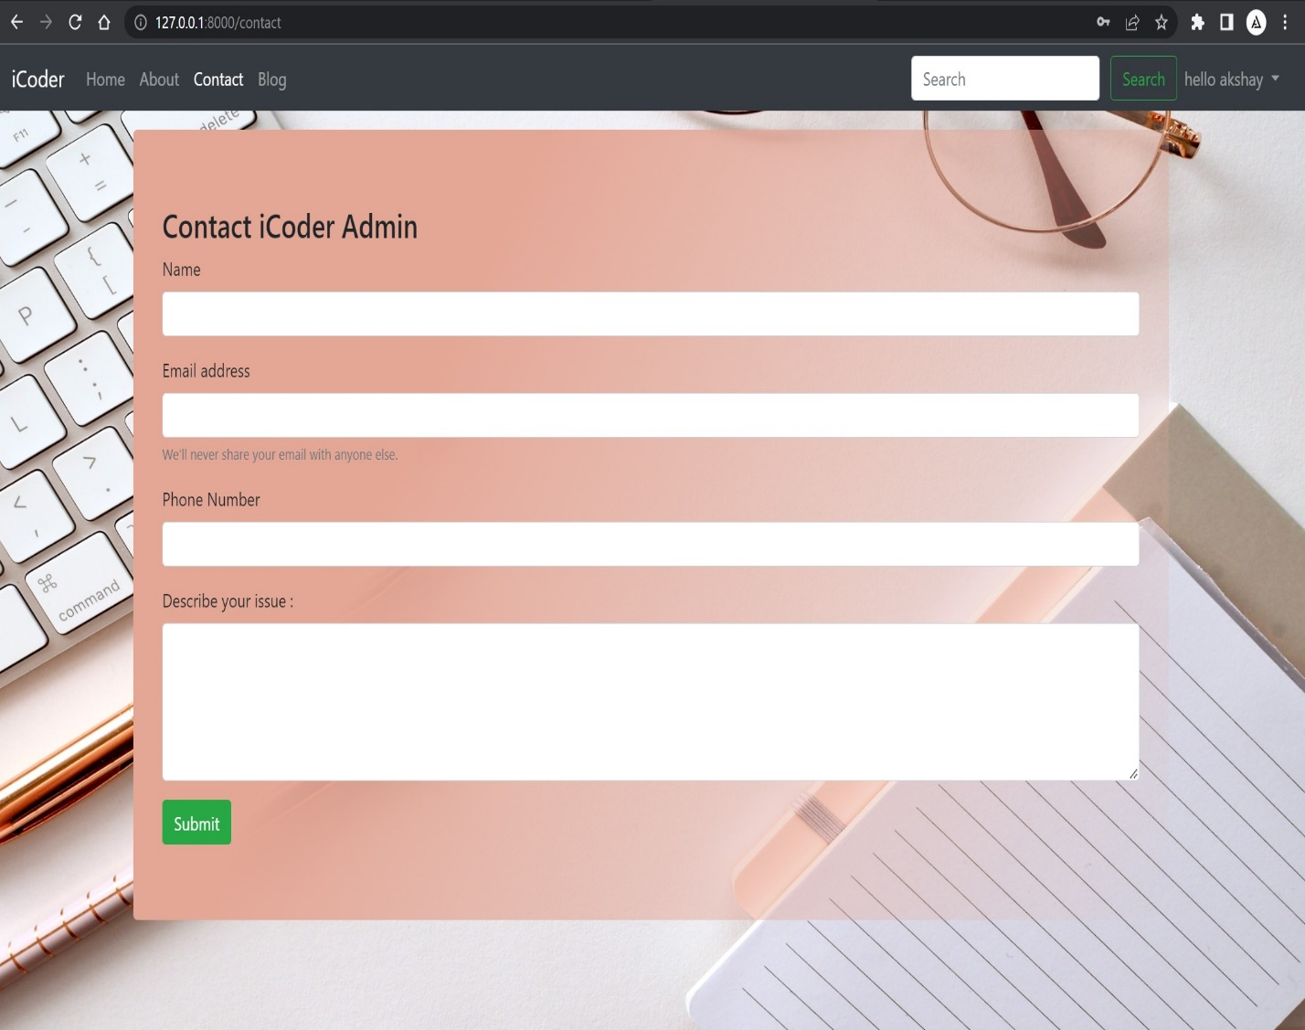

**Blog tab**

In **Blog tab** user can find the list of blogs and he can read those blogs by clicking the *continue reading* button.

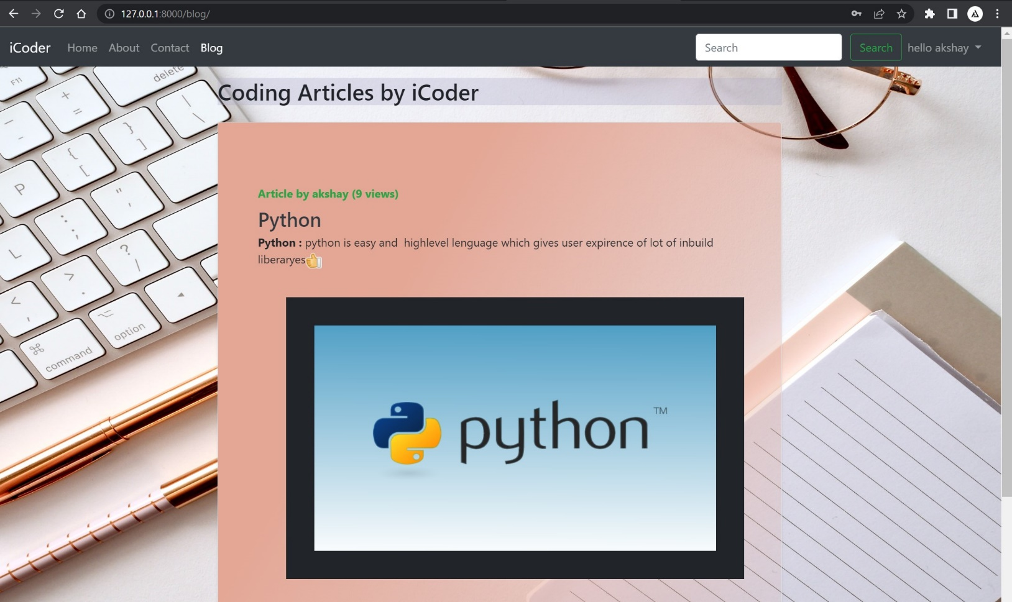

**Search bar**

In **Search bar** user can search the blog easily if the string of search bar matches the blog description, title and author it will gives the matches result.

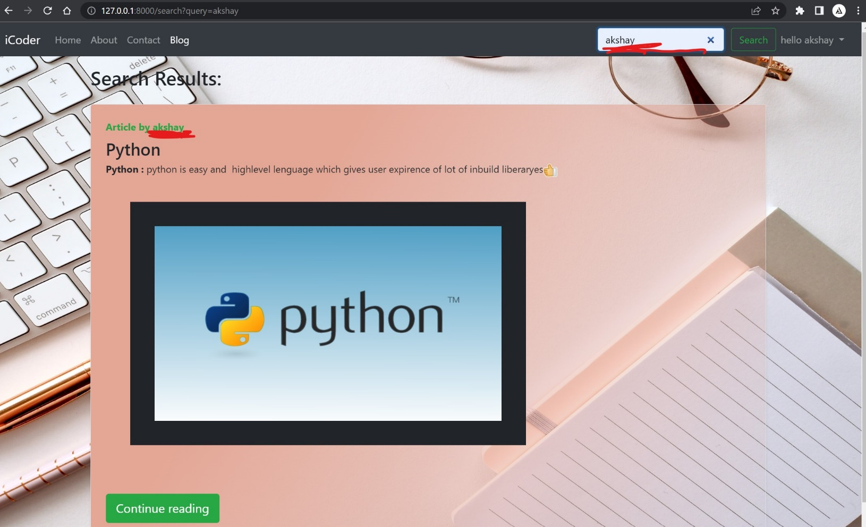

**Login and Signup**

In **login and Signup** user can login and signup in the blog website by filling some information.

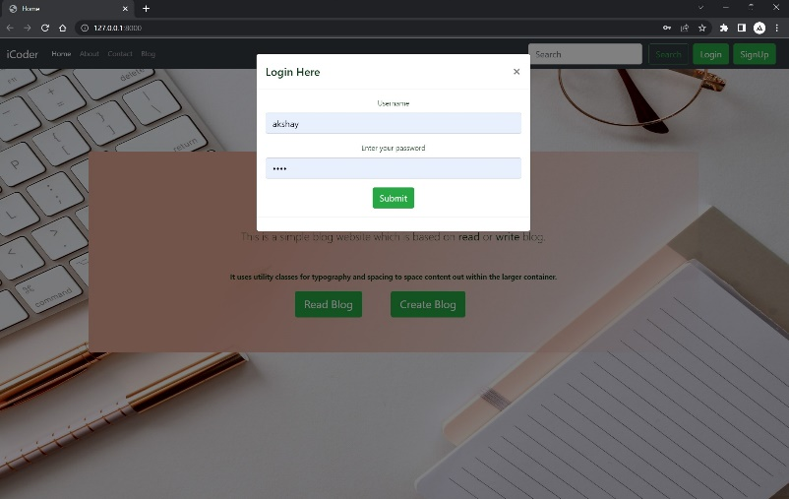

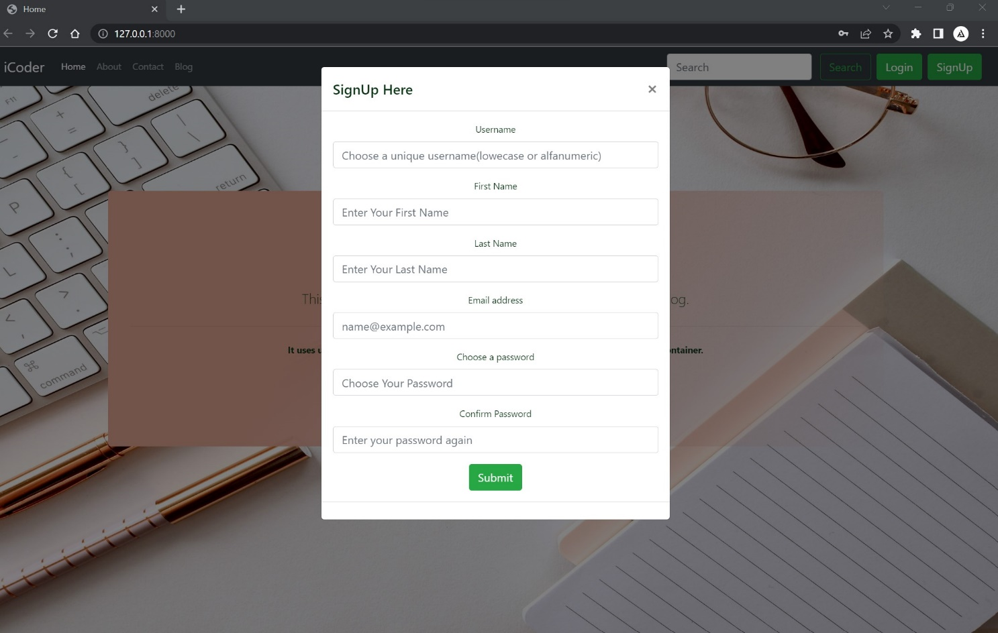

**Create Blog**

By pressing create button User can create the blog with additional text facture as like word pad.

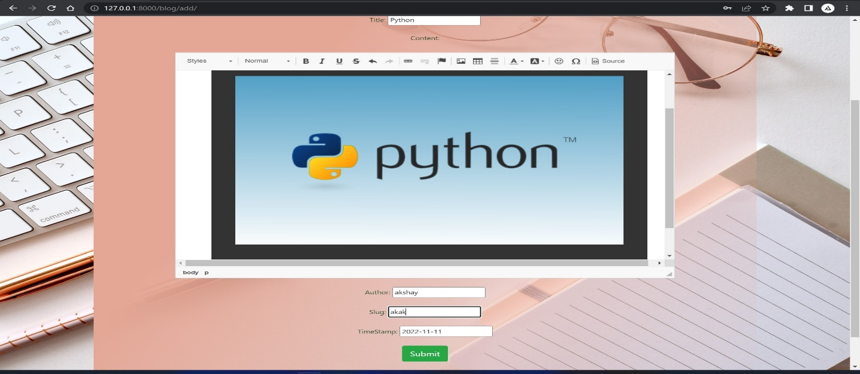

**Read Blog**

By pressing Reading button, the list of all blog is open and user can choose any one blog to read and also drop comment on the comment box

