Cascaded Dual U-Net (CD-UNet) Approach For Lane Detection in Autonomous Driving

Akshwin T
School of Computer Science and Engineering (SCOPE)
Vellore Institute of Technology
Vellore, India
akshwin.t2021@vitstudent.ac.in
Nalini N
School of Computer Science and Engineering (SCOPE)
Vellore Institute of Technology
Vellore, India
nalini@vit.ac.in

Vinay Deep Jaiswal
School of Computer Science and Engineering (SCOPE)
Vellore Institute of Technology
Vellore, India vinaydeep.jaiswal2021@vitstudent.ac.in

Abstract— Lane detection is a critical component of autonomous driving systems, providing essential information for vehicle navigation and safety. This paper presents a new approach to lane detection using a Cascaded Dual U-Net (CD-U-net) model defined by us, which leverages the strengths of convolutional neural networks to improve accuracy and robustness in varied driving conditions. Our method uses Decoder and Encoder architecture by incorporating advanced feature extraction techniques to better capture lane markings and road boundaries. The proposed model is trained and evaluated on a diverse dataset of road scenes, demonstrating superior performance in terms of accuracy and loss function. Experimental results indicate that our approach effectively handles challenging scenarios such as lane occlusions, varying lighting conditions, and different road types. This work advances the state-of-the-art in lane detection for autonomous driving, offering a more reliable and adaptive solution for real-world applications.
Keywords — Lane Detection, U-net, Autonomous Driving, Deep Learning, Convolutional Neural Network, Encoder, Decoder architecture.

Introduction
In recent times, autonomous driving systems have made significant progress with regards to lane detection, a critical element in safe and efficient navigation. The traditional lane detection methods generally use manually made features which might not be useful on different driving conditions. On the other hand, Cascaded Dual U-Net model, allows for more detailed and spatially aware lane finding as it is more learning based than traditional methods and can therefore generalize across all situations.
The Cascaded Dual U-Net model can be a promising approach to overcome the limitations of Hough Transform (HT) lane detection algorithm mainly in terms of addressing various real-world scenarios and enhancing its robustness. Cascaded Dual U-Net architecture if employed, is able to effectively overcome those limitations including sensitivity of Hough Transform-bases Lane detection to lighting changes or environmental noises. On the other hand, normal U-Net architecture has the property of being able to learn from different datasets and complex images with its incredible ability to capture minute detail. [1].
CD-U-Net could significantly influence the smart vehicle sector by enhancing lane marking perception. This improvement benefits lane following and automated lane changes, leading to more effective lane departure warnings. Consequently, there is a growing need for traffic monitoring through automated lane marking detection systems and traffic flow analysis. Through strong convolutional layers that are important for accurate localization, CD-U-net outperforms its counterparts when it comes to lane detection based on lane marking segmentation. It has also been shown to work well under different driving conditions, which makes it stand out among others. Efficient feature extraction via convolutional and pooling layers ensures computational efficiency [2][3].

LITERATURE REVIEW
Lane detection research has evolved significantly, with machine learning and deep learning techniques revolutionizing the field. In earlier times, most systems for determining which lane is being driven on utilized methods drawn from artificial intelligence for extracting features and categorizing them.
Zhang et al proposed ECPNet, a model that emphasizes lane curvature perception through the application of a different network. The approach is based on advanced curve perception techniques which address common lane detection problems such as partially or completely obscured lane markings. Among its advantages is the capability of detecting lanes in extreme curved portions of a road, ensuring its usability in practical situations. On the other hand, the drawback is that it is very computationally expensive, which would result in lower performance on less powerful devices.[4]
Qi et al proposed CLRKDNet is a system that enhances lane detection through the use of knowledge distillation. With the bigger model sounding more complicated than its small version, its authors have succeeded in preserving the accuracy yet enhancing the speed of the whole system. The benefit of this method is that the time for results to be generated is reduced, and this is an advantage for deployment in vehicles that can be driven autonomously. However, one disadvantage of this process is that it tends to compromise on accuracy when dealing with compressed models, especially for complex lane detection cases.[5]
Jhong et al has reported lane detection improvement techniques for lane assistance systems using the spatial feature aggregation techniques. The approach incorporates spatial features from different input channels to enhance the lane boundary detection. The primary benefit of this method is the accuracy in detecting lanes when the environmental and lighting condition changes which enhances safety. The downside, however, is the reliance on superior sensor data quality that limits its efficacy in cases where sensors or other spatial data is not reliable.[6]
Xiao et al. introduces an integrated methodology for scene interpretation, which adds lane detection into a wider scenario of perceptual parsing. The approach integrates scene parsing and object segmentation in one network thereby enables it to detect lanes and other objects on the road simultaneously. The benefit is that it can evaluate the entire scene which can help in decision making while driving. Still the adaptation to various driving contexts is yet to be addressed since the level of the model is the complexity which implies longer processing times.[7]
Maddiralla and co-authors suggested a lane detection algorithm that includes a convolutional attention mechanism for complex road scenarios. The model is targeted at lane detection in cases where many lanes are marked and several occlusions are present. The attention mechanism enhances the ability to concentrate on the essential elements of information making it efficient in complex situations. One of the best benefits is the fact that it works well even in situations that are labelled as adverse, crowded or otherwise obstructed areas. However, the use of attention mechanism poses a burden in terms of processing power, which is not practical for implementation in a real time environment with limited hardware resources.[8]
Ko et al. introduces a vision-based lane detection method by estimating key points. Along with that, point instance segmentation is utilized. In essence, it involves detecting the inner key points of the lanes and using instance segmentation to produce a vector map of the lane. The primary benefit of this technique is its accuracy in detecting lane boundaries even in difficult situations such as broken lines or interference from other objects. However, due to the heavy algorithmic nature of the given approach, the application of this technique in real-time in complex driving environments is quite challenging in terms of the processing capability required.[9]
Zou et al. proposed a model to detect lanes in continuous driving scenes based on deep learning employed a Recurrent Structure for the framing maintainance. The main strength of this model arises from its trackability of lanes over time, which enhances the efficacy of detection, particularly in moving vehicles. Nevertheless, the model does not perform well in certain cases where there are abrupt transitions of the surroundings, for example, in quick light changes or physical obstructions of the lanes that can cause a lot of false positive detections.[10]
Qin and others devised a structured aware deep learning model for lane detection with the ease of rapid processing, where a structure-based technique is utilized for capturing the orientation of lanes. The beauty of this specific architecture is its speed hence it can be used for real time systems in self-driving cars. The model however complicated road conditions, provides high accuracy in lane detection. The pitfall is the model’s inability to respond to all situations especially unstructured road environments that are devoid of any or have flimsy lane markings thereby reducing its overall capabilities.[11]
Zheng and coworkers suggested a fresh kind of recurrent feature-shift aggregator for improved lane detection by aggregating information from several frames. The authors inserted a recurrent shift and aggregation of the features in time to improve the consistency of lane detection from frame to frame. RESA's advantage comes from its ability to detect lanes in a video with very high temporal consistency. On the other hand, the recurrent nature of this model results in relatively slower performance in comparison to other real-time lane detection models which may restrict its employment in time critical applications.[12]
A great range of driver assistance applications have used and are under research of HT-based algorithms that are of high speediness and simplicity in revealing linear lane marks on an image. HT-based approach exploits parametric voting for line search in images, thus being effective when lane markings are clear and contrasting in comparison to other areas such as median strips or pavements. HT-based algorithms are however vulnerable to complexity in real-world surroundings such as differing light levels, car blockings or shadows which can lead to non-detection instances or in exactitudes, rather than incomplete image processing signals that could be done instead.[13].
Recent advancements in deep learning and semantic segmentation techniques, like U-Net architectures, offer promising solutions to overcome these limitations by learning feature representations directly from data, thereby improving robustness and accuracy in lane detection tasks across challenging scenarios [14].

PROPOSED FRAMEWORK

System Architecture

The system involves several steps. They are discussed further. It starts off with preprocessing the input images, converting them into RGB format, trimming their sizes to one standard size, and adjusting the pixel counts. These images which have been standardized are then passed through Cascaded Dual U-Net Architecture has two phases:
In the first phase, an encoder extracts features and a decoder reconstructs and highlights lanes and the output is generated.
In second phase, the output of the first phase is given as an input to the second phase where encoder and decoders are used to produce the final output.
The CD-U-Net model is trained on a dataset of road images with corresponding lane masks. To make sure the training process goes well, techniques like an early stop or checkpointing are used in model training to assess its performance during validation process before it can be used in real life situations after being tested against an independent set of data.
CD-U-Net is a key component of the system that performs lane segmentation in an image. When the trained model is applied on new images of roads, it produces lane masks, which highlight positions of lane markings. Such information is vital for autonomous driving systems, as they help in keeping vehicles on their paths and making them appropriate driver choices. The Figure 1 shows the system architecture of the proposed system.
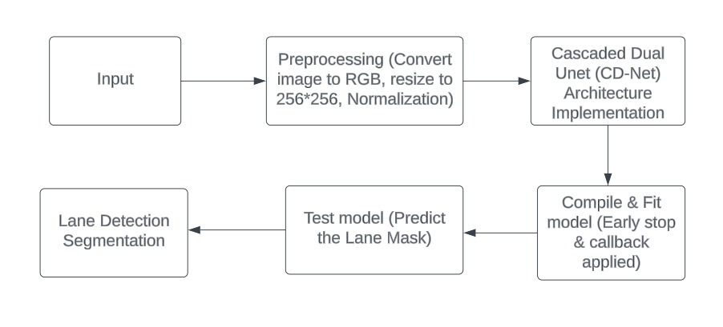
Fig 1. System Architecture

Unet Based Architecture
The provided architecture implements a U-Net model, a widely used Convolutional Neural Network (CNN) structure for semantic segmentation tasks. The model begins with an input layer designed to accommodate images with specific dimensions: IMG_HEIGHT, IMG_WIDTH, and IMG_CHANNELS. This input layer serves as the entry point for the network, accepting the images to be segmented.
There are 3 layers in the U-Net architecture apart from the input and output layers. The three main layers are Contraction layer, Bottleneck layer and expansion layer.
The U-net architecture used in two phases of Cascaded Dual U-Net architecture with the layers involved in the architecture used is given below in the figure 2.
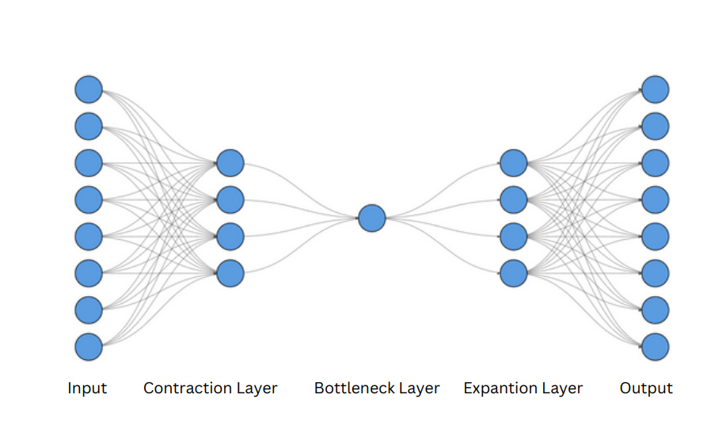

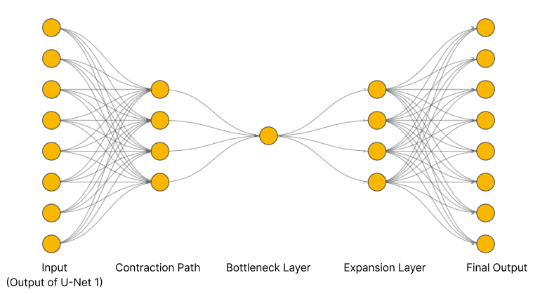

Fig 2. Outline of the architecture

Contraction Path: The core of the U-Net architecture lies in its contraction path, also known as the encoder. This path comprises several levels of convolutional blocks, each containing two consecutive convolutional layers with 3x3 kernel size, ReLU activation, 'he_normal' kernel initializer, and 'same' padding. Following each convolutional layer, a dropout layer is applied with a dropout rate of either 0.1 or 0.2, aiding in regularization. Max-pooling layers with a 2x2 pooling size are utilized to down-sample the feature maps, progressively reducing spatial dimensions while increasing the number of channels.

Bottlenect layer: At the heart of the U-Net model lies the bottleneck layer, which captures high-level features of the input data. This layer consists of two convolutional layers with 3x3 kernel size and ReLU activation, but notably, no max-pooling or down-sampling is performed here. This design choice allows the network to retain crucial spatial information while abstracting features. The Adam optimizer is used in U-net architecture.

Expansion path: The expansive path, also known as the decoder, mirrors the contraction path in reverse. It involves four levels of up-sampling blocks, each employing transpose convolutional layers with 2x2 kernel size and strides of 2x2 to up-sample the feature maps. Furthermore, concatenation with corresponding feature maps from the contraction path is performed to preserve spatial information. Similar to the contraction path, each block in the expansive path consists of two convolutional layers with ReLU activation and 'same' padding, along with dropout layers for regularization [15][16].

Output layer: At last, the U-Net model's output stratum produces the segmentation mask that consists of a single layer of convolutions having 1 x 1 kernels sizes, using sigmoid as its activation function. These probability maps output at each pixel level is based on sigmoid function output from them which shows the probability of each pixel belonging to the target class during binary segmentation; hence this system effectively captures both local details while maintaining overall information thus ensuring accurate segmentations. Regularization techniques such as dropout layers help prevent overfitting during training, contributing to the model's robustness and generalization ability [17].

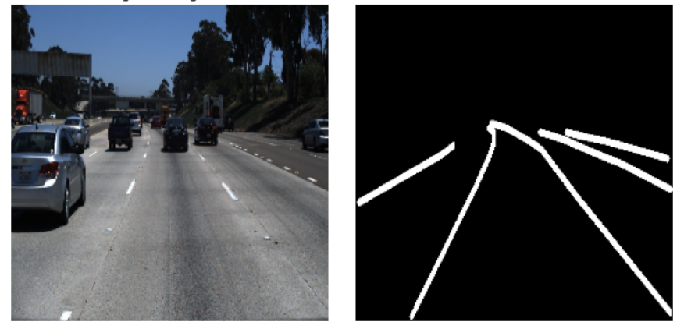
Fig 3(a). Ground Truth mask with lane masks

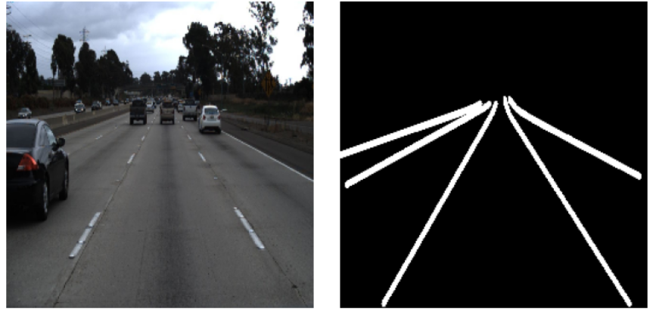
Fig 3(b). Ground Truth mask with lane marks

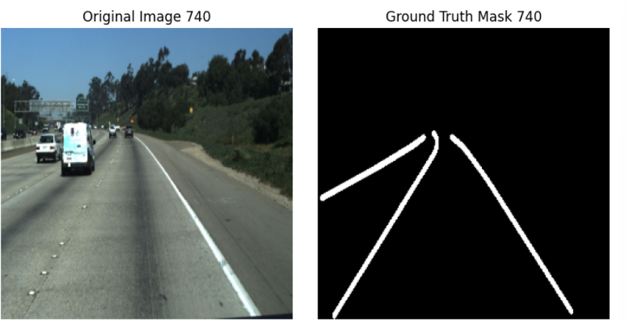
Fig 3(c). Ground Truth mask with lane mask

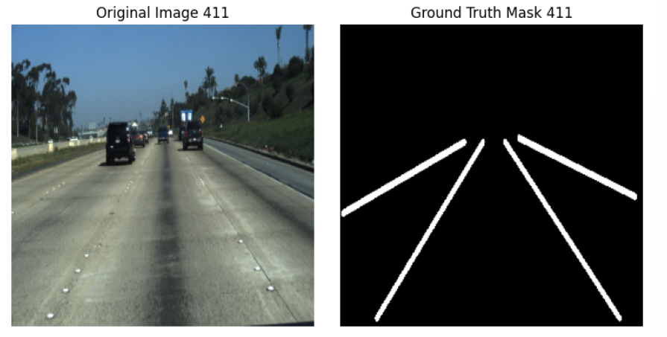
Fig 3(d). Ground Truth mask with lane marks
The figures 3(a), 3(b), 3(c), 3(d) shows the ground truth mask along with the lane marks from the dataset are given above to get idea about the input.

EXPERIMENT AND ANALYSIS
The experiment is focused on the evaluation of how well the trained U-Net model performs in lane detection tasks using the testing set from the dataset. Also, a qualitative analysis is carried out that visually inspects the model’s predictions and identifies where it could do better. Specifically, images drawn from the testing set are fed to the trained model so that there is a comparison of the predictions that are made and the ground truth masks.
The images are from the TuSimple from the source [18] dataset is divided into testing and training folders. Each folder contains frames and lane marks. The test folder contains 2782 images. The training folder contains 3626 images.
Any discrepancies or inaccuracies in the model's predictions are noted and analyzed to understand the model's strengths and limitations.
The original image along with the original lane mask and the predicted lane mask by the U-Net architecture are given in fig 4(a), fig 4(b), fig 4(c), fig 4(d).
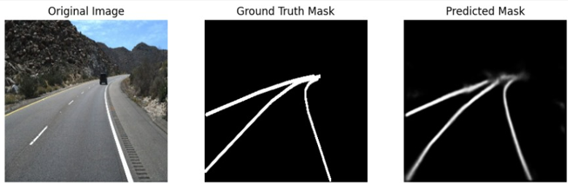
Fig 4(a). Ground Truth mask with original and predicted lane masks
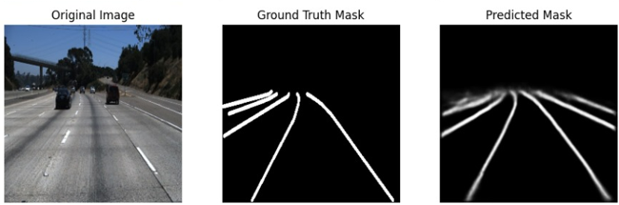
Fig 4(b). Ground Truth mask with original and predicted lane marks
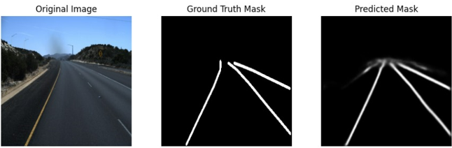
Fig 4(c). Ground Truth mask with original and predicted lane masks
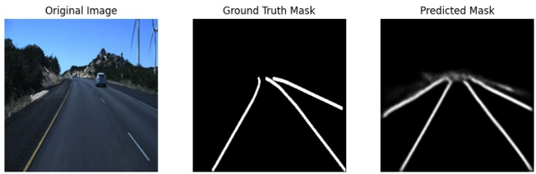
Fig 4(d). Ground Truth mask with original and predicted lane masks

Loss Curves
The Figure 5 show loss curve which shows the training and validation loss values over the epochs. It is observed that the training loss decreases consistently, indicating that the model is learning and fitting well to the training data. The validation loss, however, follows a similar decreasing trend with some fluctuations towards the end, suggesting good generalization to the validation set. The validation loss is slightly higher than the training loss in the later epochs, indicating a potential slight overfitting.
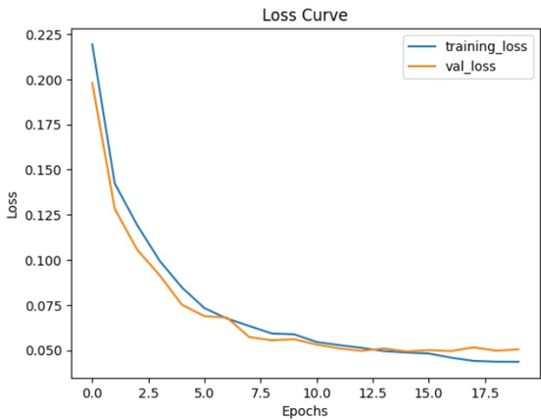
Figure 5. Loss Curve

Accuracy Curve
The Figure 6 shows the accuracy curve which illustrates the model's performance in terms of accuracy over the training epochs. The training accuracy steadily increases, reflecting the model's ability to correctly classify lane pixels during training. The validation accuracy also shows an upward trend, indicating that the model generalizes well to unseen data. The alignment between the training and validation accuracy curves suggests a balanced learning process, where the model effectively captures the relevant features for lane detection. This behavior indicates a strong generalization ability with potential room for further improvement.
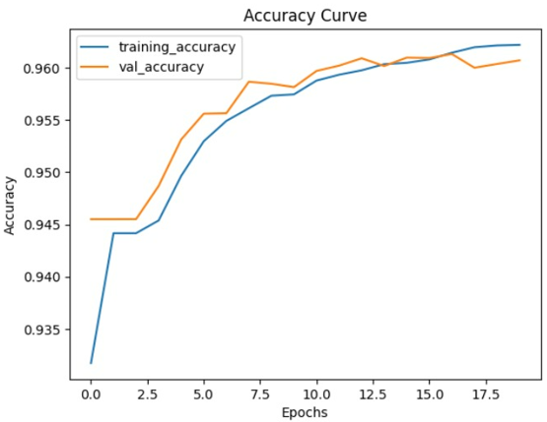
Figure 6. Accuracy Curve

Evaluation metrics

Training Accuracy: This metric tries to show if the model manages to identify road lanes correctly when being trained. The algorithm got a training accuracy of 0.9617 which means it identified lane borders correctly in most of all the training pictures.

Testing Accuracy: The evaluation of this metric involves assessing the model’s recognition performance on different data from what it was trained on like new images that have not been seen before. It was found that the model under discussion had a testing accuracy reading as 0.9607 which implies that it was able to recognize lane markings appropriately.

Training Loss: During training time the training loss will always be there to show how far away our predicted output is from actual lane markings (Choi, 2018). In this context, a smaller training loss of 0.0445 means that the model does not make many errors in its predictions during training time.

Testing Loss: On a test dataset, testing loss is used for estimating the model's prediction error. The testing loss is around 0.0505. This shows how well it can generalize and still have an insignificant error rate running over.

- Performance Metrics
Performance Metrics | Value
Training Accuracy | 0.9617
Testing Accuracy | 0.9607
Training Loss | 0.0445
Testing Loss | 0.0505

From the Table 1 , the performance metrics table shows that the model has a very good accuracy and less loss. The model also handles the overfitting and underfitting effectively.

CONCLUSION AND FUTURE WORK
The paper provides a comprehensive exploration of the U-Net architecture for lane detection in autonomous driving, showcasing a promising Cascaded U-Net model with high accuracy and low loss. The model's effectiveness is well-supported through qualitative analysis of sample images, demonstrating its accuracy in detecting lane markings. However, there is room for improvement in its generalization across diverse road conditions, as enhancing its robustness in challenging scenarios like complex lane patterns and poor lighting would strengthen its real-world applicability. Future directions could include integrating complementary sensor data, such as LiDAR or radar, to provide additional context, and experimenting with advanced training techniques like data augmentation or self-supervised learning to further boost performance. Addressing these aspects would solidify the paper’s contributions to lane detection research and advance the development of dependable autonomous driving systems.

References
- Huang, Q., & Liu, J. (2021). Practical limitations of lane detection algorithm based on Hough transform in challenging scenarios. International Journal of Advanced Robotic Systems, 18(2), 17298814211008752.Pan, X., Shi, J., Luo, P., Wang, X., & Tang, X. (2018, April). Spatial as deep: Spatial cnn for traffic scene understanding. In Proceedings of the AAAI conference on artificial intelligence (Vol. 32, No. 1).
- Niu, J., Lu, J., Xu, M., Lv, P., & Zhao, X. (2016). Robust lane detection using two-stage feature extraction with curve fitting. Pattern Recognition, 59, 225-233.
- Kim, J., Kim, J., Jang, G. J., & Lee, M. (2017). Fast learning method for convolutional neural networks using extreme learning machine and its application to lane detection. Neural Networks, 87, 109-121.
- Zhang, Y., Zheng, Y., Wu, C., Zhang, T., & Liu, Y. (2024, April). ECPNet: An Enhanced Curve Perception Network for Lane Detection. In ICASSP 2024-2024 IEEE International Conference on Acoustics, Speech and Signal Processing (ICASSP) (pp. 7380-7384). IEEE.
- Qi, W., Zhao, G., Ma, F., Zheng, L., & Liu, M. (2024). CLRKDNet: Speeding up Lane Detection with Knowledge Distillation. arXiv preprint arXiv:2405.12503.
- Jhong, S. Y., Chen, Y. Y., Hsia, C. H., & Lai, C. F. (2024). iVehicles: Spatial Feature Aggregation Network for Lane Detection Assistance System. IEEE Sensors Letters, 8(4), 1-4.
- Xiao, T., Liu, Y., Zhou, B., Jiang, Y., & Sun, J. (2018). Unified perceptual parsing for scene understanding. In Proceedings of the European conference on computer vision (ECCV) (pp. 418-434).
- Maddiralla, V., & Subramanian, S. (2024). Effective lane detection on complex roads with convolutional attention mechanism in autonomous vehicles. Scientific Reports, 14(1), 19193.
- Ko, Y., Lee, Y., Azam, S., Munir, F., Jeon, M., & Pedrycz, W. (2021). Key points estimation and point instance segmentation approach for lane detection. IEEE Transactions on Intelligent Transportation Systems, 23(7), 8949-8958.
- Zou, Q., Jiang, H., Dai, Q., Yue, Y., Chen, L., & Wang, Q. (2019). Robust lane detection from continuous driving scenes using deep neural networks. IEEE transactions on vehicular technology, 69(1), 41-54.
- Qin, Z., Wang, H., & Li, X. (2020). Ultra fast structure-aware deep lane detection. In Computer Vision–ECCV 2020: 16th European Conference, Glasgow, UK, August 23–28, 2020, Proceedings, Part XXIV 16 (pp. 276-291). Springer International Publishing.
- Zheng, T., Fang, H., Zhang, Y., Tang, W., Yang, Z., Liu, H., & Cai, D. (2021, May). Resa: Recurrent feature-shift aggregator for lane detection. In Proceedings of the AAAI conference on artificial intelligence (Vol. 35, No. 4, pp. 3547-3554).
- Chutatape, O., & Guo, L. (1999). A modified Hough transform for line detection and its performance. Pattern recognition, 32(2), 181-192.
- Chhabra, R., Krishna, C. R., & Verma, S. (2021). A survey on state-of-the-art road surface monitoring techniques for intelligent transportation systems. International Journal of Sensor Networks, 37(2), 81-99.
- Wu, D., Liao, M. W., Zhang, W. T., Wang, X. G., Bai, X., Cheng, W. Q., & Liu, W. Y. (2022). Yolop: You only look once for panoptic driving perception. Machine Intelligence Research, 19(6), 550-562.
- Sawant, K. S., Bhakare, S., Bharane, P., Borse, P., & Naphade, A. (2024). Detection of Lane and Speed Breaker Warning System for Vehicles Using Machine Learning. International Research Journal on Advanced Engineering and Management (IRJAEM), 6(07), 2341-2347.
- Satti, S. K., Devi, K. S., Dhar, P., & Srinivasan, P. (2021). A machine learning approach for detecting and tracking road boundary lanes. ICT Express, 7(1), 99-103.
- https://paperswithcode.com/dataset/tusimple

