**TBXNet Pro: A Hybrid CNN-LSTM Architecture for Tuberculosis Detection from Chest X-Ray Images**

**Abstract**

This paper presents a hybrid deep learning approach for Tuberculosis detection using a combination of convolutional neural networks (CNNs) and bidirectional long short-term memory (Bi-LSTM) networks. The model architecture leverages CNNs for feature extraction from medical images, followed by Bi-LSTM layers to capture the temporal dependencies and relationships within the extracted features. To enhance the model's performance and robustness, data augmentation techniques such as rotation, zooming, shifting, and horizontal flipping were applied to the input images. These transformations help in improving generalization and preventing overfitting by artificially increasing the diversity of the training data.

The model was trained using the Adam optimizer with a learning rate of 1e-4 and binary cross-entropy loss. A dropout layer was integrated into the network to reduce the risk of overfitting, particularly in the fully connected layers. The system was evaluated using key performance metrics such as precision, recall, F1 score, and accuracy. Additionally, a confusion matrix was employed to analyze classification performance. This architecture demonstrates 99% accuracy in detecting the tuberculosis and effectiveness in detecting diseases from medical images, offering a promising tool for clinical diagnosis and screening applications.

**Keywords:** Tuberculosis detection, Deep learning, Hybrid CNN-RNN model, medical imaging, binary classification.

**Introduction**

Tuberculosis (TB) remains one of the most significant global health challenges, accounting for an estimated 1.5 million deaths in 2020 alone [1]. The traditional diagnostic methods for TB, including sputum smear microscopy and culture tests, often fall short in terms of sensitivity and specificity, especially in cases involving extrapulmonary TB or co-infection with HIV [2]. Consequently, the development of efficient and reliable diagnostic tools is essential for timely treatment and control of the disease.

Recent advances in artificial intelligence (AI) and deep learning have opened new avenues for improving Tuberculosis diagnostics. Convolutional neural networks (CNNs), in particular, have demonstrated exceptional performance in various medical image classification tasks. These models can automatically learn to extract intricate features from images, reducing the dependency on human interpretation and the associated risks of misdiagnosis [4]. This shift towards automated diagnostics has the potential not only to enhance accuracy but also to facilitate early detection, ultimately leading to better patient outcomes.

Despite the promising capabilities of deep learning models, their performance is heavily reliant on the availability and quality of training data. A comprehensive dataset that captures the variability in TB presentations and the characteristics of normal chest X-rays is crucial for developing robust models. This research utilizes a dataset comprising 2,494 chest X-ray images from TB patients and 514 normal images from Mendeley data. The images have been meticulously processed and resized to ensure uniformity, thereby providing a solid foundation for further analysis.

In addition to leveraging a high-quality dataset, this study employs data augmentation techniques to enhance the model's generalization capabilities. Techniques such as rotation, zooming, and horizontal flipping are applied to the training dataset while maintaining the integrity of the validation and test datasets. This approach aims to mitigate overfitting and improve the model's performance in real-world scenarios.

The primary objective of this research is to develop a robust hybrid CNN-RNN model that accuratelyclassifies chest X-ray images, distinguishing between TB-infected and healthy cases. By harnessing the power of deep learning and optimizing model architecture, this study aims to contribute to the growing body of knowledge on the application of AI in medical imaging, with a focus on enhancing TB diagnostics and supporting public health initiatives.

**Literature Review**

Hooda et al. presented a deep-learning-based system aimed at improving tuberculosis (TB) detection from chest radiographs (CXRs). Recognizing that traditional computer-aided diagnosis (CAD) systems face significant challenges in accurately identifying TB due to the disease's varying impact on X-ray images, they propose an ensemble method combining three well-established architectures: AlexNet, GoogleNet, and ResNet. By training these models from scratch and creating a tailored ensemble, the study showcases a method that not only enhances classification performance but also achieves an impressive accuracy of 88.24% and an area under the curve (AUC) of 0.93. This performance surpasses many existing TB detection methods, highlighting the potential of ensemble learning in addressing the complexities of TB diagnosis in medical imaging. The research underscores the importance of integrating multiple deep learning architectures to enhance diagnostic capabilities and assist radiologists in the effective identification of TB.[4]

Liu et al. (2020) tackled the critical issue of tuberculosis (TB) diagnosis in low and middle-income countries (LMICs), where challenges such as healthcare inequalities and limited resources hinder effective management of the disease. They propose a novel approach utilizing a Convolutional Neural Network (CNN) designed to address the issues of unbalanced and less-categorized X-ray images. The authors emphasize the significance of shuffle sampling combined with cross-validation in improving the model's training process, leading to enhanced accuracy in classifying various TB manifestations. Their method achieves a remarkable classification accuracy of 85.68% on a large TB image dataset, outperforming existing state-of-the-art techniques. The findings of this research highlight the potential of advanced computer techniques to facilitate faster and more accurate TB diagnoses in resource-poor healthcare settings, ultimately contributing to the global effort to combat the TB epidemic.[5]

Ghorakavi et al. introduced TBNet, a deep learning system designed to enhance tuberculosis (TB) diagnosis using chest X-rays. This approach addresses the limitations of existing methods that often rely on unnecessary features by employing the ResNet architecture coupled with effective data augmentation strategies, including Haar and Local Binary Patterns (LBP). These techniques improve the focus on TB-affected regions, significantly boosting detection accuracy. Previous research has demonstrated the efficacy of deep convolutional neural networks (CNNs) in TB detection, reporting high classification accuracies and emphasizing the importance of robust data augmentation for model generalization. By leveraging publicly available datasets, TBNet contributes to the evolving landscape of computer-aided diagnosis, promising enhanced screening capabilities in the ongoing fight against TB.[6]

Hwang et al. developed a computer-aided diagnosis (CAD) system aimed at improving TB screening. The authors noted that TB remains a significant health threat, particularly in developing countries where diagnostic resources are limited. Traditional CAD systems often rely on handcrafted features to differentiate lesion types in chest X-rays (CXRs), but these methods may not always be effective. In contrast, the team employed a deep convolutional neural network (CNN) for automatic TB screening, taking advantage of the network's ability to perform end-to-end training from feature extraction to classification. This approach removes the need for manual feature engineering. Their results showed impressive TB screening performance, achieving area under the curve (AUC) scores of 0.96, 0.93, and 0.88 across three field datasets. The authors also highlighted the role of transfer learning in boosting the model's accuracy and adaptability. This study demonstrates the potential of CNNs in developing more accurate and scalable TB screening solutions, which could significantly enhance early diagnosis efforts in regions with limited healthcare resources.[7]

Heo et al. (2019) investigated the effectiveness of convolutional neural networks (CNNs) in detecting tuberculosis (TB) using chest radiographs and demographic information. They compared the performance of two models: one using only image data (I-CNN) and another integrating demographic variables (D-CNN). The study employed multiple deep learning architectures, including VGG19, InceptionV3, ResNet50, DenseNet121, and InceptionResNetV2, trained on 1000 chest X-ray images. The findings revealed that D-CNN models, which incorporated demographic factors like age, weight, height, and gender, consistently outperformed I-CNN models in terms of the area under the receiver operating characteristic (ROC) curve (AUC). Specifically, the AUC for VGG19 increased by 0.0144 in the training set and 0.0138 in the test set when demographic data were included, indicating statistically significant improvements. Furthermore, the D-CNN models demonstrated greater sensitivity and robustness compared to I-CNN models, especially at higher specificity levels. The study concludes that incorporating demographic information alongside image data enhances the accuracy and sensitivity of TB detection, highlighting the potential of machine learning to improve diagnostic processes in clinical settings.[8]

Karnkawinpong et al. explored the effectiveness of convolutional neural networks (CNNs) in classifying tuberculosis (TB) in chest X-ray (CXR) images. They focused on three deep neural network architectures: AlexNet, VGG-16, and CapsNet, to evaluate their performance in TB classification. The models were trained using datasets obtained from the National Library of Medicine and private Thai datasets. To enhance model performance and address the challenge of overfitting, data augmentation techniques such as shuffle sampling and affine transformations were employed. These techniques ensured that the models could generalize better when confronted with variant instances in test data that were not present in the training set. The study measured the effectiveness of the classifiers using accuracy, sensitivity, and specificity, finding that all models showed improved performance when trained on augmented datasets. This research highlights the potential of deep learning approaches, particularly CNNs, in the early detection and classification of TB from CXR images, emphasizing the importance of data augmentation in achieving higher accuracy and robustness in medical image analysis.[9]

Chithra at al. focus on tackling the challenges of accurate TB detection by leveraging deep learning techniques. The study starts with transforming the image from the RGB color space to LUV, enhancing image segmentation. Adaptive thresholding is employed to segment the images more effectively, followed by extracting relevant features such as coverage, density, color histogram, area, length, and texture. Principal Component Analysis (PCA) is used to optimize the features for better classification. The study introduces a fractional crow search-based deep convolutional neural network (FC-SVNN) to classify tuberculosis-infected regions and proposes an Adaptive Fractional Crow (AFC)-deep CNN model. This model adapts the fractional crow search method using self-adaptive concepts for improved accuracy in predicting TB severity. The image-level features like bacilli count and scattering coefficients play a crucial role in assessing infection severity. The proposed AFC-Deep CNN algorithm demonstrated high performance with a maximum accuracy of 0.935, indicating its effectiveness in enhancing TB detection and severity assessment compared to traditional methods. This study highlights the significance of combining feature extraction techniques with advanced deep learning models to improve diagnostic accuracy in medical imaging.[10]

Stefanus Kieu Tao Hwa et al. present a novel approach to improving TB detection through the use of ensemble deep learning techniques combined with enhanced imaging. The research focuses on the utilization of contrast-enhanced Canny edge detection (CEED-Canny) to produce more precise lung X-ray images, emphasizing edge details that can be crucial in identifying TB-affected areas. By generating two sets of features—one from the enhanced X-ray images and another from the edge-detected images—the study enhances the diversity of the error patterns among the base classifiers, leading to improved diagnostic accuracy. This approach addresses the limitations of previous methods that relied on training classifiers with similar features. The ensemble method proposed in this study achieved a high level of performance, with an accuracy of 93.59%, sensitivity of 92.31%, and specificity of 94.87%. This demonstrates the effectiveness of using varied feature sets to enhance the capabilities of deep learning models in detecting tuberculosis, highlighting the importance of diverse feature extraction in ensemble learning.[11]

Suci Aulia et al. proposed a system for tuberculosis (TB) detection based on chest X-ray images using the VGG-16 convolutional neural network (CNN) architecture. The study addresses the challenge of variability in X-ray image quality, which can lead to diagnostic errors such as true negatives or false negatives in TB screening. To tackle this, they implemented a CNN model using the VGG-16 architecture, trained on a dataset consisting of 700 normal and 140 TB-affected chest X-ray images. The results of their study demonstrated a high classification accuracy of 99.76% in distinguishing between normal and TB-infected lungs. The study highlighted the importance of optimizing model parameters, such as batch size, to achieve peak performance, with the highest accuracy being obtained using a batch size of 50. This research contributes to the development of a robust machine learning model for assisting radiologists in the detection of TB from chest X-rays, aiming to reduce the error rate in initial TB screening and enhance early diagnosis and treatment.[12]

Ahmed Iqbal et al. introduced a novel computer-aided diagnosis (CAD) system called TBXNet for tuberculosis (TB) detection in chest X-ray (CXR) images. The research aims to address the challenges of manual interpretation of CXR images, which often leads to variability in diagnosis among radiologists. TBXNet utilizes five dual convolution blocks with varying filter sizes (32, 64, 128, 256, and 512) integrated into a fusion layer that employs pre-trained layers to enhance feature extraction and knowledge transfer. The model was evaluated on multiple datasets, achieving high accuracy rates of 98.98% on Dataset A and 99.17% on Dataset B, with excellent performance on Dataset C, which included normal, tuberculous, pneumonia, and COVID-19 cases. The study reported high precision (95.67%), recall (95.10%), F1-score (95.38%), and overall accuracy (95.10%), demonstrating the superiority of TBXNet over other state-of-the-art methods. This work highlights the potential of deep learning frameworks in providing cost-effective, scalable, and reliable solutions for TB detection, ultimately reducing diagnostic errors and dependency on radiologists in clinical settings.[13]

|  |  |  |  |
| --- | --- | --- | --- |
| S.No | Year of publication | Methodology | Accuracy |
| 1 | 2019 | Ensemble of (AlexNet, GoogleNet &ResNet) | 88.24 |
| 2 | 2017 | CNN | 85.68 |
| 3 | 2019 | Resnet-18 | 65.77 |
| 4 | 2016 | AlexNet with transfer learning AlexNet without transfer learning | 0.90  0.71 |
| 5 | 2019 | DCNN (Image CNN +Demographic variable) | Sensitivity = 0.815  Specificity = 0.962 AUC = 0.92 |
| 6 | 2019 | AlexNet  VGG-16 CapsNet | 92.9  94.56  90.33 |
| 7 | 2020 | Adaptive Fractional Crow (AFC)-Deep CNN | 93.5 |
| 8 | 2020 | Ensemble CNN | 93.59 |
| 9 | 2022 | VGG-16 | 99.76 |
| 10 | 2022 | TBXNet | 99.17 |

**Methodology Proposed**

**System Architecture**

The proposed architecture for the tuberculosis detection model is designed as a streamlined and efficient pipeline for processing chest X-ray images. At the outset, raw images undergo a series of preprocessing steps, including resizing to a uniform dimension and normalization, ensuring that all images are suitable for input into the neural network. This is followed by data augmentation techniques, such as random rotations, zooming, shifting, shearing, and horizontal flipping. These augmentations enhance the dataset's diversity, enabling the model to generalize better by preventing overfitting to specific patterns.

The core of the architecture consists of a Convolutional Neural Network (CNN), which is responsible for feature extraction from the X-ray images. The CNN comprises several convolutional layers that progressively learn hierarchical features, followed by pooling layers that reduce the spatial dimensions of the data, leading to computational efficiency. The output of the CNN is then passed to a classification layer, which uses a sigmoid activation function to determine the probability of the input image being classified as either tuberculosis-infected or healthy. The model is trained using the Adam optimizer and binary cross-entropy as the loss function, facilitating optimal convergence during the training phase. Overall, this architecture is aimed at providing accurate and reliable predictions for tuberculosis detection from chest X-rays, thus aiding in timely diagnosis and treatment.

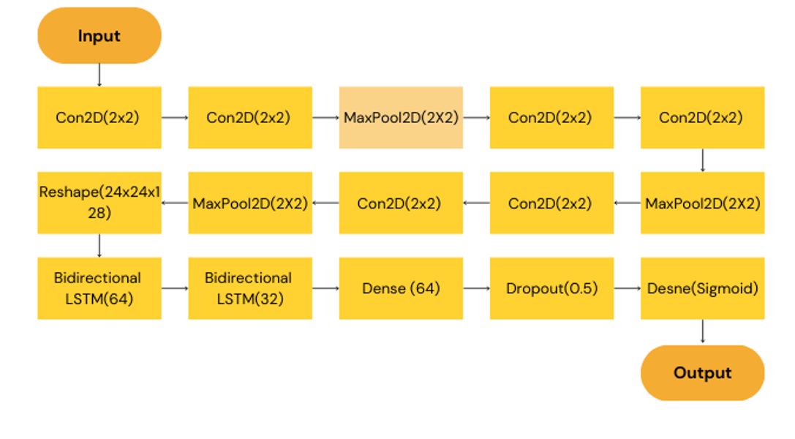System Architecture

**Proposed Methodology**

In this subsection, we provide a detailed analysis and explanation of the methodological development and implementation of our proposed architecture, a hybrid CNN-BiLSTM model designed for disease detection from medical images. The framework incorporates several stages, including data preprocessing, architectural design, and model training.

The architecture integrates two powerful deep learning models: Convolutional Neural Networks (CNNs) and Bidirectional Long Short-Term Memory (BiLSTM) networks. CNNs are responsible for extracting key spatial features from the input images, capturing important patterns and visual hierarchies. After three convolutional blocks, the model applies a flattening layer to transform the feature maps into a suitable format for the LSTM layers. Subsequently, two bidirectional LSTM layers are employed to capture both forward and backward dependencies in the sequential data, improving the model’s ability to learn temporal relationships from the extracted features. This is followed by a dense layer, a dropout layer to reduce overfitting, and a final dense output layer, which provides the prediction.

This hybrid CNN-BiLSTM architecture enhances the model's capability in processing image data, especially when sequential dependencies within the features need to be considered for accurate disease detection.

**Convolutional Neural Networks (CNN):**

CNNs are used to extract spatial features from the input X-ray images. The architecture comprises three blocks of convolutional and pooling layers:

First Block:

The input image is processed by two 2D convolution layers, each with 32 filters and a 3x3 kernel. This block is followed by a max-pooling layer that reduces the spatial dimensions by half. The output is a feature map of size (112, 112, 32), capturing local patterns such as edges and textures.

Second Block:

Similar to the first block, but with 64 filters in each convolutional layer. Max-pooling reduces the size to (56, 56, 64). These filters detect more complex patterns, such as parts of the lungs or other anatomical features.

Third Block:

This block has 128 filters in each convolutional layer. After max-pooling, the feature map size is (24, 24, 128), encoding even higher-level abstractions such as anomalies in the lung structure.

Flattening and Reshaping:

After the final CNN block, the 3D feature maps are flattened and reshaped into a 2D sequence of size (576, 128), where each of the 576 “steps” represents a spatial region of the image, and the 128 features represent learned characteristics of that region. This transformation allows the BiLSTM layers to process the spatial information sequentially.

**Bidirectional LSTM (BiLSTM):**

LSTMs are specialized for handling sequential data, and in this architecture, they process the sequence of flattened features generated by the CNN layers. Two BiLSTM layers are used:

First Layer:

The first BiLSTM layer has 64 units and returns a sequence, preserving the temporal relationships between the spatial features of the image.

Second Layer:

The second BiLSTM layer has 32 units and provides a final condensed sequence representation of the X-ray. By processing the data in both forward and backward directions (bidirectional), the BiLSTMs capture the full context of the sequence, improving the model's ability to detect subtle patterns associated with pneumonia.

**Fully connected layer**

The output from the BiLSTM layers is fed into a fully connected neural network for the final classification. This consists of:

A fully connected layer with 64 neurons and ReLU activation. This layer processes the sequence output from the BiLSTM layers and prepares it for classification.

The ReLU (Rectified Linear Unit) is used to introduce non-linearity and help the network to learn more complex patterns.

The ReLU function takes an input value and outputs the value itself if it's greater than or equal to zero, and zero if it's negative. The ReLu function is given by :

R(x) = max(0,x)

**Dropout layer:**

The dropout layer is a widely-used regularization technique in deep learning to prevent overfitting, especially in models that are prone to memorizing the training data. It works by randomly "dropping out" a fraction of the neurons during each training iteration, effectively setting their output to zero. This process forces the network to learn more robust features by preventing it from relying on specific neurons.

Mathematically, the dropout process can be represented as:

y=1/(1−p)⋅W⋅x.

Where:

* P is the dropout rate (the fraction of neurons to be dropped),
* W is the weight matrix,
* x is the input,
* y is the output of the layer after applying dropout.

The factor 1/(1-p) ensures that the outputs are appropriately scaled during training, so the magnitude of the outputs remains consistent even with some neurons being dropped. During inference (testing), no neurons are dropped, and the entire network is used for predictions.

A dropout rate of 50% is applied to reduce overfitting by randomly ignoring half the neurons during each training iteration.

This is because the regularization parameter, *p*(1-*p*) in Equation above is maximum at *p* = 0.5.

**Output Layer:**

The final layer has a single neuron with a sigmoid activation function, which outputs a probability value between 0 and 1. This represents the binary classification of either “pneumonia” (class 1) or “normal” (class 0).

σ(x)=1/1+e^−x

The main reason why we use sigmoid function is because it exists between **(0 to 1).**Therefore, it is especially used for models where we have to **predict the probability** as an output. probability of anything exists only between the range of **0 and 1,** sigmoid is the right choice.

**Experimental and Analysis**

**Dataset**

The dataset utilized in this study consists of 2,494 chest X-ray images from patients diagnosed with tuberculosis (TB) and 514 normal chest X-ray images, it’s an open-source dataset from Mendeley data with comprehensive representation of TB-affected chest X-rays, offering a diverse set of cases for analysis. All images have been uniformly resized to ensure consistency and facilitate efficient processing during model training.

|  |  |
| --- | --- |
| Class | Number of images |
| Normal Chest X-Ray | 514 |
| TB Chest X-Ray | 2494 |

**Preprocessing**

To ensure that the model learns robust and generalizable features from the chest X-ray images, a series of preprocessing steps are applied to the training dataset. This is crucial for enhancing the model's ability to handle variations in the data and avoid overfitting. The key preprocessing techniques include:

**Data Augmentation**

To artificially increase the size of the training dataset and improve the model's robustness, several augmentation strategies are implemented using TensorFlow's ImageDataGenerator. These augmentations simulate real-world variations in X-ray captures:

* Rotation: Random rotations of up to 20 degrees are applied to account for variations in the angle at which the X-ray images are taken.
* Zooming: A zoom range of 15% is applied to simulate changes in camera distance or image magnification.
* Shifting: Both width and height are shifted by up to 20% to mimic off-center captures, making the model less sensitive to the exact placement of the X-ray subject.
* Shearing: A shear transformation introduces slight distortions in the images, improving the model's invariance to geometric distortions in real-world data.
* Horizontal Flipping: Random horizontal flips are used to increase the variety of training samples, reducing the likelihood of overfitting to specific image orientations.

These transformations are applied randomly to each image in the training set during model training, thus enhancing the generalization ability of the model by exposing it to a wide range of potential distortions and orientations.

**Normalization**

After augmentation, all images are rescaled by dividing pixel values by 255, normalizing them to a range of [0, 1]. This normalization ensures that all input data is on a consistent scale, which helps improve the convergence speed during model training by reducing the variance in pixel intensity values.

**Validation and Test Sets**

To maintain the integrity of the validation and test sets, no augmentation is applied to these datasets. Instead, the images are only rescaled by a factor of 1/255, ensuring that the evaluation of the model is performed on unaltered data, thus providing a realistic assessment of model performance.

**Training and Compilation**

The proposed model is compiled using the Adam optimizer, with binary cross-entropy as the loss function and accuracy as the primary evaluation metric. The learning rate is set to 1e-4 to ensure a balance between convergence speed and training stability.

**Optimizer: Adam**

The Adam (Adaptive Moment Estimation) optimizer is employed due to its efficiency and adaptability in handling sparse gradients and noisy data. Adam combines the advantages of two traditional optimization methods: Momentum and RMSProp. The recursive update equation for a parameter θt in Adam is given by:

θt​=θt−1​−α (mt)root (vt)+ ϵ

θt​ represents the current parameter value at time step t.

α is the learning rate.

mt the first moment estimate (the moving average of the gradients), which helps smooth out oscillations.

vt​ is the second moment estimate (moving average of squared gradients), which accounts for the gradient variance.

ϵ is a small constant added to prevent division by zero.

Adam adjusts the learning rate for each parameter based on the moments of the gradients, allowing for faster convergence with reduced risk of overshooting the minimum. This makes it particularly well-suited for deep learning models like CNNs and LSTMs used in our hybrid architecture.

**Loss Function: Binary Cross-Entropy**

Given that this is a binary classification problem (e.g., predicting disease presence or absence), binary cross-entropy (BCE) is used as the loss function. The formula for BCE is:

BCE=−(y⋅log(y_pred​) +(1−y) ⋅log(1−y_pred​))

Where:

* y represents the true label (0 or 1).
* y_pred is the predicted probability for class 1.
* log denotes the natural logarithm.

This loss function calculates how far the predicted probabilities are from the true binary labels and helps guide the model's learning process to minimize the error. BCE is particularly well-suited for binary classification problems, ensuring the model is penalized proportionally to the confidence of incorrect predictions.

**Learning Rate:**

The learning rate, a critical hyperparameter, controls the step size during optimization. A smaller learning rate, like the chosen 1e-4, ensures that updates are made gradually, promoting stable convergence while avoiding overshooting minima. This value was empirically chosen after experimentation to provide a good trade-off between speed of convergence and model stability during training.

**Evaluation metrics**

**Accuracy curve**

The accuracy curve tracks the model's performance over time, showing an upward trend in both training and validation accuracy. The gradual improvement indicates that the model is learning effectively and generalizing well to unseen data without overfitting.

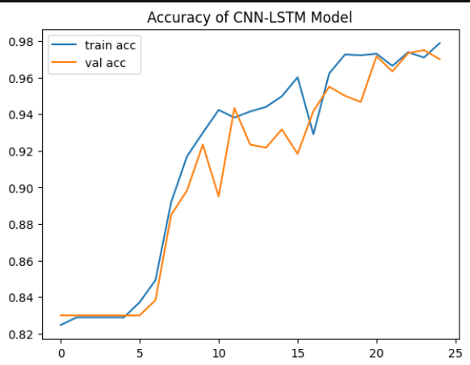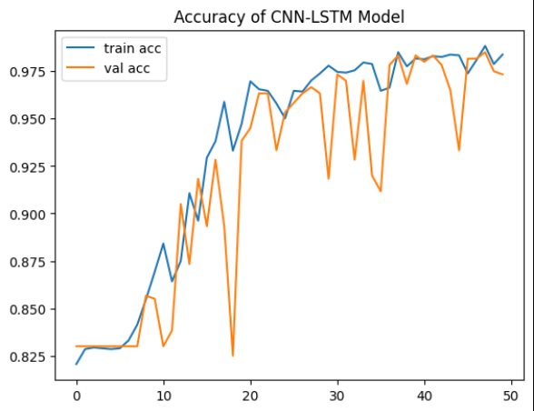

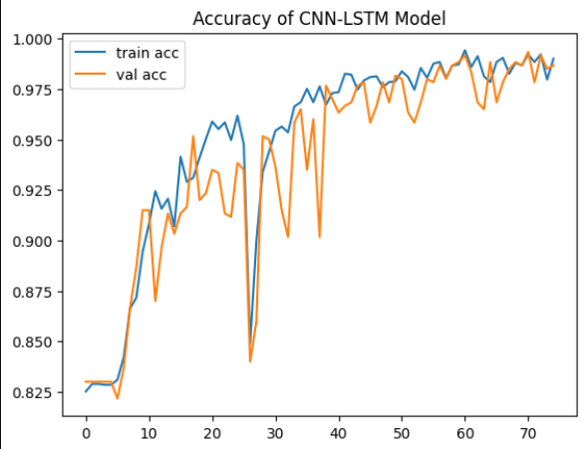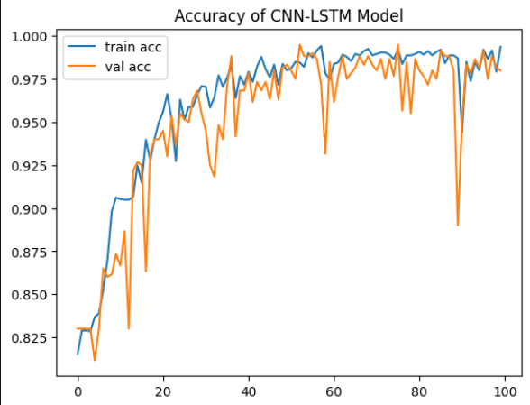

Accuracy curve of the model for 25, 50, 75 and 100 epochs

**Loss curve**

The loss curve, based on the binary cross-entropy function, shows a steady decrease in both training and validation loss across epochs. This suggests the model is minimizing errors effectively while maintaining a balance between learning and preventing overfitting.

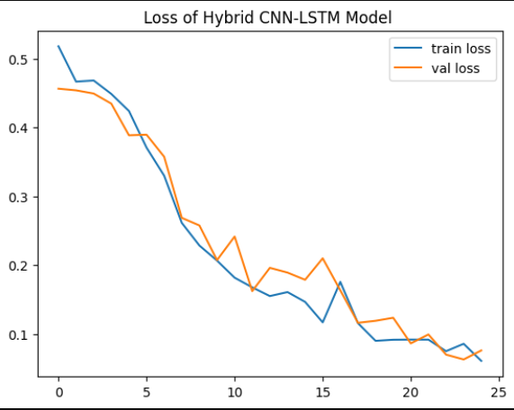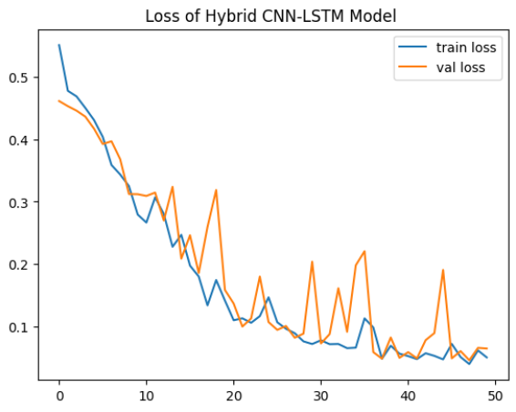

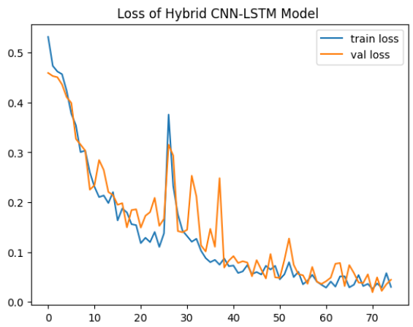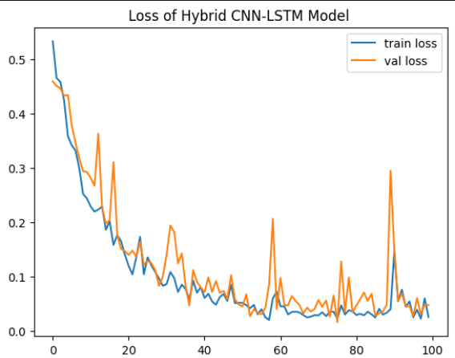

Loss curve of the model for 25, 50, 75 and 100 epochs

**Confusion matrix**

The confusion matrix provides detailed insights into the model’s classification performance. It highlights true positives, true negatives, false positives, and false negatives, indicating strong accuracy in distinguishing between tuberculosis and healthy cases, with minimal errors.

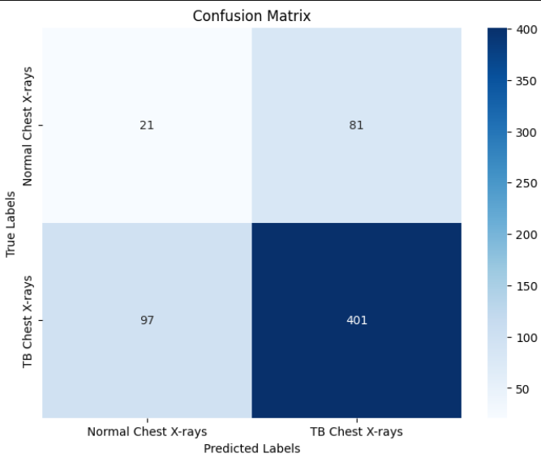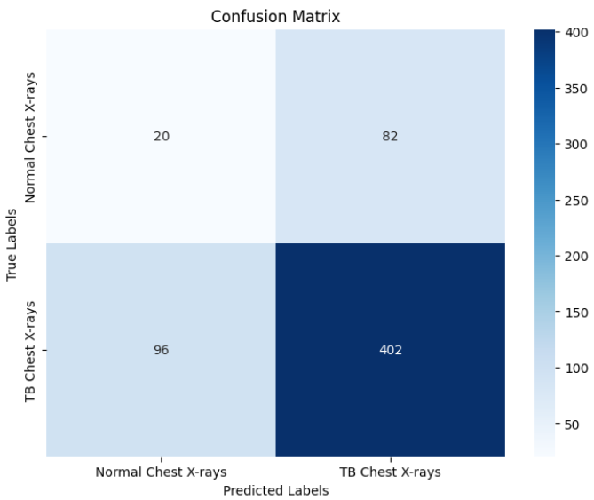

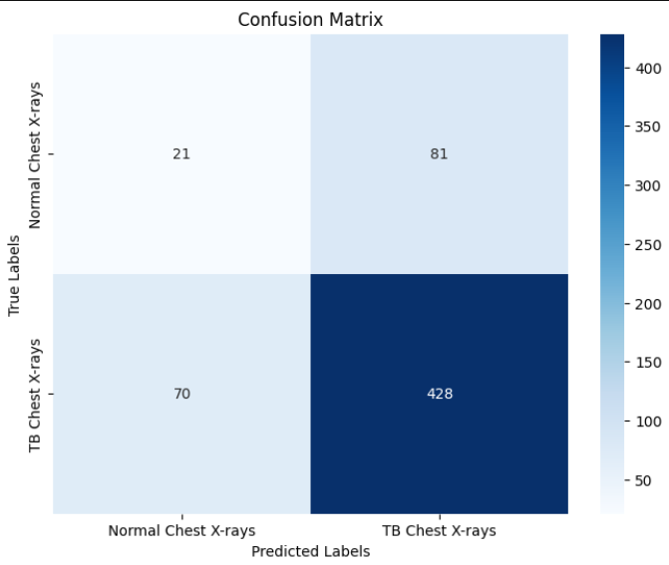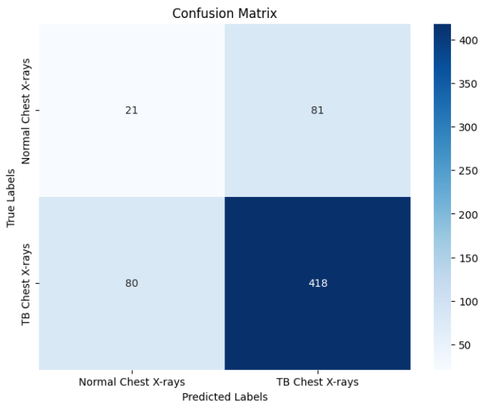

Confusion matrix of the model for 25,50,75 and 100 epochs

**Experimental Results**

|  |  |  |  |  |  |
| --- | --- | --- | --- | --- | --- |
| S.No | Epochs | Accuracy | Precision | Recall | F1 Score |
| 1 | 25 | 97.1 | 0.72 | 0.70 | 0.71 |
| 2 | 50 | 96.17 | 0.72 | 0.70 | 0.71 |
| 3 | 75 | 99 | 0.74 | 0.75 | 0.74 |
| 4 | 100 | 98.5 | 0.73 | 0.73 | 0.73 |

**Conclusion and Future Work**

In conclusion, this study demonstrates the effectiveness of deep learning techniques in the detection of tuberculosis from chest X-ray images. The model achieved a high accuracy of 99% after rigorous training and evaluation, showcasing its potential as a reliable tool for aiding radiologists in the early diagnosis of TB. The preprocessing techniques applied, including data augmentation and normalization, significantly contributed to the model's performance by enhancing its ability to generalize across diverse image conditions. This underscores the importance of robust data handling in machine learning applications in healthcare.

For future work, the dataset can be expanded to include a broader range of chest X-ray images, encompassing various stages of tuberculosis and other respiratory conditions. This will help improve the model's robustness and accuracy further. Additionally, exploring advanced architectures, such as transfer learning with pre-trained models, could enhance performance. Implementing real-time analysis tools and integrating this model into clinical workflows will also be a priority, providing healthcare professionals with efficient diagnostic support in their practice.

**References**

1. World Health Organization. (2021). Global Tuberculosis Report 2021.
2. Boehme, C. C., Nabeta, P., Hillemann, D., Nicol, M. P., Shenai, S., Krapp, F., ... & Perkins, M. D. (2010). Rapid molecular detection of tuberculosis and rifampin resistance. *New England Journal of Medicine*, *363*(11), 1005-1015.
3. Lakhani, P., & Sundaram, B. (2017). Deep learning at chest radiography: automated classification of pulmonary tuberculosis by using convolutional neural networks. *Radiology*, *284*(2), 574-582.
4. Hooda, R., Mittal, A., & Sofat, S. (2019). Automated TB classification using ensemble of deep architectures. *Multimedia Tools and Applications*, *78*, 31515-31532.
5. Liu, C., Cao, Y., Alcantara, M., Liu, B., Brunette, M., Peinado, J., & Curioso, W. (2017, September). TX-CNN: Detecting tuberculosis in chest X-ray images using convolutional neural network. In *2017 IEEE international conference on image processing (ICIP)* (pp. 2314-2318). IEEE.
6. Ghorakavi, R. S. (2019). TBNet: pulmonary tuberculosis diagnosing system using deep neural networks. *arXiv preprint arXiv:1902.08897*.
7. Hwang, S., Kim, H. E., Jeong, J., & Kim, H. J. (2016, March). A novel approach for tuberculosis screening based on deep convolutional neural networks. In *Medical imaging 2016: computer-aided diagnosis* (Vol. 9785, pp. 750-757). SPIE.
8. Heo, S. J., Kim, Y., Yun, S., Lim, S. S., Kim, J., Nam, C. M., ... & Yoon, J. H. (2019). Deep learning algorithms with demographic information help to detect tuberculosis in chest radiographs in annual workers’ health examination data. *International journal of environmental research and public health*, *16*(2), 250.
9. Karnkawinpong, T., & Limpiyakorn, Y. (2019, April). Classification of pulmonary tuberculosis lesion with convolutional neural networks. In *Journal of Physics: Conference Series* (Vol. 1195, No. 1, p. 012007). IOP Publishing.
10. Chithra, R. S., & Jagatheeswari, P. (2020). Severity detection and infection level identification of tuberculosis using deep learning. *International Journal of Imaging Systems and Technology*, *30*(4), 994-1011.
11. Hwa, S. K. T., Bade, A., Hijazi, M. H. A., & Jeffree, M. S. (2020). Tuberculosis detection using deep learning and contrastenhanced canny edge detected X-Ray images. *IAES International Journal of Artificial Intelligence*, *9*(4), 713.
12. Aulia, S., & Hadiyoso, S. (2022). Tuberculosis detection in X-Ray image using deep learning approach with VGG-16 architecture. *Jurnal Ilmiah Teknik Elektro Komputer dan Informatika*, *8*(2), 290-297.
13. Iqbal, A., Usman, M., & Ahmed, Z. (2022). An efficient deep learning-based framework for tuberculosis detection using chest X-ray images. *Tuberculosis*, *136*, 102234.