Cascaded Dual U-Net (CD-UNet) Approach For Lane Detection in Autonomous Driving

Akshwin T
School of Computer Science and Engineering (SCOPE)
Vellore Institute of Technology
Vellore, India
akshwin.t2021@vitstudent.ac.in
Kathitavan S
School of Computer Science and Engineering (SCOPE)
Vellore Institute of Technology
Vellore, India

Abstract— Pneumonia detection is one of the
Keywords — Lane Pneumonia Detection, Healthcare Automation, Segmentation, Convolutional Neural Network

Introduction

Pneumonia is a widespread respiratory infection that continues to pose a significant global health challenge, affecting millions of individuals annually, particularly children under five years of age and the elderly. According to the World Health Organization (WHO), pneumonia accounts for 14% of all deaths among children worldwide and remains a leading cause of hospitalization for older adults. The condition is primarily caused by bacteria, viruses, and fungi, with **Streptococcus pneumoniae** being the most common bacterial pathogen. Symptoms of pneumonia include cough, fever, difficulty breathing, and chest pain. If untreated, pneumonia can progress rapidly, leading to severe complications such as acute respiratory distress syndrome (ARDS), sepsis, or even death. **Early detection** and prompt treatment are therefore critical to reducing the mortality rate and improving patient outcomes, especially in low-resource settings.

The **diagnosis of pneumonia** typically relies on clinical evaluation, blood tests, and imaging techniques, with chest X-rays being the standard diagnostic tool. However, interpreting chest X-rays requires the expertise of trained radiologists, which can be a bottleneck in regions with limited access to medical professionals. This shortage of radiologists is exacerbated by the subjectivity in interpreting medical images, particularly in cases where the pneumonia manifestation is subtle or overlaps with other lung pathologies. These challenges often lead to misdiagnosis or delays in treatment, emphasizing the need for more accurate, reliable, and scalable diagnostic solutions.

In recent years, **deep learning** has emerged as a promising approach for medical image analysis, demonstrating success in various domains, including the automated detection of diseases from medical images. Convolutional Neural Networks (CNNs), a type of deep learning model, have shown exceptional ability in learning intricate patterns from image data, making them ideal candidates for tasks such as pneumonia detection from chest X-rays. Deep learning-based models can significantly enhance diagnostic accuracy, reduce the reliance on expert radiologists, and offer a scalable solution that can be implemented in real-world clinical settings, especially in resource-constrained areas. Moreover, deep learning models can operate 24/7, providing real-time diagnostics that improve healthcare accessibility.

This research paper aims to explore the potential of deep learning for pneumonia detection by comparing the performance of different CNN architectures. Specifically, we will examine models such as VGG16, ResNet50, InceptionV3, and DenseNet121, evaluating their performance based on metrics such as accuracy, precision, recall, and F1-score. Additionally, we will discuss the impact of various preprocessing techniques and the use of transfer learning to enhance model performance. By providing a comparative analysis, we aim to identify the most suitable deep learning model for pneumonia detection, with the ultimate goal of contributing to the development of automated, reliable, and scalable diagnostic tools for clinical use.

LITERATURE REVIEW
Lane detection research has evolved significantly, with machine learning and deep learning techniques revolutionizing the field. In earlier times, most systems for determining which lane is being driven on utilized methods drawn from artificial intelligence for extracting features and

PROPOSED FRAMEWORK

System Architecture

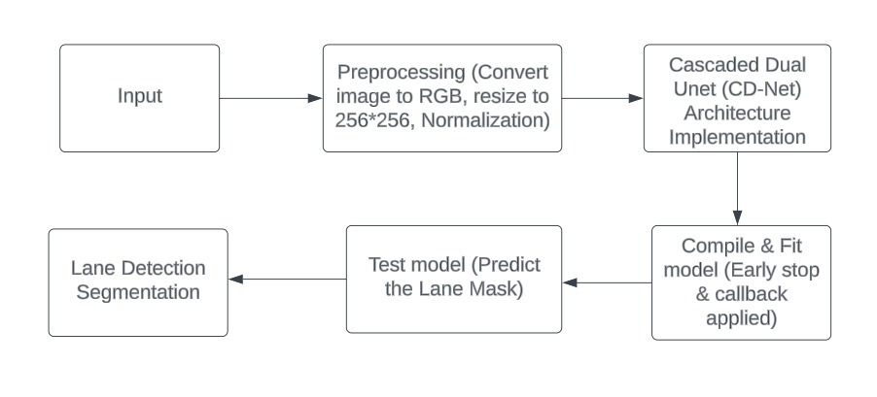
Fig 1. System Architecture

SegNet Based Architecture
The provided architecture implements a U-Net model, a widely used Convolutional Neural Network (CNN) structure for semantic segmentation tasks. The model begins with an input layer designed to accommodate images with specific dimensions: IMG_HEIGHT, IMG_WIDTH, and IMG_CHANNELS. This input layer serves as the entry point for the network, accepting the images to be segmented.
There are 3 layers in the U-Net architecture apart from the input and output layers. The three main layers are Contraction layer, Bottleneck layer and expansion layer.
The U-net architecture used in two phases of Cascaded Dual U-Net architecture with the layers involved in the architecture used is given below in the figure 2.
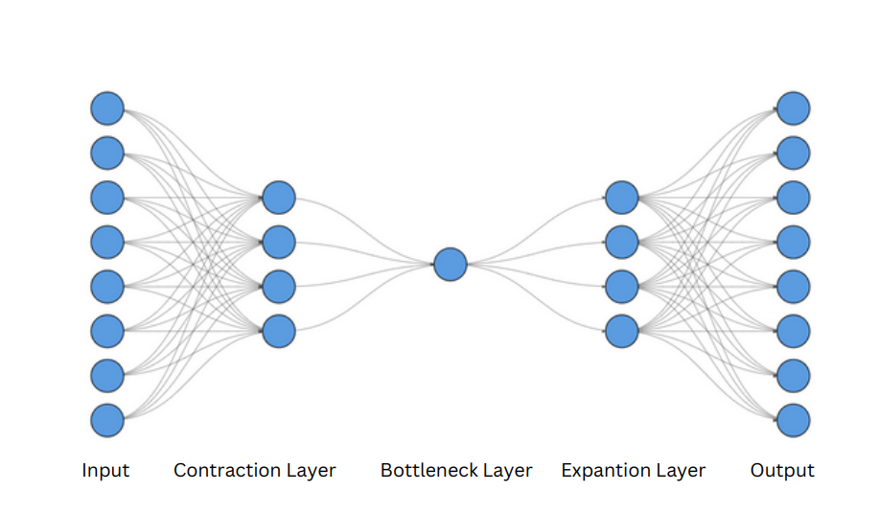
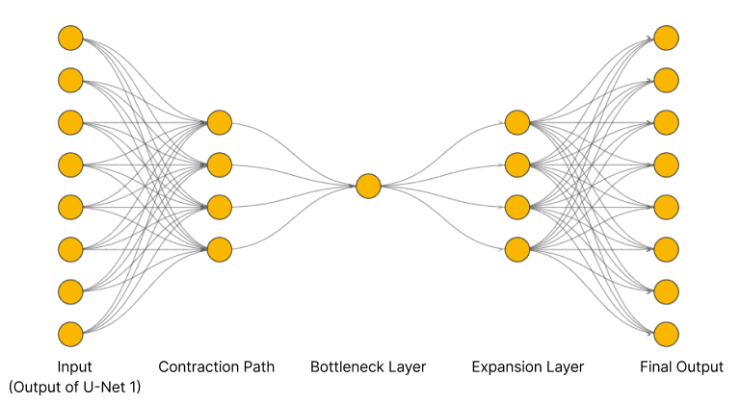

Fig 2. Outline of the architecture

Contraction Path: The core of the U-Net architecture lies in its contraction path, also known as the encoder. This path comprises several levels of convolutional blocks, each containing two consecutive convolutional layers with 3x3 kernel size, ReLU activation, 'he_normal' kernel initializer, and 'same' padding. Following each convolutional layer, a dropout layer is applied with a dropout rate of either 0.1 or 0.2, aiding in regularization. Max-pooling layers with a 2x2 pooling size are utilized to down-sample the feature maps, progressively reducing spatial dimensions while increasing the number of channels.

Bottlenect layer: At the heart of the U-Net model lies the bottleneck layer, which captures high-level features of the input data. This layer consists of two convolutional layers with 3x3 kernel size and ReLU activation, but notably, no max-pooling or down-sampling is performed here. This design choice allows the network to retain crucial spatial information while abstracting features. The Adam optimizer is used in U-net architecture.

Expansion path: The expansive path, also known as the decoder, mirrors the contraction path in reverse. It involves four levels of up-sampling blocks, each employing transpose convolutional layers with 2x2 kernel size and strides of 2x2 to up-sample the feature maps. Furthermore, concatenation with corresponding feature maps from the contraction path is performed to preserve spatial information. Similar to the contraction path, each block in the expansive path consists of two convolutional layers with ReLU activation and 'same' padding, along with dropout layers for regularization [15][16].

Output layer: At last, the U-Net model's output stratum produces the segmentation mask that consists of a single layer of convolutions having 1 x 1 kernels sizes, using sigmoid as its activation function. These probability maps output at each pixel level is based on sigmoid function output from them which shows the probability of each pixel belonging to the target class during binary segmentation; hence this system effectively captures both local details while maintaining overall information thus ensuring accurate segmentations. Regularization techniques such as dropout layers help prevent overfitting during training, contributing to the model's robustness and generalization ability [17][18].

Convolutional Neural Network

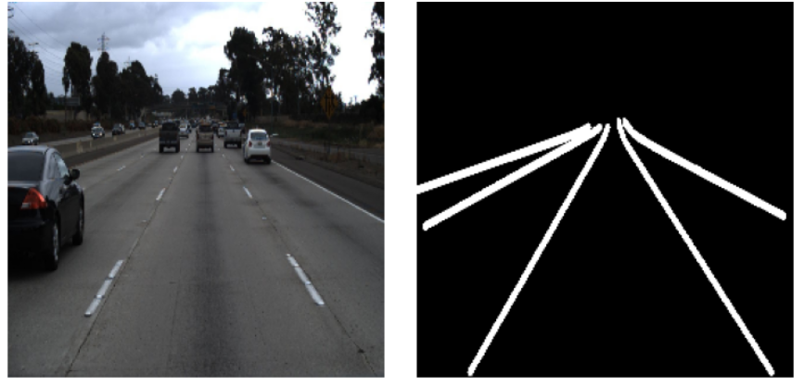
Fig 3(b). Ground Truth mask with lane marks

EXPERIMENT AND ANALYSIS

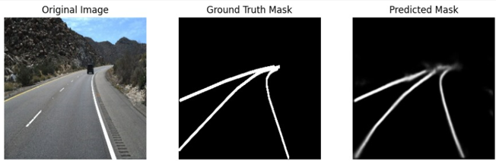
Fig 4(a). Ground Truth mask with original and predicted lane masks

Loss Curves
The Figure 5 show loss curve which shows the training and validation loss values over the epochs. It is observed that the training loss decreases consistently, indicating that the model is learning and fitting well to the training data. The validation loss, however, follows a similar decreasing trend with some fluctuations towards the end, suggesting good generalization to the validation set. The validation loss is slightly higher than the training loss in the later epochs, indicating a potential slight overfitting.
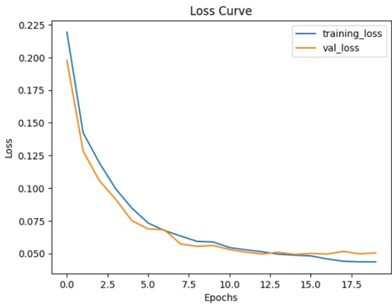
Figure 5. Loss Curve

Accuracy Curve
The Figure 6 shows the accuracy curve which illustrates the model's performance in terms of accuracy over the training epochs. The training accuracy steadily increases, reflecting the model's ability to correctly classify lane pixels during training. The validation accuracy also shows an upward trend, indicating that the model generalizes well to unseen data. The alignment between the training and validation accuracy curves suggests a balanced learning process, where the model effectively captures the relevant features for lane detection. This behavior indicates a strong generalization ability with potential room for further improvement [19].

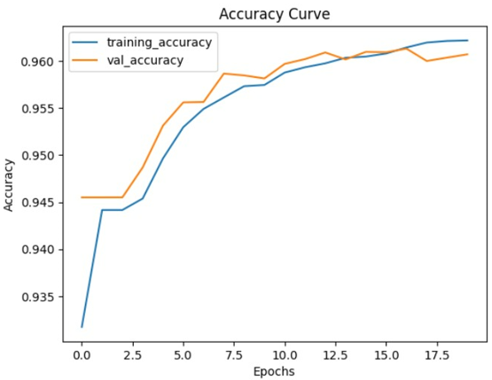
Figure 6. Accuracy Curve

Evaluation metrics

Training Accuracy: This metric tries to show if the model manages to identify road lanes correctly when being trained. The algorithm got a training accuracy of 0.9617 which means it identified lane borders correctly in most of all the training pictures.

Testing Accuracy: The evaluation of this metric involves assessing the model’s recognition performance on different data from what it was trained on like new images that have not been seen before. It was found that the model under discussion had a testing accuracy reading as 0.9607 which implies that it was able to recognize lane markings appropriately.

Training Loss: During training time the training loss will always be there to show how far away our predicted output is from actual lane markings (Choi, 2018). In this context, a smaller training loss of 0.0445 means that the model does not make many errors in its predictions during training time.

Testing Loss: On a test dataset, testing loss is used for estimating the model's prediction error. The testing loss is around 0.0505. This shows how well it can generalize and still have an insignificant error rate running over.

- Performance Metrics
Performance Metrics | Value
Training Accuracy | 0.9617
Testing Accuracy | 0.9607
Training Loss | 0.0445
Testing Loss | 0.0505

CONCLUSION AND FUTURE WORK

References

