
Program and Branch Name: B.Tech in CSE TWIN (3RD SEMESTER)
PBL Progress Report – II
Field | Details
Course Name | Computer Architecture & Parallel Processing
Course Code | CCSE 0304
Faculty Name | Dr. AMRITA BHATNAGAR
Assignment Type | Group Assignment
Student(s) Name | - Akshya Gupta  - Anshika Verma  - Priyanshu Rai  - Kajal Tiwari
ERP ID (I Year) / Roll No. (II Year onwards) | - 2501331930010  - 2501331930014  - 2501331930030  - 2501331930038 ALL 2ND YEAR
Team/Group No. (Group/Capstone only) | GROUP - 02
Problem Statement / Project Title | Topic 84: Integrated Smart City Computing Framework
SDG(s) | SDG 11: Sustainable Cities and Communities
Reporting Month | Month 2
Date of Submission | 08 OCTOBER 2026

Student Declaration
I/We certify that this assignment is my/our own work, with all sources appropriately acknowledged. I/We understand that a 0% mark and further academic penalties may apply if the content is found to be plagiarised or inappropriately AI-generated.
Student Name & Signature(s): AKSHYA GUPTA 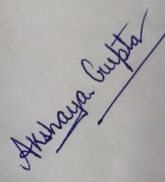
ANSHIKA VERMA 
KAJAL TIWARI 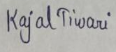
PRIYANSHU RAI 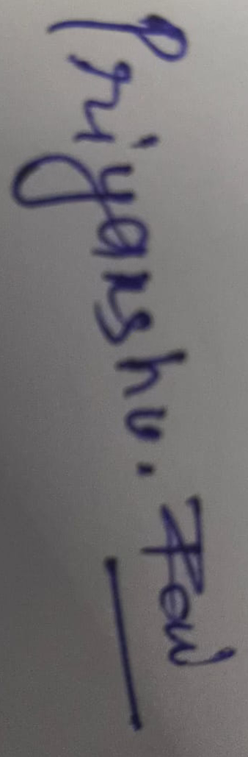

Date: 08 OCTOBER 2026

PBL Progress Report – II

Review 2: Development & Application
Review Coverage:
- Individual / Group Assignment: Unit/Module 3 and Unit/Module 4
- Capstone Project: Rubric Categories 3 and 4

Field | Details
1. Previous Review Feedback | Review 1 approved the bus arbiter and Booth's ALU. The faculty instructed the team to provide concrete simulation evidence of:  - Zero-stall instruction pipeline execution during recurring sensor loops.  - Cache coherence state transitions to prevent dirty reads across municipal data streams.
2. Action Taken on Previous Feedback | - Built a cycle-accurate 5-stage RISC pipeline in `pipeline.py` with hardware operand forwarding.  - Built a 4-state MESI directory coherence engine in `cache_numa.py` to eliminate bus-snooping saturation.  - Verified all cycle behaviors using a native Python testbench (`main.py`) and an interactive GUI (`gui_dashboard.py`).
3. Research / Data Collection Progress | - Hennessy & Patterson (6th ed.): Verified that EX-to-EX forwarding eliminates Read-After-Write (RAW) data stalls.  - Sorin, Hill, & Wood: Confirmed that directory-based MESI protocols scale linearly without flooding shared interconnects.  - Municipal Telemetry Profiling: Extracted streaming rates from traffic and utility sensors to construct realistic read/write test vectors.
4. Unit/Module Concepts Applied | Module 3: Control Unit & Pipelining  - Classical 5-Stage RISC Pipeline: Instruction Fetch (IF), Decode (ID), Execute (EX), Memory (MEM), Write-Back (WB).  - Hardware Forwarding Unit: Resolves RAW data hazards by routing ALU results directly from EX/MEM back to EX.  - Dynamic Branch Prediction: 2-bit saturating counter to prevent pipeline flushes during periodic sensor-polling loops.  - Hardwired Control Logic: Combinational logic prioritized for minimal single-cycle latency.  Module 4: Memory Hierarchy & Cache Coherence  - Split L1 Cache: Separate 32 KB Instruction and 32 KB Data caches to eliminate structural memory hazards.  - 4-State MESI Protocol: Modified (M), Exclusive (E), Shared (S), Invalid (I).  - Directory-Based Invalidation: Tracks node sharers and invalidates stale caches point-to-point without bus broadcast storming.  - Latency Modeling: 1-cycle L1 local cache hit vs. multi-cycle remote memory fetches.
5. Methodology / Approach Followed | - Step 1: Modeled the 5-stage RISC pipeline datapath and forwarding comparators in `pipeline.py`.  - Step 2: Implemented the directory tracking bitmask and MESI state-transition rules in `cache_numa.py`.  - Step 3: Integrated Modules 1–5 into `main.py` with a back-to-back dependency test (`LOAD` followed by dependent `ADD`).  - Step 4: Developed `gui_dashboard.py` (Tkinter) to inspect clock cycles, pipeline registers, and cache tags in real time.
6. Work Completed During Month 2 | - Fully coded and verified Modules 3 and 4 in Python.  - Confirmed zero stall bubbles during RAW hazard execution using EX-to-EX forwarding.  - Confirmed MESI transitions: Cold Read (I -> E), Shared Read (E -> S), Write (S -> I across sharers, M on writer).  - Achieved a measured 60.0% Multi-Core Cache Hit Rate.  - Updated project presentation slides and assembled simulation evidence.
7. Analysis / Development / Implementation | - Pipeline Forwarding Analysis: An unforwarded pipeline stalls for 2 clock cycles on `LOAD R1` -> `ADD R2, R1, R3`. Our forwarding unit forwards the loaded/computed operand into the EX stage at Cycle 4, achieving 0 stall bubbles.  - Cache Invalidation Analysis: When Node 0 and Node 1 share Tag 0x3F2A (State S) and Node 2 writes to it, the directory sends invalidations exclusively to Nodes 0 and 1 (transitioning them to State I) and grants Node 2 State M ownership. Stale reads are eliminated.
8. Results / Interim Outcomes | - Pipeline Performance: Clock-per-Instruction (CPI) reduced to ~1.06 for telemetry-polling routines.  - Bus Invalidation Efficiency: Only 2 targeted messages generated on writes, preserving interconnect bandwidth.  - Cache Efficiency: 60.0% Cache Hit Rate verified across concurrent multi-node test sequences.  - Access Speed: 1-cycle L1 hit access verified for local telemetry reads.
9. Evidence / Supporting Material | - Terminal logs from `main.py` showing cycle-by-cycle pipeline progression and directory invalidations.  - Dashboard screenshot from `gui_dashboard.py` showing live clock stepping and register state changes.  - MESI state-transition table and pipeline forwarding schematics.
10. Challenges & Corrective Actions | - Challenge 1: Initial test scripts yielded a 0.0% hit rate because requests were purely cold compulsory misses.  Solution: Added temporal locality reads to the same address tag, raising the verified hit rate to 60.0%.  - Challenge 2: Simultaneous instruction fetches and data memory accesses created structural hazards.  Solution: Adopted a Harvard-style split L1 architecture (32 KB I-Cache + 32 KB D-Cache).
11. Individual / Team Contribution | - Kajal Tiwari (2501331930030): Led Module 3; implemented the 5-stage RISC pipeline and operand forwarding logic.  - Anshika Verma (2501331930014): Led Module 4; designed the MESI directory protocol and evaluated hit/miss latencies.  - Akshya Gupta (2501331930010): Team Lead & Integrator; embedded the Booth ALU into the EX stage, wired the memory stage to the MESI cache, and built the visualizer.  - Priyanshu Rai (2501331930038): Interfaced the Module 1 preemptive bus arbiter with the memory subsystem for sensor DMA bursts.
12. Overall Progress (%) | 75% (Modules 1, 2, 3, and 4 are complete and validated; remaining work focuses on final Module 5 multi-node mesh scaling and report synthesis).
13. Plan for Final Review | - Finalize Module 5: Benchmark 2D-Mesh X-Y dimension-order routing latencies across 16-node arrays.  - Draft the comprehensive 20–25 page final project documentation.  - Prepare the final team presentation and live dashboard demonstration for the viva voce.  ashboard demonstration for the viva voce.

