Real-Time Object Detection App
A Computer Vision Project Report
Domain: Computer Vision
Technology Stack: Python, OpenCV, Ultralytics YOLOv8
VITyarthi - Build Your Own Project Submission
Date: September 2026

1. Introduction
Object detection is one of the most widely applied capabilities in computer vision, powering use cases from retail analytics to traffic monitoring and security. This project implements a complete, working real-time object detection application in Python. It uses a pretrained deep learning model (YOLOv8-nano) to detect and localize 80 everyday object classes, and supports three kinds of input: a live webcam feed, a recorded video file, or a folder of still images.
The application is built with a modular architecture separating detection, input handling and reporting concerns, so each part can be tested, replaced, or extended independently. Beyond a live preview with bounding boxes, the system produces a persistent, auditable record of every detection via CSV logs and a plain-text session summary.

2. Problem Statement
Manually reviewing camera footage or large batches of images to identify objects (people, vehicles, animals, everyday items) is slow, error-prone, and does not scale. There is a need for a lightweight tool that can automatically detect and label common objects in real time from a webcam, a recorded video, or a folder of images, and summarize what it found - without requiring specialized hardware or a cloud subscription.

Scope
- Detect and localize 80 everyday object classes (COCO dataset: person, car, bicycle, dog, chair, laptop, phone, etc.)
- Support three input modes: live webcam, video file, and image folder
- Draw bounding boxes and confidence scores on the output
- Log every detection and produce a per-session summary report
Out of scope: training a custom model from scratch, multi-camera fusion, and cloud deployment (see Future Enhancements).

Target Users
- Students/researchers who want a ready-made baseline to experiment with object detection
- Small setups (a shop, a hobby robotics project, a home camera) wanting simple detection analytics without a paid service
- Anyone who wants to batch-annotate a folder of images with detected objects

3. Functional Requirements
ID | Requirement
FR1 | Detect and classify objects in a frame using a pretrained deep-learning model, returning label, confidence, and bounding box for each detection.
FR2 | Accept input from a webcam, a video file, or a folder of images through a single unified interface.
FR3 | Log every detection (frame id, label, confidence, box coordinates) to a CSV file and produce a human-readable summary at the end of a run.
FR4 | Render bounding boxes, class labels, confidence scores and a live FPS counter on the output frame.
FR5 | Allow the user to save annotated frames/images to disk via a command-line flag.

4. Non-Functional Requirements
Category | Requirement
Performance | Sustains real-time-comparable throughput on CPU using a nano model and capped frame size; live FPS is reported to the user.
Reliability | Camera/video/model failures raise clear, caught exceptions instead of crashing; a single bad frame is skipped rather than fatal.
Security | All file-based inputs are validated against an extension allow-list and an existence check before being opened.
Usability | A single CLI with sensible defaults covers all three input modes; the live preview shows FPS and labels directly.
Maintainability | Each concern (detection, input handling, drawing, reporting, logging, configuration) lives in its own module with a single responsibility.
Logging / Monitoring | A shared logger writes timestamped, leveled logs to both console and logs/app.log for every module.
Scalability | New input types (e.g. an RTSP stream) or a different model can be added by extending InputSource or swapping MODEL_NAME.
Resource Efficiency | Frame size is capped, a nano model is used by default, and a frame-skipping option is available for slower hardware.

5. System Architecture
The application follows a layered, modular architecture: an Input Layer supplies frames from one of three sources, the Core Application processes each frame through detection, visualization and reporting modules, and an Output Layer presents results to the user (live preview, annotated images, and report files).
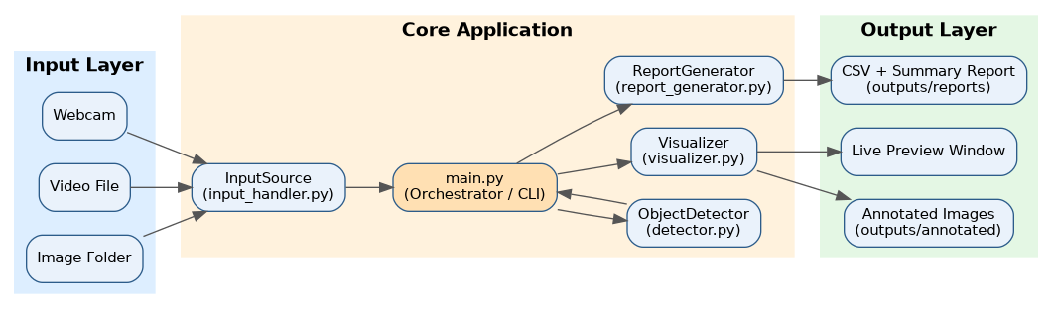
Figure 1: System Architecture Diagram

6. Design Diagrams

6.1 Process Flow / Workflow Diagram
The diagram below shows the end-to-end control flow of main.py, from CLI parsing through the per-frame detect-log-draw-display loop, to report finalization.
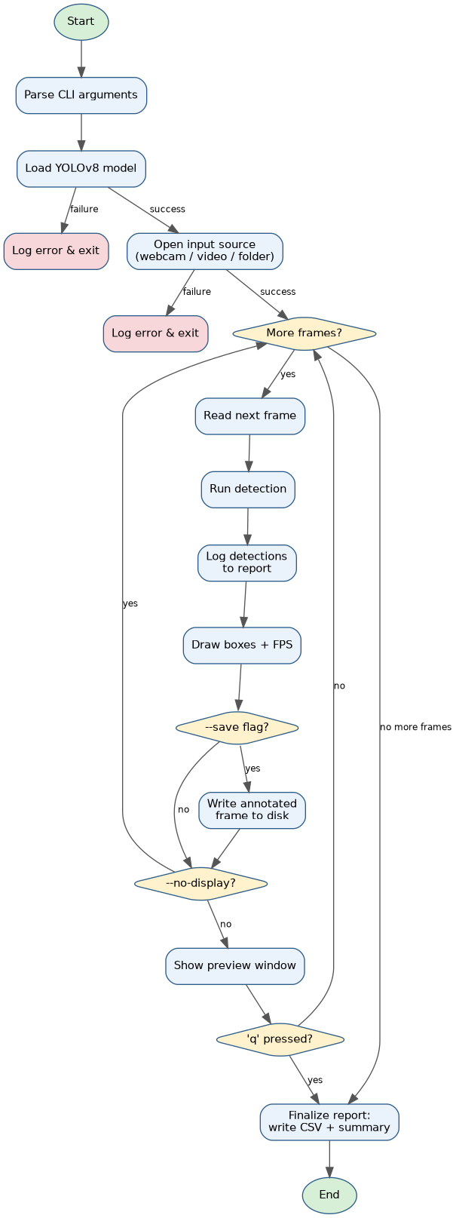
Figure 2: Process Flow / Workflow Diagram

6.2 Use Case Diagram
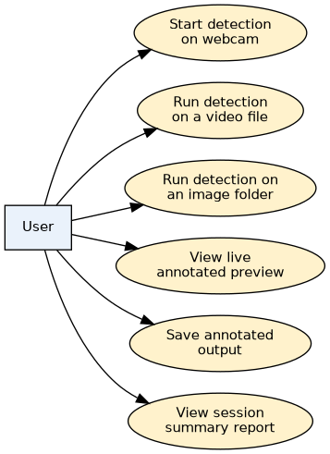
Figure 3: Use Case Diagram

6.3 Class Diagram
Detection is a simple data holder produced by ObjectDetector. InputSource is an abstract base with three concrete implementations (WebcamSource, VideoFileSource, ImageFolderSource). MainApp orchestrates ObjectDetector, an InputSource, and ReportGenerator.
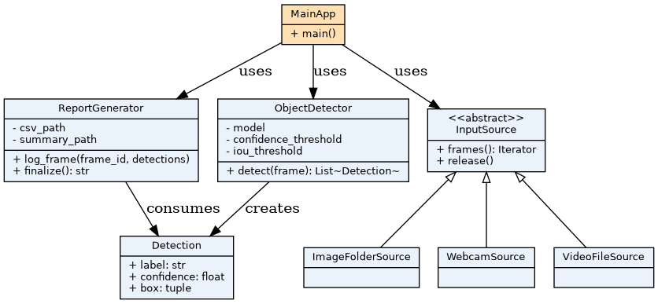
Figure 4: Class Diagram

6.4 Sequence Diagram (one frame, webcam mode)
Step | Interaction
1 | User runs: python main.py --source webcam
2 | main.py constructs ObjectDetector() (loads the YOLOv8 model)
3 | main.py calls build_input_source("webcam", 0) to open the camera
4 | Loop: InputSource.frames() yields (frame_id, frame)
5 | main.py calls ObjectDetector.detect(frame) -> list of Detection
6 | main.py calls ReportGenerator.log_frame(frame_id, detections)
7 | main.py calls draw_detections(frame, detections) -> annotated frame
8 | Annotated frame is shown in the preview window
9 | On 'q' keypress, ReportGenerator.finalize() writes the CSV + summary
10 | InputSource.release() closes the camera
Note on Database/Storage Design: this project does not use a database. Persistent output is file-based (CSV detection logs and text summaries under outputs/reports/), which is sufficient for the project's scope.

7. Design Decisions & Rationale
- YOLOv8-nano over larger variants: the nano model runs acceptably on CPU-only hardware with no GPU, keeping the project accessible without sacrificing reasonable accuracy for common objects.
- Pretrained model instead of training from scratch: the COCO-pretrained model already covers 80 everyday classes; training a custom model was out of scope and unnecessary for the target use cases.
- Unified InputSource abstraction: webcam, video file, and image folder differ in how they produce frames but not in how the rest of the app should consume them, so a common frames() interface removes duplicated logic from main.py.
- File-based reporting over a database: for a single-user, single-session tool, CSV + text summary is simpler to inspect, requires no setup, and satisfies the auditability goal without added infrastructure.
- Separate visualizer module: drawing is a presentation concern distinct from detection logic; keeping them separate makes the detector reusable in non-visual contexts (e.g. headless batch processing).
- Centralized configuration (config.py): thresholds, paths and frame sizes are defined once, making the system easier to tune and maintain.

8. Implementation Details
The project is implemented in Python 3 using OpenCV for capture/drawing/display, the Ultralytics YOLOv8 library for inference, and NumPy for array handling. The codebase is organized into a src/ package with one module per functional concern:
- config.py - central configuration (paths, thresholds, frame size, allowed file extensions)
- src/logger_setup.py - shared logger writing to console and logs/app.log
- src/detector.py - ObjectDetector class; loads the model and exposes detect(frame) -> List[Detection]
- src/input_handler.py - InputSource abstraction with WebcamSource, VideoFileSource, ImageFolderSource, plus a build_input_source() factory and path validation
- src/visualizer.py - draw_detections() and draw_fps() helpers for annotating frames
- src/report_generator.py - ReportGenerator class; writes a per-frame CSV log and a final text summary
- main.py - CLI entry point (argparse) that wires the three functional modules together into the detect-log-draw-display loop
Error handling is centered on two custom exception types, DetectorError and InputSourceError, which are caught at the point of use in main.py so that a bad camera, a missing file, or an unreadable image produces a clear log message instead of an unhandled traceback. All file inputs are validated for existence and extension before being opened.

9. Screenshots / Results
The application was tested end-to-end against a real photograph containing multiple objects (people and a bus). The model correctly detected three people and one bus, each with bounding boxes and confidence scores, as shown below. The FPS counter (top-left) reflects single-image CPU inference time.
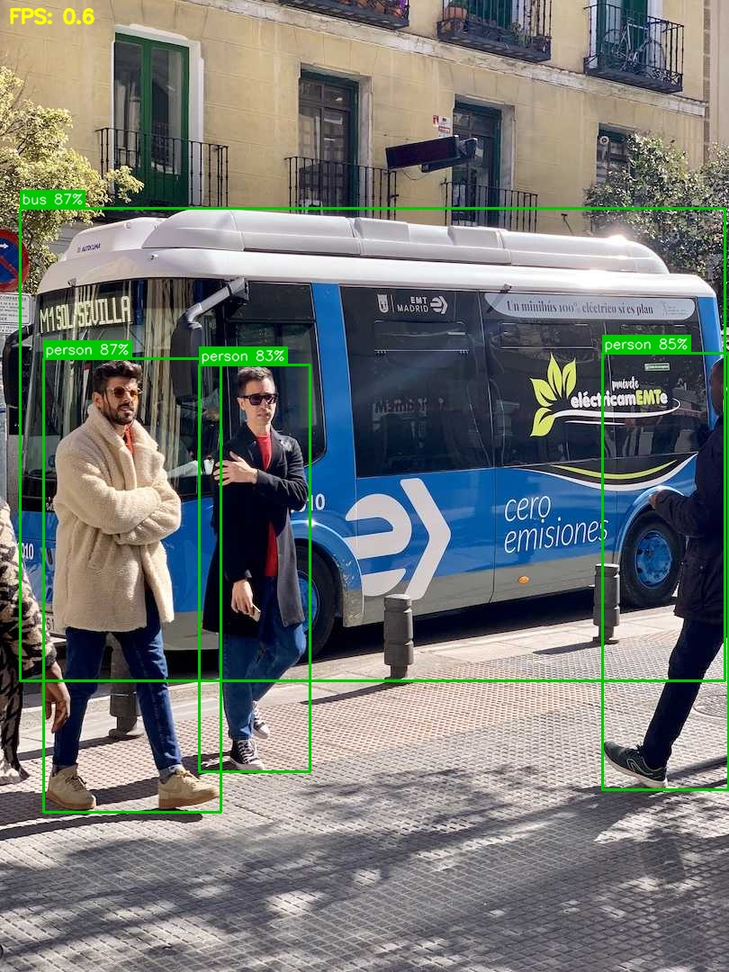
Figure 5: Annotated detection output (bus.jpg test image)

Sample Detection Log (CSV)
frame_id | label | confidence | x1 | y1 | x2 | y2
0 | bus | 0.873 | 22 | 231 | 805 | 756
0 | person | 0.866 | 48 | 398 | 245 | 902
0 | person | 0.853 | 669 | 392 | 809 | 877
0 | person | 0.825 | 221 | 405 | 344 | 857
Session Summary produced:
- Frames processed: 1
- Total detections: 4
- Average detections/frame: 4.00
- Top classes: person (3), bus (1)

10. Testing Approach
The project includes a pytest suite covering all three functional modules:
- tests/test_detector.py - verifies ObjectDetector.detect() correctly parses model output into Detection objects and rejects empty frames; the underlying model is mocked so tests run without GPU or network access.
- tests/test_input_handler.py - verifies ImageFolderSource discovers only supported image extensions, yields frames correctly, and raises InputSourceError for missing directories or unknown source types.
- tests/test_report_generator.py - verifies that logged detections are written correctly to CSV and that the summary file contains accurate counts.
All 7 unit tests pass. In addition, the full application was run end-to-end (not mocked) against a real image, confirming that model loading, detection, visualization, and report generation all work together correctly, as documented in the Screenshots / Results section above.

11. Challenges Faced
- Balancing accuracy against CPU-only performance: larger YOLOv8 variants gave marginally better accuracy but noticeably lower FPS on hardware without a GPU, so the nano variant was chosen as the practical default.
- Designing a single interface for fundamentally different input types (a live, infinite camera stream vs. a finite set of image files) required careful abstraction so main.py did not need to special-case each source.
- Making failures debuggable: early versions let OpenCV/ultralytics exceptions propagate raw; wrapping them in DetectorError/InputSourceError with actionable messages took extra iteration but significantly improved usability.
- Keeping the reporting module decoupled from the detection/display loop so that headless (--no-display) runs still produce a complete report.

12. Learnings & Key Takeaways
- Practical experience integrating a modern pretrained deep learning model (YOLOv8) into a real application, rather than just running it in a notebook.
- The value of separating concerns (detection vs. input vs. reporting vs. visualization) for testability - most of the logic could be unit-tested without any GPU, camera, or model weights.
- Designing for graceful failure (bad camera, corrupt image, missing file) is as important as the happy path for a tool meant to be used interactively.
- Even a 'simple' CV project benefits from lightweight software-engineering practices: configuration management, structured logging, and automated tests.

13. Future Enhancements
- Support for network/RTSP camera streams, enabling remote or multi-camera deployments.
- A simple web dashboard (e.g. Flask/Streamlit) to view live detections and historical reports in a browser instead of a desktop window.
- Object tracking across frames (e.g. ByteTrack) to count unique objects rather than per-frame detections, enabling footfall/traffic counting use cases.
- Optional GPU acceleration toggle and model-size selection (nano/small/medium) exposed as a CLI flag for users with more powerful hardware.
- Persisting historical session reports in a lightweight database (e.g. SQLite) to support search and trend analysis across many sessions.

14. References
- Ultralytics YOLOv8 Documentation - https://docs.ultralytics.com/
- OpenCV Documentation - https://docs.opencv.org/
- COCO Dataset - https://cocodataset.org/
- Python argparse Documentation - https://docs.python.org/3/library/argparse.html
- pytest Documentation - https://docs.pytest.org/

