A dynamic website is a website which has link to other pages .

While static website only has a single page.

Host a dynamic website using s3 and EC2 where we use s3 to store all the files and EC2 to host it.

We establish a connection between s3 and EC2 either through code or though sync and storing files on ec2 from s3 to host it.

This storing is preferred only when we have small website to host.

Create a role having full EC2 access. Create an instance and attach this role to the instance created.

Then we can directly access s3 bucket without aws configure through role.

Upload files on s3 bucket from console.

Then sync these files to EC2 instance to host it.

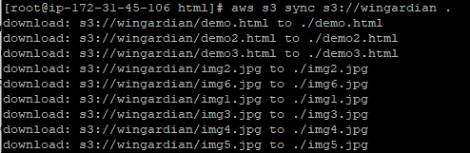

Here “ wingardian “ is the bucket name.

Here all the files gets stored in EC2 from s3 bucket



Now we can host it by





