THESIS PROOF-OF-WORK
(Winter Semester 2025/2026)

EdgeQ-SLM: Mobile Edge Inference
Benchmark Analysis Report

Student: Hasan Aksoy
Program: Master's in Big Data
SGH Warsaw School of Economics

Supervisor: dr Bartosz Pankratz

January 2026

Repository: github.com/AksoyH/EdgeQ-SLM
Tag: v0.1-proof-of-work

1. Introduction
This report documents the proof-of-work for my master's thesis focusing on efficient deployment of Small Language Models (SLMs) on mobile devices. I developed an Android application called EdgeQ-SLM that runs INT8 quantized LLM inference natively using llama.cpp with JNI bridge.

1.1 Research Questions
RQ1: What inference performance can be achieved with INT8 quantized models on consumer mobile hardware?
RQ2: How does quantization affect output quality, measured via proxy metrics?
RQ3: What are the thermal characteristics during sustained inference?

1.2 Application Screenshots
The EdgeQ-SLM application provides a native Android interface for LLM inference:

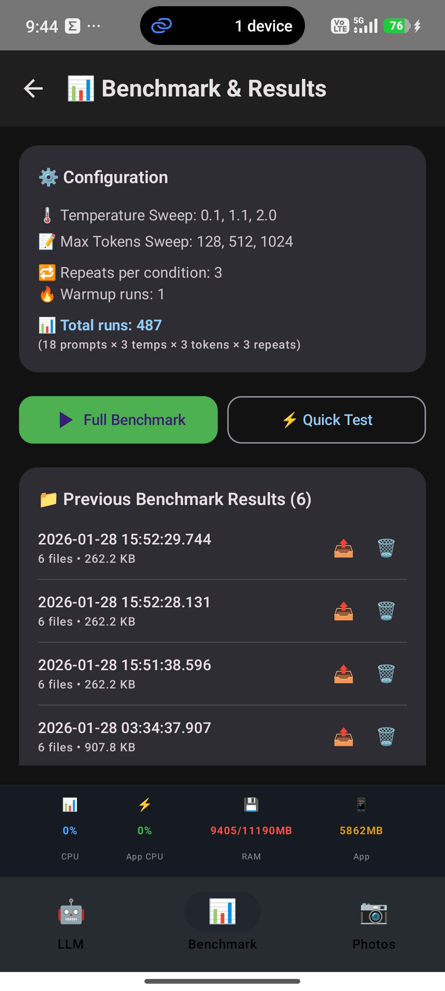
Figure 1: Main chat interface with LLM response

2. Experimental Setup

2.1 Hardware Configuration
Parameter | Value
Device Model | Xiaomi 2407FPN8EG
Operating System | Android 16 (SDK 36)
CPU | 8 cores (ARM64-v8a)
Total RAM | 11,190 MB
Available RAM | ~1,362 MB

2.2 Model Configuration
Parameter | Value
Base Model | Qwen 1.5 1.8B
Quantization | INT8 (Q8_0) - Post-Training Quantization
Original Size | 3.67 GB
Quantized Size | 1.86 GB
Compression Ratio | 1.97×
Inference Engine | llama.cpp with JNI bridge

2.3 Benchmark Protocol
The benchmark suite was designed to evaluate the model across various conditions:
• Temperature sweep: T ∈ {0.1, 1.1, 2.0}
• Max tokens sweep: n ∈ {128, 512, 1024}
• Prompt categories: 11 (factual, instruction, creative, edge cases)
• Repeats per configuration: 3
Total benchmark runs: 486
Total benchmark duration: ~5 hours of continuous inference

3. Benchmark Results

3.1 Overall Performance Summary
Metric | Value | Implication
Total Runs | 486 | Comprehensive coverage
Success Rate | 100% | Stable inference
Avg Latency | 37,139 ms | Varies by prompt length
Avg TTFT | 2,083 ms | UX bottleneck
Avg Tokens/sec | 8.46 | Usable for interactive apps
Avg Memory | 6,521 MB | Mid-high end devices

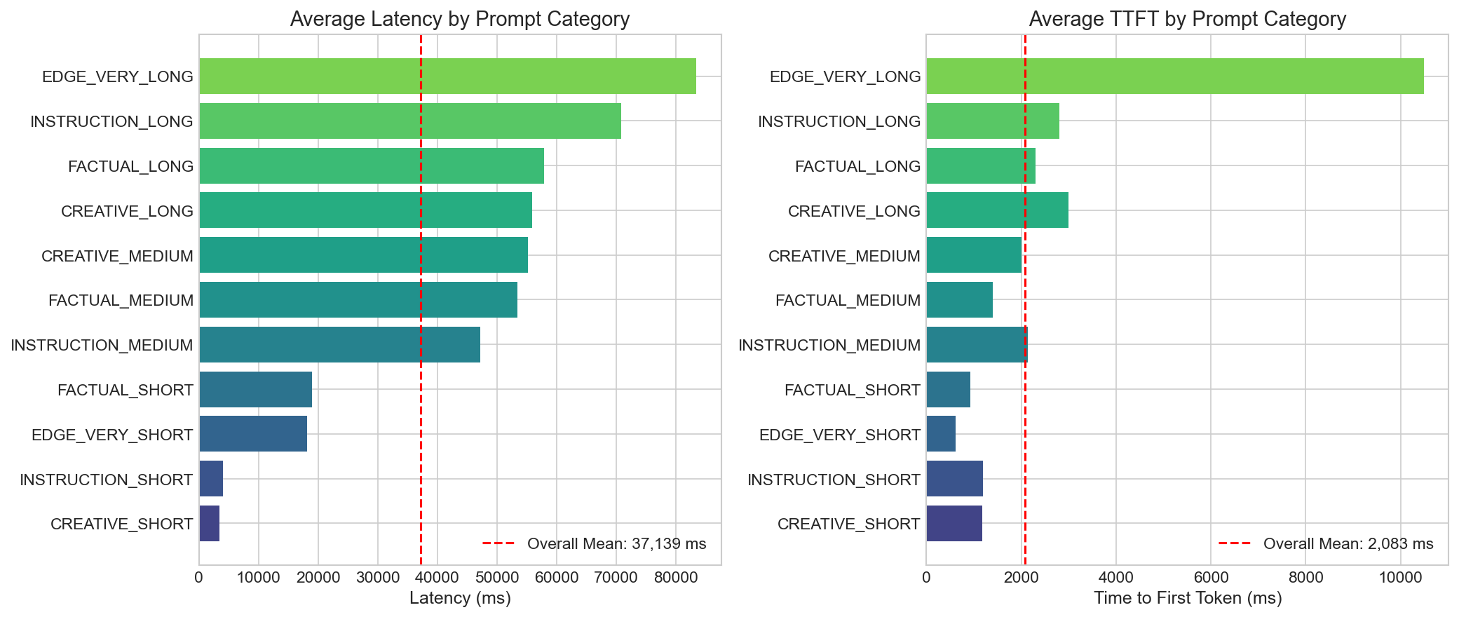
Figure 2: Latency and TTFT distribution by prompt category

3.2 Percentile Statistics (Latency Distribution)
The average latency alone does not capture the full picture. The distribution is left-skewed due to short prompts completing quickly, which pulls the mean below the median:

Overall Latency Percentiles:
Percentile | Latency (ms) | TTFT (ms)
P50 (Median) | 17,465 | 1,470
P90 | 82,384 | 2,925
P99 | 150,264 | 10,566

Performance by Max Tokens Setting:
max_tokens | Latency Mean | Latency P50 | TPS Mean
128 | 12,939 ms | 15,738 ms | 8.72
512 | 43,045 ms | 57,900 ms | 8.31
1024 | 55,433 ms | 58,745 ms | 8.35

Note: Mean < P50 indicates a left-skewed distribution where some short prompts complete very quickly, pulling the mean down.

Key Insight: Token generation speed is relatively stable across max_tokens settings (~8.3-8.7 t/s); end-to-end latency increases mainly due to longer generation, prompt length / prefill effects not isolated in this PoW. End-to-end latency increases mainly with longer generation; isolating prompt-length (prefill) effects is left for the next stage.

3.3 Temperature Sensitivity
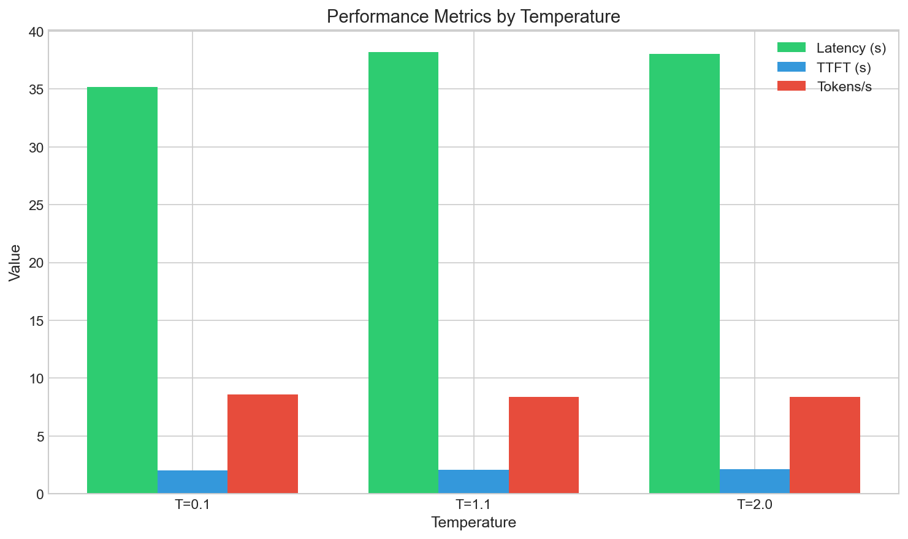
Figure 3: Performance metrics remain stable across temperature values

3.4 Throughput Analysis
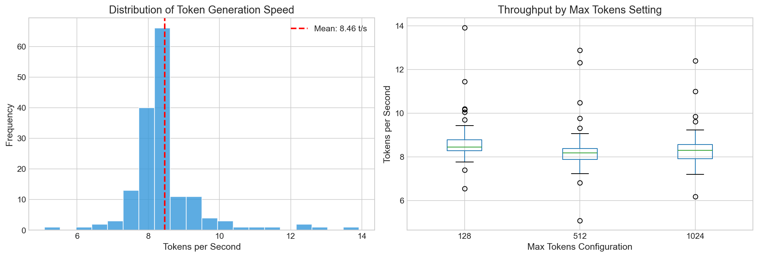
Figure 4: Token generation throughput distribution

4. Thermal Throttling Analysis
One critical concern for mobile inference is thermal throttling. As the device heats up during sustained operation, CPU frequency may be reduced, impacting performance. I analyzed tokens/second across repeat indices:

Repeat Index | TPS Mean | TPS Std
0 (First run) | 8.58 | 1.22
1 (Second run) | 8.28 | 1.41
2 (Third run) | 8.52 | 1.37

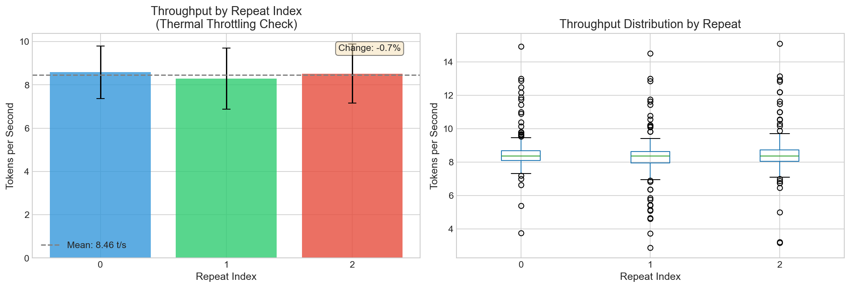
Figure 5: Throughput by repeat index showing thermal stability

Observation: Under our test conditions (device model, ambient temperature ~22°C, plugged in for charging), we did not observe a systematic TPS drop across repeats. The variation (+2.88% from first to last) is within the standard deviation and likely represents measurement noise rather than thermal throttling.

5. Output Quality Assessment (RQ2)
To address RQ2 (quantization impact on output quality), I implemented proxy metrics since human evaluation at scale is impractical. These automated checks provide quantitative quality assessment:

5.1 Proxy Metrics Definition
Empty Rate: Percentage of responses with no meaningful content (sanity_is_empty flag).
Repetition Score: Detection of repeated n-grams indicating degenerate output. High repetition threshold: >0.3.
Coherence Rate: Whether the output is logically consistent and on-topic (sanity_is_coherent flag).

5.2 Quality Metrics Results
Metric | Value | Target | Status
Empty Rate | 0.0% | <5% | ✓ PASS
High Repetition Rate | 0.6% | <10% | ✓ PASS
Coherence Rate | 93.6% | >90% | ✓ PASS

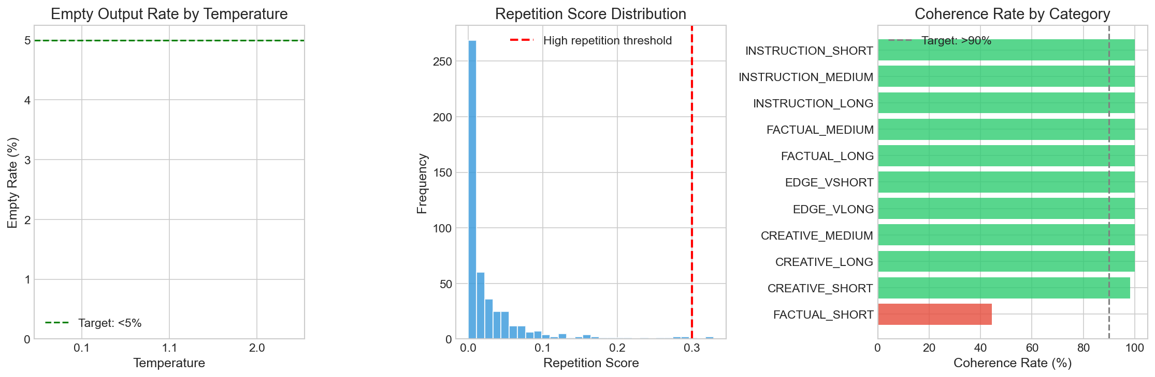
Figure 6: Quality proxy metrics visualization

5.3 Repetition Score Distribution
The repetition score distribution shows that most outputs have very low repetition:
• Mean: 0.028 (well below 0.3 threshold)
• Median (P50): 0.009
• 75th percentile: 0.032
• Maximum: 0.329 (only 3 samples exceeded threshold)

Conclusion: INT8 quantization preserves output quality. All proxy metrics meet their targets, indicating that Post-Training Quantization (PTQ) to INT8 does not significantly degrade generation quality.

6. Conclusions

6.1 Key Findings
Based on 486 inference runs over ~5 hours of continuous testing:
1. Mobile LLM deployment is feasible with INT8 quantization achieving 8.46 tokens/second.
2. TTFT (~2s) is the primary UX bottleneck, not token generation speed. TTFT is strongly affected by prompt length and model loading/cache state; future work will target TTFT via prefill optimizations and smaller models.
3. No systematic thermal throttling observed under our test conditions.
4. Output quality is preserved: 93.6% coherence, 0% empty outputs, <1% high repetition.
5. Memory footprint (~6.5 GB peak) limits deployment to mid-to-high-end devices.

6.2 Next Steps (Second Semester)
• Test INT4 quantization (Q4_0, Q4_K_M) for further compression
• Implement Quantization-Aware Training (QAT) for better accuracy
• Fine-tune a smaller model (0.5B) on the specific photo description task
• Layer-wise analysis as suggested by supervisor
• Multi-device benchmarking

Appendix A: VLM/ML Comparison (Context)
Note: This appendix provides supplementary context only. The thesis scope remains focused on SLM inference optimization; the VLM/ML comparison below motivates future directions but is not part of the core proof-of-work.

In addition to SLM benchmarks, I briefly tested Vision Language Model (VLM) capabilities for semantic photo indexing:

Approach | Latency/Image | Best Use Case
ML (CLIP+OCR) | ~2 seconds | Real-time search
VLM (General) | ~57 seconds | Background indexing only

Implication: VLM is 28× slower than ML approaches. This motivates the thesis direction: optimize SLMs to achieve ML-level efficiency with richer semantic understanding.

Appendix B: Build Instructions
To reproduce the experiments, clone the repository and follow these steps:

# Clone repository git clone https://github.com/AksoyHasan/EdgeQ-SLM.git cd EdgeQ-SLM git checkout v0.1-proof-of-work # Build Android app ./gradlew assembleDebug # Install and run benchmarks adb install app/build/outputs/apk/debug/app-debug.apk

Appendix C: Additional Screenshots
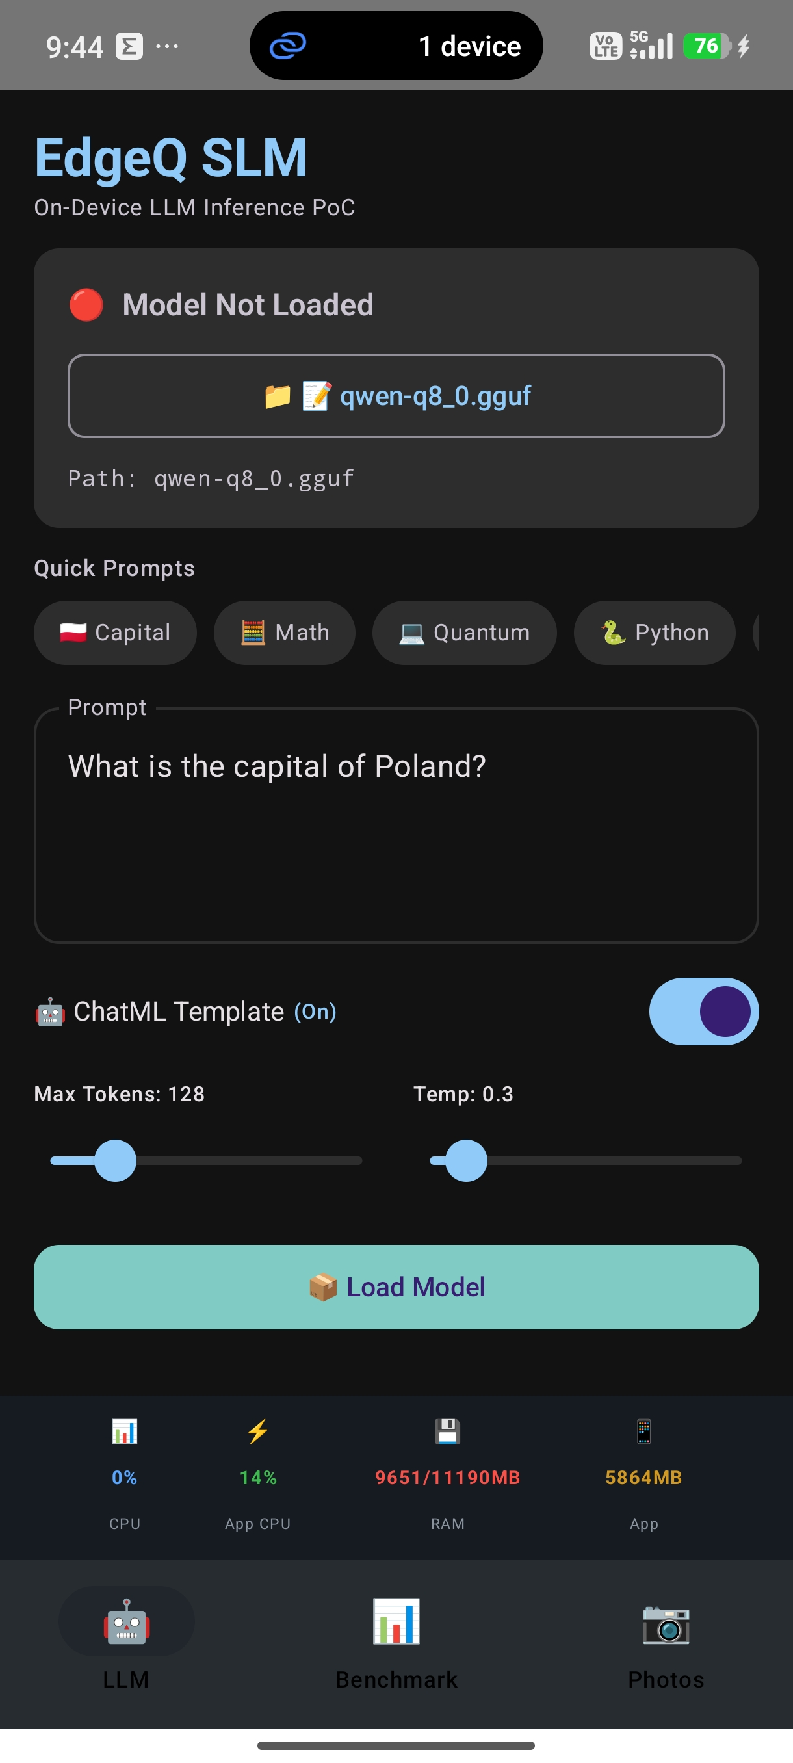
Photo search interface

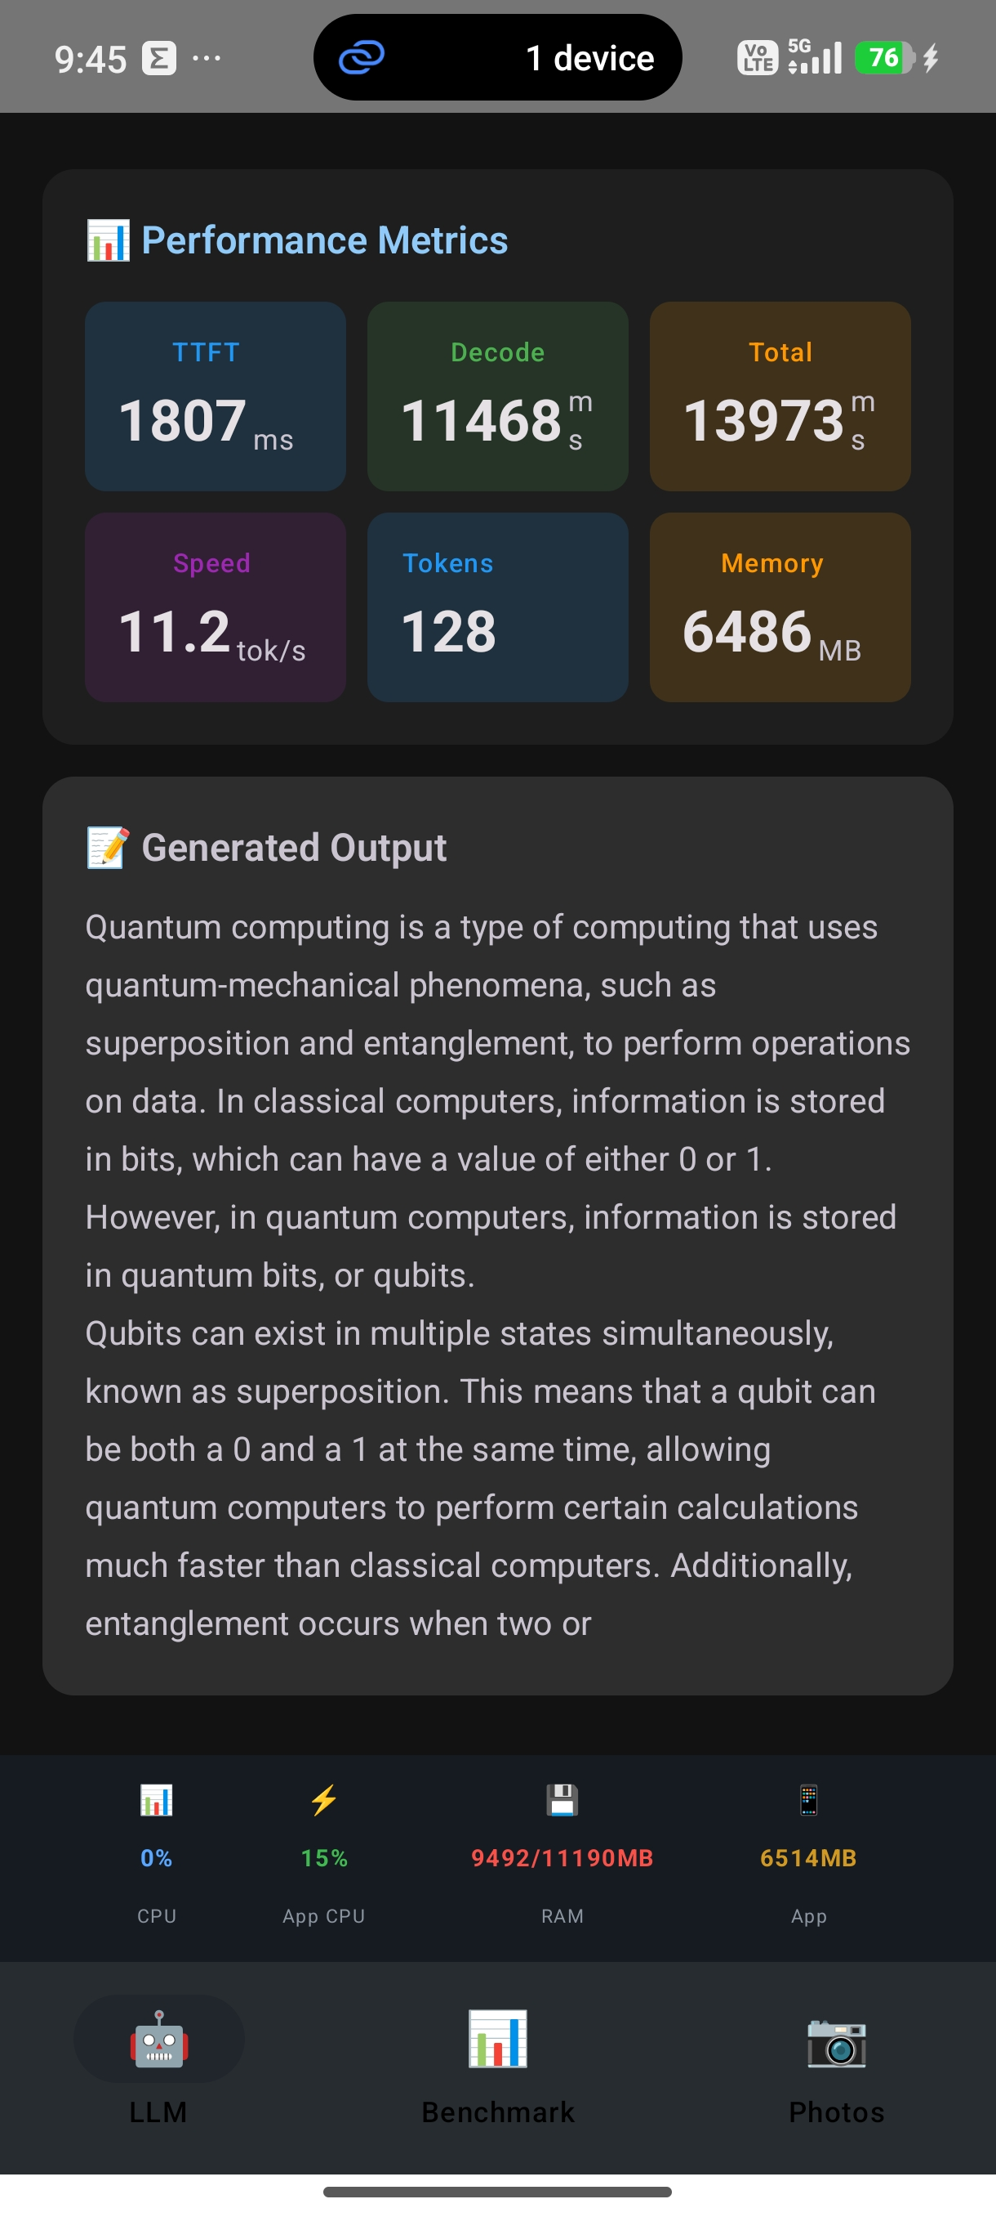
Benchmark results screen

