**Keywords:** Text-as-data analysis, social media, religion, Islam, Turkey

# Introduction

On Fridays at noon Muslims hold a special mass. Practicing men are required to listen to a *Khutba*, a sermon delivered by the Mosque’s Imam. The sermons are religious, but they often feature mundane topics. In Turkey Friday sermons are written centrally by the Presidency of Religious Affairs (TPRA). The same text is read in thousands of Mosques to millions of citizens. This gives TPRA, and through it the government a massive platform to deliver key social, political, and economic messages.

Since 2010 the Turkish government invests heavily in TPRA. From 2010 to 2020 TPRA’s budget increased from TL2.65billion to TL11.5billion and the number of religious personnel working at TPRA increased from 80,000 to 120,000 (Aksoy and Gambetta 2021). It is unclear, however, if TPRA is influential in affecting public values and opinion. Despite the recent surge in TPRA’s reach, religiosity declined since 2008 (KONDA 2019). As to Khutbas specifically, a rare systematic study shows that the sermons respond to the “threat salience” (e.g. frequency of terrorism-related news) (Alper et al. 2020). Yet, the authors do not analyze the effect of sermons on public attitudes or study other more common threats the government faces (e.g. the economy or the pandemic).

# Including Plots

You can also embed plots, for example:

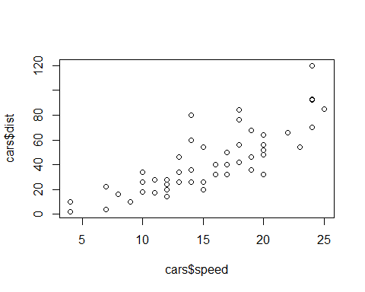

Scatterplot of Speed and Distance

# References

Aksoy, Ozan and Diego Gambetta. 2021. “The Politics Behind the Veil.” *European Sociological Review* 37(1):67–88.

Alper, Sinan, Fatih Bayrak, Elif Öykü Us, and Onurcan Yilmaz. 2020. “Do Changes in Threat Salience Predict the Moral Content of Sermons? The Case of Friday Khutbas in Turkey.” *European Journal of Social Psychology* 50(3):662–72.

Bauer, Paul C. 2020. “Writing a Reproducible Paper in R Markdown.” *SSRN Electronic Journal* 8.

KONDA. 2019. “2018 Hayat Tarzlari [Lifestyles in 2018].” *Report, Url: Https://Bit.ly/3uRZRCk*.