IBM SKILLSBUILD × AICTE × BHARATCARES
Data Analytics with AI Internship — 2026
SupplyShield AI
Predictive Shipment Delay Intelligence

PROJECT REPORT

Author | Akanksha Singh
Programme | IBM SkillsBuild x AICTE Data Analytics with AI Internship
Internship ID | IBMUEDA1357
Institution | Noida Institute of Engineering and Technology, Greater Noida
Department | Computer Science and Engineering (Data Science)
Submission date | 30 September 2026
Calibrated XGBoost classifier · 84.87% accuracy · 92.58% ROC-AUC · 180,519 orders

Table of Contents
1. Executive Summary 3
2. Problem Statement and Objectives 3
3. Dataset 3
4. Methodology 4
4.1 Preprocessing 4
4.2 Feature Engineering 4
4.3 Models and Tuning 4
5. Results 5
5.1 Model Comparison 5
5.2 What the Model Relies On 5
6. System Design 6
6.1 Architecture 6
6.2 Prediction Engine 7
6.3 Risk Levels 7
7. Dashboard 7
8. API 8
9. Verification 8
9.1 Encoding Integrity 8
9.2 Behaviour Checks 8
9.3 Score versus Observed Late Rate 9
9.4 Sensitivity to Each Input 9
10. Limitations and Future Work 10
11. Installation and Execution 11
12. Conclusion 11
References 11

1. Executive Summary
Late deliveries damage customer trust and inflate logistics cost, yet the risk is usually discovered only after a shipment has already slipped. SupplyShield AI estimates the probability that an order will be delivered late before it is dispatched, and converts that probability into a risk level and a concrete recommended action.
The system is trained on 180,519 orders from the DataCo Smart Supply Chain dataset. The production model is a calibrated XGBoost classifier that reaches 84.87% accuracy, 86.34% F1 and 92.58% ROC-AUC on a held-out test set, clearly ahead of logistic regression, decision tree and random forest baselines. It is delivered as a single Python file that contains both a Flask REST API and an interactive React dashboard.
This report also documents the verification work carried out on the deployed application: category encodings are checked against the dataset at every start-up, predictions are deterministic, and the dashboard sends exactly the values shown on the form.
At a glance
180,519 orders analysed · 57 engineered features · 4 models compared · 92.58% ROC-AUC · single-file Flask + React deployment · encoder integrity verified on every start-up.

2. Problem Statement and Objectives
Given the information available when an order is planned, predict whether it will arrive late. The project objectives were:
- Build a leakage-free binary classifier for Late_delivery_risk and compare several model families.
- Present the prediction as a 0–100 risk score with a Low / Medium / High level and a recommended action.
- Serve the model through a REST endpoint and an interactive dashboard from one deployable file.
- Make the result explainable: show which signals drive the score and how confident the model is.

3. Dataset
Property | Detail
Name | DataCo Smart Supply Chain for Big Data Analysis
Source | Kaggle (DataCo Global)
Records | 180,519 orders
Target | Late_delivery_risk (1 = delayed, 0 = on time)
Class balance | 54.83% delayed (98,977) · 45.17% on time (81,542)
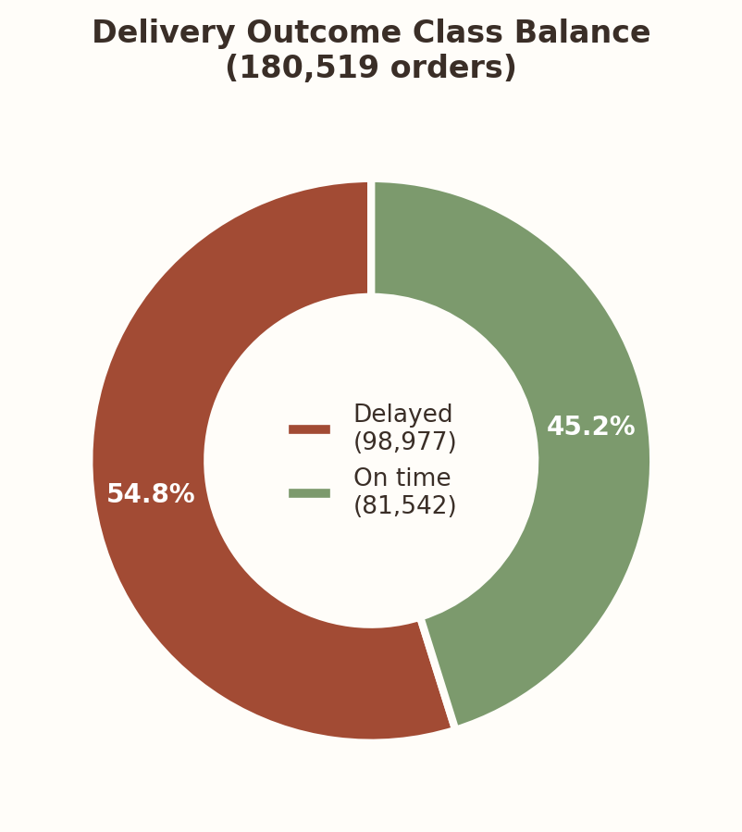
Figure 1. Delivery outcome class balance across the full dataset.
A property of this dataset shapes every result in this report: the shipping mode almost determines the delivery outcome. Each mode has a single scheduled lead time and a very different late rate.
Shipping mode | Scheduled days | Orders | Late rate
Standard Class | 4 | 107,752 | 38.1%
Second Class | 2 | 35,216 | 76.6%
First Class | 1 | 27,814 | 95.3%
Same Day | 0 | 9,737 | 45.7%
By contrast, the late rate is almost identical (about 55%) across markets, customer segments and departments, so those fields carry little predictive signal.

4. Methodology

4.1 Preprocessing
- Post-delivery columns (real shipping days, delivery status, order status, shipping date) are dropped.
- Customer names, e-mail, password, street and zip fields are dropped.
- Order month and weekday are extracted from the order date.
- 80/20 stratified split with a fixed random state; all encodings are learned from the training split only.

4.2 Feature engineering
Fourteen leakage-free business features are derived from raw columns: order quarter, weekend flag, order value, discount × quantity, high-discount flag, shipping urgency (scheduled days ÷ 4), sine/cosine encodings of month and weekday, peak-season flag, bulk-order flag and sales per unit. High-cardinality categoricals (cities, states, products, categories) receive smoothed target encoding and frequency encoding, and three interaction features are added (customer segment × region, market × shipping mode, category × department). The final matrix has 57 features.

4.3 Models and tuning
Four classifiers were trained on the same split. XGBoost was tuned with a randomised search (50 candidates, 3-fold cross-validation, ROC-AUC scoring, early stopping). Its probabilities are isotonic-calibrated, and the operating threshold (0.43) was selected on a validation split to maximise F1 subject to a precision floor.

5. Results

5.1 Model comparison
Model | Accuracy | Precision | Recall | F1 | ROC-AUC
Logistic Regression | 70.12 | 77.53 | 64.08 | 70.17 | 76.48
Decision Tree | 73.23 | 80.78 | 67.16 | 73.34 | 80.98
Random Forest | 74.27 | 83.11 | 66.60 | 73.95 | 82.30
XGBoost (production) | 84.87 | 85.51 | 87.18 | 86.34 | 92.58
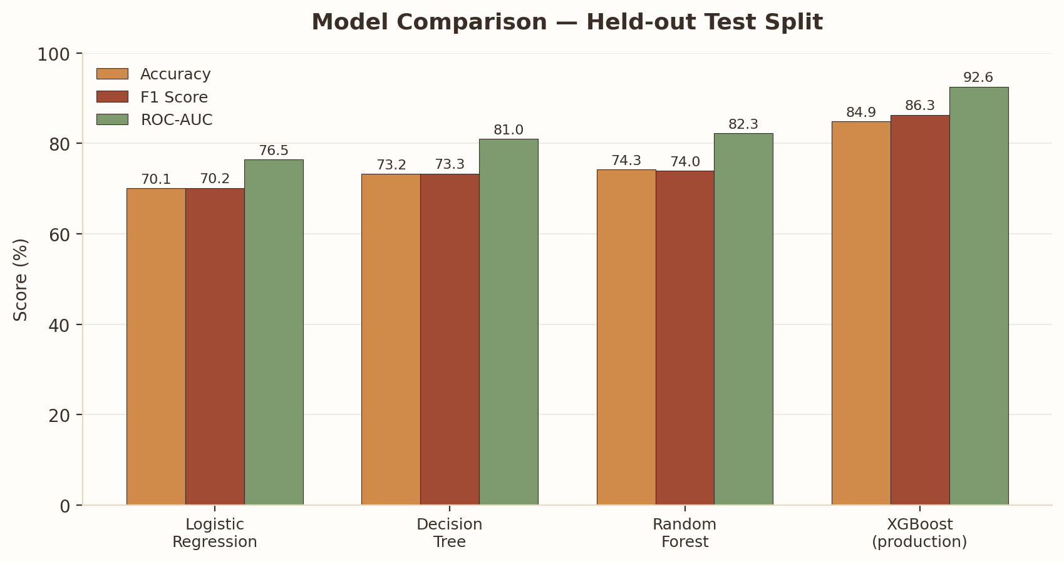
Figure 2. Accuracy, F1 and ROC-AUC for all four candidate models on the held-out test split.
All values are percentages on the held-out 20% test split. Baselines use the default 0.5 threshold.

5.2 What the model relies on
Rank | Feature | Importance
1 | Standard Class flag | 22.9%
2 | Shipping Mode | 21.6%
3 | Days for shipment (scheduled) | 12.3%
4 | Market × Shipping Mode | 7.4%
5 | Shipping Urgency | 3.9%
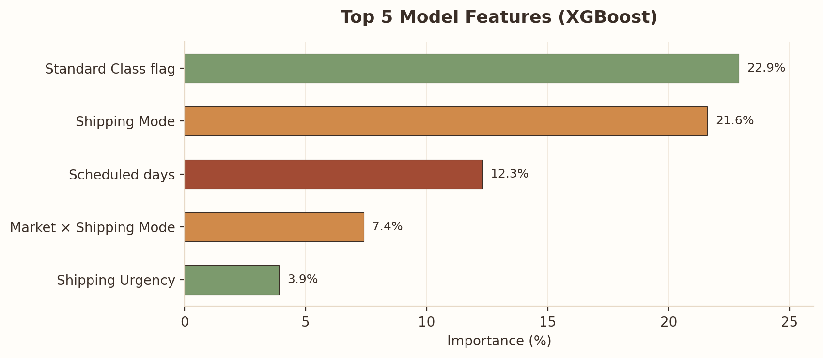
Figure 3. Top five features by XGBoost importance.
Shipping-related features account for roughly two thirds of the model's decisions. The top feature was named “Express Shipping Flag” while the training data was being prepared, but it equals 1 exactly for shipping code 3, which is Standard Class; the application therefore labels it “Standard Class Flag”.

6. System Design

6.1 Architecture
The application is one Python file. At start-up it loads a frozen model bundle and the processed feature matrix from an assets folder; nothing is retrained while serving. Flask exposes the REST endpoints and serves the React 18 dashboard, which calls the same /predict endpoint as any other client.
Layer | Responsibility
assets/supplyshield_frozen.pkl | XGBoost model, isotonic calibrator, encoders, metrics, feature importance
assets/processed_data.pkl | 180,519 × 57 processed feature matrix used for reference orders and statistics
Flask API | Input validation, feature substitution, scoring, risk banding
React dashboard | Form, risk meter, explainability panels, model metrics

6.2 Prediction engine
The model uses 57 features but the form collects nine; features such as the destination city or product are unknown when an order is planned. To score an order the engine:
- validates the request and flags values outside the range seen in training;
- translates each form value to the integer code the model was trained with;
- takes a fixed, seeded sample of 1,500 real training orders;
- substitutes the nine inputs and every feature derived from them into each sampled order;
- scores the 1,500 orders, calibrates the probabilities and returns their average.
The score is therefore the expected delay probability for an order with the entered attributes, averaged over realistic values of everything else. The same input always yields the same score.

6.3 Risk levels
Delay probability | Level | Recommended action
Below 33% | Low | No immediate action required. Monitor order progress normally.
33% – 66% | Medium | Flag order for review. Consider expedited shipping or supplier alert.
66% and above | High | Immediate intervention needed. Escalate to logistics manager and notify customer.

7. Dashboard
The dashboard is a single-page interface with a warm, minimal design. It contains:
- a hero header and a metrics ribbon showing the live accuracy, precision, recall, F1 and ROC-AUC of the production model;
- a five-step AI workflow strip (order received → feature processing → XGBoost → risk score → recommended action);
- the shipment form with two example buttons, next to the risk meter, level badge, delay probability and recommendation;
- a live preview of the automatically generated features (Standard Class flag, urgency, market × mode, high-discount flag);
- a prediction summary, feature-contribution chart, recommended actions and key business insights;
- a model-explainability section describing how XGBoost reaches its decision.
When an entry is outside the trained range, or the scheduled days do not match the shipping mode, a short note appears under the result. If a request fails, the reason is shown instead of silently keeping the previous result.

8. API
Method | Path | Purpose
GET | / | Dashboard
GET | /api/overview | Dataset totals and headline metrics
GET | /api/model_comparison | Metrics for all four models
GET | /api/feature_importance | Top-15 feature importances
GET | /api/risk_distribution | Low / Medium / High counts over the dataset
POST | /predict | Score one shipment
Example request
POST /predict
{ "Shipping Mode": "Second Class", "Days for shipment (scheduled)": 2,
"Market": "Europe", "Customer Segment": "Consumer", "Department Name": "Fan Shop",
"Order Item Quantity": 2, "Order Item Discount Rate": 0.10,
"Order Month": 6, "Order Weekday": 2 }
Example response
{ "risk_score": 87.9, "risk_level": "High", "delay_probability": 0.8795,
"recommended_action": "Immediate intervention needed. ...", "warnings": [] }
Invalid input returns HTTP 400 with an explanatory message.

9. Verification

9.1 Encoding integrity
The model was trained on integer-coded categories, so form values must be translated with exact mappings. The mapping tables were derived from the processed dataset and are re-checked at every start-up: each coded category must have the published row count, each shipping mode must have one fixed lead time, and each department must match its stored target and frequency encodings. If any check fails, the server stops with a report instead of serving incorrect predictions. A further check confirms the wired model agrees with the true labels on real orders (94.5% on the reference sample; this figure includes training rows and is a wiring check, not a test metric).

9.2 Behaviour checks
Check | Result
Repeated identical requests | Identical score every time
Values typed by hand + Predict button vs. example button | Identical result (98.3, High)
Shipping mode changed, everything else fixed | Score changes accordingly: Same Day 46.8, Second Class 87.3, Standard Class 39.7
Out-of-range entries (quantity 900, discount 50%) | Scored at the trained limit; explanatory note shown
Invalid mode / month / empty body | HTTP 400 with a clear message
Existing endpoints | Unchanged results (84.87 / 86.34 / 92.58)

9.3 Score versus observed late rate
Shipping mode | Late rate in dataset | Tool score, typical order
Standard Class | 38.1% | 36%
Same Day | 45.7% | 44%
Second Class | 76.6% | 87%
First Class | 95.3% | 98%
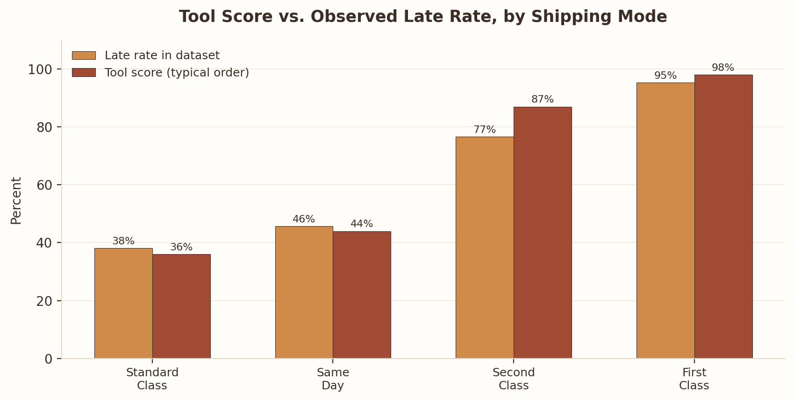
Figure 4. Tool score tracks the observed late-delivery rate for each shipping mode.
Scores follow the observed base rates, typically within about ten points; the largest gap is Second Class.

9.4 Sensitivity to each input
Changing one input at a time from a Standard Class baseline shows how much each field can move the score:
Input | Spread across all options
Shipping mode | ≈ 62 points
Department | ≈ 5 points
Order month | ≈ 4 points
Order weekday | ≈ 3 points
Discount rate | ≈ 2.5 points
Item quantity | ≈ 2.5 points
Customer segment | ≈ 2 points
Market | ≈ 1.5 points
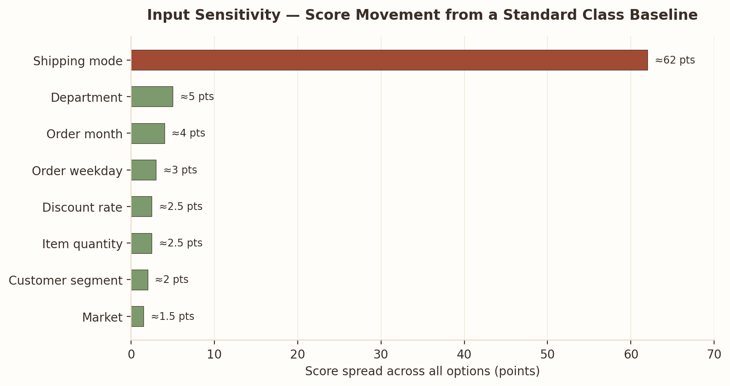
Figure 5. Score sensitivity to each input, holding the rest at a Standard Class baseline.
This mirrors the dataset itself, where only shipping mode has a strong relationship with lateness.

10. Limitations and Future Work
- Other inputs move the score only a few points because the dataset carries little signal in them.
- Air, sea, rail and road freight are not in DataCo and cannot be scored.
- Unknown features are averaged over real orders, so the score describes orders like the one entered rather than one specific consignment.
- Quantity 1–5, discount up to 25% and 0–4 scheduled days; entries beyond this are clamped and flagged.
- The bundled Flask server is for demonstration; a production WSGI server, authentication and monitoring would be added for real use.
Future work: add carrier, route and weather signals; collect a dataset that includes multi-modal freight; expose per-prediction explanations (for example SHAP values); and schedule periodic retraining with drift monitoring.

11. Installation and Execution
Requirements: Python 3.10 or newer.
pip install -r requirements.txt
python Akanksha_Singh_SupplyShieldAI.py
Then open http://localhost:5000. The assets folder must sit next to the Python file. A healthy start-up ends with “Encoders verified against processed data” and “Server ready.”
Component | Version
Python | 3.10+
Flask | ≥ 3.0
XGBoost | ≥ 3.0
scikit-learn | ≥ 1.6
NumPy / pandas | ≥ 2.1 / ≥ 2.3
React | 18 (bundled in the page)

12. Conclusion
SupplyShield AI delivers a complete, explainable delay-risk tool: a calibrated XGBoost model with 92.58% ROC-AUC, an API and dashboard in a single file, and safeguards that keep the interface honest — verified encodings, deterministic scoring, visible warnings and clear errors. The analysis also shows what the data can and cannot support: shipping mode is the decisive signal, and any further gains will need richer operational data rather than more model tuning.

References
- Breiman, L. (2001). Random Forests. Machine Learning, 45(1), 5–32. https://doi.org/10.1023/A:1010933404324
- Chen, T. and Guestrin, C. (2016). XGBoost: A Scalable Tree Boosting System. Proceedings of the 22nd ACM SIGKDD International Conference on Knowledge Discovery and Data Mining (KDD '16), 785–794.
- DataCo Global. DataCo Smart Supply Chain for Big Data Analysis. Kaggle. https://www.kaggle.com/datasets/shashwatwork/dataco-smart-supply-chain-for-big-data-analysis
- Dwivedi, V., Kadian, K., Gardiner, B., Pandey, R. and Lathwal, A. (2025). Supply Chain Analytics: A Performance Evaluation of Machine Learning, Statistical, and Time-Series Models. Baltic Journal of Modern Computing, 13(2), 453–485. https://doi.org/10.22364/bjmc.2025.13.2.09
- Micci-Barreca, D. (2001). A Preprocessing Scheme for High-Cardinality Categorical Attributes in Classification and Prediction Problems. ACM SIGKDD Explorations Newsletter, 3(1), 27–32.
- Niculescu-Mizil, A. and Caruana, R. (2005). Predicting Good Probabilities with Supervised Learning. Proceedings of the 22nd International Conference on Machine Learning (ICML '05), 625–632.
- Pedregosa, F. et al. (2011). Scikit-learn: Machine Learning in Python. Journal of Machine Learning Research, 12, 2825–2830.

