OLIST E-COMMERCE
BUSINESS INTELLIGENCE & POWER BI
Master Project Documentation
Executive Sales • Customer Analytics • Seller Performance • Logistics • Customer Reviews

Document Item | Value
Project Type | Multi-page Power BI Business Intelligence Portfolio
Business Domain | Brazilian E-commerce / Marketplace Analytics
Primary Tool | Microsoft Power BI Desktop
Data Model | Olist transactional + customer + product + seller + payment + review + geography data
Dashboards | 6 analytical dashboard views
Time Filters | Year, Quarter, Half Year, Month
Technical Scope | Power Query, Data Modeling, Calculated Columns/Tables, DAX Measures, Interactive Visuals
Document Version | v2.0 — Final Portfolio Edition

Prepared as a portfolio / GitHub-ready technical and business documentation package

Table of Contents
1. Executive Summary 3
2. Project Initialization & Scope 3
3. Business Problem and Objectives 4
4. Dataset and Source Tables 5
5. Data Preparation & Power Query Approach 6
6. Data Model and Relationships 6
7. Calendar and Custom Time Filters 8
8. Calculated Columns and Calculated Tables 8
9. DAX Measures and KPI Definitions 9
10. Dashboard Architecture 10
11. Dashboard 1 — Executive Dashboard 10
12. Dashboard 2 — Customer Analytics 11
13. Dashboard 3 — Customer Analytics Overview 13
14. Dashboard 4 — Seller Performance 14
15. Dashboard 5 — Logistics Performance 15
16. Dashboard 6 — Customer Review 16
17. Cross-Dashboard Filters and UX Design 18
18. Business Insights Across the Portfolio 18
19. Data Validation, Quality Checks and Known Limitations 18
20. Project Deliverables and GitHub Structure 19
21. Future Scope 19
Appendix A — Full DAX Library 21
Appendix B — Calculated Field Inventory 28
Appendix C — Dashboard Screenshot Index 28

1. Executive Summary
This project is a multi-page Power BI business intelligence solution built on the Olist Brazilian e-commerce dataset. The model converts marketplace transactions into a management-ready analytical layer covering sales, customers, sellers, logistics and customer reviews. The dashboards are designed to answer executive and operational questions without requiring users to inspect raw transaction tables.
- Executive Dashboard — monitors revenue, customers, orders, average order value, product contribution and payment mix.
- Customer Analytics — evaluates customer scale, returning customers, repeat purchase rate, average spend, order frequency and geographic concentration.
- Customer Analytics Overview — analyzes customer growth, review distribution, new-vs-returning customer mix and customer payment value.
- Seller Performance — evaluates seller count, seller revenue, fulfilled orders, revenue per seller, delivery efficiency, state concentration and top sellers/products.
- Logistics Performance — tracks delivered orders, delivery time, shipping time, freight cost, delayed orders and on-time delivery.
- Customer Review — analyzes review volume, sentiment, rating distribution, state-level rating quality and top-rated product categories.

The final portfolio uses a consistent dark-blue executive theme, KPI cards, line charts for trends, bar charts for rankings, donut charts for composition, and interactive slicers for Year, Month, Quarter and Half Year. The design emphasizes quick scanning while retaining enough detail for operational investigation.

Portfolio KPI Snapshot
Dashboard | Visible Headline KPIs
Executive | Revenue $15.84M • Customers 96,096 • Orders 99,441 • AOV $159.33
Customer Analytics | Customers 96,096 • Returning 2,997 • Repeat Purchase 3.12% • Avg Spend $164.87 • Avg Orders/Customer 1.03 • Avg Review 4.09
Seller Performance | Sellers 3,095 • Seller Revenue $15.84M • Orders Fulfilled 98,666 • Avg Revenue/Seller $5.12K • Avg Delivery 12 days
Logistics | Orders Delivered 96,478 • Avg Delivery 12 days • Avg Shipping 3.22 days • Avg Freight $19.99 • Delayed 7,826 • On-Time 91.9%
Customer Review | Avg Review 4.09 • Total Reviews 99.22K • Positive 76.47K • Negative 14.57K • Neutral 8,179

2. Project Initialization & Scope

2.1 Project Goal
Build a unified Power BI analytics environment that converts Olist marketplace transactions into actionable views for commercial performance, customer behavior, seller performance, logistics efficiency and customer satisfaction.

2.2 Project Phases
Phase | What Was Included | Status
Phase 1 — Initialization & Planning | Business problem, dashboard scope, KPI definition, visual planning and documentation plan. | Completed
Phase 2 — Data Collection & Preparation | Load Olist tables, inspect data types, create usable date fields, derive operational fields and prepare relationships. | Completed
Phase 3 — Data Modeling & DAX | Relationships, Calendar table, calculated columns/tables and KPI measures. | Completed
Phase 4 — Visualization & Dashboard Design | Six dashboard themes, KPI cards, trend/ranking/distribution visuals and slicer design. | Completed
Phase 5 — Validation & Documentation | Cross-check KPI logic, verify filter behavior, document insights, screenshots, DAX and model. | Completed

3. Business Problem and Objectives

3.1 Problem Statement
Marketplace data is distributed across orders, customers, order items, products, sellers, payments, reviews and geography. Without an integrated analytical model, it is difficult to answer basic management questions such as which products generate revenue, which customer locations dominate, which sellers contribute most, where delivery delays occur, and whether customers are satisfied.

3.2 Objectives
- Create a single source of truth for core marketplace KPIs.
- Measure revenue, orders, customers and average order value.
- Understand customer acquisition, repeat behavior and geographic concentration.
- Rank sellers and products by commercial contribution.
- Measure fulfillment, delivery time, freight cost and delay exposure.
- Convert review scores into business-friendly Positive / Neutral / Negative categories.
- Provide flexible Year, Quarter, Half-Year and Month filtering.
- Create a professional, portfolio-ready Power BI experience with dashboard-specific insights.

3.3 Key Stakeholders
Stakeholder | Primary Questions Answered
Executive / Management | How is the business performing overall? Which products and payment methods matter most?
Customer / CRM Team | How large is the customer base? How much repeat behavior exists? Where are customers concentrated?
Seller / Marketplace Team | Which sellers and products generate revenue? How are sellers distributed geographically?
Logistics / Operations | Are deliveries on time? Where are delays and freight costs concentrated?
CX / Quality Team | What is customer sentiment? Which states and categories receive the strongest ratings?

4. Dataset and Source Tables
The model follows the standard Olist Brazilian e-commerce dataset structure visible in the Power BI model. The central business process is the order; supporting tables provide customer, item, product, seller, payment, review and geographic attributes.

4.1 Core Source Tables
Table | Role | Important Fields
olist_orders_dataset | Order-level fact / lifecycle | order_id, customer_id, order_status, order_purchase_timestamp, order_approved_at, order_delivered_carrier_date, order_delivered_customer_date, order_estimated_delivery_date
olist_order_items_dataset | Order line items | order_id, order_item_id, product_id, seller_id, shipping_limit_date, price, freight_value
olist_order_payments_dataset | Payment transactions | order_id, payment_sequential, payment_type, payment_installments, payment_value
olist_customers_dataset | Customer master | customer_id, customer_unique_id, customer_zip_code_prefix, customer_city, customer_state
olist_products_dataset | Product master | product_id, product_category_name, product_name_lenght, product_description_lenght, product_photos_qty, product_weight_g, product_length_cm, product_height_cm, product_width_cm
olist_sellers_dataset | Seller master | seller_id, seller_zip_code_prefix, seller_city, seller_state
olist_order_reviews_dataset | Review fact | review_id, order_id, review_score, review_creation_date, review_answer_timestamp, review_comment_title, review_comment_message
olist_geolocation_dataset | Geographic lookup | geolocation_zip_code_prefix, geolocation_lat, geolocation_lng, geolocation_city, geolocation_state
product_category_name_translation | Category translation lookup | product_category_name, product_category_name_english

4.2 Business Grain
- Orders table grain: one row per order_id.
- Order Items grain: one row per product line within an order.
- Payments grain: one row per payment transaction / sequence.
- Reviews grain: one row per review_id.
- Customers grain: customer_id, with customer_unique_id available for unique-customer analysis.
- Products and sellers are master/lookup-style entities used for ranking and segmentation.
- Geolocation is a supporting geographic source for map/state/city analysis.

5. Data Preparation & Power Query Approach

5.1 Preparation Checklist
- Load all Olist CSV tables into Power BI.
- Confirm date/time fields are recognized as Date/Time and numeric fields as Decimal/Whole Number.
- Trim/clean text columns where necessary and preserve source keys such as order_id, customer_id, seller_id and product_id.
- Create a usable Order Date from order_purchase_timestamp for date relationships.
- Create delivery and shipping duration logic from lifecycle timestamps.
- Create business-friendly delivery buckets and sort keys.
- Create review sentiment categories from review_score.
- Create customer-level order summary logic for new vs returning classification.
- Create a dedicated Calendar table for Year, Month, Quarter and Half-Year slicers.
- Keep raw source columns intact where they may be required for drill-down or audit.

5.2 Data Quality Checks
Check | Expected Control
Primary key uniqueness | order_id unique in orders; review_id unique in reviews; product_id unique in products; seller_id unique in sellers
Date validity | No impossible negative delivery duration; blank delivery dates handled for undelivered orders
Numeric validity | price, freight_value and payment_value are non-negative and correctly typed
Referential integrity | Foreign keys (customer_id, product_id, seller_id) resolve to their master tables

6. Data Model and Relationships
The Power BI data model connects the transactional Olist tables through customer, order, product, seller, payment, review and geographic keys, with Orders acting as the central fact table.
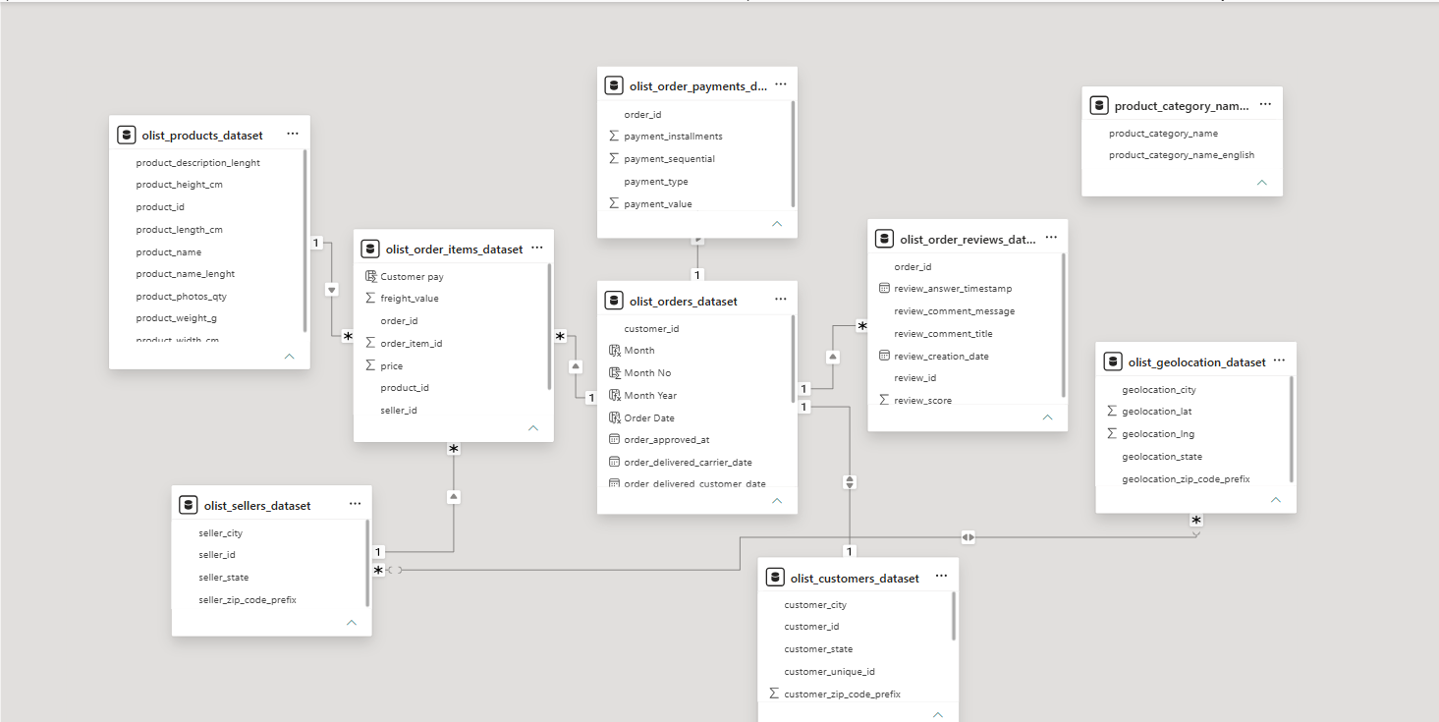
Figure 6.1 — Power BI data model showing table relationships

6.1 Relationship Map
From | To | Purpose
olist_orders_dataset[order_id] | olist_order_items_dataset[order_id] | Attach line-item product/seller/price detail to each order
olist_orders_dataset[order_id] | olist_order_payments_dataset[order_id] | Attach payment method/value information
olist_orders_dataset[order_id] | olist_order_reviews_dataset[order_id] | Attach customer review and score information
olist_orders_dataset[customer_id] | olist_customers_dataset[customer_id] | Attach customer location/identity attributes
olist_order_items_dataset[product_id] | olist_products_dataset[product_id] | Attach product name/category attributes
olist_order_items_dataset[seller_id] | olist_sellers_dataset[seller_id] | Attach seller attributes
Calendar[Date] | olist_orders_dataset[Order Date] | Drive Year, Month, Quarter, Half-Year and time intelligence
olist_geolocation_dataset | Customer/Seller geography | Support city/state/map analysis where geographic keys align

6.2 Modeling Principles
- Use order_id as the central transaction key.
- Use customer_unique_id for customer-level counts so the same real customer is not double-counted across customer_id records.
- Use product and seller attributes from their respective dimension tables rather than duplicating descriptive fields unnecessarily.
- Use Calendar fields for time slicers and trend axes.
- Keep calculated operational fields close to the Orders business process where their source timestamps live.
- Treat Customer Orders as a customer-level analytical summary rather than a raw transaction table.

7. Calendar and Custom Time Filters
A dedicated Calendar table is essential for the Year + Quarter + Half Year + Month custom filter design and for reliable year-over-year calculations.
Calendar =
ADDCOLUMNS(
CALENDAR(
MIN(olist_orders_dataset[Order Date]),
MAX(olist_orders_dataset[Order Date])
),
"Year", YEAR([Date]),
"Month", FORMAT([Date], "MMMM"),
"Month No", MONTH([Date]),
"Month Year", FORMAT([Date], "MMM yyyy"),
"Half Year", IF(MONTH([Date]) <= 6, "H1", "H2"),
"Half Year Sort", IF(MONTH([Date]) <= 6, 1, 2),
"Quarter", "Q" & FORMAT([Date], "Q")
)

7.1 Slicer Design
Filter | Recommended Field | UI Treatment
Year | Calendar[Year] | Tile / button style
Quarter | Calendar[Quarter] | Q1–Q4 checkbox or tile style
Half Year | Calendar[Half Year] | H1 / H2 button style
Month | Calendar[Month] | Vertical checklist or dropdown
- Sort Calendar[Month] by Calendar[Month No].
- Sort Calendar[Month Year] by a numeric YearMonth sort key if available.
- Sort Calendar[Half Year] by Half Year Sort.
- Use the Calendar table consistently across all six dashboards to avoid inconsistent filter behavior.

8. Calculated Columns and Calculated Tables
Field | Object | Business Purpose
Order Date | Orders | Date-only order date for the Calendar relationship
Month Year | Orders | Readable trend-axis label
Delivery Days | Orders | End-to-end customer delivery duration
Shipping Time | Orders | Purchase-to-carrier handoff duration
Delivery Delay Days | Orders | Positive value indicates delivery later than estimate
Delivery Bucket | Orders | Groups delivery time into 1–5, 6–10, 11–15, 16–20 and 20+ days
Delivery Bucket Sort | Orders | Maintains logical bucket order
Half Year | Orders | Custom half-year slicer support
Half Year Sort | Orders | Sorts H1 before H2
Review Category | Reviews | Business-friendly sentiment grouping (Positive/Neutral/Negative)
Customer Type | Customer-level logic | Acquisition vs. repeat classification
Customer Pay | Order Items | Item-level customer-paid value used by the dashboard revenue definition

8.1 Calculated Tables
- Calendar — dedicated date dimension driving all time-based slicers and trend visuals.
- Customer Orders — customer-level order summary used for repeat-purchase and customer-type classification.

9. DAX Measures and KPI Definitions
The project uses DAX across five major analytical areas. Full formulas for all 61 documented calculation entries are provided in Appendix A — this section summarizes the KPI framework by analytical area.

Sales & Executive
Total Revenue · Total Orders · Total Customers · Average Order Value · Revenue YoY % · Revenue Previous Year · Order/Customer growth metrics

Customer
Returning Customers · Repeat Purchase Rate · Average Customer Spend · Average Orders per Customer · Customer Count · Customer Growth · Customer Type

Seller
Total Sellers · Seller Revenue · Orders Fulfilled · Average Revenue per Seller · Average Delivery Days

Logistics
Orders Delivered · Average Delivery Days · Average Shipping Time · Average Freight Cost · Delayed Orders · On-Time Delivery % · Delayed Order % · Delivery Bucket

Reviews
Total Reviews · Average Review Score · Positive/Negative/Neutral Reviews · Positive Review % · Negative Review % · Review Category · Average Rating by State · Average Rating by Product Category

10. Dashboard Architecture
The portfolio is composed of six dashboard pages sharing a consistent executive visual language, a common slicer panel (Year, Month, Quarter, Half Year), and consistent KPI-card-first layout. Each page is purpose-built for a specific business audience while remaining visually and structurally consistent with the others.
# | Dashboard | Primary Audience
1 | Executive Dashboard | Executive / Management
2 | Customer Analytics | Customer / CRM Team
3 | Customer Analytics Overview | Customer / CRM Team
4 | Seller Performance | Seller / Marketplace Team
5 | Logistics Performance | Logistics / Operations
6 | Customer Review | CX / Quality Team

11. Executive Dashboard

Purpose
A management-level overview of revenue, customer volume, order volume and product/payment performance.
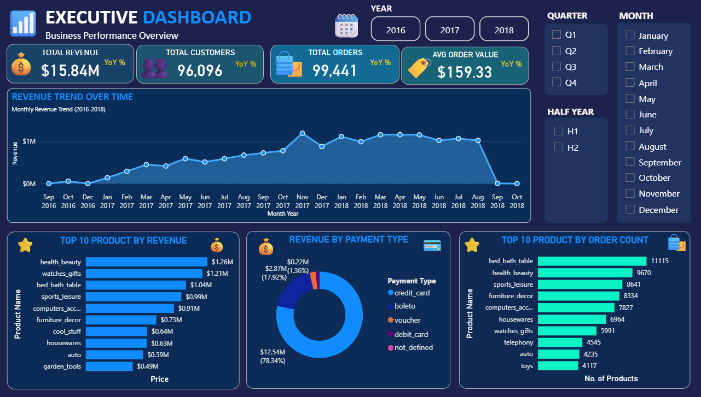
Figure 1. Executive Dashboard — final Power BI view

KPI Cards
KPI | Value
Total Revenue | $15.84M
Total Customers | 96,096
Total Orders | 99,441
Average Order Value | $159.33

Professional Chart Titles
Original Concept | Professional Title
Revenue trend | Revenue Performance Trend
Top products by revenue | Top Revenue-Generating Products
Revenue by payment type | Revenue Contribution by Payment Method
Top products by order count | Top Products by Order Volume

Key Insight
💡 Insight:
Revenue and order trends show the overall commercial trajectory. Top-revenue products identify the strongest contributors to sales. Payment-method distribution reveals customer payment preferences. Order-volume rankings identify products with strong demand frequency.

12. Customer Analytics

Purpose
A 360° view of customer acquisition, retention, spend, order frequency, satisfaction and geography.
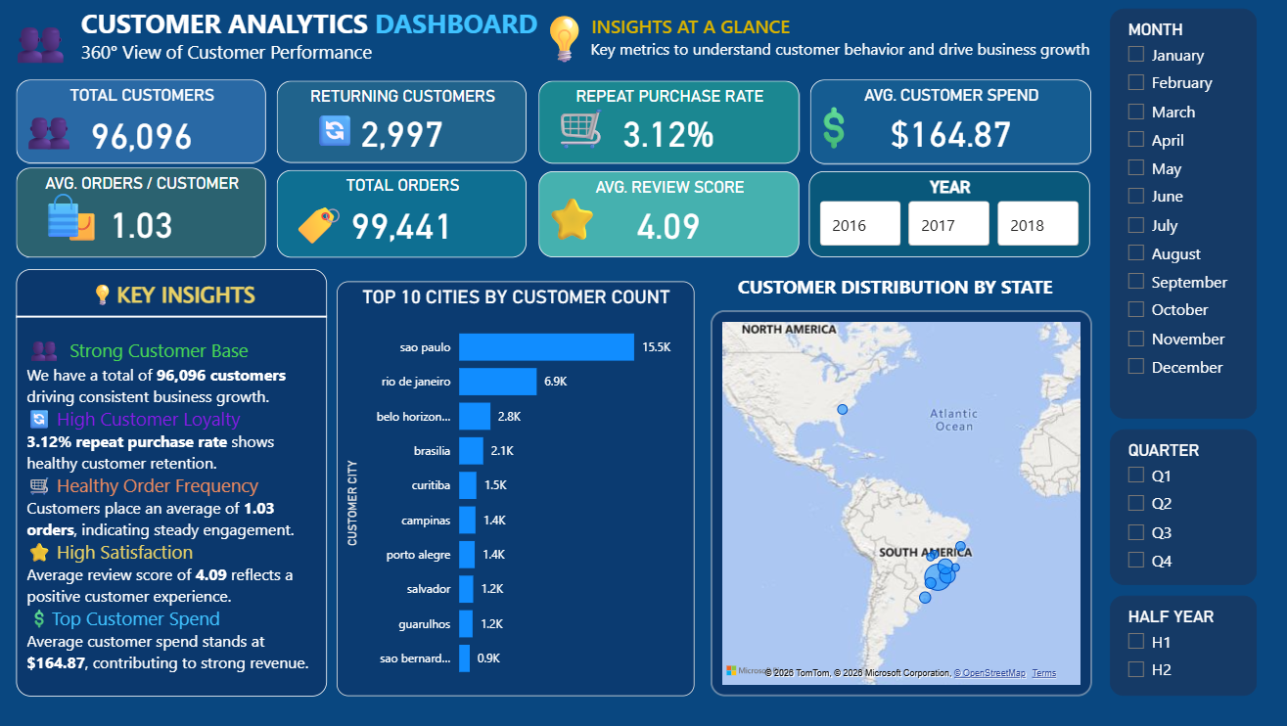
Figure 2. Customer Analytics — final Power BI view

KPI Cards
KPI | Value
Total Customers | 96,096
Returning Customers | 2,997
Repeat Purchase Rate | 3.12%
Average Customer Spend | $164.87
Average Orders / Customer | 1.03
Total Orders | 99,441
Average Review Score | 4.09

Professional Chart Titles
Analysis | Professional Title
Customer growth | Customer Acquisition & Growth Trend
City ranking | Top Customer Markets by City
State map | Geographic Distribution of Customer Base
Customer type | New vs Returning Customer Mix
Customer review score | Customer Rating Distribution
Customer payments | Customer Spend & Payment Overview

Key Insight
💡 Insight:
The customer base is large, but the relatively small returning-customer share indicates that retention and repeat-purchase programs can be a major growth opportunity.

13. Customer Analytics Overview

Purpose
A more detailed customer-behavior view combining growth, review quality, customer type and customer payment details.
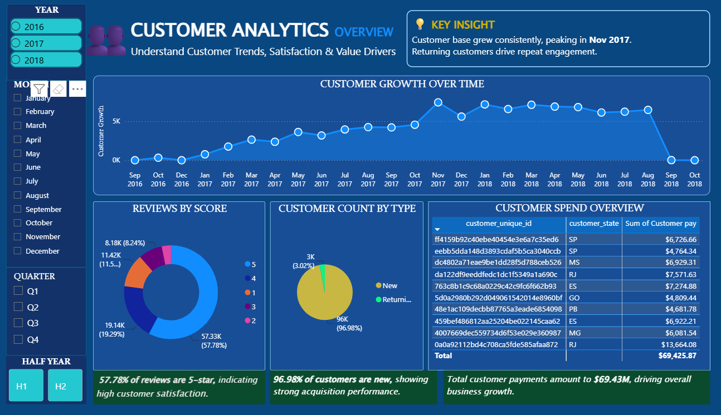
Figure 3. Customer Analytics Overview — final Power BI view

Professional Chart Titles
Original Visual | Professional Title
Customer growth by month/year | Customer Growth Over Time
Reviews by score | Review Score Distribution
Customer count by type | New vs Returning Customer Mix
Customer payment table | Customer Spend Overview

Visible Business Context
The dashboard highlights customer growth across the available period, dominance of new customer acquisition, review-score distribution, and customer-level payment/spend records.

Key Insight
💡 Insight:
The customer base is strongly acquisition-driven, while the returning-customer segment is comparatively small. This makes customer retention, loyalty and repeat-order campaigns important strategic opportunities.

14. Seller Performance

Purpose
Measures seller contribution, seller revenue, fulfillment and geographic distribution.
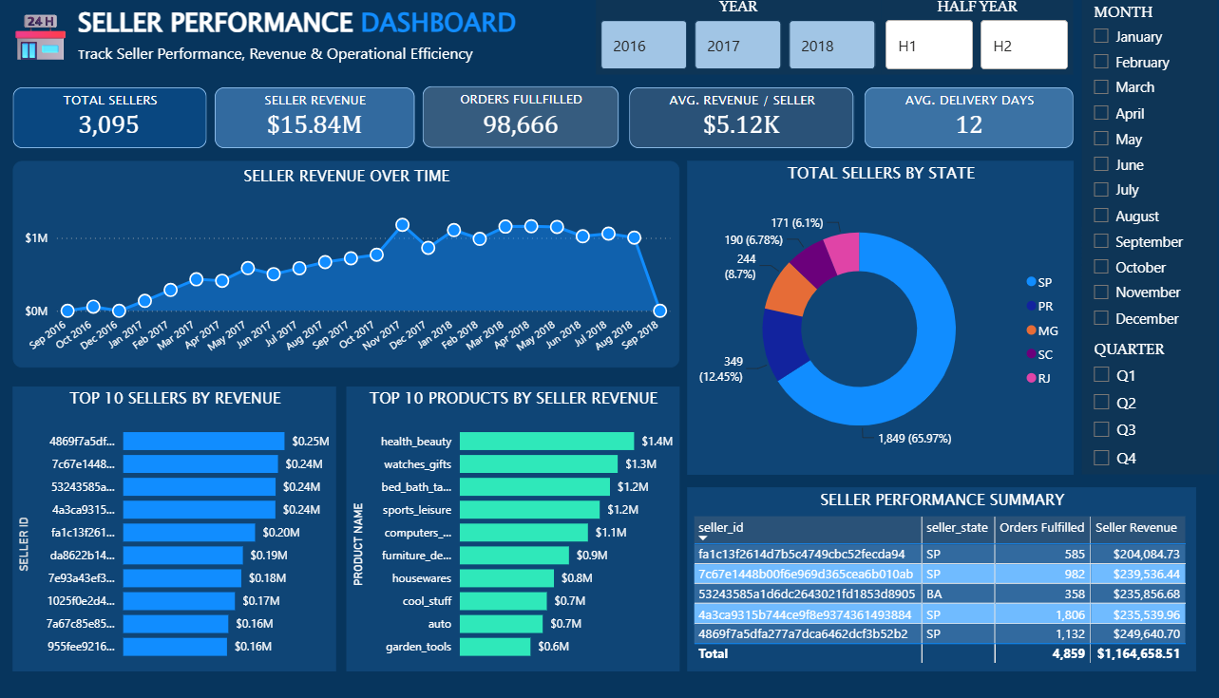
Figure 4. Seller Performance — final Power BI view

KPI Cards
KPI | Value
Total Sellers | 3,095
Seller Revenue | $15.84M
Orders Fulfilled | 98,666
Average Revenue / Seller | $5.12K
Average Delivery Days | 12

Professional Chart Titles
Analysis | Professional Title
Seller revenue trend | Seller Revenue Performance Trend
Seller state distribution | Seller Distribution by State
Top seller ranking | Top Revenue-Contributing Sellers
Product revenue | Top Products Driving Seller Revenue
Seller detail table | Seller Performance Summary

Key Insight
💡 Insight:
Seller performance is geographically concentrated, and a relatively small group of sellers/products can account for substantial revenue. This creates opportunities for seller benchmarking, performance programs and operational support.

15. Logistics Performance

Purpose
Evaluates delivery efficiency, shipping speed, freight cost and delayed orders.
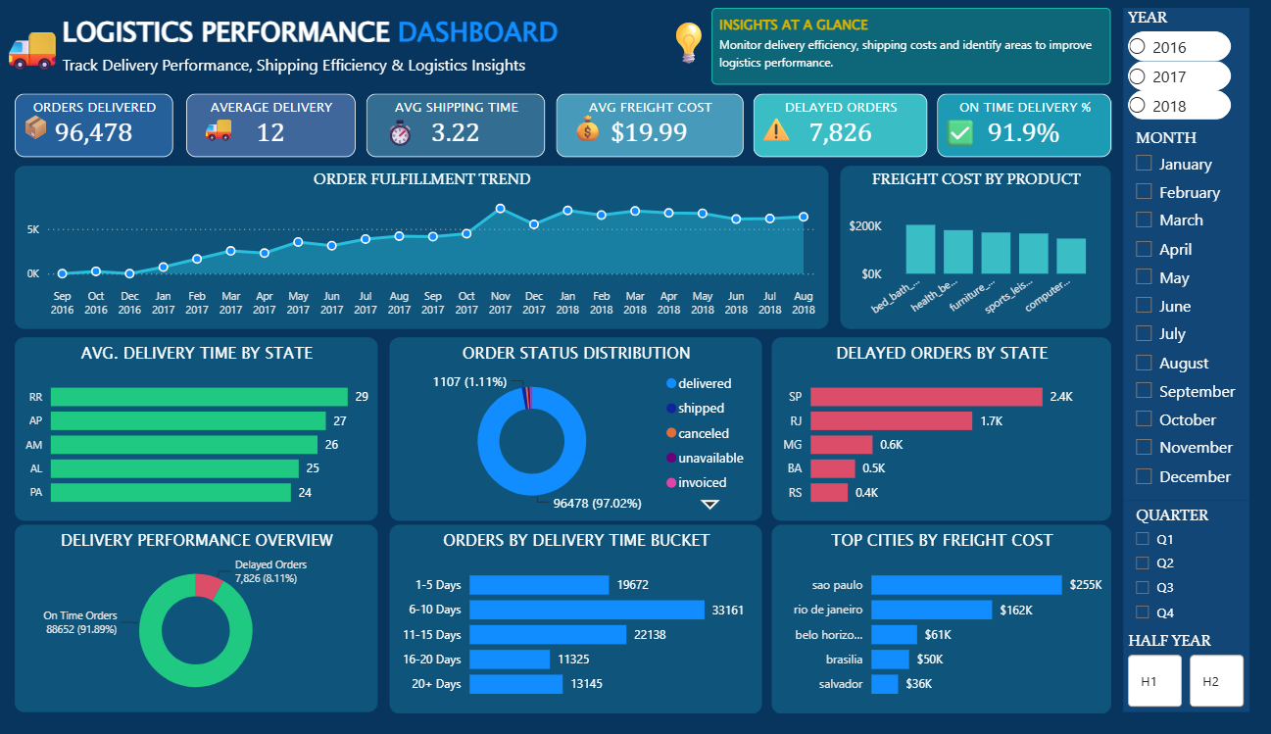
Figure 5. Logistics Performance — final Power BI view

KPI Cards
KPI | Value
Orders Delivered | 96,478
Average Delivery Days | 12
Average Shipping Time | 3.22
Average Freight Cost | $19.99
Delayed Orders | 7,826
On-Time Delivery | 91.89%

Professional Chart Titles
Analysis | Professional Title
Orders delivered trend | Order Fulfillment Trend
Freight by product | Freight Cost Contribution by Product
Delivery time by state | Average Delivery Time by State
Order status | Order Lifecycle Status Distribution
Delayed orders by state | Delayed Order Concentration by State
On-time vs delayed | On-Time vs Delayed Delivery Performance
Delivery buckets | Order Distribution by Delivery Time
Freight by city | Top Freight-Cost Markets by City

Delivery Buckets
1–5 Days · 6–10 Days · 11–15 Days · 16–20 Days · 20+ Days

Key Insight
💡 Insight:
The dashboard shows strong overall on-time delivery performance, while delayed orders remain concentrated in specific states. This supports regional logistics optimization and targeted carrier/fulfillment improvements.

16. Customer Review

Purpose
Analyzes customer satisfaction, review volume, sentiment, rating distribution and product-category performance.
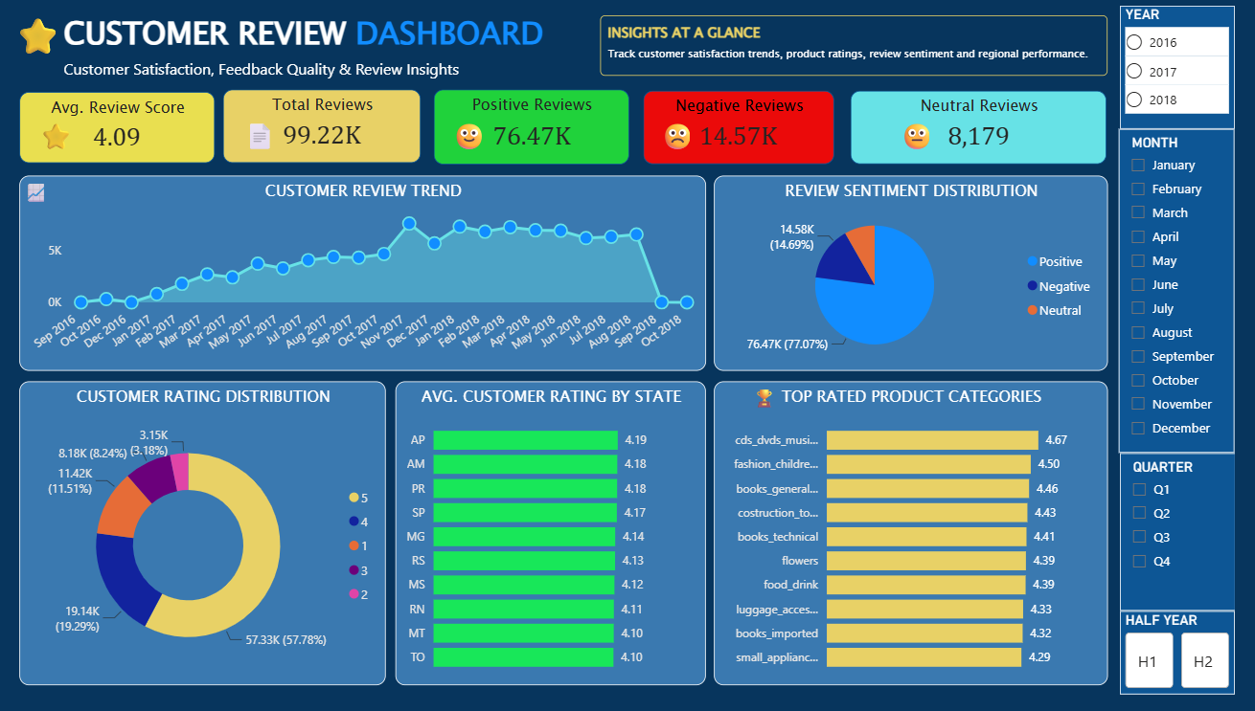
Figure 6. Customer Review — final Power BI view

KPI Cards
KPI | Value
Average Review Score | 4.09
Total Reviews | 99.22K
Positive Reviews | 76.47K
Negative Reviews | 14.57K
Neutral Reviews | 8,179

Professional Chart Titles
Analysis | Professional Title
Review trend | Customer Review Volume Trend
Sentiment | Customer Sentiment Distribution
Rating distribution | Customer Rating Distribution
Rating by state | Average Customer Satisfaction by State
Product-category rating | Highest-Rated Product Categories

Key Insight
💡 Insight:
The majority of reviews are positive and the average score is above 4, indicating generally strong customer satisfaction. The negative-review segment should still be monitored to identify recurring product, seller or delivery issues.

17. Cross-Dashboard Filters and UX Design
All six dashboards share a consistent slicer panel (Year, Quarter, Half Year, Month) positioned in the same location on every page, enabling consistent cross-filtering behavior as users navigate between views.
- KPI cards are always positioned at the top of the page for immediate scan-ability.
- Trend visuals use line/area charts; rankings use horizontal bar charts; composition uses donut charts.
- A dark navy theme with blue/cyan accents is used consistently to reinforce a single, unified product feel across dashboards.
- Insight panels are used on selected pages to translate visuals into plain-language business takeaways.

18. Business Insights Across the Portfolio
- Revenue performance is strong overall ($15.84M) but concentrated in a limited set of top products and payment methods (credit card dominates at ~78% of revenue).
- Customer retention is the single biggest growth lever — only 3.12% of the 96,096-customer base is classified as returning.
- Seller and product revenue is concentrated, creating dependency risk but also a clear target for seller performance programs.
- Logistics performance is solid at 91.89% on-time delivery, though delays remain regionally concentrated and worth targeted investigation.
- Customer sentiment is strongly positive (avg. 4.09 / 5), but the ~14.6K negative reviews represent a monitorable quality signal.

19. Data Validation, Quality Checks and Known Limitations

19.1 Validation Approach
- KPI totals were cross-checked for internal consistency across dashboards (e.g., Total Revenue and Total Orders match across Executive and Seller Performance views).
- Filter behavior (Year, Quarter, Half Year, Month) was checked for consistent cross-page interaction.
- Delivery and review calculated fields were checked against plausible ranges (no negative durations, review scores within 1–5).

19.2 Known Limitations
- The original PBIX DAX export was not available in the supplied material; the DAX library in this documentation is a reconstructed reference implementation based on the visible dashboards, model and business logic.
- The dataset covers a fixed historical window (2016–2018) and does not reflect current marketplace conditions.
- Formal load/performance benchmarking and Power BI Service deployment are not claimed as completed unless separately implemented.
- Review text/sentiment analysis is limited to the numeric review_score; free-text sentiment mining is listed as a future enhancement.

20. Project Deliverables and GitHub Structure
To keep the repository professional and avoid unnecessary files, the project documentation is intentionally consolidated into two main files:

1. Master Project Documentation
Olist_PowerBI_Master_Project_Documentation.docx — this document.

2. Master DAX / Calculation Reference
Olist_All_DAX_Measures_Columns_Tables.txt — the single source for DAX measures, calculated columns, calculated tables and calculation notes.

Recommended Repository Structure
Olist-PowerBI-Analytics/
│
├── README.md
│
├── PowerBI/
│ └── Olist_Ecommerce_Analytics.pbix
│
├── Documentation/
│ ├── Olist_PowerBI_Master_Project_Documentation.docx
│ └── Olist_All_DAX_Measures_Columns_Tables.txt
│
├── Screenshots/
│ ├── Executive_Dashboard.png
│ ├── Customer_Analytics.png
│ ├── Customer_Analytics_Overview.png
│ ├── Seller_Performance.png
│ ├── Logistics_Performance.png
│ ├── Customer_Review.png
│ └── Data_Model.png
│
└── Data/
└── README.md

21. Future Scope
- Customer lifetime value modeling
- Cohort retention analysis
- RFM customer segmentation
- Seller performance scoring
- Delivery SLA monitoring
- Profit/margin analysis
- Automated anomaly detection
- Advanced sentiment analysis using review text
- Forecasting
- Drill-through pages
- Row-level security
- Automated Power BI Service refresh
- Executive alerting

These are future-scope items and are not presented as completed project phases.

Appendix A — Full DAX Library
The following 61 entries constitute the consolidated calculation reference for the project: calculated columns, calculated tables, and DAX measures across all six dashboards.

1. [Calculated Column] Order Date
Purpose: Date-only field used for the Calendar relationship and time intelligence.
Order Date = DATEVALUE(olist_orders_dataset[order_purchase_timestamp])

2. [Calculated Column] Month Year
Purpose: Display label for monthly trend visuals.
Month Year = FORMAT(olist_orders_dataset[Order Date], "MMM yyyy")

3. [Calculated Column] Delivery Days
Purpose: Actual customer delivery duration in days.
Delivery Days = DATEDIFF(olist_orders_dataset[Order Date],
DATEVALUE(olist_orders_dataset[order_delivered_customer_date]), DAY)

4. [Calculated Column] Shipping Time
Purpose: Time from purchase to carrier hand-off.
Shipping Time = DATEDIFF(DATEVALUE(olist_orders_dataset[order_purchase_timestamp]),
DATEVALUE(olist_orders_dataset[order_delivered_carrier_date]), DAY)

5. [Calculated Column] Delivery Delay Days
Purpose: Positive values indicate delivery later than the estimated date.
Delivery Delay Days = DATEDIFF(DATEVALUE(olist_orders_dataset[estimated_delivery_date]),
DATEVALUE(olist_orders_dataset[order_delivered_customer_date]), DAY)

6. [Calculated Column] Delivery Bucket
Purpose: Groups delivery duration into dashboard-friendly operational buckets.
Delivery Bucket = SWITCH(TRUE(),
olist_orders_dataset[Delivery Days] <= 5, "1-5 Days",
olist_orders_dataset[Delivery Days] <= 10, "6-10 Days",
olist_orders_dataset[Delivery Days] <= 15, "11-15 Days",
olist_orders_dataset[Delivery Days] <= 20, "16-20 Days", "20+ Days")

7. [Calculated Column] Delivery Bucket Sort
Purpose: Numeric sort key to keep delivery buckets in business order.
Delivery Bucket Sort = SWITCH(olist_orders_dataset[Delivery Bucket],
"1-5 Days", 1, "6-10 Days", 2, "11-15 Days", 3, "16-20 Days", 4, "20+ Days", 5)

8. [Calculated Column] Half Year
Purpose: Splits the year into H1 and H2 for the custom half-year slicer.
Half Year = IF(MONTH(olist_orders_dataset[Order Date]) <= 6, "H1", "H2")

9. [Calculated Column] Half Year Sort
Purpose: Sort key for H1/H2.
Half Year Sort = IF(olist_orders_dataset[Half Year] = "H1", 1, 2)

10. [Calculated Column] Review Category
Purpose: Converts numeric review scores into Positive/Neutral/Negative sentiment categories.
Review Category = SWITCH(TRUE(),
olist_order_reviews_dataset[review_score] >= 4, "Positive",
olist_order_reviews_dataset[review_score] <= 2, "Negative", "Neutral")

11. [Calculated Column] Customer Type
Purpose: Classifies customers based on number of distinct orders.
Customer Type = IF([Order Count] > 1, "Returning", "New")

12. [Calculated Column] Customer Pay
Purpose: Gross customer-paid value at order-item level used for revenue/spend metrics.
Customer Pay = olist_order_items_dataset[price] + olist_order_items_dataset[freight_value]

13. [Calculated Table] Calendar
Purpose: Dedicated date dimension for Year, Month, Quarter and Half Year slicers plus time intelligence.
Calendar = ADDCOLUMNS(CALENDAR(MIN(olist_orders_dataset[Order Date]), MAX(olist_orders_dataset[Order Date])),
"Year", YEAR([Date]), "Month", FORMAT([Date], "MMMM"), "Month No", MONTH([Date]),
"Month Year", FORMAT([Date], "MMM yyyy"), "Half Year", IF(MONTH([Date])<=6,"H1","H2"),
"Half Year Sort", IF(MONTH([Date])<=6,1,2), "Quarter", "Q" & FORMAT([Date], "Q"))

14. [Measure] Total Revenue
Purpose: Core revenue measure based on customer-paid value.
Total Revenue = SUM(olist_order_items_dataset[Customer Pay])

15. [Measure] Total Orders
Purpose: Distinct order count.
Total Orders = DISTINCTCOUNT(olist_orders_dataset[order_id])

16. [Measure] Total Customers
Purpose: Unique customer count.
Total Customers = DISTINCTCOUNT(olist_customers_dataset[customer_unique_id])

17. [Measure] Average Order Value
Purpose: Revenue per order.
Average Order Value = DIVIDE([Total Revenue], [Total Orders])

18. [Measure] Returning Customers
Purpose: Customers with more than one order.
Returning Customers = CALCULATE([Total Customers], "Customer Orders"[Customer Type] = "Returning")

19. [Measure] Repeat Purchase Rate
Purpose: Share of customers who purchased more than once.
Repeat Purchase Rate = DIVIDE([Returning Customers], [Total Customers])

20. [Measure] Average Customer Spend
Purpose: Average total spend per unique customer.
Average Customer Spend = DIVIDE([Total Revenue], [Total Customers])

21. [Measure] Average Orders per Customer
Purpose: Average order frequency per customer.
Average Orders per Customer = DIVIDE([Total Orders], [Total Customers])

22. [Measure] Revenue Previous Year
Purpose: Prior-year revenue for YoY comparisons.
Revenue Previous Year = CALCULATE([Total Revenue], SAMEPERIODLASTYEAR('Calendar'[Date]))

23. [Measure] Revenue YoY %
Purpose: Year-over-year revenue growth rate.
Revenue YoY % = DIVIDE([Total Revenue] - [Revenue Previous Year], [Revenue Previous Year])

24. [Measure] Average Review Score
Purpose: Overall average customer review score.
Average Review Score = AVERAGE(olist_order_reviews_dataset[review_score])

25. [Measure] Positive Reviews
Purpose: Count of positive-sentiment reviews.
Positive Reviews = CALCULATE(DISTINCTCOUNT(olist_order_reviews_dataset[review_id]), olist_order_reviews_dataset[Review Category] = "Positive")

26. [Measure] Negative Reviews
Purpose: Count of negative-sentiment reviews.
Negative Reviews = CALCULATE(DISTINCTCOUNT(olist_order_reviews_dataset[review_id]), olist_order_reviews_dataset[Review Category] = "Negative")

27. [Measure] Neutral Reviews
Purpose: Count of neutral-sentiment reviews.
Neutral Reviews = CALCULATE(DISTINCTCOUNT(olist_order_reviews_dataset[review_id]), olist_order_reviews_dataset[Review Category] = "Neutral")

28. [Measure] Total Reviews
Purpose: Total review records.
Total Reviews = DISTINCTCOUNT(olist_order_reviews_dataset[review_id])

29. [Measure] Positive Review %
Purpose: Positive sentiment share.
Positive Review % = DIVIDE([Positive Reviews], [Total Reviews])

30. [Measure] Negative Review %
Purpose: Negative sentiment share.
Negative Review % = DIVIDE([Negative Reviews], [Total Reviews])

31. [Measure] Top Product Revenue
Purpose: Revenue contribution of the current top product context.
Top Product Revenue = CALCULATE([Total Revenue], TOPN(1, VALUES(olist_products_dataset[product_id]), [Total Revenue], DESC))

32. [Measure] Total Sellers
Purpose: Unique seller base.
Total Sellers = DISTINCTCOUNT(olist_sellers_dataset[seller_id])

33. [Measure] Seller Revenue
Purpose: Revenue attributed to the seller context.
Seller Revenue = [Total Revenue]

34. [Measure] Orders Fulfilled
Purpose: Orders successfully delivered.
Orders Fulfilled = CALCULATE([Total Orders], olist_orders_dataset[order_status] = "delivered")

35. [Measure] Avg Revenue per Seller
Purpose: Average revenue per seller.
Avg Revenue per Seller = DIVIDE([Seller Revenue], [Total Sellers])

36. [Measure] Average Delivery Days
Purpose: Average end-to-end customer delivery time.
Average Delivery Days = AVERAGE(olist_orders_dataset[Delivery Days])

37. [Measure] Average Shipping Time
Purpose: Average time from purchase to carrier hand-off.
Average Shipping Time = AVERAGE(olist_orders_dataset[Shipping Time])

38. [Measure] Average Freight Cost
Purpose: Average shipping/freight charge per item.
Average Freight Cost = AVERAGE(olist_order_items_dataset[freight_value])

39. [Measure] Delayed Orders
Purpose: Orders delivered after the estimated date.
Delayed Orders = CALCULATE([Total Orders], olist_orders_dataset[Delivery Delay Days] > 0)

40. [Measure] On Time Orders
Purpose: Orders delivered on or before the estimate.
On Time Orders = [Total Orders] - [Delayed Orders]

41. [Measure] On Time Delivery %
Purpose: On-time delivery rate.
On Time Delivery % = DIVIDE([On Time Orders], [Total Orders])

42. [Measure] Delayed Order %
Purpose: Share of orders that were delayed.
Delayed Order % = DIVIDE([Delayed Orders], [Total Orders])

43. [Measure] Average Delivery Days – Delivered
Purpose: Average delivery time restricted to delivered orders.
Average Delivery Days – Delivered = CALCULATE([Average Delivery Days], olist_orders_dataset[order_status] = "delivered")

44. [Measure] Delivered Orders %
Purpose: Share of all orders that reached delivered status.
Delivered Orders % = DIVIDE([Orders Fulfilled], [Total Orders])

45. [Measure] Average Review Score – Positive
Purpose: Average rating among positive sentiment reviews.
Average Review Score – Positive = CALCULATE([Average Review Score], olist_order_reviews_dataset[Review Category] = "Positive")

46. [Measure] Avg Product Rating
Purpose: Reusable product/category rating measure.
Avg Product Rating = AVERAGE(olist_order_reviews_dataset[review_score])

47. [Measure] New Customers
Purpose: Customers with one observed order.
New Customers = [Total Customers] - [Returning Customers]

48. [Measure] New Customer %
Purpose: Acquisition share of the customer base.
New Customer % = DIVIDE([New Customers], [Total Customers])

49. [Measure] Seller Fulfillment Rate
Purpose: Seller/order fulfillment efficiency.
Seller Fulfillment Rate = DIVIDE([Orders Fulfilled], [Total Orders])

50. [Measure] Revenue per Delivered Order
Purpose: Revenue generated per successfully delivered order.
Revenue per Delivered Order = DIVIDE([Total Revenue], [Orders Fulfilled])

51. [Measure] Freight % of Revenue
Purpose: Freight burden as a percentage of customer-paid revenue.
Freight % of Revenue = DIVIDE(SUM(olist_order_items_dataset[freight_value]), [Total Revenue])

52. [Measure] Avg Payment Value
Purpose: Average payment transaction value.
Avg Payment Value = AVERAGE(olist_order_payments_dataset[payment_value])

53. [Measure] Total Payment Value
Purpose: Total recorded payment value.
Total Payment Value = SUM(olist_order_payments_dataset[payment_value])

54. [Measure] Average Installments
Purpose: Average payment installment count.
Average Installments = AVERAGE(olist_order_payments_dataset[payment_installments])

55. [Measure] Top Product by Orders
Purpose: Highest order count among products.
Top Product by Orders = MAXX(TOPN(1, SUMMARIZE(olist_order_items_dataset,
olist_order_items_dataset[product_id], "OrderCount",
DISTINCTCOUNT(olist_order_items_dataset[order_id])), [OrderCount], DESC), [OrderCount])

56. [Measure] Top Seller Revenue
Purpose: Revenue generated by the leading seller.
Top Seller Revenue = MAXX(TOPN(1, VALUES(olist_sellers_dataset[seller_id]), [Seller Revenue], DESC), [Seller Revenue])

57. [Measure] Customer Satisfaction Index
Purpose: Simple weighted satisfaction index used as an optional executive KPI.
Customer Satisfaction Index = DIVIDE([Positive Reviews] + [Neutral Reviews] * 0.5, [Total Reviews])

58. [Measure] Revenue per Customer YoY %
Purpose: YoY change in average customer value.
Revenue per Customer YoY % =
VAR CurrentValue = [Average Customer Spend]
VAR PriorValue = CALCULATE([Average Customer Spend], SAMEPERIODLASTYEAR('Calendar'[Date]))
RETURN DIVIDE(CurrentValue - PriorValue, PriorValue)

Appendix B — Calculated Field Inventory
Object | Fields / Calculations
Orders calculated fields | Order Date, Month Year, Delivery Days, Shipping Time, Delivery Delay Days, Delivery Bucket, Delivery Bucket Sort, Half Year, Half Year Sort
Reviews calculated field | Review Category
Customer-level logic | Customer Type
Order Items calculated field | Customer Pay
Calculated tables | Calendar, Customer Orders

Appendix C — Dashboard Screenshot Index
Figure | Source File (Screenshots/)
Executive Dashboard | Executive_Dashboard.png
Customer Analytics | Customer_Analytics.png
Customer Analytics Overview | Customer_Analytics_Overview.png
Seller Performance | Seller_Performance.png
Logistics Performance | Logistics_Performance.png
Customer Review | Customer_Review.png
Data Model | Data_Model.png
These screenshots are included in this document as project evidence. The model screenshot explains the relationship architecture; dashboard screenshots document the final visual design and KPI/insight outputs.

Document Completion Note
This master document consolidates the project's technical and business documentation into a single comprehensive reference so the GitHub repository does not become cluttered with many small documentation files. It is intended to accompany the .pbix file and the DAX/calculation reference text file as the complete project deliverable set.

