Peer-Review Report — When resolution consistency fails: an information-matched audit for disaster remote sensing
Reviewed file: studies/disaster-resolution-audit/paper/main.pdf
Backing source: paper/*.tex, experiments/imported/, evidence/*.jsonl
Target venue: International Journal of Remote Sensing
Date: 25 July 2026

1. Summary
The article audits two evaluation hazards in resolution-reliability studies: unavailable fine-reference access and train/test contamination. It reports exact-hash-clean three-seed AIDER and Hurricane experiments, matched ViM/EO-kNN baselines, guarded CRASAR crops, and 1,441 paired UAS/satellite buildings from four sites and two events.
Overall verdict: Major revision; not submission-ready.
All headline arithmetic checked against the supplied JSON. The central privileged-information and event-heterogeneity findings are supported. Four substantive manuscript/reproducibility issues remain: the release claim has no accessible release, dataset provenance is absent from the bibliography/data statement, training detail is incomplete in the paper, and the abstract attributes conclusion reversal to duplicate/spatial leakage without a before/after effect estimate.

2. Verification coverage
- Extracted and read all 11 PDF pages and the complete LaTeX source.
- Re-ran experiments/code/verify_audit_claims.py: all 12 registered checks passed.
- Recomputed means, sample SDs, split totals, pair totals, AUROC lifts, coverage, selective risk and all reported W11–W13 outcomes from imported JSON.
- Inspected both vector figures at print size: no clipping, pixelation or data/caption mismatch was found.
- Audited 10 citation keys against 10 BibTeX entries: no missing or uncited entry.
- Verified the primary sources for JS disagreement, AugMix, ViM, deep kNN, the ten-method EO OOD benchmark, DPN-RS, spatial validation, and duplicate leakage.
- Verified IJRS style guidance: an abstract is required and the journal states that keywords are not used.
Reviewer confidence is high for internal arithmetic and source/result synchronisation. Public reproducibility cannot be verified because the manuscript provides no release URL.

3. Strengths and contributions
- The information-set comparison ranks identical s=8 errors and reports positive privileged-minus-received AUROC differences for all six corpus/seed runs.
- The measured-GSD expansion reports the negative generalisation result: both Hurricane Michael site lifts are negative and all spatial-cluster interval includes zero.
- Exact hash groups, crop-intersection controls, failed runs, W12 failure and W13 failure are retained rather than removed.
- The source has complete funding, competing-interest, AI-use, limitations and data-availability sections in the IJRS author-year template.

4. Novelty and outcome assessment
The paper does not claim JS divergence, transformation consistency, ViM, kNN or spatial blocking as new. Its concrete delta is the combined information-set and leakage audit applied to resolution-shift reliability, followed by a multi-event measured-GSD failure analysis. This is distinct from Schirmer et al. (distributional model disagreement), AugMix (consistency training), and the Li et al. EO OOD benchmark. The outcome is explicitly quantified, but its operational scope remains disaster scene and building-damage classification with one backbone family.

5. Substantive findings
S1 The manuscript claims a release, but no accessible release is identified.
Evidence: The abstract states that the audit protocol is released. The data-availability statement instead uses future tense and contains no repository, DOI, version, tag or archive URL.
Analysis: A reader cannot obtain the code, exact splits, checkpoints, logs or ledgers that the paper says are released. Public reproducibility is therefore not verifiable.
Action: Publish an immutable versioned archive and repository, add resolving URLs and licences, and replace future tense. Otherwise change the abstract to state that the protocol will be released after acceptance.
S2 Dataset provenance and licensing are not traceable from the manuscript.
Evidence: The data statement names AIDER, Satellite Images of Hurricane Damage and CRASAR-U-DROIDs only as public datasets under their respective licences. The 10-entry bibliography contains methodological papers but no dataset records.
Analysis: The exact source, snapshot/version, DOI or URL, and applicable licence for each empirical dataset cannot be recovered from the submitted paper.
Action: Add primary dataset citations and a data statement listing each DOI/URL, snapshot or version, access date and licence; cite the records in the setup.
S3 The training protocol is incomplete without the unavailable local code.
Evidence: Section 4.2 reports ResNet-18, AdamW, class-weighted cross-entropy, epochs, seeds and augmentation, but not learning rate, weight decay, batch size, pretrained-weight identifier, class-weight formula, interpolation or software versions.
Analysis: These settings affect the checkpoints used for each quantitative endpoint. Because S1 leaves the code inaccessible, an external reader cannot reconstruct them.
Action: Add a compact hyperparameter/environment table and identify the exact pretrained weights and software versions, or provide and cite the immutable executable archive.
S4 The abstract over-attributes conclusion reversal to duplicate and spatial leakage.
Evidence: The source JSON directly quantifies reversal for privileged reference access and site pooling. The duplicate audit reports group counts and the guarded split reports zero post-correction intersections, but the paper does not report contaminated-versus-corrected endpoint differences that isolate either leakage mechanism.
Analysis: The evidence shows that duplicate and overlap controls were necessary and applied; it does not show that each one reversed an operational conclusion.
Action: Narrow the abstract to say these factors can compromise evaluation, or add a pre-specified before/after ablation quantifying their effect on the relevant conclusions.

6. Minor and presentation findings
M1 Internal criterion labels are not defined before use.
Evidence: Results state that A1 passes and W11–W13 pass or fail, but the manuscript does not list the formal criteria attached to these labels.
Analysis: The surrounding prose gives the outcomes, but the labels require the external preregistration to interpret.
Action: Define A1 and W11–W13 in the experimental setup or remove the internal labels.
M2 Several uncertainty abbreviations and symbols appear before full definition.
Evidence: AUROC is used in the abstract before expansion; DPN-RS is used without its expanded name; W, b and the pseudoinverse superscript in the ViM description are not explicitly defined.
Analysis: The intended meaning can be inferred, but first-use expansion and symbol definitions are missing.
Action: Expand the terms at first use and define W, b and the pseudoinverse notation.
M3 Figure 1 has dense x-axis labels at print size.
Evidence: The vector figure is sharp and unclipped, but seven rotated labels are packed into each of two narrow panels.
Analysis: The values remain readable when enlarged; normal print-size scanning is slower.
Action: Shorten labels, increase label font/figure height, or move score names to a shared legend.
M4 The submission source depends on files outside its paper directory.
Evidence: paper/main.tex loads the interact class and tfcad bibliography style through relative paths into studies/disaster-rcg-gsd/paper-ijrs.
Analysis: The current local tree compiles, but a standalone IJRS source upload will not.
Action: Copy the journal class/style into the submission source package and switch to local references before packaging.

7. Disclosed design choices (not defects)
- Measured GSD remains coupled to platform, sensor, geometry, processing and physical footprint; the limitations section states this explicitly.
- Pair selection conditions on cross-product label agreement; the limitations section states that resulting class proportions are not prevalence estimates.
- The protocol was locally pre-specified but not externally timestamped before execution; this is disclosed.
- Only exact hashes are audited; possible near-duplicates and the one-backbone scope are disclosed.

8. Verified-consistent items
- AIDER retained total: 4,499 + 961 + 969 = 6,429.
- Hurricane retained total: 6,997 + 997 + 2,000 = 9,994.
- AIDER privileged and received mean AUROCs are 0.964 and 0.623; mean inflation rounds to 0.341.
- Hurricane privileged and received mean AUROCs are 0.989 and 0.590; mean inflation rounds to 0.399.
- All six paired privileged-information bootstrap intervals exclude zero.
- CRASAR pair counts sum to 531 + 269 + 337 + 304 = 1,441 across four sites.
- Pooled satellite received-consistency minus confidence AUROC is positive for each seed, while both Hurricane Michael site means are negative.
- W11 passes; W12 and W13 fail exactly as stated. Figure and table values match JSON.

9. Acceptance assessment
Current likelihood band for IJRS: Low. The paper has a clear negative characterisation and strong internal evidence, but the release/provenance gap prevents reproducibility and the abstract contains one unsupported attribution. Acceptance rate was not independently verified. After S1–S4 are resolved, the methodological scope and event-level negative result support a materially stronger resubmission; acceptance remains an editorial decision.

10. Verdict and required changes
Verdict: Major revision; not submission-ready.
Required:
- Publish and cite a versioned immutable code/evidence archive.
- Add complete dataset citations, versions, URLs and licences.
- Make the training/environment protocol reproducible from the paper/archive.
- Narrow or experimentally support the duplicate/spatial-leakage reversal claim.
Optional but recommended:
- Define criterion labels and acronyms/symbols; improve Figure 1 labels.
- Make the IJRS source package self-contained.
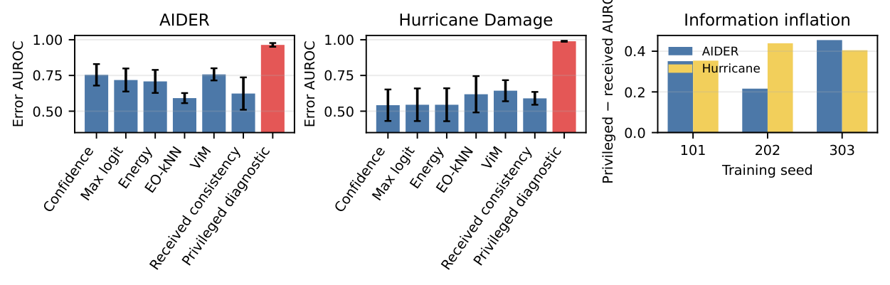
Reviewed Figure 1: vector output is correct and unclipped; x-axis labels are dense.
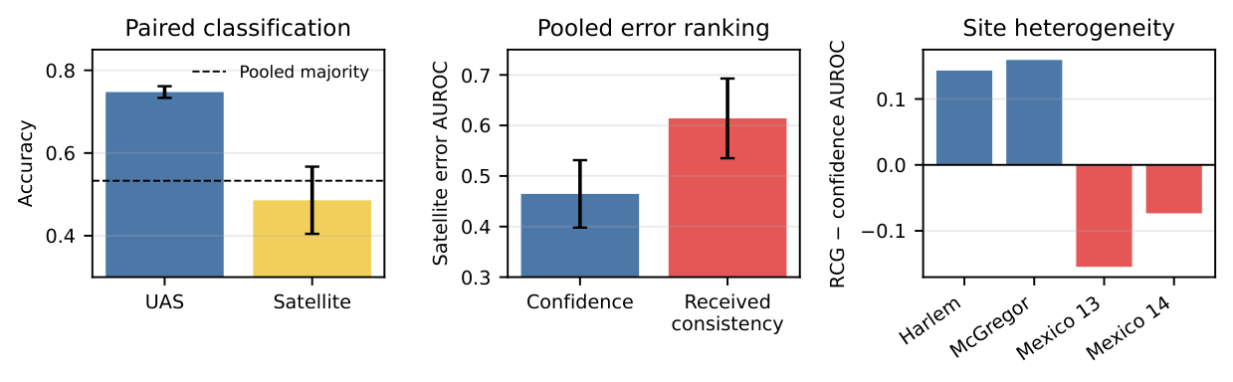
Reviewed Figure 2: pooled and site-level signs match the registered JSON.

