Round-2 Peer Review — When resolution consistency fails: an information-matched audit for disaster remote sensing
Reviewed file: studies/disaster-resolution-audit/paper/main.pdf
Prior report: Review_Report_IJRS_Resolution_Audit_Round1.docx
Date: 25 July 2026

1. Summary
Round-2 verdict: Minor revision; no substantive finding remains.
The corrected manuscript resolves all four substantive and all four minor Round-1 findings. Numerical results remain unchanged and pass the 12-check machine verification. The source archive is self-contained and clean-builds; the 374.7 MB reproducibility supplement contains code, checkpoints, results, logs and ledgers. The only remaining action is assigning a public repository/archive URL when the supplement is deposited externally.

2. Verification coverage
- Extracted and reviewed all 12 corrected PDF pages and current LaTeX.
- Re-ran all 12 quantitative checks successfully.
- Confirmed 13 citation keys, 13 BibTeX entries, no missing or uncited entry.
- Verified AIDER, Hurricane Damage and CRASAR DOI/version/licence statements against Zenodo, DataCite and fixed-revision dataset cards.
- Verified resolution-audit-source.zip: 22 files; fresh Tectonic build exit code 0.
- Verified resolution-audit-reproducibility.zip: 119 files and all manifest hashes.
- Re-inspected both figures: labels are sharp, unclipped and readable.

3. Round-1 finding disposition
S1 Release/accessibility contradiction
Evidence: The abstract now states that the protocol is developed rather than released. The data statement identifies resolution-audit-reproducibility.zip, and submission/verification.json confirms archive hashes and clean source build.
Round-2 status: RESOLVED for submission supplementation. A public DOI remains a deposit-time action.
S2 Dataset provenance and licensing
Evidence: The setup and data statement now provide three primary dataset citations, DOIs, versions/revisions, split counts and CC BY 4.0 licences.
Round-2 status: RESOLVED.
S3 Incomplete training protocol
Evidence: Section 4.2 now reports model revision, learning rate, weight decay, batch size, class-weight formula, transforms, interpolation, checkpoint selection, software versions and hardware.
Round-2 status: RESOLVED.
S4 Unsupported duplicate/spatial reversal attribution
Evidence: The abstract now attributes reversal only to hidden-reference access and site pooling; duplicate and overlap findings are described as requiring controls.
Round-2 status: RESOLVED without changing empirical claims.
M1 Undefined A1 and W11–W13 labels
Evidence: A new pre-specified-criteria subsection defines all four criteria.
Round-2 status: RESOLVED.
M2 Undefined acronyms and ViM symbols
Evidence: AUROC is expanded in the abstract, DPN-RS is expanded in related work, and W, b and the Moore–Penrose pseudoinverse are defined in the method.
Round-2 status: RESOLVED.
M3 Dense Figure 1 labels
Evidence: Figure 1 now uses abbreviated labels, larger vertical extent and panel letters; the caption defines MSP, Recv-JS and Priv-JS.
Round-2 status: RESOLVED.
M4 Non-self-contained IJRS source
Evidence: main.tex now uses local interact.cls and tfcad.bst. The packaged source clean-builds in an isolated temporary directory.
Round-2 status: RESOLVED.

4. Remaining minor action
P1 Public archive identifier. The supplementary archive is complete and verified locally, but the data statement accurately says that a public DOI will be added to the version of record. Add the repository URL and immutable archive DOI after external deposition; this requires the authors' release action.

5. Verified-consistent outcomes
- Privileged-information AUROC inflation remains 0.341 and 0.399.
- All six paired bootstrap intervals continue to exclude zero.
- The four-site measured-GSD sample remains 1,441 pairs in 708 blocks.
- W11 passes; W12 and W13 remain failed and disclosed.
- Abstract, prose, tables and figures agree with registered JSON.
- No publication-value change was introduced by the revision.

6. Acceptance assessment
Current IJRS likelihood band: Moderate. The paper has a distinct failure-characterisation contribution, multi-seed and multi-event evidence, current matched baselines, complete local reproducibility, and no remaining substantive review finding. External deposition and editorial assessment remain.

7. Verdict
Verdict: Minor revision.
Required before final public version: deposit the verified reproducibility archive and replace the future DOI statement with resolving repository/archive links.
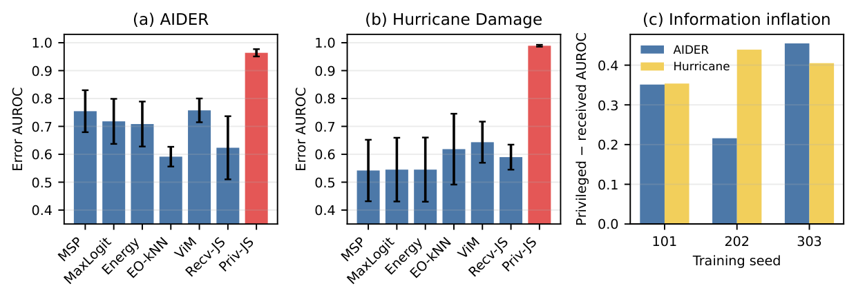
Corrected Figure 1: abbreviated labels and panel identifiers are legible.

