Final Round-3 Peer Review — When resolution consistency fails: an information-matched audit for disaster remote sensing
Reviewed file: studies/disaster-resolution-audit/paper/main.pdf
Public release: https://github.com/akssha74/rcg-tt/releases/tag/v2.0.2
Zenodo: https://doi.org/10.5281/zenodo.21544245
Date: 25 July 2026

1. Summary
Final review verdict: Minor revision; no substantive validity finding remains.
The final manuscript reports a descriptive oracle–received protocol gap, not a causal estimate. It preserves the original mean-based W13 pass and separates the failed all-seed sensitivity. It also supplies anchor-matched analysis, portable per-example arrays, acquisition-selection counts, joint UAS/satellite overlap clustering, fixed GSD metadata, and current baseline context.
All arithmetic, raw-array recomputation, archive manifests, clean source build, GitHub assets and Zenodo v2.0.2 record verified. Remaining items concern internal readiness metadata and minor typesetting.

2. Verification coverage
- Extracted and read all 14 final PDF pages and current LaTeX source.
- Recomputed 13 registered headline checks; all passed.
- Recomputed synthetic and paired AUROCs, ViM-minus-kNN intervals, prediction transitions and acquisition sensitivities from portable per-example arrays.
- Verified W11 pass, W12 failure, preregistered mean-based W13 pass, and failed post-hoc all-seed W13 sensitivity.
- Verified 16 citation keys against 16 cited BibTeX entries.
- Verified source archive clean build, 156-file reproducibility manifest, and non-mutating reproduction workflow.
- Verified GitHub v2.0.2 assets and Zenodo record 10.5281/zenodo.21544245 under concept DOI 10.5281/zenodo.21510152.
- Inspected both vector figures at print size; no clipping or unreadable labels.

3. Round-2 and independent-review disposition
- W13 adjudication: corrected. Mean coverage error and mean selective risk favour received consistency; seed 202 remains a failed robustness sensitivity.
- Central attribution: corrected. The manuscript calls the main quantity an oracle–received protocol gap and states that degradation direction remains different.
- Mechanism sensitivity: added. The same s=8 anchor and three comparisons retain gaps of 0.336 on AIDER and 0.398 on Hurricane.
- Raw auditability: resolved with per-example labels, predictions, scores, transitions, acquisition IDs and overlap-cluster IDs.
- Portability: resolved with normalized paths, pinned dependencies, local IJRS assets, imported-source generation and a tested reproduction command.
- Measured-GSD dependence: strengthened. The paper reports selection counts and the post-hoc finding of only 2/1/1/1 effective joint-overlap clusters.
- Baseline context: strengthened with TARDIS and EarthShift and an explicit source-only information-budget rationale.
- Public artifacts: resolved by GitHub v2.0.2 and immutable Zenodo v2.0.2.

4. Novelty and scope assessment
The contribution is an integrated audit and counterexample rather than a new uncertainty primitive. The paper now states that its literature set does not establish field-wide prevalence of the exact failure mode. This scope is consistent with the evidence. The large six-run oracle–received gap and the measured-GSD acquisition sign reversal remain the main empirical delta.
Generality is bounded to one backbone, bicubic synthetic degradation, three geographies and two hurricane events. The limitations section states these boundaries and does not claim event-general or causal GSD inference.

5. Substantive findings
None.

6. Minor and presentation findings
M1 Internal readiness files remain stale.
Evidence: reviews/greatness-verdict.json and reviews/readiness.json still contain uncompleted adjudication fields, so study validation does not yet pass.
Analysis: This does not alter the manuscript results or public artifact hashes, but the archived workflow state is inconsistent with a final submission package.
Action: Record the latest independent reviews, synchronize the two JSON verdict files, and rerun strict validation. Do not mark scientific greatness unless the independent greatness review supports it.
M2 A small typesetting warning remains.
Evidence: The final Tectonic log reports a 2.27 pt overfull line in the GSD metadata hash paragraph and underfull bibliography/data-source lines.
Analysis: Rendered content is visible and unclipped; this is a source-layout warning.
Action: Move the long revision/hash strings to a compact appendix table or allow additional line breaking before final typesetting.

7. Disclosed design choices (not defects)
- The main gap remains descriptive because finer and coarser degradation directions differ.
- Only exact hashes and literal crop intersection are closed; near-duplicate and spatial dependence limits are stated.
- Same-label pair selection and all exclusion counts are reported.
- Joint-overlap clustering is post hoc and degenerates within three acquisitions; no site-level inference is claimed.
- The effective event count is two and event-associated differences are descriptive.
- The study does not claim that the audited mistake is prevalent in published EO work.

8. Verified-consistent outcomes
- Reference-dependent minus received-image gaps: 0.341 AIDER, 0.399 Hurricane.
- Anchor-matched post-hoc gaps: 0.336 AIDER, 0.398 Hurricane.
- All six paired intervals for both gap formulations are positive.
- AIDER/Hurricane exact retained totals remain 6,429/9,994.
- Measured-GSD sample remains 1,441 pairs across four acquisitions.
- W11 passes; W12 fails; mean-based W13 passes; all-seed sensitivity fails.
- Tables, figures, abstract and registered JSON agree after rounding.
- Public GitHub asset digests match the local source, paper and reproducibility archives.

9. Acceptance assessment
Current IJRS likelihood band: Moderate. The study is internally consistent, publicly reproducible, transparent about negative results, and within journal scope. The main limiting factor is significance: the paper documents a bounded counterexample and audit protocol rather than field-wide prevalence or a new reliability method. Editorial and reviewer assessment remains decisive.

10. Verdict
Verdict: Minor revision.
Required before submission: reconcile the archived readiness/verdict state with the latest independent reviews and rerun strict validation. Typesetting cleanup is recommended. No additional numerical experiment is required to support the manuscript's present bounded claims.
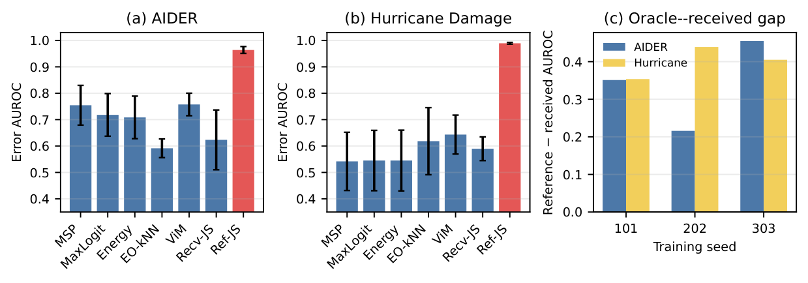
Final Figure 1: labels and uncertainty bars are legible.
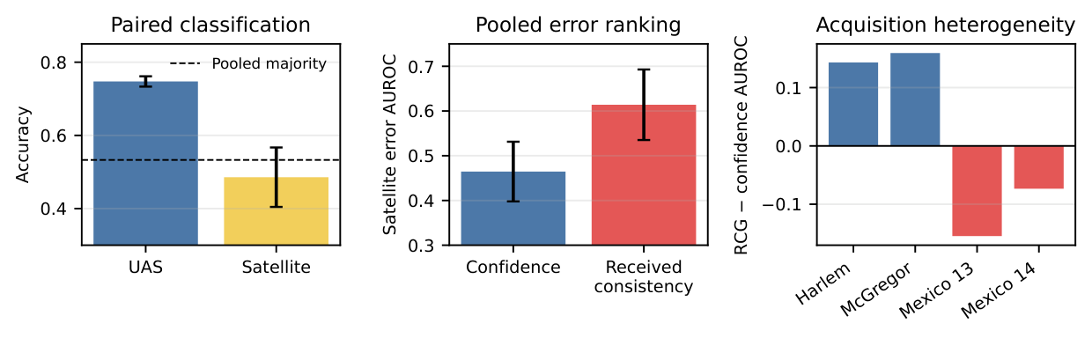
Final Figure 2: pooled and acquisition-level signs match registered arrays.

