**AWS Account Signup:**

1. Login to <https://aws.amazon.com/>
2. Right hand size corner you will see Create **an AWS Account** click on it.
3. Sign up for AWS account, you required following details
   1. Root user email address
   2. AWS account name & **Verify Email Address** (verify code from your mail id)
4. Create a Root user Password
5. Contact Information:
   1. Choose: personal- for your own project
   2. Full Name
   3. Phone Number
   4. Choose Country
   5. Residential Address
   6. Click on Continue
6. Billing Information:
   1. Fill your Credit/ Debit card details Like card number, expire MM/YY, CVV, etc
   2. They will be debit Rs. 2/- from account
   3. After verification, they will be refund Rs.2/- back.
7. Do you have PAN: select **No & Verify**
8. Enter OTP received from Register Mobile Number.
9. Confirm your Identity
   1. User Name:
   2. Primary purpose of account registration : Academic
   3. Ownership type: individual
   4. Mandatory you need to provide : Government Identity details (like PAN/Aadhaar/Driving Licenses/ etc)
   5. Click on contine..
10. Final verification with Mobile number OTP with security check (captcha) & Verify + contine
11. Now you will land over to **Select a support Plan**
    1. **Basic –support : Free 🡪 Choose this one**
    2. Developer support- 29$/month
    3. Business support - 100$/month
12. Now click on complete sign up page.

Now you will receive **Congratulation Message…**

1. <https://aws.amazon.com/> 🡪 goto Sign In
2. Select root user & root user email id address (Which is provided by you) & click next
3. Enter password which is given early session created by you
4. Finally you can see Console…

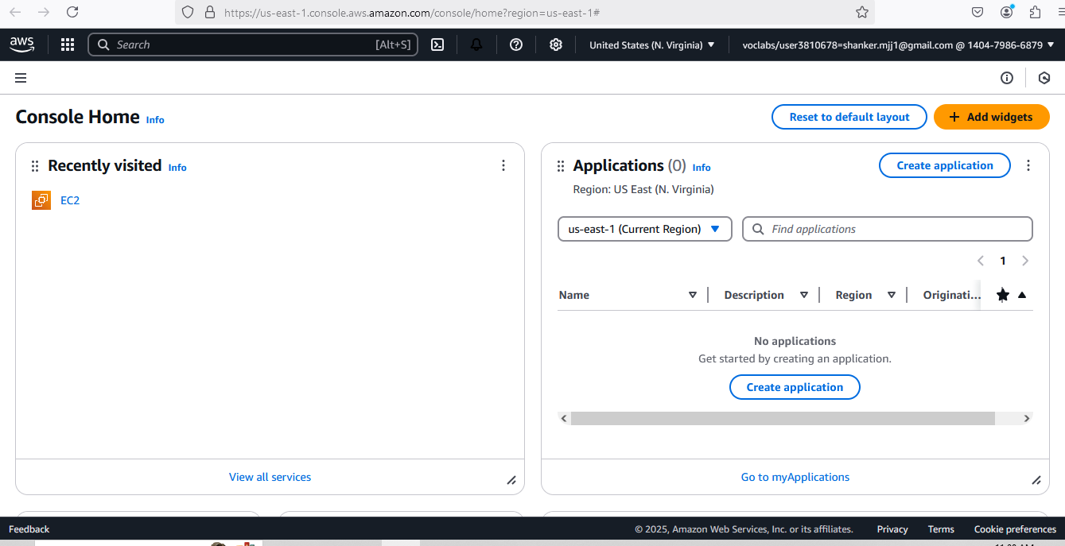

| **Experiment No-1**  Establish an AWS account. Use the AWS Management Console to launch an EC2 instance and connect to it. |
| --- |

**Step1 :** Login into AWS

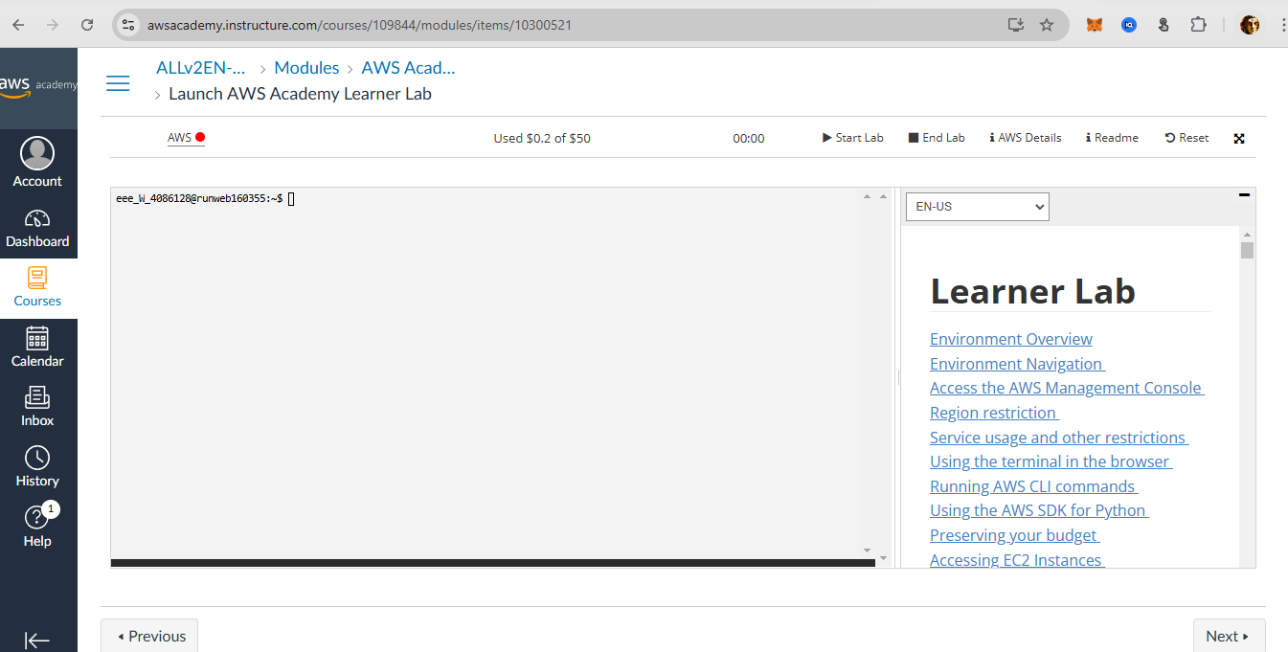

**Step2:** Activate AWS (Green Color) → Click **Start Lab → click AWS search EC2 in** search Bar

1. In search bar type EC2 {**Elastic Compute cloud**}

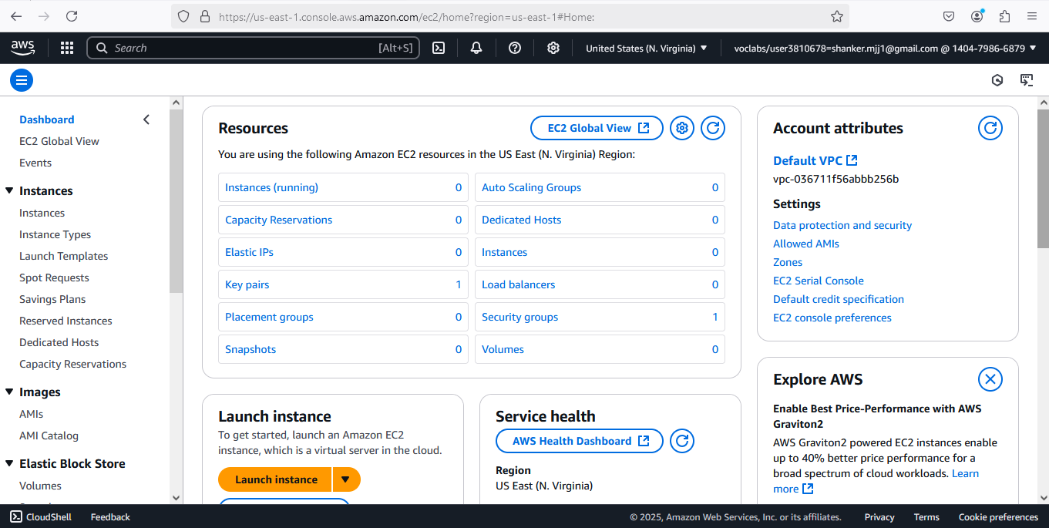

1. You will get EC2 Dashboard contains resources
   1. Instances (choose)
   2. Elastics IPs
   3. Key Pairs
   4. Snapshot
2. First Launch Instance

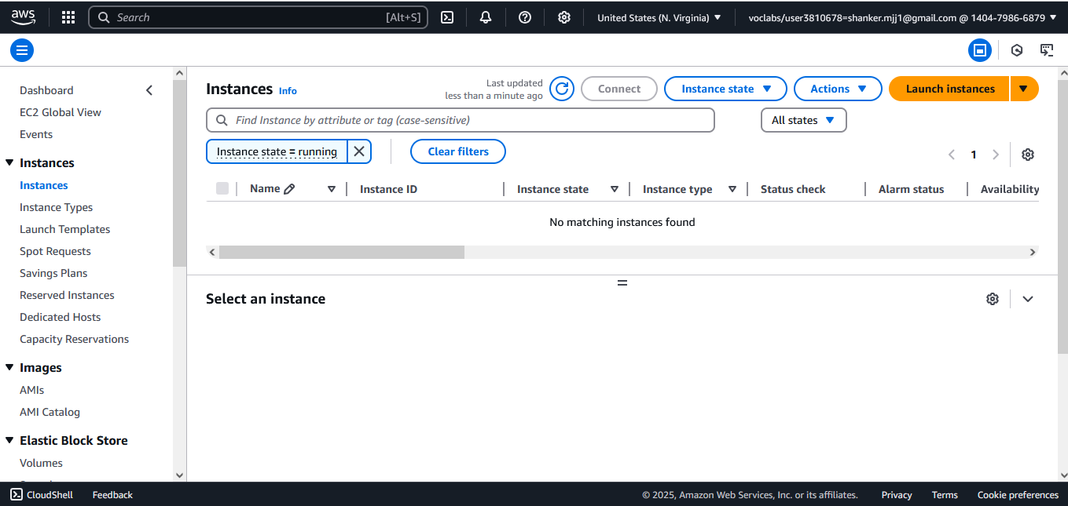

1. EC2 allows you to create virtual machines, or instances, that run on the AWS Cloud
   1. Name and tags : Rollno_EC2
   2. Application and OS Images (Amazon Machine Image) : you can choose Ubuntu /Windows
   3. Amazon Machine Image (AMI) : choose **Free tier eligible** like Amazon Linux 2023 AMI
      1. Description: explains about machine advantage
      2. Architecture: 64 Bit

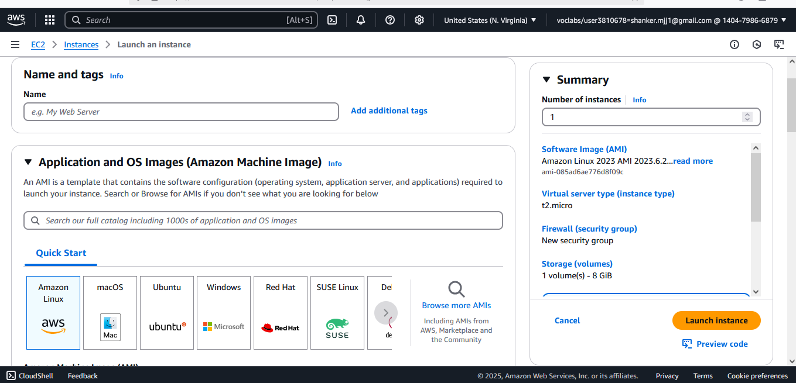

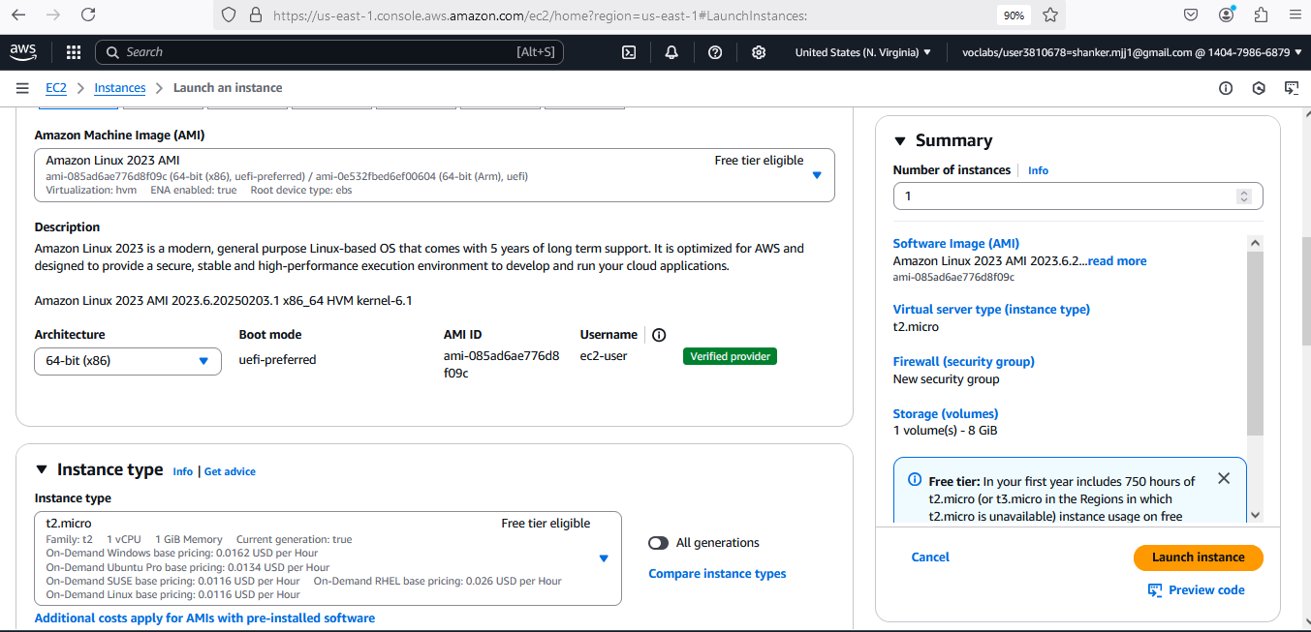

1. Instance type: t2.micro (**Free tier eligible**)
2. Key pair (login) : Create & Download {Everyone have Unique} & Download
   1. RSA (choose)
   2. ED25519

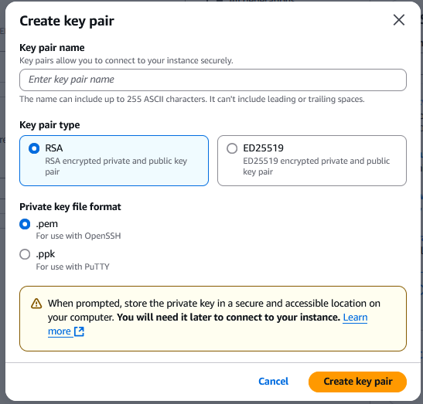

PEM: (Choose)

PPK:

1. **Network settings**  : click checkbox **Allow SSH traffic from** & Choose **Anywhere to access** system

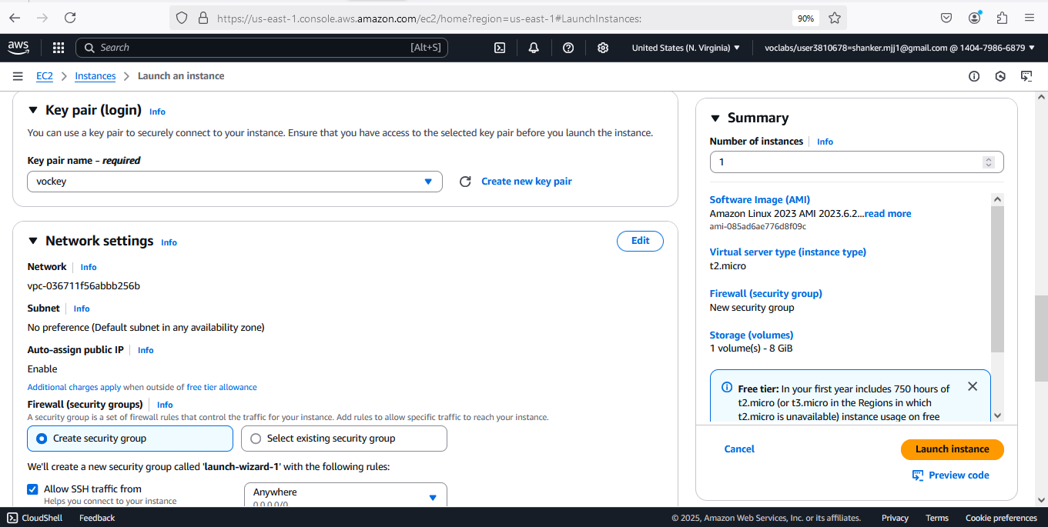

1. Configure storage:
2. In Summary choose 2 Instances

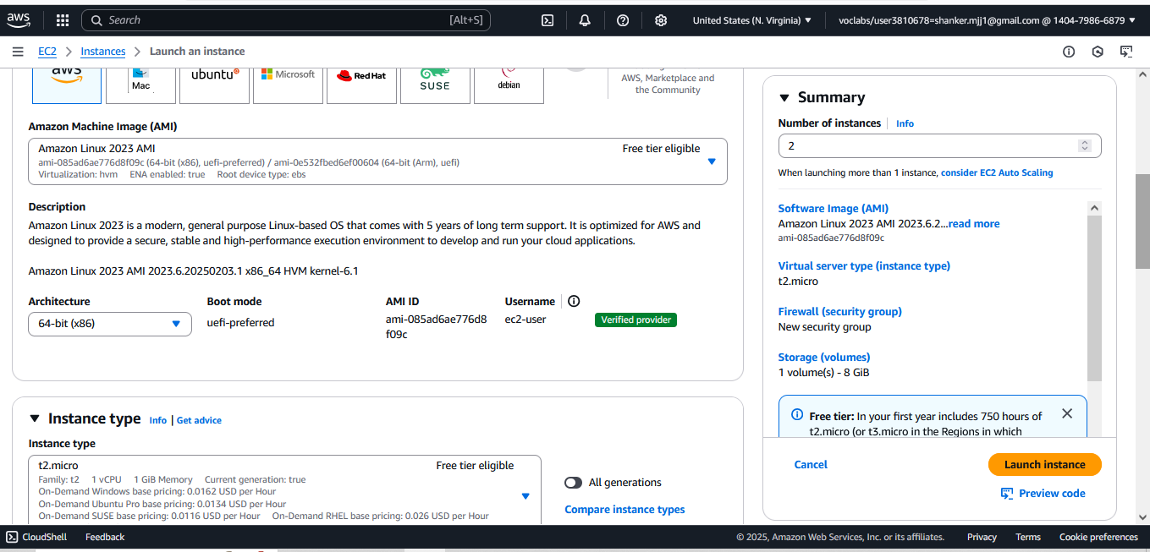

1. Click Launch Instance..
2. GO Back & check Instance is create by 2/2 steps execution 1. For Software check & 2nd for Hardware check
3. Select the Instance Created & Click on **Connect**

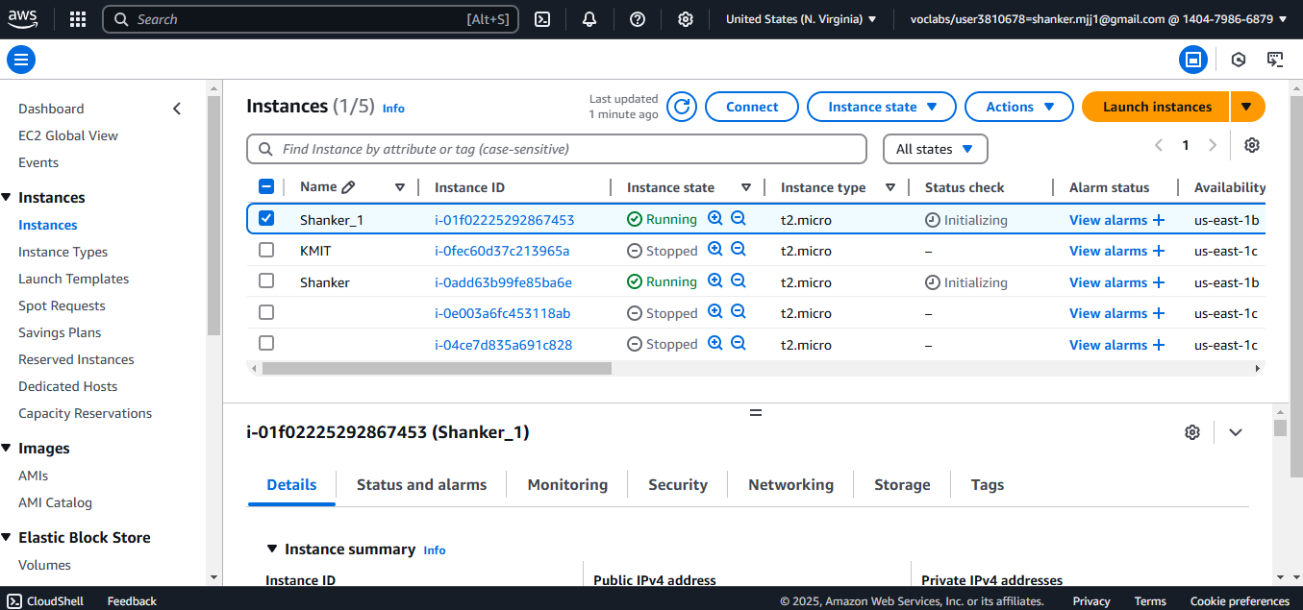

1. After connecting UI Look Like Below

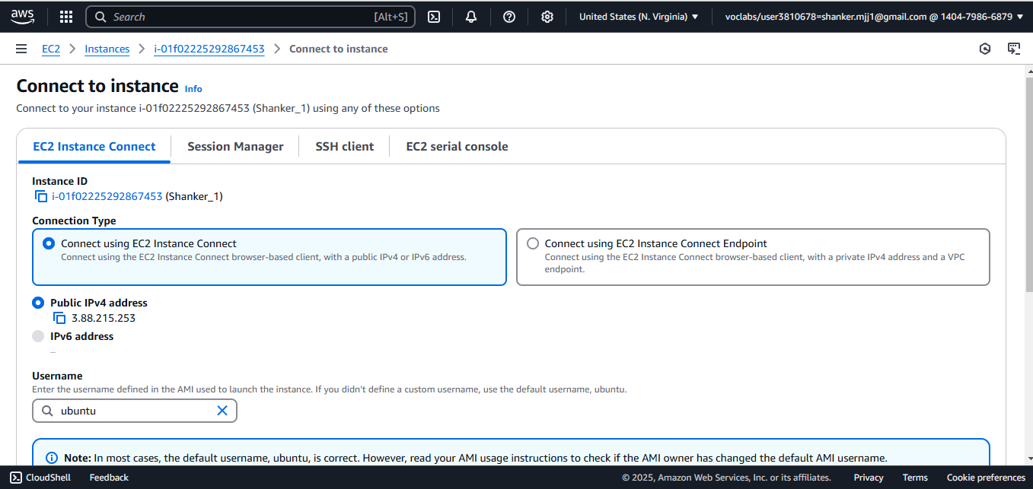

1. First connect with **EC2 Instance Connect** **Method-1**
   1. click on connect
   2. UI Looks Like Below

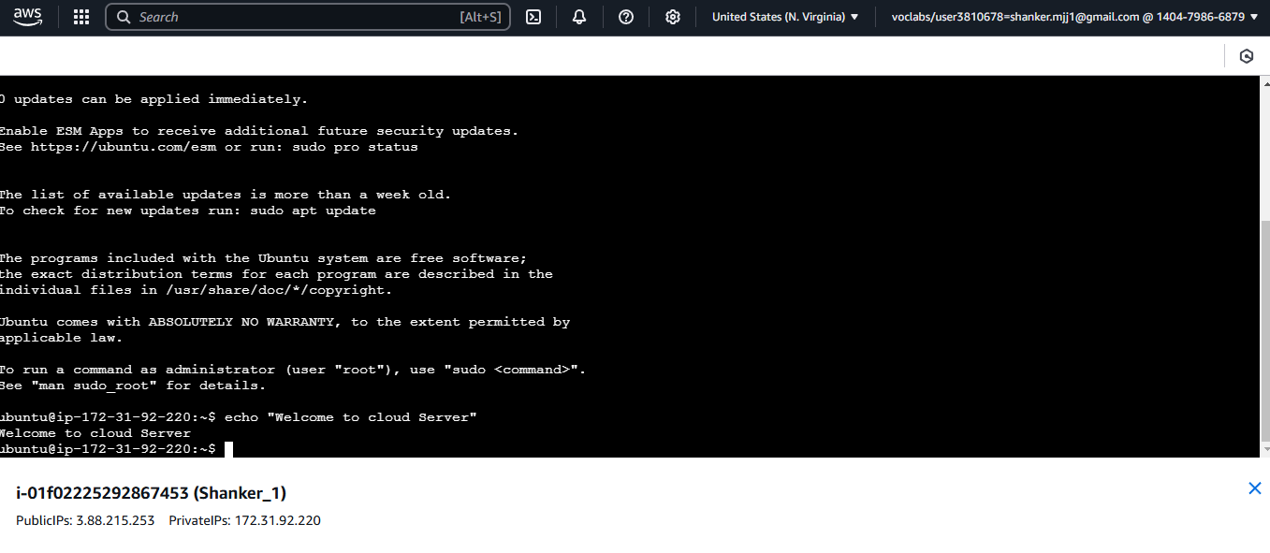

* 1. perform unix commands like create directory with your Roll no, chmod, ls, vi, install java package & run the java code

**Method 2: Connect with SSH**

**CONNECT Putty with EC2 Machine using PEM key pair..**

1. Open putty key generation & load your Private PEM file & Save the Private Key
   1. convert PEM File into PPK (Putty private key)
   2. 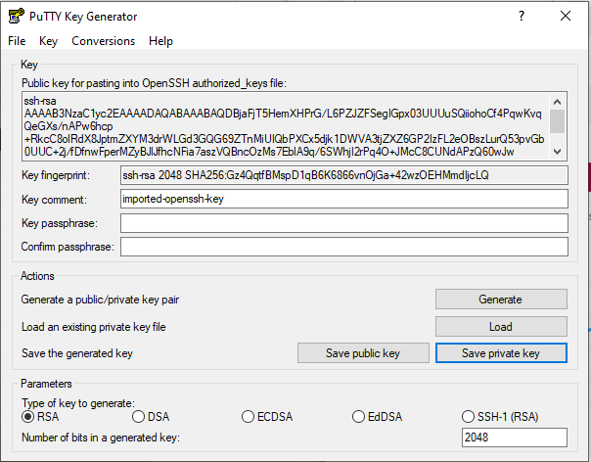
   3. No
2. Now open Putty
   1. Now copy publick IPV4 link from SSH **Connect to your instance using its Public DNS**:
   2. paste link in putty Host Name (ec2-3-88-215-253.compute-1.amazonaws.com) port 22
   3. In connection click Data & type ubuntu in Auto-login username
   4. Save the Session with ur Rollno

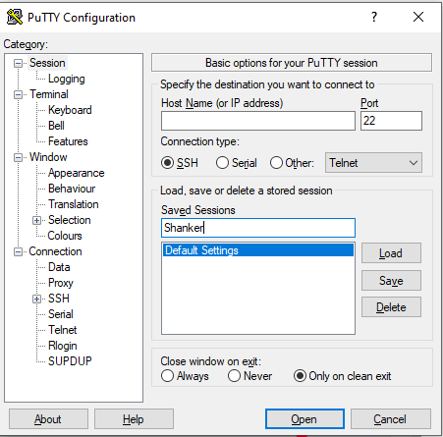

* 1. Load PPK File connection → SSH → Auth → credentials → insert PPK File → click on open

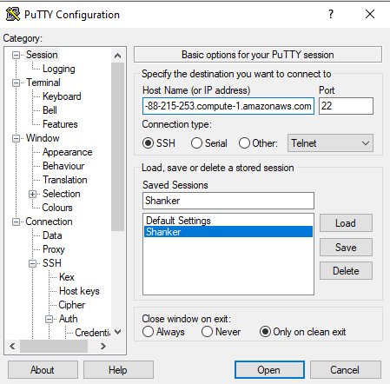

* 1. Accept the pop-up

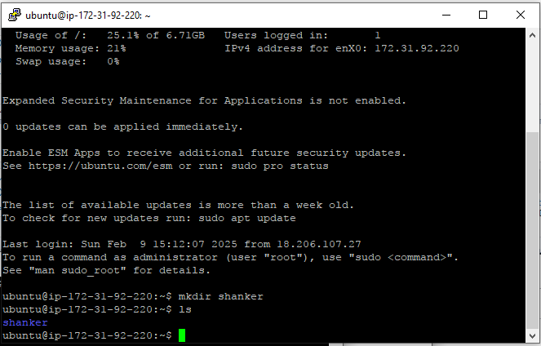

* 1. Same console in server terminal as to visible

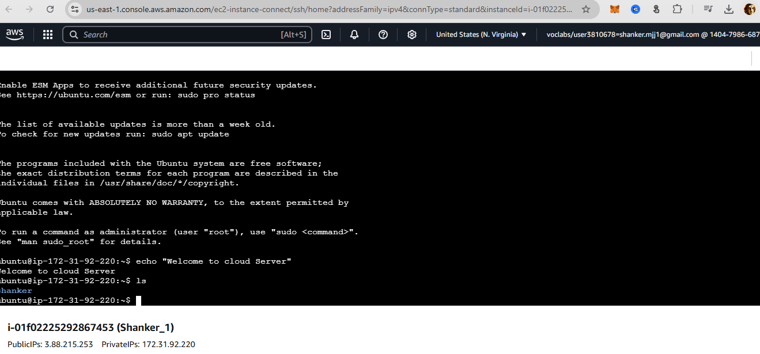

https://awsacademy.instructure.com/