**AWS Lambda:**

AWS Lambda is a serverless, event-driven compute service that allows you to run code without provisioning or managing servers, paying only for the compute time you consume

Advantage:

1. No Server setup
2. No start or stop
3. No Additional Cost
4. Serverless

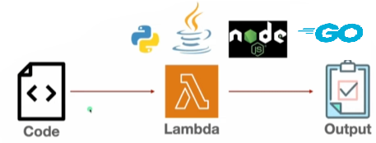

1. **Login** into AWS Account then **Start Lab** Launch **AWS Console Home**
2. In console Home **search** **Lambda** (Scalable storage in the cloud)
3. Click Lambda

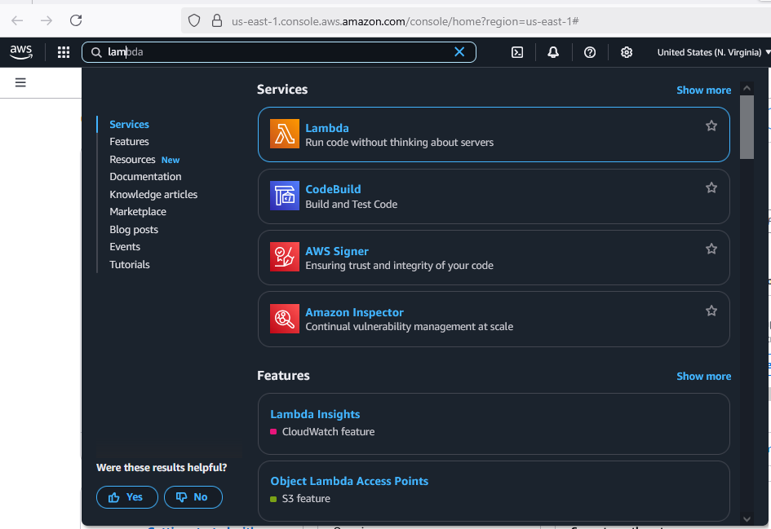

Step 1: Click on Create a Function

1. Select Author from Scratch

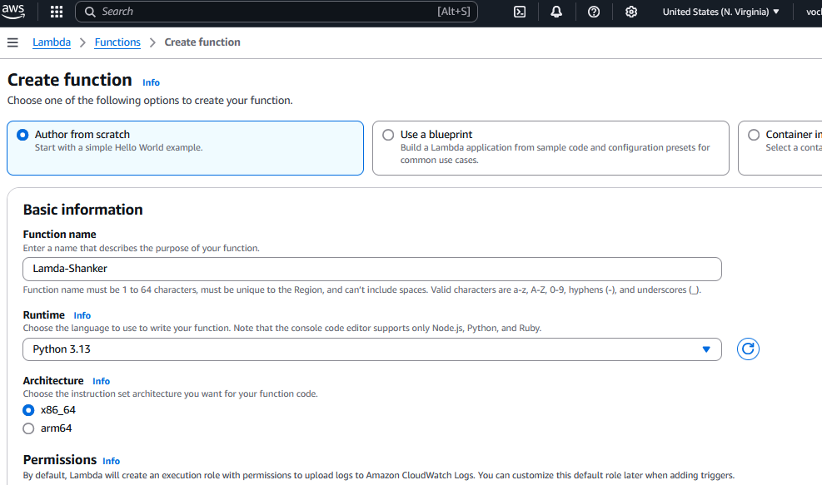

1. Basic Information
   1. Function Name: Lamda-Rollno
   2. Runtime: Select Python
   3. Architecture : x64
   4. Change default execution role:
      1. Select: Use an existing role
      2. Existing role : Choose Lab Role
   5. Additional Configurations : default
2. Click Create Function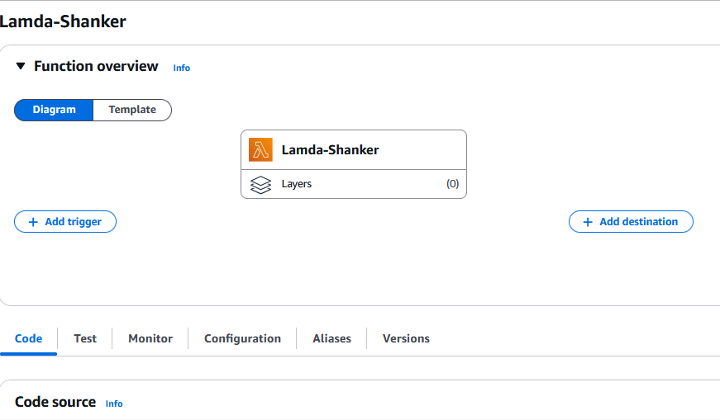

Step 2: Scroll down you will find code

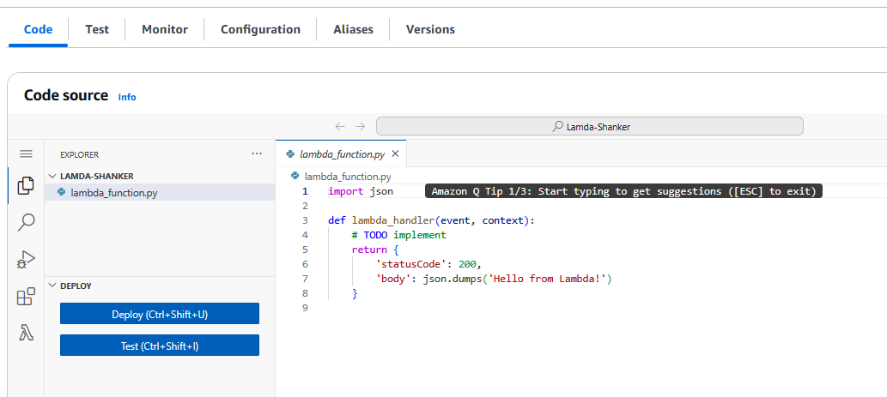

1. Line no 2: Add print statement
   1. print(“Hello Welcome to Lamda Environment”);
   2. print(“My Roll No is _____”);
2. Save the file ctrl+ s

Step 3: Click on Test

1. Test event action : Create new event
2. Event name : Demo-Rollno-event
3. Event sharing setting :Private
4. Template - *optional :* hello world
5. Event JSON

| {  "": ""  } |
| --- |

1. Click on save
2. Click on Test & you will get output below

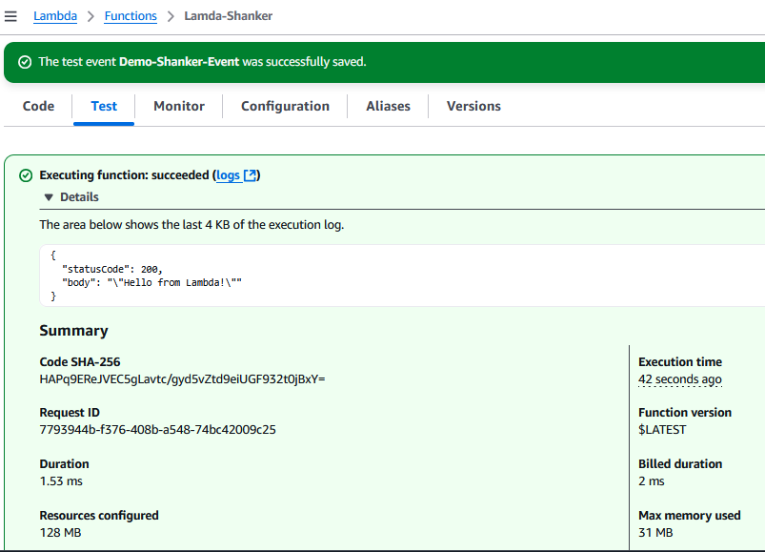

PART 2: Real Time Project Deployment with DynamoDB (Only AWS account can able to do)

Step 1: Upload the Project

1. In local Machine: Open Your VS code IDE
2. Create a Folder Name Called Project_Rollno
3. cd Project_Rollno
4. create file called requirement.txt

| requests==2.26.0  boto3==1.20.19 |
| --- |

1. pip install -r requirement.txt

Step 2: Create DynamoDB

1. In search bar search [**DynamoDB**](https://us-east-1.console.aws.amazon.com/dynamodbv2/home?region=us-east-1)
2. Click Create Table

## **Table details**

Table name: studentData

Partition key : studentid (Primary Key)

Sort key - *optional :*

## **Table settings**

default

* 1. Create Table

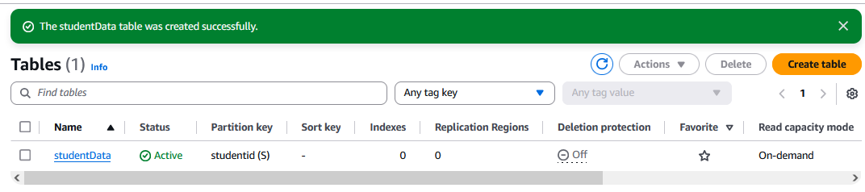

Step 3: goto → searchbar & search Lambda & click it

Select Author from Scratch

1. Create Function:

## **Basic information**

* + 1. Function name : getStudent
    2. Runtime : python 3.13
    3. Architecture : x86_64
  1. Change default execution role:
     1. Use an existing role
     2. Role: Lab Role
     3. Click on create

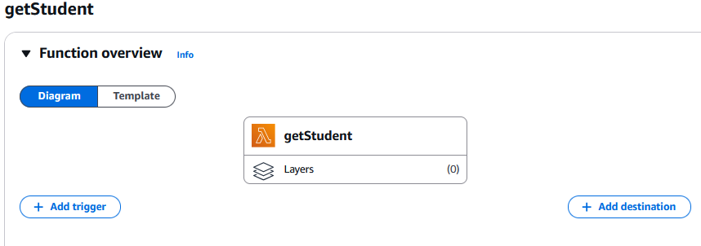

Step 4: goto→ code

1. Paste the below code in lambda_function.py

| import json  import boto3  def lambda_handler(event, context):  # Initialize a DynamoDB resource object for the specified region  dynamodb = boto3.resource('dynamodb', region_name='us-east-2')  # Select the DynamoDB table named 'studentData'  table = dynamodb.Table('studentData')  # Scan the table to retrieve all items  response = table.scan()  data = response['Items']  # If there are more items to scan, continue scanning until all items are retrieved  while 'LastEvaluatedKey' in response:  response = table.scan(ExclusiveStartKey=response['LastEvaluatedKey'])  data.extend(response['Items'])  # Return the retrieved data  return data |
| --- |

1. Right side you will have drop down button (Select old version);
   1. Click on Deploy

https://youtu.be/pK52mfm69i0