|  |
| --- |
| **Experiment: 2**  Create your First AWS S3 Bucket and Upload Content to Bucket and Manage their Access and Create Static Website using AWS S3 |

1. **Login** into AWS Account then **Start Lab** Launch **AWS Console Home**
2. In console Home **search** **S3** (Scalable storage in the cloud)

**Advantage: Store and retrieve any amount of data from anywhere**

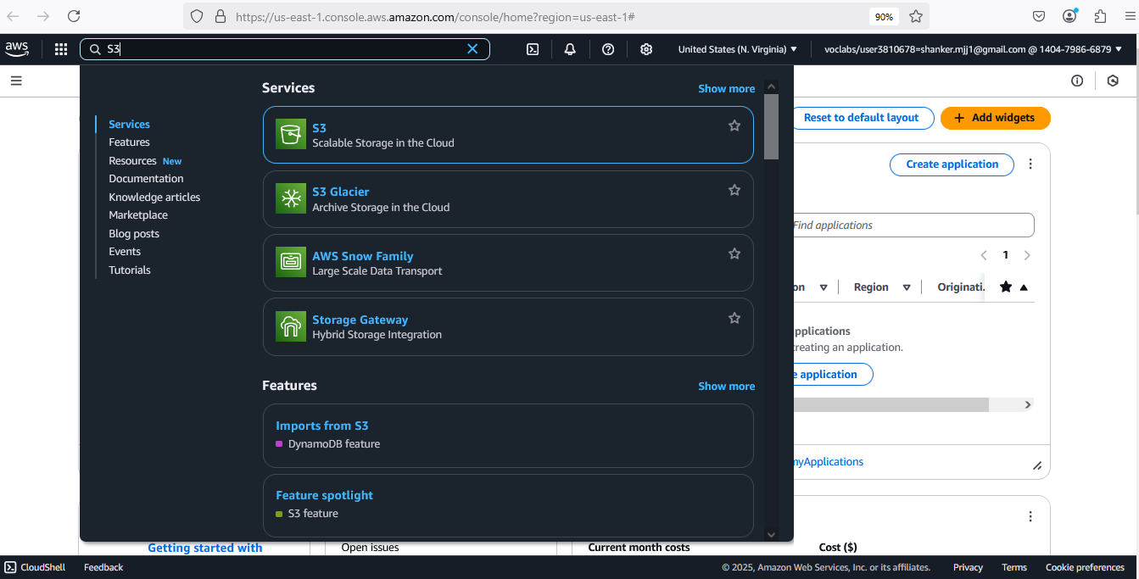

1. It will navigates to below page, then click **Create a bucket**

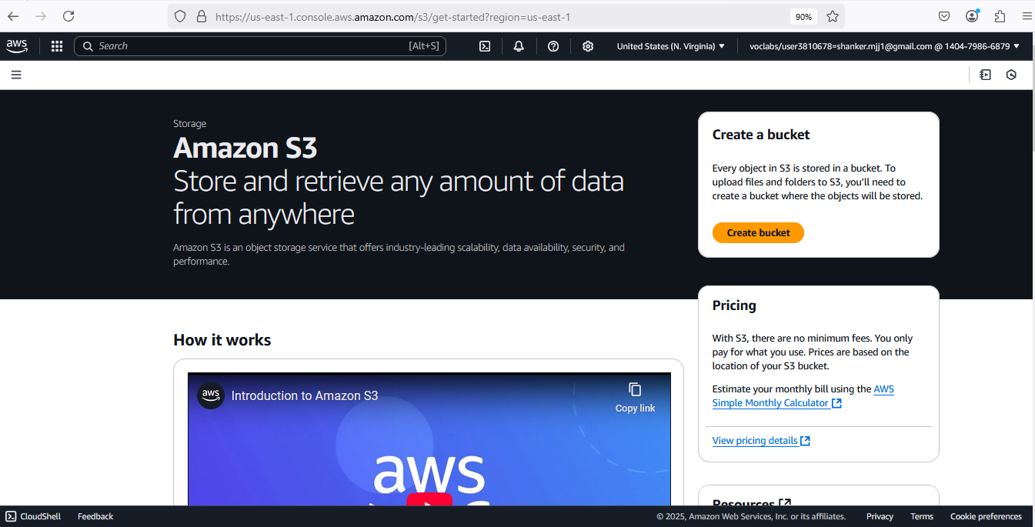

1. **Create Bucket:**
   1. General configuration
      1. **Bucket Name:** RollNumber-S3
      2. Note: see rules to create bucket Name like no capitals, no “_” , no space etc
   2. Object Ownership
      1. Choose **Object Ownership**
   3. **Block Public Access settings for this bucket** (Keep default)
   4. **Bucket Versioning** : click to **enable**
   5. **Tags - optional (0)** (Keep default)
   6. **Default encryption**
      1. **Encryption type :** Server-side encryption with Amazon S3 managed keys (SSE-S3)
      2. **Bucket Key :** Enable
   7. **Advanced settings** (Keep default)
   8. **Finally Click on Create Bucket**

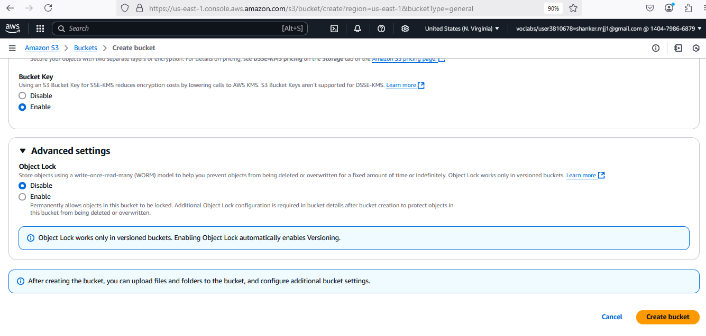

1. **S3 Bucket Created Successfully with below Image**

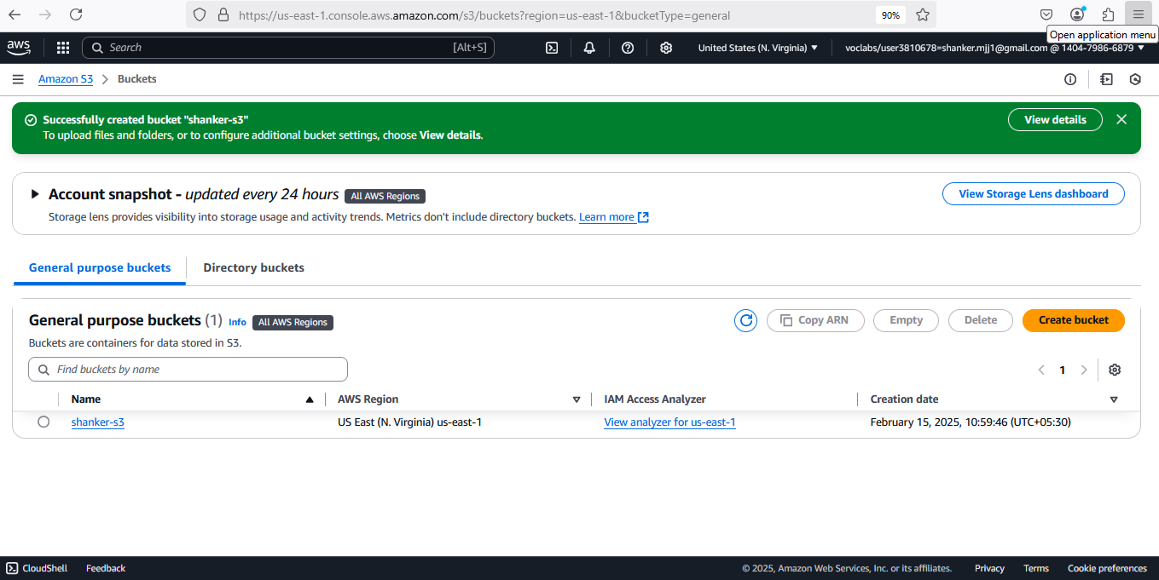

1. **Click on view Details (Green Color above picture)**

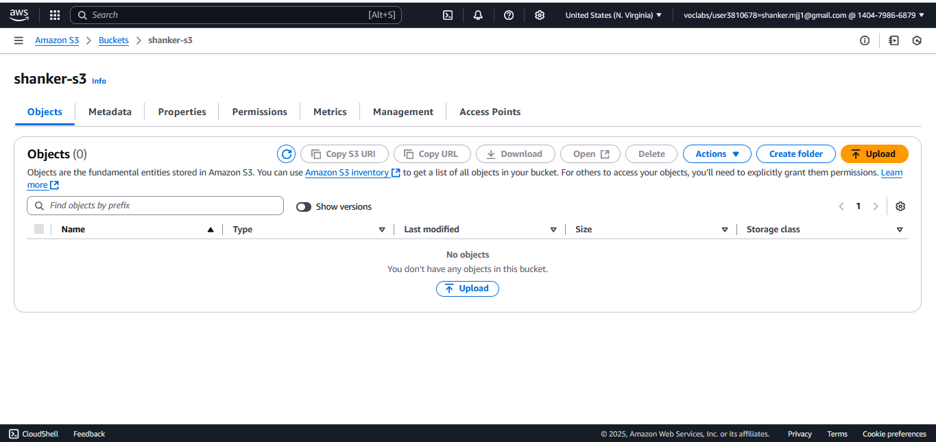

1. **Click on buckets 🡪 click on bucket Name & Upload the File**

**Project TASK:**

* 1. While Uploading Files, You need to create a React JS File
  2. **File contains Basic Details like**
     1. **Text Box:** You need to Enter your **name**
     2. **Button:** While clicking this button, you need to display message as

**“Hi ‘Name!!!’ Welcome to S3 Bucket”**

|  |  |
| --- | --- |
| **Step 1:** npx create-react-app shanker-app  **Step 2:** cd shanker-app  **Step 3:** Create a component called welcome.js & Paste Below file..   |  | | --- | | import React, { useState } from 'react';  const WelcomeMessage = () => {    const [name, setName] = useState('Shanker'); // Pre-filled name    const [showMessage, setShowMessage] = useState(false);    const handleButtonClick = () => {      setShowMessage(true);    };    return (      <div>        <input          type="text"          value={name}          onChange={(e) => setName(e.target.value)}          placeholder="Enter your name"        />        <button onClick={handleButtonClick}>Show Welcome Message</button>        {showMessage && <p>Hi "{name}!!!" Welcome to S3 bucket</p>}      </div>    );  };  export default WelcomeMessage; |   **Step 4:** Import WelcomeMessage.js file in App.js  import WelcomeUser from './welcome'  return (      <div className="App">        <WelcomeUser/>        </div>    );  Step 5: run the code **npm start**    **Step 6:** Build the app  npm run build |

1. **Click on property tab🡪** go to bottom you will find **Static website hosting** click on **Edit**  click & **enable**

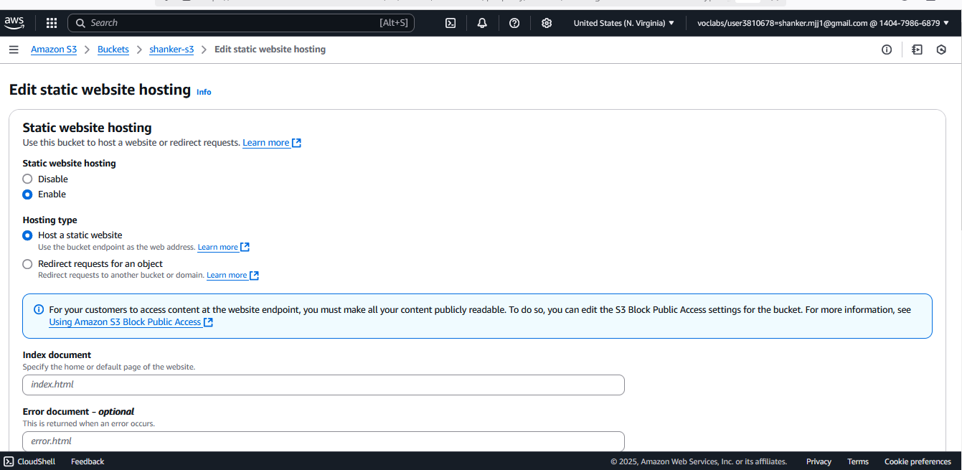

**Static website hosting**

* 1. **Static website hosting :** enable
  2. **Hosting type :** Host a static website
  3. **Index document :** index.html
  4. **Remaining :** default & click save change

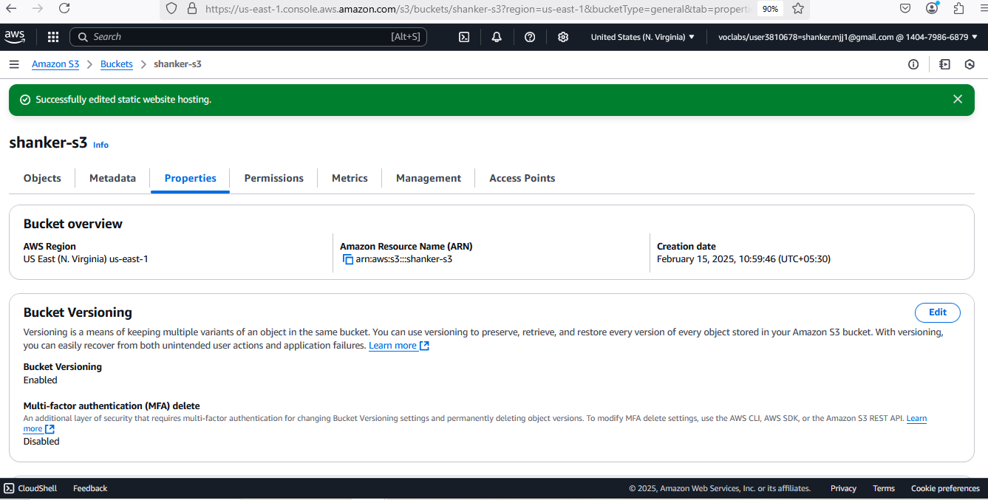

1. **Now click on Permissions:**
   1. **Block public access (bucket settings) : enable all permission (default is blocking all)**
   2. **Click edit and disable all 🡪 save changes**

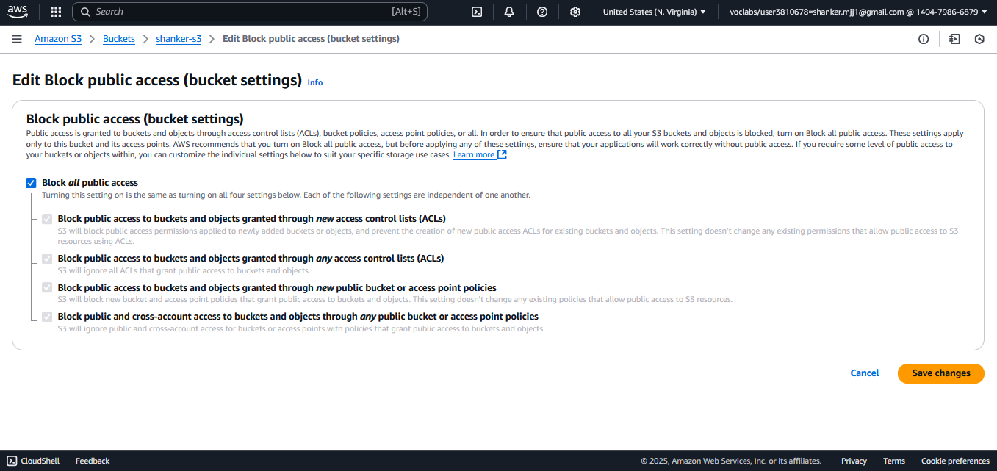

* 1. **It will ask confirmation type confirm & click OK**

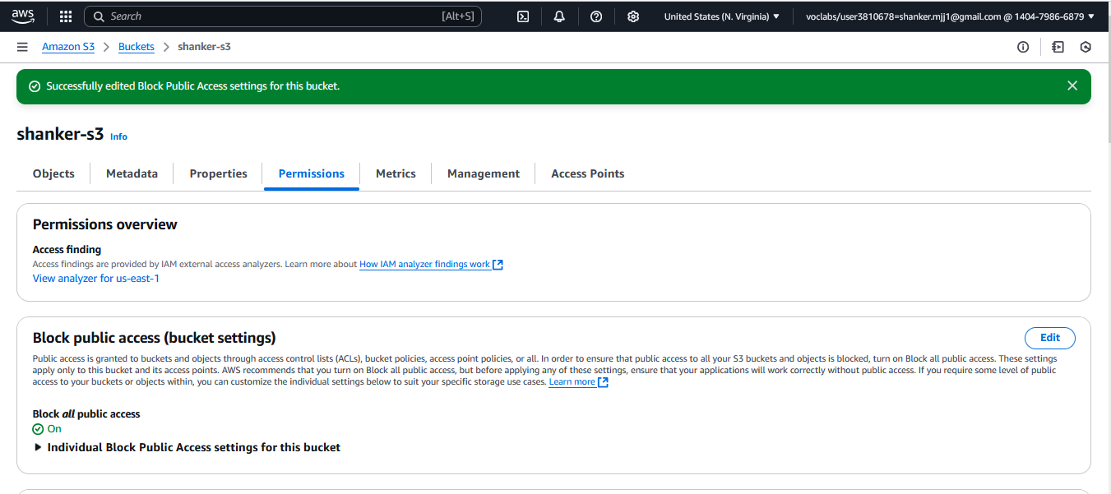

1. Scroll down, you will find **Bucket Policy: click on edit**

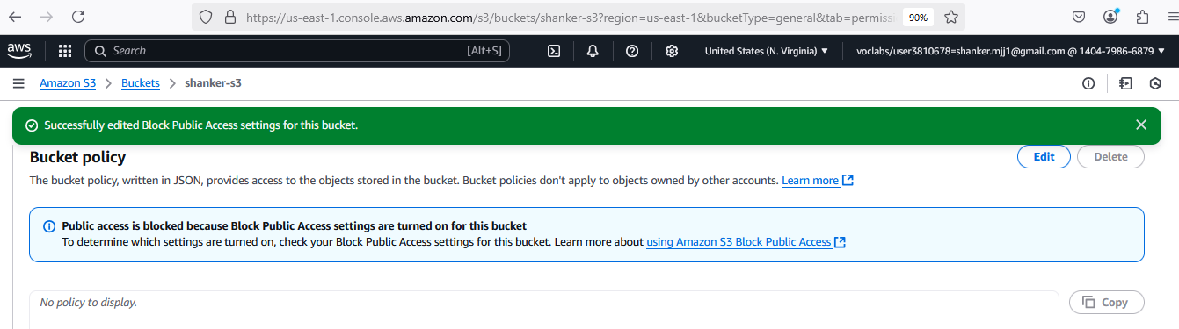

1. **You will navigate below Image**

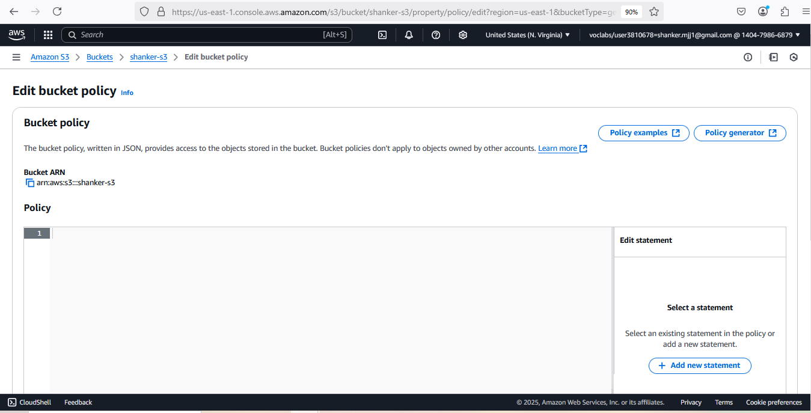

1. Now click **on Policy generator**  now you will navigate to other page

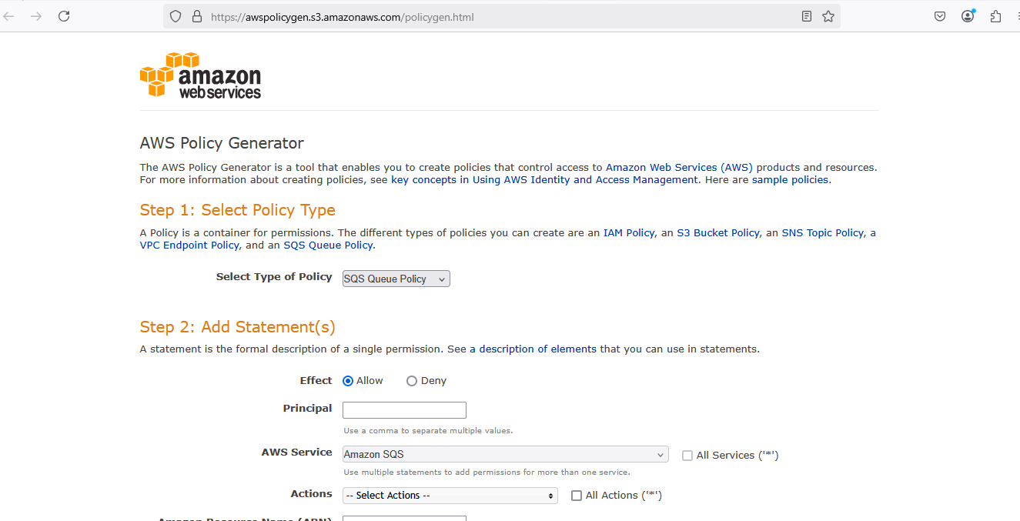

**AWS Policy Generator**

1. **Step 1: Select Policy Type :** select **S3 Bucket policy**
2. **Step 2: Add Statement(s)**
   1. **Principal add : \***
   2. **Actions :** Get Object (select)
   3. **Amazon Resource Name (ARN) :** go back previous tab &Copy ARN **paste ARN** Example: **arn:aws:s3:::shanker-s3**

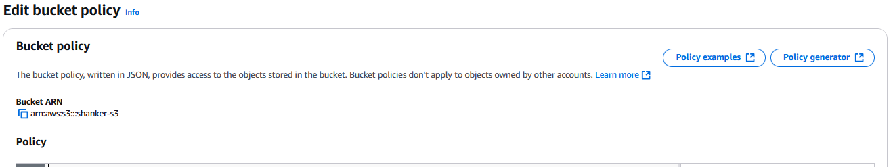

* 1. **Click Add statement**

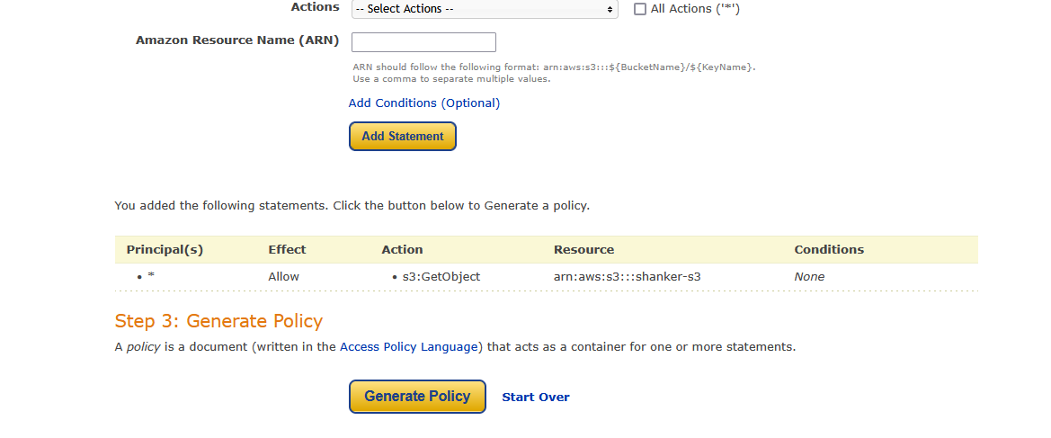

* 1. **Click generate policy : copy the JSON Format (sample shown below)**

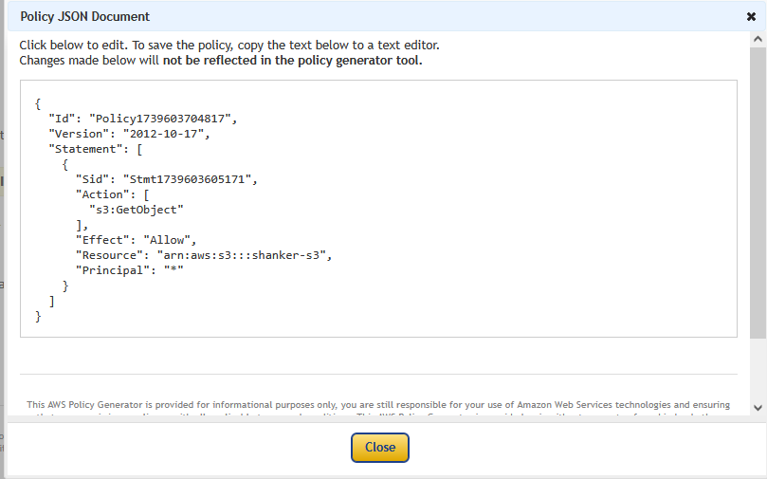

* 1. **Now copied JSON Format as to paste in policy**

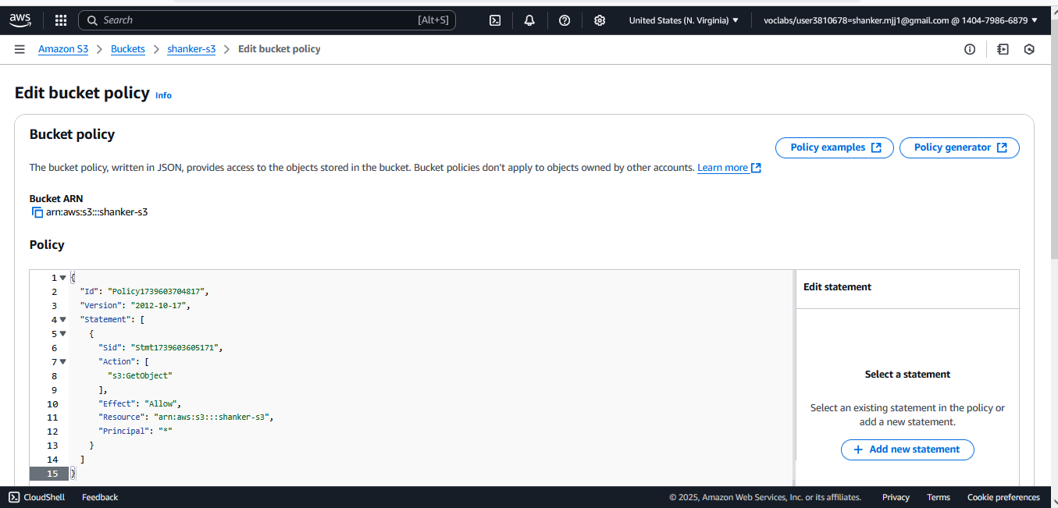

* 1. **Line no 11 Resource:** add **/\*** { otherwise it will not work}

**Eg: "Resource": "arn:aws:s3:::shanker-s3/*",**

* 1. **Simply click & save the changes**

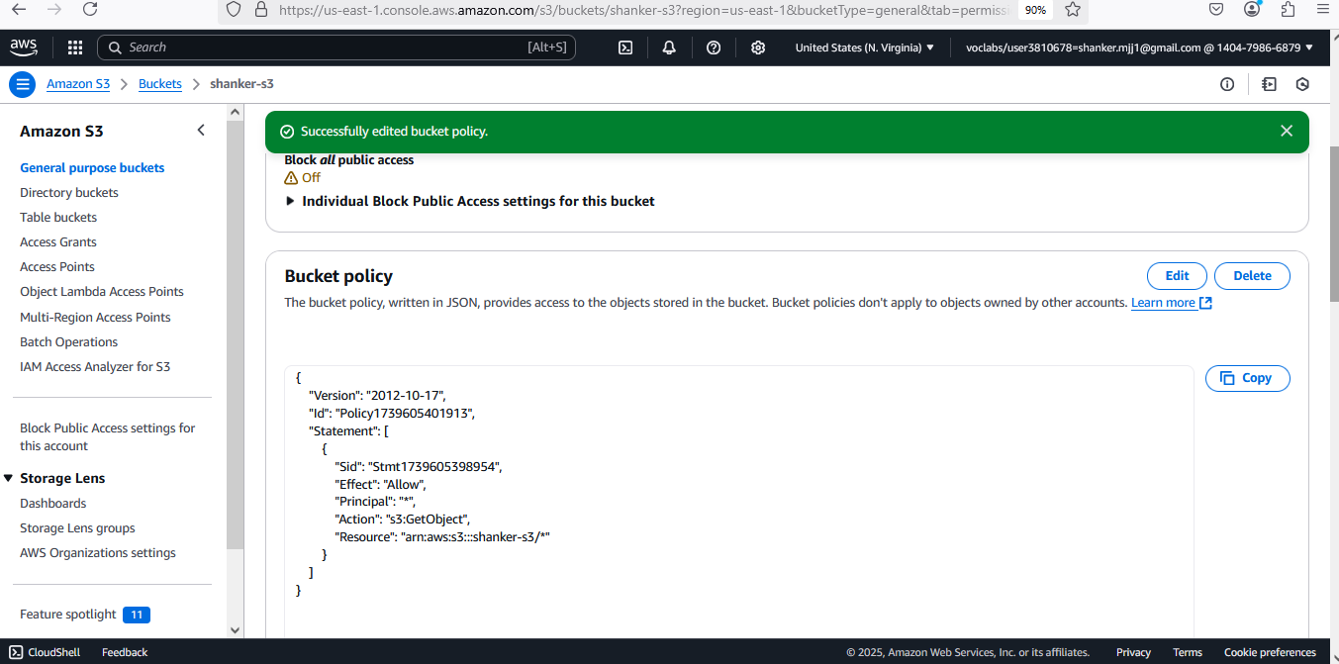

1. Now go to **Objects** Section tab & upload all files from **Build** Folder generated by command **npm run build**

Just Drag & Drop to upload

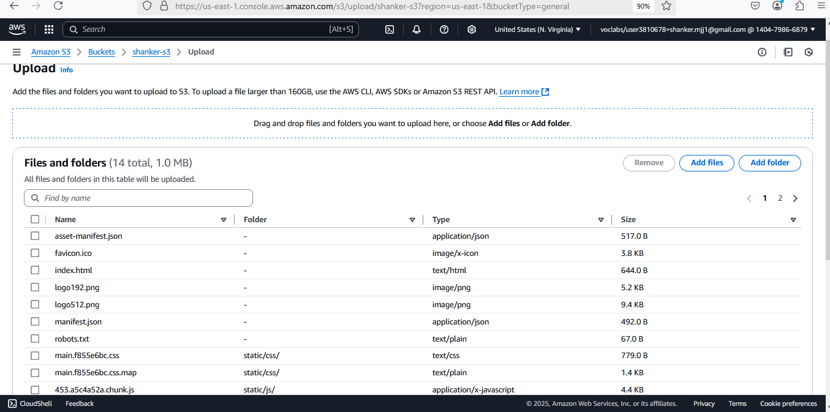

1. **Click & upload you will get below uploaded Information**

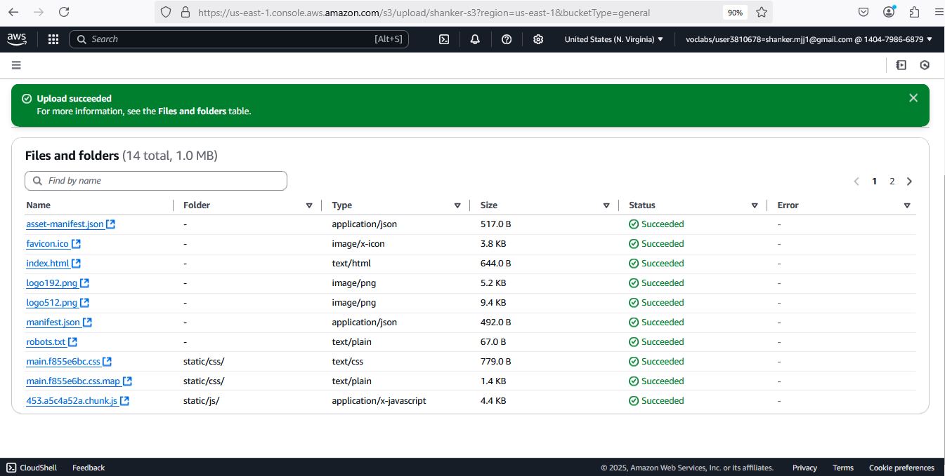

1. **Now you need to find url** 
   1. **Properties 🡪 Static website hosting (scroll down)**
   2. **You will find url**

[**http://shanker-s3.s3-website-us-east-1.amazonaws.com**](http://shanker-s3.s3-website-us-east-1.amazonaws.com)

* 1. **That it… you have created a Web hosting successfully in S3 BUCKET**