- Create a view to show details of all flights that are departing on a specific date.
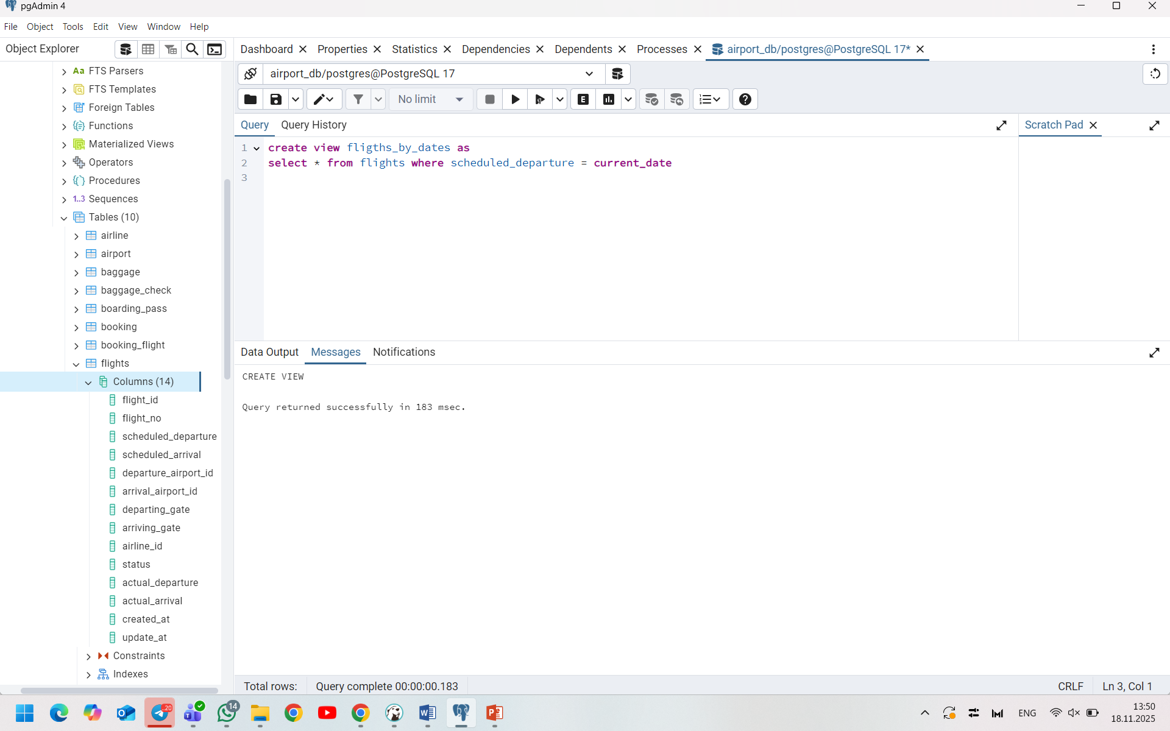
- Create a view that shows bookings for flights scheduled to depart within the next week.
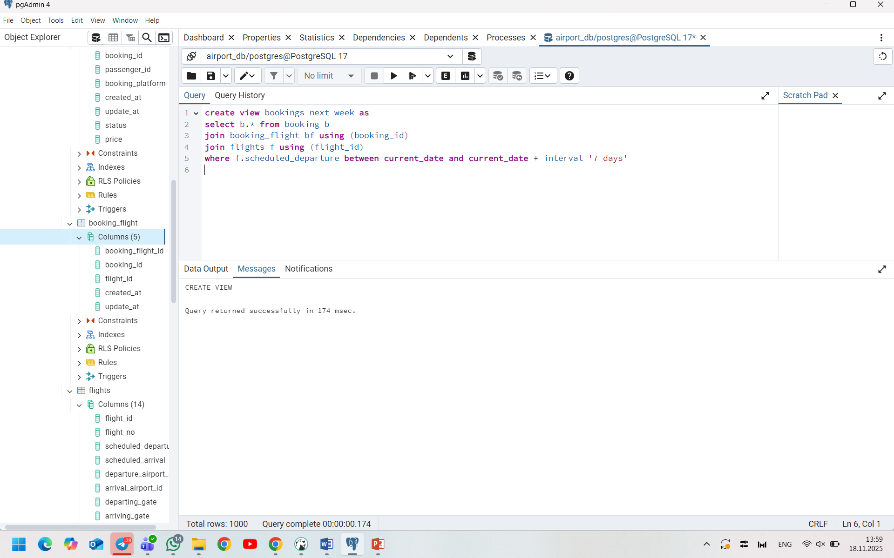
- Create a view to show the top 5 most popular flight routes based on the number of bookings.
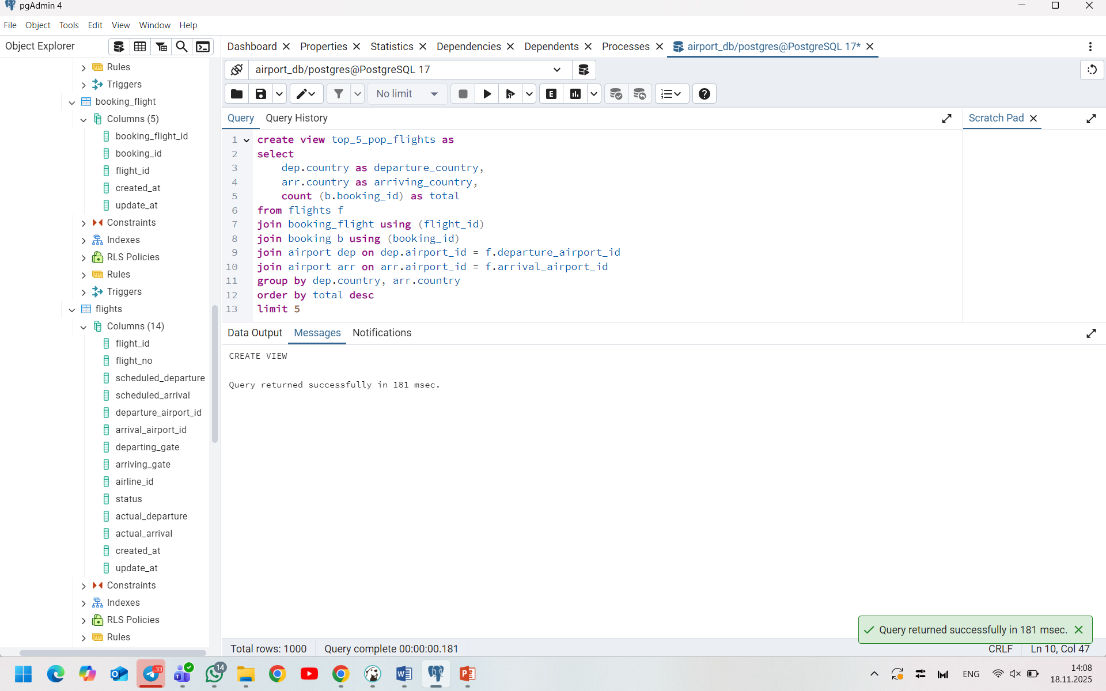
- Create a view that lists all flights for a specific airline.
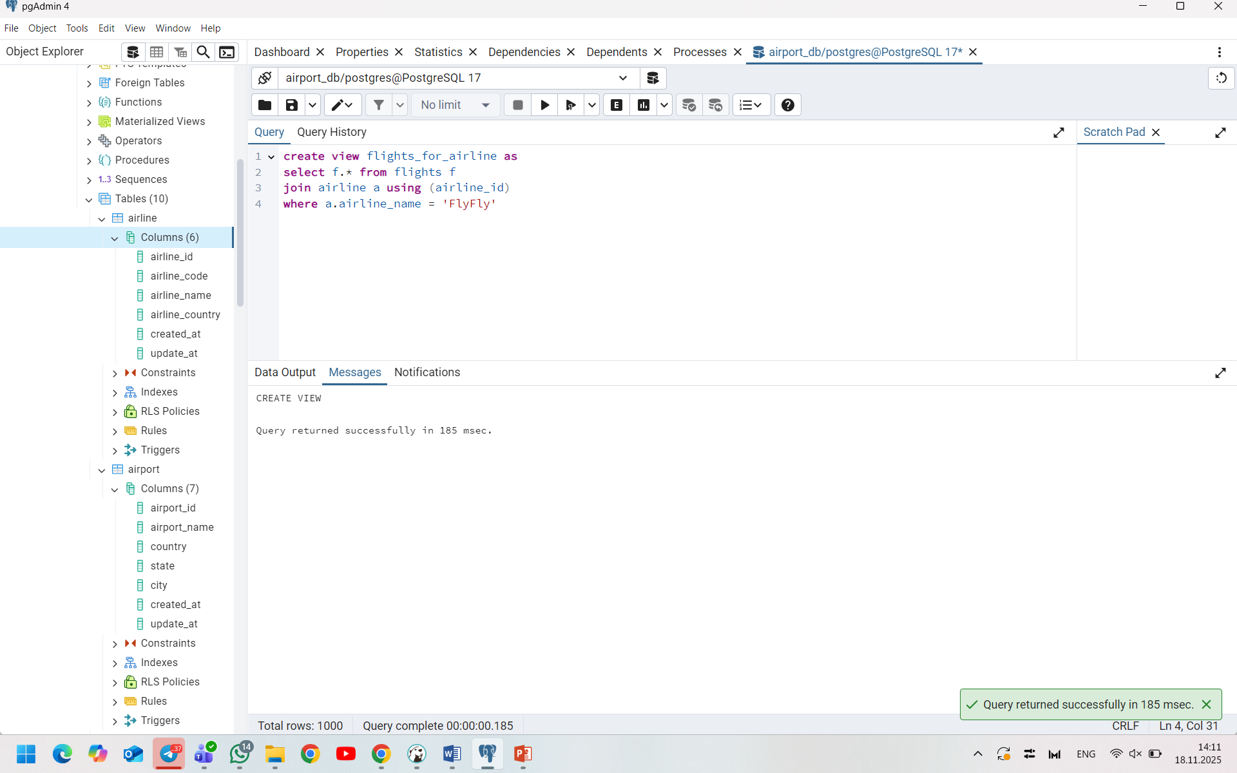
- Modify the view created in task 4 to show only flights departing within the next 7 days for a specific airline.
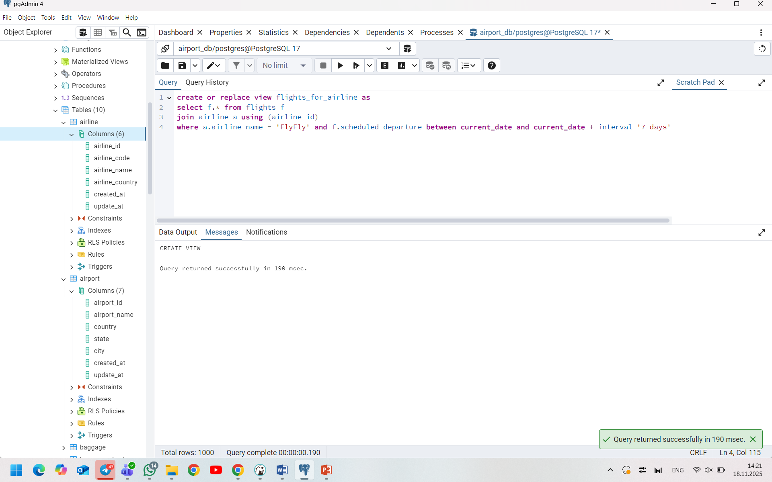
- Create a view to show flights that are delayed by more than 24 hours.
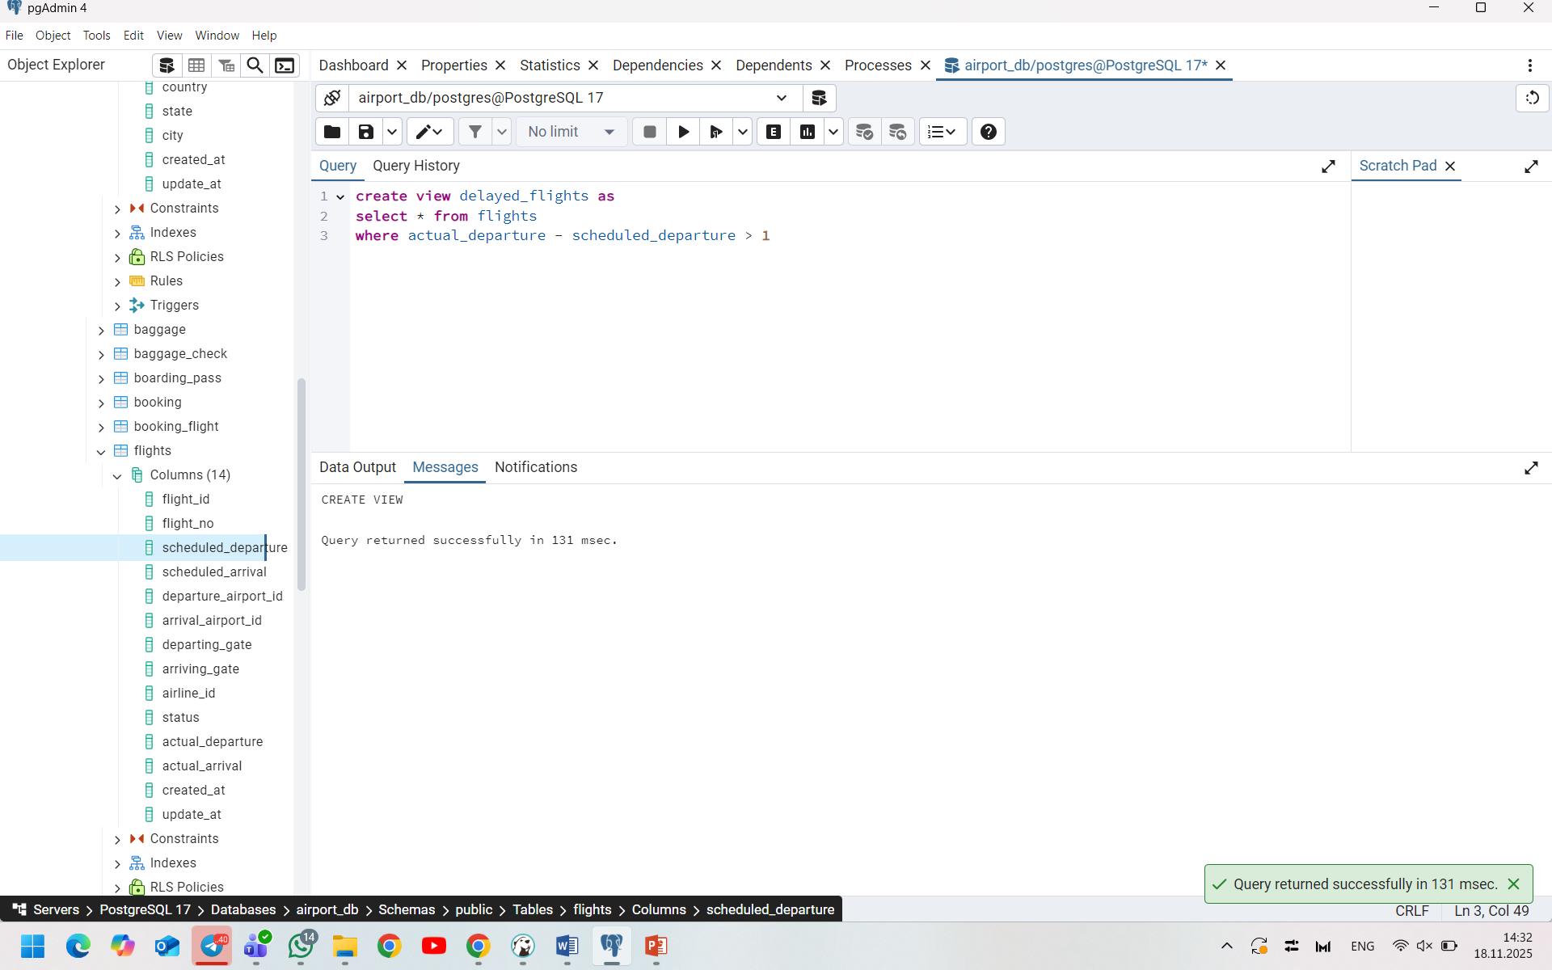
- Create a view in which you can display the full name and country of origin of passengers who made bookings on Leffler-Thompson platform. Then show the list of that passengers.
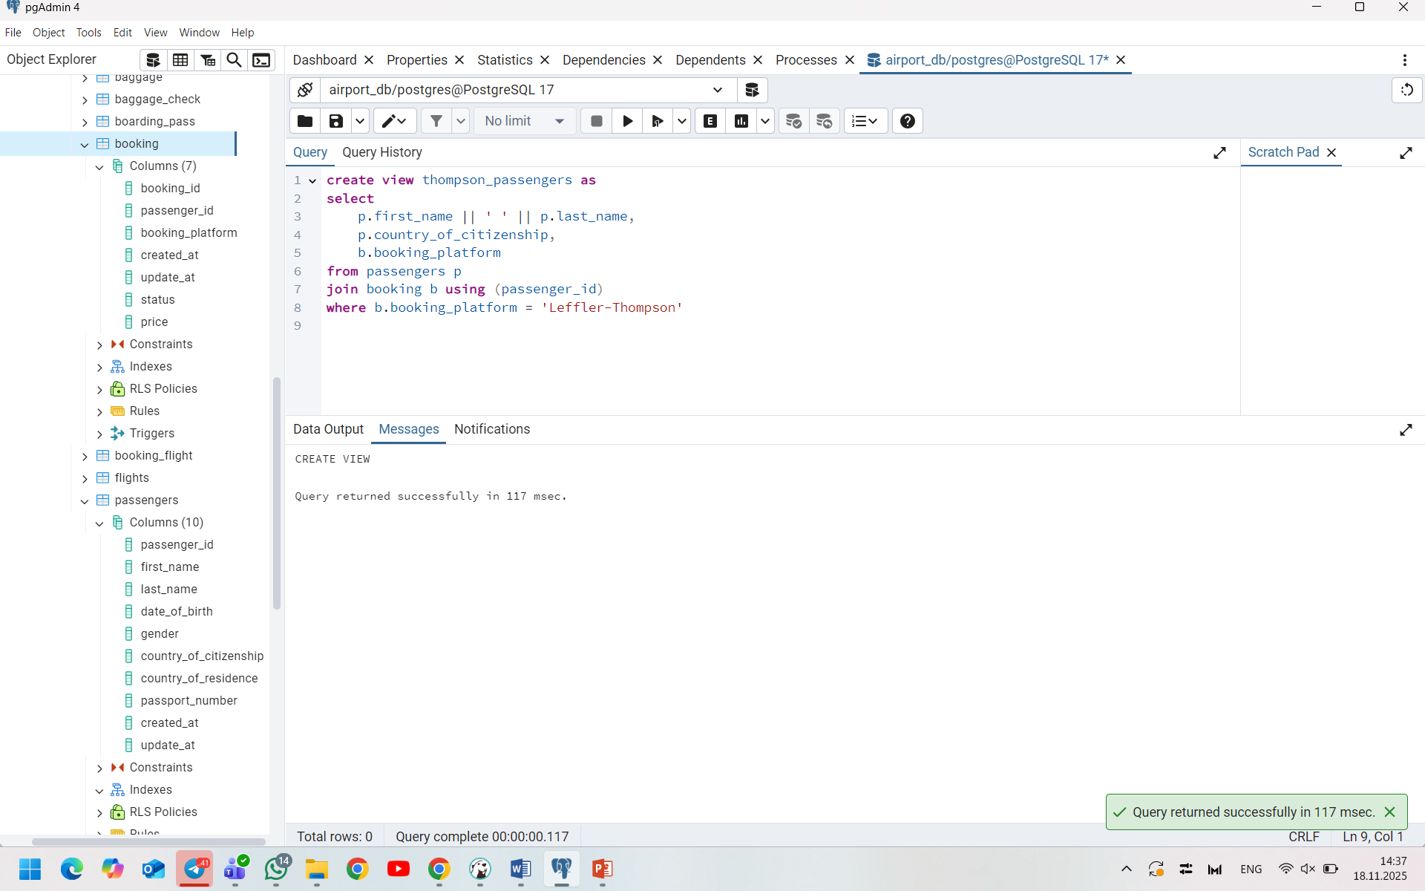
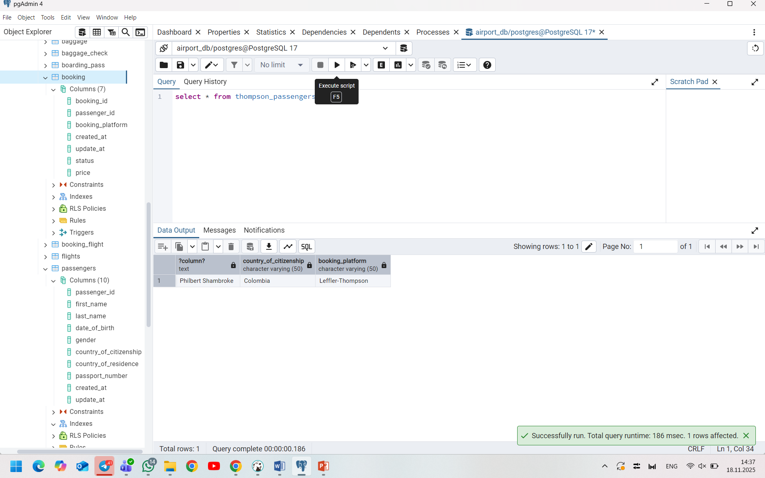
- Create a view that shows top 10 most visited countries.
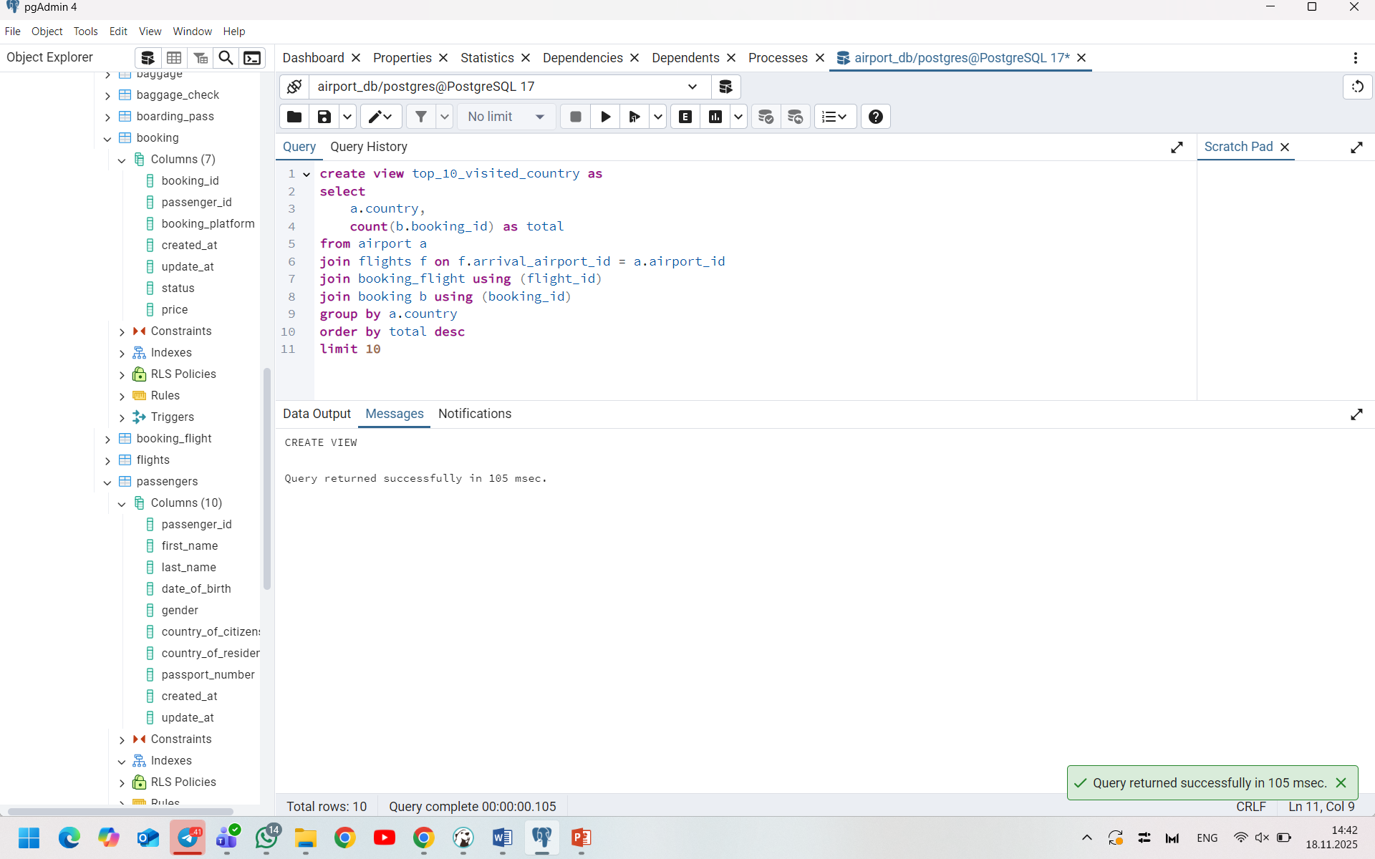
- Update any of the created views by adding new information in the view table. Show results.
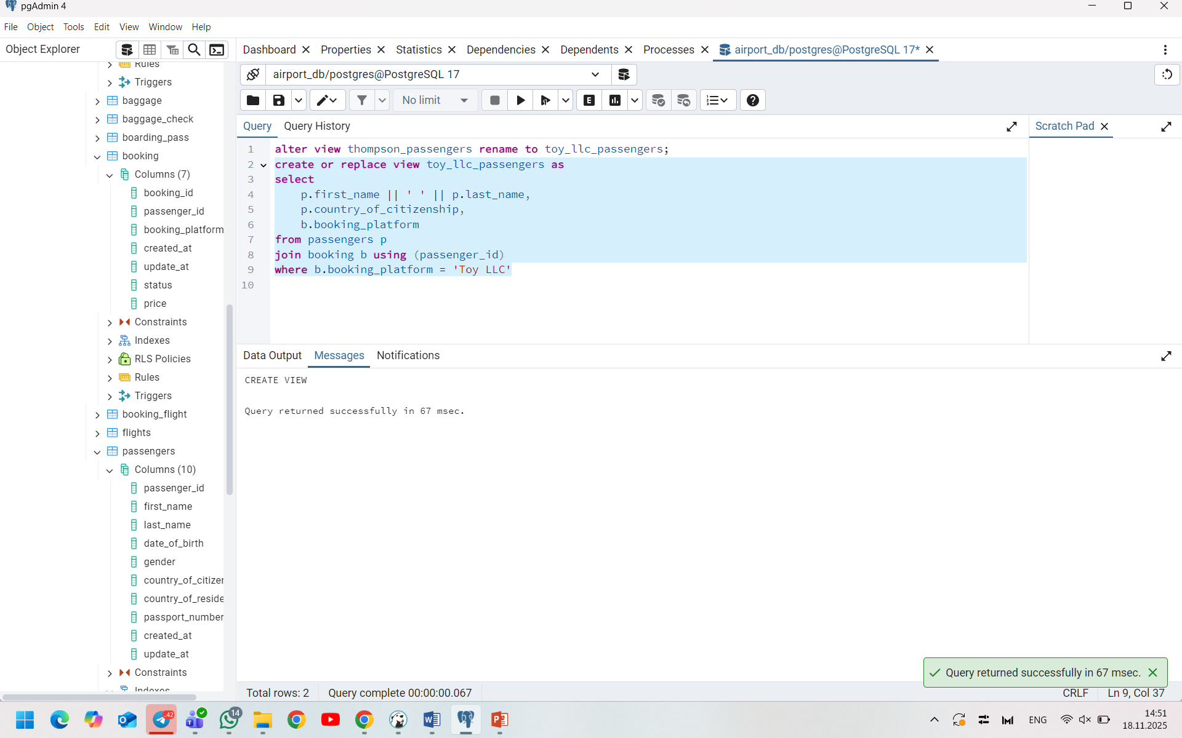
- Drop all existing views.
