PROJECT AND TIME MANAGEMENT METHODS

- Getting started
- CPM Time Calculations
- CPM Cost Calculations - Generate Complete Time-Cost Trade-Off Curve
- CPM Cost Calculations - Determine Activities to Invest in Time Reduction (Crash) to Attain a Given Project Duration
- PERT - Heuristic
- PERT – Simulation
- Summary of Datasets

Project and Time Management Methods

1. Getting Started

The time management function of HOM allows the user to analyze the process required to complete a time dependent project such as:

a) New product introduction campaign
b) A consulting or accounting engagement
c) Software development, etc.

The key questions a manager might want to answer are:

a) What is the shortest time it will take me to complete the project?
b) Can I save time if I invest financial resources, and where should this be done?
c) If I’m not certain of exactly how long a task will take, can I determine the
likelihood of the project taking a fixed amount of time?

The key to being able to answer the above questions depends on the user’s ability to initially specify

a) The tasks involved in the project
b) The duration of each task
c) The order in which the tasks must be completed (precedence relationships).

Please consult the tutorial for step-by-step instructions on how to run a model. The following is primarily a technical description of the methods. To access tutorial, click on the Project Management Tutorial option in the HOM module which can be accessed using the Add-Ins option on the tool bar.

The HOM Project Management calculation schema is given below.

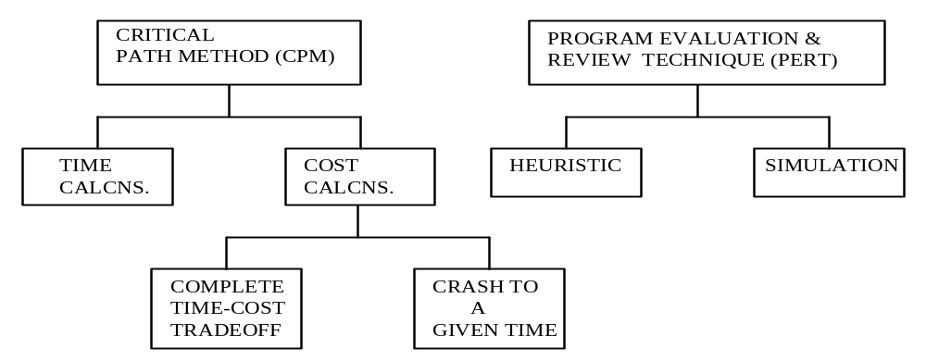

Five different methods for Project and Time Management are available in this application: (i) CPM Time Calculations - Determine Project Completion Time, Early Start, Late Start, Slack, and so on; (ii) CPM Cost Calculations - Generate Complete Time-Cost Trade-Off Curve; (iii) CPM Cost Calculations - Determine Activities to Crash to Attain a Given Project Completion Time; (iv) PERT - Heuristic Calculation of Expected Completion and Probability of Completion; and (v) PERT - Simulation.

- CPM Time Calculations – For each activity, HOM reports Early Start, Early Finish, Late Start, Late Finish and slack. Early Start and Finish are the earliest an activity can be started and finished. Late Start and Finish are the latest an activity can be started/finished without delaying the project.
- CPM Cost Calculations - Cost/Time Trade-Off will produce the complete cost-time trade-off curve shown below. The optimal cost of crashing is calculated for ten values of the project duration - start from the minimum duration (obtained by first crashing all activities to their shortest durations) and increase in nine equal steps to the normal duration (i.e., the duration of the project with no activities crashed). The calculations may take a while if the project is large.
- CPM Cost Calculations - Choosing Crash to a Specified Time will give the optimal cost of crashing to the desired completion time. If the project cannot be crashed to this duration, the program will prompt for another completion time.
- PERT – The PERT method assumes activity durations are random. If produces the probabilities of finishing the project for different durations. HOM produces an “expected completion time” for the project based on the Critical Path (CP). It also reports the Standard Deviation of the CP
- PERT – Simulation – Here, Simulation is used to determine whether some of the noncritical activities become critical if their durations vary in a random manner. HOM reports the frequency distribution of completing the project for different durations.

The HOM Project Management module is as shown in the following figure

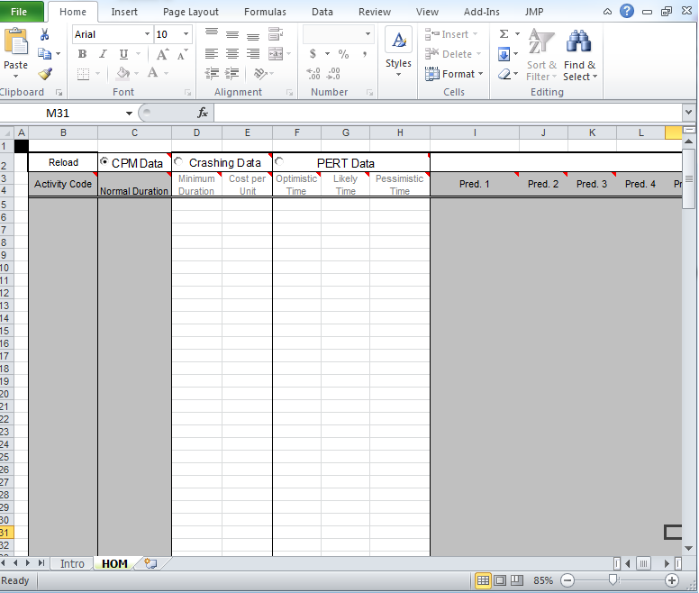

Note: The model has to be selected before any data input is done. To select the model open the Parameters dialog box to make your choices or select the radio buttons (CPM data or crashing data or PERT data).

  - Step-by-step instruction for loading an example.
In this section we provide step-by-step instructions for Example 1. This procedure can be adopted for the rest of the examples.

    - Obtaining the dialog box

To obtain dialog box, select HOM module from the Add-Ins option on the tool bar. This will open the Dialog box which allows you to determine which data to forecast and what method to use. Sample parameters Dialog box is given below.

Sample Parameters Dialog Box

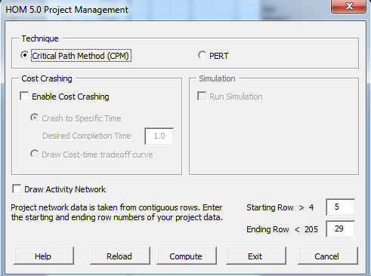

    - Selecting the example data file to load.

Press Reload button on the dialog box to load an example. Example 1 can be found in the data file Project_CPM_time.csv in the EXAMPLES directory. The data will be loaded to the HOM module.

In the new worksheet, you will see the following data from Example 1 (Project_CPM_time.csv)

Reload | CPM data | Crashing Data |  | PERT Data
Activity Code | Normal Duration | Minimum Duration | Cost per Unit | Optimistic Time | Likely Time | Pessimistic Time | Pred. 1 | Pred. 2 | Pred. 3
move | 2 | 1 | 1000 | 2 | 2 | 2
rbo | 4 | 3 | 6000 | 4 | 4 | 4
frame1 | 3 | 2 | 5000 | 3 | 3 | 3 | rbo
wire1 | 6 | 4 | 5000 | 6 | 6 | 6 | frame1
instal | 1 | 0.6 | 5000 | 0.4 | 0.6 | 0.8 | wire1 | move
ckt-a | 2 | 1 | 7500 | 2 | 2 | 2 | instal
conn | 1 | 0.7 | 6667 | 1 | 1 | 1 | ckt-a
ckt-b | 2 | 1 | 7500 | 2 | 2 | 2 | conn
walk1 | 0.5 | 0.5 | 0 | 0.5 | 0.5 | 0.5 | ckt-b
touch1 | 1 | 0.7 | 5000 | 0.5 | 0.7 | 1 | walk1
online | 0 | 0 | 0 | 0 | 0 | 0 | touch1 | touch3
layout | 4 | 3 | 6000 | 1.5 | 3 | 4
frame3 | 4 | 2.5 | 4667 | 1.5 | 2.5 | 4 | layout
roof | 3 | 2 | 6000 | 1 | 2 | 3 | frame3
ext | 2 | 1 | 5000 | 2 | 2 | 2 | frame3
plumb | 5 | 3 | 4000 | 5 | 5 | 5 | roof | ext
wire3 | 6 | 4 | 5000 | 2 | 4 | 6 | roof | ext
hvac | 4 | 3 | 3000 | 4 | 4 | 4 | roof | ext
insul | 2 | 1.5 | 8000 | 2 | 2 | 2 | plumb | wire3 | hvac
int | 2 | 1.5 | 6000 | 1 | 1.5 | 2 | insul
paint | 1 | 0.7 | 10000 | 1 | 1 | 1 | int
fixt | 1 | 0.7 | 6667 | 1 | 1 | 1 | paint
carpet | 0.5 | 0.5 | 0 | 0.5 | 0.5 | 0.5 | fixt
walk3 | 0.5 | 0.5 | 0 | 0.5 | 0.5 | 0.5 | carpet
touch3 | 1 | 0.7 | 5000 | 0.5 | 0.7 | 1 | walk3

Following is the screenshot of the same.

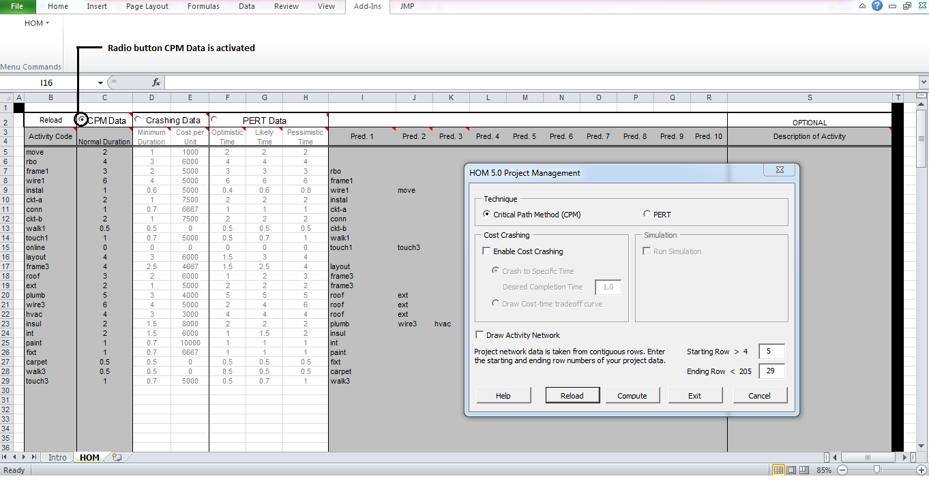

Note: Radio button CPM Data is activated

2. CPM Time Calculations

Inputs
Activity Name Use a number, letter, or short abbreviation (less than 8 characters) in the ACTIVITY column. A more complete definition can be given for each activity, if desired, by moving the cursor to the extreme right of the spreadsheet to the activity DESCRIPTION column.

Activity Duration After designating the task name in column one, the user should enter its duration in the next column, DURATION, in the same row.

Predecessors
Each task can have up to ten immediate predecessors. If a task has only one immediate predecessor, enter it in column PRED 1. If it has two, use columns PRED 1 and PRED 2, and so on. The name used to identify the predecessor must be identical to its short activity name. A task without predecessors (i.e., starting tasks) will have no predecessors listed in its appropriate row.

First Activity Row number of the first activity to include in the project.

Last Activity Row number of the last activity to include in the project.
(All activities in between the 1st and the last are included in the project.)

After reloading the example 1 as explained in section 1.1, click Compute button in the parameters dialog box to see the output.

Note: Observe the choice of first and last activity -- all activities in rows 5 through 29 are included in the project.

Output for Sample Data File (CPM - Time Calculations)

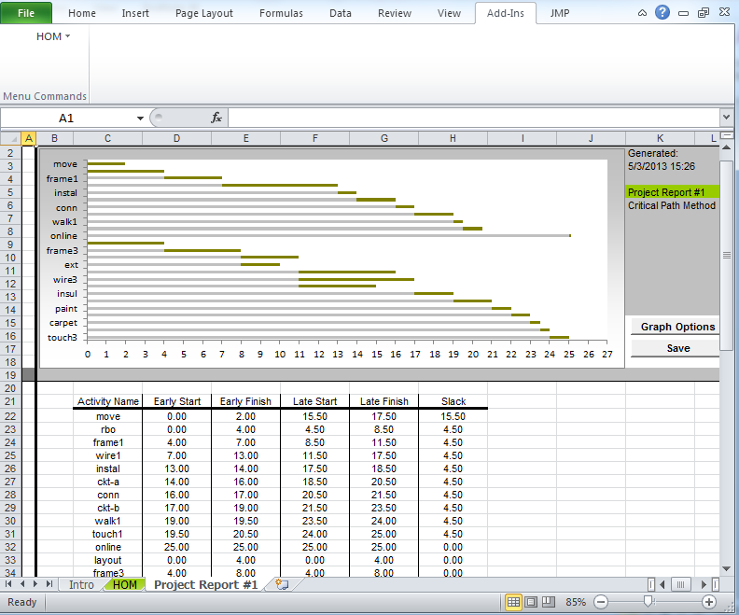

The graph above is called a Gantt chart and shows the start and finish time for each activity.

For each activity, HOM reports Early Start, Early Finish, Late Start, Late Finish and slack. Early Start and Finish are the earliest an activity can be started and finished. Late Start and Finish are the latest an activity can be started/finished without delaying the project.
Slack = Late Start – Early Start = Late Finish – Early Finish

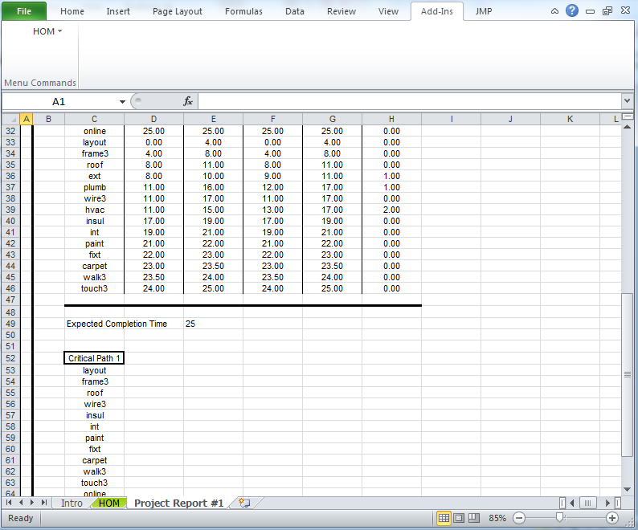

The Critical Path is the longest path in the network. It only has critical activities. When there are multiple critical paths, HOM lists all critical paths.

By the graph there is a Graph Options box. Clicking on it gives the user the opportunity to choose how the Gantt chart is drawn: Early Start-Finish or Late Start-Finish. See the dialog box below.

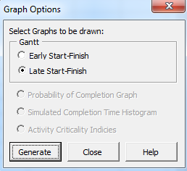
Draw Activity Network
Choosing Draw Activity Network will produce the activity network shown below. This allows for a clearer picture of the sequence of events that take place along the network.

Sample Parameters Dialog Box

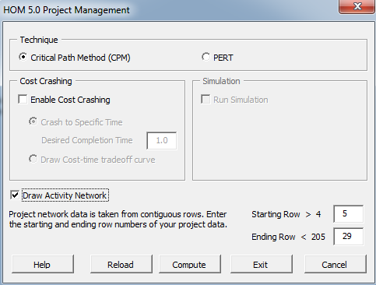

Output for Sample Data (CPM – Activity Network)

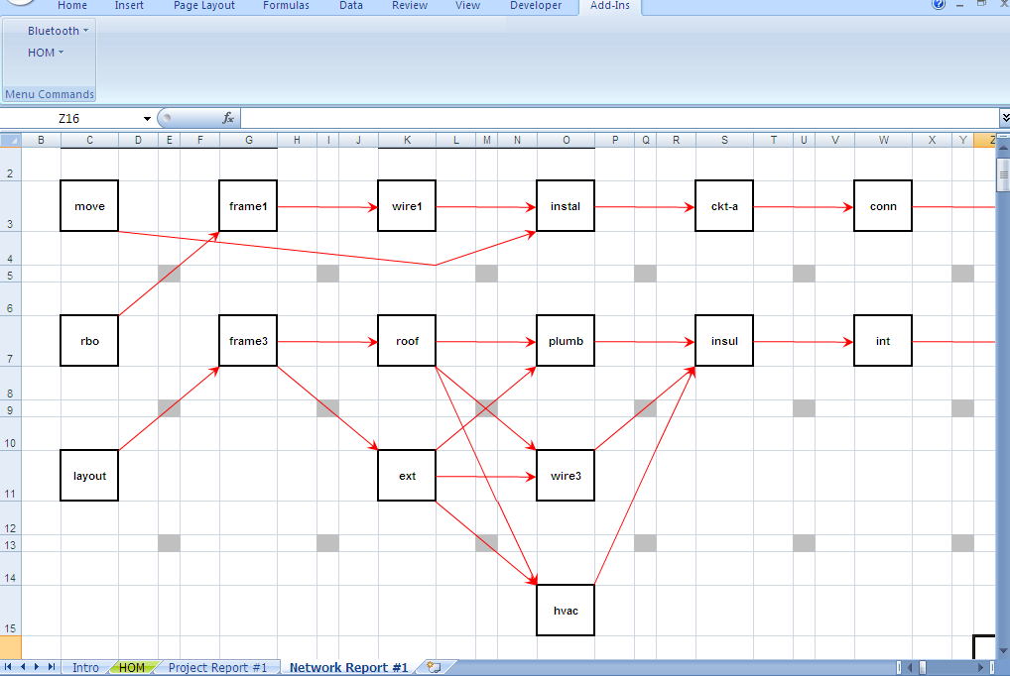
3. CPM Cost Calculations - Generate Complete Time-Cost Trade-Off Curve

4. CPM Cost Calculations - Determine Activities to Invest in Time Reduction (Crash) to Attain a Given Project Duration

Both these methods need two additional inputs when compared to CPM - Time Calculations:

Additional Inputs for Methods 3 and 4

Minimum Duration This is the minimum duration to which the activity can be crashed. Please see picture below.

Cost/Time The cost of reducing the duration of an activity (crashing) by a unit of time. Please see picture below.

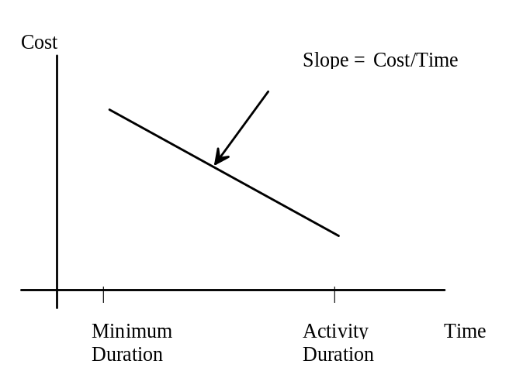

The activty duration given in the third column of
the input spreadsheet is usually referred to in the literature as the “Normal Duration.”

For example, for the activity wire-1,
Duration = 6,
Minimum duration = 4,
Cost/time = 5000.
This means activity wire-1 can be “normally” completed in 6 time units. However, its duration can be shortened by crashing it at a cost of 5000 per unit of time. The “minimum” duration to which it can be crashed is 4.

If an activity can not be crashed set minimum time equal to normal time and crash cost = 0.

The optimization problem is to finish the project within a desired completion time at the minimum cost. This may require reducing the duration of several activities.
Linear Program: When the calculations start, the given data are first converted into a linear program. The conversion method is outlined in Eppen, Gould and Schmidt, (1993). Then the resulting LP is solved by a standard two-phase simplex method.

Infeasibility may occur in crashing if the project cannot be crashed to meet the target duration; that is, the desired completion time (in method 3) is too small. The program will notify you at that point and will ask you to input a different completion time.

Choose the right radio button to enter data.

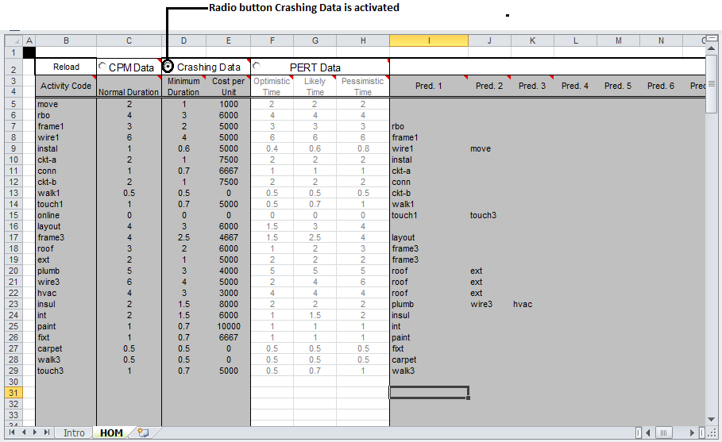

Output for 3 (Complete Cost-Time Trade-Off): Choosing Cost/Time Trade-Off will produce the complete cost-time trade-off curve shown below. The optimal cost of crashing is calculated for ten values of the project duration - start from the minimum duration (obtained by first crashing all activities to their shortest durations) and increase in nine equal steps to the normal duration (i.e., the duration of the project with no activities crashed). The calculations may take a while if the project is large.

Sample Parameters Dialog Box

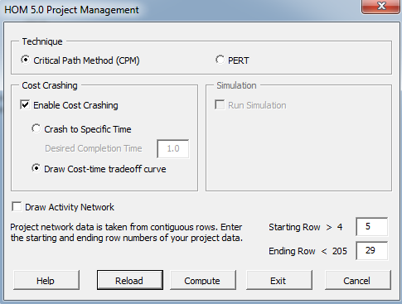

Output for Sample Data (CPM - Complete Cost/Time Trade-Off)

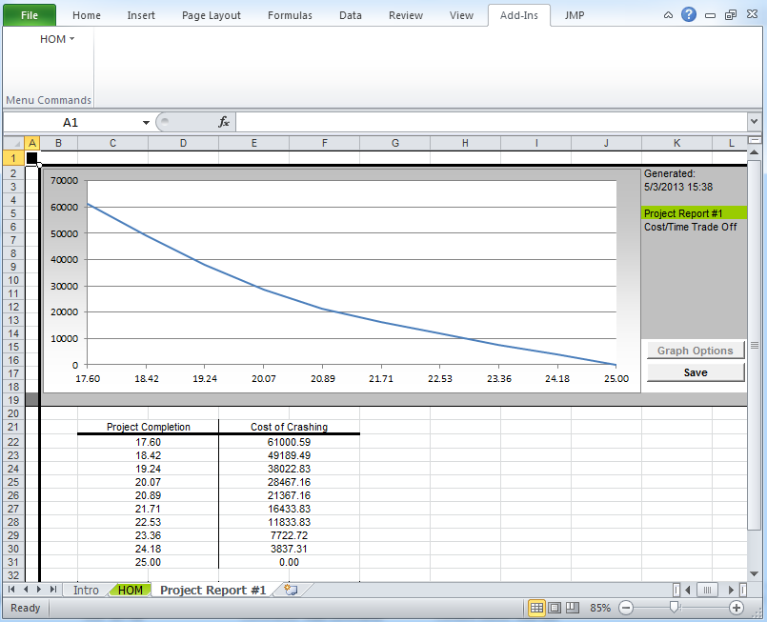

Output for 4 (Crash to Specified Time): Choosing Crash to a Specified Time will give the optimal cost of crashing to the desired completion time. If the project cannot be crashed to this duration, the program will prompt for another completion time.

Sample Parameters Dialog Box

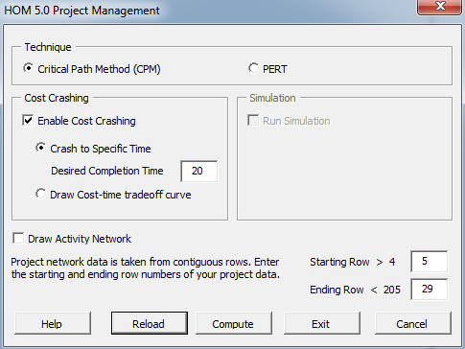

Output for Sample Data (CPM - Crash to a Particular Duration)
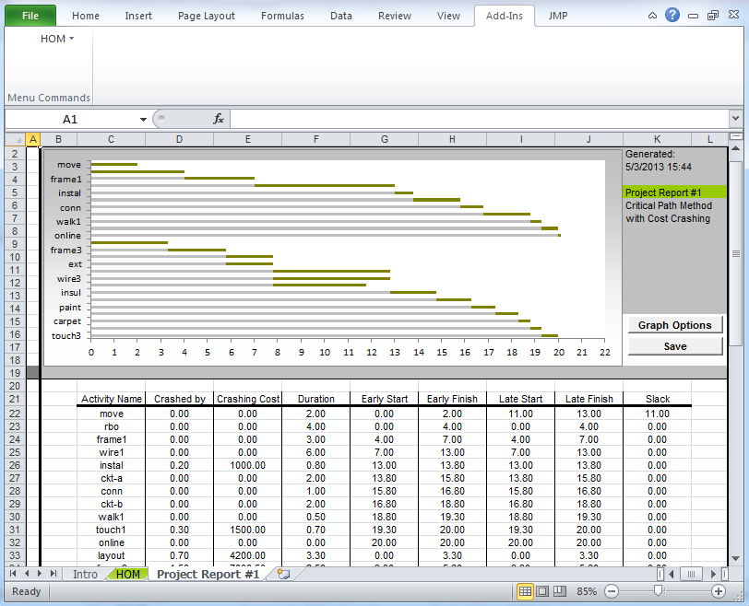

The second column indicates the amount by which each activity duration has been reduced and at what cost.
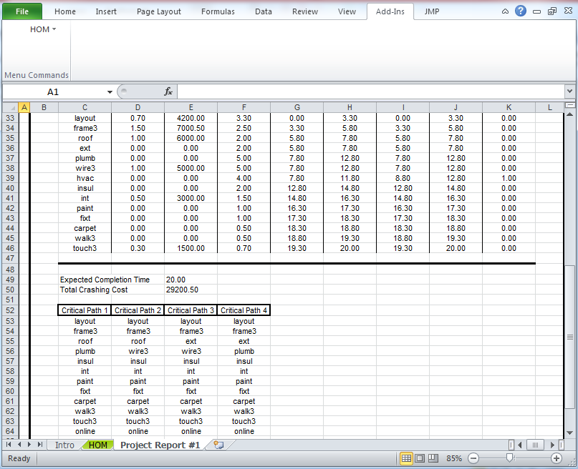

The optimal cost of completing the project within 20 days is $ 29,200.50. In the “crashed” network, there are four critical paths.

Discussion: If the task durations need to be integral then the problem becomes an integer program. Other interesting restrictions, including resource restrictions can be modeled (not in this version!).

For example (not in this version): One can model constraints such as concrete mixing can start soon as foundation 1 or foundation 2 is complete; or, Either the crane and loader must be free or else the crane and two dumpers are necessary. In general, rule based constraint programming is possible.
5. PERT - Heuristic

6. PERT - Simulation

Inputs
Activity Name Use a number, letter, or short abbreviation (less than 8 characters) in the ACTIVITY column. A more complete definition can be given for each activity, if desired, by moving the cursor to the extreme right of the spreadsheet to the activity DESCRIPTION column. (If you have already specified the names for a CPM - Time Calculation, you can use their rows to input the required data.)

Predecessors Each task can have up to ten immediate predecessors. If a task has only one immediate predecessor, enter it in column PRED 1. If it has two, use columns PRED 1 and PRED 2, and ao on. The name used to identify the predecessor must be identical to its short activity name. A task without predecessors (i.e., starting tasks) will have no predecessors listed in its appropriate row. (If you have already specified the network for a CPM - Time Calculation, you can use those rows to input the required data.)

First Activity Row number of the first activity to include in the project.

Last Activity Row number of the last activity to include in the project.
(All activities in between the 1st and the last are included in the project.)

Optimistic, Likely, Three time estimates are required for each activity. These
and Pessimistic Estimates must be placed in their appropriate columns.
of Activity Duration

The PERT method assumes activity durations are random. It produces the probabilities of finishing the project for different durations. The methods used and outputs are given below.

Method for 5 (PERT- Heuristic)

If an activity has three durations specified, then the average duration as well as the standard deviation of the activity's duration is computed using the following formulae:

Let a, m, and b stand for the optimistic, most likely, and pessimistic activity duration time. Then,

Mean Duration of Activity = (a + 4m + b)/6;
Standard Deviation of Activity Duration = (b - a)/6.

The critical path is determined using the CPM technique.

The mean project duration and the standard deviation of the project duration are approximated as follows:

Let ti, si , i = 1, 2, ..., M, be the means and standard deviations of the M activities on the critical path. Then,

Mean Project Duration (approximate) T = t1 + t2 + ... + tM
Standard Deviation of Project Duration (approximate), 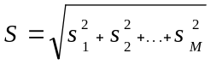.

Remarks:
- The latter formula assumes the independence of the M activities.
- Moreover, the procedure assumes that an activity that is not on the critical path (determined by the CPM technique) never becomes critical.
- Thus the heuristic estimate of the mean duration of the project is an optimistic estimate. To avoid this potential bias, the PERT - Simulation technique could be employed.

The project duration random variable is approximated by a normally distributed random variable with mean = T and standard deviation = S, that is, N(T, S2). The probability of the project completing within a given duration is calculated using the standard normal distribution.

The probability table for completing the project in a given time is calculated in addition to the critical path. The probability of completion is given for the range from expected completion time minus three standard deviations to expected completion time plus three standard deviations with a step size of 0.2 standard deviation. Thus, the table contains 31 entries.

Sample Data File
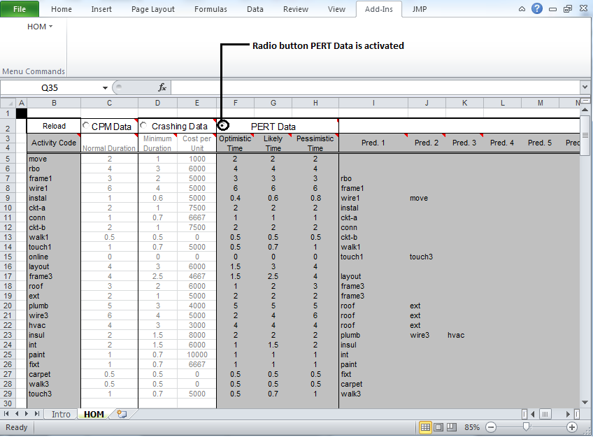
|< -- 3 Times Estimate -->|

Sample Parameters Dialog Box
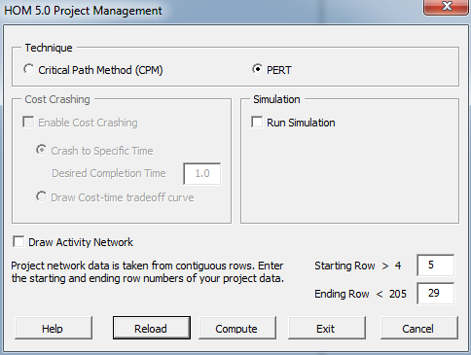

Outputs for Sample Data (PERT - Heuristic)

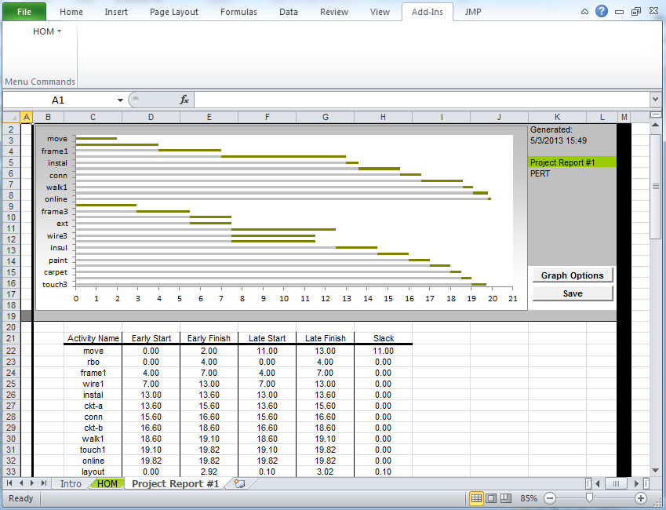

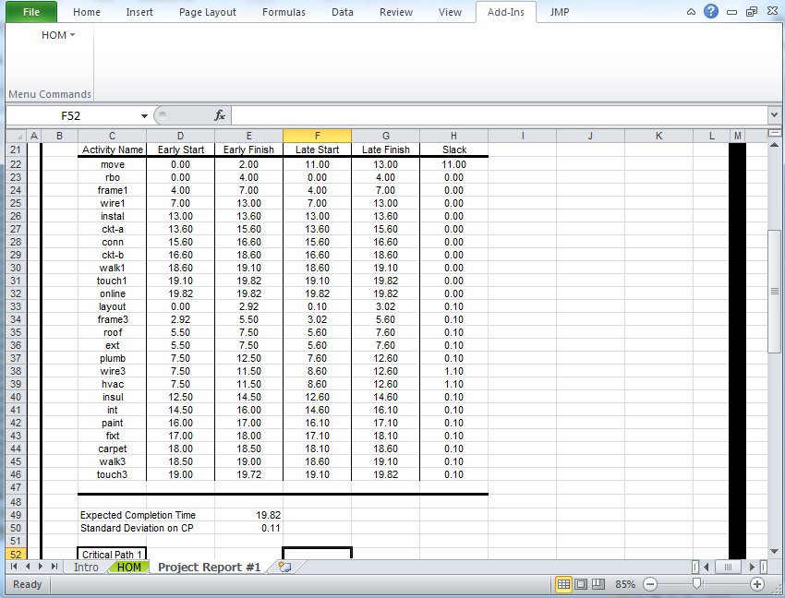

Even though the output looks like that of CPM, HOM produces an “expected completion time” for the project based on the Critical Path (CP). It also reports the Standard Deviation of the CP.
Outputs for Sample Data (continued)
(PERT - Heuristic)
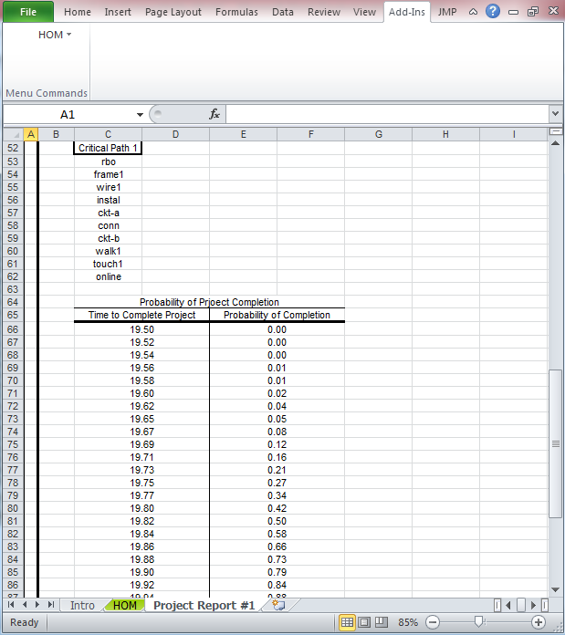

Using the normal approximation, HOM reports the probability of completing the project for different durations.
Method for 6 (PERT - Simulation)

In method 5, only the critical path was used in the calculations. Here the project itself is simulated.

Simulation is used to determine whether some of the noncritical activities become critical if their durations vary in a random manner. The simulation of the project is carried out 1,000 times. The CPM program is invoked 1,000 times and all CPM calculations are performed, such as finding the slacks, start and finish times, as well the project duration.

For each run the activity durations are each independently and randomly chosen from a suitable Beta distribution. The Beta distribution is chosen to fit the three time estimates for the activity duration.

The frequency distribution of the project duration, as well as the mean and standard deviation of the project duration is found using the simulation statistics.

The criticality factor for each activity is determined by the formula:

Criticality Factor = (Number of Runs in which the Activity Was Critical)/1,000
The higher this factor, the more critical the activity. The value of the factor ranges between 0 and 1.

Sample Parameters Dialog Box

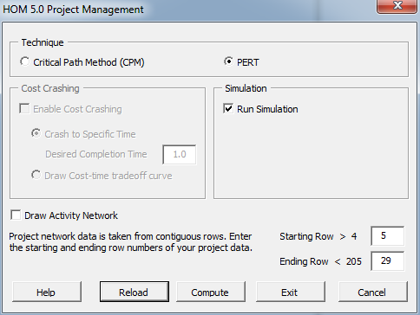

Outputs for Sample Data
(PERT - Simulation)
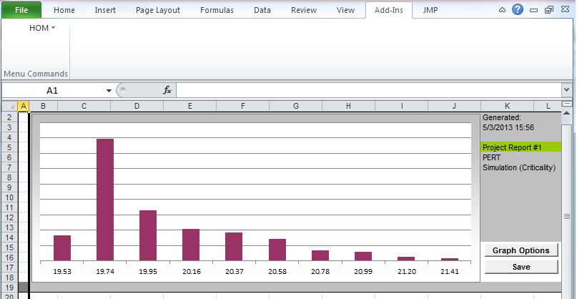

HOM reports the frequency distribution of completing the project for different durations.

Outputs for Sample Data (continued)

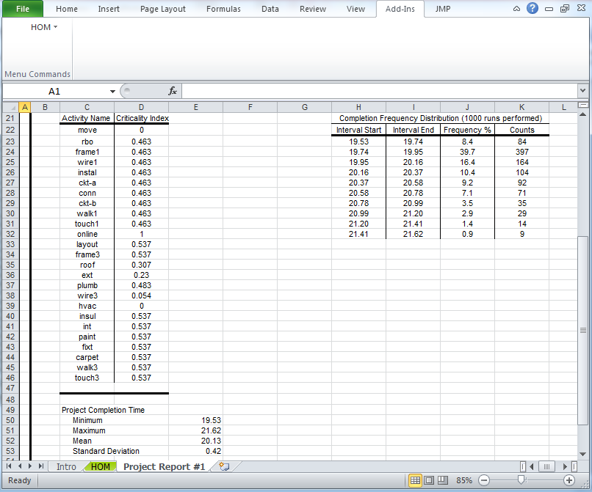

It also reports with what frequency activities were on the CP during the simulations.
Example: frame 1 was on the CP 46.3% of the time.

Based on the simulations,HOM computes Minimum, Maximum, Mean and Standard Deviation of the project duration.

Discussion (not in this version): In general, one can simulate a project where resources are required for completion of an activity.

7. Summary of Datasets

Project_CPM_time.csv
Project_CPM_costtime_tradeoff.csv
Project_CPM_Costcrashing.csv
Project_PERT_Heuristic.csv
Project_PERT_Simulation.csv

References

Chase, R. B., and N. J. Aquilano Production and Operations Management 7th ed. Burr Ridge, , IL: Richard D. Irwin, 1995.

Eppen, G. D.; F. J. Gould; and C. P. Schmidt Introductory Management Science Englewood Cliffs, New Jersey: Prentice Hall, 1993.

Law, Averill M., and W. David Kelton Simulation Modeling & Analysis 2nd ed. New York: Mc- Graw-Hill, 1991.

Nahmias, S. Production and Operations Analysis 3rd ed. Burr Ridge, IL: Richard D. Irwin, 1997.

Phillips, D. T.; A. Ravindran; and J. J. Solberg Operations Research Principles and Practices, New York: John Wiley & Sons, 1976.

Stevenson, W. J. Production/Operations Management 5th ed. Burr Ridge,IL: Richard D. Irwin, 1996.

Note: Edited by Suresh Dasari on 11-May-13

The mean and variance based on the formulae given in Method 4 are used to determine the shape parameters of the Beta distribution, see Phillips et al (1976).

