Name: Serekbol Aksunkar
ID: 24B030056
Group: Wednesday 17:00-19:00
4.7.2
1.
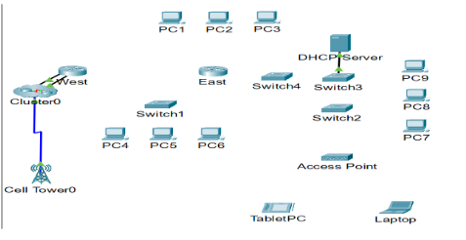
2
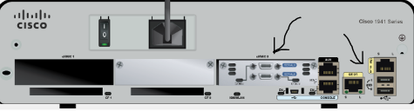
3.
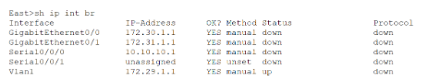
4. 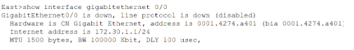
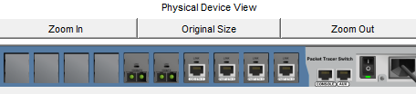

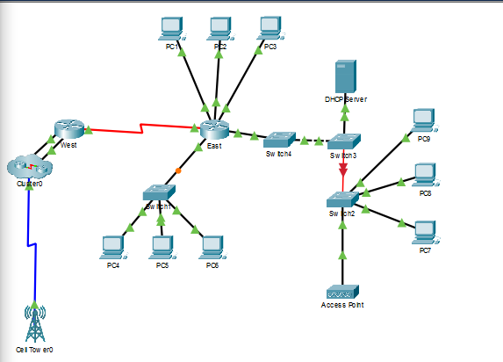

To be honest I watched youtube video to understand and I followed exact his steps
I hope this wouldn’t considered as cheated
Also if you wanna see the link is here -> https://www.youtube.com/watch?v=zWLdPpQ2wv0
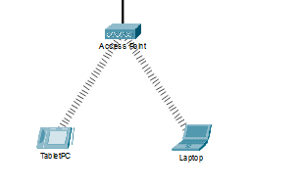
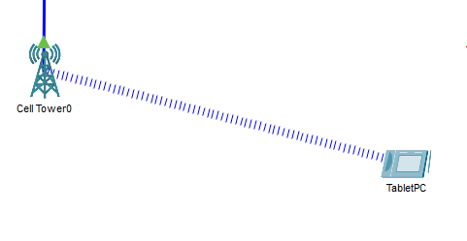
Laptop
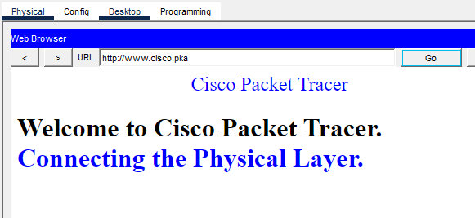
Tablet
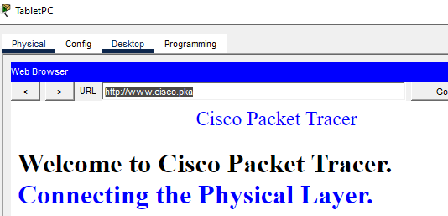
PC1,2,3
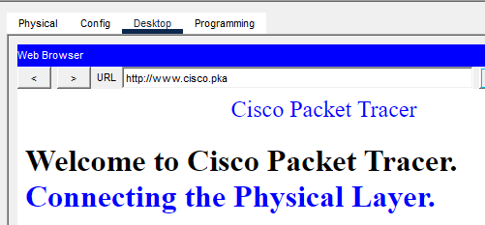
PC4,5,6
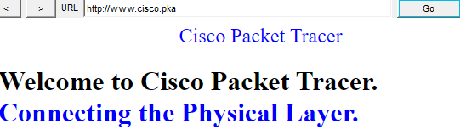
PC7,8,9


