Name: Serekbol Aksunkar
ID: 24B030056
Group: Wednesday 17:00-19:00
4.6.5
1. Choose copper-straight cable to connect Router0 F0/0 to Cloud Eth6.
2. Choose coax cable to connect Cloud Coax7 to Modem Port0.
3. Choose Serial DCE to connect Router0 Ser0/0/0 to Router1 Ser0/0.
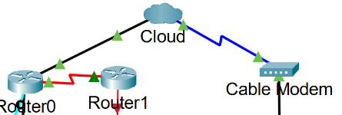
4. Choose the copper cross over cable to connect Router0 F0/1 to netacad.pka F0
since Routers and computers traditionally use the same wires to transmit (1 and 2)
and receive (3 and 6).
5. Choose the console cable to connect Router0 Console to Configuration Terminal
RS232.
6. Choose the MULTI MODE FIBER cable to connect Router1 F1/0 to Switch F0/1.
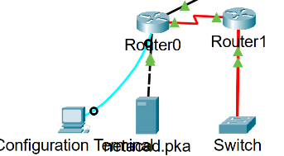
7. Choose the copper straight cable to connect Cable Modem Port1 to Wireless
Router Internet port.
8. Choose the copper straight cable to connect Wireless Router Ethernet 1 to Family
PC.
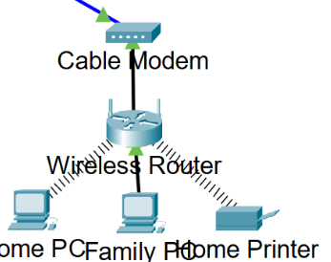
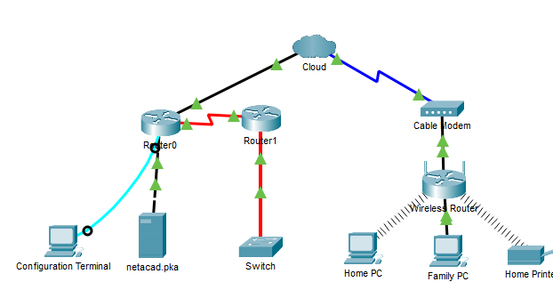
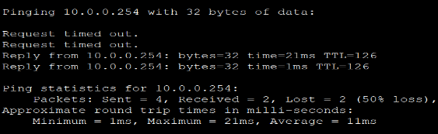
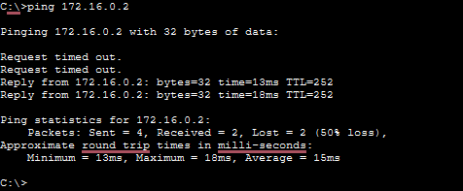
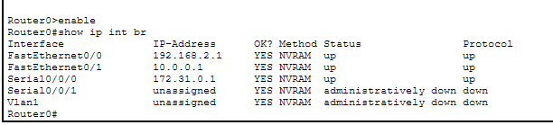
Examine the cloud
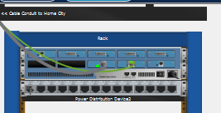2 wires are connected
Primary network
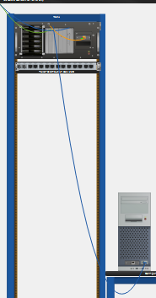answer-pc (conf t)
Secondary network
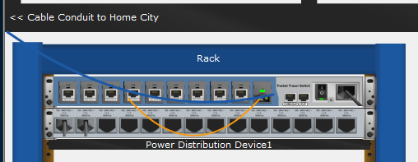
Answer
One cable for transmitting and second is receiving

