Practice 3 - VLAN Technology
Student name: Serekbol Aksunkar
Student ID: 24B030056
Group: Wednesday
- Step 1,2 (open conf terminal and name Bob and Alice)
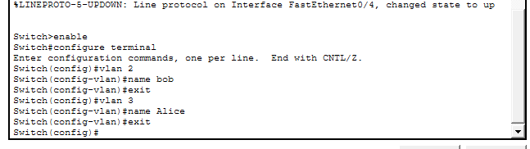
- Step 3: Configuring interfaces In VLAN 2, according to the topology, there are two computers: PC1 and PC3. They are connected to the switch through Fa0/2 and Fa0/3.
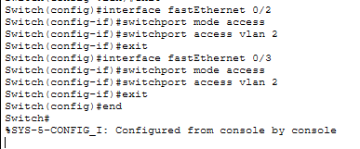
- Switch trough Fa0/1 and Fa0/4
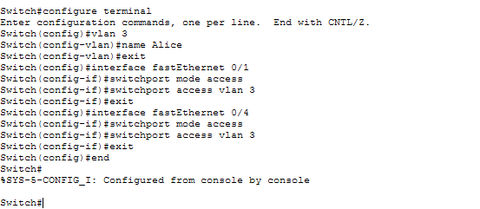
- Show vlan brief
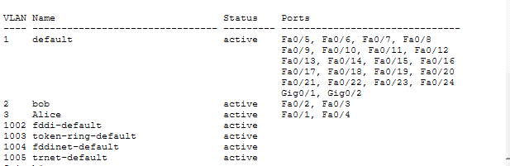
- Step4 save the conf
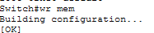
- Step5
PC0
PC1
PC2
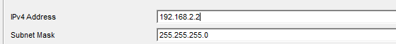
PC3
- Step6 verify connect with ping
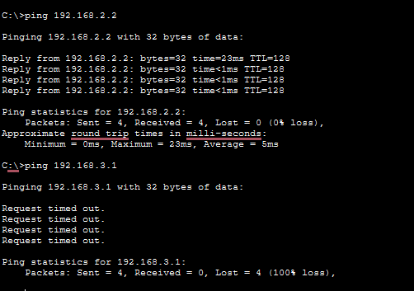

Part 2
Trunk port
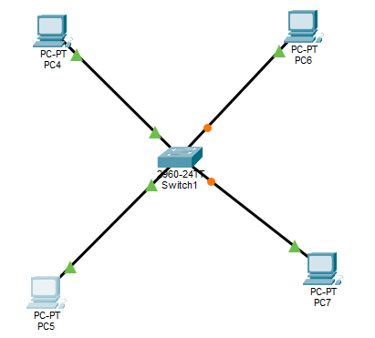
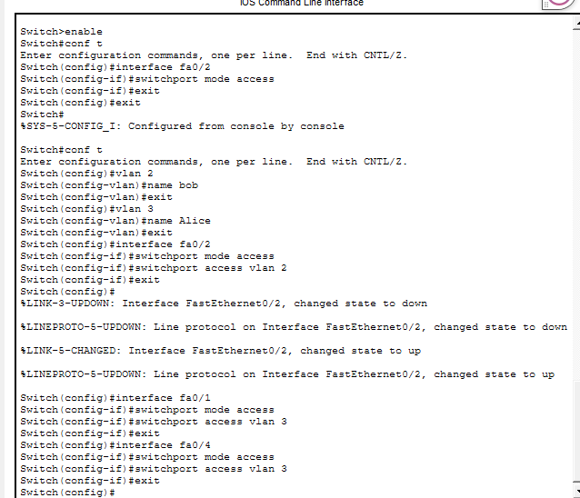
IP addresses
PC4
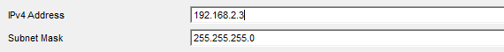
PC5
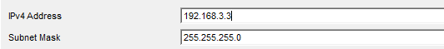
PC6
PC7
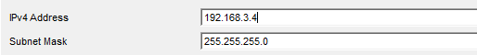
Switch0
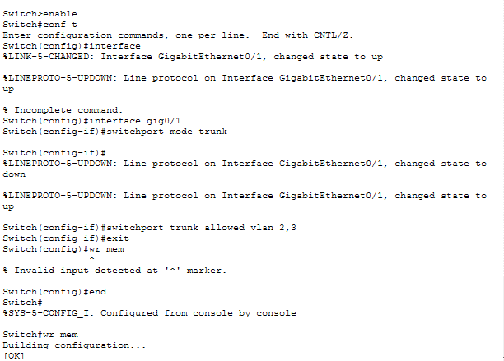
Switch1
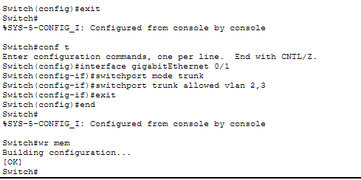
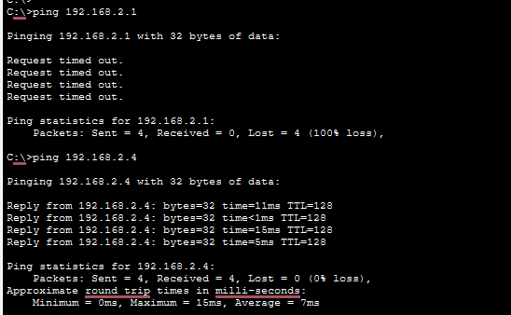
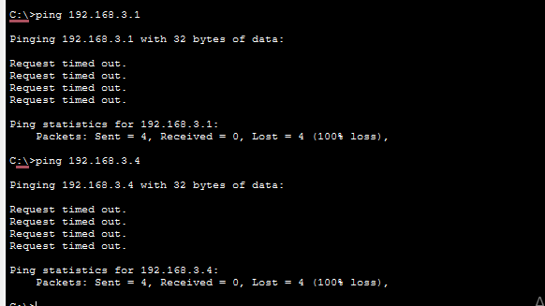
Practical task
PC8
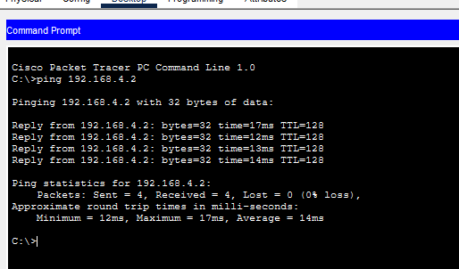
PC9
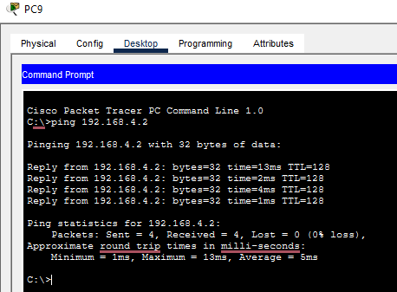
Final look
