Practice 4 - Methods of organizing

fail-safe communication channels
Student name:Serekbol Aksunkar
Student ID: 24B030056
Group: Wednesday 17-19

Part 1: Link Redundancy
  - Exploring STP set up
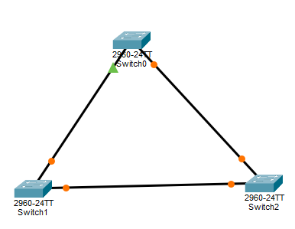
Step2
Switch0
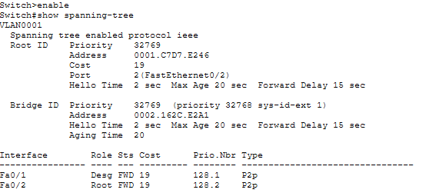
Switch1
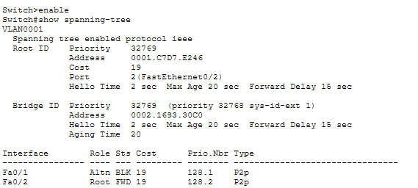
Switch3
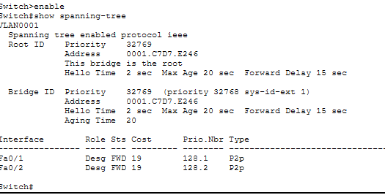
3. Identify which switch is the Root Bridge and why.
The Root Bridge is the switch with MAC address 0001.C7D7.E246.
It is identified as the Root Bridge because the output shows: “This bridge is the root.”
In STP, the Root Bridge is selected based on the lowest Bridge ID (Priority + MAC address).
4. Check port roles: Root Port (RP), Designated Port (DP), and Blocked Port.
Which port is in a blocking state(BLK) and why?
On the Root Bridge, all ports are Designated Ports (DP) and are in Forwarding (FWD) state.
On the non-root switch:
- Fa0/2 is the Root Port (RP) and is in Forwarding state.
- Fa0/1 is in Blocking (BLK) state and has the role Alternate (Altn).
Port Fa0/1 is in Blocking state to prevent a switching loop in the network. STP blocks one redundant link to ensure network stability.
5. What other state do you know?
Other STP port states are:
- Blocking
- Listening
- Learning
- Forwarding
- Disabled
These states help STP prevent loops and maintain a stable network.
Step3
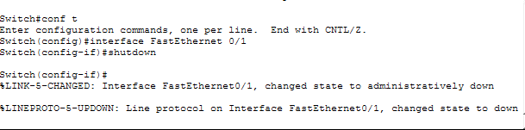
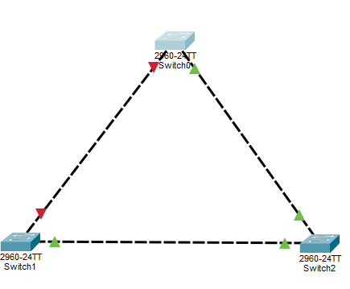
Switch2 show spanning-tree
s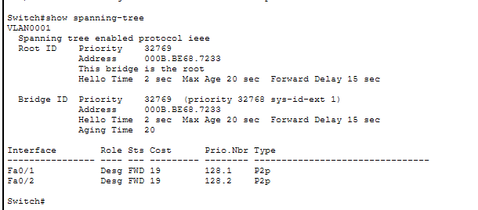

1.2 RSTP (Rapid STP)

PC0
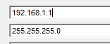
pC1
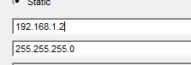
3. testing connectivity
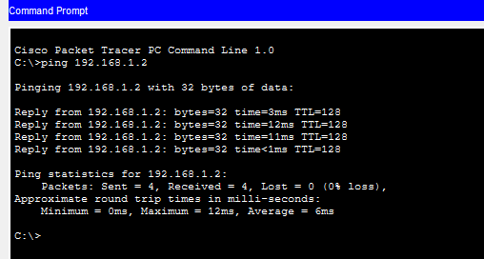
Step3
RSTP
Switch3
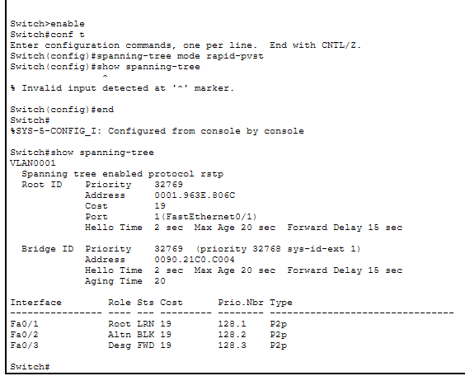
Switch4
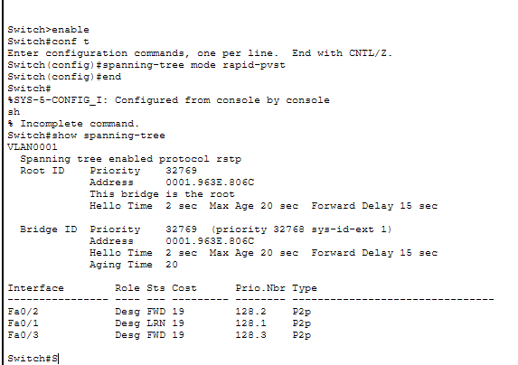
Step5 fail test
Switch4
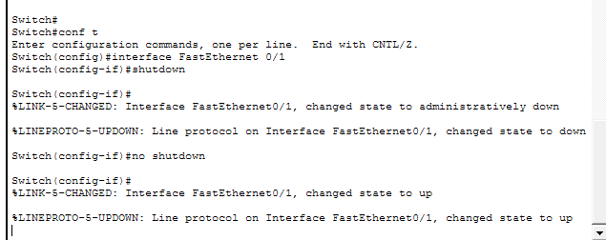

Part2
PC0
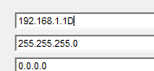
Switch0
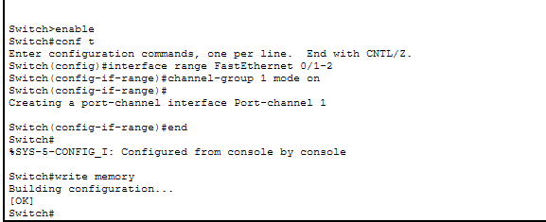
Switch1
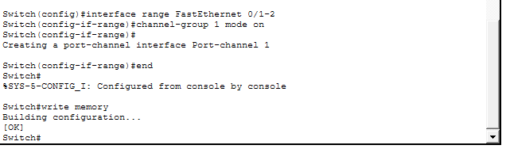
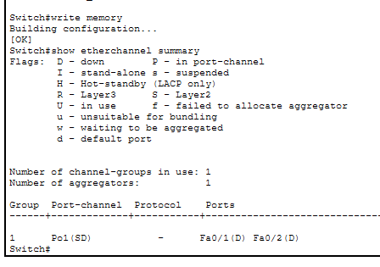
Independent task
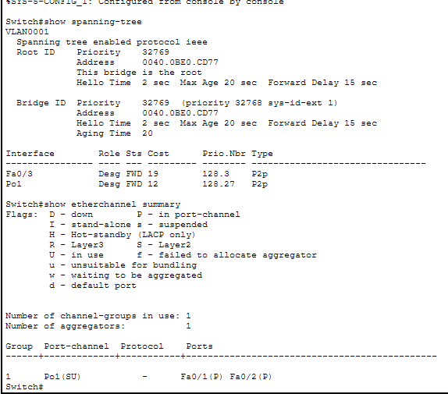
Shutdown and no shutdown
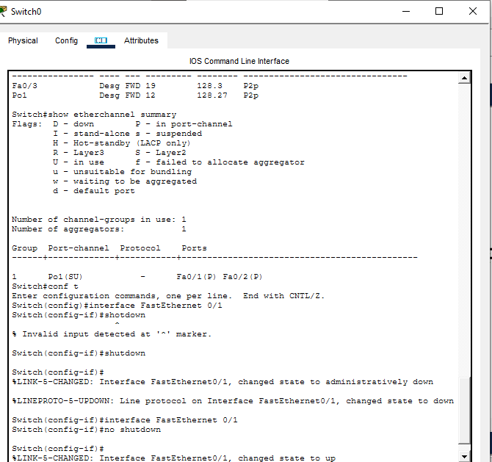
Ping
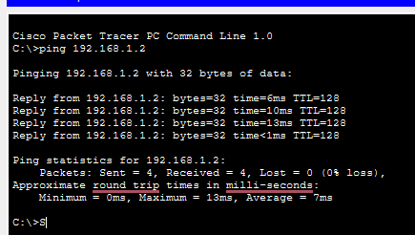
Answers:
1. After running the command show spanning-tree, I found that this switch is the Root Bridge, because the output says “This bridge is the root.”
Since it is the root switch, all its ports are in the Designated and Forwarding state.
- Fa0/3 – Designated, Forwarding
- Po1 – Designated, Forwarding
There are no blocked ports on this switch
2. Using show etherchannel summary, I confirmed that EtherChannel is working correctly.
The output shows Po1 (SU), which means:
- S → Layer 2
- U → In use
Interfaces Fa0/1 and Fa0/2 are successfully bundled into Port-channel 1.
3. I disabled interface FastEthernet0/1 using the shutdown command to simulate a link failure.
The interface went down as expected.
After that, I enabled it again using no shutdown, and the link returned to nor
4. I tested the connection using:
ping 192.168.1.2
All packets were received successfully (0% packet loss), which confirms that the network is stable and redundancy is working.

