Practice 5 – Work with L3 Switch

and Router
Student name: Serekbol Aksunkar
Student ID: 24B030056
Group: Wednesday 17:00-19:00
Part 1: L3 Switch
  - Routing between VLANs
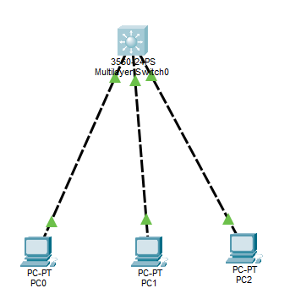

    - Create VLANs
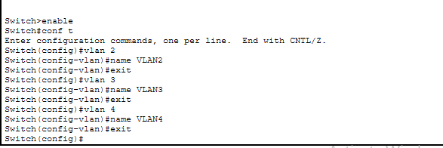
    - Assign Ports to VLANs
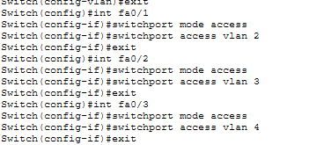
    - Assign IP Addresses to VLAN Interfaces
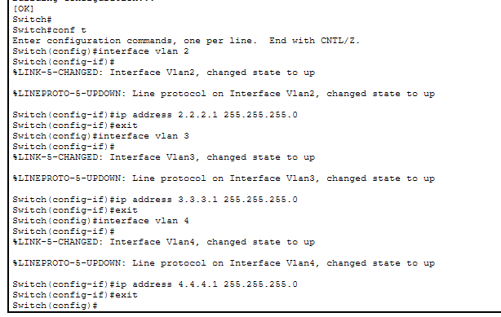
    - Configure PCs.
Pc0
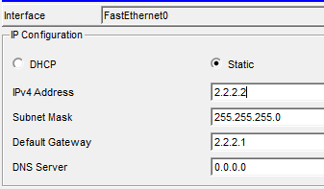
Pc1
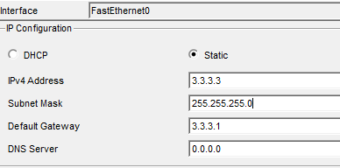
Pc2
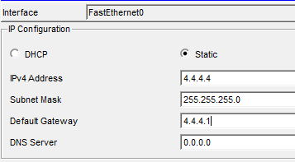
    - ip routing
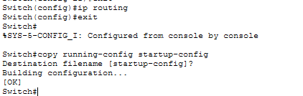
Answers:
- VLAN segmentation separates devices into different logical networks. It reduces broadcast traffic and improves security.
- The ip routing command enables the Layer 3 switch to route packets between different VLANs or networks.
- L2 switch only switches traffic, L3 switch can route traffic between networks.
  - L3 Switch as a Distribution Layer
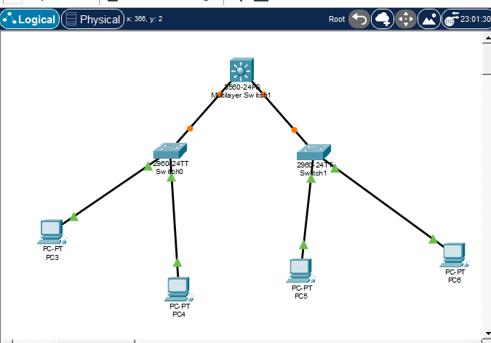
L2 swtich 0
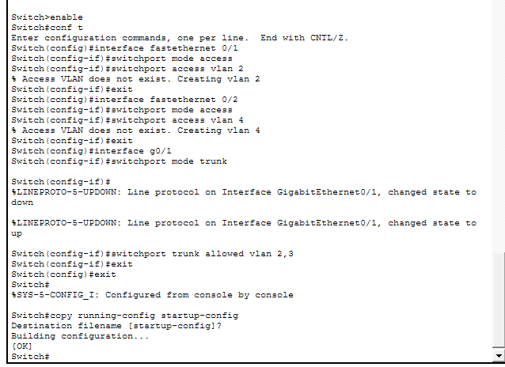
Switch1
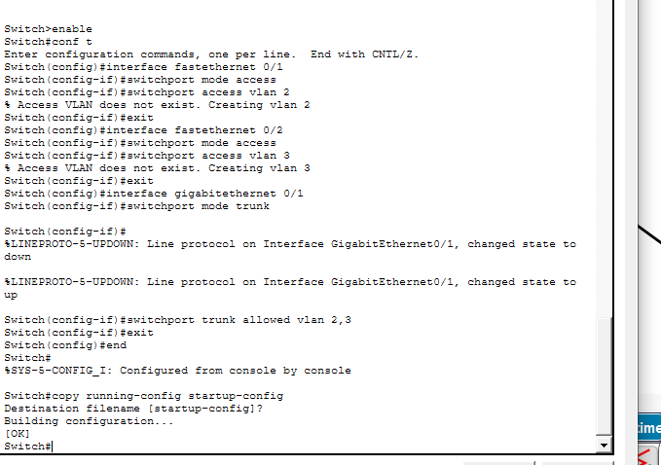
L3 switch
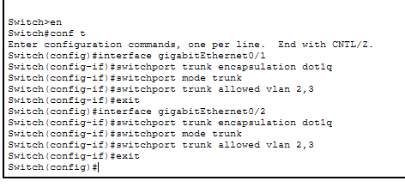
Ip routing
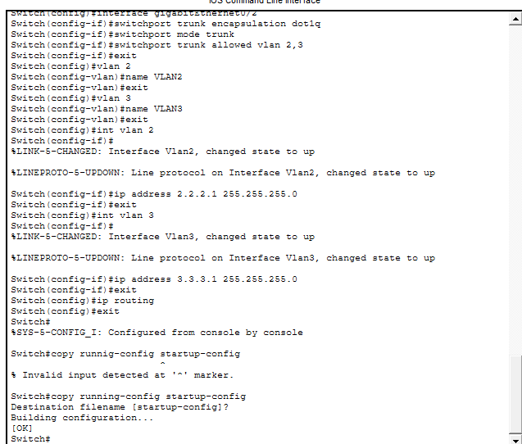
Configuring PCs
PC3 PC5 pc 4 PC6
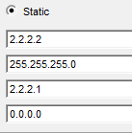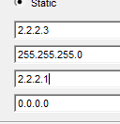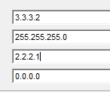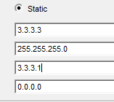
Pinging
PC3&PC4
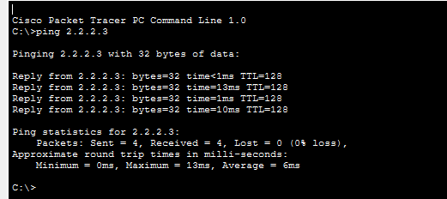

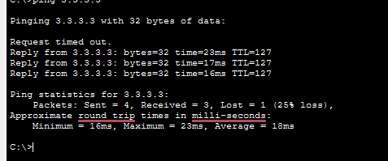
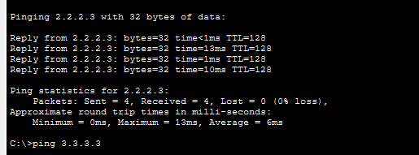
Part 2: Setting Up a Router for VLAN
Communication
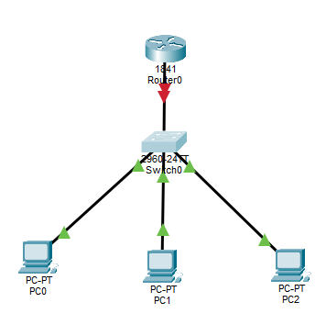
Switch configuration
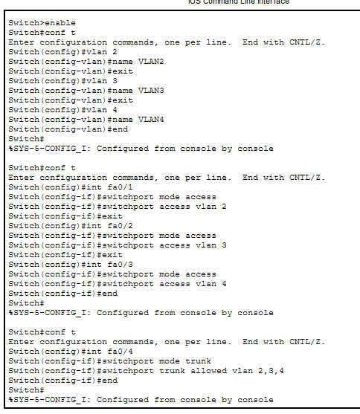
ROUTER CLI
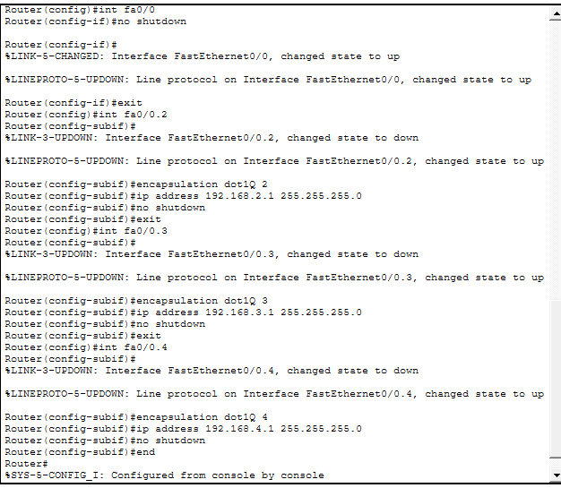
Answers:
- Trunk encapsulation defines the VLAN tagging method (e.g., 802.1Q) before enabling trunk mode.
- The switch creates the VLAN automatically so the port can be assigned to that VLAN.
- Devices in different VLANs will not be able to communicate with each other.
- An access port carries traffic for one VLAN, while a trunk port carries traffic for multiple VLANs.
- It enables VLAN tagging and assigns the subinterface to VLAN X.
- Subinterfaces allow the router to route traffic between multiple VLANs using one physical interface.
- It activates or enables a network interface.
TASK
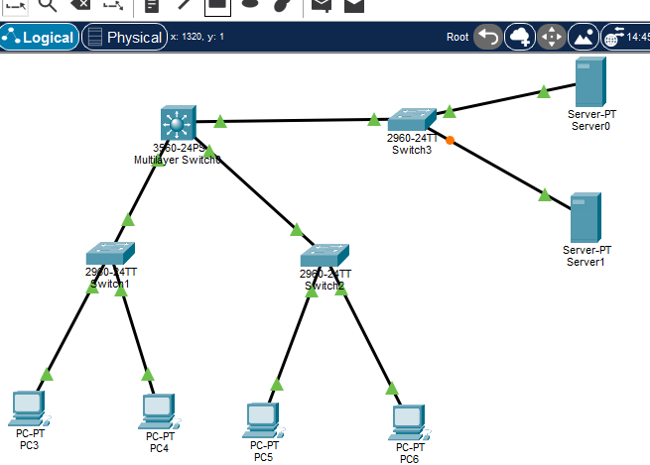
Steps:
- Vlan5 on l3
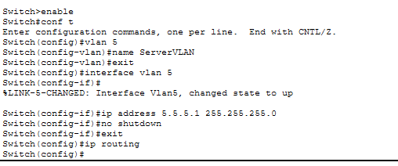
- L2 server 0
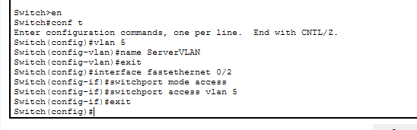
L2 server 1
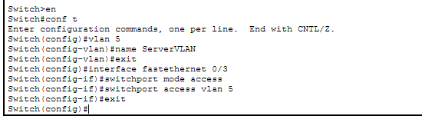
Vlan 2,3,4
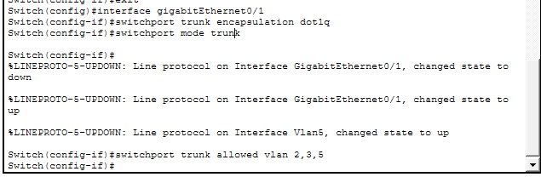
Switch 3
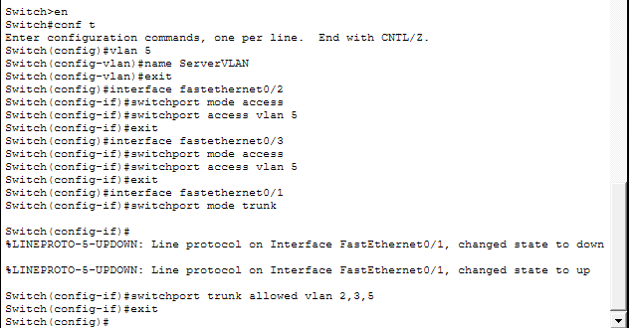
- Configure IP Addresses on the Serve
Server0 server1
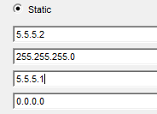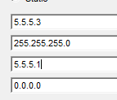
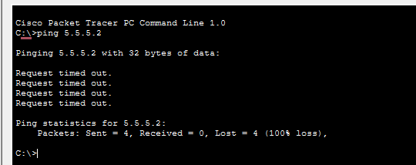
My pings are failed idk where is the problem

