Lab 5 - Static Routing
Student name: Serekbol Aksunkar
Student ID: 24B030056
Group: Wednesday 17:00-19:00
  - Topology and Components

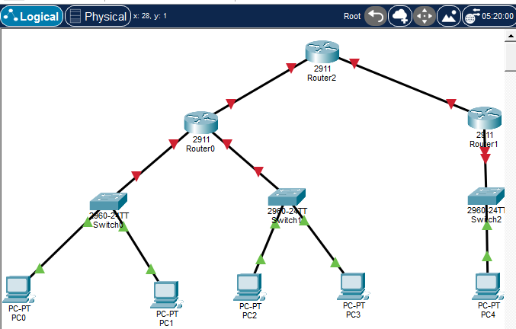
  - IP address configuration
- Router 0 configuration
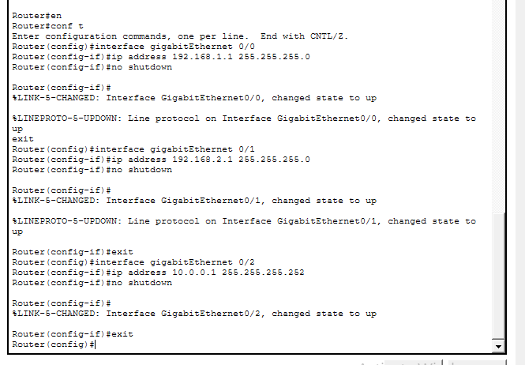
- Router1 configuration
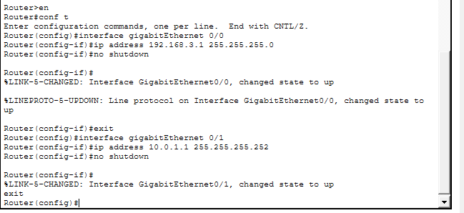
- Router2 configuration
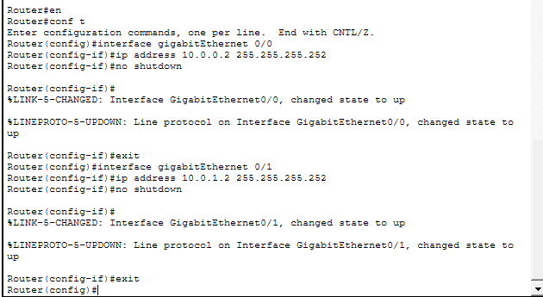
- PC0
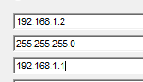
- PC1
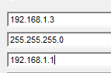
- PC2
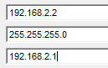
- PC3
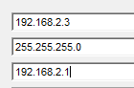
- PC4
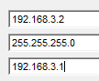
Result:
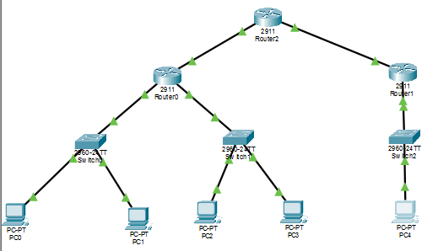
Pinging
PC0->PC1, router0
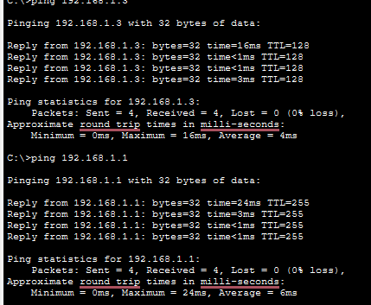
Pc0->pc2
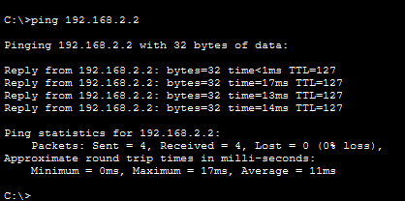
PC2->pc3, pc4 , router2 (every ping is success it means every part of topology is fully connected)
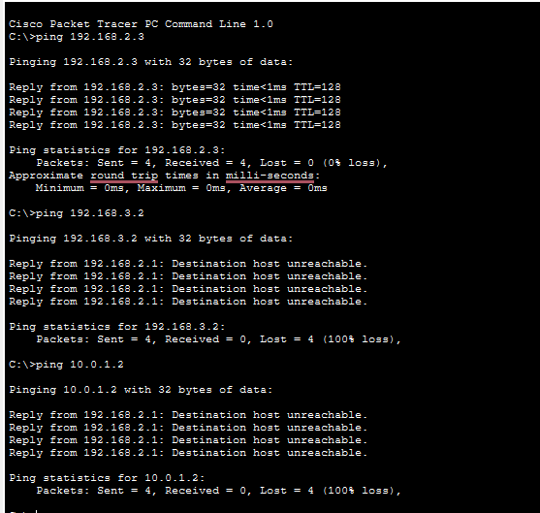
Part2: static routing configuration
2.1 router0:
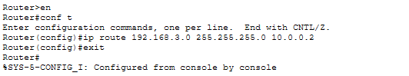
Router1:
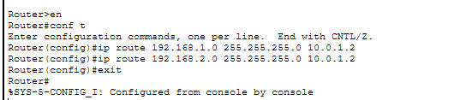
Router2
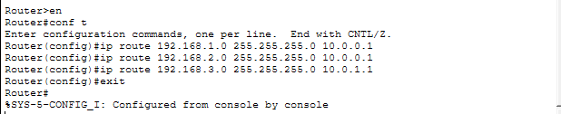
2.2 configure default routes
Router0
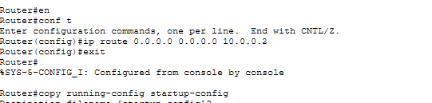
Router 1
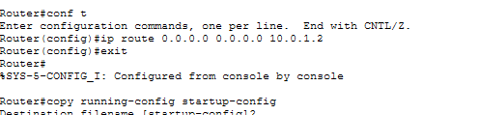
Part3 testing and vertification
Router0
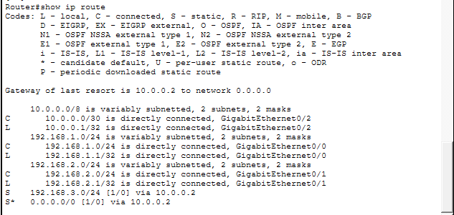
Router1
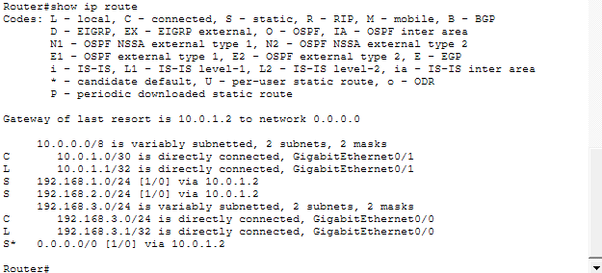
Router2
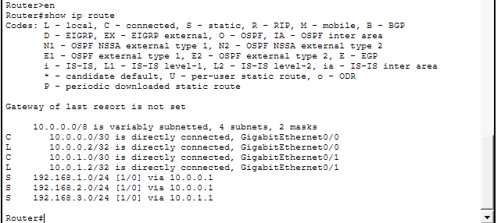
3.2 test connectivity with ping
Pc0->pc4
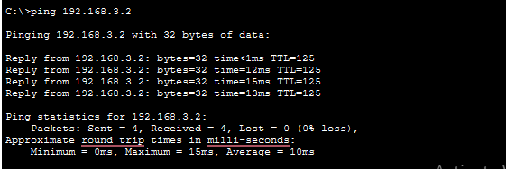
Pc3->pc4
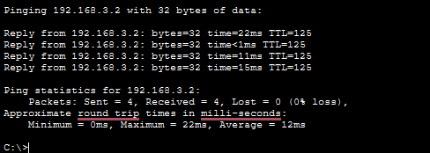
Part4: additional task-adding a new subnet
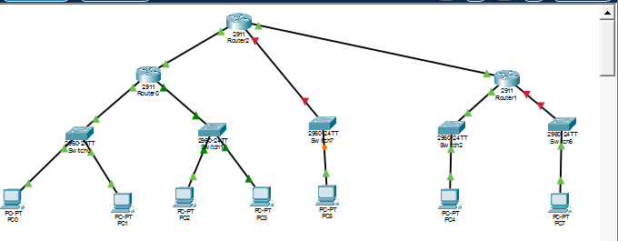
New PCs and switches(please do not pay attention for number of the PCs I deleted previous pcs due to wrong connectivity)
2. pc7 192.168.4.0 255.255.255.0
Pc8 192.168.5.0 255.255.255.0
3. 4. router1
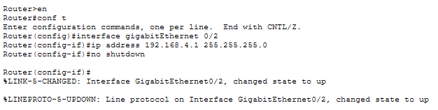
Router 2
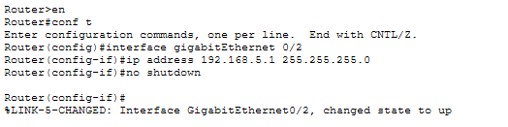
5.6 pc7
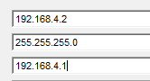
Pc8
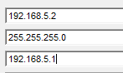
7. router0
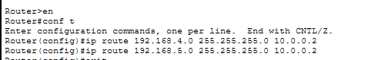
Router1
ROUTER2
8. ping PC0-> pc7, pc8
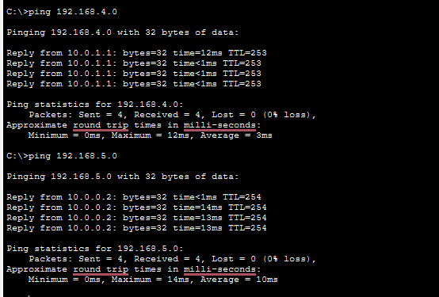
Part5
Remove static routes
Router0
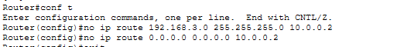
Router1
Router2
Configure OSPF
Router0
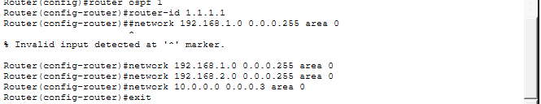
Router1
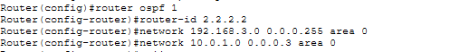
Router2
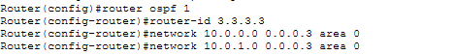
Vertification
Router0
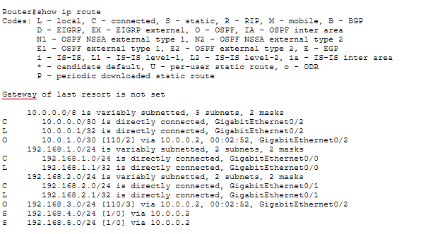
Router1
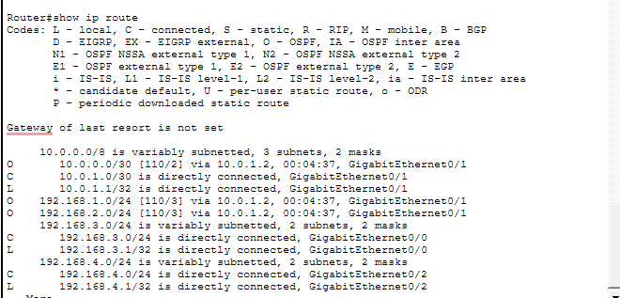
Router2
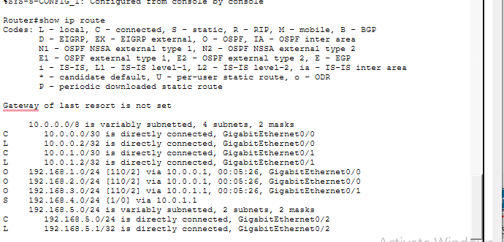
Testing connectivity
Pc0->pc4
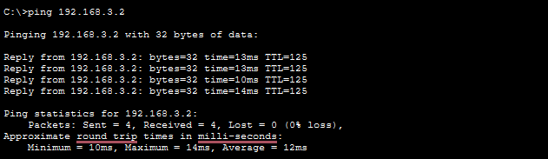
Pc3 ->pc4
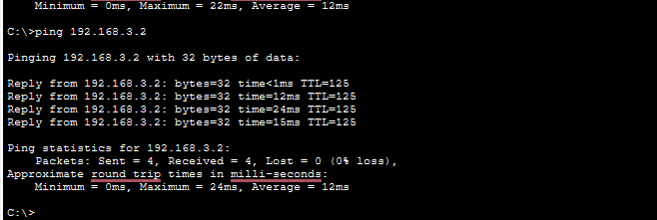
I found that Static Routing is okay for small networks, but it takes a lot of effort because I had to manually type every route on each router. When I added the new subnets for PC7and PC8, it became even more difficult to update everything again.On the other hand, OSPF was much easier and faster to configure. I only had to tell the routers about their own directly connected networks using wildcard masks, and they shared the information automatically. In my opinion, OSPF is much better for growing networks because it saves time and reduces by people errors.
In short:
Static routing<<<<<OSPF ^^
Answers :
- A specific static route tells the router exactly how to reach one particular network (like 192.168.3.0). A default static route (0.0.0.0 0.0.0.0) is a "catch-all" that the router uses for any destination it doesn't know.
- The router usually chooses the "longest match," which means the most specific route to the destination. If two routes are the same, it looks at the administrative distance or metric to find the best one.
- I would use the same command used to create it, but add the word no at the beginning. For example: no ip route 192.168.3.0 255.255.255.0 10.0.0.2
- It allows me to see if the routes are active in the routing table. Static routes are marked with the letter "S", so I can check if the destination network and the next-hop IP are correct.
- The main difference is how they update. In static routing, the admin must manually enter every path. In OSPF, routers automatically talk to each other and share network information.
- The "O" symbol stands for OSPF, meaning the router learned that specific route automatically through the OSPF protocol.
- OSPF uses wildcard masks (like 0.0.0.255) to tell the router which parts of the IP address must match exactly. It is basically the inverse of a subnet mask.
- Area 0 is the backbone area. In OSPF, all other areas must connect to Area 0 to share routing information between them.
- If a link fails, the routers immediately sense the change and talk to each other to find a new best path. The routing table updates automatically without me doing anything.
- I would use static routing for very small, simple networks with only one exit point. I would choose dynamic routing (like OSPF) for larger or growing networks because it is much easier to manage and updates by itself.

Final look:
