Practice 10 - Understanding and
Configuring the DHCP Protocol
Student name:Serekbol Aksunkar
Student id : 24B030056
Class: Wednesday 17:00-19:00

Part 1: Setting Up a Simple DHCP Network
Topology:
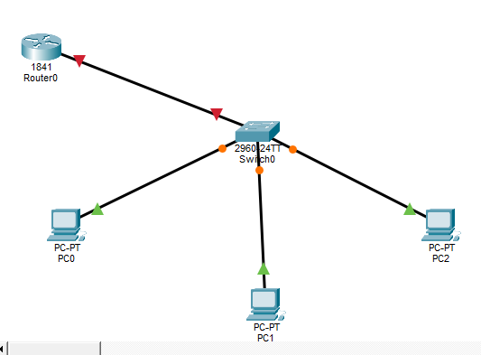
  - Router configuration
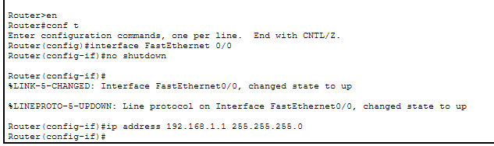
  - Configuring DHCP Pool on Router
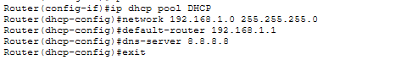
  - Excluding IP Addresses
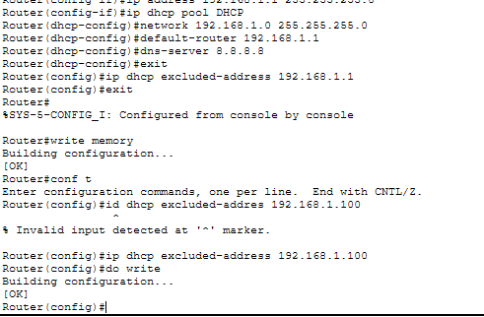
Explaining : I accidentally forgot to write 192.168.1.100, so I wrote it again ,there is no problem with excluding the ip address now .I hope everything is correct ^^
  - PC Configuration
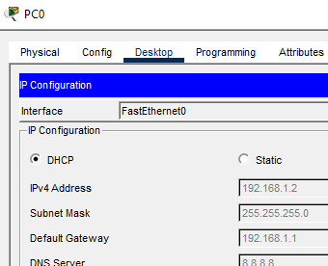

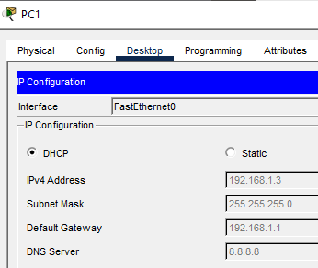
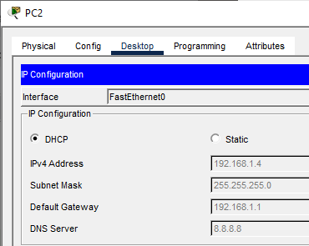
Step2

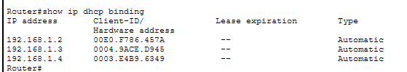
  - test connectivity
pinging PC0->PC1 , PC2
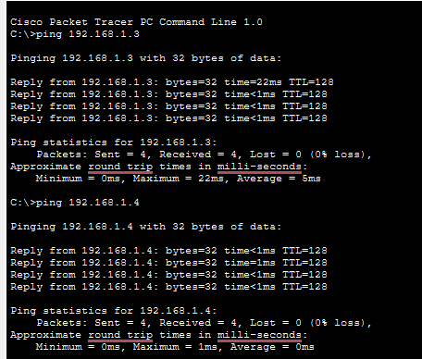
Final result:
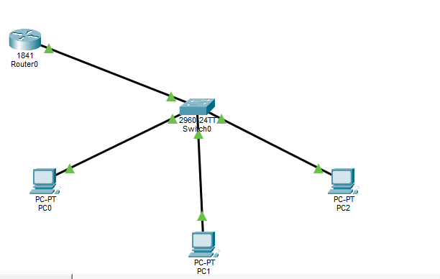

Part 2: VLAN Configuration with DHCP Relay
Topology :
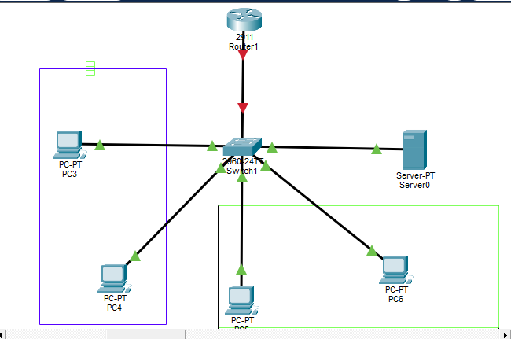
2.1.1 Create VLANs and Assign Names
Creating vlan 2,3,4
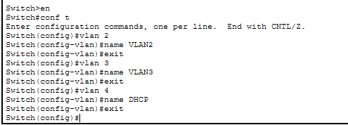

2.1.2 Assign VLANs to Switch Ports
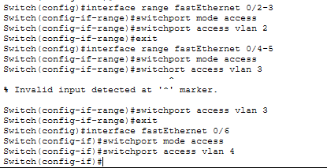
2.1.3 Configure the Trunk Port
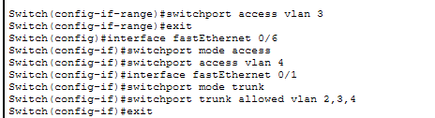
2.1.4 Save Configurations

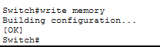
2.2 Configuring Sub-Interfaces on the Router for Inter-
VLAN Routing
2.2.1 Configure Sub-Interface for VLAN 2
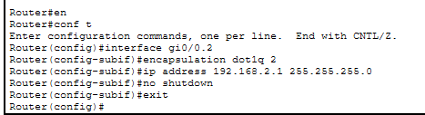
2.2.2 Configure Sub-Interface for VLAN 3
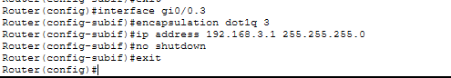
2.2.3 Configure Sub-Interface for VLAN 4(DHCP VLAN)
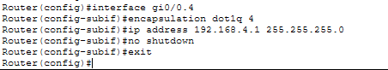
2.2.4 Enable Physical Interface GigabitEthernet 0/0
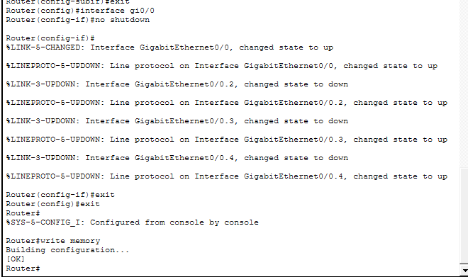
2.3 Configure DHCP Server
2.3.1 Assign IP Address to the Server
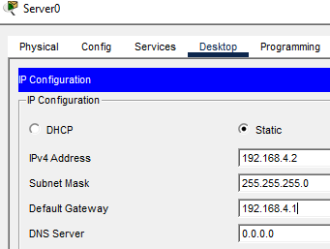
2.3.2 Configure DHCP for VLAN2
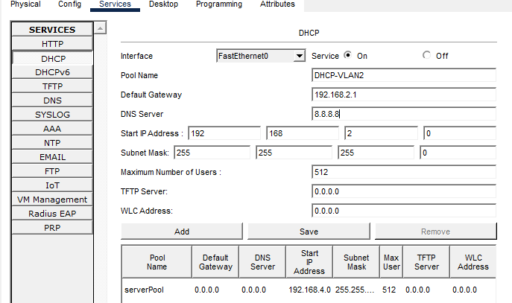
Added:
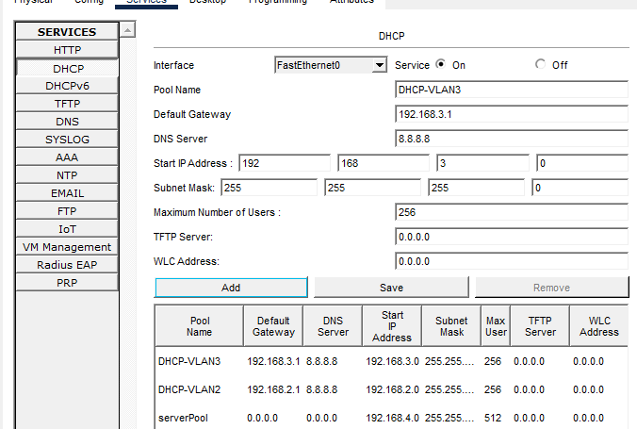

Configure DHCP for VLAN 2
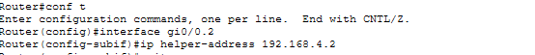
Configure DHCP for VLAN 3
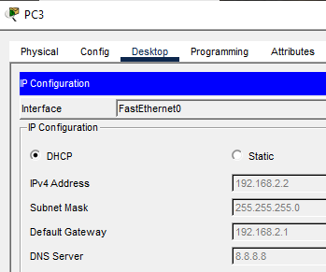

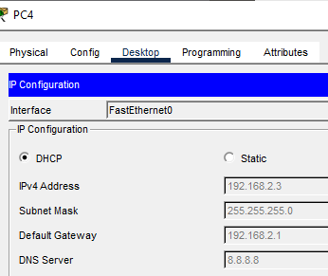
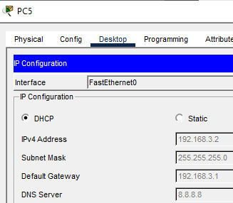
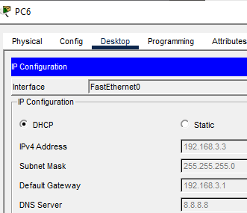
2.6 Test Connectivity
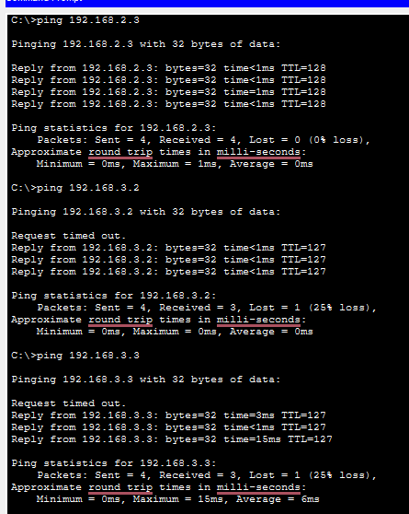
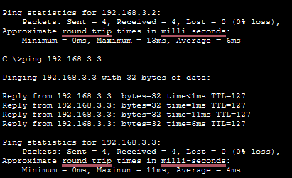
Final result:
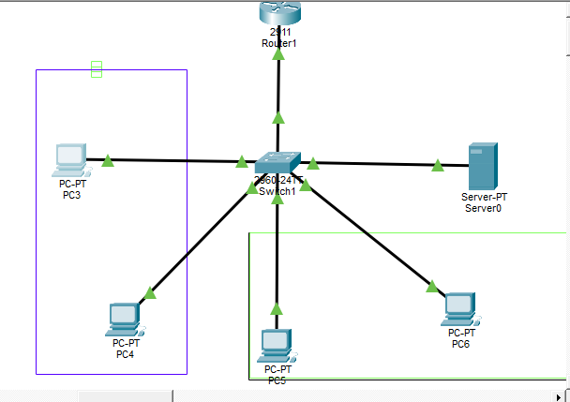

Part 3: Additional Task - Add new VLAN
- Added two more PCs on my topology
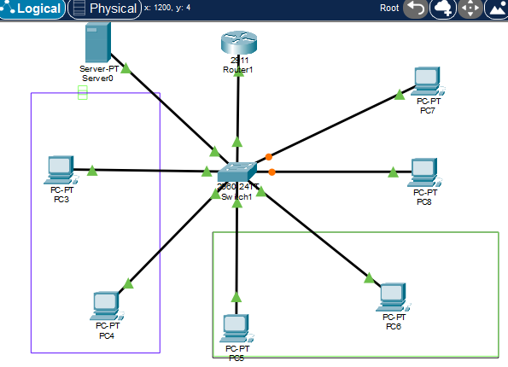
- Creating VLAN5 fastethernet0/7-8
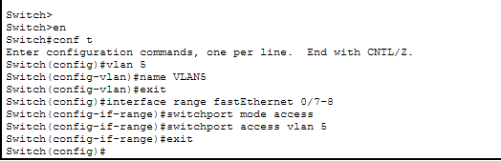
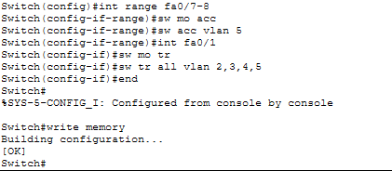
- In the Router create a sub-interface GigabitEthernet 0/0.5 with VLAN encapsulation
dot1Q 5.Then assign IP address 192.168.5.1/24 to the sub-interface
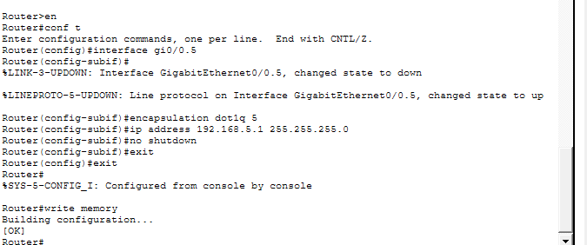

- DHCP Configuration in the Server. Set up a DHCP pool for VLAN 5
- 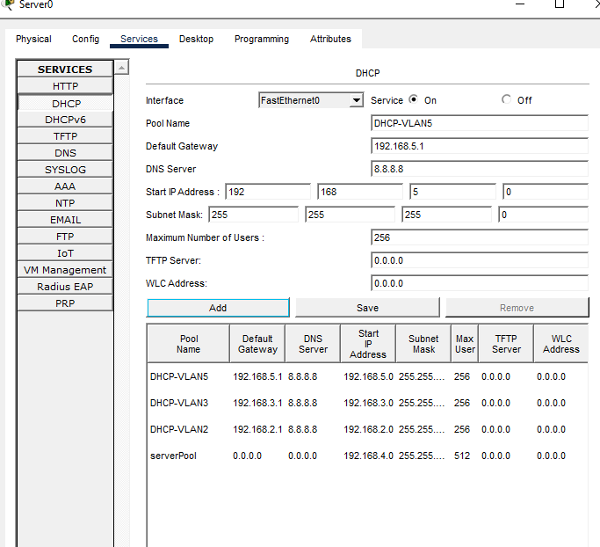
5. If the DHCP server is in VLAN 4, configure ip helper-address 192.168.4.2
on the sub-interface for VLAN 5.
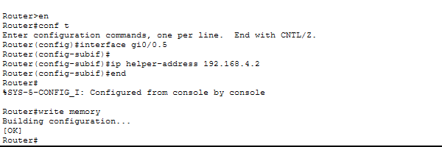
6. Verify that devices in VLAN 5 receive IP addresses via DHCP and can communicate
with other VLANs
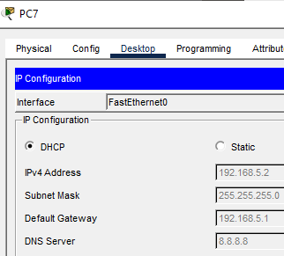
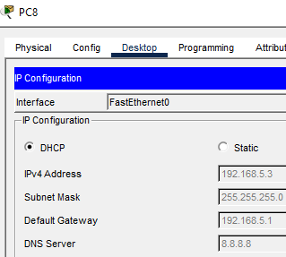
Pc8-> pc9 , pc3
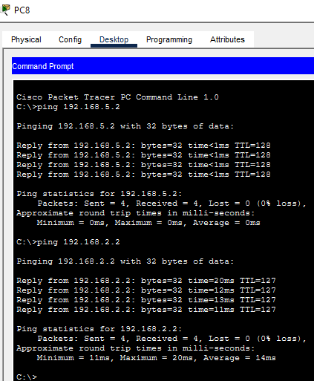
Pc7->pc8,pc3,pc4
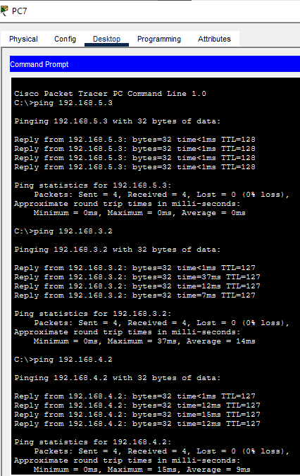

Final result:
