AIRFOIL SELECTION AND AERODYNAMIC
ANALYSIS BY ATHARV S. (B26063)
Two RC aircraft: payload stability vs aerobatic manoeuvrability

Hi,My name is Atharv Shrivastava , i have a genuine interest in rc plane , making it optimum for flying wrt its aerodynamics , steamline flow and countering drag force while increasing the glide ratio , I would love to be a part of this team and contribute to fullest , about this report , I have used ai for the data and writing things properly ,rest excel sheets are made by me, diagrams are generated by claude and pictures are taken from google but apart from it , I am familiar with the terms and would be able to explain what I have written (mostly ;))

1. Aim and assumptions
Aircraft A is a conventional fixed-wing RC aircraft intended to carry the largest practical payload while retaining predictable, stable flight. Aircraft B is an aerobatic RC aircraft intended for rapid turns, rolls and loops. Both are assumed to fly at low subsonic speed, without deployable high-lift devices. For a representative small-RC comparison, use a chord-based Reynolds number Re = 2.0 × 10⁵ as the initial analysis point; the actual value must be recalculated from Re = ρVc/μ using the aircraft's speed and mean chord. Airfoil coefficients vary with Reynolds number, angle of attack, surface finish and transition assumptions, so there is no single universal Cl, Cd or Cl/Cd for a named profile.

2. Candidate shortlist and selection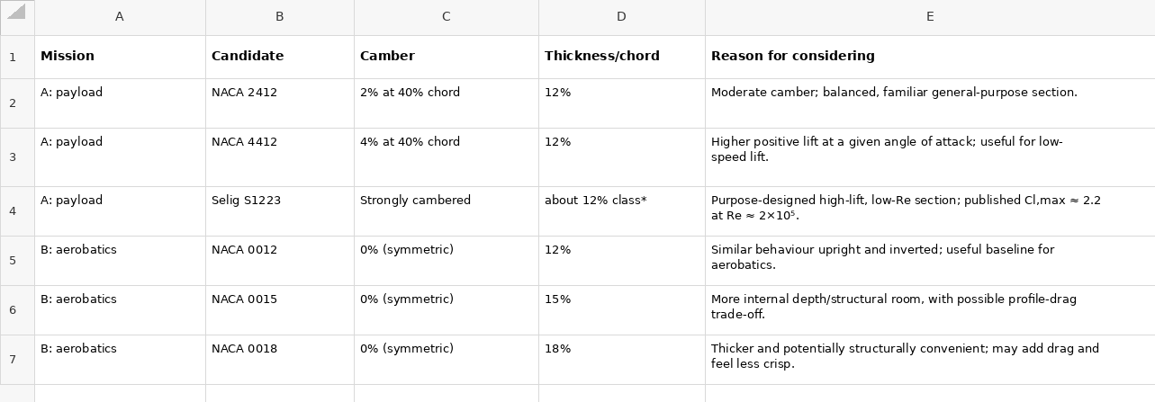
S1223 is a specialist high-lift section; confirm its exact coordinates and thickness from the chosen coordinate file before designing the spar. Recommended selections: Aircraft A — NACA 4412 as the practical baseline; Aircraft B — NACA 0012 as the aerobatic baseline. If Aircraft A's overriding requirement is minimum stall speed/short take-off at Re near 2×10⁵, test S1223 as an alternative, but do not assume its very high lift automatically gives the best overall payload aircraft.

3. Aerodynamic comparison
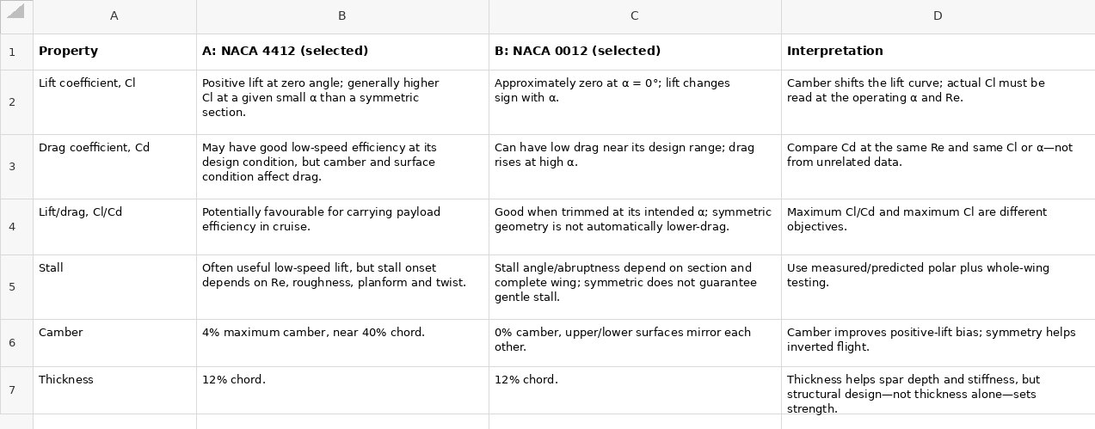
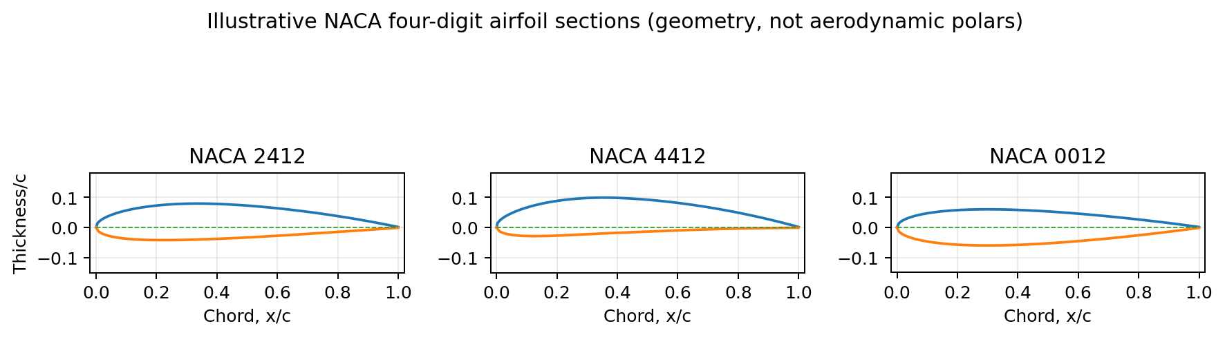
THIS FIGUREE: NACA profile geometry generated from the standard four-digit definition. These are shape illustrations, not measured aerodynamic data.
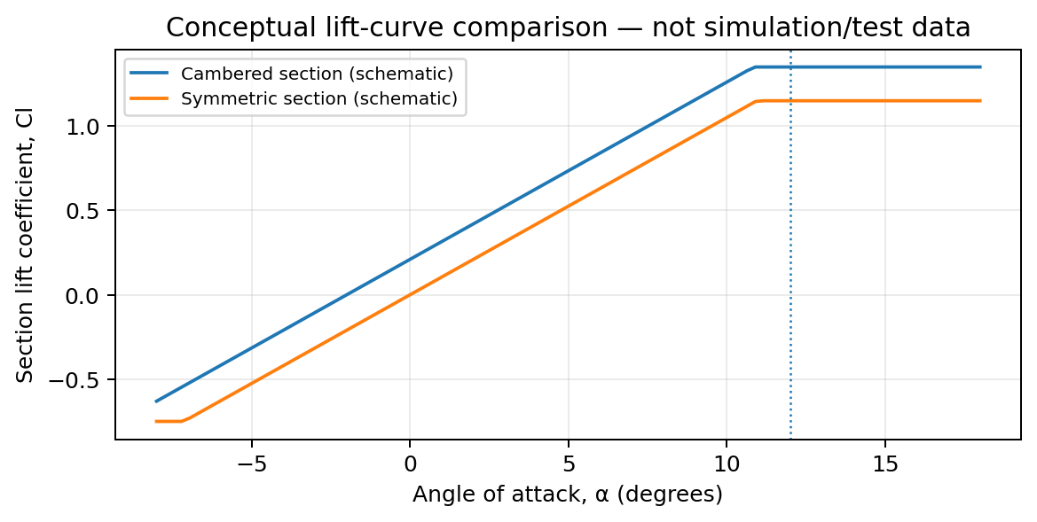
Figure 2. Conceptual lift-curve sketch only; it is not an XFOIL/XFLR5 result and must not be reported as measured data.

4. How geometry changes performance
Camber changes the zero-lift angle and the lift produced at a given angle of attack. A cambered section is usually attractive for a payload aircraft that spends most of its time upright, because it can generate useful positive lift at a relatively small angle. A symmetric section produces approximately zero lift at zero angle of attack and can produce positive or negative lift in a similar way, making upright and inverted aerobatic flight more balanced. Greater thickness can provide more room for a spar, wiring and a rigid wing structure, but may increase pressure drag depending on the profile and operating point. Leading-edge shape, thickness distribution and pressure recovery affect boundary-layer separation and stall. No geometry guarantees a particular stall; low-Reynolds-number laminar separation bubbles and surface imperfections can change the result.
One airfoil can fly both missions, but it is a compromise. NACA 2412 or 4412 is sensible for a general-purpose aircraft that mostly flies upright and needs useful lift. It is less balanced for sustained inverted flight because camber creates a pitching-moment and lift asymmetry. NACA 0012 is a reasonable aerobatic choice and can carry a payload if the wing area, speed and power are adequate, but it may need a higher angle of attack or more wing area than a strongly cambered high-lift design for the same low-speed lift target. Use separate airfoils if the missions are genuinely different; otherwise, choose the section that suits the dominant mission and tune the rest of the aircraft. 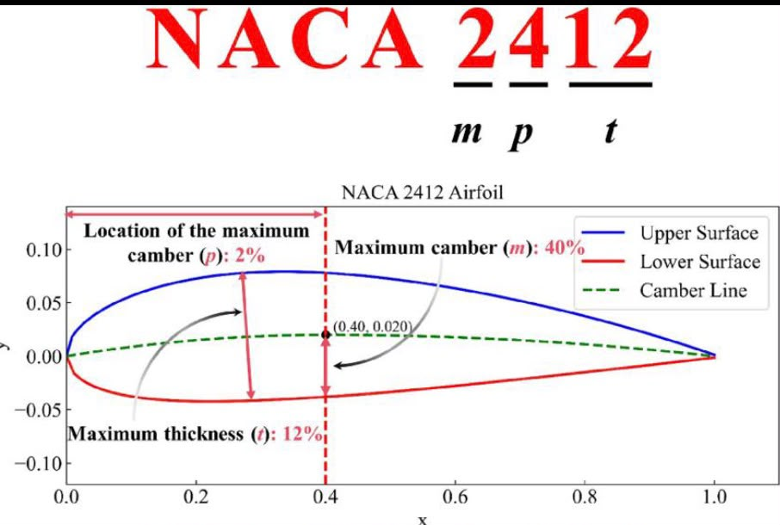

6. Airfoil vs whole-aircraft effects
Airfoil data describe a two-dimensional wing section. Maximum payload and handling depend on more than the section: (1) wing area and wing loading W/S set the lift coefficient needed in flight and strongly affect stall speed; (2) aspect ratio and planform influence induced drag and roll response; (3) centre of gravity, tail volume and static margin influence stability; (4) aileron/elevator/rudder size, placement and servo speed determine control authority; (5) spar, skin, joints and flutter margin determine safe structural limits; (6) motor/propeller thrust, battery mass and power determine climb and acceleration. At a steady level condition, L = W and L = ½ρV²SCl. Thus a high Cl,max can lower stall speed, but payload capacity still requires sufficient total lift, structural strength, thrust and controllability.

7. Bonus analysis: reproducible XFOIL/XFLR5 s
No numerical XFOIL/XFLR5 polar is claimed in this report. To complete the bonus honestly, import coordinate files for NACA 2412, NACA 4412
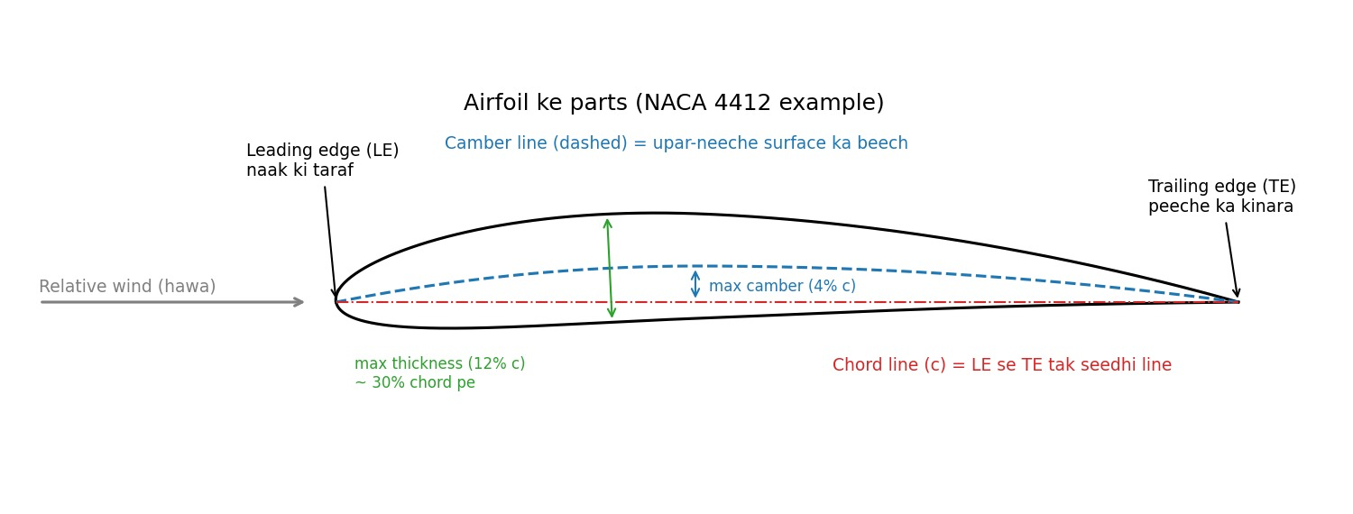, S122s3, NACA 0012, NACA 0015 and NACA 0018; use identical conditions for every profile: Re = 200,000, Mach = 0.0, Ncrit = 9 (state this assumption), and sweep α from −6° to +16° in 0.5° increments. Save plots of Cl vs α, Cd vs α, Cl/Cd vs α, and Cm vs α. Record Cl,max, maximum Cl/Cd, the α at each maximum, and any solver convergence failures. Use the same transition/roughness settings and report them. XFOIL is a prediction method, not a substitute for wind-tunnel or flight validation; near stall, convergence and accuracy can deteriorate. Do not present the conceptual sketch in Figure 2 as the requested simulation plot.

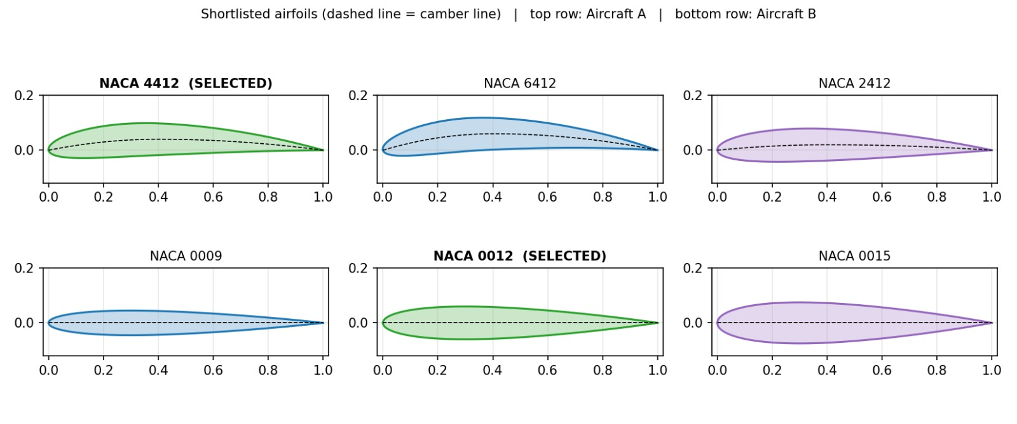
THESE ARE THE SHAPES DISCUSSED IN THIS RESEARCH AND THE BOLD ONES ARE THE PRIORTISED (SELECTED) ONES

References
- 1. NASA, “NACA Airfoils,” explanation of NACA airfoil numbering and geometry (2017): https://www.nasa.gov/image-article/naca-airfoils/
- 2. Selig, M. S. & Guglielmo, J. J. (1997), “High-Lift Low Reynolds Number Airfoil Design,” Journal of Aircraft, 34(1), 72–79. DOI: 10.2514/2.2137. Open paper: https://m-selig.ae.illinois.edu/pubs/GuglielmoSelig-1997-JofAC-S1223.pdf
- 3. University of Illinois, UIUC Airfoil Data Site, coordinate database including S1223: https://m-selig.web.engr.illinois.edu/ads/coord_database.html
- 4. NASA Technical Reports Server, “Tests of N.A.C.A. 0009, 0012, and 0018 Airfoils in the Full-Scale Tunnel,” NACA-TR-647 (1938): https://ntrs.nasa.gov/search.jsp?R=19930091723
- 5. Foil.tools, NACA 4412 geometry and analysis interface (use as a secondary reference): https://foil.tools/foil/naca4412
Engineering note: the recommended sections are starting points, not final proof of optimality. Final selection should be based on the actual aircraft chord, speed, wing loading, structure, control layout and comparable polar data.

THANKING YOU!!

