Go Live

A Travelling Social Network

**UML Diagram**

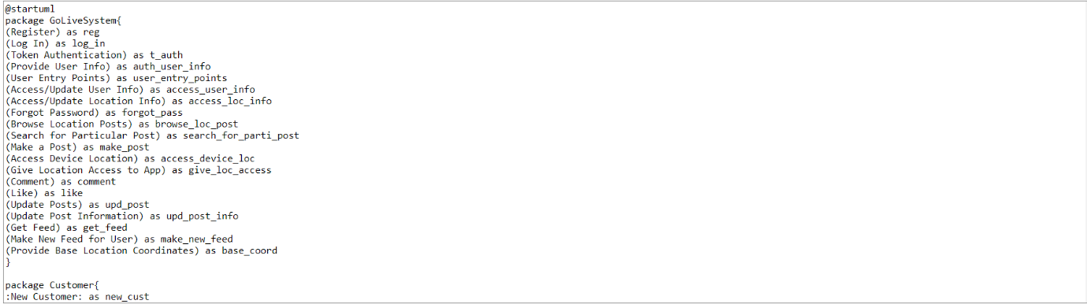

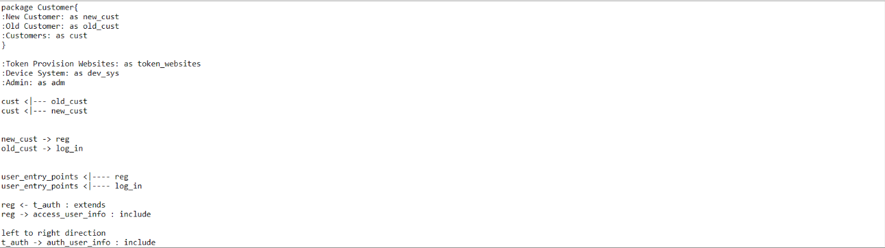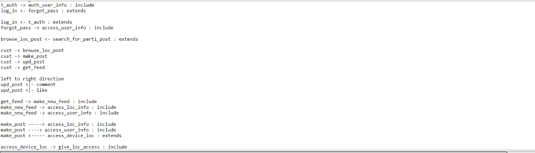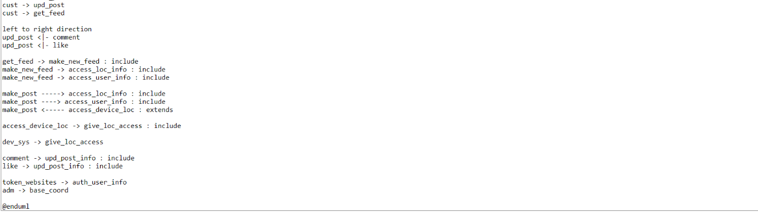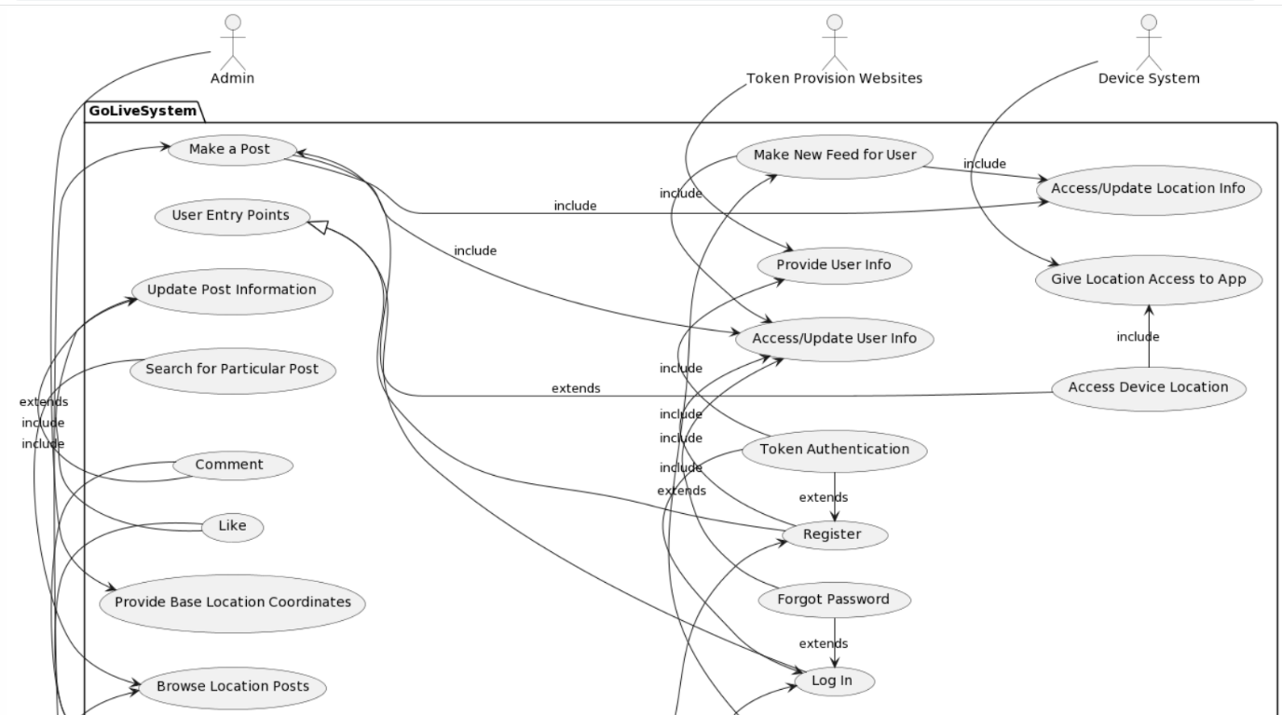

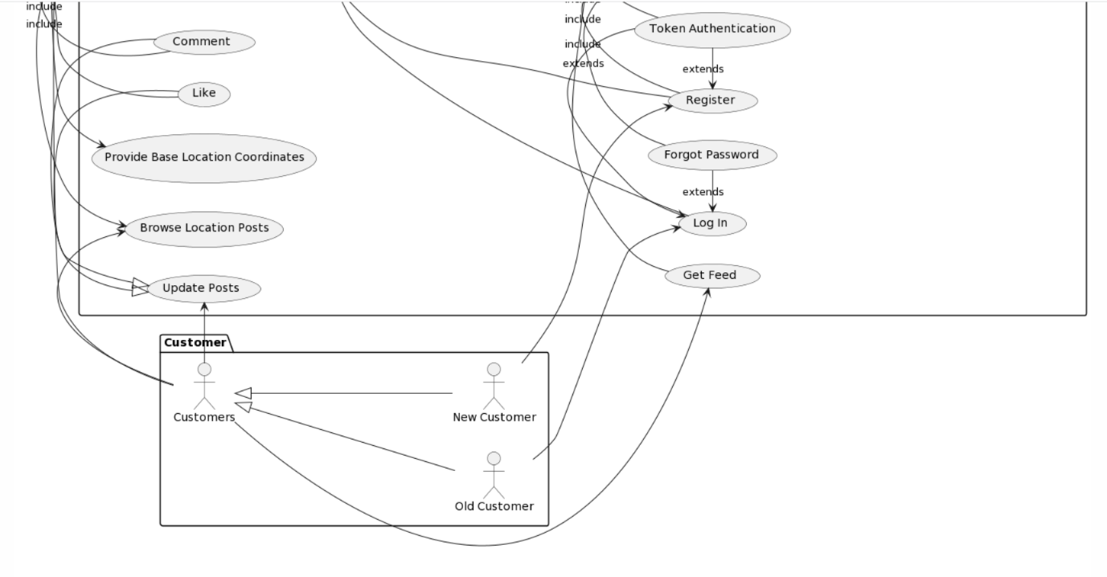

PTO

**Sequence Diagram**