**Sales Data Analysis Report: Commercial Store**

**1 Introduction:**

* The purpose of the analysis:

The purpose of this sales data analysis is to explore sales performance for different products and categories, identify trends over time, and provide insights for improving sales strategies.

**2 Data Overview**:

* A short description of the data i analyzed (mention what the data includes, like dates, products, sales amounts, etc.):

The dataset consists of sales data for four products (Product A, Product B, Product C, and Product D) across four categories (Electronics, Furniture, Clothing, and Accessories) over a period of 100 days, starting from January 1, 2023. The data includes daily sales figures, product quantities sold, and product categories.

**3 Key Findings**:

* Summarize the key insights i gathered:

- Product B had the highest total sales, while Product A had the lowest.

- Sales peaked in March and April, showing a seasonal trend.

- The Electronics and Furniture categories were the highest performers, with Accessories having the lowest sales.

**4 Visualizations**:

* Generated (sales by product, sales trends over time, sales by category)

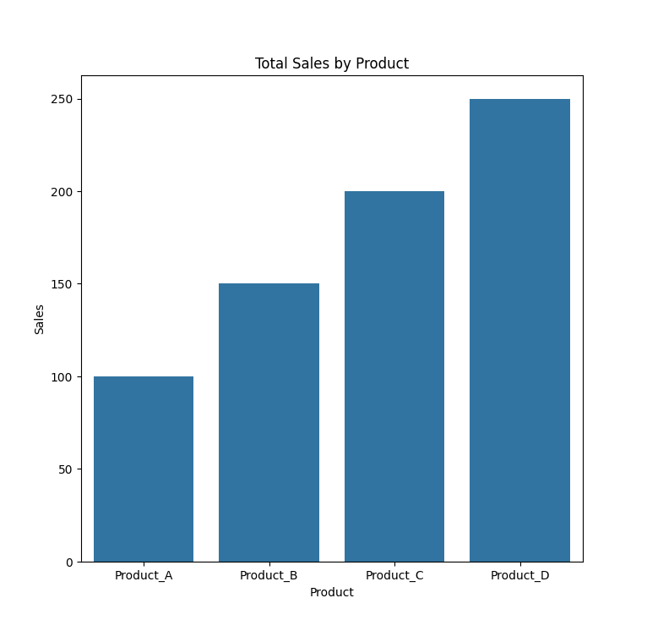

* Image files or Python with this code:

plt.savefig('sales_by_product.png')

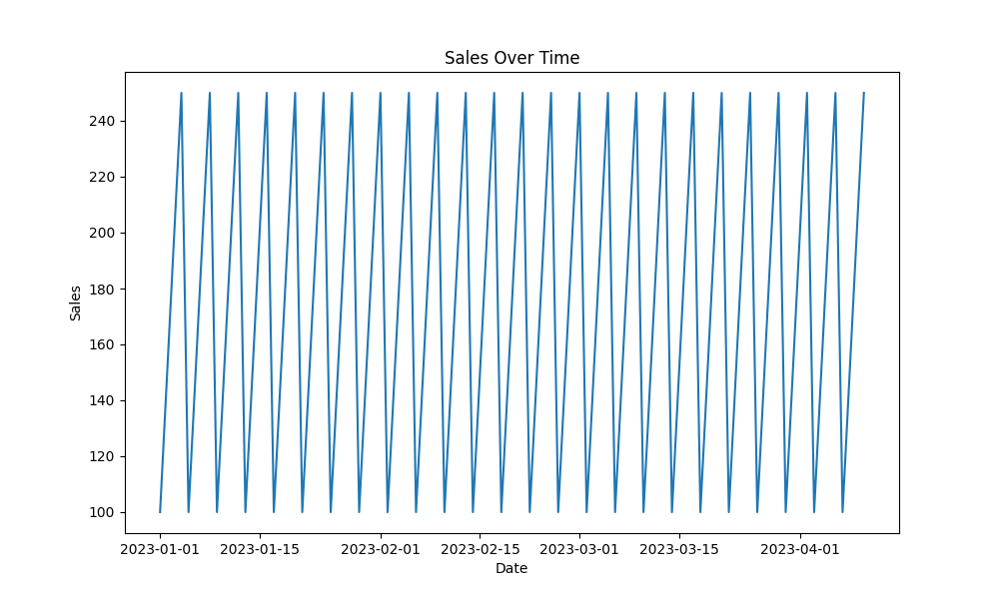

**5 Conclusion**:

* Analysis, write a conclusion or recommendation:

Based on the analysis, it is recommended that Product A and the Accessories category receive additional marketing efforts to boost sales. Seasonal sales promotions should be considered during peak periods to maximize revenue.