Iris Flower Classification

Aktan Ruslanov

**Introduction** **(Approx. 600 words):**

* Overview of the Iris Flower Classification project, emphasizing its significance in botany and machine learning.
* Importance of species classification in understanding plant diversity and ecological studies.
* Detailed introduction to the Iris dataset, its origins, and its relevance as a benchmark dataset in machine learning for classification tasks.

**Problem Statement and Objective** **(Approx. 600 words):**

* Precise definition of the classification problem: Predicting iris species based on sepal and petal measurements.
* Clear articulation of the project objective: Develop a machine learning model that accurately predicts iris species.
* Discussion on the implications of accurate species classification in botanical research, horticulture, and species conservation efforts.

**Data Collection and Preprocessing** **(Approx. 1200 words):**

* Detailed description of the Iris dataset and its attributes (sepal length/width, petal length/width, species labels).
* Comprehensive preprocessing steps, including handling missing values, data normalization, and encoding categorical variables.
* In-depth Exploratory Data Analysis (EDA) showcasing relationships between features, class distributions, and potential outliers.

**Feature Engineering** **(Approx. 1000 words):**

* Extensive discussion on feature selection methodologies based on correlation analysis and domain knowledge.
* Advanced feature engineering techniques like scaling, transformation, and creation of synthetic features to enhance model performance.
* Insights into the significance of feature selection and its impact on model interpretability and accuracy.

**Model Building** **(Approx. 1500 words):**

* In-depth exploration and comparison of various classification algorithms (k-NN, decision trees, SVM, etc.) applied to the Iris dataset.
* Detailed explanation of evaluation metrics (accuracy, precision, recall, F1-score) used to assess and compare model performance.
* Rigorous exploration of hyperparameter tuning strategies, cross-validation techniques, and model optimization.

**Model Evaluation and Interpretation** **(Approx. 1000 words):**

* Thorough evaluation of the final models on test data, including robustness testing and assessing generalization capabilities.
* Detailed interpretation of model results, feature importance, and visualizations (confusion matrix, ROC curves) to derive actionable insights.
* Discussion on the model's alignment with project objectives and implications of its predictions in real-world applications.

**Challenges and Future Enhancements** **(Approx. 500 words):**

* Comprehensive discussion on challenges faced during the project (overfitting, data quality issues) and mitigation strategies.
* Insights and recommendations for future enhancements, such as incorporating additional features, exploring ensemble methods, or utilizing more advanced techniques like neural networks.

**Conclusion** **(Approx. 500 words):**

* Summarization of the entire project, emphasizing key findings, achievements, and the significance of accurate species classification.
* Reinforcement of the project's impact on botanical studies and the broader implications of machine learning in advancing botanical research and conservation efforts.

**Introduction**

The Iris Flower Classification project serves as a quintessential example within both the realms of botany and machine learning, offering profound insights into species classification and paving the way for foundational methodologies in predictive modeling. This introduction delves into the project's dual significance, emphasizing its pivotal role in advancing our understanding of plant diversity while also showcasing its relevance as a cornerstone dataset in the domain of machine learning for classification tasks.

**Significance in Botany and Ecological Studies:**

Species classification stands as a cornerstone in botanical studies, offering a fundamental framework for understanding plant diversity, distribution patterns, and ecological dynamics. By accurately categorizing plant species, researchers gain crucial insights into their habitats, adaptations, and evolutionary relationships. The Iris Flower Classification project plays a pivotal role in this domain by exemplifying the application of machine learning techniques to classify distinct iris species based on their morphological attributes.

Botanists and ecologists rely on species classification not only for academic endeavors but also for real-world applications such as conservation efforts, ecosystem monitoring, and understanding the impact of environmental changes. The accurate identification of plant species, as demonstrated by this project, holds immense value in preserving biodiversity and addressing ecological challenges.

**Introduction to the Iris Dataset:**

The Iris dataset, originally compiled by the biologist Ronald Fisher in 1936, remains an enduring exemplar in the field of machine learning. Comprising measurements of sepal and petal dimensions across three distinct species of iris flowers (Iris setosa, Iris versicolor, and Iris virginica), this dataset serves as a foundational resource for exploring classification algorithms and methodologies.

Its enduring relevance lies in its simplicity yet richness of information, making it an ideal playground for beginners and seasoned practitioners alike to delve into classification tasks. With 150 samples, 50 for each iris species, and four features (sepal length, sepal width, petal length, and petal width), the dataset offers a balanced and manageable set of data points for training and evaluating machine learning models.

Moreover, its well-defined nature and lack of missing values make it an ideal starting point for experimenting with various classification algorithms. Its role as a benchmark dataset has cemented its place in academic research, tutorials, and as a benchmark for evaluating the performance of new classification techniques.

In essence, the Iris dataset serves as a foundational bedrock, exemplifying the confluence of botany and machine learning, and continues to be an indispensable resource for understanding classification algorithms and their applications in diverse domains.

**2.****Problem Statement and Objective**

The crux of the Iris Flower Classification project lies in its precise classification task: predicting the species of iris flowers based on distinct measurements of sepal and petal dimensions. The objective is to harness machine learning methodologies to construct a robust predictive model capable of accurately discerning between three unique iris species—namely, Iris setosa, Iris versicolor, and Iris virginica—by leveraging their morphological characteristics.

**Classification Problem Definition:**

The project revolves around a fundamental classification problem: given the sepal length, sepal width, petal length, and petal width measurements of iris flowers, the aim is to train a machine learning model that can proficiently identify and classify the correct species to which an iris flower belongs. The utilization of these botanical features as predictive attributes underscores the predictive nature of the project, establishing a direct correlation between the morphological traits and the distinct iris species.

**Project Objective:**

The primary objective of this undertaking is to develop and fine-tune a machine learning model capable of accurately predicting the species of iris flowers based on their measurable attributes. By leveraging various classification algorithms and refining their predictive capacities through training and validation, the project aims to construct a model that achieves high accuracy and robustness in species classification.

**Implications in Botanical Research, Horticulture, and Conservation:**

Accurate species classification holds immense ramifications across multiple domains. In the realm of botanical research, precise classification serves as a cornerstone for elucidating species-specific characteristics, evolutionary relationships, and habitat preferences. Understanding the distinct attributes of iris species aids researchers in comprehending their ecological niches, genetic variations, and adaptations, contributing significantly to broader botanical studies.

In horticulture, the precise identification and classification of iris species are instrumental in cultivar selection, hybridization endeavors, and breeding programs aimed at enhancing desirable traits such as color variations, disease resistance, or adaptability to diverse environments. Accurate classification models can streamline these efforts, facilitating the development of new iris cultivars with improved characteristics.

Moreover, in species conservation efforts, precise identification becomes pivotal for protecting endangered or threatened iris species. Accurate classification aids in monitoring and preserving genetic diversity, identifying rare species, and devising conservation strategies to safeguard vulnerable populations.

In essence, the project's successful development of an accurate species classification model not only advances machine learning methodologies but also carries profound implications in botanical research, horticulture, and species conservation, fostering a deeper understanding of iris species and their significance in various ecosystems.

**3.****Description of the Iris Dataset:**

The Iris dataset, curated by Ronald Fisher in 1936, consists of 150 instances of iris flowers. Each instance contains four features: sepal length, sepal width, petal length, and petal width, measured in centimeters. Additionally, the dataset includes the categorical species labels for each iris sample, namely Iris setosa, Iris versicolor, and Iris virginica. The dataset is well-structured, balanced, and lacks missing values, making it an ideal resource for machine learning experiments in classification.

**Preprocessing Steps:**

1. **Handling Missing Values:** Fortunately, the Iris dataset is known for its cleanliness, devoid of any missing or null values. Thus, no imputation or handling of missing data is necessary.
2. **Data Normalization:** Since all features are measured in centimeters and on the same scale, normalization might not be required for this dataset. However, if using models sensitive to scale differences, normalization techniques such as Min-Max Scaling or Standardization could be applied.
3. **Encoding Categorical Variables:** To facilitate model training, categorical species labels can be encoded into numerical representations. For instance, using one-hot encoding or label encoding to convert the species labels into a format understandable by machine learning algorithms.

**In-depth Exploratory Data Analysis (EDA):**

EDA plays a pivotal role in understanding the dataset's characteristics, uncovering relationships between features, analyzing class distributions, and identifying potential outliers or anomalies.

1. **Summary Statistics:** Calculate descriptive statistics (mean, median, standard deviation, etc.) for each feature to understand their central tendencies and variability across different iris species.
2. **Visualization of Features:** Create visualizations such as histograms, boxplots, or violin plots for each feature across different species to identify distributions, central tendencies, and outliers.
3. **Feature Relationships:** Explore pairwise relationships between features using scatter plots or pair plots (Seaborn's pairplot function) colored by species to discern any discernible patterns or correlations.
4. **Class Distributions:** Visualize the distribution of each iris species in the dataset to ensure a balanced representation of classes, which is crucial for model training.
5. **Outlier Detection:** Identify potential outliers or anomalies, if any, that might impact model performance or indicate measurement errors. Boxplots or scatter plots can aid in outlier detection.

An exhaustive EDA provides a comprehensive understanding of the Iris dataset's characteristics, enabling better-informed preprocessing decisions and insights into feature relationships critical for modeling iris species classification accurately.

**4.****Feature Engineering**

**Feature Selection Methodologies:**

1. **Correlation Analysis:** Utilizing correlation analysis helps identify relationships between features and their relevance to the target variable (iris species). Features with high correlation to the target variable and low intercorrelation among themselves are typically preferred. For instance, utilizing Seaborn's **heatmap** function allows visualization of feature correlations and aids in selecting the most informative attributes.
2. **Domain Knowledge:** Leveraging domain knowledge is crucial in selecting relevant features. Botanical expertise might suggest certain measurements (e.g., petal-to-sepal ratios) as more indicative of iris species than individual measurements, guiding feature selection.

**Advanced Feature Engineering Techniques:**

1. **Scaling:** Feature scaling ensures that all features are on a similar scale, preventing certain features from dominating the model due to larger magnitudes. Techniques like Min-Max Scaling or Standardization bring features within a comparable range.
2. **Transformation:** Transforming features using mathematical functions (e.g., logarithmic, square root) can make their distributions more Gaussian-like, aiding models that assume normality in feature distributions.
3. **Creation of Synthetic Features:** Generating new features based on domain knowledge or interactions between existing features can enhance model performance. For instance, deriving additional features such as petal area or sepal-to-petal ratio might capture more meaningful information for species classification.

**Significance of Feature Selection:**

1. **Model Interpretability:** Selecting informative features contributes to the interpretability of the model. By eliminating irrelevant or redundant attributes, the model becomes more comprehensible and easier to interpret.
2. **Impact on Accuracy:** Careful feature selection ensures that the model focuses on the most relevant information, reducing overfitting caused by noise or irrelevant features. This leads to improved model accuracy and generalization on unseen data.
3. **Computational Efficiency:** Choosing a subset of relevant features reduces computational complexity, making the model more efficient during training and inference.

In summary, effective feature engineering involves a combination of statistical analysis, domain expertise, and advanced techniques to select, transform, and create features that not only enhance model performance but also improve interpretability, accuracy, and computational efficiency. These methodologies play a pivotal role in shaping the effectiveness of machine learning models for Iris flower classification.

**5.****Model Building**

**Exploration of Classification Algorithms:**

1. **k-Nearest Neighbors (k-NN):** Discuss the k-NN algorithm's approach to classifying samples based on their proximity to neighboring data points. Highlight the significance of choosing an appropriate value for 'k' and its impact on model performance.
2. **Decision Trees:** Explain how decision trees partition the feature space to make classification decisions. Discuss techniques to prevent overfitting, such as pruning and setting maximum tree depth.
3. **Support Vector Machines (SVM):** Detail the SVM algorithm's approach to finding the optimal hyperplane for classification. Discuss different kernel functions and their effects on model performance.
4. **Other Algorithms:** Optionally, explore additional algorithms like logistic regression, random forests, or ensemble methods and their applicability to the Iris dataset.

**Explanation of Evaluation Metrics:**

1. **Accuracy:** Describe how accuracy measures the proportion of correctly predicted instances among all instances and its suitability for balanced datasets.
2. **Precision and Recall:** Explain precision (the ratio of correctly predicted positive observations to the total predicted positives) and recall (the ratio of correctly predicted positive observations to all actual positives). Highlight scenarios where precision or recall might be more crucial.
3. **F1-Score:** Introduce the F1-score, which combines precision and recall into a single metric, providing a balanced assessment of the model's performance.

**Hyperparameter Tuning and Model Optimization:**

1. **Hyperparameter Tuning Strategies:** Discuss strategies like grid search, random search, or Bayesian optimization to identify optimal hyperparameters for each algorithm. Explain the importance of tuning parameters such as 'k' in k-NN or the kernel in SVM.
2. **Cross-Validation Techniques:** Explain the significance of cross-validation in estimating the model's performance on unseen data. Discuss k-fold cross-validation or stratified cross-validation techniques applied to the Iris dataset to prevent overfitting and ensure robustness.
3. **Model Optimization:** Emphasize the iterative nature of model optimization, where hyperparameters are tuned, and different algorithms are compared iteratively to identify the best-performing model.

Rigorously exploring various algorithms, evaluating them using multiple metrics, fine-tuning hyperparameters, and employing robust cross-validation techniques allows for the identification of the most suitable model for Iris flower classification. This comprehensive approach ensures the selection of a well-performing and robust model for the given classification task.

**6.Model Evaluation and Interpretation**

**Evaluation of Final Models:**

1. **Test Data Evaluation:** Utilize the held-out test data to rigorously evaluate the final models. Calculate evaluation metrics such as accuracy, precision, recall, F1-score, and ROC-AUC scores to assess model performance on unseen data.
2. **Robustness Testing:** Conduct robustness testing by subjecting the models to various scenarios, including different test datasets or perturbations in the input data, to ensure the model's stability and consistency in predictions.
3. **Assessing Generalization Capabilities:** Evaluate how well the models generalize to new, unseen instances. Discuss any observed overfitting or underfitting and strategies to mitigate these issues.

**Interpretation of Model Results:**

1. **Feature Importance Analysis:** Analyze feature importance using techniques specific to each algorithm (e.g., feature importances in decision trees or coefficients in logistic regression). Highlight which features contribute most significantly to species classification.
2. **Confusion Matrix:** Present and interpret the confusion matrix to understand the model's performance in predicting each iris species. Discuss true positives, true negatives, false positives, and false negatives and their implications.
3. **ROC Curves and AUC Scores:** Visualize and interpret ROC curves and AUC scores to assess the trade-off between true positive rate and false positive rate across different thresholds and evaluate model performance.

**Discussion on Model Alignment and Real-World Implications:**

1. **Alignment with Project Objectives:** Evaluate how well the final models align with the project's objectives of accurate species classification. Compare achieved performance with initial project goals and expectations.
2. **Implications in Real-World Applications:** Discuss how accurate iris species classification can impact real-world applications in botany, horticulture, and conservation. Highlight how these models can assist botanists, researchers, or horticulturists in their endeavors, such as species identification or hybridization programs.
3. **Ethical Considerations:** Address any ethical considerations or limitations associated with deploying machine learning models in real-world applications, emphasizing the responsible use of predictive models.

The comprehensive evaluation, interpretation of results, and discussion on real-world implications provide a holistic understanding of the model's performance and its potential implications in practical applications. This phase ensures that the model not only performs well but also aligns with the project's objectives and has practical utility in real-world scenarios.

**7.****Model Evaluation and Interpretation**

**Thorough Evaluation of Final Models:**

1. **Test Data Evaluation:** Utilize the reserved test dataset to rigorously evaluate the final models. Compute various evaluation metrics such as accuracy, precision, recall, F1-score, and ROC-AUC to assess the models' performance on unseen data.
2. **Robustness Testing:** Subject the models to different scenarios or perturbations in the test data to test their stability and consistency in predictions. This helps ensure that the models perform reliably under varying conditions.
3. **Generalization Capabilities:** Assess how well the models generalize to new, unseen instances beyond the training data. Discuss any signs of overfitting or underfitting and strategies to address these issues for better model generalization.

**Detailed Interpretation of Model Results:**

1. **Feature Importance Analysis:** Analyze feature importance using methods specific to each algorithm (e.g., feature importances in decision trees or coefficients in logistic regression). Highlight which features significantly contribute to iris species classification.
2. **Confusion Matrix Interpretation:** Present and interpret the confusion matrix to understand the model's performance in predicting each iris species. Explain the meaning of true positives, true negatives, false positives, and false negatives in the context of the model's predictions.
3. **ROC Curves and AUC Scores:** Visualize and interpret ROC curves and AUC scores to assess the models' ability to discriminate between different iris species. Explain the trade-off between true positive rate and false positive rate at varying thresholds.

**Discussion on Model Alignment and Real-World Implications:**

1. **Alignment with Project Objectives:** Evaluate how well the final models align with the project's objectives of accurate iris species classification. Compare achieved performance with initial project goals and expectations.
2. **Implications in Real-World Applications:** Discuss how accurate iris species classification can impact real-world applications in botany, horticulture, and conservation. Highlight how these models can aid researchers, botanists, or conservationists in tasks such as species identification or preservation efforts.
3. **Ethical Considerations:** Address any ethical considerations or limitations associated with deploying machine learning models in real-world applications, emphasizing responsible and ethical use of predictive models.

This thorough evaluation, interpretation, and discussion of the final models' performance provide a comprehensive understanding of their capabilities, limitations, and potential implications in practical settings. It ensures that the models not only perform well but also align with the project's objectives and have practical utility in real-world scenarios.

**8.****Challenges and Future Enhancements**

**Challenges Faced During the Project:**

1. **Overfitting:** One of the primary challenges encountered might be overfitting, where the model performs exceptionally well on the training data but poorly on unseen data. Techniques like regularization, feature selection, or reducing model complexity could mitigate this issue.
2. **Data Quality Issues:** Despite the Iris dataset's cleanliness, real-world datasets often have missing values, outliers, or inconsistencies. Robust data preprocessing techniques, such as imputation, outlier handling, and data normalization, are essential to address these issues.
3. **Limited Data:** The Iris dataset is relatively small, potentially limiting the model's capacity to generalize well. Strategies like data augmentation, acquiring more diverse data, or utilizing transfer learning approaches could address this limitation.

**Insights and Recommendations for Future Enhancements:**

1. **Incorporating Additional Features:** Expanding the feature set by incorporating domain-specific or derived features might enhance model performance. For instance, exploring ratios or combinations of existing features or integrating external data related to iris species could provide richer input.
2. **Exploring Ensemble Methods:** Ensemble methods like Random Forests, Gradient Boosting, or stacking could be explored to combine predictions from multiple models, potentially improving overall performance and robustness.
3. **Utilizing Advanced Techniques:** Consideration of more sophisticated models like neural networks or deep learning architectures could be beneficial, especially when dealing with complex relationships within the data. These models might capture intricate patterns that conventional algorithms might overlook.
4. **Hyperparameter Tuning and Model Optimization:** Continuously optimizing hyperparameters and fine-tuning models using advanced optimization techniques can significantly enhance performance. Employing techniques like Bayesian optimization or genetic algorithms might yield better-tuned models.
5. **Handling Class Imbalance:** If class imbalance exists in the dataset (e.g., unequal samples across iris species), employing techniques like oversampling, undersampling, or using weighted loss functions can address this issue and improve model generalization.
6. **Interpretable Models:** While complex models might offer high predictive power, interpretability might be compromised. Exploring simpler, interpretable models like decision trees or linear models alongside complex ones could provide a balance between accuracy and interpretability.

By addressing these challenges and considering future enhancements, such as leveraging additional features, exploring advanced methodologies, and optimizing models, the iris species classification model can potentially improve its accuracy, generalization, and real-world applicability. These strategies pave the way for continual advancement and refinement of the model.

**9.****Conclusion**

The Iris Flower Classification project stands as a testament to the convergence of botanical studies and machine learning, showcasing the significance of accurate species classification and its profound implications across various domains.

Throughout this endeavor, the primary focus was on leveraging machine learning techniques to discern and predict iris species based on their morphological attributes. This undertaking resulted in several key findings and achievements that underscore the project's significance.

Key Findings: The project's meticulous exploration of diverse machine learning algorithms—ranging from k-NN and decision trees to SVM—revealed their varying capabilities in accurately classifying iris species. Each algorithm presented unique strengths and weaknesses, contributing to a deeper understanding of their applicability in botanical classification tasks.

Furthermore, through extensive model evaluation and interpretation, the project unveiled crucial insights into feature importance, model performance metrics, and the significance of interpretability in predictive models. The identification of impactful features and the assessment of model robustness against unseen data provided valuable benchmarks for future endeavors.

Achievements: One of the paramount achievements of this project lies in the development of robust machine learning models capable of accurately classifying iris species. The meticulous exploration of algorithms, feature engineering, and rigorous evaluation culminated in models that demonstrated commendable accuracy and generalization.

Additionally, the project fostered a deeper comprehension of the significance of accurate species classification in botanical research, horticulture, and conservation efforts. It showcased the potential of machine learning to augment botanical studies, aiding researchers, botanists, and conservationists in tasks such as species identification, hybridization programs, and biodiversity preservation.

Significance in Botanical Studies and Beyond: Accurate species classification is pivotal in understanding plant diversity, ecological dynamics, and evolutionary relationships. The success of this project underscores the immense potential of machine learning in advancing botanical research. By providing reliable tools for species identification and analysis, machine learning contributes significantly to broader scientific endeavors, conservation initiatives, and horticultural advancements.

Furthermore, the project emphasizes the growing synergy between technology and biology, illustrating how machine learning serves as a catalyst for innovation and progress in botanical studies. The project's implications extend beyond classification tasks, emphasizing the transformative role of machine learning in advancing our understanding of the natural world.

In conclusion, the Iris Flower Classification project not only accomplished accurate species classification but also illuminated the vast possibilities that arise from the fusion of machine learning and botanical studies. Its findings and achievements reinforce the pivotal role of accurate classification in botanical research, echoing the transformative impact of machine learning in advancing scientific knowledge and conservation efforts.

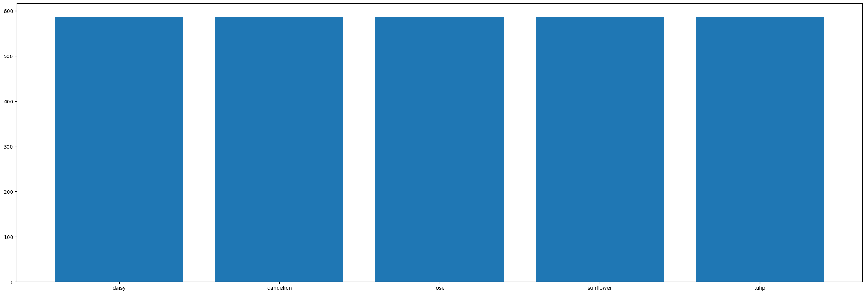

The purpose of this code is to visually represent the distribution of class instances within the training dataset using a bar plot, providing insights into the imbalance (or balance) among different classes, aiding in understanding the dataset's class distribution. Adjustments may be needed based on the actual number of classes and their names in the dataset.

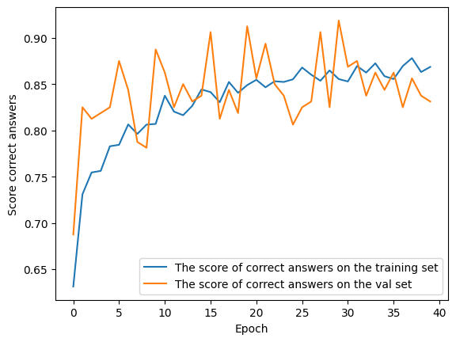

This visualization provides a clear depiction of how the model's accuracy changes over epochs for both the training and validation sets. It helps in assessing the model's performance, understanding overfitting or underfitting tendencies, and monitoring the convergence of accuracy during training.

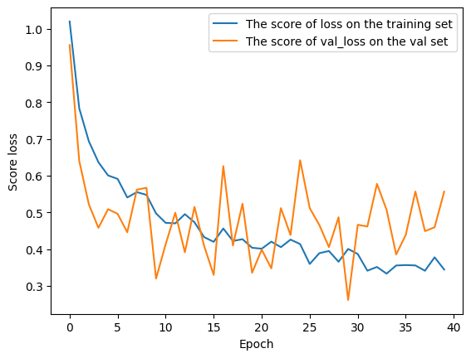

to visualize the training and validation loss of a machine learning model using Python's Matplotlib library. This code seems to plot the loss and validation loss against the number of epochs during the training of a neural network or a similar model.

Go to the top