Nemo eKYC — Technical Documentation
Product, Architecture, Audit & Level-2 Certification Roadmap
AKTech — Nemo Platform Engineering
1 August 2026 · v1.0
Table of Contents

1 eKYC Product Overview — Nemo KYC
Part 1 of the Nemo eKYC documentation set (docs/ekyc/) — 2026-08-01. Peers: System Architecture* · Flows & Sequences · Component Reference · Current-State Audit · Level-2 Upgrade Plan · Index.*

1.1 1. What this product is
Nemo KYC is the in-house electronic Know-Your-Customer engine of the Nemo platform (“neobank in a box” — see docs/nemo/01-vision.md). It closes gap A2 of the Nemo roadmap (docs/nemo/02-gap-analysis-and-roadmap.md): self-service onboarding — phone/ID capture, document OCR, selfie liveness, sanctions/PEP screening, and risk-tiered auto-approval — so a low-risk applicant can open an account in under five minutes with zero human touch, replacing today’s officer-driven KYC.
It exists in two commercial frames:
- Internal capability — every Nemo tenant (a tenant is a neobank) gets self-service onboarding out of the box, configured per market via market-pack KYC rule sets.
- “Nemo KYC” white-label product (ambition) — the same stack (scan-first onboarding, OCR, face match, liveness, screening, referral queue) offered as a per-check API through the public API platform (gap G2), independently certified (iBeta ISO/IEC 30107-3 PAD) and calibrated on East African faces — a regional-calibration claim no imported SDK matches (docs/nemo/09-liveness-build-and-certify.md). This is planned; the Current-State Audit tracks what is built versus planned.
The founder decision is in-house first: the default engine is our own (ekyc-ml-service), with commercial vendors remaining a pluggable secondary option per client (§7).

1.2 2. Capabilities catalogue
Capability | What it does (functionally) | Status
Document capture + OCR | Extracts full name, document number, date of birth (with per-field confidence) from an ID-document photo. The MRZ is the trust anchor: passport TD3 and ID-card TD1 machine-readable zones are parsed with full ICAO 9303 check-digit verification; a checksum-valid MRZ overrides visual-zone OCR. On-device OCR (Google ML Kit) pre-fills the form; the server always re-extracts and stays authoritative — no verification decision moves client-side. | Server engine built; scan-first on-device flow per doc 07
1:1 face match | Compares the document portrait to the live selfie and returns a 0..1 similarity score. Score ≥ 0.85 is the auto-approve line; a degraded (fallback) engine hard-caps its score at 0.75, below that line, so a fallback-scored applicant always reaches a human. | Built
Liveness (tiered) | Confirms the selfie is a live person, not a photo, screen replay or mask — three tiers, below. | Tier 1+2 approved & building; Tier 3 pluggable
Sanctions/PEP screening | Fuzzy name matching (diacritic-stripped, token-sort/token-set, default threshold 0.85) against operator-provisioned sanctions and PEP lists (OFAC, UN, EU consolidated lists in production). Missing lists is a hard error, never a silent pass. | Built (ships demo lists; production lists are an ops drop-in)
Risk-tiered decisioning | Combines document, face, liveness and screening results into one of three outcomes (§3): auto-approve, refer to a compliance officer’s queue, or reject. Fail-closed philosophy: a degraded or erroring subsystem can never contribute to an auto-approval — any engine failure routes the applicant to a human. | Built (referral queue in the back-office portal)

1.2.1 The three liveness tiers (doc 08)
Tier | What the applicant/operator sees | Cost | Limit
1 — Active challenge (on-device) | A randomized 2–3 step challenge over the selfie camera (blink → turn head → smile), detected by ML Kit face classification; frames captured mid-challenge become the selfie set. Works offline. | Free per check | 2D only — a video replay of someone doing the challenge passes
2 — Passive PAD (server-side) | Invisible to the applicant: MiniFASNetV2 classifies each selfie frame live vs print/replay attack. Ships shadow-mode first (scores logged, nothing decided) because the model’s training data skews East-Asian; thresholds are calibrated on real Kenyan traffic before enforcement, with retry-not-reject UX. | Free per check | Not certified; known skin-tone/lighting domain gap until recalibrated
3 — Certified commercial (pluggable) | An iBeta ISO/IEC 30107-3 PAD Level 2 product (ID R&D IDLive Face, Smile ID SmartSelfie, AWS Rekognition class) behind the same LivenessProvider seam, selected per client/market. Escalation on risk signals (large first deposit, device anomaly, borderline Tier-2 score) rather than paying per-check on everything. | Per-check or SDK licence | Vendor dependency; the build-and-certify plan (doc 09) aims to replace it with our own certified stack

1.3 3. The applicant journey
The design principle from doc 07: the document is the source of truth and the form is a confirmation screen. Registration effort collapses to one scan and one OTP on the happy path.
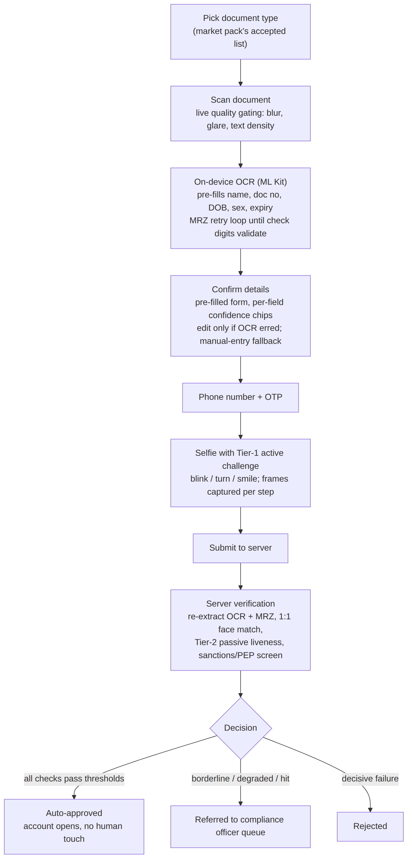
Figure 1

1.3.1 Decision outcomes
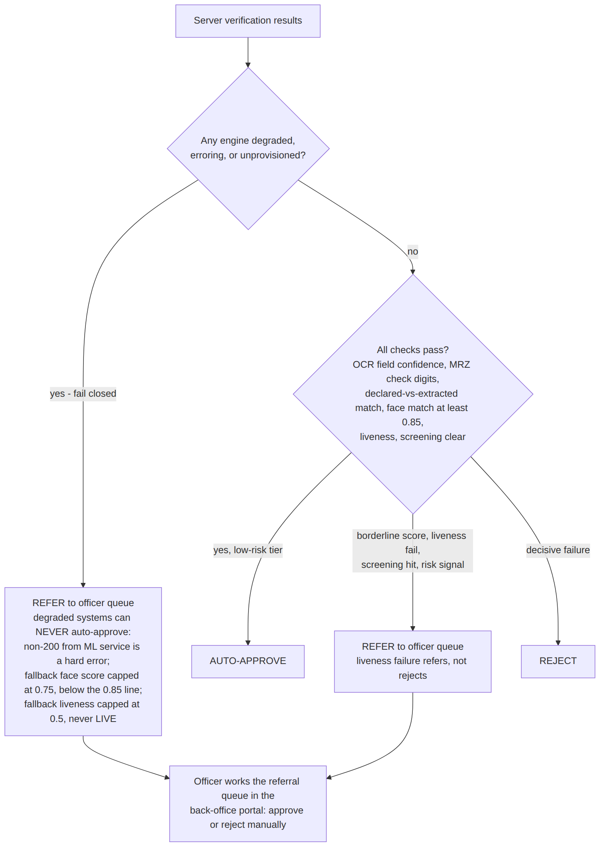
Figure 2
Key properties:
- Fail closed. The ML service fails loudly (4xx/5xx) rather than fabricating results; the Go provider treats any non-200 as a hard error and refers the applicant to a human. An unprovisioned deployment (missing model files, missing screening lists) structurally cannot auto-approve anyone.
- Referral over rejection for soft failures — liveness fail and borderline scores route to the officer queue, preserving the applicant’s chance with a human.
- Provider-agnostic decisioning. The onboarding flow, tiering and referral queue do not change when the underlying eKYC provider changes (§7).

1.4 4. Market & document matrix
Launch matrix from doc 07 — Kenya and Ethiopia, per the Nemo market sequencing:
Market | Document | Key identifiers & format | On-device OCR strategy | Notes
KE | National ID | 7–9 digit ID number | English labels/values — full field extraction (label-anchored) | Server extraction profile exists
KE | Passport | TD3 MRZ (two 44-char lines) | MRZ only — pure Latin, checksum-verifiable; visual zone as fallback | Cheapest, highest-confidence path; ships first
ET | Fayda national ID | FAN, 16-digit (number printed on card); FIN out of scope for v1 | Bilingual card — extract the English/Latin half on-device (ML Kit has no Amharic support); server keeps the full image | Only genuinely new extraction work
ET | Passport | TD3 MRZ | Same as KE passport — free once MRZ ships
MRZ is the great equalizer: for passports the visual zone is not scraped on-device at all — parse the two lines, verify check digits, done. Both KE and ET passports are e-passports; an NFC chip read (true authenticity check) is a natural later upgrade using the BAC key the MRZ already yields (planned, out of current scope).

1.5 5. Personas
Persona | Relationship to the product
Applicant | The end customer opening an account on the tenant’s app. Sees: doc-type picker, camera scan, pre-filled confirmation screen, OTP, selfie challenge, and either an instant open or a “under review” state.
Compliance officer | Works the referral queue in the back-office portal — every referred application lands here with the extracted fields, scores and reasons; the officer approves or rejects manually. The queue spans tenants for staff with the cross-tenant override.
Ops | Owns deploy-time provisioning: face/liveness ONNX model files (drop-ins; /health reports which engine is live), and daily-refresh sanctions/PEP list files (demo data must be replaced in production; /health exposes entry counts for staleness alerting).
Per-tenant operator | The neobank operator (Nemo’s customer). Chooses the eKYC/liveness provider for their deployment (§7), the market pack (which sets accepted document types and KYC rules), and — under the white-label ambition — may consume Nemo KYC itself as a per-check API.

1.6 6. Regulatory context
Jurisdiction | Requirement | Implication for the product
Kenya — CBK | CBK guidance permits biometric remote onboarding; no statute names a specific PAD certification. | Certified PAD is bank-partner/auditor due diligence, not law.
Kenya — Data Protection Act / ODPC | A DPIA is required before selfie/liveness/face-match processing at scale; the ODPC is the regulator. | DPIA artifact must exist before production liveness enforcement in Kenya. On-prem/in-house biometric processing (no images leaving the deployment) strengthens the DPIA position.
Ethiopia — NBE / Fayda | NBE has mandated Fayda digital ID for banking (phased 2025→2026), with onboarding through VeriFayda 2 (national eKYC via EthSwitch). | ET liveness/1:1 likely routes through the national platform: VeriFayda is treated as another provider behind the same seam (§7). Integration scoping is a separate design doc when the ET pilot starts.
Bank-partner bar | iBeta ISO/IEC 30107-3 PAD Level 1/2 is the de-facto certification banks and auditors ask for. | Level 1: zero spoofs through (~900 presentations, 6 attack species). Level 2 adds 3D mask attacks at APCER ≤1%. The build-and-certify path is the subject of the Level-2 Upgrade Plan and doc 09.

1.7 7. Provider strategy
In-house first, pluggable always. The Go compliance-service selects the eKYC implementation by name from a provider registry via a single env var (EKYC_PROVIDER=inhouse is the default). Swapping a client onto a commercial vendor is: implement the provider interface, register it, set the env var — the onboarding flow, risk tiering and referral queue are provider-agnostic, and every provider must fail closed on errors like the in-house one.
Provider | Class | Role
In-house (ekyc-ml-service) | Tesseract OCR + ICAO 9303 MRZ, YuNet/SFace face match, MiniFASNetV2 passive PAD, fuzzy-match screening | Default for all markets; the asset behind the white-label ambition
Smile ID / Veriff class | Full-KYC commercial vendors (Smile ID: iBeta L2, Flutter SDK, Africa pricing ~$0.30–1.00/check, Kenyan ID-registry lookups) | Pluggable per client where a certified end-to-end vendor is demanded
ID R&D IDLive Face | iBeta L1+L2 single-image passive liveness, on-prem SDK | Tier-3 liveness option; keeps biometrics on-prem (helps the ODPC/DPIA argument)
AWS Rekognition Face Liveness | Managed, ~$0.015/check, iBeta-benchmarked (not certified) | Budget Tier-3 fallback, not flagship
VeriFayda 2 | Ethiopia’s national eKYC platform (EthSwitch) | The ET provider where the NBE Fayda mandate applies — same seam
Bridge SDK (MiniAiLive/KBY-AI class) | iBeta-L2 on-prem SDK, ~$2–8k/yr | Planned Stage-0 stopgap so “Level 2 certified” is claimable while the in-house stack is built and certified
The liveness seam mirrors this: a LivenessProvider interface ({frames} → {liveScore, decision, provider, auditRef}) lets Tier 3 products drop in server-side with zero mobile-app changes, escalated on risk signals rather than invoked on every check.

Next: 02-system-architecture.md* for how these capabilities are realised across the mobile app, BFF, compliance-service and ekyc-ml-service; 05-current-state-audit.md for the precise built-vs-planned status of everything named above.*

2 eKYC System Architecture
Part of the Nemo eKYC technical documentation. 2026-08-01. Technical architecture of the self-service onboarding & eKYC subsystem (gap A2): services, boundaries, deployment topology, data model and configuration. Sequence-level detail is in 03 — Flows & Sequences; ML-engine internals in 04 — Component Reference.

2.1 1. System context
The eKYC subsystem spans two channels (mobile applicant, staff portal), three backend services (bff-gateway, compliance-service, media-service), one ML sidecar (ekyc-ml-service) and two databases. It is multi-tenant end to end — a tenant is a neobank, and every row and media object is tenant-scoped.
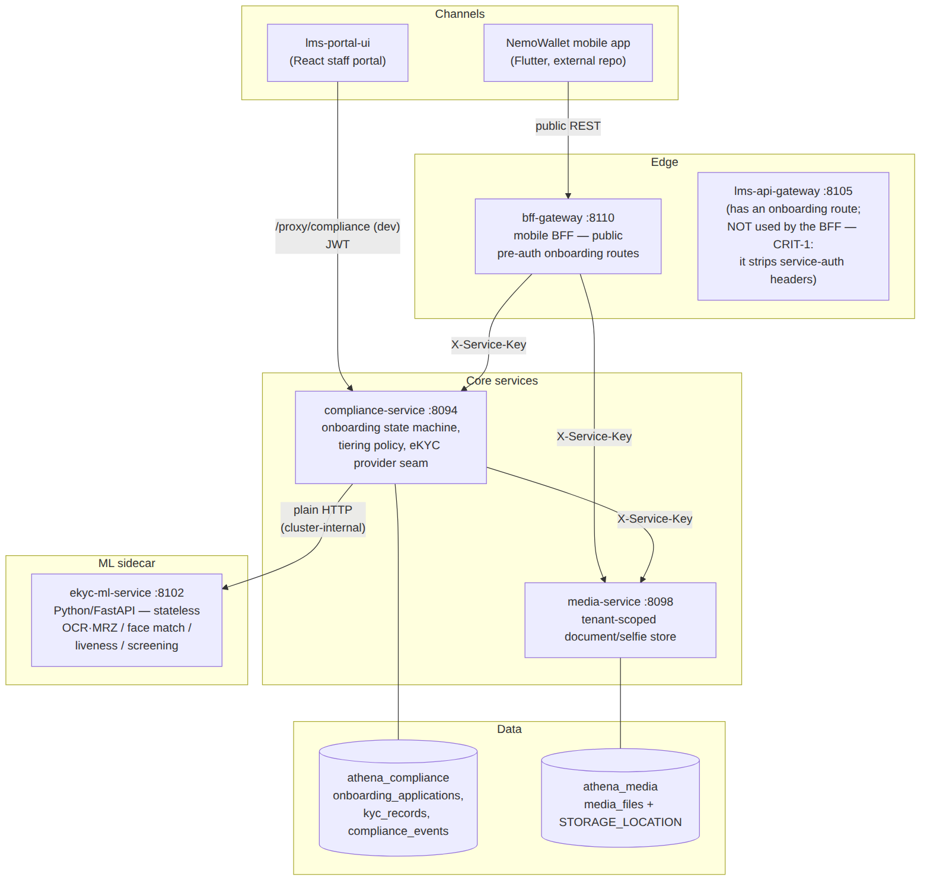
Figure 3
Trust boundaries:
- Public → BFF: the four /api/v1/mobile/onboarding/* routes are deliberately pre-auth (an applicant has no account yet). Upload size is capped at 12 MiB; media types whitelisted (ID_FRONT, ID_BACK, PASSPORT, SELFIE, PROOF_OF_ADDRESS).
- Service ↔ service: X-Service-Key (= LMS_INTERNAL_SERVICE_KEY) with X-Service-Tenant / X-Service-User stamping via auth.ServiceKeyTransport; service callers get roles [SERVICE, ADMIN].
- compliance → ekyc-ml: plain HTTP, no auth — the sidecar port must never be exposed outside the cluster network.
- Portal → compliance: JWT; the decide endpoints additionally require compliance.decide (fallback roles ADMIN, MANAGER).

2.2 2. Component responsibilities
Component | Responsibility | Key code
bff-gateway | Public onboarding facade: media upload relay, submission relay, status polling with nextStep hints, market-pack document list | internal/bff/gateway/ (handler/service/client)
compliance-service | Onboarding state machine (RECEIVED → AUTO_APPROVED \| REFERRED → APPROVED \| REJECTED), market-pack document validation, tiering policy, provider registry, KYC record upsert, compliance event trail | internal/compliance/service/onboarding_service.go, internal/compliance/ekyc/
ekyc-ml-service | Stateless verification engine: document extract (OCR + MRZ), 1:1 face match, passive liveness (PAD), sanctions/PEP screening | ekyc-ml-service/ — see 04
media-service | Tenant-scoped binary store for documents/selfies; download served only to matching tenant | internal/media/
lms-portal-ui | Officer referral queue: list/filter REFERRED, approve/reject with mandatory reason, cross-tenant view (tenantId=*) | src/pages/OnboardingReferralsPage.tsx, src/services/onboardingService.ts

2.2.1 2.1 Provider seams (pluggability)
Two registries decouple policy from vendors:
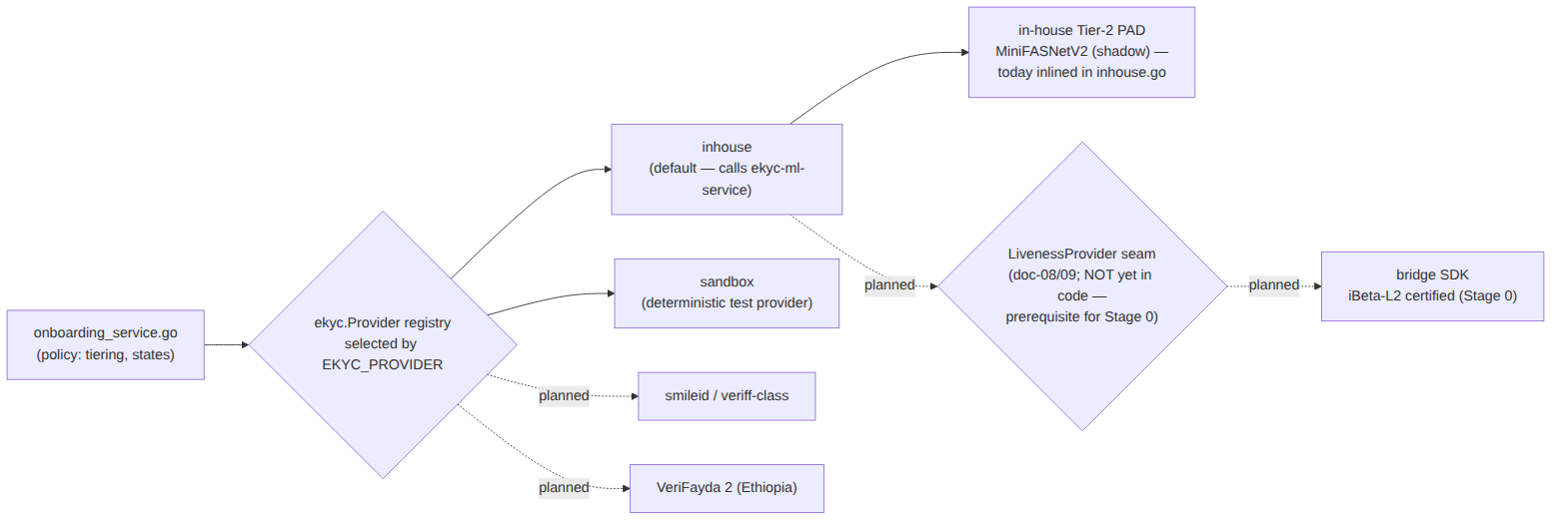
Figure 4
- ekyc.Provider = Name() + Verify(ctx, Request) (Result, error) (internal/compliance/ekyc/ekyc.go:53). Registered implementations: sandbox (built-in) and inhouse (wired in cmd/compliance-service/main.go). EKYC_PROVIDER selects by lowercased name; empty → sandbox; unknown → startup error.
- ekyc.Result carries: DocumentVerified, LivenessPassed, FaceMatchScore, SanctionsHit, PEPHit, ProviderRef, plus liveness observability (LivenessScore ∈ [0,1] or −1, LivenessMode ∈ "" | shadow | shadow-error | enforce).
- The onboarding flow, tiering and referral queue are provider-agnostic — swapping vendors is one env var per deployment/tenant.

2.3 3. Deployment topology

2.3.1 3.1 docker-compose (dev/staging)
docker-compose.go.yml overlays the base stack:
Compose service | Image/build | Container port | Host port | Notes
go-compliance-service | monorepo build, SERVICE: compliance-service | 8094 | 28094 | EKYC_PROVIDER=${EKYC_PROVIDER:-inhouse}; depends_on: ekyc-ml-service (healthy)
go-media-service | monorepo build | 8098 | 28098 | DB_NAME: athena_media
ekyc-ml-service | build.context: ./ekyc-ml-service | 8102 | 28102 | healthcheck GET /health
go-bff-gateway | monorepo build | 8110 | 28110 + NodePort 30100 | COMPLIANCE_SERVICE_URL, MEDIA_SERVICE_URL direct (bypasses public gateway)
lms-api-gateway | monorepo build | 8105 | 28105 | public /lms/api/v1/onboarding/ route exists but is not the mobile path
Portal dev proxy: vite.config.ts maps /proxy/compliance → http://localhost:28094.

2.3.2 3.2 Kubernetes (Helm, deploy/helm/nemo/)
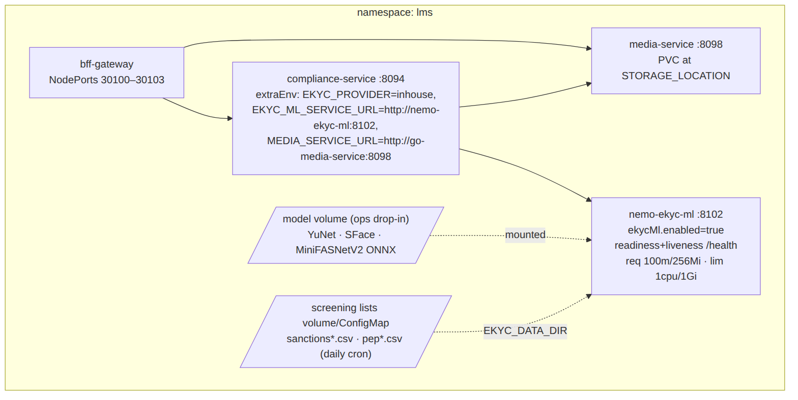
Figure 5
Disabling the sidecar for a vendor-based tenant: ekycMl.enabled=false + EKYC_PROVIDER=<vendor>.

2.3.3 3.3 Scaling & operational properties
- ekyc-ml-service is stateless — horizontal scaling is trivial; the heavy call is OCR (Tesseract, CPU-bound). Models are ~3 MB total; no GPU anywhere.
- compliance-service holds the only durable onboarding state; migrations run at boot (db.MigrateGate, file://migrations/compliance).
- Timeouts: engine client 60 s, media client 30 s. Engine responses capped at 1 MiB read; media downloads capped at 20 MiB.
- Observability: liveness shadow scores are recorded in decision_reasons (LIVENESS[mode=… score=… frames=…]) for threshold calibration; /health on the sidecar reports which engines are live (faceEngine, livenessEngine, list counts).

2.4 4. Data model
Two databases, no shared tables. All rows carry tenant_id.
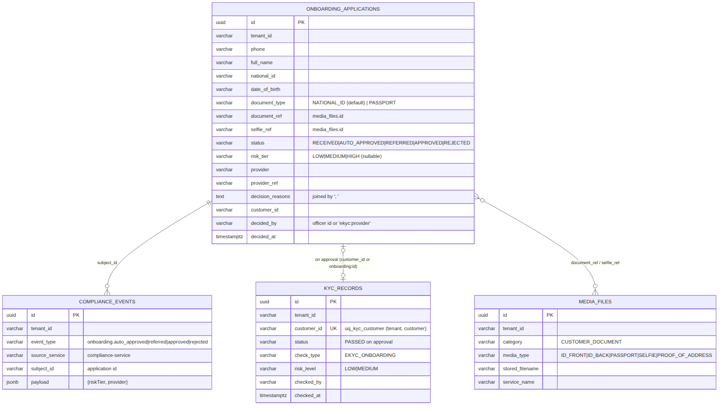
Figure 6
Integrity rules worth knowing:
- uq_onboarding_open — partial unique index on (tenant_id, national_id) where status IN ('RECEIVED','REFERRED'): one open application per identity per tenant; violation surfaces as a BusinessError.
- selfie_frame_refs is request-only (no column): Tier-1 challenge frames feed the liveness call and surface only in the LIVENESS[…] reason string.
- Compliance events are DB rows only (audit trail); the onboarding path publishes nothing to RabbitMQ — event-trail write failures are logged, never fatal (“the decision stands even if the trail write fails”).
- Media downloads are tenant-filtered in SQL (WHERE id = $1 AND tenant_id = $2); the service key’s X-Service-Tenant decides which tenant a service call reads.

2.5 5. Configuration reference

2.5.1 5.1 compliance-service (Go)
Env var | Default | Effect
EKYC_PROVIDER | sandbox (compose/Helm set inhouse) | provider registry selection. ⚠️ the sandbox default auto-approves (score 0.97) — every production deploy target must pin inhouse or a vendor; all three current targets do
EKYC_ML_SERVICE_URL | — (required for inhouse) | sidecar base URL; empty → Verify fails closed
MEDIA_SERVICE_URL | — (required for inhouse) | media base URL; empty → Verify fails closed
LMS_INTERNAL_SERVICE_KEY | compose: athena-internal-key | service-to-service auth
LIVENESS_ENFORCE | unset → shadow mode | exactly "true" enables enforcement ("1"/"TRUE" do not)
MARKET_PACK / MARKET_PACK_DIR | KE | market pack (accepted doc types, number patterns, OCR profiles)
PORT / DB_NAME | 8094 / athena_compliance | service basics

2.5.2 5.2 Thresholds (compile-time, not env-tunable today)
Threshold | Value | Where | Used for
Face-match auto-approve | 0.85 | onboarding_service.go:22 (faceMatchThreshold) | tiering
Field-confidence floor | 0.60 | inhouse.go (defaultMinFieldConfidence) | document verification
Name-match threshold | 0.75 | inhouse.go (defaultNameMatchThreshold) | declared vs extracted name
Liveness threshold | 0.5 (placeholder) | inhouse.go (defaultLivenessThreshold) | enforce mode only; calibrating in shadow
Max liveness frames | 5 | inhouse.go / api/face.py | frame cap both sides
Screening threshold | 0.85 | engine/screening.py | sanctions/PEP fuzzy match

2.5.3 5.3 ekyc-ml-service (Python)
See 04 §5: EKYC_DATA_DIR, FACE_DETECTOR_MODEL, FACE_EMBEDDER_MODEL, FACE_LIVENESS_MODEL.

2.6 6. Known architectural debts
Tracked in detail in 05 — Current-State Audit:
- Thresholds are compile-time constants — per-tenant/per-market tuning (a market pack concern) requires a code change today.
- CRIT-1: the public lms-api-gateway strips service-auth headers, which is why the mobile BFF calls compliance-service directly; the gateway’s onboarding route is effectively vestigial for this flow.
- Liveness threshold uncalibrated — 0.5 is a documented placeholder pending shadow-mode data; enforcement must not be enabled before calibration (06 — Upgrade Plan).
- No RabbitMQ events from onboarding — downstream consumers (e.g. notification templates for “application received/approved”) would need the compliance event publisher wired into OnboardingService.
- Sidecar port is unauthenticated by design — network policy must guarantee it is cluster-internal.

3 eKYC Flows & Sequence Diagrams
Part of the Nemo eKYC technical documentation. 2026-08-01. Every runtime path of the onboarding & eKYC subsystem: end-to-end sequences, the verification pipeline, the tiering decision, the officer review loop and the failure paths. Endpoint paths, state names and thresholds are taken from the code (compliance-service, bff-gateway, media-service, ekyc-ml-service) as of this commit.

3.1 1. Application state machine
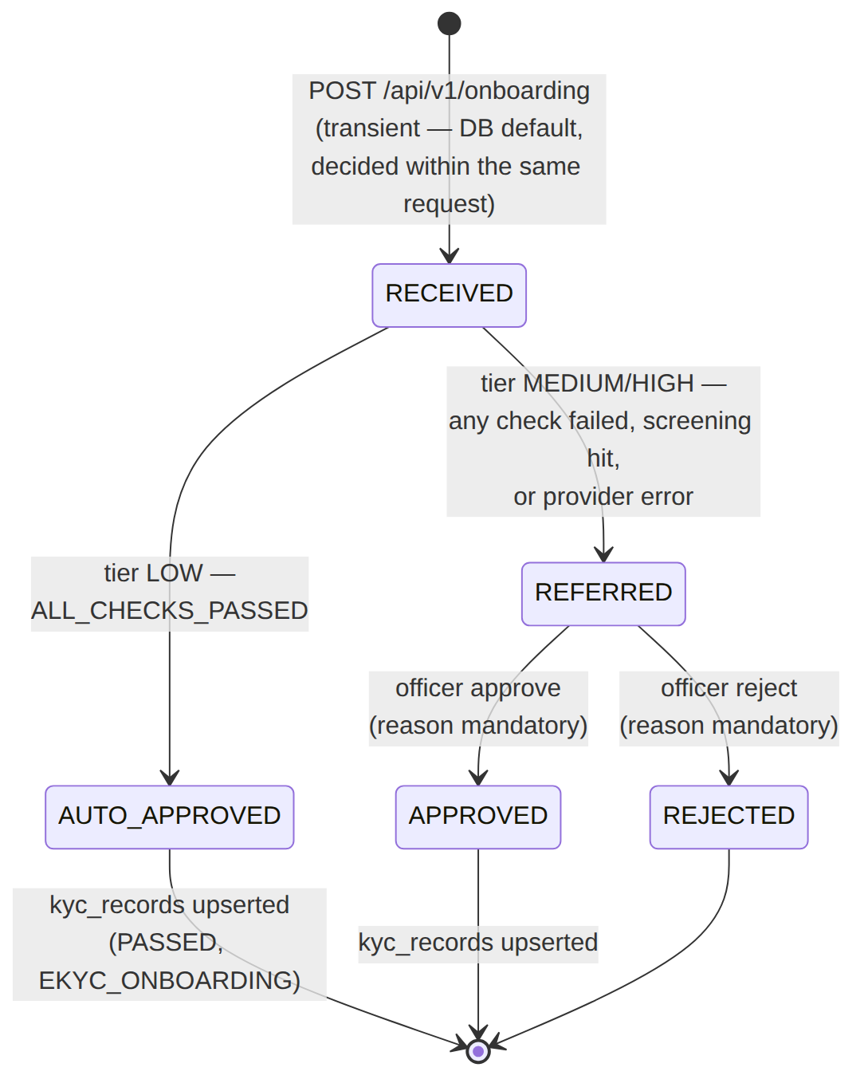
Figure 7
- v1 never auto-rejects — a machine can approve, only a human can reject.
- One open application per identity: partial unique index uq_onboarding_open on (tenant_id, national_id) for statuses RECEIVED/REFERRED.
- Only REFERRED applications can be decided; deciding anything else returns a BusinessError.

3.2 2. End-to-end onboarding (happy path, auto-approve)
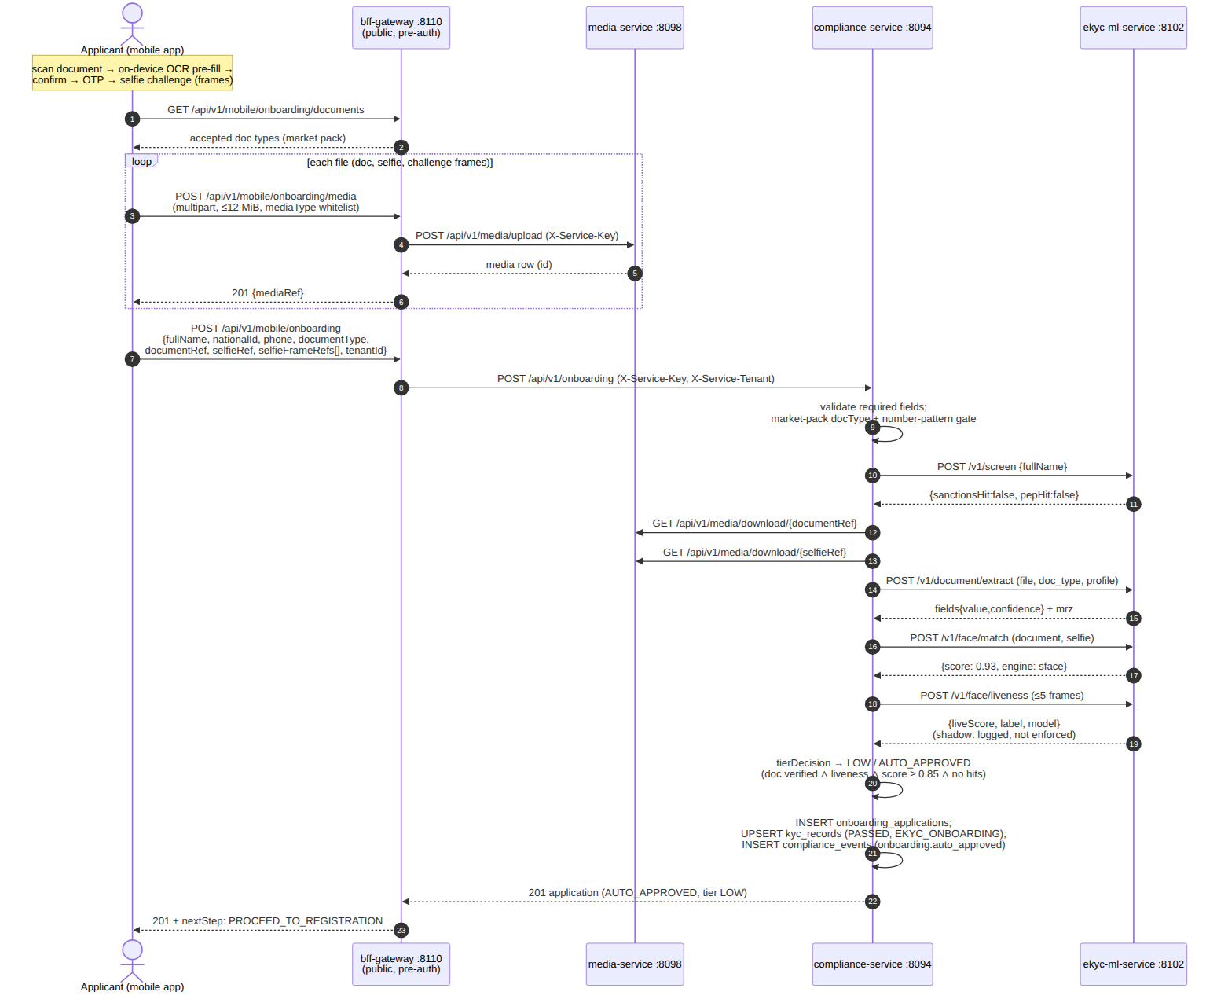
Figure 8

3.3 3. Verification pipeline inside inhouse.Verify
Exact order and error semantics (internal/compliance/ekyc/inhouse.go):
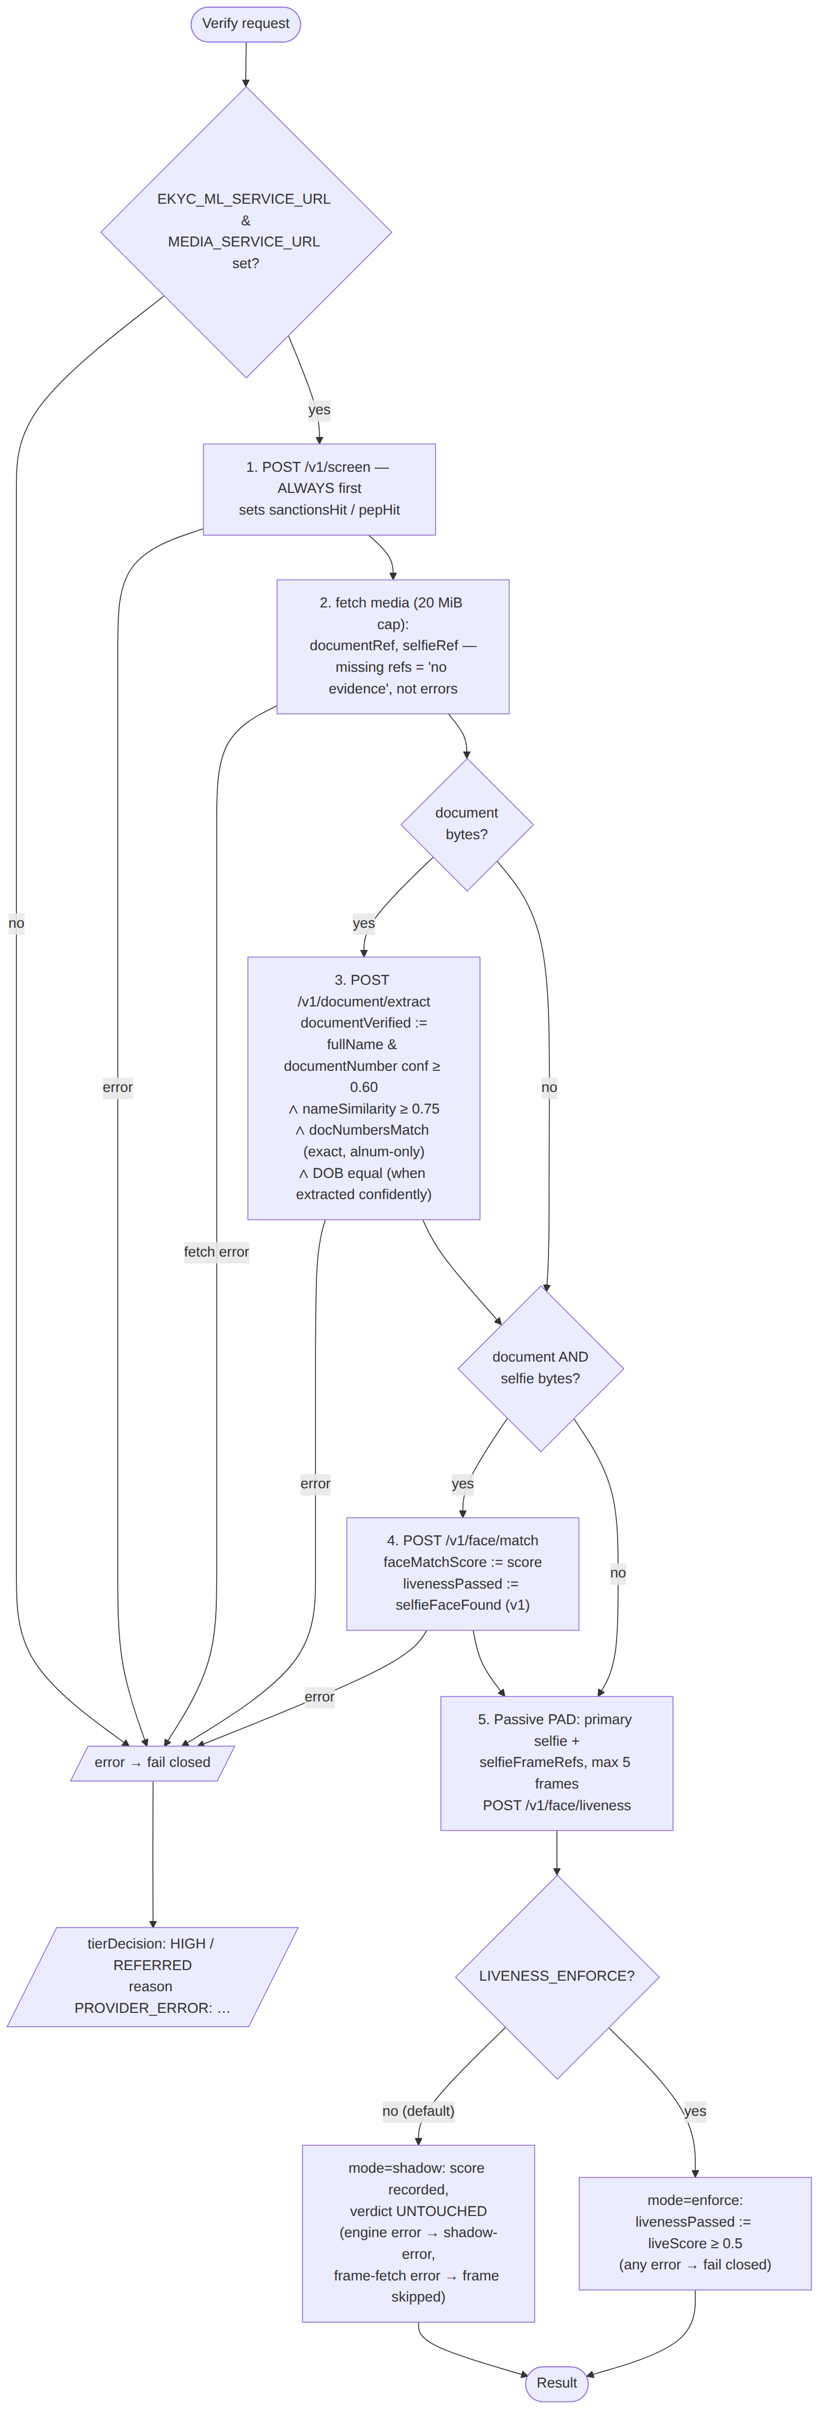
Figure 9

3.4 4. Tiering decision
tierDecision (onboarding_service.go) evaluates in strict order — screening hits short-circuit the document/biometric checks:
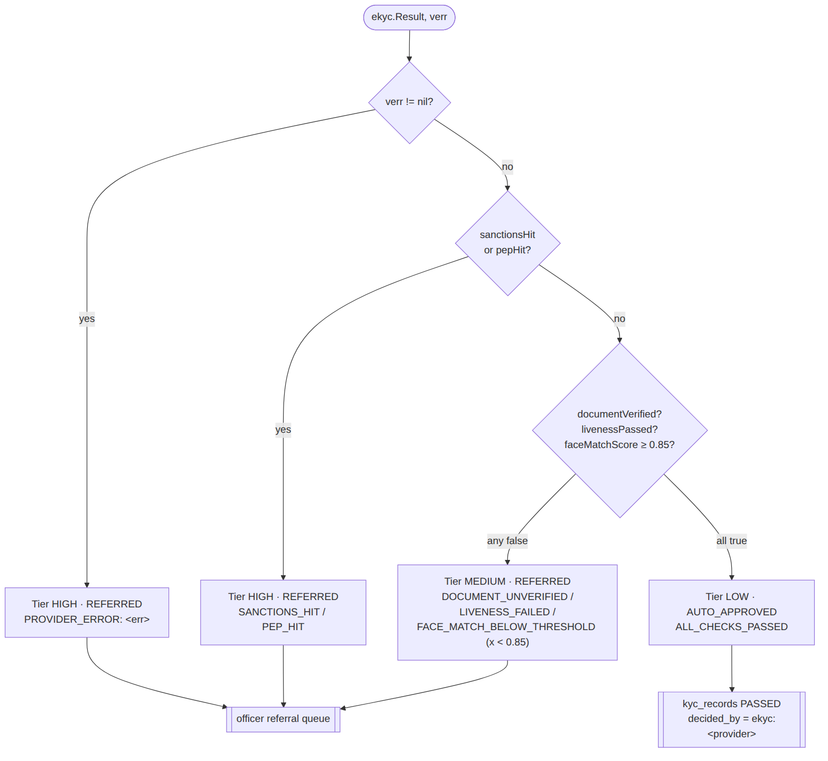
Figure 10
When a PAD call ran, an observability reason is appended regardless of outcome: LIVENESS[mode=<shadow|shadow-error|enforce> score=<%.2f> frames=<n>] — this is the shadow-mode calibration data source for the Level-2 upgrade plan.

3.5 5. Officer review loop (referral queue)
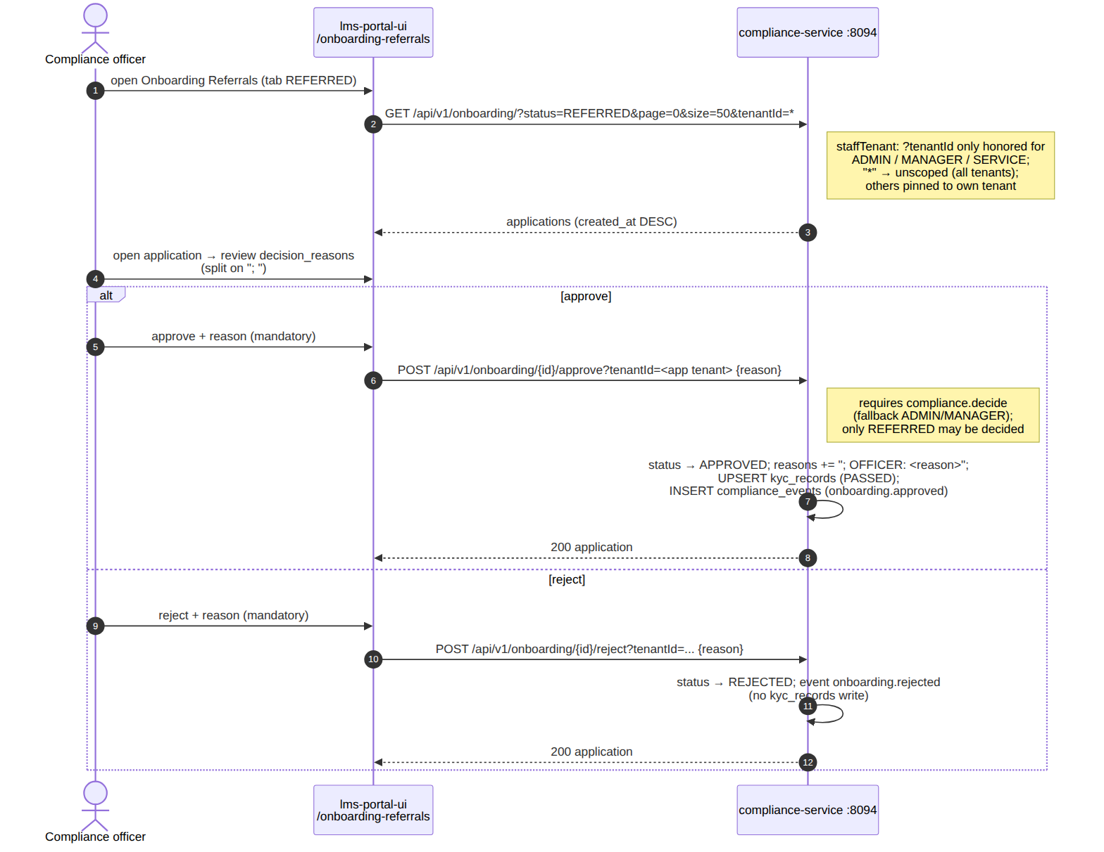
Figure 11
Meanwhile the applicant polls:
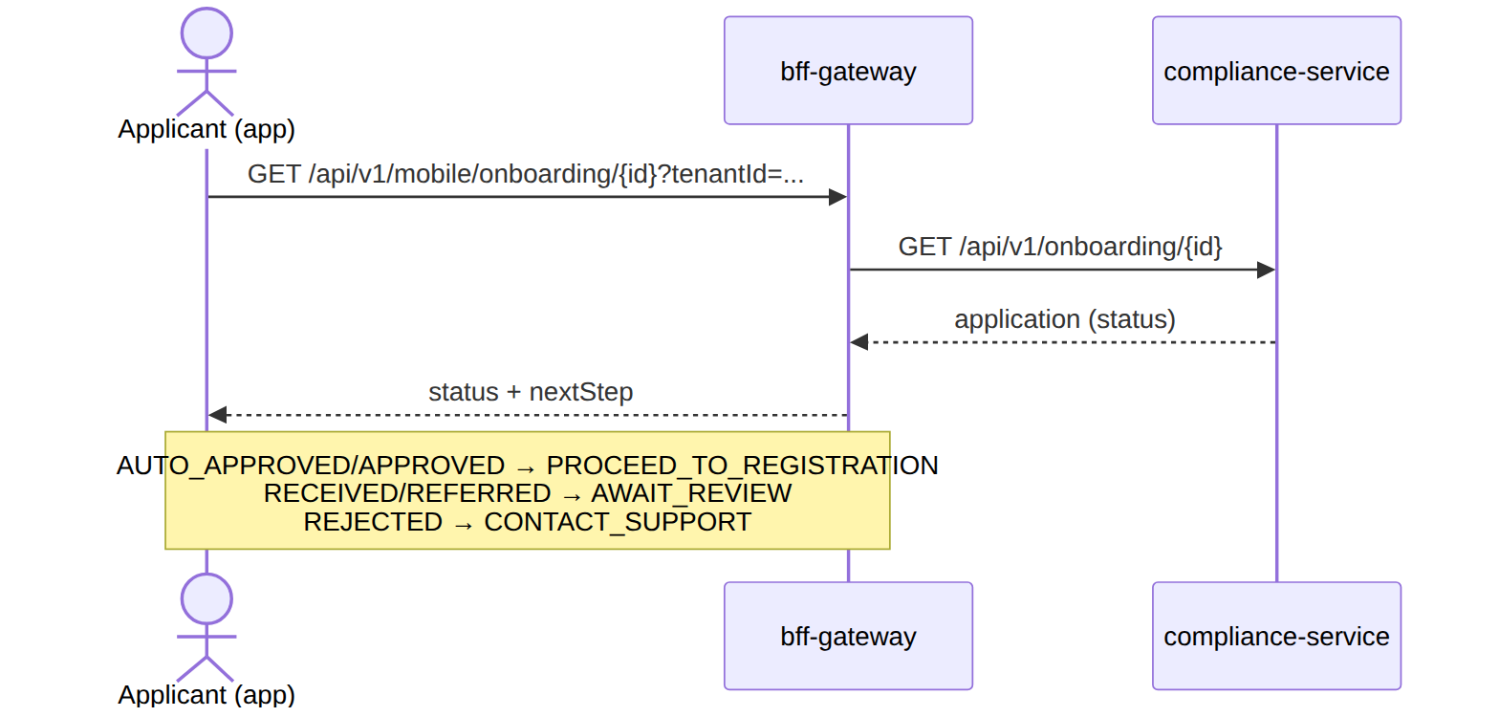
Figure 12

3.6 6. Failure paths (fail-closed catalogue)
Failure | Where it surfaces | Outcome for the applicant
Sidecar down / non-200 / undecodable image | inhouse.Verify error | Tier HIGH, REFERRED, PROVIDER_ERROR: … — human decides
Tesseract or screening lists missing | sidecar 503 | same as above (fail closed)
Face models missing | fallback engine, score ≤ 0.75 | FACE_MATCH_BELOW_THRESHOLD → REFERRED (can never auto-approve)
Liveness model missing | label UNKNOWN, score ≤ 0.5 | shadow: no effect; enforce: LIVENESS_FAILED → REFERRED
Media fetch error (either ref) | inhouse.Verify error | PROVIDER_ERROR → REFERRED
Challenge-frame fetch error | skipped (shadow) / error (enforce) | shadow unaffected / PROVIDER_ERROR when enforcing
Sanctions or PEP hit | screening, checked first | Tier HIGH → REFERRED (SANCTIONS_HIT/PEP_HIT)
docType not accepted by market pack / number-pattern mismatch | Submit validation | 400 Bad Request before any verification
Duplicate open application | uq_onboarding_open | BusinessError — “an open onboarding application already exists”
Compliance-event trail write fails | logged only | decision stands (audit trail is best-effort)
Design invariant across every row: no degraded component can produce an auto-approval. Missing models cap below thresholds; missing binaries and lists are hard 5xx; hard errors become REFERRED, never APPROVED.

3.7 7. Media upload flow (detail)
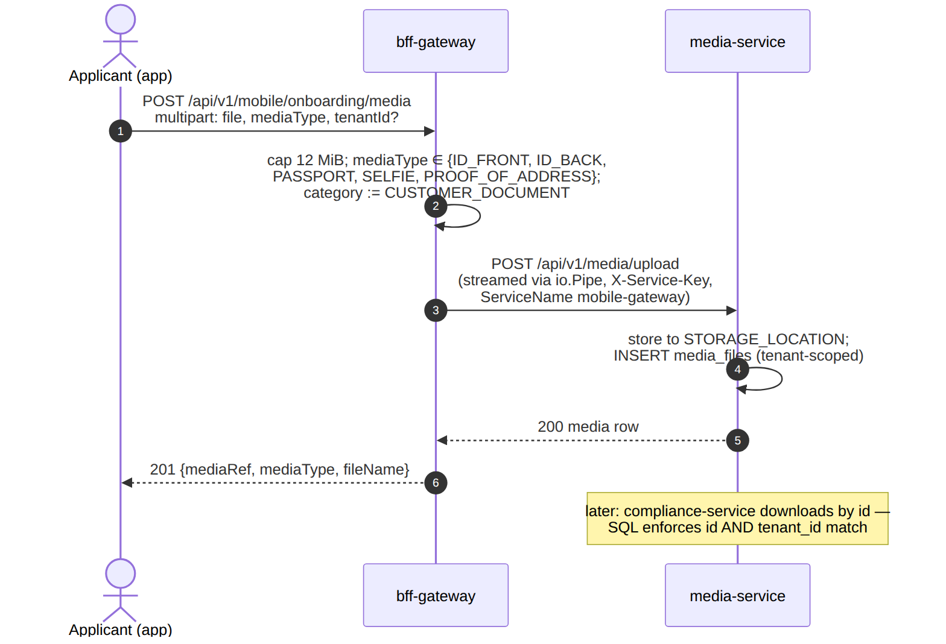
Figure 13

3.8 8. Cross-references
- Engine internals of steps 3–5 (OCR/MRZ, face match, PAD): 04 — Component Reference
- Why liveness is shadow-mode and what replaces it: 06 — Level-2 Upgrade Plan
- Which of these paths are fully built vs partial: 05 — Current-State Audit

4 eKYC Component Reference — ekyc-ml-service
Part of the Nemo eKYC technical documentation. Covers the Python/FastAPI verification engine in depth: every endpoint, every model, every threshold, and the fail-safe design that makes an unprovisioned or degraded deployment unable to fabricate a verification pass.

4.1 1. Role in the system
ekyc-ml-service is the in-house verification engine for the Nemo platform (gap A2). It is a stateless sidecar: it holds no database, stores no images, and keeps no per-applicant state. compliance-service (Go) calls it over plain HTTP inside the cluster network when EKYC_PROVIDER=inhouse (the default). It mirrors the fraud-ml-service sidecar pattern — FastAPI app, slim Docker image, never exposed publicly, no auth on the internal port.
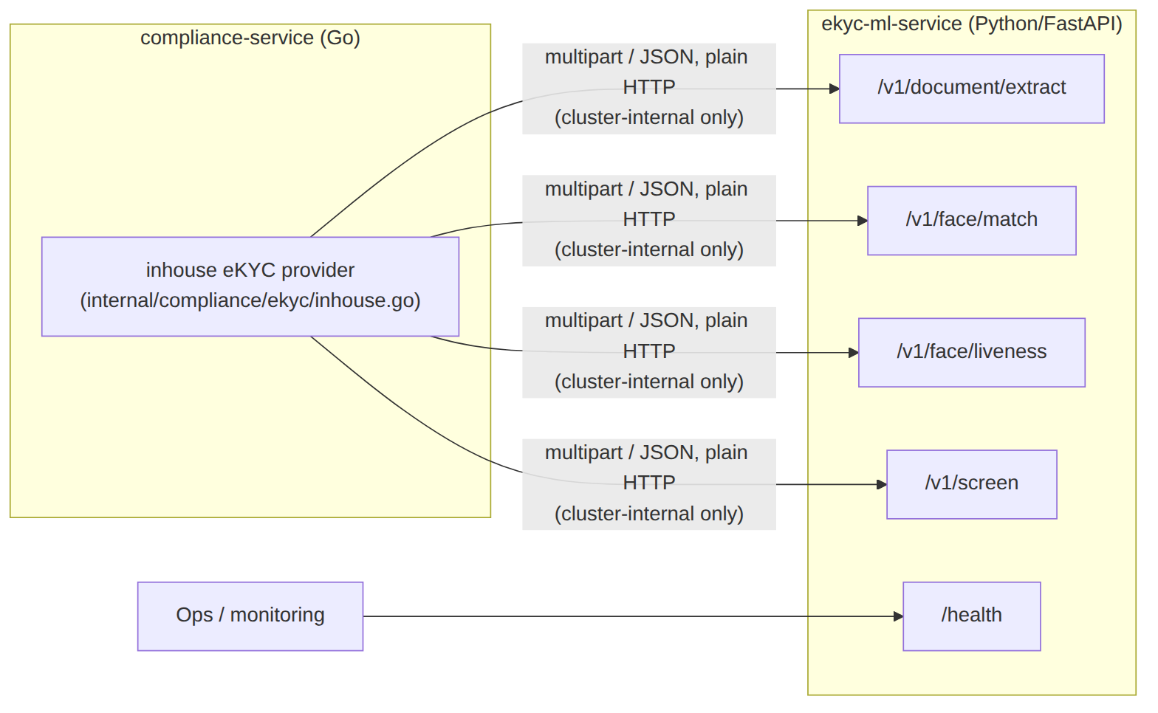
Figure 14
Design rule: fail loudly, fail closed. The service returns 4xx/5xx rather than fabricated results — no OCR binary → 503, no screening lists → 503, undecodable image → 422. The Go provider treats any non-200 as a hard error and the onboarding flow refers the applicant to a human.

4.2 2. API surface
Endpoint | Request | Response
POST /v1/document/extract | multipart file (ID-document image) | fields map (fullName, documentNumber, dateOfBirth), each {value, confidence}; mrz block when a machine-readable zone was found (per-check-digit results + overall valid)
POST /v1/face/match | multipart document + selfie | {engine, score (0..1), documentFaceFound, selfieFaceFound}
POST /v1/face/liveness | multipart, 1–5 frame parts | {liveScore (0..1, min across frames), label (LIVE\|SPOOF\|UNKNOWN), perFrame[{score, faceFound}], model}
POST /v1/screen | JSON {"fullName": "...", "threshold": 0.85?} | {sanctionsHit, pepHit, matches[], listsLoaded}
GET /health | — | engine availability: OCR present, faceEngine: sface\|fallback, livenessEngine: minifasnet_v2\|fallback, screening-list entry counts

4.3 3. Pipeline internals

4.3.1 3.1 Document extraction (OCR + MRZ)
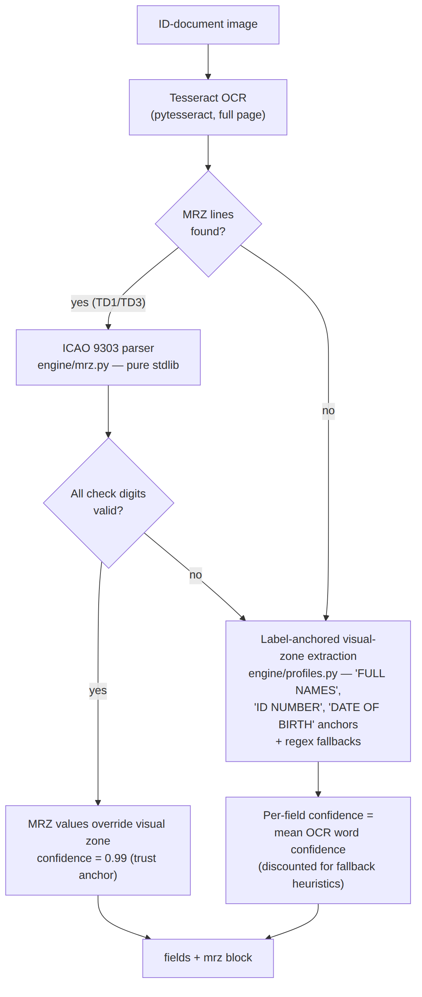
Figure 15
- OCR engine: Tesseract (tesseract-ocr apt + pytesseract). Chosen over PaddleOCR for deterministic installs on python:3.12-slim (~40 MB vs several-hundred-MB wheels with a history of breaking slim images). Accuracy is adequate because the MRZ is the trust anchor, not the visual zone.
- MRZ parsing (engine/mrz.py, 191 lines, zero dependencies): TD3 (passports, 2×44 chars) and TD1 (ID cards, 3×30 chars) with full ICAO 9303 check-digit verification (7-3-1 weighted mod-10; a < check digit accepted only for the all-filler optional field, per 9303). A checksum-valid MRZ overrides visual-zone OCR at confidence 0.99.
- Visual-zone profiles (engine/profiles.py): label-anchored line matching tuned for Kenyan-ID-class layouts, regex fallbacks per field. Extraction profiles keyed by (market, docType) are the doc-07 WS-1 extension point (KE ID exists; passport MRZ-only and ET Fayda profiles planned).

4.3.2 3.2 Face match (1:1 verification)
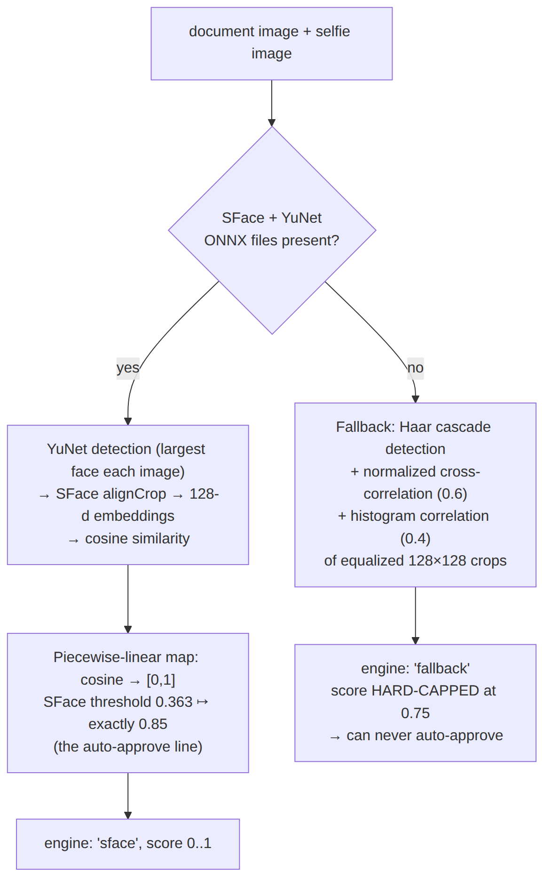
Figure 16
- Models: YuNet (face_detection_yunet_2023mar.onnx) + SFace (face_recognition_sface_2021dec.onnx), ~2 MB combined, OpenCV model zoo, run by opencv-python-headless — no GPU, no extra ML framework. Inputs are bounded to a 1600 px long side before detection (YuNet degrades on very large images).
- Score mapping (engine/facematch.py:72): SFace’s published cosine verification threshold (0.363) is pinned to 0.85 so the Go side reasons only in [0,1] — same-person pairs land above the auto-approve line, different-person pairs below; cosine ≥ 0.6 maps to ~1.0.
- Degradation contract: without model files the deterministic fallback caps at 0.75 < 0.85, so a fallback-scored applicant always reaches a human. The engine field in every response and /health (faceEngine) make the active path observable.

4.3.3 3.3 Passive liveness (Tier-2 PAD)
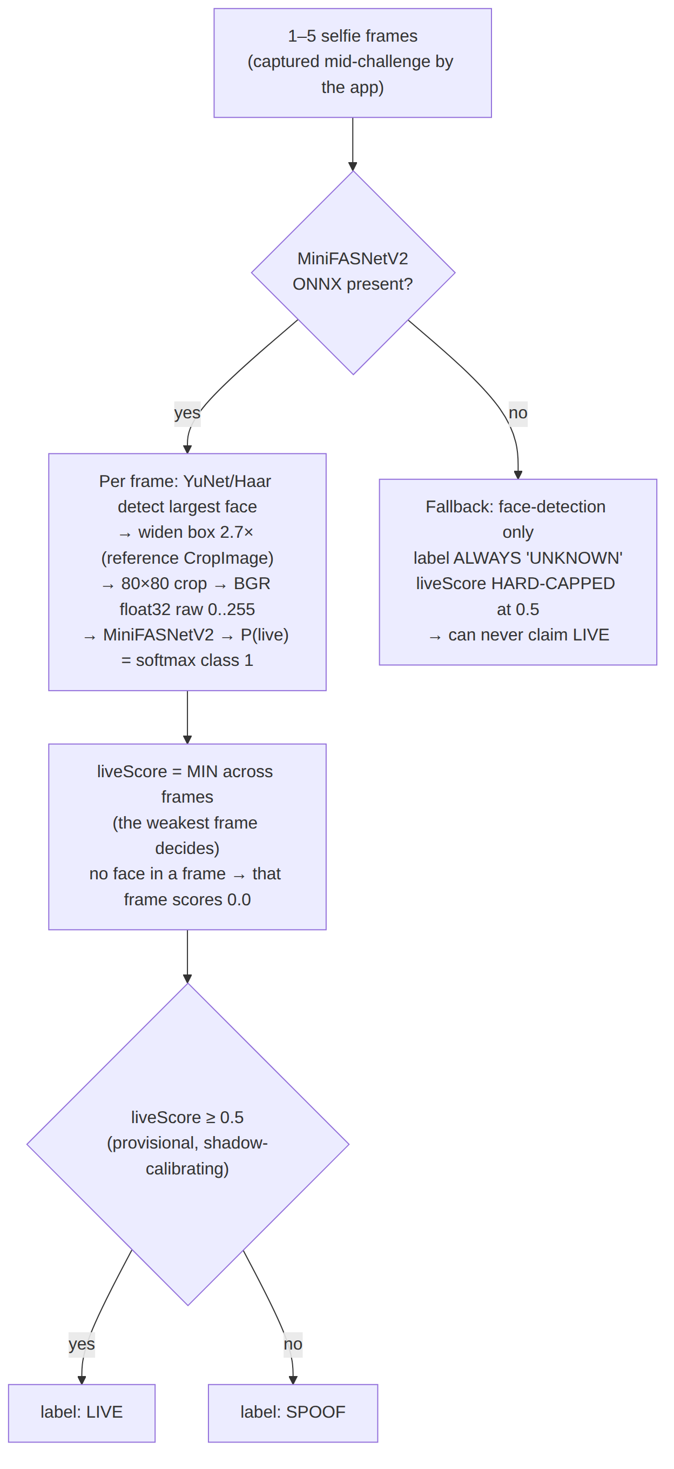
Figure 17
- Model: MiniFASNetV2 (MiniVision Silent-Face-Anti-Spoofing, Apache-2.0, ~600 KB ONNX) on the same OpenCV dnn stack. Preprocessing follows the reference implementation exactly: 2.7× widened crop, 80×80, raw 0–255 BGR float32 (the reference ToTensor does not divide by 255), softmax index 1 = live; an export that already ends in softmax is detected (outputs sum ≈ 1) and not re-normalized.
- Enforcement lives Go-side (LIVENESS_ENFORCE, shadow mode by default): the engine only reports; the compliance-service decides. See 03 — flows and doc-08.
- Known limitation (why the upgrade plan exists): MiniFASNetV2 is MiniVision’s demo tier; training data skews East-Asian, with documented false rejects in low light and elevated risk on darker skin tones. This is the direct motivation for the NLD-EA data campaign and the Level-2 plan — see 06 — upgrade plan.

4.3.4 3.4 Sanctions / PEP screening
- Matcher (engine/names.py, mirrored in the Go provider for declared-vs-extracted comparison): NFKD diacritic stripping + casefold + token-sort / token-set similarity; default threshold 0.85.
- Lists (engine/screening.py): loads every sanctions*.csv / pep*.csv in EKYC_DATA_DIR. CSV shape id,name,aliases,country,program, aliases ;-separated. The shipped sanctions_demo.csv / pep_demo.csv are fictional development data; production must drop in real consolidated lists on a daily ops cron: OFAC SDN + Consolidated, UN Security Council Consolidated, EU Consolidated, and a commercial/curated PEP feed. listsLoaded (per call) and /health entry counts exist so ops can alert on stale or empty data.

4.4 4. Fail-safe matrix
The service is engineered so that no missing dependency can ever manufacture a pass:
Degraded condition | Behaviour | Worst outcome
Tesseract binary missing | 503 on /v1/document/extract | hard error → human referral
Face ONNX models missing | fallback engine, score ≤ 0.75 | below 0.85 → never auto-approves
Liveness ONNX missing | fallback, label UNKNOWN, score ≤ 0.5 | can never claim LIVE
OpenCV 5 wheel without Haar cascade | “no face” → UNKNOWN | fail-safe, never a fabricated LIVE
Screening lists missing/empty | 503 on /v1/screen | hard error → human referral
Undecodable image | 422 | hard error → human referral
Any non-200 seen by the Go provider | treated as hard failure | applicant referred to a human (fail closed)

4.5 5. Configuration
Env var | Default | Purpose
EKYC_DATA_DIR | packaged data/ | screening-list directory (mount a volume/ConfigMap in production)
FACE_DETECTOR_MODEL | /app/models/face_detection_yunet_2023mar.onnx | YuNet ONNX
FACE_EMBEDDER_MODEL | /app/models/face_recognition_sface_2021dec.onnx | SFace ONNX
FACE_LIVENESS_MODEL | /app/models/minifasnet_v2.onnx | MiniFASNetV2 PAD ONNX (ops drop-in; no build-time download yet)
Model provisioning: the Dockerfile best-effort downloads the two face models from the OpenCV model zoo at build time (an offline build still succeeds → fallback mode). The liveness model is a deploy-time drop-in. Verify via /health: "faceEngine": "sface", "livenessEngine": "minifasnet_v2".

4.6 6. Constants quick reference
Constant | Value | Where | Meaning
SFace cosine threshold | 0.363 | engine/facematch.py | published verification cutoff, pinned to 0.85
Face fallback cap | 0.75 | engine/facematch.py | fallback can never reach auto-approve
Liveness crop scale | 2.7× | engine/liveness.py | MiniFASNet standard box widening
Liveness input | 80×80 | engine/liveness.py | model input resolution
Live class index | 1 | engine/liveness.py | softmax index of the genuine class
Live threshold | 0.5 | engine/liveness.py | provisional; calibrating in shadow mode
Liveness fallback cap | 0.5 | engine/liveness.py | fallback can never look confidently live
Name-match threshold | 0.85 | engine/names.py / /v1/screen | screening + name-agreement default
MRZ confidence | 0.99 | extraction pipeline | checksum-valid MRZ overrides visual OCR

4.7 7. Tests
cd ekyc-ml-service && python3 -m pytest tests/ -v
Pure-logic tests (MRZ check digits, field post-processing, name matcher, screening) need no Tesseract/OpenCV/model files. test_liveness.py exercises the fallback path and endpoint contract (needs numpy/OpenCV/FastAPI, skips itself when missing, never needs model files). The OCR and face pipelines are exercised against the running service by the pytest API suite in tests/.

4.8 8. Swapping in a commercial vendor
The engine is one implementation behind a provider seam. The Go side selects by name (internal/compliance/ekyc/ekyc.go registry, EKYC_PROVIDER env):
- Implement ekyc.Provider (e.g. smileid.go) calling the vendor API, mapping onto ekyc.Result, failing closed on vendor errors — exactly like inhouse.
- ekyc.Register(...) it in cmd/compliance-service/main.go.
- Deploy with EKYC_PROVIDER=<vendor>; this sidecar can then be disabled (ekycMl.enabled=false in Helm).
Per-client provider choice is one env var — onboarding flow, tiering and the referral queue are provider-agnostic. A matching LivenessProvider seam is planned (doc-08/09) as the mount point for the Stage-0 bridge SDK; today liveness is inlined in the inhouse provider, so extracting that seam is a prerequisite step (see 05 — audit and 06 — upgrade plan).

5 eKYC Current-State Audit
Part 5 of the docs/ekyc/ set (peers: 01-product-overview, 02-system-architecture, 03-flows-and-sequences, 04-component-reference, 06-level2-upgrade-plan). Audit date 2026-08-01, verified against code at commit b84277c (LMS repo) and d5d0c14 (NemoWallet repo) — every claim below carries a file reference; where the plans (docs/nemo/07–10) and the code disagree, the code wins. Unit tests were re-run as part of this audit.

5.1 1. Scorecard
Capability | Status | Evidence | Gaps
Document OCR + MRZ | ✅ built | ekyc-ml-service/engine/ocr.py, engine/mrz.py (ICAO 9303 TD1+TD3, per-check-digit), api/document.py:9-61 | Tesseract eng only — no amh traineddata in Dockerfile:11; accuracy on real (non-synthetic) documents unmeasured
Extraction profiles (KE ID / KE passport / ET Fayda / ET passport) | ✅ built | engine/profiles.py:164-168 registry: ke-national-id, passport-mrz (covers both passports), et-fayda (FAN-16); wired from market packs packs/ke.yaml:32-40, packs/et.yaml:30-38 | Validated on synthetic fixtures only; no corpus of real KE ID / Fayda scans
On-device OCR (doc-07 WS-2) | ✅ built (separate repo) | NemoWallet: pubspec.yaml:27 (google_mlkit_text_recognition), lib/core/kyc/document_ocr.dart, lib/core/kyc/mrz_parser.dart, commit 544fe94 | Lives outside this repo; emulator-tested via gallery upload, limited real-device coverage
DocType taxonomy (doc-07 WS-1) | ✅ built | ekyc/ekyc.go:23-24 (DocumentType, OCRProfile on Request); service/onboarding_service.go:63-83 (pack validation + number pattern); migrations/compliance/6_onboarding_document_type.up.sql; BFF passthrough bff/gateway/service/onboarding_service.go:64-71,110-123 | NATIONAL_ID \| PASSPORT only; doc_type accepted but unused by the engine (api/document.py:33-35 — profile id alone dispatches)
Face match (1:1) | ✅ built | engine/facematch.py (YuNet detect + SFace embed); Go call ekyc/inhouse.go:357-365; threshold 0.85 service/onboarding_service.go:22 | Runs in fallback mode (Haar + correlation, capped 0.75 at facematch.py:35,173) whenever ONNX files are absent — see model provisioning row
Tier-1 active challenge (blink/turn/smile) | ✅ built (app-side) | NemoWallet lib/core/kyc/liveness_challenge.dart:12 (enum LivenessChallenge { blink, turnLeft, turnRight, smile }), face_signals_adapter.dart, kyc_selfie_screen.dart, commit d5d0c14; frames flow as selfieFrameRefs end-to-end | Challenge completion is client-verified only — the server receives frames but cannot prove a challenge happened; a tampered client can send arbitrary frames
Tier-2 passive liveness (MiniFASNetV2) | 🟡 partial | engine/liveness.py (full ONNX pipeline, 2.7× crop, class-index-1 = live), endpoint api/face.py; Go call ekyc/inhouse.go:200-231 | Model file not present (models/ holds only .gitkeep); Dockerfile download source unverified (HF community conversion, Dockerfile:28); threshold 0.5 is an explicit placeholder (liveness.py:42, inhouse.go:40-43)
Liveness enforcement / shadow | 🟡 shadow only | inhouse.go:61,105 (LIVENESS_ENFORCE, default false), shadow/enforce branch inhouse.go:215-231; score recorded in reasons service/onboarding_service.go:100-103 | LIVENESS_ENFORCE set in no deploy manifest (compose/Helm/k8s) — shadow everywhere, which is intended, but shadow scores land only in the free-text decision_reasons column: no dedicated DB column, no metric — weak substrate for calibration
Tier-3 bridge SDK (doc-09 Stage 0) | 🔴 not started | No code. grep -rn LivenessProvider go-services/ → 0 hits | Docs 09/10 describe mounting the bridge “behind the existing LivenessProvider seam” — that seam does not exist; liveness is inlined in the Inhouse eKYC provider. Vendor outreach is a pending founder action (doc 10)
Screening lists | 🟡 demo only | Matcher: engine/screening.py, engine/names.py (fuzzy, threshold 0.85); data: data/sanctions_demo.csv, data/pep_demo.csv — 5+5 fictional entries | No real OFAC/UN/EU lists anywhere in the repo; no ops cron/refresh tooling exists; nothing prevents demo lists reaching production
Referral queue / officer portal | ✅ built | service/onboarding_service.go:200-247 (List status=REFERRED, Decide), lms-portal-ui/src/pages/OnboardingReferralsPage.tsx, cross-tenant officer queue (commit d8ebbbf), migration 5_onboarding.up.sql | Referral view shows decision_reasons text; no structured display of per-check evidence (scores, extracted fields)
DPIA / compliance artifacts | 🔴 not started | grep -rl DPIA docs/ → plan references only (docs/nemo/08:55, 10:33) | Required by the Kenya DPA before liveness/face-match at scale, and gates the NLD-EA capture campaign (doc 10 G1)
Model provisioning (ONNX actually present) | 🟡 fragile | Repo models/: empty (.gitkeep only). Dockerfile:23-36: best-effort build-time download of YuNet + SFace (OpenCV zoo) + MiniFASNetV2 (Hugging Face garciafido/...) | Offline/failed build silently ships fallback engines; no checksums pinned; no volume mounts in Helm (deploy/helm/nemo/templates/ekyc-ml.yaml — no volumes: at all) or compose (docker-compose.go.yml:467-477); only /health reveals which engine mode is live
Test coverage | 🟡 good logic, thin pipeline | ekyc-ml: 67 passed, 5 skipped (this audit, 0.35 s); Go: 8 tests each in ekyc/inhouse_test.go, service/onboarding_service_test.go; pytest tests/test_35_document_types.py; Flutter test/core/kyc/{mrz_parser,liveness_challenge,ocr_profiles,face_signals_adapter}_test.dart | All Python tests are pure-logic (no Tesseract/OpenCV/model needed); the 5 skips are the liveness endpoint tests (FastAPI/numpy absent locally); real OCR/face/PAD pipelines exercised only via a running stack; zero attack-image corpus

5.2 2. Detail findings

5.2.1 2.1 ekyc-ml-service (Python sidecar)
The service matches its README closely — the README is honest about fallbacks and the code implements them as described:
- Endpoints: /v1/document/extract, /v1/face/match, /v1/face/liveness (1–5 frame parts), /v1/screen, /health (main.py:19-42). /health self-reports engine modes: faceEngine: sface|fallback, livenessEngine: minifasnet_v2|fallback, screening file list + entry count.
- Fail-closed contract is real: no Tesseract → 503 (api/document.py:18-20), undecodable image → 422; the Go provider hard-errors on any non-200 (inhouse.go:423-438) and the tier policy converts that to REFERRED (onboarding_service.go:159-162).
- Fallback caps are correctly conservative: face-match fallback score capped at 0.75 (facematch.py:35) — below the 0.85 auto-approve line; liveness fallback always UNKNOWN, capped at 0.5 (liveness.py:43,182-188) — an unprovisioned box can never claim LIVE.
- MRZ engine (engine/mrz.py): TD3 + TD1, all check digits + composite, OCR-noise tolerant; checksum-valid MRZ overrides visual zone at 0.99 confidence. The passport-mrz profile deliberately does not fall back to label extraction when the MRZ fails (profiles.py:96-111) so bad passports refer to an officer.
- Liveness pipeline (engine/liveness.py): faithful to the MiniVision reference (raw-0..255 BGR preprocessing, 2.7× crop, 80×80), min-across-frames scoring, softmax-detection guard. But it has never run against real weights in this repo — the class-order assumption (liveness.py:19-24,41) and the HF ONNX conversion are unverified. _LIVE_THRESHOLD = 0.5 is annotated as provisional (liveness.py:42).
- Screening: the matcher is solid and tested; the data is 10 fictional rows. Loading is glob-based (sanctions*.csv/pep*.csv under EKYC_DATA_DIR), so production readiness is purely an ops drop-in — which no tooling in this repo performs (nothing in deploy/ or scripts/ touches list refresh).

5.2.2 2.2 Go compliance-service
- Provider registry (ekyc/ekyc.go:58-77): EKYC_PROVIDER selects sandbox (built-in) or inhouse (registered in cmd/compliance-service/main.go). The code default when the env var is unset is sandbox — a deterministic demo provider that auto-approves anything with media refs at face-match 0.97 (ekyc.go:89-101). All three deploy targets pin inhouse (compose docker-compose.go.yml:281, Helm values.yaml:89, k8s deploy/k8s/contabo/lms-nemo.yaml:505), but a misconfigured environment fails open, not closed.
- Inhouse provider (ekyc/inhouse.go): orchestrates media fetch → extract (with doc_type + profile from the market pack) → face match → screen → liveness. Thresholds: field-confidence floor 0.60, name-match 0.75, liveness 0.5 placeholder, ≤5 PAD frames (inhouse.go:34-46). Name similarity mirrors engine/names.py including a difflib-equivalent ratio (inhouse.go:447-553).
- LivenessPassed today is still “a selfie face was found” (inhouse.go:195) while shadow mode is on; only LIVENESS_ENFORCE=true switches it to the PAD verdict (inhouse.go:224-226). This matches doc 08’s rollout plan.
- Tier policy (onboarding_service.go:159-186): screening hit → HIGH/ REFERRED; any failed check → MEDIUM/REFERRED; all pass → LOW/AUTO_APPROVED; v1 never auto-rejects. Officer Decide flow + KYC record materialization are complete and tested.
- Migrations: 5_onboarding.up.sql (applications table, one-open-per- identity partial unique index), 6_onboarding_document_type.up.sql (docType column). No column for liveness score/mode — shadow output exists only inside the decision_reasons string (onboarding_service.go:100-103).

5.2.3 2.3 Mobile app (NemoWallet — separate repo, /home/adira/projects/aktech/NemoWallet)
Doc-07 WS-2 and the doc-08 Tier-1 challenge have landed, but in the wallet repo, not this one:
- Doc-type picker (kyc_doc_type_screen.dart, document_types_provider.dart), on-device ML Kit OCR (document_ocr.dart), Dart MRZ parser with fragment recovery (mrz_parser.dart, commit bce7d8e), pre-filled confirmation screen (kyc_details_screen.dart).
- Active challenge (liveness_challenge.dart): randomized blink / turnLeft / turnRight / smile with eye-open, smile-probability and Euler-yaw thresholds, at most one head turn per sequence; frame capture per completed step; frames upload as selfieFrameRefs (onboarding_repository.dart:66-82).
- Unit tests exist for the MRZ parser, challenge state machine, OCR profiles and face-signal adapter (test/core/kyc/). Real-camera liveness remains a physical-device task (emulators can’t exercise it), per doc 08 §4.

5.2.4 2.4 Deployment wiring
- Compose overlay: ekyc-ml-service on 28102 with /health healthcheck (docker-compose.go.yml:467-477); compliance depends on it and defaults EKYC_PROVIDER=inhouse (:281). No model or data volume mounts.
- Helm: ekycMl.enabled=true (deploy/helm/nemo/values.yaml:180-186), deployment+service in templates/ekyc-ml.yaml — again no volumes, so model/list provisioning depends entirely on what the image build downloaded.
- LIVENESS_ENFORCE appears in no manifest → shadow mode everywhere (correct for now, but enforcement day requires touching every deploy target).

5.2.5 2.5 Test run (this audit)
cd ekyc-ml-service && python3 -m pytest tests/ -v
→ 67 passed, 5 skipped in 0.35s
The 5 skips are tests/test_liveness.py::TestLivenessEndpoint (needs FastAPI/numpy, absent in the audit environment — by design the suite self-skips). The pytest API suites (tests/test_35_document_types.py, test_12_compliance.py, test_24_compliance_comprehensive.py) call live services over HTTP via requests/conftest.url and were not run — they require the full docker-compose stack.

5.3 3. Top risks
- MiniFASNetV2 demographic skew — training data skews East-Asian; doc 08 documents elevated false-reject risk in low light and on darker skin tones. With threshold 0.5 uncalibrated and no local eval data, flipping LIVENESS_ENFORCE=true today would reject genuine East-African users at an unknown rate. This is precisely why the NLD-EA campaign (doc 10) exists — and that campaign has not started (DPIA gate G1 unmet).
- Demo screening lists in production = compliance hole. The shipped CSVs are fictional; the service will happily report sanctionsHit=false for a real SDN name. There is no list-refresh automation, no “is this demo data?” guard, and only a /health entry count for ops to alert on.
- Silent fallback engines. Model downloads are best-effort at image build (Dockerfile:29-36) with no checksums; an offline or 404’d build ships an image whose face match is capped-correlation and whose liveness is always UNKNOWN. Caps make this fail-safe for decisions, but shadow-mode liveness data collected from a fallback deployment is worthless for calibration — and nothing but /health says which mode is live.
- Unverified PAD model provenance. The MiniFASNetV2 ONNX source is a community Hugging Face conversion; the class-order assumption (liveness.py:19-24) has not been validated against known live/spoof images anywhere in the repo. First calibration step must be a sanity eval.
- No LivenessProvider seam. Docs 09/10 plan Stage 0 (bridge SDK) around a seam that is not in the code — liveness is welded into the inhouse eKYC provider. The bridge SDK, VeriFayda routing, and in-house-vs-bridge shadow comparison all need this refactor first.
- Shadow scores are unqueryable. Liveness mode/score live in a free-text decision_reasons column. Threshold calibration on real traffic (doc 08’s stated must-do) needs a structured store (column or event) plus a metric.
- Tier-1 challenge is client-attestable only. The server cannot distinguish genuine challenge frames from a replayed video of someone doing a challenge; Tier 2 (not yet enforcing) is the only server-side check.
- Fail-open provider default. Unset EKYC_PROVIDER resolves to sandbox (ekyc.go:68-70), which auto-approves. Deploy manifests all pin inhouse, but the safe default would be to refuse to start (or default to inhouse) in production builds.
- DPIA not started — legally gates both production liveness/face-match enforcement in Kenya and the NLD-EA data campaign.

5.4 4. Recommended next actions (ranked, feeding doc 06)
- Provision and verify the real models: pin checksummed YuNet/SFace/ MiniFASNetV2 ONNX files (volume mount or baked layer), add a startup sanity eval (known live + known spoof image → expected labels), and alert on /health engine-mode != expected. Unblocks all liveness work.
- Structure the shadow data: add liveness_score/liveness_mode columns (or a compliance event) + a Prometheus histogram, so calibration has a dataset from day one of real traffic.
- Extract the LivenessProvider seam ({frames} → {liveScore, decision, provider, auditRef} registry, doc 08 style) out of inhouse.go — the prerequisite for Stage-0 bridge SDK, VeriFayda (ET), and A/B shadow.
- Kill the demo-list hazard: ship a list-sync job (OFAC/UN/EU → CSV, daily), refuse to report clean screens when only *_demo.csv files are loaded in production mode, and alert on list staleness.
- File the DPIA (counsel + ODPC) — gates both enforcement and NLD-EA capture (doc 10 G1); everything demographic-calibration-related queues behind it.
- Execute Stage 0 + NLD-EA per doc 10: bridge-SDK eval (APCER ≤1%, BPCER ≤10% on our captures) behind the new seam; 400-subject capture campaign with the Monk 7–10 over-sampling.
- Build a real-image regression corpus: genuine KE ID / KE passport / Fayda scans + iBeta-L1-repertoire attack images, wired into CI against the running sidecar — today all confidence rests on synthetic fixtures.
- Close the fail-open default: make an unset EKYC_PROVIDER fatal (or inhouse) outside dev builds.
- Enforcement switch dry-run: once calibrated, stage LIVENESS_ENFORCE into compose/Helm/k8s manifests explicitly (it appears in none today) with referral-not-reject UX confirmed.

6 Level-2 Upgrade Plan — Certified Liveness & the NLD-EA Data Campaign
Part of the Nemo eKYC technical documentation. 2026-08-01. This is the execution roadmap that takes the in-house liveness stack described in docs 04–05 from an uncertified shadow-mode scorer to iBeta ISO/IEC 30107-3 PAD certification. It consolidates three planning documents — docs/nemo/08-liveness-plan.md (tiers and the LivenessProvider seam), docs/nemo/09-liveness-build-and-certify.md (open-model landscape, certification economics, staged plan), and docs/nemo/10-liveness-stage0-and-data-campaign.md (Stage-0 execution and the NLD-EA dataset) — into one plan of record.

6.1 1. Goal
Today the platform’s passive PAD is a single MiniFASNetV2 ONNX model (ekyc-ml-service/engine/liveness.py) running in shadow mode: it scores every selfie set but decides nothing, because its training data skews East-Asian and its false-reject behavior on darker skin tones and low light is unverified (doc 08’s calibration warning). The plan moves from that position to a certified, owned product in three deliberate steps:
- Immediate (Stage 0) — license an iBeta-Level-2-certified bridge SDK behind a LivenessProvider seam (planned in doc 08; the audit confirms it must first be extracted from inhouse.go), so sales can truthfully claim “Level 2 certified liveness” within weeks, while the in-house stack keeps scoring 100% of traffic in shadow.
- Owned and certified (Stages 1–2) — upgrade the in-house model via multi-frame fusion and a domain-generalization teacher→student pipeline trained on the NLD-EA dataset, then certify it at iBeta Level 1 (~$25–40k, months 4–6).
- Level 2 when it pays for itself — defer the L2 submission (3D mask attacks, +$30–50k) until liveness is revenue-attributable; the bridge SDK covers L2 claims in the interim. The end state is “Nemo KYC”: the full scan-first onboarding, OCR, face-match, screening, and liveness stack as a white-label per-check API, certified and calibrated on East African faces — a regional-calibration claim no incumbent vendor matches (doc 09 §4).

6.2 2. Staged timeline
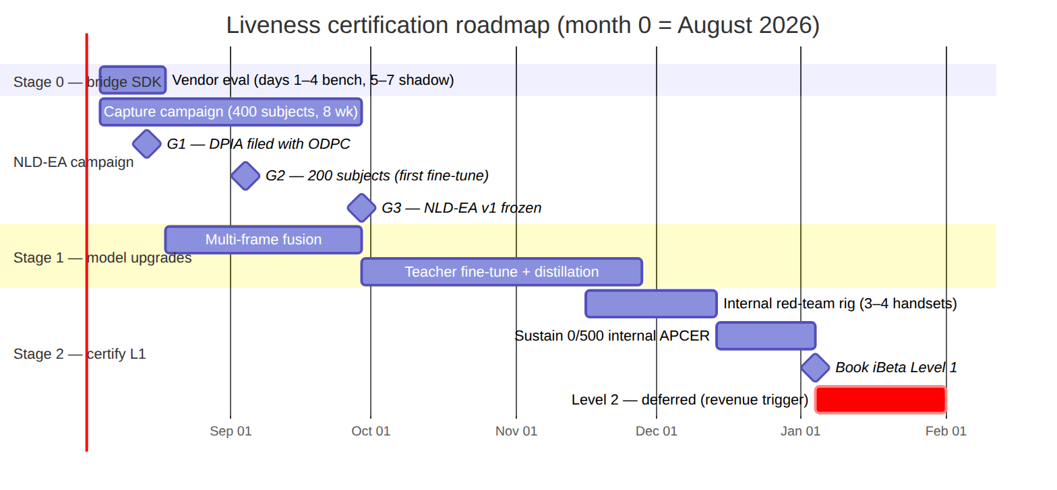
Figure 18
The NLD-EA campaign runs concurrently with Stage 1: gate G2 (200 subjects at week 5) deliberately triggers the first teacher fine-tune on half the data, so model work never blocks on campaign completion.

6.3 3. Model-evolution pipeline
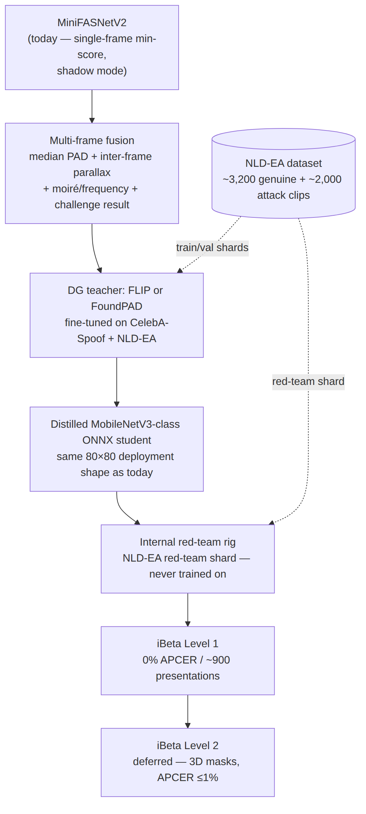
Figure 19
The student model ships in the exact deployment shape the service runs today — an 80×80 face-crop ONNX classifier behind cv2.dnn — so the swap is a model-file drop-in, not a service rewrite.

6.4 4. Stage 0 — bridge SDK (weeks 1–2)
Why. Certification of the owned model is months away, but bank partners and prospects ask for the iBeta letter now. A certified on-prem SDK mounted as a second LivenessProvider implementation lets sales claim Level 2 immediately at a fixed annual cost — explicitly not per-check SaaS, for both data-residency and unit-economics reasons (doc 09 §3).
Shortlist (all hold current iBeta L2 confirmation letters):
Vendor | Est. price | Form factor | Notes
MiniAiLive | ~$3–8k/yr | Linux/Docker on-prem | Primary candidate
KBY-AI | ~$2–6k/yr | Server + mobile SDKs | Primary candidate
Facia | quote | on-prem | Fallback if both fail gates
Evaluation protocol (2 weeks from receipt of eval builds):
- Days 1–4 — bench: run each SDK against our held-out genuine/attack captures; measure APCER, BPCER, and latency on the production box CPU.
- Days 5–7 — shadow: side-by-side with ekyc-ml on staging; measure the disagreement rate against the in-house scorer.
- In parallel — license diligence: on-prem terms; white-label/resale rights (REQUIRED — without them the SDK cannot back the Nemo KYC product); the iBeta letter must match the shipped SDK version; no phone-home telemetry.
Decision gates: APCER ≤1% on our attack set · BPCER ≤10% on our genuine set · price ceiling $8k/yr. Any failure → next vendor on the shortlist.
Integration: mounts behind the LivenessProvider seam ({frames} → {liveScore, decision, provider, auditRef}) as a second registered implementation. Prerequisite: the seam does not exist in code yet — liveness is inlined in the inhouse eKYC provider; extracting it is ranked action 3 of the audit. The in-house scorer stays on 100% of traffic in shadow regardless of which provider decides. Ethiopia routes to VeriFayda 2 (national eKYC via EthSwitch) behind the same seam either way (doc 08, regulatory notes).

6.5 5. NLD-EA — the East-African training-data campaign (weeks 1–8)
This is the centerpiece. MiniFASNet’s documented East-Asian training skew — elevated false-reject risk on darker skin tones and in low light — is exactly the failure mode a Kenyan/Ethiopian deployment cannot tolerate. No open dataset fixes it, and no vendor’s marketing can claim what a model trained on this data can demonstrate. NLD-EA (Nemo Liveness Dataset, East Africa) is the moat: the regional-calibration claim behind Nemo KYC rests on it.
Targets: 400 consenting subjects → ~3,200 genuine clips + ~2,000 attack clips in 8 weeks, ≈ $8.6k all-in.
Session protocol (~15 min/subject): 3 lighting stations (daylight >1,000 lux · office ~300 lux · dim <50 lux — dim deliberately over-sampled, it is MiniFASNet’s failure zone) × 2 devices × 2 takes = 12 genuine clips per subject, including a full blink→turn→smile challenge run so training data matches production capture.
Attack desk — clips fabricated from each subject’s own media, mapped to the iBeta Level-1 attack repertoire:
Attack species | Target clips
Matte print | 400
Glossy print | 300
Cutout mask | 300
Phone-screen replay | 500
Monitor replay | 300
Challenge-replay | 200
Total | ~2,000
Demographic and device quotas:
Axis | Quota
Skin tone (Monk scale) | Full 1–10 coverage, ≥60% in 7–10
Age | 45% 18–30 · 40% 31–50 · 15% 51+
Gender | 50/50 ±5%
Device fleet | Actual Kenyan market: 2 budget (Tecno/Redmi) + 2 mid-range (Samsung A / Camon); model recorded per clip
Sites | Nairobi CBD + university + peri-urban; Addis pilot (50 subjects) weeks 7–8
Compliance gate (G1 — hard gate, before any capture): DPIA filed with the ODPC before the first session; tablet-signed plain-language consent covering purpose, compensation, withdrawal-by-subject-ID with deletion, 36-month retention, encrypted on-prem storage, and anti-fraud-model-development-only use; minors excluded. This is the binding Kenyan constraint (Data Protection Act — doc 08).
Pipeline: capture app (consent + session script) → encrypted on-prem store keyed by erasable subject-ID → label sheet (genuine|attack·species, device, lux, station, Monk tone) → subject-disjoint train/val/red-team shards. The red-team shard never touches training and becomes the internal certification rig for Stage 2.
Budget (doc 10):
Line item | Amount
Subject compensation (400 × KES 800) | $2,480
Field agents | $2,400
Devices | $900
Capture kit (lighting, tripods) | $450
Attack materials | $350
Legal / DPIA counsel | $1,200
Contingency | $780
Total | $8,560
Gates: G1 DPIA filed (week 2) · G2 200 subjects (week 5 — triggers the first teacher fine-tune on half the data) · G3 NLD-EA v1 frozen (week 8).

6.6 6. Stage 1 — model upgrades (months 1–4)
Two upgrades, in this order, per doc 09 §3:
1. Multi-frame fusion (first — biggest APCER win per engineering hour, zero licensing risk). Replace today’s single-frame min-score decision with 10-frame aggregation: median PAD score + inter-frame parallax + moiré/frequency features, fused with the ML Kit challenge result into one decision score. The Tier-1 challenge screen already captures multi-frame selfie sets, so the plumbing exists end-to-end — this is scoring logic, not new capture infrastructure. It directly retires the weakest-frame-decides behavior in score_frames() today.
2. Domain-generalization teacher → distilled student. Fine-tune FLIP (CLIP-based, best published cross-dataset generalization of its generation) or FoundPAD (2025, DINOv2+LoRA, built for unseen-domain generalization) on CelebA-Spoof (625K images — license check required first) plus the NLD-EA train shard, then distill to a MobileNetV3-class ONNX student in the exact 80×80 deployment shape. This is the step that kills MiniFASNet’s skin-tone/lighting domain gap — in the field and, critically, in the certification lab.

6.7 7. Stage 2 — certify Level 1 (months 4–6)
What iBeta Level 1 actually takes (doc 09 §2):
- ~900 presentations across 6 cheap attack species (print, replay, cutouts).
- Pass bar: 0% APCER — zero spoofs may get through — with BPCER ≤15% (generous; aggressive spoof-averse thresholds plus retry-not-reject UX are legal).
- Tested per app-build, per device — the submitted build/device pairs are what the letter covers.
- Budget: realistic $25–40k (lab fee + one retest reserve + rig/devices); 4–12 weeks elapsed. Retests are normal and billed — budget for one from the start. Get a competing quote from BixeLab before booking.
Sequence: build the internal red-team rig replicating the L1 attack repertoire on 3–4 handsets, driven by the NLD-EA red-team shard (subject-disjoint, never trained on); book iBeta only after sustaining 0/500 internal APCER. Small teams demonstrably pass — iBeta’s letter list includes 2-to-10-person shops at both levels.
Level 2 deferral logic: L2 adds 3D attacks (silicone/latex/resin masks, APCER ≤1%) and roughly +$30–50k plus mask-fabrication skills. Trigger: liveness becomes revenue-attributable (Nemo KYC per-check sales, or a contract naming L2 for the in-house stack). Until then the Stage-0 bridge SDK legitimately covers L2 claims.

6.8 8. Business case — build vs buy
 | Buy (Smile ID-class) | Build + certify (this plan)
Cost model | $0.30–1.00 per check, forever | One-time ~$35k L1 + ~$8.6k data + bridge $2–8k/yr
Break-even | — | Low tens of thousands of checks
Data residency | Vendor cloud | Fully on-prem
Regional calibration | Generic | Trained on NLD-EA (East African faces, Kenyan device fleet)
Product upside | None (pure cost) | “Nemo KYC” white-label per-check API via the G2 platform
Skip condition | — | Only if liveness stays a pure internal checkbox — which the neobank-in-a-box strategy rules out
Smile ID’s traction proves regional demand for certified KYC APIs; no Chinese SDK vendor matches the East-African calibration claim (doc 09 §4).

6.9 9. Decision log — pending founder decisions
# | Decision | Blocks | Status
1 | Send Stage-0 outreach emails (MiniAiLive + KBY-AI; drafts in the doc-10 artifact §1.4) | Stage-0 eval clock | Pending
2 | Approve $8.6k NLD-EA budget + KES 800/subject compensation rate | Campaign start, gate G1 | Pending
3 | Name counsel for the DPIA | Gate G1 (hard gate — no capture before filing) | Pending
Everything technical for Stage 0 is ready on receipt of vendor eval builds (doc 10).

6.10 10. Risks & mitigations
Risk | Impact | Mitigation
DPIA/ODPC delay or adverse finding on NLD-EA | Campaign blocked; Stage-1 fine-tune slips | G1 is a hard gate before capture; counsel engaged early ($1.2k budgeted); consent design (withdrawal, 36-month retention, purpose limitation) built into the capture app
CelebA-Spoof license unsuitable for commercial training | Teacher fine-tune loses its largest public corpus | License check scheduled before Stage-1 step 2; fallback is NLD-EA + other permissive PAD sets with a heavier NLD-EA weighting
MiniFASNet class-order assumption wrong for a given ONNX export | Live/attack classes swapped in shadow scores | Documented in liveness.py (index 1 = live per the reference repo); shadow-mode score distributions on real traffic will surface an inversion before enforcement
iBeta retest(s) required | +weeks and +$10k-class cost per retest | Budgeted explicitly ($25–40k includes a retest reserve); internal 0/500 APCER gate before booking; BixeLab competing quote
Bridge vendor diligence failure (telemetry, letter/SDK version mismatch, no resale rights) | L2 claim unsound; Nemo KYC white-label blocked | Diligence items are explicit Stage-0 gates: no telemetry, letter must match shipped version, white-label/resale rights required — any failure moves to the next shortlisted vendor
Field-capture quality drift (lux, labels, quotas) | Dataset undertrained in exactly the target domains | Per-clip metadata (device, lux, station, Monk tone), lighting-station protocol, G2 mid-campaign checkpoint at 200 subjects

6.11 11. Sources
- docs/nemo/08-liveness-plan.md — tier design, MiniFASNet calibration warning, LivenessProvider seam, Kenya/Ethiopia regulatory notes.
- docs/nemo/09-liveness-build-and-certify.md — open-model landscape (FLIP, FoundPAD, CelebA-Spoof), certification economics, staged plan, business case, full external link list.
- docs/nemo/10-liveness-stage0-and-data-campaign.md — Stage-0 shortlist and eval protocol, NLD-EA targets, protocol, quotas, budget, gates.
- ekyc-ml-service/engine/liveness.py — the current single-frame min-score implementation this plan upgrades.

