

Course Code: CSE110

Course Title: Object Oriented Programming

Section: 05

**PROJECT REPORT**

on

**Inventory Management System**

**Submitted by:**

Name: Abdullah al Tamim

ID: 2020-1-60-127

Name: Fatema Akter

ID: 2020-1-60-115

Name: Fahad Ahammed

ID: 2020-2-60-174

**Submitted to:**

Tanni Mitra

Senior Lecturer

Dept. of Computer Science Engineering

East West University

**Project Description**

1. **Project Explanation:**

The inventory management system will contain a shop’s all products, stock, supplier and customer information. The application must have enough security. Because it may contain sensitive information about the shop. So any user who wants to use the application must log in first. The application should be able to add new products, remove any existing products, search a product, to show its all information and also update the price, if the market price changes, and update the quantity, if any product is restocked to the inventory. It should also be able to make payment slips for the customers. They will be able to pay the amount through electronic payment also. After the payment is done, they will get their payment slip.

1. **System Requirements:**

(Recommended)

Processor: Intel pentium / AMD athlon 600 or higher.

RAM: 128 mb or higher.

Disk space: 50 mb or higher.

Operating System: Windows 7/8/10.

IDE: Netbeans IDE 8.2 or higher.

1. **UML class diagram:**

User

-

userName: String

userId: String

-

-

Password:String

+

logIn(): boolean

+

logOut(): void

Product

productId: String

-

productName: String

-

-

category: String

-

price: double

-

quantity: int

+

paymentDisplay():String

+

compareTo(Product t):int

Payment

totalAmount: double

-

due: double

-

+

printPaymentSlip(): void

vatAmount(double totalAmount): double

+

Category

#catName : String

*Vat*

-

Rate:double

*vatAmount(): double*

+

Customer

-

cusName: String

-

cusAddres: String

cusPhone: long

-

CreditCard

-

creditNumber:Sting

password:String

-

BankCard

accNumber:String

-

-

password:String

Supplier

-

supName:String

-

supPhone:String

supList: Supplier

[]

-

1..*

1

1..*

1

1..*

*..*

1..*

1

1

1..*

0..*

0..*

1

0..*

1

1

1

0..*

0..*

1

Cash

cashTendered: double

-

0..*

1

1. **All Features:**
2. **Security:** Password is needed to enter into the application

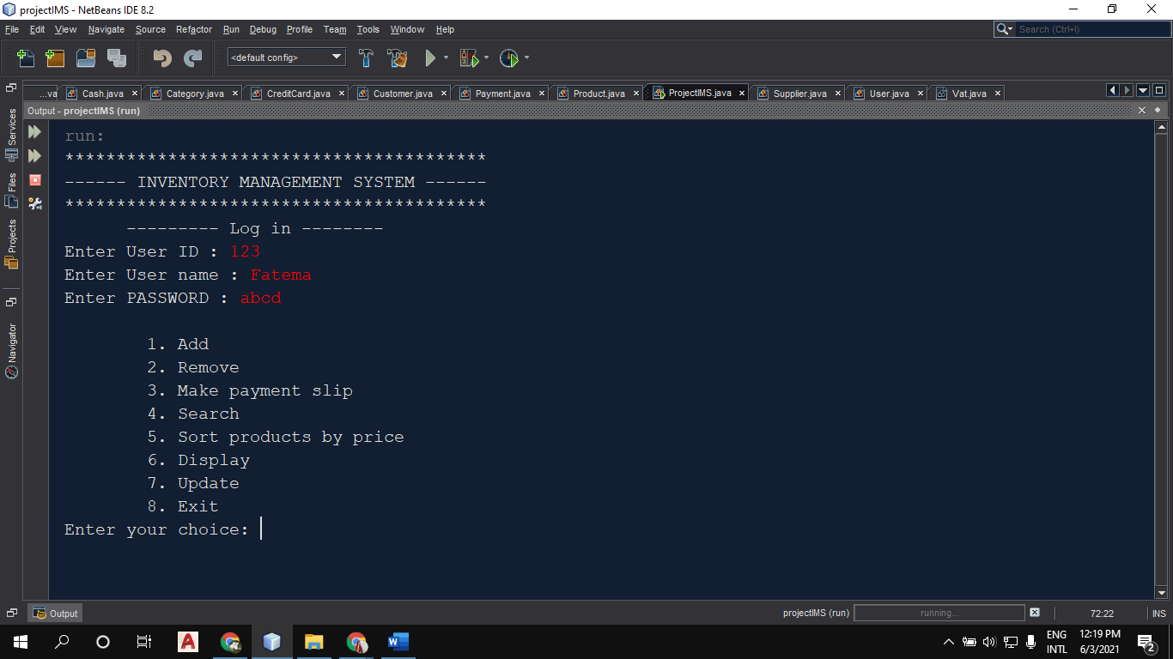

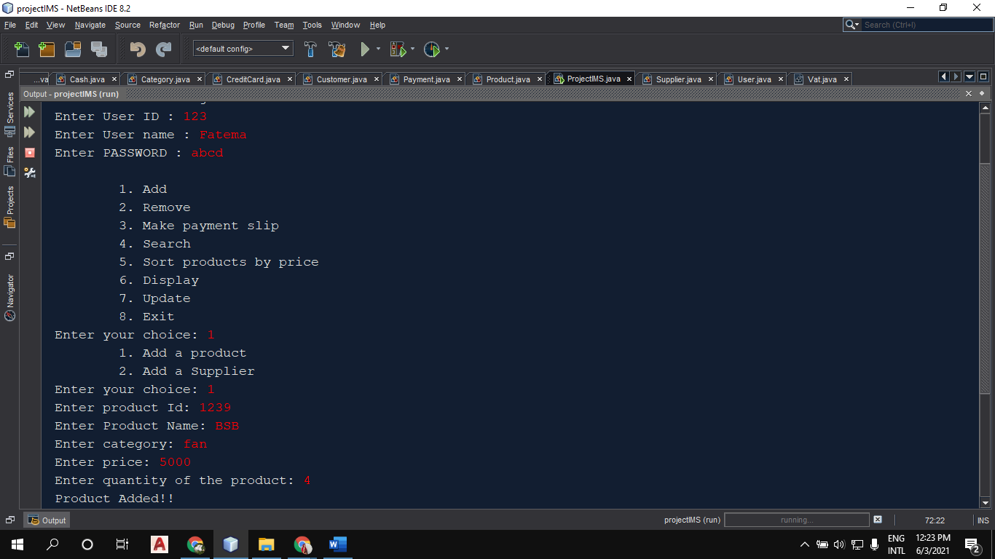

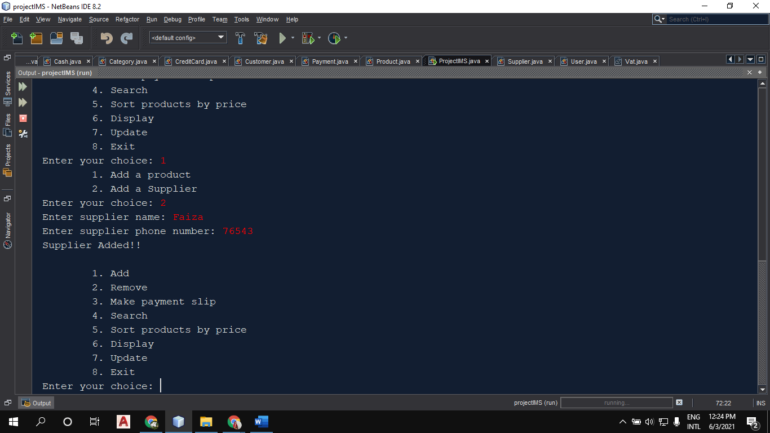

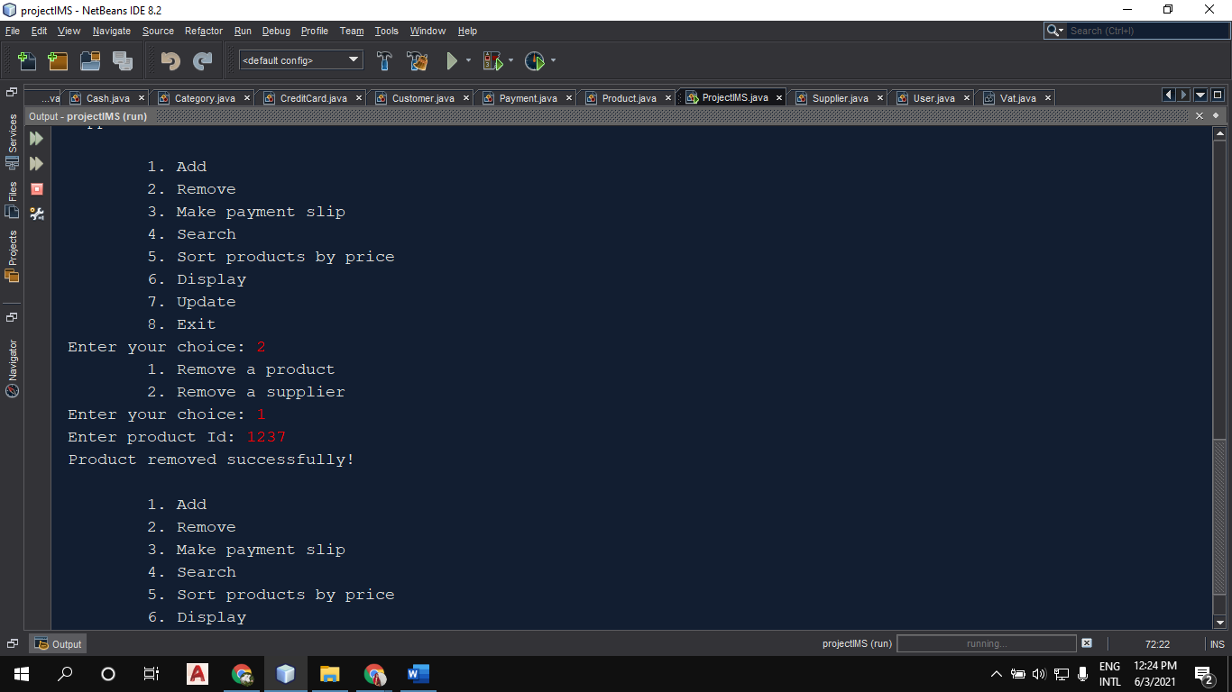

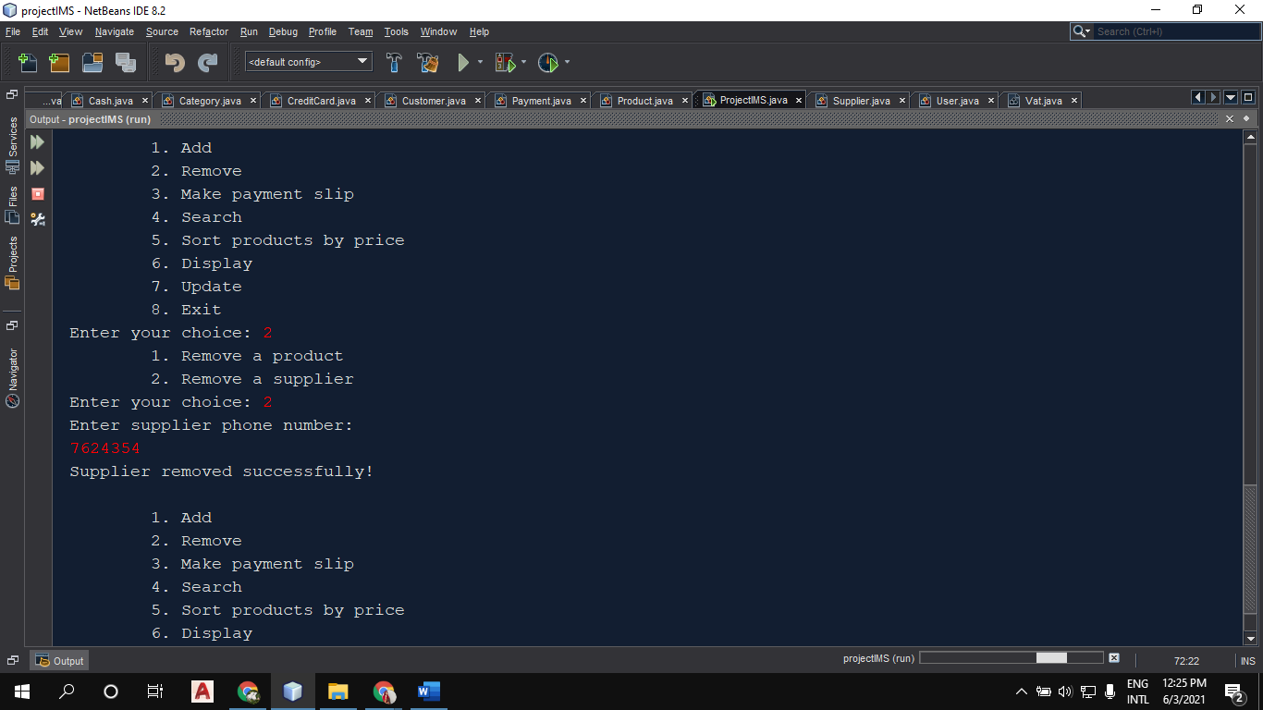



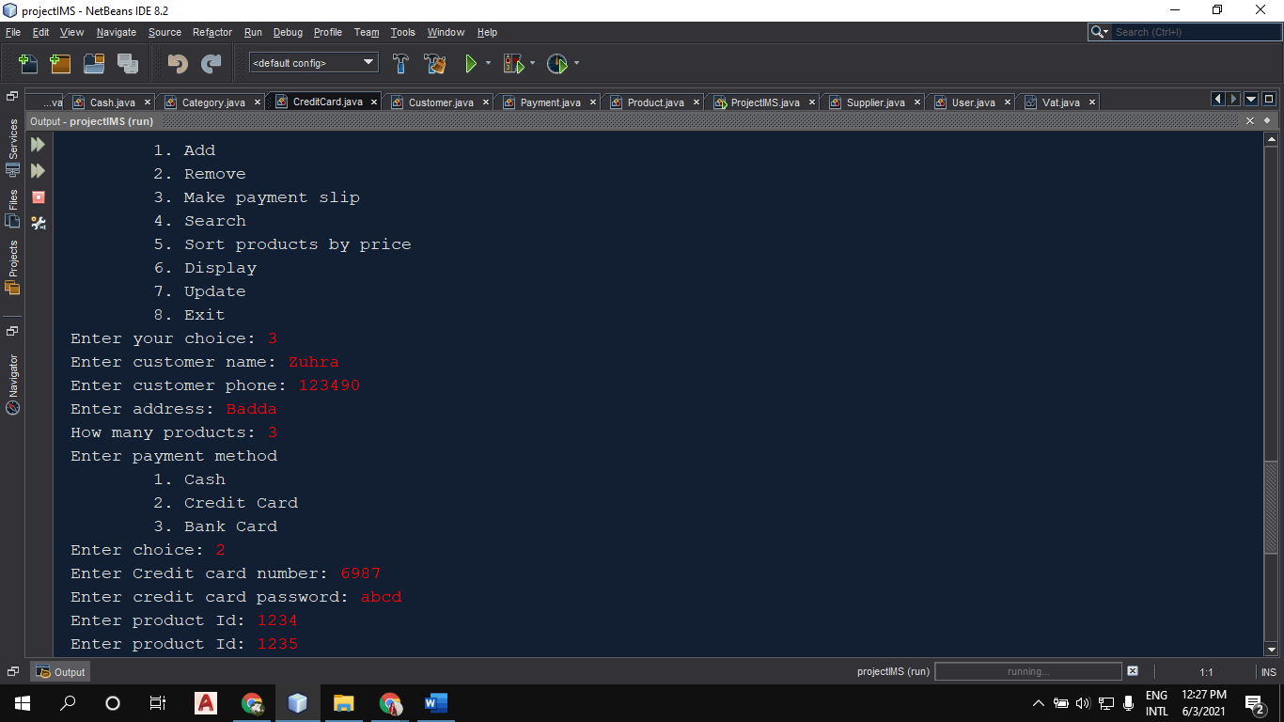

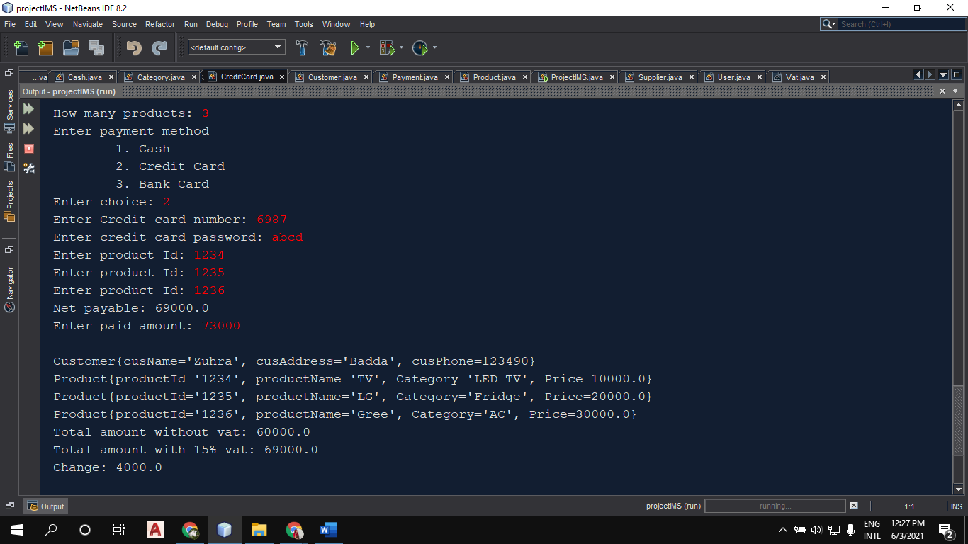



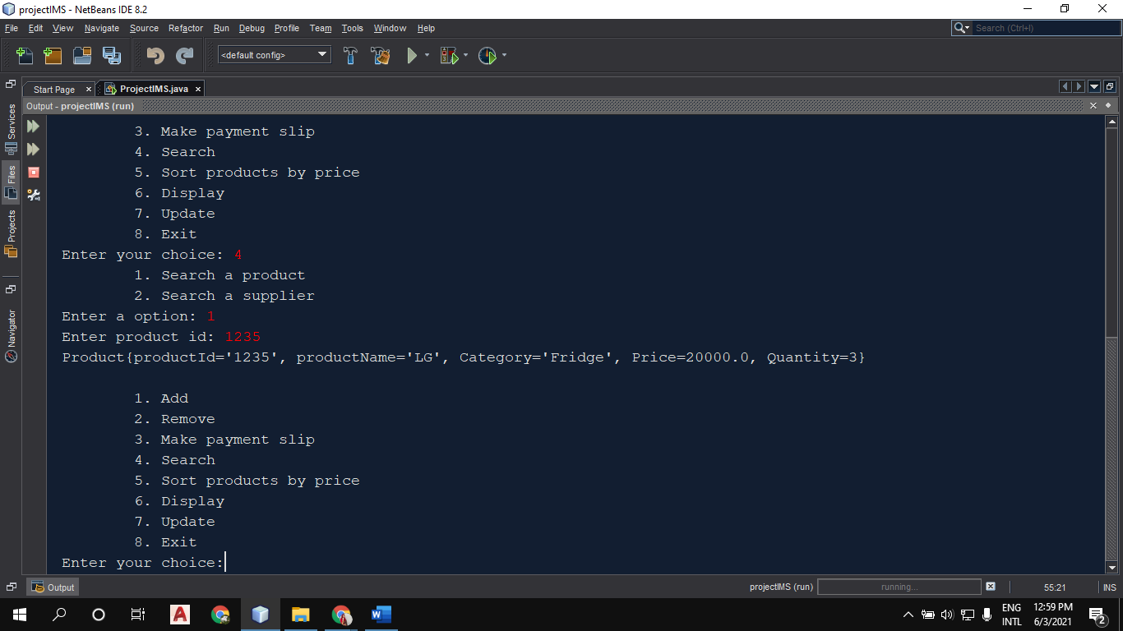

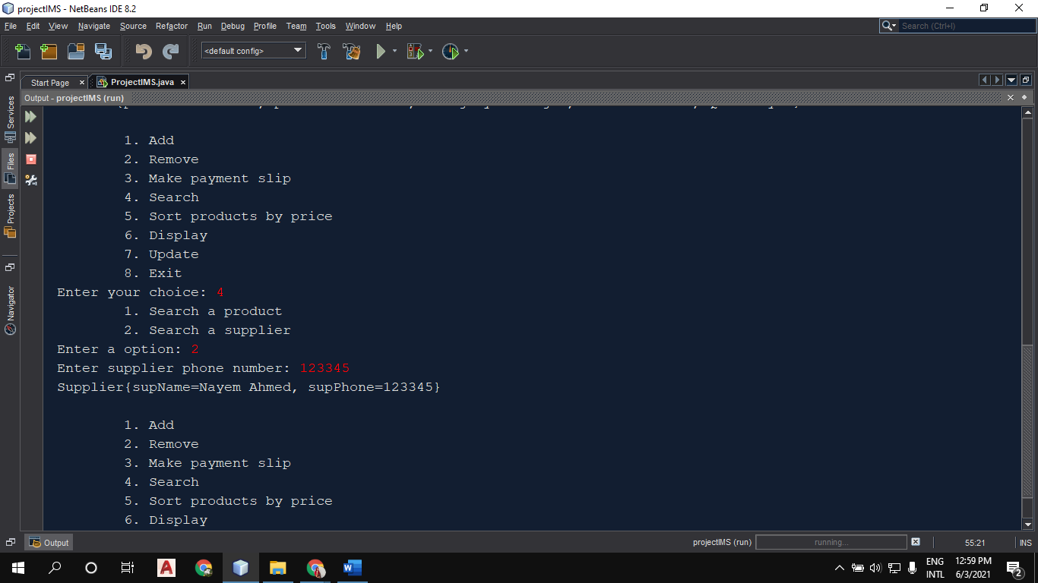

1. 