Day-1
1) Basics of Python.
A) Current versions are in use.
3.10

B) How to define a variable and how it will interpret at runtime.
Assign value to variable useing single ‘=’sign.
ie. N=10
if new value is assign on existing variable then it replace the value.\
ie. N=100
REPL(Reda, Evaluate, Print, Loop): To execute single command and display result.
Ie. print(N) or N o/p :- 100
Chained assignment: To asign same value to different variable
Method of multi-word Variable name:
Camel-case:- instead of first letter of word, all the word of first letter is capital. ie. bcDefHij
Pascal Case:- It should be use for class names. Same sa Camel-case but fiest letter is also capital ie. AbcDefHi
Snake case:- It should be use for function and variable name. Word are separeted by underscores. ie.abc_def_hi

C) Importance of Indentation.
Indentation is the leading whitespace(space or tabs) before any statement in python. Indentation in other language like C or Java use {()}. It is use to create group of statement or to create blocks for function and loop.
Adavantages:
In most of the programming language, indentation is used to properly structure the code. In Python, it’s used for grouping, making the code automatically beautiful.
Disadvantsges:-
Since whitespaces are used for indentation, if the code is large and indentation is corrupted then it’s really tedious(boring) to fix it. It happens mostly in copying the code from online sources, Word document, or PDF files.

Most of the popular programming languages use braces for indentation, so anybody coming from other side of the development world finds it hard at first to adjust to the idea of using whitespaces for the indentation.

Standard Indentation and Mixed Indentation issues.

D) Python Keywords.
True: This keyword is used to represent a boolean true. If a statement is true, “True” is printed.
- False: This keyword is used to represent a boolean false. If a statement is false, “False” is printed.
- None: This is a special constant used to denote a null value or a void. It’s important to remember, 0, any empty container(e.g empty list) does not compute to None.
It is an object of its datatype – NoneType. It is not possible to create multiple None objects and can assign them to variables.
- with:-keyword is used to wrap the execution of block of code within methods defined by context manager.here is no need to call file.close() when using with statement.
- as:-keyword is used to create the alias for the module imported. i.e giving a new name to the imported module. E.g import math as mymath
is :- This keyword is used to test object identity, i.e to check if both the objects take the same memory location or not.
Lamda:- A lambda function can take any number of arguments, but can only have one expression. ie. g=lamda x:x*x*x print(g(2)).

Exception Handling
try : This keyword is used for exception handling, used to catch the errors in the code using the keyword except.
except : As explained above, this works together with “try” to catch exceptions.
finally : No matter what is result of the “try” block, block termed “finally” is always executed.
- raise: We can raise an exception explicitly with the raise keyword. You can define what kind of error to raise, and the text to print to the user.
X = "hello"
if not type(x) is int:
raise TypeError("Only integers are allowed")
- assert: This function is used for debugging purposes. Usually used to check the correctness of code. If a statement is evaluated to be true, nothing happens, but when it is false, “AssertionError” is raised.
Exceptions can be triggered by raise , assert , and a large number of errors such as trying to index an empty list. raise is typically used when you have detected an error condition. assert is similar but the exception is only raised if a condition is met.
del is used to delete a reference to an object. Any variable or list alue can be deleted using del.

import, from:- to import perticular functionality form the module.

And, or, not, in,
Iteration Keywords – for, while, break, continue
Conditional keywords – if, else, elif, Pass
def, return
class,

E) Print and String Formatters with Format Specifiers (%d, %f).
Formatters:-
3 types of formatting.
% operator formatting
‘format()’
‘f-string’ formatting.
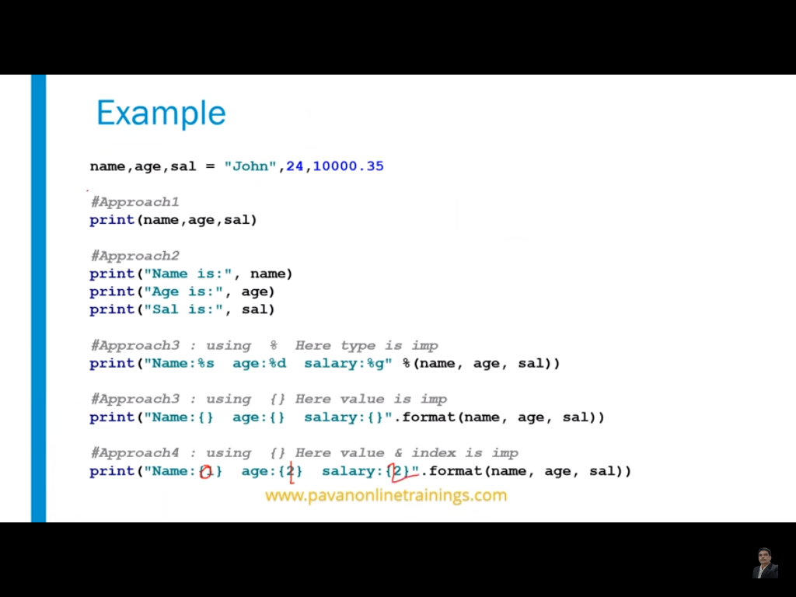
Here, ss has 1 and 2 type of formatting
F-string Formatting:- F-strings are faster than the two most commonly used string formatting
val = 'Geeks'
print(f"{val}for{val} is a portal for {val}.")

name = 'Tushar'
age = 23
print(f"Hello, My name is {name} and I'm {age} years old.")

O/P
GeeksforGeeks is a portal for Geeks.
Hello, My name is Tushar and I'm 23 years old.

%d :- It is used to print the signed integer value where signed integer means that the variable can hold both positive and negative values.
%f :- It is used for printing the decimal floating-point values. By default, it prints the 6 values after '.'.
F) Operator and Expressions.
+,-,*,/,//,**,% ie. -a :- Take a as negative value useing ‘-’.or use ‘+’ for pluse val ;

G) Python Manual using Termina.

2) Data Types
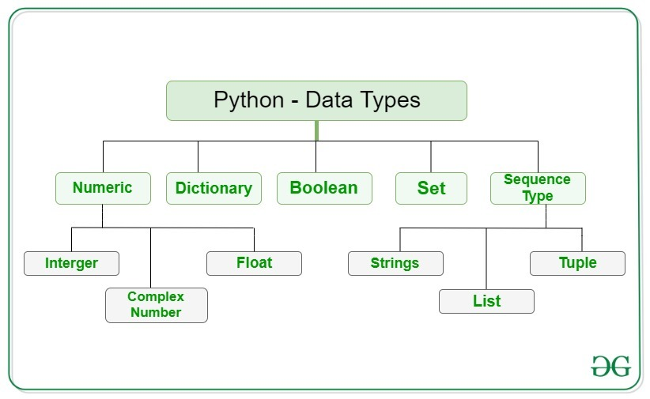
Integers:- This value is represented by int class. It contains positive or negative whole numbers (without fraction or decimal). In Python there is no limit to how long an integer value can be.
Float:- This value is represented by float class. It is a real number with floating point representation. It is specified by a decimal point. Optionally, the character e or E followed by a positive or negative integer may be appended to specify scientific notation.
Complex Numbers :-Complex number is represented by complex class. It is specified as (real part) + (imaginary part)j. For example – 2+3j

Tuple:- Creation of Python tuple without the use of parentheses is known as Tuple Packing.
# declaring tuple containing student's infomation
# without using parenthesis
student = "prem", 21, 98.56, "New Delhi"

# printing its type
print('Type of student:', type(student))

# printing the tuple
print("student: ", student)

# unpacking tuple and printing each values
name, age, perc, city = student
print('Name:', name)
print('Age:', age)
print('Percentage:', perc)
print('City: ', city)
Output:-
Type of student: <class 'tuple'>
student: ('prem', 21, 98.56, 'New Delhi')
Name: prem
Age: 21
Percentage: 98.56
City: New Delhi

3) Control Flow.
If, If..else,Nested if

4) Loops with Control Flow Statements.
https://www.geeksforgeeks.org/loops-and-loop-control-statements-continue-break-and-pass-in-python/
A) for
B) range() and its parameters.
C) while
D) continue:- it dosen’t execute block of code after the ‘continues’ keyword and directely increment value of i.
E) break
F) pass

Questions:-

Standard Indentation and Mixed Indentation issues.
/n & /r

G) Python Manual using Terminal

Day-2

5) Functions: Definition Creation and Calls

A parameter is the variable listed inside the parentheses in the function definition.
An argument is the value that is sent to the function when it is called.

A) Without Parameters.
User doesn’t pass parameter while calling to function.

B) With Parameters.
While call to function user give parameter to function.
Default Parameter:-
def my_function(country = "Norway"):
print("I am from " + country)

my_function("Sweden")
my_function("India")
my_function()
my_function("Brazil")
O/P
I am from Sweden
I am from India
I am from Norway
I am from Brazil

Arbitrary Arg, *arg:-
If you do not know how many arguments that will be passed into your function, add a * before the parameter name in the function definition.
def my_function(*kids):
print("The youngest child is " + kids[2])

my_function("Emil", "Tobias", "Linus")
O/P
The youngest child is Linus

Keyword Arg:-
You can also send arguments with the key = value syntax.This way the order of the arguments does not matter
def my_function(child3, child2, child1):
print("The youngest child is " + child3)
my_function(child1 = "Emil", child2 = "Tobias", child3 = "Linus")
O/P
The youngest child is Linus
D) What is an ambiguity error and how to resolve it?
E) Return multiple values

6) Global, Local and Nonlocal Variables.
nonlocal variable :- If we change the value of a nonlocal variable, the changes appear in the local variable.

Decorator is use for changing behavior of existing function at the compile time.

