Day – 3

9) Data Structures (Number of data structures and signature only).\

Buit-in function:- https://docs.python.org/3/library/functions.html

List[]

Note:- In list use of dotted notation for accessing methods of the objects.

Tuple() :-
You have to specify it using a comma following the first (and only) item so that Python can differentiate between a tuple and a pair of parentheses surrounding the object in an expression i.e. you have to specify singleton = (2 , ) if you mean you want a tuple containing the item 2.

Dictonary{}:- items() method is used to return the list with all dictionary keys with values. It dosen’t contain any parameter
When an item in the dictionary changes value, the view object also gets updated:

Set():- The issuperset() method returns True if all items in the specified set exists in the original set, otherwise it retuns False.

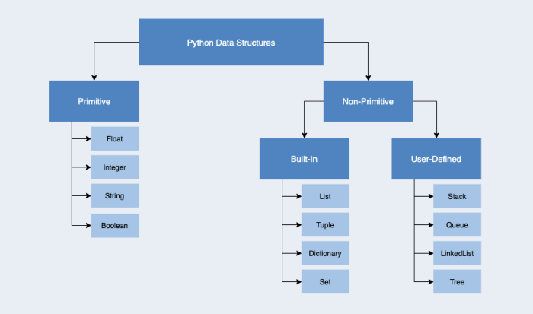

Different ways to define and store in variables.
Difference between data structures.

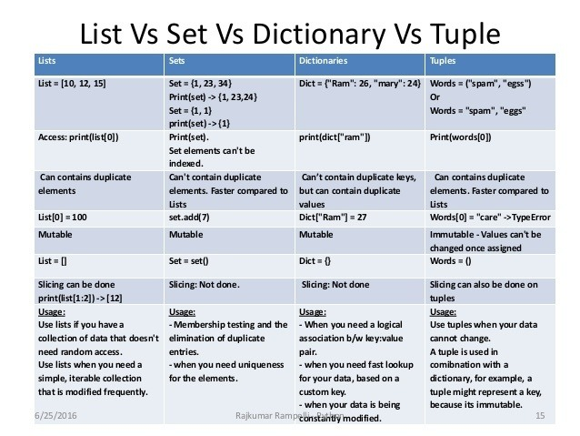
Generic Built-in Functions with Data Structures in python
https://realpython.com/python-data-structures/

MAP() is use for compression of code, we can use instead of for loop or calling to function on some data type for passing data loike, list, tuple, set, dictionary to modify original data.

Lambda() is use for performing multiple opertaions on single line instead of using function.

Iteration:- object remembers iteration count via internal count variable.
Once the iteration is complete, it raises a StopIteration exception and the iteration count cannot be reassigned to 0.
Therefore, it can be used to traverse the container just once.
# converting list using iter()
lis1 = iter(lis1)

qgv9-py3y-ym4v

