STUDENT MANAGEMENT

An INTERNSHIP REPORT

Submitted by

ADARSH DONGA

[191263107007]

In partial fulfillment for the award of the degree of

BACHELOR OF ENGINEERING

in

Sal Engineering & Technical Institute
College in Ahmedabad, Gujarat.




Gujarat Technological University, Ahmedabad.

[APRIL 2022]

Sal Engineering & Technical Institute
College in Ahmedabad, Gujarat.

CERTIFICATE

This is to certify that the project report submitted along with the project entitled STUDENT
MANAGEMENT has been carried out by ADARSH DONGA under my guidance in
partial fulfillment for the degree of Bachelor of Engineering in Computer Engineering, 8th .
Semester of Gujarat Technological University, Ahmadabad during the academic year 2021-22.

PROF. MADHURI PAREKH DR. AJAY UPADHYAYA
Internal Guide Head of Department

Aktiv Software

703 - Venus Atlantis Corporate Park, 100 Feet Rd, Near Shell Petrol Pump, Prahalad Nagar, Ahmedabad, Gujarat 380015

DECLARATION

We hereby declare that the Internship / Project report submitted along with the Internship / Project entitled Student Management submitted in partial fulfillment for the degree of Bachelor of Engineering in Instrumentation and control to Gujarat Technological University, Ahmedabad, is a bonafide record of original project work carried out by me/us at Aktiv Software under the supervision of ‘Alpesh Savalia’ and that no part of this report has been directly copied from any students’ reports or taken from any other source, without providing due reference.

 | Name of the Student | Sign of Student
 | Adarsh Donga

ACKNOWLEDGEMENT

The internship opportunity I had with Aktive Software Pvt. Ltd. was a great chance for learning and professional development. Therefore, I consider myself as a very lucky individual as I was provided with an opportunity to be a part of it.
Bearing in mind previously I am using this opportunity to express my deepest gratitude and special thanks to the Mr. Alpesh Savalia Head of Company who despite being extraordinarily busy with his duties, took time out to hear, guide, and keep me on the correct path and allowing me During My training at Aktive Software Pvt. Ltd.
I am very thankful to our faculty mentor Prof. Madhuri Parekh who constantly helped by encouraging me and also helping me in writing this report. Without his constant help and support, it is not possible.
I would also like to thank from bottom of our heart to the head of the department Dr. Ajay Upadhyaya, all the faculty members the of instrumentation and control department, and all our colleagues who directly or indirectly helped me complete the internship and report.

List of Images

- Student management home screen
- Student Details
- Fees Payment
- Mark-sheet of student
- Sending Mail to the student and parent
- Get fees receipt of student
- Adding new subject to the syllabus
- To get the excel report of all the student

List of Tables

- First-month syllabus
- Second-month syllabus
- Third-month syllabus

Table of Contents
Acknowledgment……………………………………………………………………........3 Declaration…………………………………………………………………………….......5
List of Figures……………………………………………………………………..………6
List of Table …………………………………………………………………..…………..7
Table of Contents……………………………………………………….….……………...8
Chapter-1: COMPANY OVERVIEW…………………………………...………....…...9
1.1 About the company
1.2 About the internship
Chapter-2: Table of Training………………………………………………….........…...10
2.1 First-Month Training
2.2 Second-Month Training
2.3 Third-Month Training
Chapter-3: CONCEPTS OF PYTHON ……………………………………..…………13
Chapter-4 ODOO INSTALLATION.………………………………………………..…14
Chapter-5: PROJECT ASSIGNMENT……………………………………..……….…15

5.1 Description of each folder
5.2 Home page
5.3 Student fees List
5.4 Student Subjects
5.5 E-mail Send
5.6 Generate Excel-report
5.7 Student Mark-sheet
Chapter-6: CONCLUSION……………..…………………………………..……….…25

1. COMPANY OVERVIEW

Aktiv Software was est. in 2015 as a business software development organization. Since then, we have been offering various business management solutions that support and automate the business processes of our customers and partners. Mainly we cater to ERP (Odoo, MS Dynamics) and e-commerce (Magento) solutions while helping you choose the best-suited software for your business requirement and more. Ans also deploy and maintain model microservice. Also, build maintainable data pipelines for deep learning models.
Mission: We strive to simplify the business needs by suggesting the best-suited options, keeping ease of use at the core and utmost convenience through software enhancements.
Vision: To be the service provider of choice for organizations, by helping them achieve their digitalization goals.

We have over 60+ Odoo developers. We are Odoo 12 and Odoo version 13 certified. The company has over 200 satisfied clients with 80+ Odoo apps developed. Our sister company narrative is mainly focused on PHP development. We have managed over 1000 projects since 2015 only on the Odoo segment. Domains we serve are Trading, Healthcare Manufacturing, Restaurant, E-commerce Management, Education, Service

Scale up your Business Processes with our Odoo Offerings:
As the open-source model of Odoo allows us to encompass all-rounding business needs, we are serving a complete suite of tools to accompany any business requirement. Be it optimizing business processes, boosting sales, integrating services, streamlining operations, building websites, managing finances, or customizing any business requirement, we act as one of the most reliable Odoo service providers.

Odoo Business Consultancy: We follow the rigorous cycle of consultancy and propose solutions that align with the business objectives.

Odoo Module Development: We curate a compilation of generic modules that works for most of the business types.

Custom Odoo Development: Modifying existing Odoo applications and features to fit your specific business requirements.
Odoo Integration: We assist the businesses running on Odoo or on another platform to integrate smoothly.

1.1 Communication:
- Company Address
- 703 - Venus Atlantis Corporate Park, 100 Feet Rd, near Shell Petrol Pump, Prahlad Nagar, Ahmedabad, Gujarat 380015.

- Phone: 099099 42388

- Company Website: https://www.aktivsoftware.com

1.2 About the internship:
- During the internship I have gain some extra knowledge of company work and Odoo technology.
- After company has introduce python with brief knowledge. And start from Odoo basics.
- Once I have gain some knowledge of Odoo then started to design some diagrams for the student management model in odoo.

- TABLE OF TRAINING

1.1 First Month | Syllabus
Python Basics
Different Data types, Loops & Function.
Recursion, Decorator and Data structure.
Advance function features.
Built-in Functions.
String Operations.
Date-time operation
List Comprehension in python.
Lambda Function in Python.
Generic Built-in functions.
Practices of python Progrmmes.
Test of python
Odoo installation and configurations.

1.2 Second Month
  Introduction to run-boot in odoo.
  Learn basic git commands.
  Module structure and view structure.
  Simple fields
  Menu and sub-menu of odoo.
  View inheritance
  Created one custom module and role of security file.
  Relations field (O2m, M2o & M2m).
  Different Attributes (read-only, invisible, default, required, help).
  Search view, kanban View.
  Button type: action & object and use of related field.
  Widgets (phone, email, image, ratting, status-bar, radio, selection).
  Functional workflow sessions By Saurabh.
  Apps mainly covered in the session are Sales, Invoice and Sales to Delivery flow.

1.3 Third Month
  Wizards (TransientModel) in odoo.
  - QWeb report
  - Excel report
  - Constraints SQL and Python constraints.
  Chatter, tracking and message_post
  ORM methods (create, write and unlink).
  Smart-button with fa-icons.
  name_get, name_search and default_get methods.
  Method overloading, overriding and inheritance.
  Role of Domain in fields.
  API Decorators (onchange, depends and model ).
  Res config settings, system parameters, set_param, get_param, set_value, get_value.
  Rcolumn_invisible, force_save, no_create, no_create_edit.
  Adavance actions.
  Send E-mail using Python code.
  Functional workflow sessions By Saurabh.
  Apps mainly covered in the session are Purchase, Vendor Bills, Receipts etc.

3. CONCEPTS OF PYTHON

- In the beginning part of the internship our knowledge of a python programming language was polished and then tested.
- Different data types and built-in data structures of python were practiced.
- Use of the terminal in ubuntu version 21 and git command using terminals were practiced.
- Some important coding standards like PEP-8, Flake8, and Pylint were introduced.
- Date, Datetime, Time Delta, and Relative Delta were practiced.
- At the end of the python revision assessment was done.

4. ODOO INSTALLATION

- In this task steps for installation for Odoo and PostgreSQL were introduced.
- Pip up-gradation was done.
- Important requirements were also installed.
- PyCharm IDE was installed and got the setup for Odoo ready.
- Tested the first module made from scaffold functionality of Odoo.
- Understood the working flow of Odoo.

5. PROJECT ASSIGNMENT

- In this task we were each assigned a project by our project manager.
- Requirements were given and understood by the PM.
- For starters we were told to create a module for an ‘Student Management’ project.
- All folder structures were tested and verified required for the Student Management Project.
- Here is the sample screenshot of folder structure and workflow.

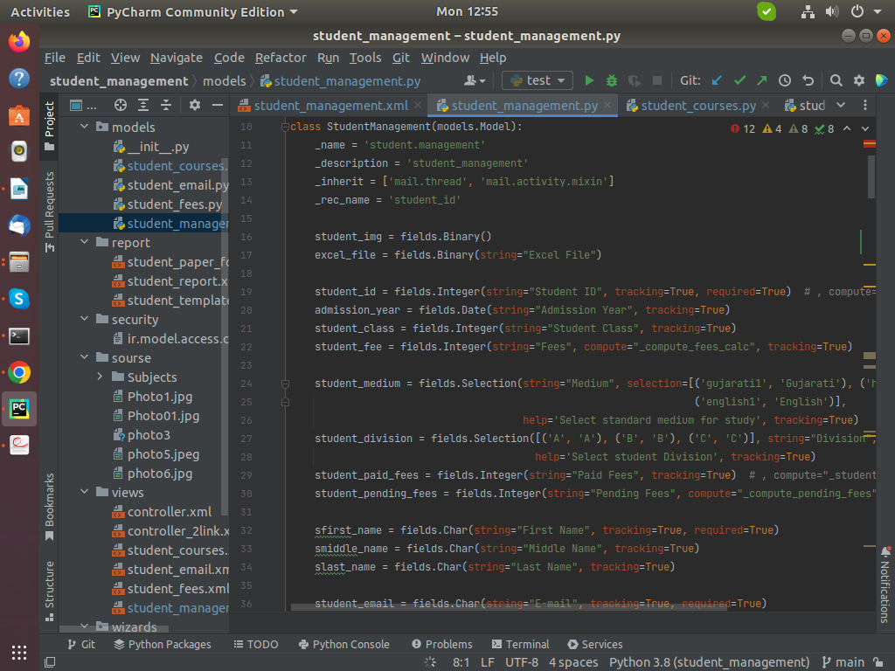

5.0.1 Student Management Code.

5.1 DESCRIPTION OF EACH FOLDER

  - MODELS:- All the python related codes and database table definitions were made here. In this project features like student model, student mark-sheet, etc. Were made in different models.

  - VIEWS:- All the things we are able to see on the GUI side were described in the Views folder of the module. All the models have their separate views.

  - There are a total of 4 types of views available in Odoo.
      - List view
      - Form view
      - Kanban View
      - Search view

  - REPORTS: To print the data in pdf format separate folder of reports is made. In this folder paper format of the report and the content of the pdf, report are defined.
            - SECURITY:- Access rights are given in this file.
            - __init__.py:- In this file, all the models are registered.
            - __manifest__.py:- Necessary details of the projects like the author, data, dependencies, and versions are defined in this file.
            - V15 is the link to the Odoo version 15 to provide the environment of Odoo.

5.2 HOME PAGE

- With the use of Odoo functionality of default filter home page of our project was made.
- Menu items as per need were defined regarding the functionality.
- Here is the sample screenshot for the home screen.
- All the students are listed here on the home screen.
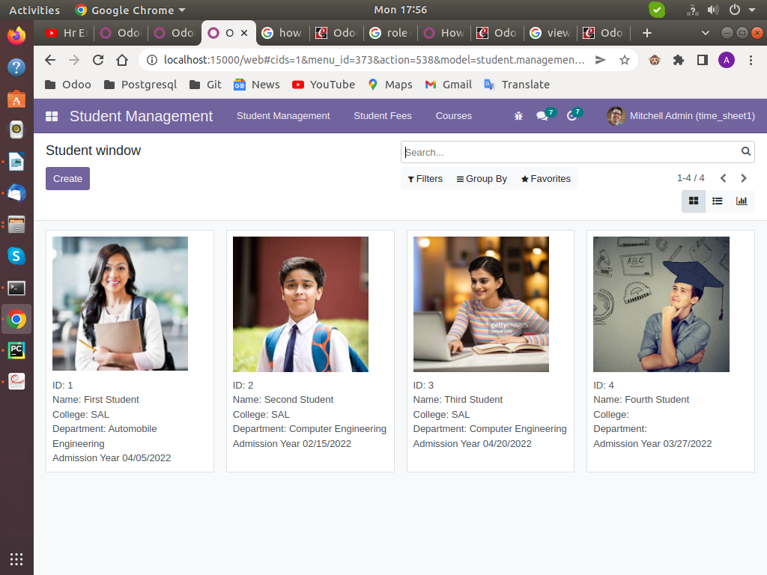

5.2.1 Student Management Home Screen.

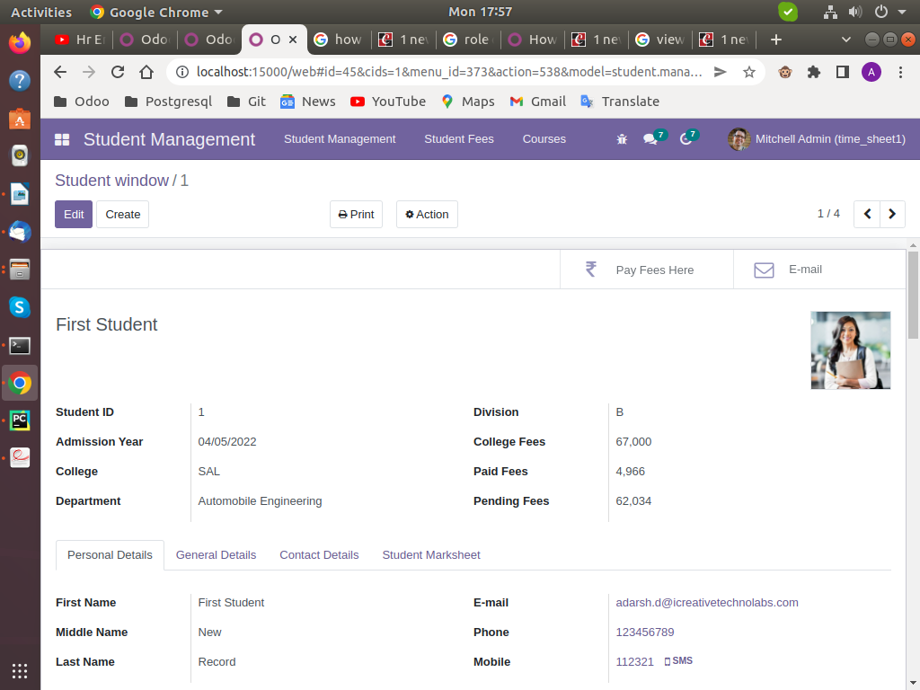

5.2.2 Student windows

5.3 STUDENT FEES LIST

- First menu item provides the List view of the student management in the database.
- We can edit and create the new student fees receipt from the form view, and it will directly modify the database.
- Here is the sample screenshot of the Student Fees view.
- With create button click a form view will open and we can create new record considering some required fields.
- After fill the filled, it will generate other data and we can take print-out of fees receipt.

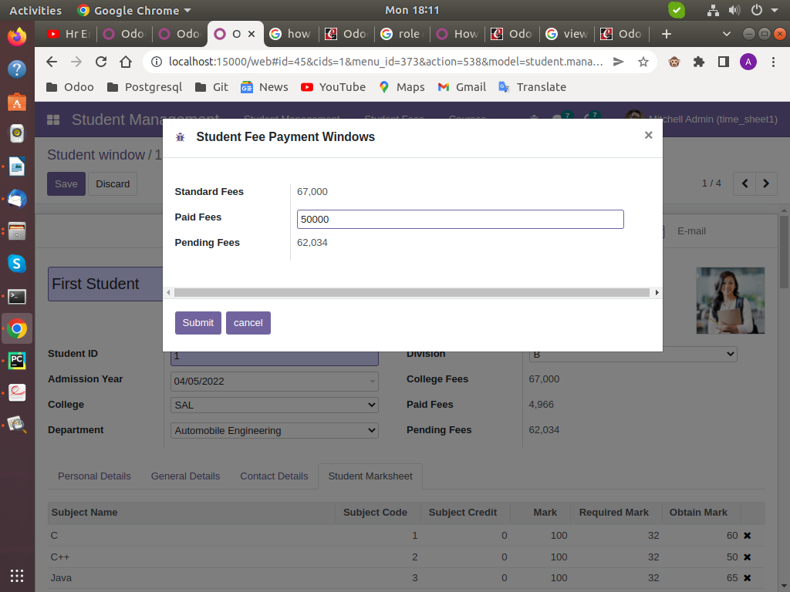

5.3.1 Student fees Payment.

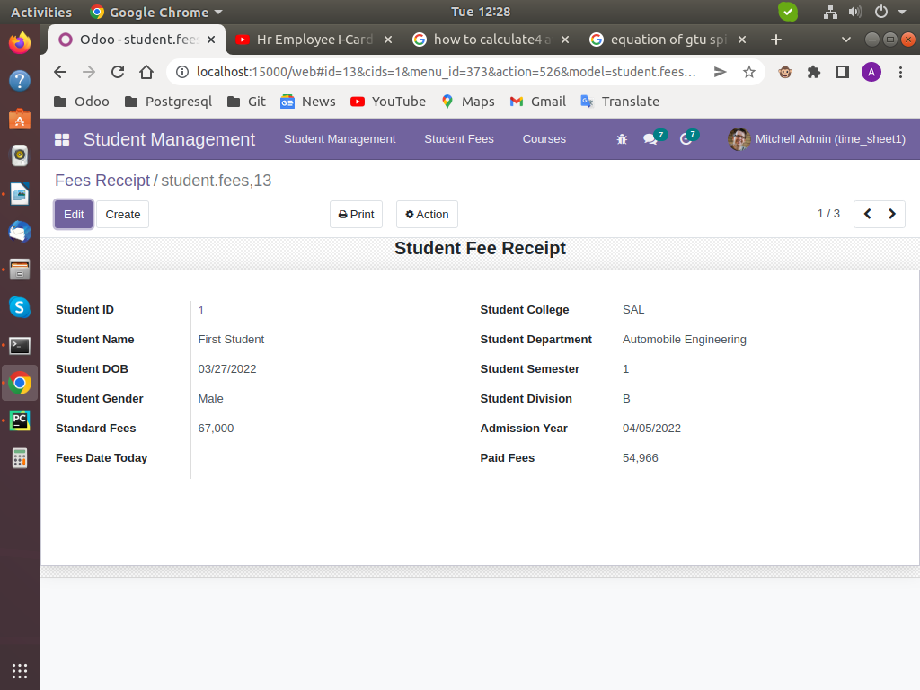

5.3.2 Student Fees List

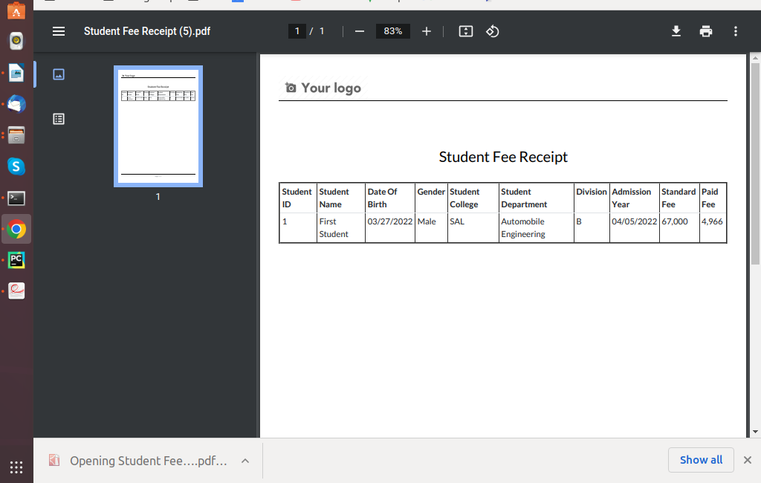

5.3.3 Fee Print-out.

5.4 ALL THE SUBJECT LIST

- This model will display a kanban view of the student subjects.
- We can add or remove the subjects from here.
- All the subjects are displayed in student management.

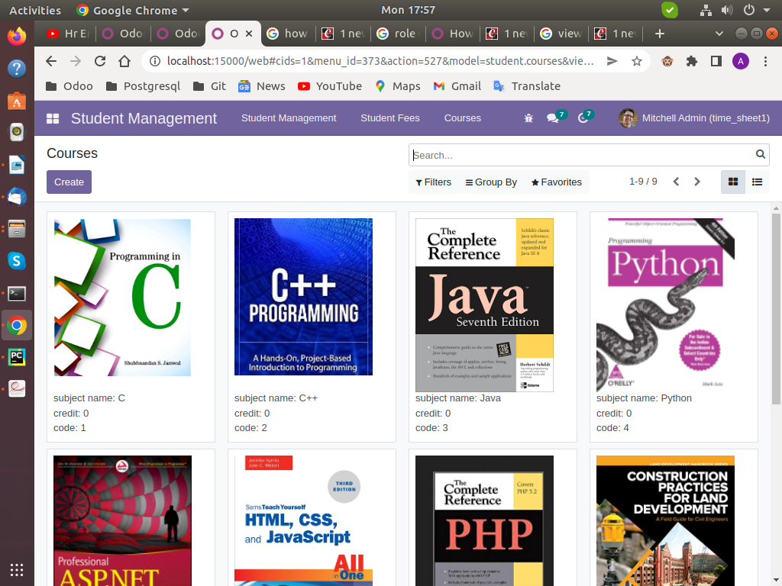

5.4.1 Subject List view

5.5 SENDING MAIL TO THE STUDENT

- Here we have use E-mail functionality to reach all the update to student parents.
- we can send the E-mail to the student and he/she parent.
- The mail contains various student information.
- Here is the sample screen shot of E-Mail data.

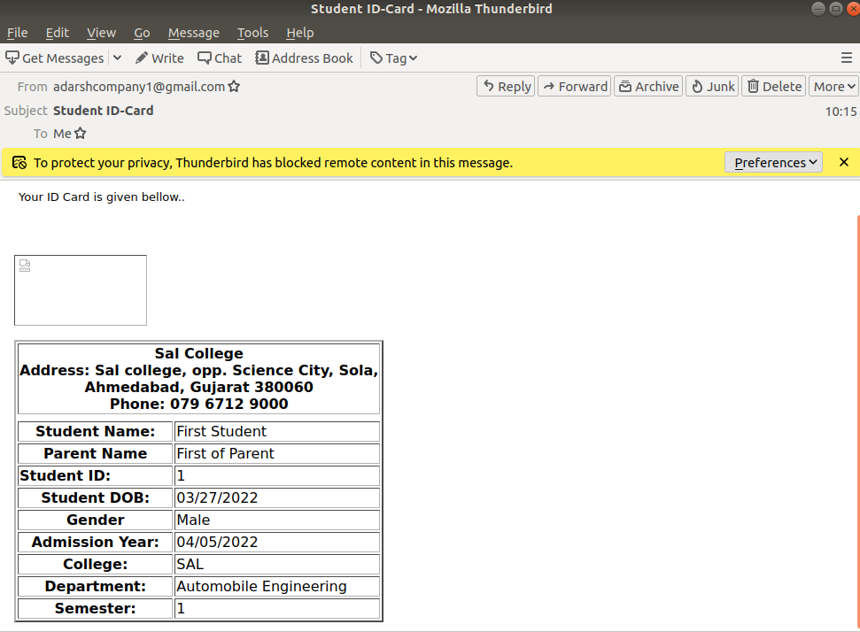

5.5.1 Student ID-card

5.6 GENERATE EXCEL REPORT OF STUDENTS

- When user wants to collect or analysis on organizational student then the excel report will help-full.
- Here is the sample screen shot of Excel report.

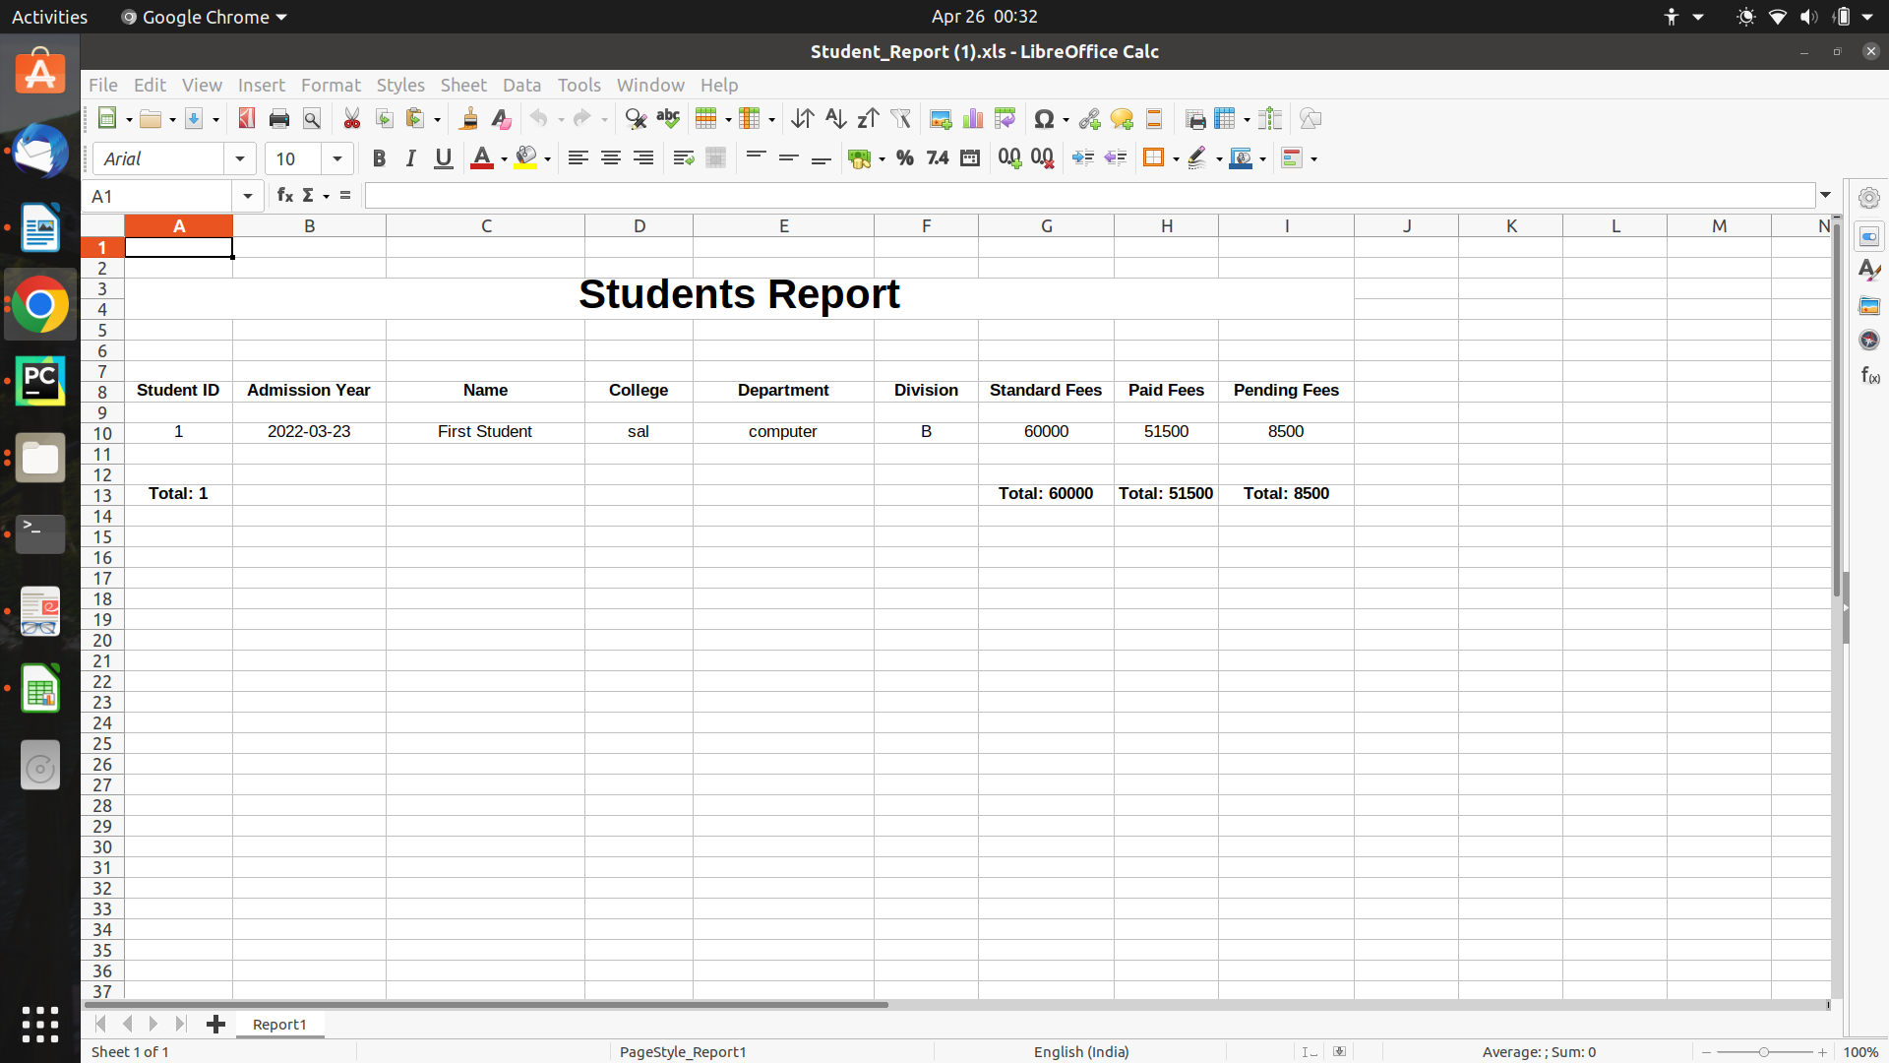
5.6.1 Student Excel report.

5.7 STUDENT MARK-SHEET

- Student management has provide the student mark-sheet functionality to get the student progress.
- Here we can create student mark-sheet according to the student department and his/her sem.
- We can also access all the subjects which are created on the course module.
- Here is screen shots for student marksheet.
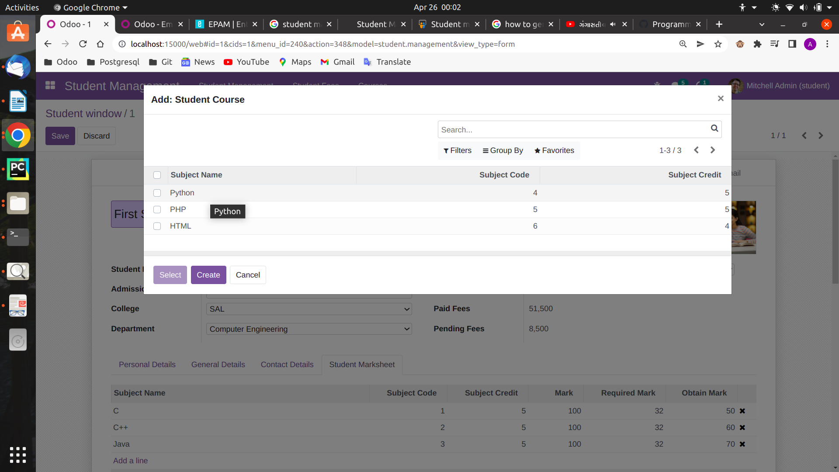
5.7.1 Mark-sheet sujects.

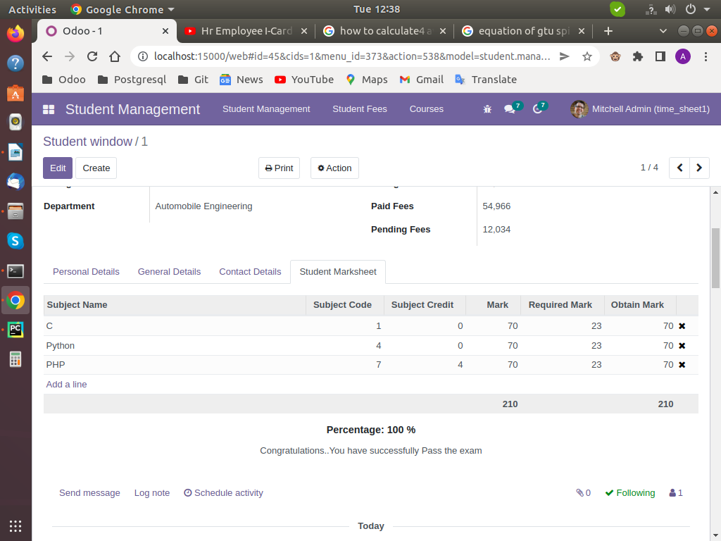

5.7.2 Mark-sheet view.

CONCLUSION

The Student Management project has been successfully designed and tested. The student management is developed on learned Odoo functionality and Python as a back-end. The presence of every module has been reasoned out and
placed carefully thus contributing to the best working of the unit. Secondly, using
highly advanced features and with the help of growing versions of Odoo, the
project has been successfully implemented.

The development of ERP systems using Odoo is an emerging technology with high potential. In the past decades, the Django framework of Python ruled the market. The last decade witnessed the revolution of Odoo based ERP systems. With regards to the requirements gathered the manual work and the complexity of
counting can be achieved with the help of this framework.

