**Revealing Differential Psychotic Symptoms in Schizophrenia and Bipolar I Disorder by Manifold Learning and Network Analyses**

Young Hoon Kim1, Jinhyeok Jang1, Nuree Kang1, Jae Hoon Jeong1, Jayoun Kim2, Yong Min Ahn1,3, Yong Sik Kim4*, Se Hyun Kim1,3*

Running title: Manifold and Network Analysis in Schizophrenia and Bipolar I Disorder

1Department of Psychiatry, Seoul National University Hospital, 101 Daehak-ro, Jongno-gu, Seoul, 03080, Republic of Korea

2Medical Research Collaborating Center, Soul National University Hospital, 101 Daehak-ro, Jongno-gu, Seoul, 03080, Republic of Korea

3Department of Psychiatry, Seoul National University College of Medicine, 101 Daehak-ro, Jongno-gu, Seoul, 03080, Republic of Korea

4Department of Psychiatry, Nowon Eulji Medical Center, Eulji University, 327 Gongneung-ro, Nowon-gu, Seoul, 01830, Republic of Korea

**Corresponding authors**

*Yong Sik Kim, M.D., Ph.D.

Department of Psychiatry, Nowon Eulji Medical Center, Eulji University, 327 Gongneung-ro, Nowon-gu, Seoul, 01830, Republic of Korea. (E-mail) kys@snu.ac.kr

*Se Hyun Kim, M.D., Ph.D.

Department of Psychiatry, Seoul National University Hospital/Department of Psychiatry, Seoul National University College of Medicine, 101 Daehak-ro, Jongno-gu, Seoul, 03080, Republic of Korea. (E-mail) sh3491@snu.ac.kr

**Abstract**

The field of psychiatry has encountered ongoing challenges in understanding the intricate nature of psychotic symptoms, particularly when they manifest in individuals diagnosed with bipolar disorder or schizophrenia. In this study, we employed manifold and network analyses to investigate whether the pattern of symptom occurrence differs between schizophrenia and bipolar I disorder. We analyzed data collected from 555 individuals, 282 of whom were diagnosed with schizophrenia-related disorders and 273 with bipolar I disorder. In the context of schizophrenia, manifold analysis demonstrated that negative symptoms, particularly avolition, exert a significant influence on the array of symptoms experienced by individuals. Network analysis further supported that avolition exhibits a high degree of centrality. Avolition is a clinically relevant phenomenon associated with clozapine use, patterns of deterioration, tendency toward remission, and illness severity. Conversely, bipolar I disorder exhibits discernible patterns where positive symptoms play a central role in network analysis. Unexpectedly, manifold analysis revealed two distinct clusters of patients. In conclusion, schizophrenia and bipolar I disorder, while sharing psychotic symptoms, exhibit distinct co-occurrence patterns. Schizophrenia demonstrates negative symptoms, whereas bipolar I disorder exhibits positive symptoms, with a variable strength of association between these symptoms. In particular, bipolar I disorder displays stronger connections between psychotic symptoms compared to schizophrenia. These findings highlight the complexity of psychotic symptom patterns and their relevance for understanding psychiatric disorders.

**Introduction**

The distinction between bipolar disorder and schizophrenia has long been a subject of discussion in psychiatry 1,2. Emil Kraepelin’s pioneering work categorizing major psychosis into manic depression and dementia praecox has been a source of fundamental assumptions in psychiatry since the early 20th century 3-5. Eugen Bleuler emphasized the central role of negative symptoms in schizophrenia 6. The overlapping phenomenology and neurobiological basis of schizophrenia and bipolar spectrum disorders, particularly bipolar I disorder, make differentiation challenging 7-10. Kraepelin recognized the challenges in applying the dichotomy he had suggested 11,12. The expanded applications of second-generation antipsychotics as mood stabilizers have increased these challenges 13-16. Based on the historical context and challenges associated with distinguishing these disorders, their shared and distinct characteristics should be investigated. Distinguishing between the two disorders has significant clinical implications, including for treatment selection and prognostication 17. In particular, the disorders share psychotic symptoms, which are important for distinguishing them. Traditional Schneiderian first-rank symptoms for schizophrenia are also common in bipolar disorders 18,19, and the presence of particular psychotic symptoms lacks diagnostic value. Furthermore, negative symptoms, such as anhedonia and avolition, have been observed in patients with bipolar disorder, and they persist even during periods of mood abnormalities 20-22. In cases of bipolar disorders with psychotic features, misdiagnosis as schizophrenia is common, which is associated with delayed treatment and a poor prognosis 23-26. Psychotic symptoms are multi-dimensional phenomena 27-29. In addition to major categories such as hallucinations, delusions, disorganized behaviors, thought process abnormalities, and negative symptoms, each dimension comprises sub-dimensions. Hallucinations can be categorized according to the perception modalities, including auditory, visual, tactile, olfactory, and gustatory. Delusions also have multiple sub-dimensions distinguished according to the content of thoughts, such as paranoid, persecutory, grandiose, religious, somatic, and erotic.

The patterns of psychotic symptoms differ between schizophrenia and bipolar disorder. For example, delusions of grandiosity and religious themes are highly correlated with manic episodes 30,31. The subtypes of negative symptoms also differ between schizophrenia and bipolar disorders 22,32,33. Moreover, each symptom domain has interconnections that form symptom networks 33-37. Although the presence of single psychosis-related symptoms may not have diagnostic value for differentiating schizophrenia and bipolar disorder, the analysis of complex patterns between symptoms may reveal differences between these conditions. By examining the interactions between various dimensions and subdimensions of symptomatology, we can gain insight into the distinctive profiles of schizophrenia and bipolar disorder. Understanding the complex symptom networks and their configurations holds promise for enhancing the accuracy of differential diagnosis and our knowledge of the underlying mechanisms of these disorders.

To analyze high-dimensional data, manifold analysis tools 38,39 from the field of machine learning, such as Uniform Manifold Approximation and Projection (U-MAP) 38, have emerged as valuable resources in recent years. These tools allow the exploration and visualization of complex datasets by reducing their dimensionality while maintaining their underlying structure. U-MAP can reduce the high-dimensional data associated with symptoms and potentially facilitate understanding of the intricate patterns and relationships between symptoms in the context of psychiatric symptomatology. Using such techniques, we can gain insights into the clustering, groupings, and interconnections within the symptom space.

In addition to manifold analysis, our study also utilized network analysis as a complementary method for understanding the interactions and patterns of symptoms in schizophrenia and bipolar disorder. By constructing symptom networks, we aimed to identify key symptoms that play central roles in these disorders and to investigate the relationships between various symptom domains 34,35. This combined approach of manifold and network analyses offers a comprehensive framework for elucidating the intricate symptom profiles and illuminating the underlying dynamics of schizophrenia and bipolar disorder. In addition, the clinical implications were determined by examining the associations among core symptoms, symptom patterns, and pertinent outcomes, such as hospitalization dates and medication use.

**Material and Methods**

**Participants and Data Collection**

We recruited patients with schizophrenia, schizoaffective disorder, and bipolar I disorder from Seoul National University Hospital, Korea. The participants fulfilled the Diagnostic and Statistical Manual-IV diagnostic criteria for their respective disorder. During regular meetings between at least three psychiatrists, a final consensus diagnosis was reached. Participants were individually interviewed by trained nurses using the Korean version of the Diagnostic Interview for Genetic Studies (DIGS) 40,41, which has poly-diagnostic capability and provides detailed assessments of psychotic and mood syndromes in terms of chronology and comorbidity with other psychiatric illnesses. In particular, we utilized the DIGS data to compare the symptomatic characteristics of bipolar disorder and schizophrenia, including clinical outcomes such as the number of suicide attempts, deterioration pattern, and remission rate, in addition to ratings of psychotic symptoms that are not associated with the diagnosis.

Participants with a history of organic brain disease, substance or drug abuse, or other physical conditions that can cause psychiatric symptoms were excluded. The study included 555 patients with schizophrenia, schizoaffective disorder, or bipolar I disorder (287 males, 268 females; mean [SD] age, 33.4 [10.7]). Among these participants, 282 were diagnosed with schizophrenia or schizoaffective disorder and 273 with bipolar I disorder.

All participants provided written informed consent. The study protocol was approved by the Ethics Committee of Seoul National University Hospital (approval no.: 0106-080-002).

**Data Processing**

We collected the information for data analysis from DIGS. We evaluated symptoms that were observed in ≥ 5% of individuals diagnosed with both schizophrenia and bipolar disorder. Eighteen symptoms related to psychosis or anxiety were selected based on these criteria.

Within the realm of delusional symptoms, we documented a range of manifestations, including paranoid delusions, delusions of reference, grandiose delusions, religious delusions, erotic delusions, and guilt delusions. With regard to hallucinatory symptoms, only auditory and visual hallucinations were recorded, as olfactory, gustatory, and tactile hallucinations were seldom reported. Delusional self-experience 42, encompassing delusions of being controlled, thought broadcasting, and thought insertion, was also recorded. Negative symptoms were also recorded, including avolition, anhedonia, and mutism. Furthermore, we collected information on thought form disorders and disorganized behaviors. Obsessions and compulsions were considered as a composite symptom entity, and phobia was integrated into the assessment.

The evaluation of symptoms was based on lifetime occurrences rather than present status. This approach allowed for binary data collection, categorizing symptoms as present or absent.

**Statistical Analysis**

We collected information on 18 psychotic and anxiety-related symptoms from each participant. To effectively manage the complex and multidimensional nature of symptom data, we implemented an advanced dimensionality reduction technique known as U-MAP. This algorithm functions by generating a high-dimensional graph for the data, which is subsequently projected optimally into a lower-dimensional space. This approach preserves the local and global structure of data, while facilitating visualization and analysis of the symptom distribution in a reduced dimensional space, thereby facilitating manifold learning 38. The advantage of U-MAP lies in its ability to facilitate the interpretation of intricate psychiatric symptom patterns by identifying clusters or groupings of symptoms that may not be readily observable in spaces with a higher number of dimensions.

Furthermore, to delve deeper into the patterns identified through U-MAP, we utilized support vector machine (SVM) analysis 43, which is a robust supervised machine learning algorithm that is particularly suitable for classification tasks. We utilized SVM to classify participants according to their symptom profiles. The algorithm accomplishes this by identifying the hyperplane that effectively divides the data into separate classes with the largest possible margin. This enables us to detect distinct patterns and potential diagnostic categories within the manifold identified by U-MAP. The performance of the SVM model was assessed using a standard metric, i.e., accuracy. The Python programming language was used to implement the U-MAP and SVM algorithms.

For network analysis, we used the eLasso method included in the IsingFit package in R 44. By constructing a symptom network structure, this method enables us to examine the interconnections and interactions among symptoms within the network structure, thus unveiling their connectivity and centrality. This method facilitates a comprehensive understanding of the intricate relationships between symptoms by clarifying these network properties. The impact of each symptom on the network was assessed using centrality metrics, such as betweenness, closeness, and strength. Nodes with high-betweenness centrality serve as connectors in the network. Closeness centrality assesses the proximity of a symptom to all other symptoms in the network, whereas strength measures the overall level of connectivity between a symptom and other symptoms in the network. In addition, we employed Katz centrality, a measure that expands upon the notion of degree centrality by considering not only the direct connections of a symptom but also the connections of its neighboring symptoms. Using this method, we identified symptoms that, although not necessarily linked directly, were influential due to longer pathways in the symptom network.

To evaluate the clinical implications of symptom dimensions, we compared the clinical outcomes of groups with and without certain symptom dimensions using the chi-square test. This allowed us to evaluate the potential impact of particular symptom dimensions on a variety of clinical parameters.

**Results**

**Manifold Analysis of Schizophrenia**

Manifold analysis tools facilitate the recognition of patterns in high-dimensional data. Using U-MAP, we reduced data into psychotic and anxiety-related symptoms. The color of the data points was encoded with the number of symptoms the patient had ever experienced. The number of symptoms gradually increases along the first axis of U-MAP (Fig. 1a). To interpret this pattern, we trained SVM to predict whether a patient has ever experienced each symptom based on their 2D U-MAP coordinates. Avolition, mutism, and anhedonia are 3 of the 18 psychotic and anxiety-related symptoms that SVM predicted correctly (Fig. 1c, Table 1, Fig. S1).

Positive, negative, and dissociative symptoms, as well as anxiety symptoms such as phobia and obsessions and compulsions, were analyzed. Based on the intriguing fact that only negative symptoms could be divided with an SVM, we counted the number of negative symptoms for each patient and encoded them according to the color of data points on the 2D U-MAP. The number of negative symptoms mirrored the patient's total number of symptoms (Fig. 1b; Pearson’s correlation: .606, p < .001).

**Manifold Analysis for Bipolar I Disorder**

Using the same methodology, we reduced the feature space of bipolar I disorder symptoms. In contrast to schizophrenia, patients were organized into two clusters in the reduced manifold space (Fig. 2a). One cluster had a lower prevalence of the majority of psychotic symptoms (cluster 2), whereas the other cluster had a higher prevalence of all psychotic symptoms (cluster 1). None of the individual symptoms could distinguish between the two clusters.

The feature space was independently reduced for both clusters. Cluster 1 was characterized by a low prevalence of psychotic and anxiety symptoms (Fig. 2b), displaying a greater prevalence of psychotic and anxiety-related symptoms. Unlike schizophrenia, the distribution of symptoms along the reduced manifold space did not show any particular pattern (Fig. 2c).

**Network Analysis of Symptoms in Schizophrenia and Bipolar I Disorder**

To gain a better understanding of the relationships between symptoms in schizophrenia and bipolar I disorder, we performed network analyses using the eLasso method.

Using random walk clustering, we found that the 18 symptoms of schizophrenia formed nine distinct communities (Fig. 3a). Phobia, delusions of guilt, and obsessions/compulsions were distinct and unrelated to other symptoms. Delusional self-experience, such as the delusion of being controlled, thought broadcasting, and insertion, were categorized together based on their shared association with self-destruction. Hallucinatory symptoms, such as auditory and visual hallucinations, were categorized together and were considered distinct from the other psychotic symptoms, with auditory hallucination having a weak connection with delusions of being controlled, avolition, and thought form disorder. Thought form disorder and disorganized behavior were also grouped together and connected to avolition but not to thought broadcasting or insertion. Notably, the three negative symptoms (avolition, mutism, and anhedonia) were categorized into the same community, which is consistent with our manifold analysis, demonstrating that these symptoms had well-defined support vector borders and high leave-one-out validation accuracy (Table 1). To determine the contribution of each symptom to other symptoms, we measured the Katz, betweenness, closeness, and strength of centrality of the symptom network. In patients with schizophrenia, avolition had the highest Katz, betweenness, and closeness centrality scores, ranked second for strength centrality, and thus had a high ranking in all four centrality measures. Other negative symptoms categorized with avolition (anhedonia and mutism) were not highly ranked for most centrality measures, with the exception of anhedonia, which received the highest score for strength centrality. Disorganized behavior ranked second for centrality on the betweenness and closeness scale and sixth for strength. This was in line with the network results, as disorganized behavior serves as a hub between various symptom communities; however, its strength appears to be weaker than that of avolition. Other symptoms that were ranked highly in certain centrality measurements had inconsistent rankings in other centrality assessments (Fig. 4a).

The 18 symptoms of bipolar I disorder formed eight distinct communities (Fig. 3b). Obsession/compulsion and phobia formed a single community linked to positive symptoms via paranoid and guilt delusions. In contrast to schizophrenia, psychotic symptoms, such as paranoid delusion, guilt delusion, auditory hallucination, and delusion of reference, formed a single community. Interestingly, auditory and visual hallucinations were categorized into distinct categories within the context of bipolar disorder. Consistent with schizophrenia, religious and grandiose delusions were grouped together, having connections with the thought form disorder and disorganized behavior community. The three negative symptoms (avolition, anhedonia, and mutism) formed a community similar to the network for schizophrenia. However, unlike schizophrenia, the negative symptom community did not form connections with other symptoms. Instead, thought broadcasting formed a community group that included erotic delusion and visual hallucinations. In general, the connections between the nodes in the symptom network of bipolar I patients were stronger. This is also evident when comparing the centrality values of patients with schizophrenia and bipolar I: the symptom network of patients with bipolar I disorder had, on average, higher values for most centrality measures (except betweenness). In bipolar I disorder patients, delusions of reference and paranoid delusions exhibited high centralities across all four measures.

These network analyses provide additional insights into the complex relationships between symptoms in schizophrenia and bipolar I disorder, highlighting both similarities and differences between the network structures of these two disorders. To assess the stability of the network obtained from the data, we employed the bootstrapping technique. Strength exhibited strong resilience to subsampling, whereas betweenness and closeness showed greater susceptibility to bootstrapping. The centrality stability (CS) coefficients for schizophrenia were 0.472 for strength and 0 for closeness and betweenness. The strength value for bipolar I disorder was 0.366, whereas the values for closeness and betweenness were 0 (Fig. S2). The bootstrap confidence intervals for the edge weights exhibited significant overlap (Fig. S3).

**Clinical characteristics of schizophrenia patients depending on avolition**

On the basis of observations derived from manifold and network analyses, avolition emerged as a primary symptom of schizophrenia, encompassing a constellation of lifelong psychotic and anxiety-related manifestations. Consequently, it can be regarded as the primary “gate symptom” that leads to the emergence of additional symptoms in affected individuals. To demonstrate the clinical significance of avolition, we compared the clinical characteristics of schizophrenia patients who have and have not experienced avolition. Comparative clinical characteristics included patterns of deterioration, types of remission, illness severity, suicide attempts, and clozapine use.

Among various clinical characteristics, clozapine use, deterioration, remission pattern, and severity demonstrated statistically significant differences between the two entities (Table 2; all p < 0.01). In particular, schizophrenia patients with avolition had a higher rate of clozapine use, a more severe pattern of deterioration, and a lower remission rate. However, the suicide rate did not differ significantly between the two groups (Table 2).

**Discussion**

Since the disorder's initial description, negative symptoms have been regarded as a central feature of schizophrenia. Prior research has frequently reported the presence of negative symptom-like traits, such as social withdrawal and anhedonia, in children and adolescents with schizophrenia 45,46. The severity of negative symptoms correlates with the duration of untreated psychosis 47, and the association between negative symptoms and cognition or global functioning has been examined in several studies utilizing network analysis. These investigations have consistently revealed the importance of negative symptoms, such as avolition and anhedonia, as central features within the symptom network of schizophrenia 33,34,48.

The significant position of negative symptoms within the symptom profile of schizophrenia is supported by our manifold analysis. The presence of negative symptoms, namely avolition, mutism, and anhedonia, could be accurately predicted based on the 2D U-MAP coordinates in the SVM analysis (Table 1, Fig. 1c). This suggests that these symptoms have distinct patterns in the manifold space, and therefore their presence or absence can provide valuable information regarding the diversity of schizophrenia patients. The cumulative count of psychotic symptoms exhibited by individuals diagnosed with schizophrenia demonstrated a gradual and consistent increase in a specific trajectory, with a positive correlation observed between the number of negative symptoms and this cumulative count (Fig. 1a, b). Hence, it is plausible that the existence of negative symptoms could be linked to a more severe symptomatology among individuals diagnosed with schizophrenia.

Based on these findings, we hypothesized that negative symptoms could potentially act as factors influencing the interconnected symptom clusters in schizophrenia. We validated our hypothesis through network analysis. Based on the symptom community derived through the utilization of the random walk algorithm, three negative symptoms, avolition, anhedonia, and mutism, were closely associated and formed a single community (Fig. 3a). In addition, avolition ranked second for strength and possessed the highest centrality with respect to Katz, betweenness, and closeness. Integrating the results from both manifold and network analyses, it appears that negative symptoms might potentially influence the emergence and evolution of other symptom dimensions in individuals with schizophrenia (Fig. 4a).

Extending the observation that negative symptoms are important, we focused on avolition in particular within our cohort, building on prior research highlighting the impact of negative symptoms on patient functioning and clinical outcomes 49-51. We examined whether the presence of avolition could impact the course and prognosis of the illness in schizophrenia. Using DIGS data intended to assess the course and prognostic outcome, we found that group who had experienced avolition exhibited a higher rate of clozapine use, a greater tendency for deterioration, a decreased remission rate, and a larger proportion of severe cases (Table 2). In particular, substantial disparity in clozapine use was found between patients with and without avolition. These findings could reflect a higher possibility of treatment resistance in patients with negative symptoms, as evidenced by previous reports 48,52,53. On the other hand, it could be related to the superior efficacy of clozapine not only for positive symptoms but also negative symptoms of schizophrenia 54. Through a comprehensive analysis, we determined the predictive significance of avolition, supporting the results of prior investigations.

Previous research has identified avolition as a significant negative symptom in schizophrenia 6,33,48,49,55. These findings align with our own findings, which highlight the significant influence of avolition on patient clustering, multiple symptom dimensions, patient outcomes, and treatment approaches. A recent network analysis also reported the high centrality of negative symptoms and their connections with multiple functional domains. However, anhedonia demonstrated the highest expected influence value, followed by avolition in the psychotic symptom network 34. This discrepancy in the most influential negative symptom within the symptom network may be explained by methodological differences, such as the centrality metric used. Furthermore, DIGS assesses if a specific symptom has consistently manifested throughout the entire duration of the illness. Hence, our findings suggest that a history of avolition may have clinical significance in shaping long-term disease progression rather than merely its presence in a cross-sectional context. Further investigations will be necessary to delve into the specific clinical implications of avolition, a motivational deficit, in contrast to anhedonia, an affective dysfunction, within the context of schizophrenia.

In contrast to schizophrenia, in the bipolar disorder symptom network, a community of negative symptoms, including anhedonia, mutism, and avolition, showed no links with other symptom communities. Intriguingly, our analysis reveals that positive symptoms assume a central role in the symptom network of bipolar disorder. In particular, paranoid delusions and delusions of reference were highly ranked in the betweenness, closeness, and Katz centrality measures (Fig. 4b). Formation of fewer symptom communities and stronger connectivity between positive psychotic symptoms in bipolar I disorder was demonstrated. The connection between anxiety-related symptoms and psychotic symptoms was another notable feature of bipolar I disorder. There was high intra-connectivity between communities and inter-connectivity with positive symptoms, indicating that these symptoms frequently co-occur with positive symptoms. We cautiously suggest that bipolar I disorder tends to exhibit a high likelihood of symptom co-occurrence within each cluster, particularly highlighting the high co-occurrence of positive symptoms (Fig. 2a).

The distinct clustering of bipolar I disorder patients in the U-MAP projection space also supported the symptom co-occurrence pattern. This is consistent with the DSM-5 specifier that differentiates between bipolar I disorder with and without psychotic features 56, indicating that psychotic features may have a significant impact on the symptom profile of the disorder (Fig. 2b, c). Indeed, cluster 1 in the U-MAP analysis (Fig. 2c) of bipolar I disorder, which has a high prevalence of psychotic symptoms, appears to be located on the boundary of the psychosis and bipolar spectrums. Given the overlapping symptomatology evidenced by this observation, the spectrum from bipolar disorder to schizophrenia may represent unitary psychosis 57-59.

DIGS can evaluate the detailed multi-dimensional psychiatric symptoms for the entire period of illness, enabling us to compare how these detailed symptoms are clustered in schizophrenia and bipolar I disorder 41. In schizophrenia, similar symptoms formed distinct communities, whereas in bipolar disorder, the symptoms were interconnected and blended within communities. For example, auditory and visual hallucinations formed a community in schizophrenia but were distinct in bipolar disorder. Obsessive-compulsive symptoms were outside the psychotic symptom network in schizophrenia and linked to other delusions in bipolar disorder. Delusional self-experiences such as thought insertion, thought broadcasting, and delusions of being controlled formed a community in schizophrenia but were scattered in bipolar disorder. Although the effect of mood symptoms on the symptom network of bipolar disorder has not been considered 60, our findings of interconnected features of psychotic and anxiety symptoms during the entire disease course could provide psychopathological and therapeutic insights.

The differences in the density and interconnectedness of the symptom network between schizophrenia and bipolar disorder have therapeutic implications. The reduced connectivity observed in schizophrenia suggests resistance to treatment, as individual symptoms may operate independently and persist without the interconnections necessary for overall improvement 61. In schizophrenia, each symptom might have distinct pathophysiological mechanisms and thus should be considered as an independent treatment target. Achieving overall improvements in the broad construct may not be realistic due to the loosely connected network and the independence of individual domains in schizophrenia. Clinical trials should focus on specific domains instead of the overall construct. The higher density and interconnectedness in our bipolar disorder symptom network suggest a shared underlying cause. This calls for a holistic treatment approach addressing these co-occurring symptoms. Furthermore, a newly formed symptom community based on different subdomains could be a focus for treatment in bipolar disorder.

There were several limitations in our study. First, our research largely focused on examining the long-term development of symptoms in individuals, offering a thorough understanding of their symptomatology. However, it is crucial to acknowledge that we did not perform a cross-sectional analysis of symptom incidence. Nevertheless, the utilization of a longitudinal strategy provides distinct and valuable information on symptom progression. Second, we collected symptoms in a binary manner, categorizing them as present or absent without taking into account their level of severity. Although this simplification may fail to capture certain nuances, it also serves to clarify underlying patterns in psychiatric conditions, such as schizophrenia and bipolar disorder. Furthermore, our bootstrap analysis indicated that centrality measurements and connectedness may exhibit variability in terms of their reliability. The binary nature of our data might not provide the granularity needed to fully capture the complexity of connections provided by continuous data. This lack of granularity could affect the accuracy of our interpretations. Therefore, while our findings shed light on networks associated with schizophrenia and bipolar disorder, further studies should use various analytical methods for a more nuanced understanding. Finally, as a result of the constraints imposed by our limited sample size, we were unable to perform a comprehensive analysis to differentiate between schizophrenia and schizoaffective illness. Subsequent investigations utilizing more extensive datasets could enhance our comprehension of these aforementioned conditions. In brief, this work makes significant contributions to the field, although it is crucial to acknowledge the limitations that may impact the interpretation of our findings.

Our findings add to the growing body of evidence demonstrating the importance of negative symptoms in schizophrenia by highlighting their central role in shaping the overall symptom profile of the disorder. This lends credibility to the notion that the negative symptoms of schizophrenia influence several aspects of the disorder 49,62,63. The potential clinical implications of taking these symptoms into account in diagnosis and treatment are also highlighted by our study. Furthermore, the relatively low centrality of negative symptoms in bipolar I disorder highlights their significance in schizophrenia. In contrast, bipolar I disorder is characterized by a greater centrality of positive symptoms as well as strong connections between psychotic symptoms. Importantly, we assessed the co-occurrence of symptoms longitudinally, as opposed to cross-sectionally. For many cases of bipolar I disorder with psychotic features and schizophrenia spectrum disorders, diagnostic stability is known to be inadequate, calling into question the utility of strict distinctions 31,64-67. Instead, symptom-based clustering beyond the diagnosis may have better prognostic value 57,68,69. By examining symptom patterns and their clinical implications, we can acquire a deeper understanding of these complex disorders. We hope to improve our understanding and management of these challenging psychiatric disorders by focusing on symptom patterns rather than diagnostic categories.

**Code Availability**

All codes used in the analysis are available in <https://github.com/aktivhoon/scz_bip_manifold>

**Author Contributions**

Y.H.K., J.J., N.K., J.H.J., J.K., Y.M.A., Y.S.K., and S.H.K. contributed to the study concept and the overall design. J.J., N.K., J.H.J., Y.M.A., Y.S.K., and S.H.K. collected the clinical data. Y.H.K., J.K. performed the statistical analysis. Y.H.K., Y.S.K., S.H.K. drafted this manuscript. All authors critically reviewed the manuscript and approved the final version.

**Acknowledgements**

We would like to thank the participants who took part in this study.

**Funding**

This research was supported by a grant from the Korea Health Technology R&D Project through the Korea Health Industry Development Institute (KHIDI), funded by the Ministry of Health & Welfare, Republic of Korea (no. HL19C0026).

**Conflict of Interest**

All authors have no conflict of interest to declare.

**References**

1 Pearlson, G. D. Etiologic, phenomenologic, and endophenotypic overlap of schizophrenia and bipolar disorder. *Annual review of clinical psychology* **11**, 251-281 (2015).

2 Lake, C. R. Vol. 40 72-75 (Slack Incorporated Thorofare, NJ, 2010).

3 Kraepelin, E. *Einf? hrung in die psychiatrische Klinik*. (Рипол Классик, 1916).

4 Lehmann, H. E. & Ban, T. A. The history of the psychopharmacology of schizophrenia. *The Canadian Journal of Psychiatry* **42**, 152-162 (1997).

5 Möller, H.-J. Systematic of psychiatric disorders between categorical and dimensional approaches: Kraepelin’s dichotomy and beyond. *European Archives of Psychiatry and Clinical Neuroscience* **258**, 48-73 (2008).

6 Bleuler, E. Dementia praecox or the group of schizophrenias. (1950).

7 Ruderfer, D. M. *et al.* Genomic dissection of bipolar disorder and schizophrenia, including 28 subphenotypes. *Cell* **173**, 1705-1715. e1716 (2018).

8 Gandal, M. J. *et al.* Shared molecular neuropathology across major psychiatric disorders parallels polygenic overlap. *Science* **359**, 693-697 (2018).

9 Crow, T. J. The continuum of psychosis and its implication for the structure of the gene. *The British Journal of Psychiatry* **149**, 419-429 (1986).

10 Pierre, J. Deconstructing schizophrenia for DSM-V: challenges for clinical and research agendas. *Clinical Schizophrenia & Related Psychoses* **2**, 166-174 (2008).

11 Dubrovsky, B. Fundamental neuroscience and the classification of psychiatric disorders. *Neuroscience & Biobehavioral Reviews* **19**, 511-518 (1995).

12 Craddock, N. & Owen, M. J. Rethinking psychosis: the disadvantages of a dichotomous classification now outweigh the advantages. *World Psychiatry* **6**, 84 (2007).

13 McIntyre, R. S. *et al.* Bipolar disorders. *The Lancet* **396**, 1841-1856 (2020).

14 Kishi, T. *et al.* Mood stabilizers and/or antipsychotics for bipolar disorder in the maintenance phase: a systematic review and network meta-analysis of randomized controlled trials. *Molecular psychiatry* **26**, 4146-4157 (2021).

15 Ertugrul, A. & Meltzer, H. Y. Antipsychotic drugs in bipolar disorder. *International Journal of Neuropsychopharmacology* **6**, 277-284 (2003).

16 Zohar, J. *et al.* A review of the current nomenclature for psychotropic agents and an introduction to the Neuroscience-based Nomenclature. *European Neuropsychopharmacology* **25**, 2318-2325 (2015).

17 Raio, A. *et al.* Similarities and differences between multivariate patterns of cognitive and socio-cognitive deficits in schizophrenia, bipolar disorder and related risk. *Schizophrenia* **9**, 11 (2023).

18 Conus, P., Abdel-Baki, A., Harrigan, S., Lambert, M. & McGorry, P. D. Schneiderian first rank symptoms predict poor outcome within first episode manic psychosis. *Journal of affective disorders* **81**, 259-268 (2004).

19 Tanenberg-Karant, M. *et al.* Bizarre delusions and first-rank symptoms in a first-admission sample: a preliminary analysis of prevalence and correlates. *Comprehensive psychiatry* **36**, 428-434 (1995).

20 Thaler, N. S. *et al.* Emotion perception abnormalities across sensory modalities in bipolar disorder with psychotic features and schizophrenia. *Schizophrenia research* **147**, 287-292 (2013).

21 Mancuso, S. G. *et al.* A comparison of schizophrenia, schizoaffective disorder, and bipolar disorder: Results from the Second Australian national psychosis survey. *Journal of affective disorders* **172**, 30-37 (2015).

22 Strauss, G. P., Vertinski, M., Vogel, S. J., Ringdahl, E. N. & Allen, D. N. Negative symptoms in bipolar disorder and schizophrenia: a psychometric evaluation of the brief negative symptom scale across diagnostic categories. *Schizophrenia research* **170**, 285-289 (2016).

23 Hui, S. *et al.* Analysis of misdiagnosis of bipolar disorder in an outpatient setting. *Shanghai archives of psychiatry* **30**, 93 (2018).

24 Ayano, G. *et al.* Misdiagnosis, detection rate, and associated factors of severe psychiatric disorders in specialized psychiatry centers in Ethiopia. *Annals of general psychiatry* **20**, 1-10 (2021).

25 Nasrallah, H. A. Consequences of misdiagnosis: inaccurate treatment and poor patient outcomes in bipolar disorder. *The Journal of clinical psychiatry* **76**, 27608 (2015).

26 Post, R. M. *et al.* Double jeopardy in the United States: early onset bipolar disorder and treatment delay. *Psychiatry Research* **292**, 113274 (2020).

27 Woodward, T. S. *et al.* Symptom dimensions of the psychotic symptom rating scales in psychosis: a multisite study. *Schizophrenia bulletin* **40**, S265-S274 (2014).

28 Russo, M. *et al.* Association between symptom dimensions and categorical diagnoses of psychosis: a cross-sectional and longitudinal investigation. *Schizophrenia bulletin* **40**, 111-119 (2014).

29 Stein, F. *et al.* Factor analyses of multidimensional symptoms in a large group of patients with major depressive disorder, bipolar disorder, schizoaffective disorder and schizophrenia. *Schizophrenia Research* **218**, 38-47 (2020).

30 Goodwin, F. K. & Jamison, K. R. *Manic-depressive illness: bipolar disorders and recurrent depression*. Vol. 2 (Oxford university press, 2007).

31 Kim, J. S. *et al.* Diagnostic stability of first-episode psychosis and predictors of diagnostic shift from non-affective psychosis to bipolar disorder: a retrospective evaluation after recurrence. *Psychiatry research* **188**, 29-33 (2011).

32 Piskulic, D. *et al.* Negative symptoms in individuals at clinical high risk of psychosis. *Psychiatry research* **196**, 220-224 (2012).

33 Strauss, G. P. *et al.* Network analysis reveals which negative symptom domains are most central in schizophrenia vs bipolar disorder. *Schizophrenia bulletin* **45**, 1319-1330 (2019).

34 Abplanalp, S. J. *et al.* Understanding connections and boundaries between positive symptoms, negative symptoms, and role functioning among individuals with schizophrenia: a network psychometric approach. *JAMA psychiatry* **79**, 1014-1022 (2022).

35 Jimeno, N. *et al.* Main symptomatic treatment targets in suspected and early psychosis: new insights from network analysis. *Schizophrenia Bulletin* **46**, 884-895 (2020).

36 Yang, Y. *et al.* Structure of hypomanic symptoms in adolescents with bipolar disorders: a network approach. *Frontiers in Psychiatry* **13**, 844699 (2022).

37 Demyttenaere, K. *et al.* Disentangling the symptoms of schizophrenia: network analysis in acute phase patients and in patients with predominant negative symptoms. *European Psychiatry* **65**, e18 (2022).

38 McInnes, L., Healy, J. & Melville, J. Umap: Uniform manifold approximation and projection for dimension reduction. *arXiv preprint arXiv:1802.03426* (2018).

39 Van der Maaten, L. & Hinton, G. Visualizing data using t-SNE. *Journal of machine learning research* **9** (2008).

40 Joo, E.-J. *et al.* Korean version of the diagnostic interview for genetic studies: Validity and reliability. *Comprehensive psychiatry* **45**, 225-229 (2004).

41 Nurnberger, J. I. *et al.* Diagnostic interview for genetic studies: rationale, unique features, and training. *Archives of general psychiatry* **51**, 849-859 (1994).

42 Heering, H. D., van Haren, N. E. & Derks, E. M. A two-factor structure of first rank symptoms in patients with a psychotic disorder. *Schizophrenia research* **147**, 269-274 (2013).

43 Cortes, C. & Vapnik, V. Support-vector networks. *Machine learning* **20**, 273-297 (1995).

44 Van Borkulo, C. D. *et al.* A new method for constructing networks from binary data. *Scientific reports* **4**, 5918 (2014).

45 Matheson, S. L. *et al.* Systematic meta-analysis of childhood social withdrawal in schizophrenia, and comparison with data from at-risk children aged 9–14 years. *Journal of psychiatric research* **47**, 1061-1068 (2013).

46 Schmidt, A. *et al.* Improving prognostic accuracy in subjects at clinical high risk for psychosis: systematic review of predictive models and meta-analytical sequential testing simulation. *Schizophrenia bulletin* **43**, 375-388 (2017).

47 Boonstra, N. *et al.* Duration of untreated psychosis and negative symptoms—a systematic review and meta-analysis of individual patient data. *Schizophrenia research* **142**, 12-19 (2012).

48 Strauss, G. P. *et al.* Network analysis indicates that avolition is the most central domain for the successful treatment of negative symptoms: evidence from the roluperidone randomized clinical trial. *Schizophrenia Bulletin* **46**, 964-970 (2020).

49 Foussias, G., Agid, O., Fervaha, G. & Remington, G. Negative symptoms of schizophrenia: clinical features, relevance to real world functioning and specificity versus other CNS disorders. *European Neuropsychopharmacology* **24**, 693-709 (2014).

50 Foussias, G. & Remington, G. Negative symptoms in schizophrenia: avolition and Occam's razor. *Schizophrenia bulletin* **36**, 359-369 (2010).

51 Carbon, M. & Correll, C. U. Thinking and acting beyond the positive: the role of the cognitive and negative symptoms in schizophrenia. *CNS spectrums* **19**, 35-53 (2014).

52 Iasevoli, F. *et al.* Disease severity in treatment resistant schizophrenia patients is mainly affected by negative symptoms, which mediate the effects of cognitive dysfunctions and neurological soft signs. *Frontiers in Psychiatry* **9**, 425442 (2018).

53 Saleh, Y. *et al.* Negative symptoms and cognitive impairment are associated with distinct motivational deficits in treatment resistant schizophrenia. *Molecular Psychiatry*, 1-11 (2023).

54 Huhn, M. *et al.* Comparative efficacy and tolerability of 32 oral antipsychotics for the acute treatment of adults with multi-episode schizophrenia: a systematic review and network meta-analysis. *The Lancet* **394**, 939-951 (2019).

55 Antonova, E., Sharma, T., Morris, R. & Kumari, V. The relationship between brain structure and neurocognition in schizophrenia: a selective review. *Schizophrenia research* **70**, 117-145 (2004).

56 American Psychiatric Association, D. & Association, A. P. *Diagnostic and statistical manual of mental disorders: DSM-5*. Vol. 5 (American psychiatric association Washington, DC, 2013).

57 Kühne, G.-E., Morgner, J. & Koselowski, G. The model of unitary psychosis as a basis for understanding affective processes in psychoses. *Psychopathology* **21**, 89-94 (1988).

58 Craddock, N., O'Donovan, M. C. & Owen, M. J. Psychosis genetics: modeling the relationship between schizophrenia, bipolar disorder, and mixed (or “schizoaffective”) psychoses. *Schizophrenia bulletin* **35**, 482-490 (2009).

59 Huda, A. & Petch, J. Too soon to discard Kraepelin: improving diagnosis by appropriate use of neo-Kraepelinian and unitary psychosis models. *BJPsych Advances* **29**, 177-186 (2023).

60 Koenders, M. *et al.* A network approach to bipolar symptomatology in patients with different course types. *PLoS One* **10**, e0141420 (2015).

61 Esfahlani, F. Z., Sayama, H., Visser, K. F. & Strauss, G. P. Sensitivity of the positive and negative syndrome scale (PANSS) in detecting treatment effects via network analysis. *Innovations in clinical neuroscience* **14**, 59 (2017).

62 Nakagami, E., Xie, B., Hoe, M. & Brekke, J. S. Intrinsic motivation, neurocognition and psychosocial functioning in schizophrenia: testing mediator and moderator effects. *Schizophrenia research* **105**, 95-104 (2008).

63 Galderisi, S., Mucci, A., Buchanan, R. W. & Arango, C. Negative symptoms of schizophrenia: new developments and unanswered research questions. *The Lancet Psychiatry* **5**, 664-677 (2018).

64 Laursen, M. F. *et al.* Diagnostic stability in children and adolescents with bipolar disorder, a nationwide register-based study. *International journal of bipolar disorders* **8**, 1-10 (2020).

65 Wood, A. J., Carroll, A. R., Shinn, A. K., Ongur, D. & Lewandowski, K. E. Diagnostic stability of primary psychotic disorders in a research sample. *Frontiers in psychiatry* **12**, 734272 (2021).

66 Altamura, A. C. *et al.* Misdiagnosis, duration of untreated illness (DUI) and outcome in bipolar patients with psychotic symptoms: a naturalistic study. *Journal of affective disorders* **182**, 70-75 (2015).

67 Gonzalez-Pinto, A. *et al.* First episode in bipolar disorder: misdiagnosis and psychotic symptoms. *Journal of affective disorders* **50**, 41-44 (1998).

68 Hanlon, F. M. *et al.* A symptom-based continuum of psychosis explains cognitive and real-world functional deficits better than traditional diagnoses. *Schizophrenia research* **208**, 344-352 (2019).

69 Lake, C. R. & Hurwitz, N. Schizoaffective disorder merges schizophrenia and bipolar disorders as one disease–there is no schizoaffective disorder. *Current opinion in psychiatry* **20**, 365-379 (2007).

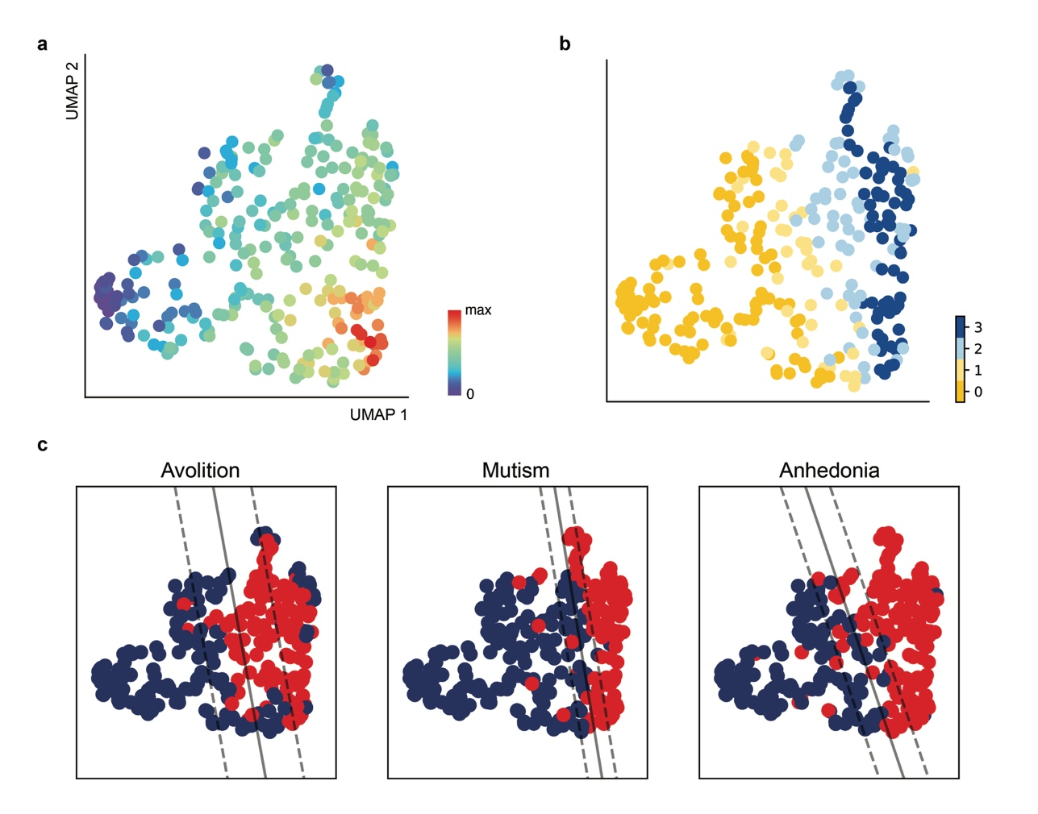

**Fig. 1 a** Symptom manifolds projected into 2D space in schizophrenia patients. The color shows the normalized number of symptoms that the patient has ever experienced. **b** Scatter plot of people with schizophrenia, with each color representing the number of negative symptoms (avolition, mutism, and anhedonia). The number of negative symptoms is comparable between the total number of psychotic and anxiety symptoms. **c** Using the coordinates in the 2D U-MAP space, a support vector machine was trained to predict the presence of negative symptoms. Each of the three symptoms had a well-defined vector support border. Therefore, the presence or absence of these symptoms indicated the diversity of schizophrenia patients.

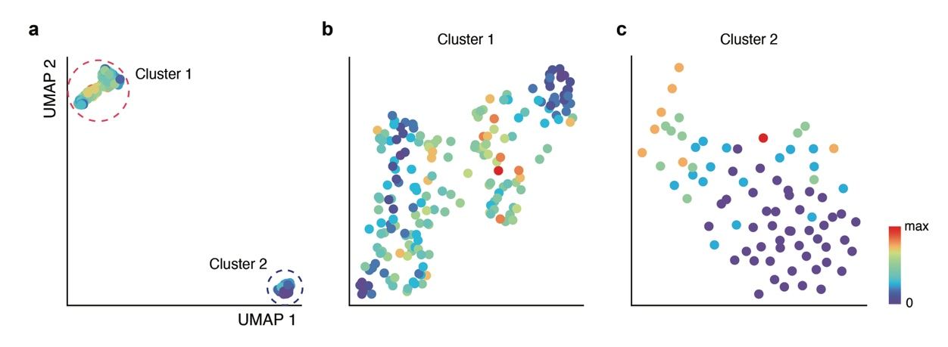

**Fig. 2 a** Symptom manifolds projected into two-dimensional space for bipolar I disorder patients. The color indicates the patient’s normalized lifetime symptom count. In the reduced feature space, unlike schizophrenia, patients are clustered into two distinct groups. **b** A manifold reduction was performed on cluster 1, which is the group of patients located at the top left. Greater numbers of psychotic and anxiety-related symptoms were experienced by the majority of patients. **c** For cluster 2, the group of patients located in the lower right-hand corner, a manifold reduction was performed. Unlike cluster 1, patients in this cluster exhibited fewer psychotic and anxiety-related symptoms.

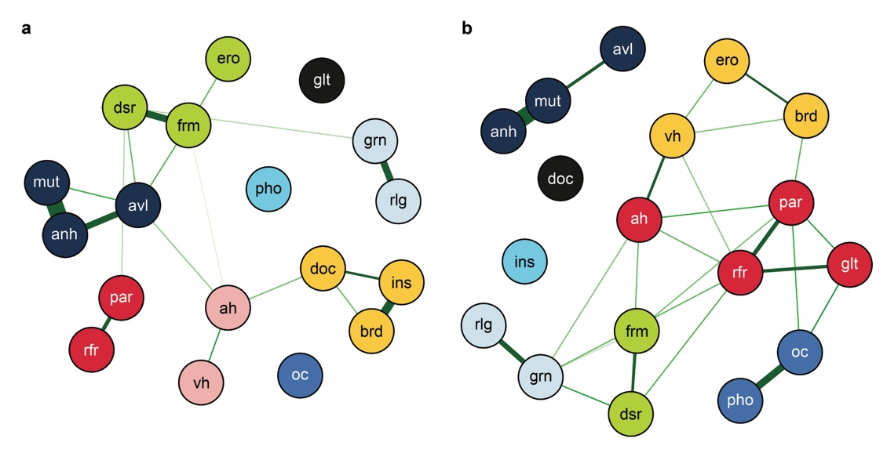

**Fig. 3 a, b** Network analysis of psychotic and anxiety-related symptoms in schizophrenia (left) and bipolar I disorder (right).  
par; paranoid delusion, rfr; delusion of reference, doc; delusion of being controlled, ah; auditory hallucination, vh; visual hallucination, dsr; disorganized behavior, frm; thought form disorder, grn; grandiose delusion, rlg; religious delusion, ero; erotic delusion, glt; delusion of guilt, avl; avolition, anh; anhedonia, mut; mutism, brd; thought broadcasting, ins; thought insertion, oc; obsession/compulsion, pho; phobia

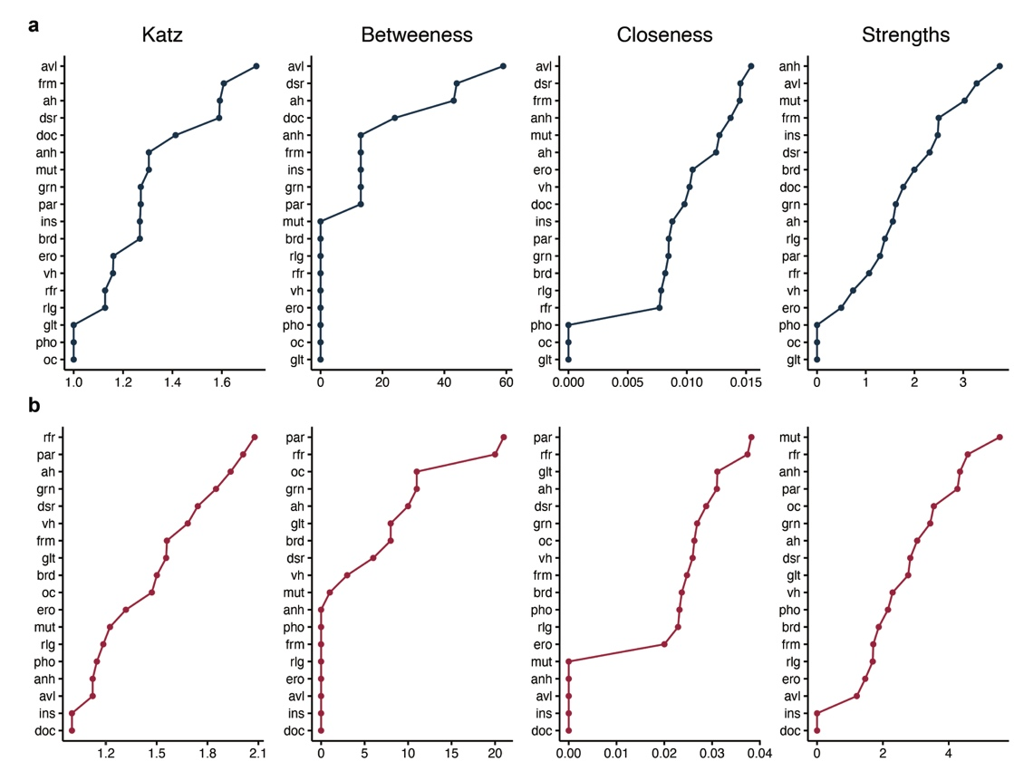

**Fig. 4 a, b** Centrality measures of psychotic and anxiety-related symptoms for the schizophrenia network (upper panel) and bipolar I disorder network (lower panel). Four different centralities were measured: Katz, betweenness, closeness, and strength.

par; paranoid delusion, rfr; delusion of reference, doc; delusion of being controlled, ah; auditory hallucination, vh; visual hallucination, dsr; disorganized behavior, frm; thought form disorder, grn; grandiose delusion, rlg; religious delusion, ero; erotic delusion, glt; delusion of guilt, avl; avolition, anh; anhedonia, mut; mutism, brd; thought broadcasting, ins; thought insertion, oc; obsession/compulsion, pho; phobia

**Table 1** Leave-one-out cross-validation accuracy for each symptom using the 2D coordinates in the U-MAP

|  |  |  |
| --- | --- | --- |
| Symptoms | Accuracy (%) | |
| Grandiose Delusion | | 65.60 |
| Thought Form Disorder | | 66.31 |
| Obsession & Compulsion | | 69.86 |
| Visual Hallucination | | 74.11 |
| Paranoid Delusion | | 78.01 |
| Erotic Delusion | | 78.72 |
| Thought Broadcasting | | 79.79 |
| Religious Delusion | | 80.85 |
| Delusion of Reference | | 81.21 |
| Delusion of Being Controlled | | 81.91 |
| Auditory Hallucination | | 81.91 |
| Avolition | | 81.91* |
| Delusion of Guilt | | 82.98 |
| Disorganized Behavior | | 84.40 |
| Thought Insertion | | 84.40 |
| Anhedonia | | 91.84* |
| Phobia | | 92.20 |
| Mutism | | 92.55* |

* Symptoms with high accuracy in leave-one-out cross-validation, while having balanced number of samples (over 35 percent for the smaller group) for both classes.

**Table 2** Comparison of clinical characteristics between schizophrenia patients with and without avolition.

|  |  |  |  |  |  |  |  |  |  |
| --- | --- | --- | --- | --- | --- | --- | --- | --- | --- |
|  | Symptom dimension | | | | |  | (df) | P value | |
| Avolition (+) | |  | Avolition (-) | |  |  |  |
| N | (%) |  | N | (%) |  |  |  |
| Suicide |  |  |  |  |  |  | .92(1) | .337 |
| Yes | 26 | 21.0 |  | 25 | 15.8 |  |  |  |
| No | 98 | 79.0 |  | 133 | 84.2 |  |  |  |
| Clozapine use |  |  |  |  |  |  | 21.7(1) | .000* |
| Yes | 72 | 58.1 |  | 47 | 29.7 |  |  |  |
| No | 52 | 41.9 |  | 111 | 70.3 |  |  |  |
| Deterioration |  |  |  |  |  |  | 43.8(1) | .000* |
| Yes | 54 | 43.5 |  | 14 | 8.9 |  |  |  |
| No | 79 | 56.5 |  | 144 | 91.1 |  |  |  |
| Remission |  |  |  |  |  |  | 7.74(1) | .005* |
| Yes | 36 | 36.4 |  | 32 | 61.5 |  |  |  |
| No | 63 | 63.6 |  | 20 | 38.5 |  |  |  |
| Severity |  |  |  |  |  |  | 6.83(1) | .009* |
| Severe | 53 | 54.6 |  | 16 | 30.8 |  |  |  |
| Not severe | 44 | 45.4 |  | 36 | 69.2 |  |  |  |

* Statistically significant results (P value < .01)

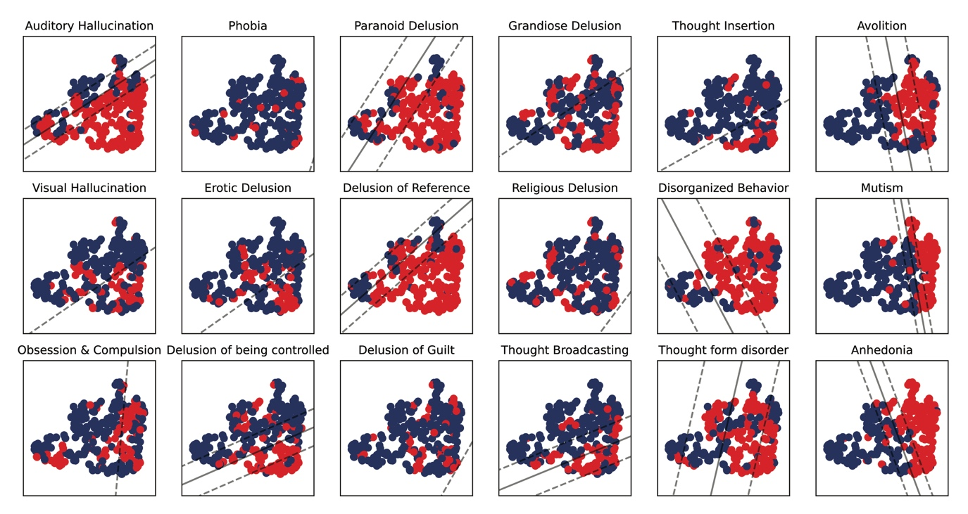

**Fig. S1** A support vector machine utilized 2D U-MAP coordinates to categorize individuals based on the presence of negative symptoms, with red dots representing symptomatic schizophrenia patients and blue dots indicating those without symptoms.

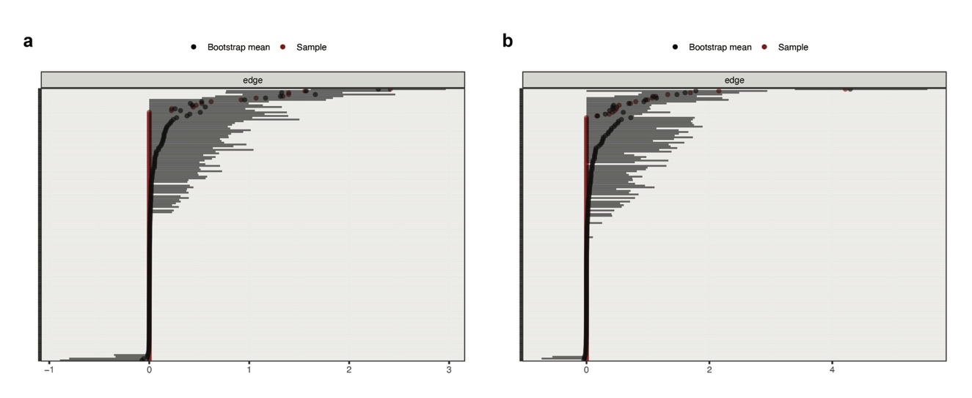

**Fig. S2** Bootstrapping analysis of edge weight accuracy with 95% confidence intervals for **a** schizophrenia and **b** bipolar I disorder.

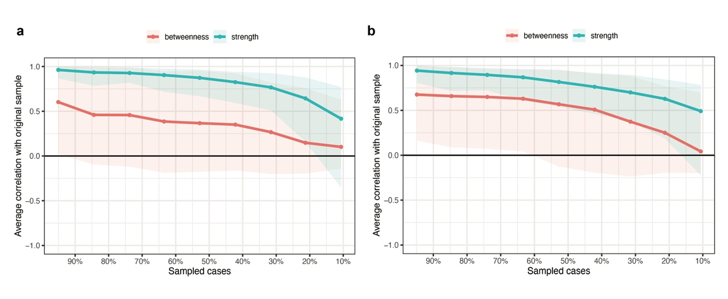

**Fig. S3** Bootstrapping analysis of centrality measures in **a** schizophrenia and **b** bipolar I disorder. Given the lack of variance, closeness is not represented visually.