Проверяем работоспособность Maven.

Microsoft Windows [Version 10.0.18362.356]

(c) Корпорация Майкрософт (Microsoft Corporation), 2019. Все права защищены.

C:\Users\37529>set mave

MAVEN_HOME=C:\Users\37529\apache-maven-3.6.2

C:\Users\37529>set ja

JAVA_HOME=C:\Program Files\jdk-12.0.2

C:\Users\37529>set pa

Path=C:\Program Files (x86)\Common Files\Oracle\Java\javapath;C:\Windows\system32;C:\Windows;C:\Windows\System32\Wbem;C:\Windows\System32\WindowsPowerShell\v1.0\;C:\Windows\System32\OpenSSH\;C:\Program Files (x86)\NVIDIA Corporation\PhysX\Common;C:\Program Files\Git\cmd;C:\Program Files\Java\jdk1.8.0_212\bin;C:\Program Files\Intel\WiFi\bin\;C:\Program Files\Common Files\Intel\WirelessCommon\;C:\Program Files (x86)\Intel\Intel(R) Management Engine Components\DAL;C:\Program Files\Intel\Intel(R) Management Engine Components\DAL;C:\WINDOWS\system32;C:\WINDOWS;C:\WINDOWS\System32\Wbem;C:\WINDOWS\System32\WindowsPowerShell\v1.0\;C:\WINDOWS\System32\OpenSSH\;C:\Users\37529\apache-maven-3.6.2\bin;C:\Users\37529\AppData\Local\Microsoft\WindowsApps;D:\Downloads\chromedriver_win32;D:\Downloads\geckodriver-v0.24.0-win64;C:\Program Files\IntelliJ-IDEA-Community-Edition-2019.2.3\bin;;C:\Users\37529\apache-maven-3.6.2\bin;

PATHEXT=.COM;.EXE;.BAT;.CMD;.VBS;.VBE;.JS;.JSE;.WSF;.WSH;.MSC

C:\Users\37529>mvn --version

Apache Maven 3.6.2 (40f52333136460af0dc0d7232c0dc0bcf0d9e117; 2019-08-27T18:06:16+03:00)

Maven home: C:\Users\37529\apache-maven-3.6.2\bin\..

Java version: 12.0.2, vendor: Oracle Corporation, runtime: C:\Program Files\jdk-12.0.2

Default locale: ru_RU, platform encoding: Cp1251

OS name: "windows 10", version: "10.0", arch: "amd64", family: "windows"

Убедившись, что Maven работает, пытаемся собрать проект при помощи цели test

C:\Users\37529\Desktop\automation\MavenHomeWork\Java from EPAM>mvn test

[INFO] Scanning for projects...

[INFO]

[INFO] ---------------< com.github.vitalliuss.helloci:hello-ci >---------------

[INFO] Building hello-ci 1.0-SNAPSHOT

[INFO] --------------------------------[ jar ]---------------------------------

[INFO]

[INFO] --- maven-resources-plugin:2.6:resources (default-resources) @ hello-ci ---

[WARNING] Using platform encoding (Cp1251 actually) to copy filtered resources, i.e. build is platform dependent!

[INFO] skip non existing resourceDirectory C:\Users\37529\Desktop\automation\MavenHomeWork\Java from EPAM\src\main\resources

[INFO]

[INFO] --- maven-compiler-plugin:3.1:compile (default-compile) @ hello-ci ---

[INFO] Changes detected - recompiling the module!

[WARNING] File encoding has not been set, using platform encoding Cp1251, i.e. build is platform dependent!

[INFO] Compiling 2 source files to C:\Users\37529\Desktop\automation\MavenHomeWork\Java from EPAM\target\classes

[INFO]

[INFO] --- maven-resources-plugin:2.6:testResources (default-testResources) @ hello-ci ---

[WARNING] Using platform encoding (Cp1251 actually) to copy filtered resources, i.e. build is platform dependent!

[INFO] skip non existing resourceDirectory C:\Users\37529\Desktop\automation\MavenHomeWork\Java from EPAM\src\test\resources

[INFO]

[INFO] --- maven-compiler-plugin:3.1:testCompile (default-testCompile) @ hello-ci ---

[INFO] Changes detected - recompiling the module!

[WARNING] File encoding has not been set, using platform encoding Cp1251, i.e. build is platform dependent!

[INFO] Compiling 1 source file to C:\Users\37529\Desktop\automation\MavenHomeWork\Java from EPAM\target\test-classes

[INFO]

[INFO] --- maven-surefire-plugin:3.0.0-M1:test (default-test) @ hello-ci ---

[INFO]

[INFO] -------------------------------------------------------

[INFO] T E S T S

[INFO] -------------------------------------------------------

[INFO] Running com.github.vitalliuss.helloci.AppTest

[ERROR] Tests run: 5, Failures: 1, Errors: 0, Skipped: 1, Time elapsed: 0.123 s <<< FAILURE! - in com.github.vitalliuss.helloci.AppTest

[ERROR] testShouldBeFailed(com.github.vitalliuss.helloci.AppTest) Time elapsed: 0.018 s <<< FAILURE!

java.lang.AssertionError

at com.github.vitalliuss.helloci.AppTest.testShouldBeFailed(AppTest.java:21)

[INFO]

[INFO] Results:

[INFO]

[ERROR] Failures:

[ERROR] AppTest.testShouldBeFailed:21

[INFO]

[ERROR] Tests run: 5, Failures: 1, Errors: 0, Skipped: 1

[INFO]

[INFO] ------------------------------------------------------------------------

[INFO] BUILD FAILURE

[INFO] ------------------------------------------------------------------------

[INFO] Total time: 5.905 s

[INFO] Finished at: 2019-10-03T13:25:15+03:00

[INFO] ------------------------------------------------------------------------

[ERROR] Failed to execute goal org.apache.maven.plugins:maven-surefire-plugin:3.0.0-M1:test (default-test) on project hello-ci: There are test failures.

[ERROR]

[ERROR] Please refer to C:\Users\37529\Desktop\automation\MavenHomeWork\Java from EPAM\target\surefire-reports for the individual test results.

[ERROR] Please refer to dump files (if any exist) [date].dump, [date]-jvmRun[N].dump and [date].dumpstream.

[ERROR] -> [Help 1]

[ERROR]

[ERROR] To see the full stack trace of the errors, re-run Maven with the -e switch.

[ERROR] Re-run Maven using the -X switch to enable full debug logging.

[ERROR]

[ERROR] For more information about the errors and possible solutions, please read the following articles:

[ERROR] [Help 1] http://cwiki.apache.org/confluence/display/MAVEN/MojoFailureException

C:\Users\37529\Desktop\automation\MavenHomeWork\Java from EPAM>

Проект не собрался. Пытаемся понять почему.

При просмотре файла pom.xpml обнаруживаем недочет (строка 48), представленный ниже на рисунке.

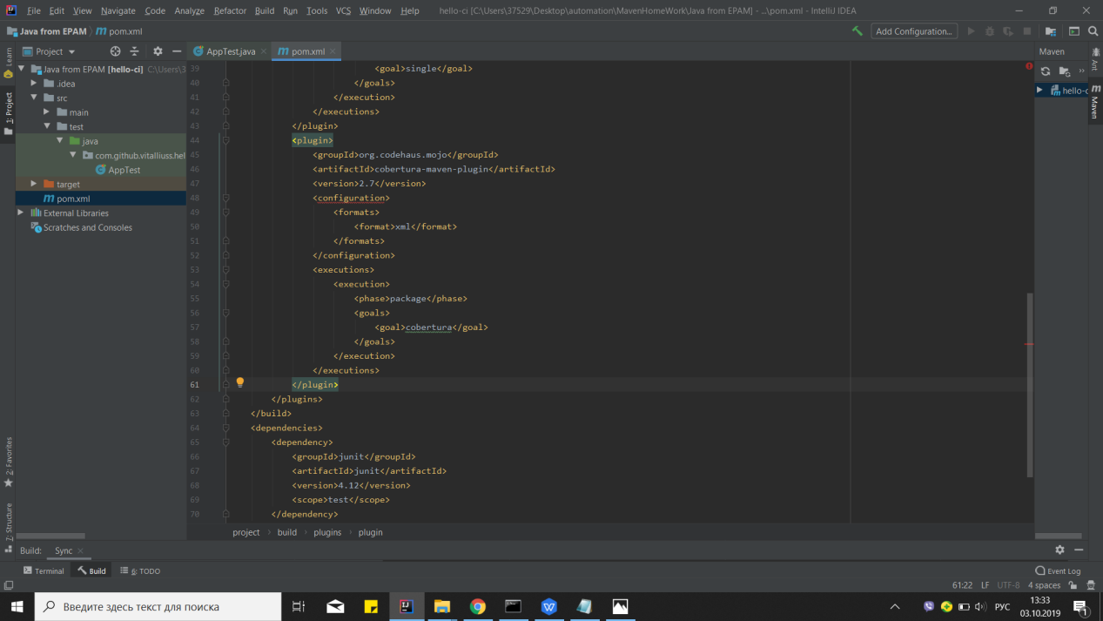

Исправляем недочет при помощи подсказки intellij idea.

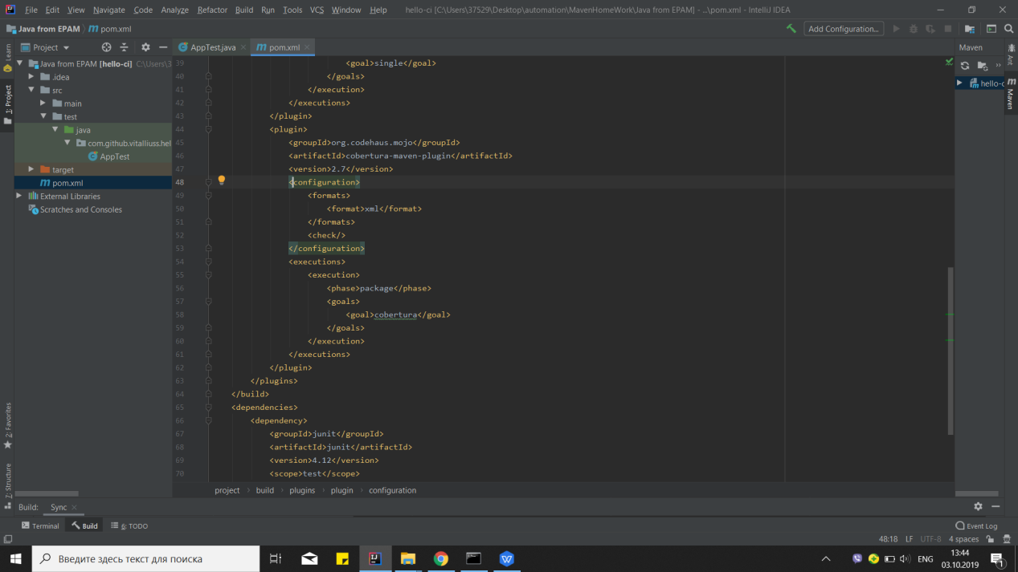

При просмотре файла AppTest находим ошибку в условии метода:

public void testShouldBeFailed() { assertTrue(false);}

Исправляем условие assertTrue(true) и опять запускаем цель test.

C:\Users\37529\Desktop\automation\MavenHomeWork\Java from EPAM>mvn test

[INFO] Scanning for projects...

[INFO]

[INFO] ---------------< com.github.vitalliuss.helloci:hello-ci >---------------

[INFO] Building hello-ci 1.0-SNAPSHOT

[INFO] --------------------------------[ jar ]---------------------------------

[INFO]

[INFO] --- maven-resources-plugin:2.6:resources (default-resources) @ hello-ci ---

[WARNING] Using platform encoding (Cp1251 actually) to copy filtered resources, i.e. build is platform dependent!

[INFO] skip non existing resourceDirectory C:\Users\37529\Desktop\automation\MavenHomeWork\Java from EPAM\src\main\resources

[INFO]

[INFO] --- maven-compiler-plugin:3.1:compile (default-compile) @ hello-ci ---

[INFO] Nothing to compile - all classes are up to date

[INFO]

[INFO] --- maven-resources-plugin:2.6:testResources (default-testResources) @ hello-ci ---

[WARNING] Using platform encoding (Cp1251 actually) to copy filtered resources, i.e. build is platform dependent!

[INFO] skip non existing resourceDirectory C:\Users\37529\Desktop\automation\MavenHomeWork\Java from EPAM\src\test\resources

[INFO]

[INFO] --- maven-compiler-plugin:3.1:testCompile (default-testCompile) @ hello-ci ---

[INFO] Changes detected - recompiling the module!

[WARNING] File encoding has not been set, using platform encoding Cp1251, i.e. build is platform dependent!

[INFO] Compiling 1 source file to C:\Users\37529\Desktop\automation\MavenHomeWork\Java from EPAM\target\test-classes

[INFO]

[INFO] --- maven-surefire-plugin:3.0.0-M1:test (default-test) @ hello-ci ---

[INFO]

[INFO] -------------------------------------------------------

[INFO] T E S T S

[INFO] -------------------------------------------------------

[INFO] Running com.github.vitalliuss.helloci.AppTest

[WARNING] Tests run: 5, Failures: 0, Errors: 0, Skipped: 1, Time elapsed: 0.116 s - in com.github.vitalliuss.helloci.AppTest

[INFO]

[INFO] Results:

[INFO]

[WARNING] Tests run: 5, Failures: 0, Errors: 0, Skipped: 1

[INFO]

[INFO] ------------------------------------------------------------------------

[INFO] BUILD SUCCESS

[INFO] ------------------------------------------------------------------------

[INFO] Total time: 5.161 s

[INFO] Finished at: 2019-10-03T13:53:15+03:00

[INFO] ------------------------------------------------------------------------

C:\Users\37529\Desktop\automation\MavenHomeWork\Java from EPAM>

Проект собран.

Изменяем версию junit в файле pom.xml c 4.12 на 4.11(рисунок представлен ниже) и собираем проект снова.

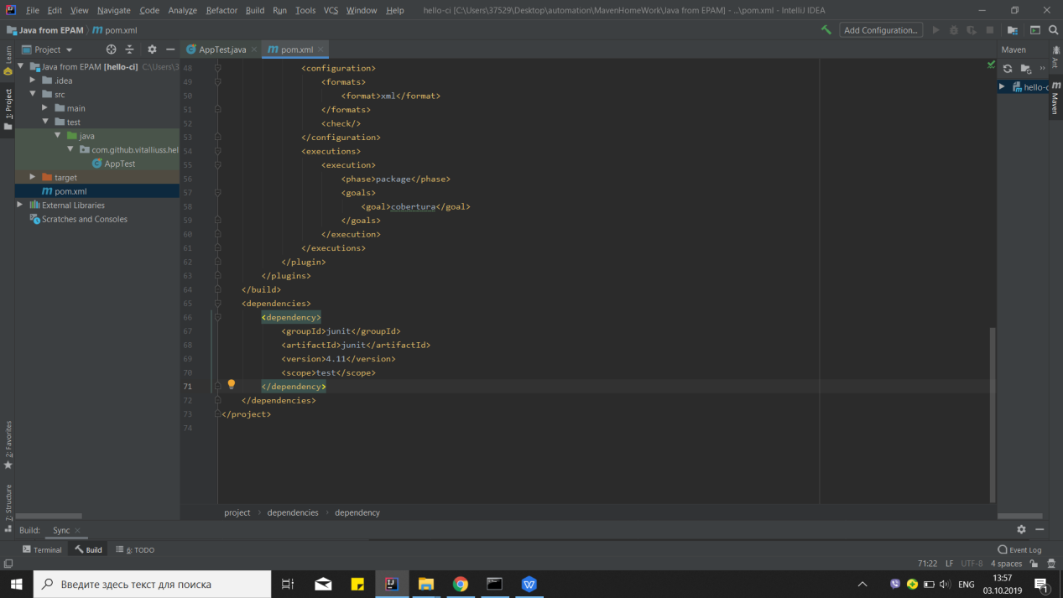

C:\Users\37529\Desktop\automation\MavenHomeWork\Java from EPAM>mvn test

[INFO] Scanning for projects...

[INFO]

[INFO] ---------------< com.github.vitalliuss.helloci:hello-ci >---------------

[INFO] Building hello-ci 1.0-SNAPSHOT

[INFO] --------------------------------[ jar ]---------------------------------

[INFO]

[INFO] --- maven-resources-plugin:2.6:resources (default-resources) @ hello-ci ---

[WARNING] Using platform encoding (Cp1251 actually) to copy filtered resources, i.e. build is platform dependent!

[INFO] skip non existing resourceDirectory C:\Users\37529\Desktop\automation\MavenHomeWork\Java from EPAM\src\main\resources

[INFO]

[INFO] --- maven-compiler-plugin:3.1:compile (default-compile) @ hello-ci ---

[INFO] Nothing to compile - all classes are up to date

[INFO]

[INFO] --- maven-resources-plugin:2.6:testResources (default-testResources) @ hello-ci ---

[WARNING] Using platform encoding (Cp1251 actually) to copy filtered resources, i.e. build is platform dependent!

[INFO] skip non existing resourceDirectory C:\Users\37529\Desktop\automation\MavenHomeWork\Java from EPAM\src\test\resources

[INFO]

[INFO] --- maven-compiler-plugin:3.1:testCompile (default-testCompile) @ hello-ci ---

[INFO] Nothing to compile - all classes are up to date

[INFO]

[INFO] --- maven-surefire-plugin:3.0.0-M1:test (default-test) @ hello-ci ---

[INFO]

[INFO] -------------------------------------------------------

[INFO] T E S T S

[INFO] -------------------------------------------------------

[INFO] Running com.github.vitalliuss.helloci.AppTest

[WARNING] Tests run: 5, Failures: 0, Errors: 0, Skipped: 1, Time elapsed: 0.106 s - in com.github.vitalliuss.helloci.AppTest

[INFO]

[INFO] Results:

[INFO]

[WARNING] Tests run: 5, Failures: 0, Errors: 0, Skipped: 1

[INFO]

[INFO] ------------------------------------------------------------------------

[INFO] BUILD SUCCESS

[INFO] ------------------------------------------------------------------------

[INFO] Total time: 5.207 s

[INFO] Finished at: 2019-10-03T14:01:03+03:00

[INFO] ------------------------------------------------------------------------

C:\Users\37529\Desktop\automation\MavenHomeWork\Java from EPAM>

Фото библиотек в в .m2/repository представлено ниже.

