Shell PowerBi Hands On Assessment

Name: Akshita Verma

Requirement1: Data Loading

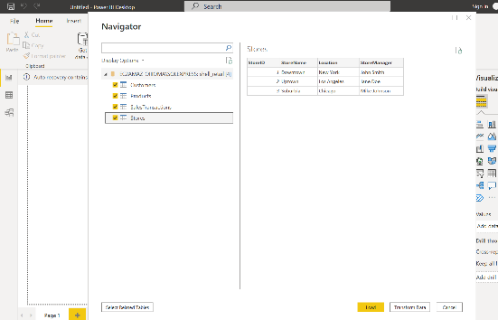

Requirements2 Data Transformation

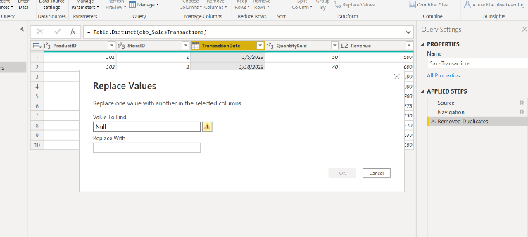

Add columns

Day_of_the week extracted from transaction date of table sales_transactions

Calculated columns

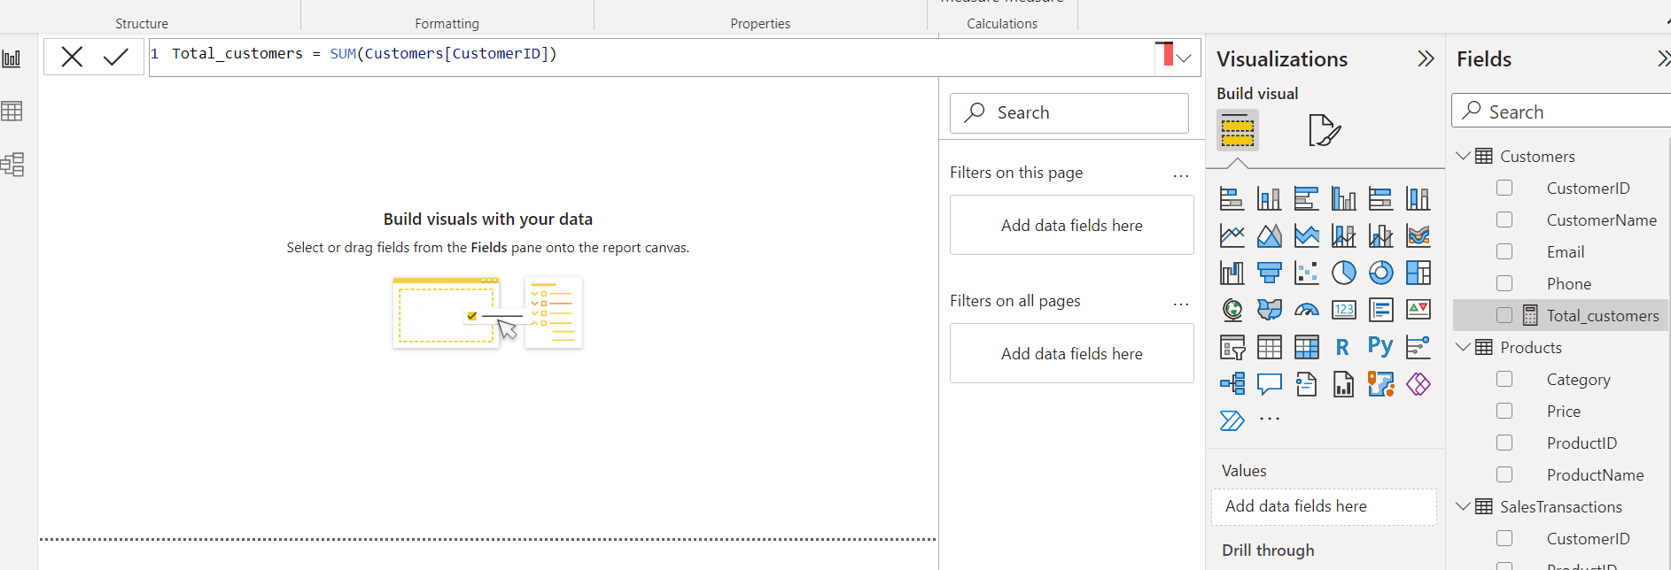

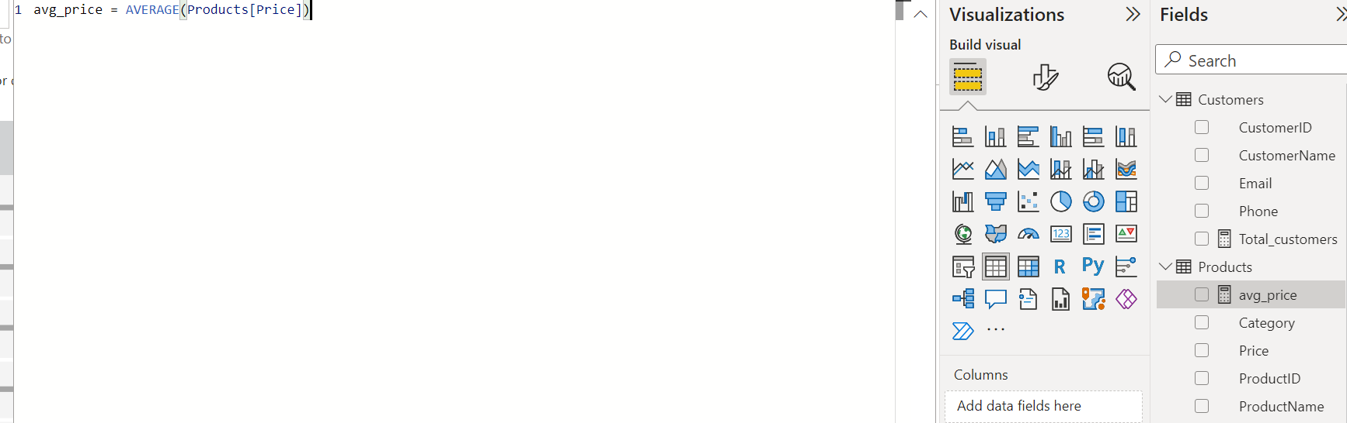

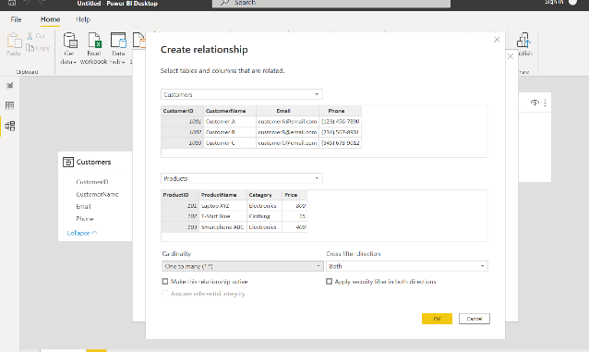 3) Create Relationship

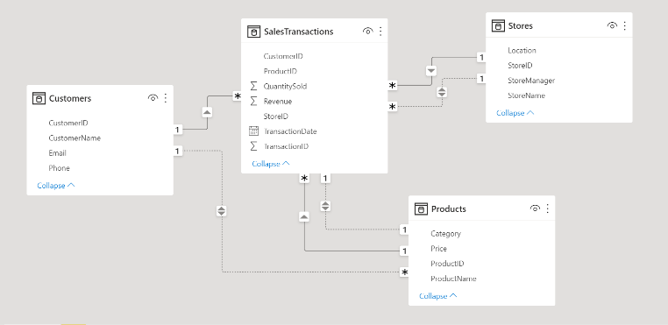

Create hierarchy

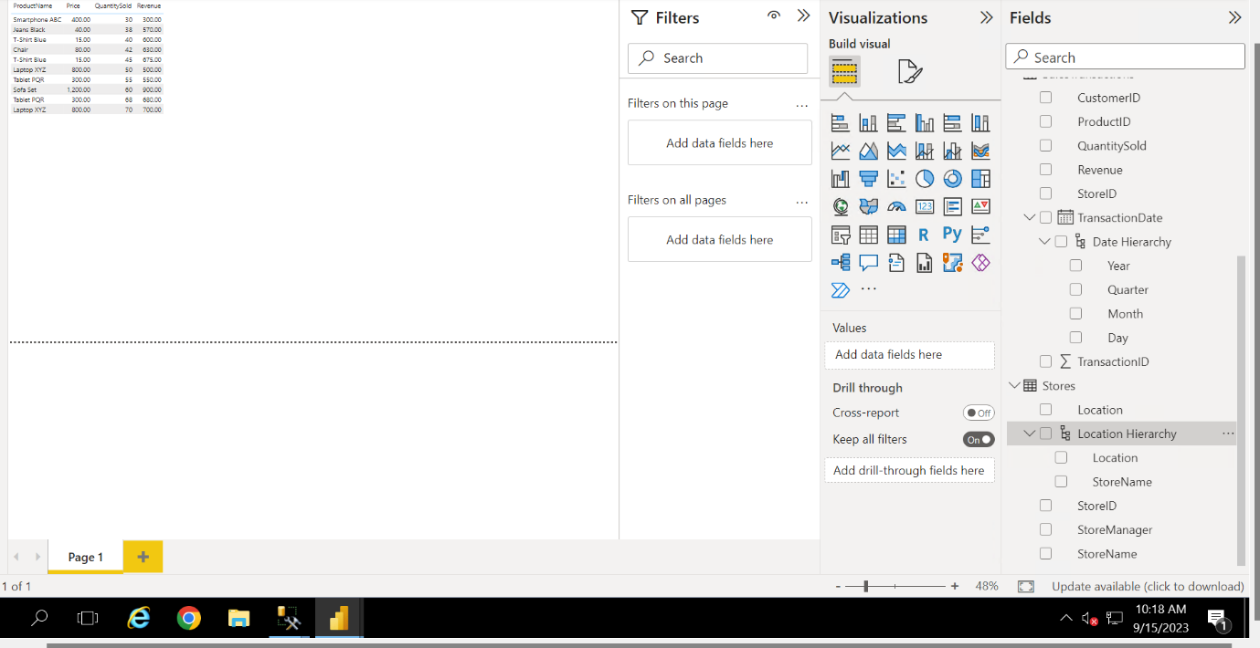

4)

1. Who are the top-spending customers based on their total purchase amount?

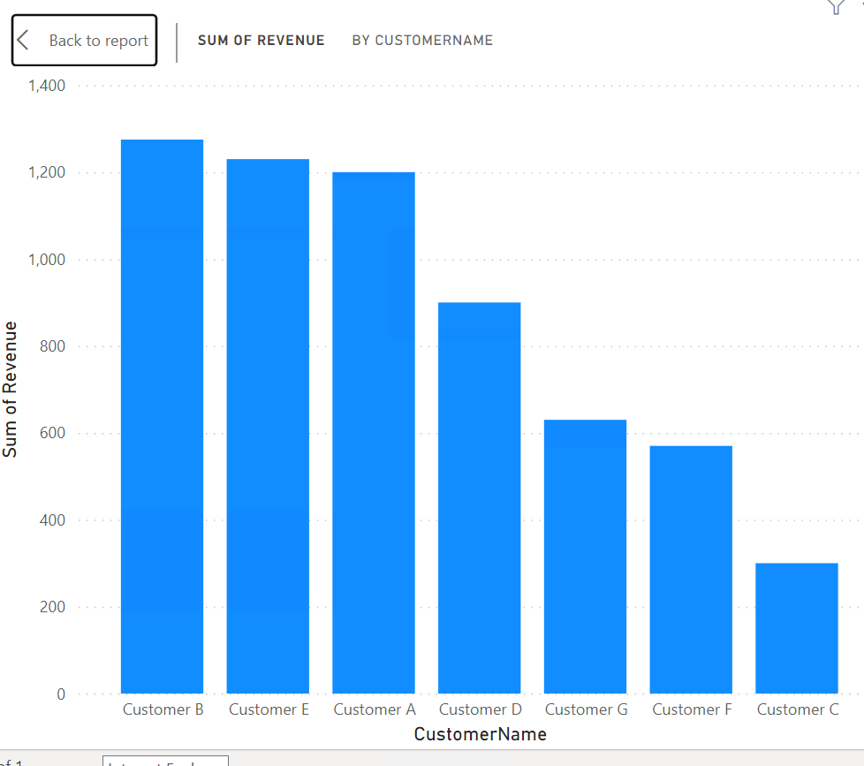

Customer B

2. How is sales revenue distributed among different store managers?

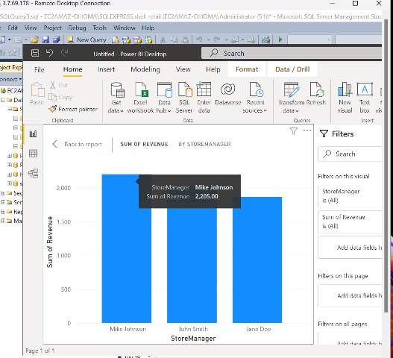

3. What is the average price of products in each category?

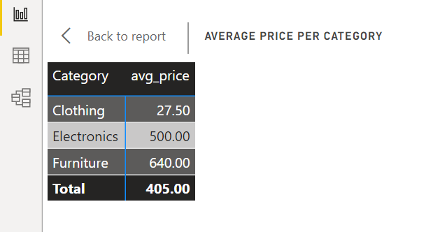

4. Are there specific days of the week when sales are higher?

Based on the above graph, Tuesday has the highest sales, followed by Monday, Wednesday and Thursday.

5. How do sales trends vary by product category on a monthly basis?

6. What percentage of products account for 80% of total sales revenue?

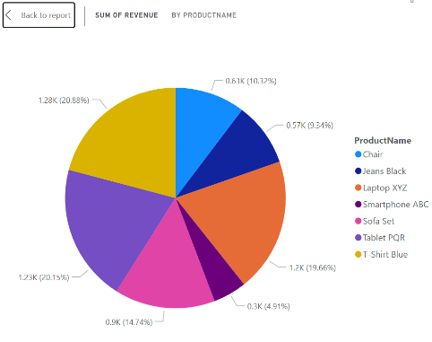

No product accounts for 80% of total sales revenue.

7. Are there any trends in repeat customer purchases?

8. Which product categories perform best at each store location?

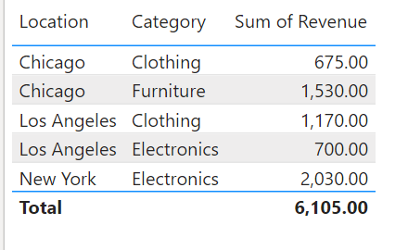

Chicago: Furniture

Los Angeles: Clothing

New York: Electronics

9. Are there any seasonal patterns or trends in sales for specific products or categories?

From the above graph you can see, chairs have high sale during august, laptop xyz has significant sales around jan and April.

10. Can customers be segmented into high, medium, and low-value segments based on their purchase history.

Requirements5

From the above graph you can see, chairs have high sale during august, laptop xyz has significant sales around jan and April.

We can infer from this graph, the day when sales are usually higher i.e, Tuesday



Location Chicago has highest sales for furniture, LA has for clothing and NY has for electronics.