Project Design Phase-II
Data Flow Diagram & User Stories

Date | 31 January 2026
Team ID | Data Warrior
Project Name | EV Industry Analytics & Intelligence Platform
Maximum Marks | 4 Marks

Data Flow Diagrams:
A Data Flow Diagram (DFD) is a traditional visual representation of the information flows within a system. A neat and clear DFD can depict the right amount of the system requirement graphically. It shows how data enters and leaves the system, what changes the information, and where data is stored.
DFD Symbol Legend
Symbol | Name | Description
Oval / Rounded  shape | External Entity | A person, organization, or system outside the project that sends or receives data (e.g., Customer, Payment Gateway).
Rectangle with  numbered header | Process | An activity that transforms incoming data into outgoing data (e.g., Validate Request, Process Order).
Rectangle (solid fill, no number) | Data Store | A place where data is held for later use (e.g., Customer Database, Inventory).
Labeled arrow | Data Flow | The movement of data between entities, processes, and data stores, labeled with what data is being passed.

Example: DFD Level 0 (Industry Standard)

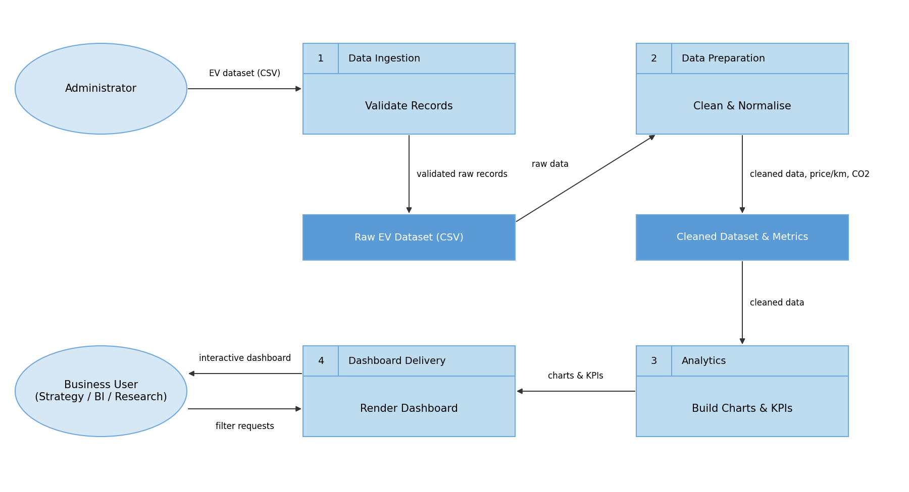

User Stories
Use the below template to list all the user stories for the product.
User Type | Functional Requirement (Epic) | User Story Number | User Story / Task | Acceptance criteria | Priority | Release
Strategy Director (Emily Johnson) | Sales & Market Analysis | USN-1 | As a Strategy Director, I can view EV sales volume and revenue by vehicle category so that I can optimise the product portfolio. | Category chart shows SUV, Sedan, Hatchback, Two-Wheeler, Truck and Bus | High | Sprint-1
 |  | USN-2 | As a Strategy Director, I can see the leading automakers by market share so that I can benchmark competitors. | Market share chart ranks all 12 OEMs | High | Sprint-1
 |  | USN-3 | As a Strategy Director, I can track customer satisfaction against price and charging reliability. | Price vs Rating chart displays satisfaction scores | Medium | Sprint-2
 |  | USN-4 | As a Strategy Director, I can compare regional sales distribution across years. | Regional chart updates for 2021-2026 | Medium | Sprint-2
 | Filters | USN-5 | As a user, I can filter the dashboard by year, category, region and automaker. | Charts and KPI cards refresh instantly | High | Sprint-1
 | Dashboard | USN-6 | As a user, I can view KPI cards (deliveries, revenue, range, satisfaction, CO2) and switch dark/light theme. | KPI counters load on the home tab | High | Sprint-1
BI Manager (David Chen) | Market Intelligence | USN-7 | As a BI Manager, I can monitor OEM share, assembly concentration and battery technology distribution. | Battery chemistry and regional charts are available | High | Sprint-2
Research Analyst (Dr. Sarah Williams) | Sustainability Research | USN-8 | As a Research Analyst, I can analyse energy consumption (Wh/km) and CO2 displaced by vehicle type. | CO2 and Wh/km metrics shown by category | High | Sprint-2
Administrator | Data Management | USN-9 | As an Administrator, I can load and validate the 1,200-record EV dataset so that dashboards use accurate data. | Validation passes with zero data errors | High | Sprint-1
BI Manager (David Chen) | Market Intelligence | USN-10 | As a BI Manager, I can compare price-per-km across battery chemistries (LFP, NMC, NCA). | Price-per-km metric is calculated for every record | Medium | Sprint-2
Research Analyst (Dr. Sarah Williams) | Sustainability Research | USN-11 | As a Research Analyst, I can view the battery chemistry timeline including Sodium-Ion and Solid-State. | Timeline chart covers all 5 chemistries | Medium | Sprint-3
Administrator | Deployment | USN-12 | As an Administrator, I can publish the dashboard on GitHub Pages and Tableau Public for mentor review. | Live demo and Tableau links open without errors | Medium | Sprint-3

