Project Design Phase-I
Solution Architecture

Date | 19 September 2026
Team ID | Data Warrior
Project Name | EV Industry Analytics & Intelligence Platform
Maximum Marks | 4 Marks

Solution Architecture:
Solution architecture is a complex process – with many sub-processes – that bridges the gap between business problems and technology solutions. Its goals are to:
- Find the best tech solution to solve existing business problems.
- Describe the structure, characteristics, behavior, and other aspects of the software to project stakeholders.
- Define features, development phases, and solution requirements.
- Provide specifications according to which the solution is defined, managed, and delivered.

Sample Solution Architecture Diagram:
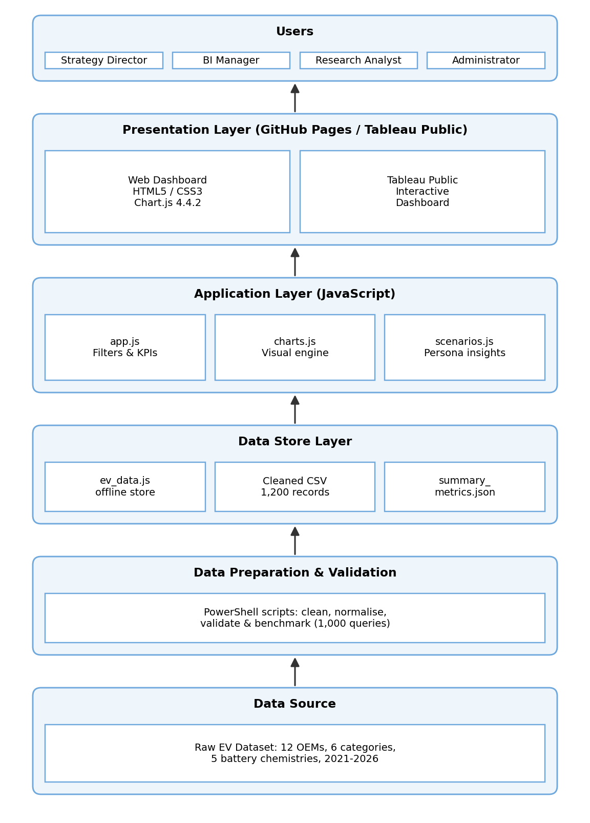

Component Description Table
Component Name | Description / Role in Architecture | Technology Used
Data Source | Synthetic EV dataset: 1,200 records, 20 columns, 12 OEMs, 6 categories, 5 battery chemistries (2021-2026). | CSV, PowerShell (generate_data.ps1)
Data Preparation & Validation | Cleans nulls, normalises data types, calculates price-per-km and CO2 metrics, runs integrity and range checks. | PowerShell, CSV, JSON
Data Store | Holds cleaned dataset, precomputed summary metrics and the offline data bridge used by the web app. | ev_market_data_cleaned.csv, summary_metrics.json, ev_data.js
Application Logic | Manages filters, KPI counters and persona scenario insights (Emily, David, Dr. Sarah). | JavaScript (app.js, scenarios.js)
Visualization Layer | Renders 10+ charts and a multi-tab responsive dashboard with dark/light themes; Tableau dashboard for analysis. | Chart.js 4.4.2, HTML5, CSS3, Tableau Public
Hosting & Testing | Publishes the live demo and benchmarks query performance (1,000 queries in 7.6 ms). | GitHub, GitHub Pages, PowerShell (test_performance.ps1)

