Precision UI BDD Automation Project

Veeva Systems Project Documentation
Team Name: Automation Architects
Institution: Sagi Rama Krishnam Raju Engineering College
Team Members:
- Name: Kopparthi Aditya
Branch: Computer Science and Engineering
Email: adityakopparthi5@gmail.com

- Name: Akula Kalyan Sai Ram
Branch: Computer Science and Engineering
Email: Kalyanakula00@gmail.com
Project Link: GitHub


TABLE OF CONTENTS
1. Abstract .....................................................…. 3
2. Introduction ................................................… 4
3. Problem Statement ....................................…. 5
4. Objectives ............................................……….. 6
5. Technical Stack .........................................……. 6
6. System Architecture ....................................... 7
7. Project Features ......................................…….. 8 - 9
8. Test Scenarios ................................................. 10- 12
9. Implementation Details ................................... 13- 31
9.1 Test Execution Setup
9.2 Feature Files (BDD)
9.3 Step Definitions
9.4 Page Object Model (POM)
9.5 Hooks (Test Lifecycle)
9.6 DriverFactory (WebDriver Management)
9.7 Utilities
9.8 Maven Configuration (pom.xml)
10. Project Structure ........................................ 32 - 35
11. Execution Instructions ................................... 36
12. Results ......................................................... 36 -38
13. Conclusion ..................................................... 39
14. Team Contribution ....................................... 39 - 40
15. Future Enhancements .................................... 40
Abstract
This project, titled “Precision UI BDD Automation Project,” focuses on the development of a Behavior-Driven Development (BDD) based automation framework for testing web applications. The main objective of this project is to enhance collaboration between developers, testers, and stakeholders by using a common, human-readable language to define application behavior.
To address the limitations of traditional testing approaches, this project adopts the BDD methodology using Cucumber, where test scenarios are written in Gherkin language. The framework is implemented using Selenium WebDriver for browser automation, Java as the programming language, TestNG for test execution, and Maven for dependency management.
The framework follows the Page Object Model (POM) design pattern to ensure better code structure, reusability, and maintainability. As part of this project, key user scenarios such as product search functionality and add-to-cart operations are automated. These scenarios validate core functionalities of an e-commerce application, ensuring that users can successfully search for products and add them to the cart.
Key features of the framework include scenario-based test execution, reusable step definitions, data-driven testing, and detailed test reporting. The integration of BDD improves clarity, ensures alignment with business requirements, and enhances overall testing efficiency.
The outcome of this project demonstrates a scalable and maintainable automation solution that reduces manual effort, increases accuracy, and ensures high-quality software delivery.

Introduction
The rapid growth of web applications has increased the need for efficient and reliable software testing methodologies. Traditional manual testing methods are time-consuming, repetitive, and prone to human errors, making them less suitable for modern agile environments. Automation testing helps overcome these challenges by improving accuracy, reducing execution time, and enabling continuous testing.
This project, titled “Precision UI BDD Automation Project,” focuses on implementing an automation framework using Behavior-Driven Development (BDD). BDD enhances collaboration between developers, testers, and stakeholders by using a common, human-readable language. In this project, Cucumber is used to write test scenarios in Gherkin syntax, ensuring clarity and alignment with business requirements.
The framework is developed using Selenium WebDriver, Java, TestNG, and Maven, and follows the Page Object Model (POM) design pattern for better code reusability and maintainability. Key functionalities such as product search and add-to-cart operations are automated to validate core features of an e-commerce application.
The objective of this project is to build a scalable, maintainable, and efficient automation framework that supports behavior-driven testing and ensures high-quality software delivery.

Problem Statement
In modern web applications, ensuring the reliability and functionality of critical user features is essential for delivering a seamless user experience. Manual testing of such applications is often repetitive, time-consuming, and prone to human errors, especially when validating frequently used features like product search and cart operations.
According to the project requirements provided in the assignment, key scenarios such as searching for a product and adding items to the cart were originally defined using the Amazon application . However, in this project, these scenarios are implemented on the Amazon web application to achieve similar functional validation in a real-world e-commerce environment.
The challenge lies in automating these scenarios efficiently while maintaining code reusability, scalability, and readability. Additionally, there is a need to ensure that the framework supports Behavior-Driven Development (BDD), enabling better collaboration between technical and non-technical stakeholders through clear and understandable test scenarios.
Therefore, this project aims to address these challenges by developing a robust BDD-based automation framework that accurately validates core functionalities such as product search and add-to-cart operations on Amazon, ensuring improved test efficiency and software quality.

Objectives
Design and implement a robust automation framework that:
- Follows Page Object Model (POM)
- Implements BDD using Cucumber
- Supports Data-Driven Testing
- Generates Execution Reports
- Supports Maven command execution (mvn clean test)
- Proper use of OOPs concepts
- Provides Cross- Browser support

Technical Stack
This assignment requires trainees to develop a Hybrid Test Automation Framework using:
- Java
- Selenium
- Maven
- Cucumber
- Git/GitHub
- Json
- Log4j
- Extent Reports

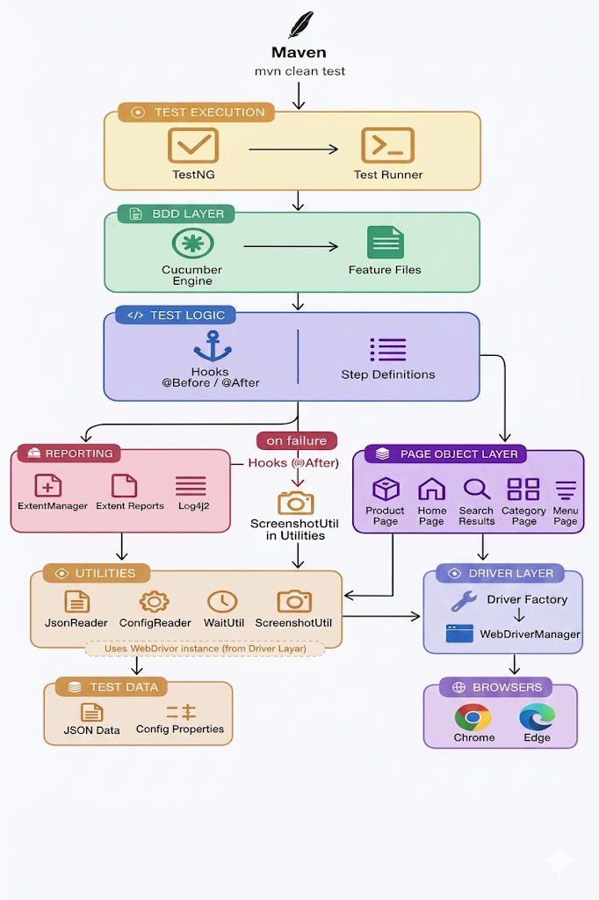
System Architecture
Project Features
- Hybrid Automation Framework
Developed using a hybrid approach combining Page Object Model (POM), Behavior Driven Development (BDD), and Data-Driven Testing, ensuring scalability and maintainability.
- Behavior Driven Development (BDD) with Cucumber
Test scenarios are written in Gherkin syntax, making them easy to understand for both technical and non-technical stakeholders.
- Page Object Model (POM) Implementation
All web elements and actions are organized into separate page classes, promoting code reusability and separation of concerns.
- Data-Driven Testing using JSON
External test data is stored in JSON files, allowing execution of test cases with multiple datasets without modifying the code.
- TestNG Integration for Execution Control
TestNG is used as the execution engine to manage test runs, configurations, and enable advanced features like parallel execution.
- Parallel Test Execution
Supports parallel execution of test cases using TestNG, reducing overall execution time and improving efficiency.
- Cross-Browser Testing Support
Framework supports execution on multiple browsers such as Chrome and Edge, configurable through properties file.
- Hooks-Based Test Lifecycle Management
Implemented Cucumber Hooks (@Before, @After) for setup and teardown operations, ensuring proper test initialization and cleanup.
- Automatic Screenshot Capture on Failure
Screenshots are captured automatically on test failure using Hooks and utility classes, aiding in debugging.
- Robust Reporting Mechanism
Integrated Extent Reports and Log4j2 logging to generate detailed execution reports and logs.
- Driver Management using DriverFactory Pattern
Centralized driver management using a DriverFactory, ensuring consistent and reusable WebDriver instances.
- WebDriverManager Integration
Automatically handles browser driver setup, eliminating the need for manual driver configuration.
- Reusable Utility Classes
Utility components such as WaitUtil, ConfigReader, JsonReader, and ScreenshotUtil are implemented for common operations.
- Configurable Environment Setup
Application URL, browser type, and other configurations are managed via config.properties file.
- Modular and Scalable Design
Framework is designed in a modular way, making it easy to extend with new test cases and features.

Test Scenarios:
Feature: Amazon Add to CartFunctionality
Scenario: Add product to cart from Toys category
Given user is on Amazon homepage
When user navigates to Toys category from menu
And user selects a product from category page
And user switches to product tab
Then product page should be displayed
When user adds product to cart
And user navigates to cart page
Then product should be added to cart
And subtotal should be displayed
And cart count should be updated

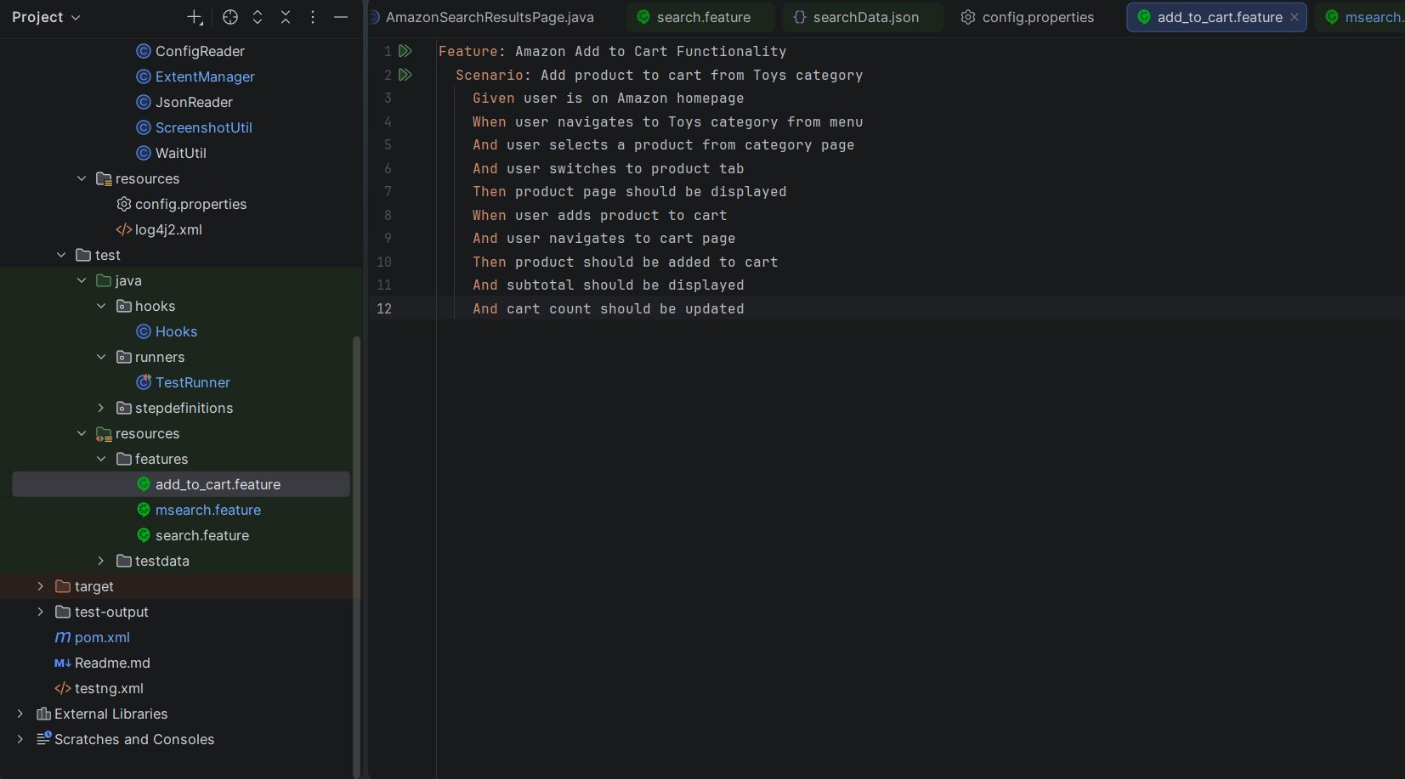

Feature: Amazon Search Functionality
Scenario: Search product using JSON data
Given user opens Amazon homepage
When user enters product from json
And user clicks on first suggestion
Then results page should be displayed
And results should be relevant to entered product

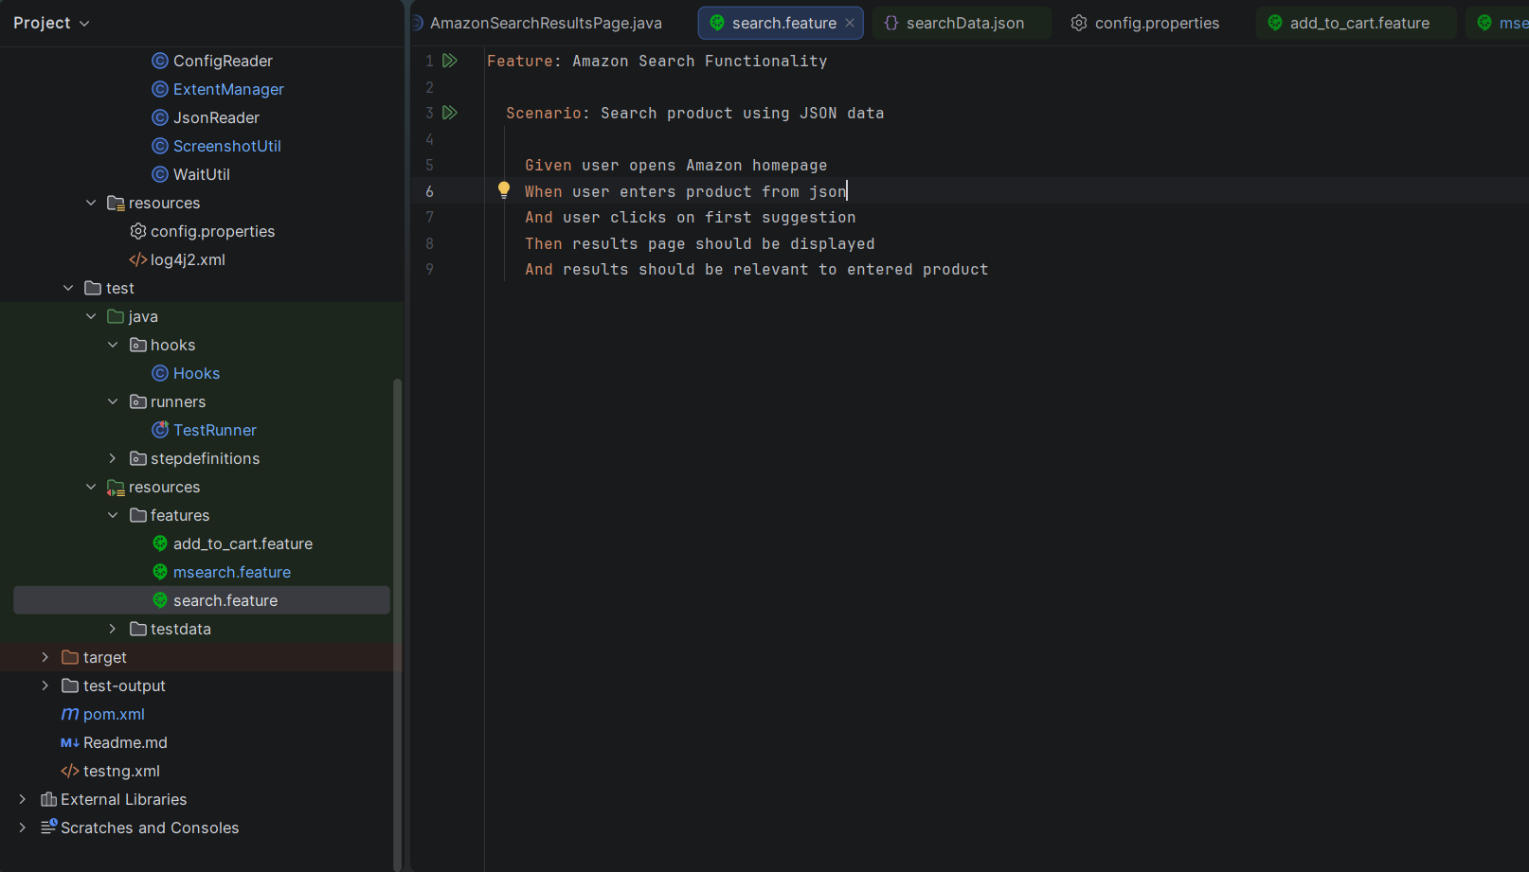

Feature: Amazon Search Functionality
Scenario Outline: Search product using multiple data
Given user opens Amazon homepage
When user enters "<product>" in search bar
And user clicks on first suggestion
Then results page should be displayed
And results should be relevant to entered product
Examples:
| product |
| iPhone |
| Samsung |
| Laptop |

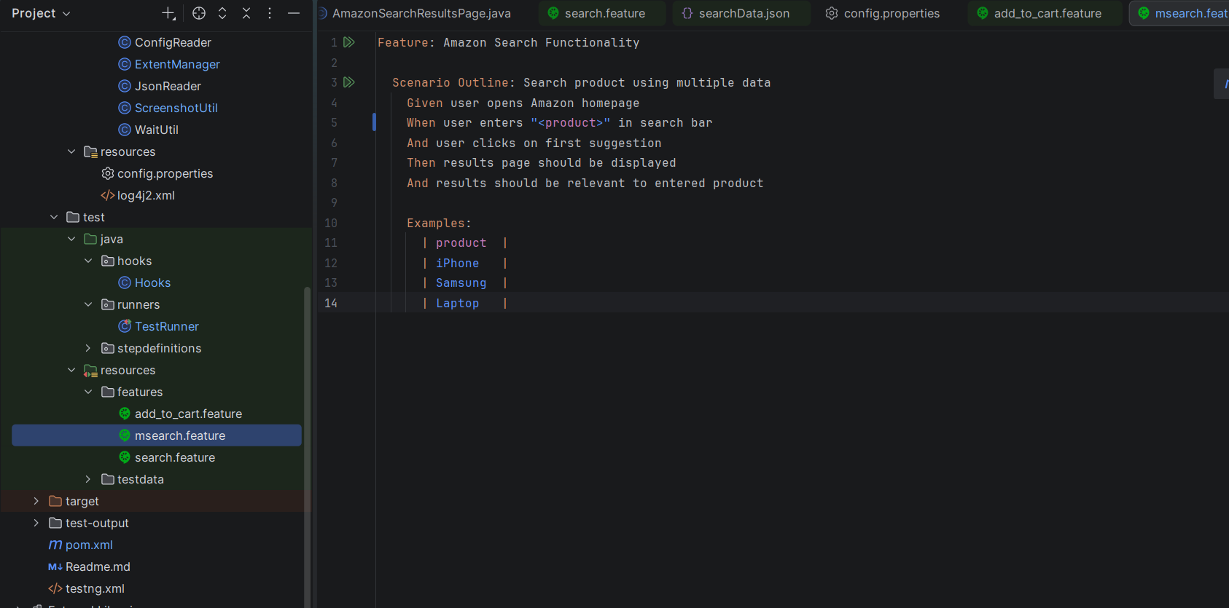

Implementation:
1. Test Execution Setup
The test execution is triggered using Maven, which invokes TestNG and the
Cucumber Test Runner.
Code:
package runners;
import io.cucumber.testng.AbstractTestNGCucumberTests;
import io.cucumber.testng.CucumberOptions;
import org.testng.annotations.DataProvider;
@CucumberOptions(
features = "src/test/resources/features/msearch.feature",
glue = {"stepdefinitions", "hooks"},
plugin = {"pretty","html:target/report.html"},
monochrome = true)
public class TestRunner extends AbstractTestNGCucumberTests {
@Override
@DataProvider(parallel = true)
public Object[][] scenarios() {
return super.scenarios();
}
}

2. Feature File Implementation (BDD)
Test scenarios are written in Gherkin format.
Code:
Feature: Amazon Add to Cart Functionality
Scenario: Add product to cart from Toys Category
Given user is on Amazon homepage
When user navigate to Toys category from menu
And user selects a product from category page
And user switches to product tab
Then product page should be displayed
When user adds product to cart
And user navigates to cart page
Then product should be added to cart
And subtotal should be displayed
And cart count should be updated
Feature: Amazon Search Functionality
Scenario: Search product using JSON data
Given user opens Amazon homepage
When user enters product from json
And user clicks on first suggestion
Then results page should be displayed
And results should relevant to entered product
Feature: Amazon Search Functionality
Scenario Outline: Search product using multiple data
Given user opens Amazon homepage
When user enters "<product>" in search bar
And user clicks on first suggestion
Then results page should be displayed
And results should be relevant to entered product
Examples:
| product |
| iPhone |
| Samsung |
| Laptop |
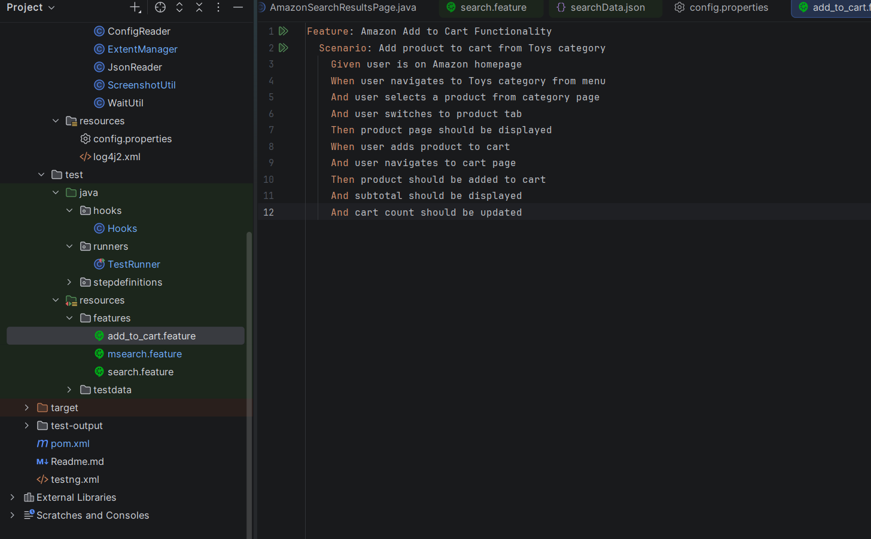

3. Step Definitions Implementation
Step definitions map Gherkin steps to Java methods.
Step definitions Cart Functionality:
- Navigation to Category
@When("user navigates to Toys category from menu")
public void navigateMenu() {
menu.navigateToToysGames();
}
- Product Selection from Category
@And("user selects a product from category page")
public void selectProduct() {
category.selectProduct();
}
- Switching Tab & Capturing Product Details
@And("user switches to product tab")
public void switchTab() {
product.switchToTab();

selectedProduct = product.getProductTitle();
selectedPrice = product.getProductPrice();
}
- Add Product to Cart
@When("user adds product to cart")
public void addCart() {
product.addToCart();
}
- Validate Product Added to Cart
@Then("product should be added to cart")
public void validateProductAdded() {
Assert.assertTrue(
cart.isCorrectProductAdded(selectedProduct, selectedPrice)
);
}
- Validate Subtotal
@And("subtotal should be displayed")
public void validateSubtotal() {
String subtotal = cart.getSubtotal();
Assert.assertTrue(subtotal.contains("₹"));
}
- Validate Cart Count
@And("cart count should be updated")
public void validateCartCount() {
int count = Integer.parseInt(cart.getCartCount());
Assert.assertTrue(count == 1);
}
Step Definition Search Functionality:
- Reading Data from JSON:
@When("user enters product from json")
public void enterSearch() {
product = JsonReader.getProduct("src/test/resources/testdata/searchData.json");
homePage.enterSearchText(product);
}
- Parameterized Step (Scenario Outline):
@When("user enters {string} in search bar")
public void enterSearch(String product) {
this.product = product;
homePage.enterSearchText(product);
}
- User Action Step:
@And("user clicks on first suggestion")
public void clickFirstSuggestion() {
homePage.clickFirstSuggestion();
}
- Validation – Results Page:
@Then("results page should be displayed")
public void verifyResultsPage() {
Assert.assertTrue(resultsPage.isResultsPageDisplayed());
}
- Validation – Result Relevance :
@And("results should be relevant to entered product")
public void validateResults() {
Assert.assertTrue(resultsPage.verifyResultsContain(product));}

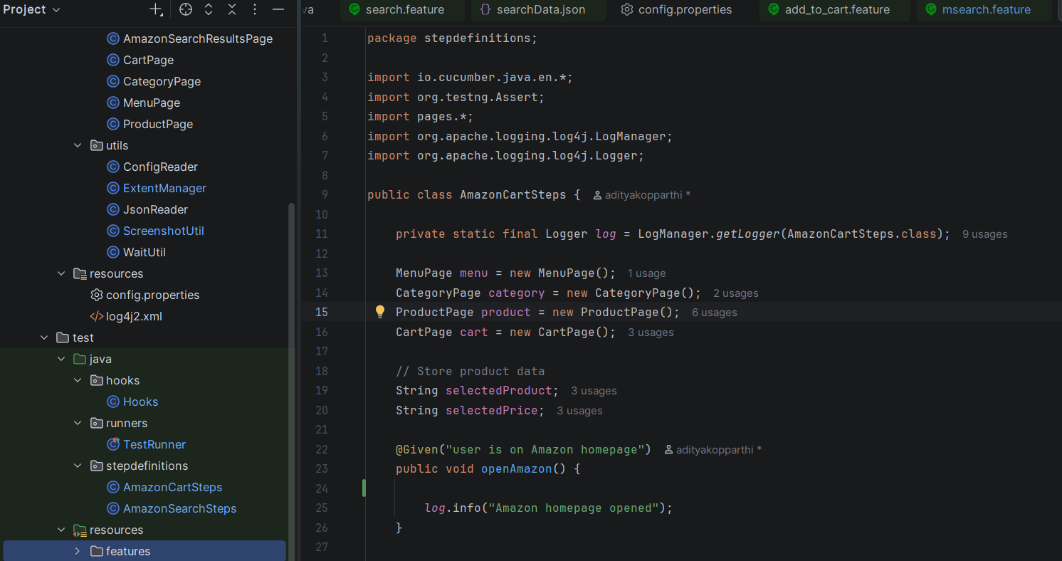

4. Page Object Model (POM)
The framework follows the Page Object Model (POM) design pattern, where each web
page is represented as a separate class. These classes contain web element locators and
reusable methods to perform actions on the UI.
This approach ensures separation of concerns, improves code reusability, and makes
the framework easy to maintain and scalable.
Key Responsibilities of Page Classes
- Define web elements using locators
- Implement reusable methods for user actions
- Encapsulate UI interaction logic
- Provide clean interface for Step Definitions
Page Object Model – Search Results Page
1. Web Element Locator
By results = By.cssSelector("div.s-main-slot div[data-component-type='s-search-
result']");
2. Validate Results Page Display
public boolean isResultsPageDisplayed() {
try {
return WaitUtil.waitForElement(driver, results).isDisplayed();
} catch (Exception e) {
return false;
}
}
3. Validate Search Results Relevance
public boolean verifyResultsContain(String product) {
try {
List<WebElement> list = WaitUtil.waitForElements(driver, results);
for (WebElement e : list) {
if (e.getText().toLowerCase().contains(product.toLowerCase())) {
return true;
}
}
} catch (Exception e) {
return false;
}
return false;
}
Note: Only key methods are shown. Complete implementation is available in the project repository.
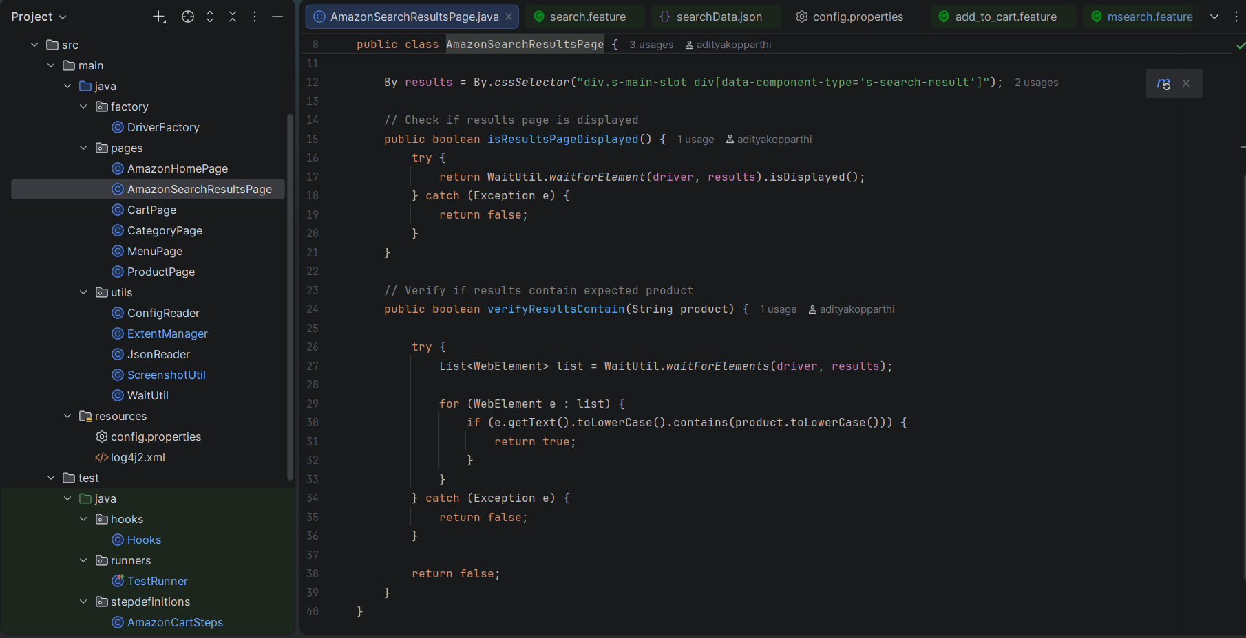

Page Object Model – Cart Page
1. Navigation to Cart Page
public void goToCartPage() {
try {
WaitUtil.click(driver, cartButton);
} catch (Exception e) {
driver.get("https://www.amazon.in/gp/cart/view.html");}
}
2. Validate Product Presence in Cart
public boolean isProductPresent() {
try {
List<WebElement> addedMsg = driver.findElements(addedToCartMsg);

if (!addedMsg.isEmpty()) {
return WaitUtil.waitForElement(driver, addedToCartMsg).isDisplayed();
}

return WaitUtil.waitForElement(driver, cartItems).isDisplayed();

} catch (Exception e) {
return false;
}
}
3. Get Product Details (Title & Price)
public String getCartProductTitle() {
return WaitUtil.waitForElement(driver, cartProductTitle)
.getText().trim();
}
public String getCartProductPrice() {
String price = WaitUtil.waitForElement(driver, cartProductPrice).getText();
return price.replaceAll("[^0-9.]", "").split("\\.")[0];
}
4. Validate Correct Product Added
public boolean isCorrectProductAdded(String expectedName, String expectedPrice) {

String actualName = getCartProductTitle();
String actualPrice = getCartProductPrice();

String expectedShort = expectedName.toLowerCase().trim()
.substring(0, Math.min(30, expectedName.length()));

String actualShort = actualName.toLowerCase().trim()
.substring(0, Math.min(30, actualName.length()));

return actualShort.equals(expectedShort) && actualPrice.equals(expectedPrice);}
5. Validate Subtotal and Cart Count
public String getSubtotal() {
try {
if (!driver.findElements(subtotalContainer).isEmpty()) {
return WaitUtil.waitForElement(driver, subtotalContainer).getText();
}
return WaitUtil.waitForElement(driver, subtotalWhole).getText();
} catch (Exception e) {
return "Subtotal not found";
}
}
public String getCartCount() {
try {
return WaitUtil.waitForElement(driver, cartCount).getText();
} catch (Exception e) {
return "0";
}
}
Note: Only key methods are shown. Complete implementation is available in the project repository.

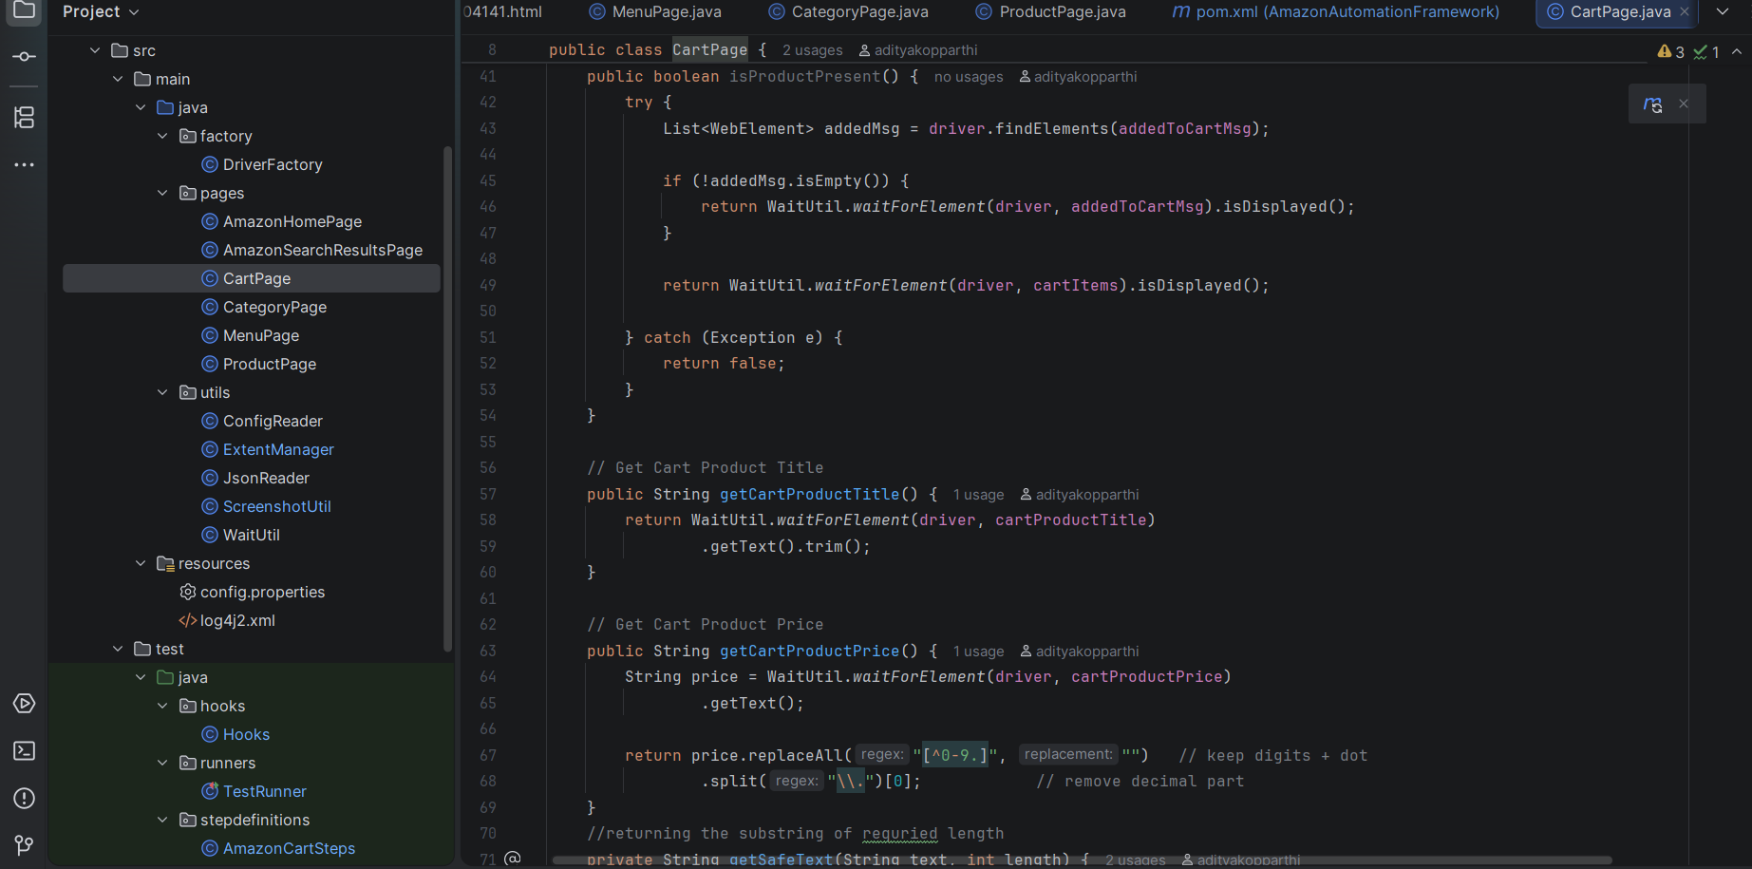

5. Hooks (Test Lifecycle Management)
Hooks are used to manage the test execution lifecycle. They execute before and after
each test scenario to handle setup, teardown, logging, and reporting.
- @Before → Initializes browser and reporting
- @After → Handles test result, captures screenshot on failure, and closes browser
This ensures reliable execution, proper logging, and failure tracking.
1. Setup Before Test Execution
@Before
public void setup(Scenario scenario) {
test = extent.createTest(scenario.getName());
DriverFactory.initDriver();
WebDriver driver = DriverFactory.getDriver();
driver.get(ConfigReader.get("url"));
}
2. Failure Handling with Screenshot
if (scenario.isFailed()) {
byte[] screenshot = ((TakesScreenshot) driver)
.getScreenshotAs(OutputType.BYTES);
scenario.attach(screenshot, "image/png", scenario.getName());
ScreenshotUtil.capture(driver, scenario.getName());
}
3. Extent Report Logging
if (scenario.isFailed()) {
test.fail("Test Failed: " + scenario.getName());
} else {
test.pass("Test Passed: " + scenario.getName());
}
4. Teardown After Execution
finally {
DriverFactory.quitDriver();
extent.flush();
}
6. DriverFactory (WebDriver Management)
DriverFactory is responsible for initializing, managing, and closing WebDriver instances.
It uses ThreadLocal to ensure thread-safe driver handling, enabling parallel execution of
test cases.
The browser type is configured using config.properties, allowing flexibility to run tests on
different browsers like Chrome and Edge.
1. Thread-Safe Driver Declaration
private static ThreadLocal<WebDriver> driver = new ThreadLocal<>();
2. Driver Initialization (Cross-Browser Support)
public static void initDriver() {
String browser = ConfigReader.get("browser");
if (browser.equalsIgnoreCase("chrome")) {
WebDriverManager.chromedriver().setup();
ChromeOptions options = new ChromeOptions();
options.addArguments("--start-maximized");
driver.set(new ChromeDriver(options));
} else if (browser.equalsIgnoreCase("edge")) {
EdgeOptions options = new EdgeOptions();
options.addArguments("--start-maximized");
driver.set(new EdgeDriver(options));}
else {
throw new RuntimeException("Browser not supported: " + browser);}
3. Get Driver Instance
public static WebDriver getDriver() {
return driver.get();
}
4. Quit Driver
public static void quitDriver() {
if (driver.get() != null) {
driver.get().quit();
driver.remove();
}
}
7. Utilities (Reusable Components)
Utility classes are used to provide reusable functionalities such as configuration handling,
waits, screenshots, reporting, and data reading. These utilities improve code reusability,
maintainability, and stability of the framework.
1. ConfigReader (Configuration Management)
public static String get(String key) {
return prop.getProperty(key);
}
2. ExtentManager (Reporting)
ExtentSparkReporter spark= new ExtentSparkReporter(path);
ExtentReports extent = new ExtentReports();
extent.attachReporter(spark);

3. JsonReader (Data-Driven Testing)
public static String getProduct(String filePath) {
ObjectMapper mapper = new ObjectMapper();
Map<String, String> data = mapper.readValue(new File(filePath),
Map.class);
return data.get("product");
}
Example:{
"product":"iphone"
}
4. ScreenshotUtil (Failure Handling)
File src = ((TakesScreenshot) driver.getScreenshotAs(
OutputType.FILE);
FileUtils.copyFile(src, dest);
5. WaitUtil (Synchronization)
public static WebElement waitForElement(WebDriver driver, By locator) {
WebDriverWait wait = new WebDriverWait(driver, Duration.ofSeconds(10));
return wait.until(ExpectedConditions.visibilityOfElementLocated(locator));
}
public static WebElement waitForClickable(WebDriver driver, By locator)
{WebDriverWait wait = new WebDriverWait(driver, Duration.ofSeconds
(TIMEOUT));
return wait.util(ExpectedConditions.elementToBeClickable(locator));
}

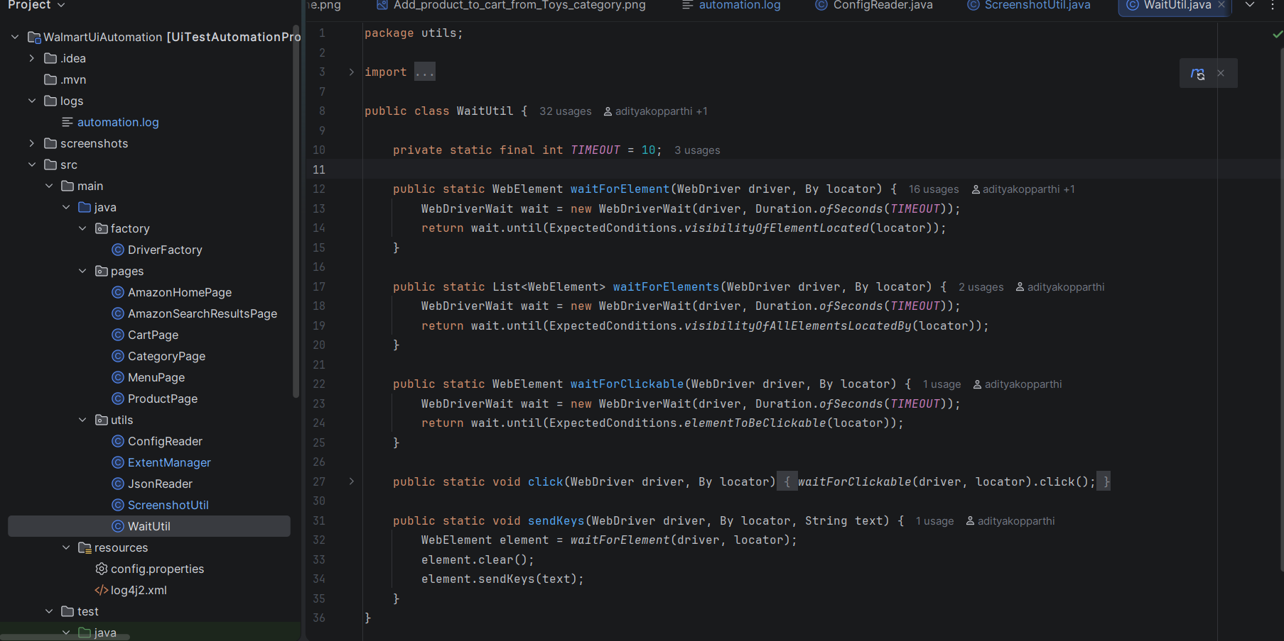

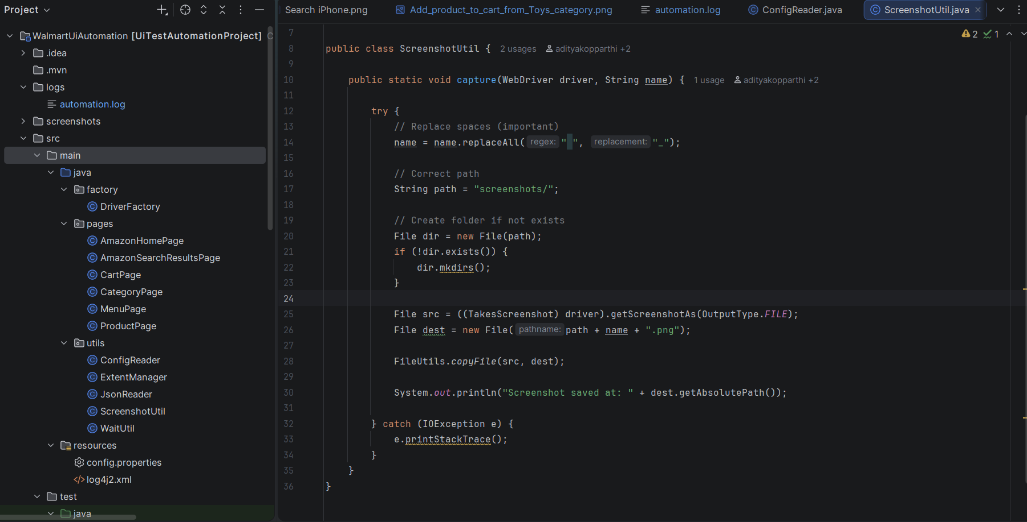
8. Maven Configuration (pom.xml)
The project uses Maven as the build tool for managing dependencies, compiling code,
and executing test cases. The pom.xml file defines all required libraries, plugins, and
project configuration.
1.SeleniumWebDriver
<!--Source:https://mvnrepository.com
/artifact/org.seleniumhq.selenium/selenium-java-->
<dependency>
<groupId>org.seleniumhq.selenium</groupId>
<artifactId>selenium-java</artifactId>
<version>4.41.0</version>
<scope>compile</scope>
</dependency>
Purpose: Used for automating browser interactions.

2. TestNG
<dependency>
<groupId>org.testng</groupId>
<artifactId>testng</artifactId>
<version>7.12.0</version>
<scope>test</scope>
</dependency>
Purpose: Used as the test execution framework and supports parallel execution.
3. Cucumber (BDD)
<!-- Source: https://mvnrepository.com/artifact/io.cucumber/cucumber-java-->
<dependency>
<groupId>io.cucumber</groupId>
<artifactId>cucumber-java</artifactId>
<version>7.34.3</version>
<scope>compile</scope>
</dependency>
<!--Source:https://mvnrepository.com/artifact/io.cucumber/cucumber-testng-->
<dependency>
<groupId>io.cucumber</groupId>
<artifactId>cucumber-testng</artifactId>
<version>7.34.3</version>
<scope>compile</scope>
</dependency>
Purpose: Enables Behavior Driven Development using Gherkin and integrates with
TestNG.
4. WebDriverManager
<!--Source:https://mvnrepository.com/artifact/io.github.bonigarcia/webdriver
manager-->
<dependency>
<groupId>io.github.bonigarcia</groupId>
<artifactId>webdrivermanager</artifactId>
<version>6.3.3</version>
<scope>compile</scope>
</dependency>
Purpose: Automatically manages browser drivers (Chrome, Edge).
5. Log4j2 (Logging)
<!-- Source: https://mvnrepository.com/artifact/org.apache.logging.log4j/log4j-api -->
<dependency>
<groupId>org.apache.logging.log4j</groupId>
<artifactId>log4j-api</artifactId>
<version>2.25.4</version>
<scope>compile</scope>
</dependency>
<!--Source:https://mvnrepository.com/artifact/org.apache.logging.log4j/log4j-core-->
<dependency>
<groupId>org.apache.logging.log4j</groupId>
<artifactId>log4j-core</artifactId>
<version>2.25.4</version>
<scope>compile</scope>
</dependency>
Purpose: Used for logging execution steps and debugging.
6. Extent Reports
<dependency>
<groupId>com.aventstack</groupId>
<artifactId>extentreports</artifactId>
<version>5.1.1</version>
</dependency>
Purpose: Generates detailed HTML test execution reports.
7. JSON Library
<!--Source:https://mvnrepository.com/artifact/org.json/json-->
<dependency>
<groupId>org.json</groupId>
<artifactId>json</artifactId>
<version>20251224</version>
<scope>compile</scope>
</dependency>
Purpose: Used for handling JSON-based test data.
Build Plugins
1. Maven Compiler Plugin
<plugin>
<groupId>org.apache.maven.plugins</groupId>
<artifactId>maven-compiler-plugin</artifactId>
<version>3.13.0</version>
<configuration>
<source>17</source>
<target>17</target>
</configuration>
</plugin>
Purpose: Compiles Java code using specified Java version
2. Maven Surefire Plugin
<plugin>
<groupId>org.apache.maven.plugins</groupId>
<artifactId>maven-surefire-plugin</artifactId>
<version>3.2.5</version>
<configuration>
<suiteXmlFiles>
<suiteXmlFile>testng.xml</suiteXmlFile>
</suiteXmlFiles>
</configuration>
</plugin>
Purpose: Executes test cases using TestNG (testng.xml).
Note: Only key dependencies and plugins are shown. Full configuration is available in the
Project repository.

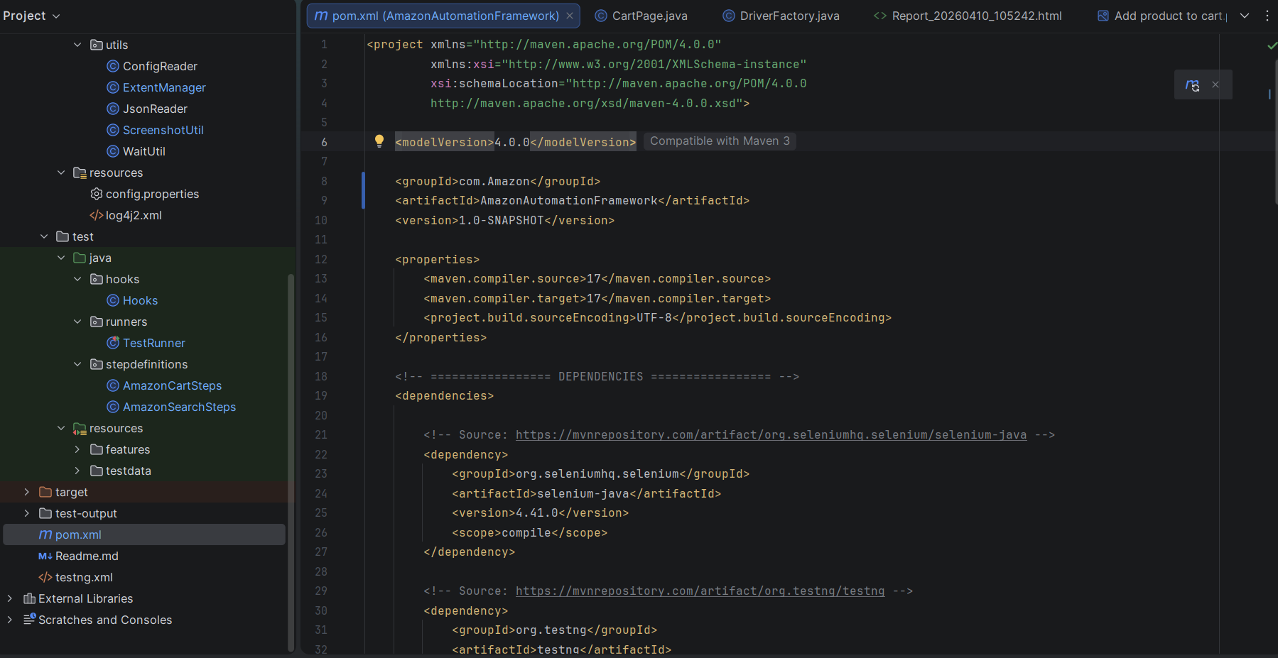

Project Structure
|──logs
| |──automation.log
|── src
│ |── main
│ │ |── java
│ │ │ |── factory
│ │ │ │ |── DriverFactory.java
│ │ │ │
│ │ │ |── pages
│ │ │ │ |── AmazonHomePage.java
│ │ │ │ |── AmazonSearchResultsPage.java
│ │ │ │ |── MenuPage.java
│ │ │ │ |── CategoryPage.java
│ │ │ │ |── ProductPage.java
│ │ │ │ |── CartPage.java
│ │ │ │
│ │ │ |── utils
│ │ │ |── ConfigReader.java
│ │ │ |── ExtentManager.java
│ │ │ |── JsonReader.java
│ │ │ |── ScreenshotUtil.java
│ │ │ |── WaitUtil.java
│ │ │
│ │ |── resources
│ │ |── config.properties
│ │ |── log4j2.xml
│ │

│ |── test
│ |── java
│ │ |── hooks
│ │ │ |── Hooks.java
│ │ │
│ │ |── runners
│ │ │ |── TestRunner.java
│ │ │
│ │ |── stepdefinitions
│ │ |── AmazonSearchSteps.java
│ │ |── AmazonCartSteps.java
│ │
│ |── resources
│ |── features
│ │ |── search.feature
│ │ |── add_to_cart.feature
│ │ |── msearch.feature
│ |── testdata
│ |── searchData.json
│
|── screenshots
│ |── (captured failure screenshots)
│
|── test-output
|── target
|── pom.xml
|── testng.xml
|── README.md

Structure:
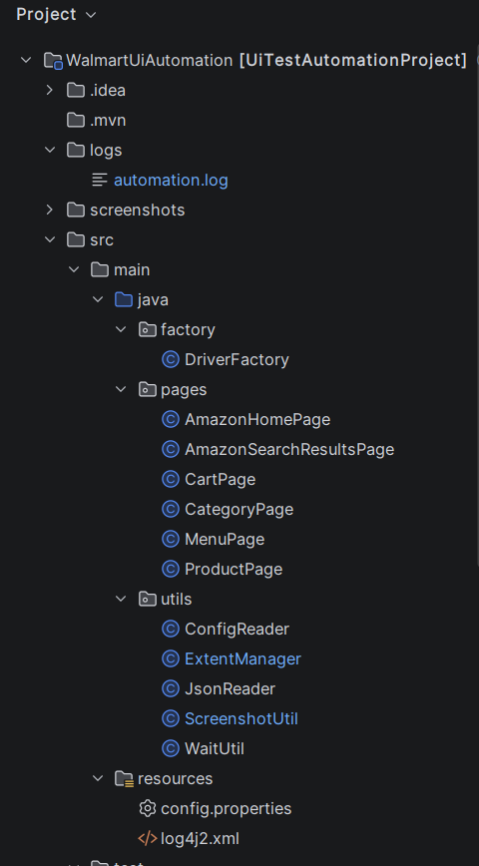
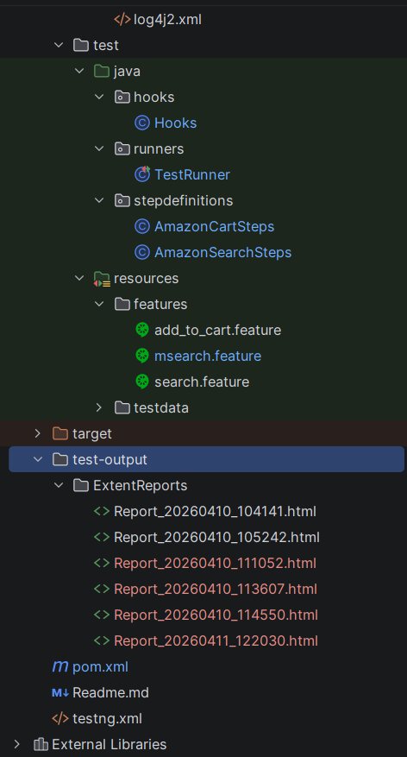

Execution Instructions
Test Execution: The test cases can be executed using Maven command.
Code: “mvn clean test”
- Maven triggers test execution using Surefire plugin.
- TestNG runs the Test Runner class.
- Cucumber executes feature files through the Test Runner.
- Step Definitions perform actions using Page Objects.
- Reports are generated after execution.
Results
The developed Precision UI BDD Automation Framework was successfully implemented and tested on the Amazon web application. The framework efficiently automated key user scenarios such as product search and add-to-cart functionality.
Key Outcomes:
- Successful Test Execution
All test scenarios were executed using the Maven command mvn clean test without any failures in stable conditions.
- BDD Implementation Achieved
Test scenarios written in Gherkin were successfully mapped to step definitions, ensuring clear communication between stakeholders.
- Data-Driven Testing Validation
Both JSON-based input and Scenario Outline executions worked correctly, validating multiple datasets.
- Cross-Browser Execution
Tests were successfully executed on multiple browsers such as Chrome and Edge using configuration settings.
- Parallel Execution Efficiency
Parallel execution using TestNG significantly reduced overall execution time.
- Accurate Validation of Application Behavior
Functional validations such as product selection, cart addition, subtotal verification, and search relevance were successfully verified.
- Automatic Screenshot Capture on Failure
Screenshots were captured during failures using Hooks, improving debugging efficiency.
- Detailed Reporting Generated
Extent Reports and Log4j2 logs provided clear insights into test execution status, including pass/fail results and execution steps.

Output:
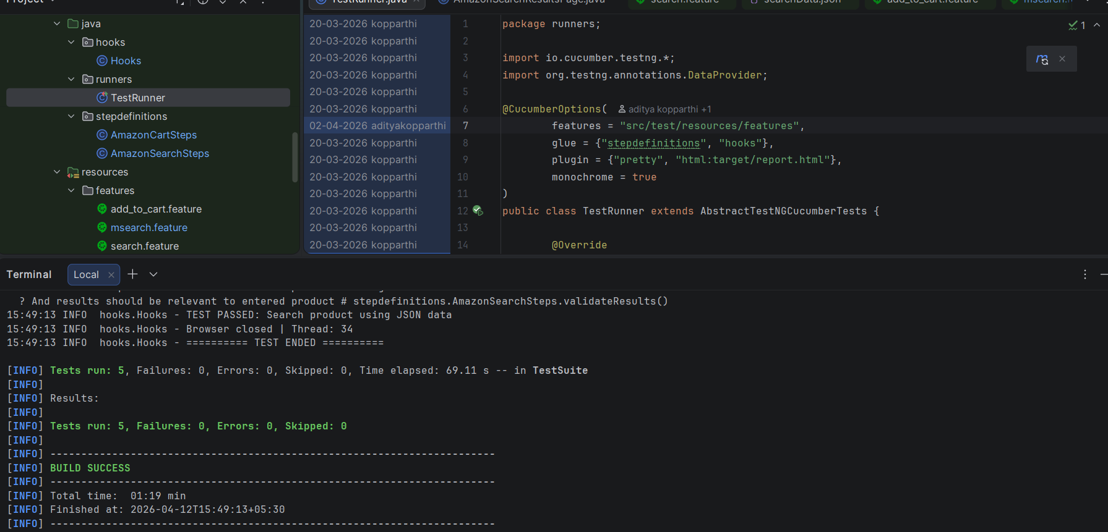

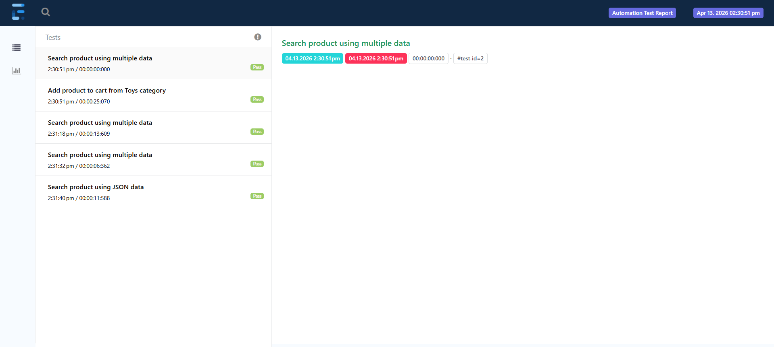
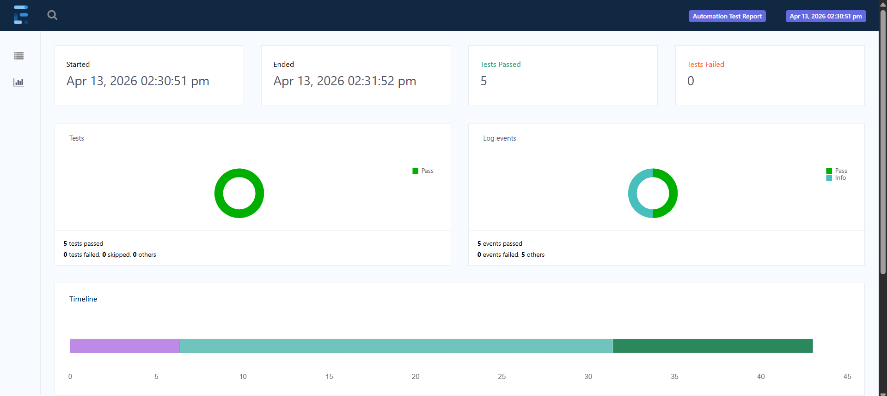

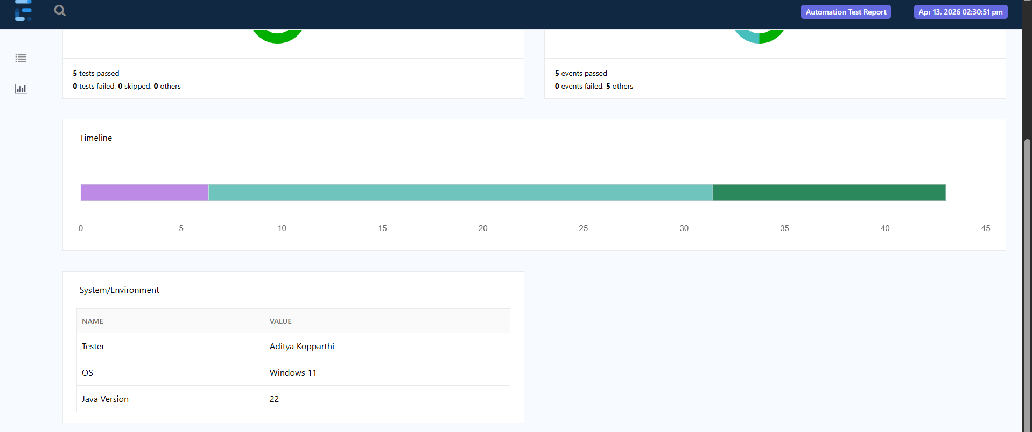
Conclusion
The automation framework is designed using a hybrid approach by combining Page Object Model (POM), Behavior Driven Development (BDD), and Data-Driven Testing, ensuring a scalable and maintainable structure.
The framework supports parallel execution, cross-browser testing, and robust reporting using TestNG, Selenium WebDriver, and Extent Reports. Proper separation of concerns is achieved by organizing reusable components such as Page Objects, Utilities, and DriverFactory in the main layer, while test logic is maintained in the test layer.
Failure handling is implemented using Hooks, where screenshots are automatically captured and attached to reports for better debugging. Maven is used for dependency management and test execution, ensuring consistency across environments.
Overall, the framework follows industry best practices and provides a reliable solution for automating web applications, making it suitable for real-world testing scenarios.
Team Contribution
- Aditya Kopparthi GitHub
- Designed and implemented the Hybrid Automation Framework (POM + BDD + Data-Driven)
- Integrated Cucumber with TestNG for scalable execution
- Implemented parallel execution using TestNG DataProvider
- Developed Page Object Model for modular automation
- Integrated Extent Reports with screenshot capture on failure
- Implemented data-driven testing using JSON and Scenario Outline
- Built utility layer (ConfigReader, ScreenshotUtil, WaitUtil, ExtentManager)
- Implemented logging using Log4j
- Configured Maven and Surefire Plugin for execution
- Implemented cross-browser testing using config.properties
- Designed overall framework architecture

- Akula Kalyan Sai Ram GitHub
- Developed BDD feature files for search and add-to-cart scenarios
- Implemented step definitions mapping Gherkin steps to code
- Worked on assertions and validation logic
- Assisted in debugging and fixing test failures
- Maintained test data and ensured smooth execution
- Contributed to Git repository management
- Assisted in implementing reusable page methods
- Helped validate execution reports and results

Future Enhancements
- Integration with CI/CD tools (Jenkins / GitHub Actions)
- Execution on Selenium Grid or cloud platforms
- API testing integration
- Docker-based environment setup
- Implementation of advanced data-driven testing techniques for handling multiple datasets dynamically

