Roll Number : 238W1A1267

Week – 1

Post Labs :

1. Given a **non-empty** array of integers nums, every element appears *twice* except for one. Find that single one.

You must implement a solution with a linear runtime complexity and use only constant extra space.

Ans :

int singleNumber(int* nums, int numsSize) {

int result = 0;

for (int i = 0; i < numsSize; i++) {

result ^= nums[i];

}

return result;

}

Output :

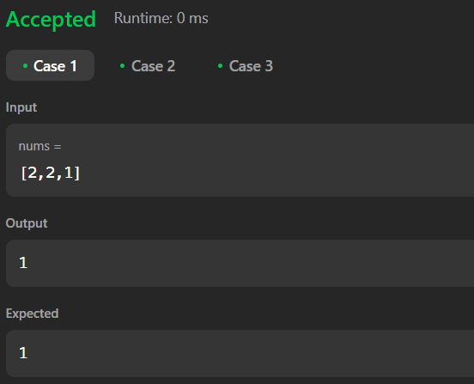

2. . You are given a **0-indexed** array of integers nums of length n. You are initially positioned at nums[0].

Each element nums[i] represents the maximum length of a forward jump from index i. In other words, if you are at nums[i], you can jump to any nums[i + j] where:

* 0 <= j <= nums[i] and
* i + j < n

Return *the minimum number of jumps to reach*nums[n - 1]. The test cases are generated such that you can reach nums[n - 1].

Ans :

if (numsSize <= 1) {

return 0;

}

int jumps = 0;

int currentEnd = 0;

int farthest = 0;

for (int i = 0; i < numsSize - 1; i++) {

farthest = (i + nums[i] > farthest) ? i + nums[i] : farthest;

if (i == currentEnd) {

jumps++;

currentEnd = farthest;

if (currentEnd >= numsSize - 1) {

break;

}

}

}

return jumps;

Output :

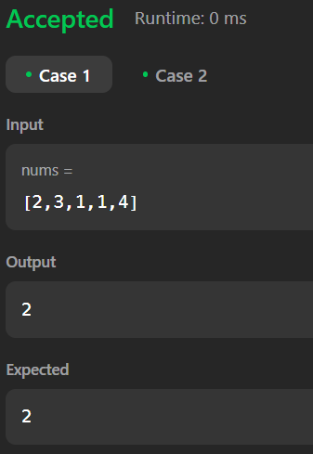

3. Given an integer array nums sorted in **non-decreasing order**, remove some duplicates [**in-place**](https://en.wikipedia.org/wiki/In-place_algorithm) such that each unique element appears **at most twice**. The **relative order** of the elements should be kept the **same**.

Since it is impossible to change the length of the array in some languages, you must instead have the result be placed in the **first part** of the array nums. More formally, if there are k elements after removing the duplicates, then the first k elements of nums should hold the final result. It does not matter what you leave beyond the first k elements.

Return k*after placing the final result in the first*k*slots of*nums.

Do **not** allocate extra space for another array. You must do this by **modifying the input array**[**in-place**](https://en.wikipedia.org/wiki/In-place_algorithm) with O(1) extra memory.

Ans :

if (numsSize <= 2) {

return numsSize;

}

int i = 2;

for (int j = 2; j < numsSize; j++){

if (nums[j] != nums[i - 2]) {

nums[i] = nums[j];

i++;

}

}

return i

