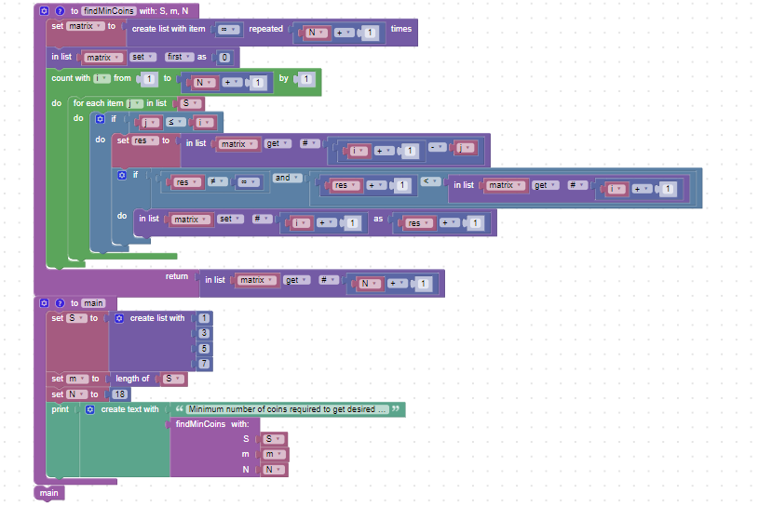

In main() function which is called, the variables are initialized with the same values as in the earlier code. To calculate the answer, findMinCoins() function is called.In this function, a list matrix is stored in which matrix[i] stores minimum number of coins that have to be used for payment of a change of Rs i. Thus, instead of recursion, which may take exponential time, the code runs in time complexity of O(N\*m) where N is amount of change and m is number of denominations. matrix[0] is initialized as 0 as no currency notes are required for payment of Rs 0. Rest all elements in matrix are initialized as infinity and are relaxed whenever possible, starting from matrix[1] in increasing order. Thus, the answer, that is number of currency notes required for payment of Rs N, is matrix[N]. This is return by findMinCoins() function in coins.py which is called from main() function and the output is printed.