# Coffee Shop Online System - Data Analytics Project

## Author: Andrei Kulebiakin

## Project Overview

This project is a data system for coffee shop online system, it has transactional (OLTP) and analytical (OLAP) databases. The result is visualized Power BI sales report.

## Power BI report

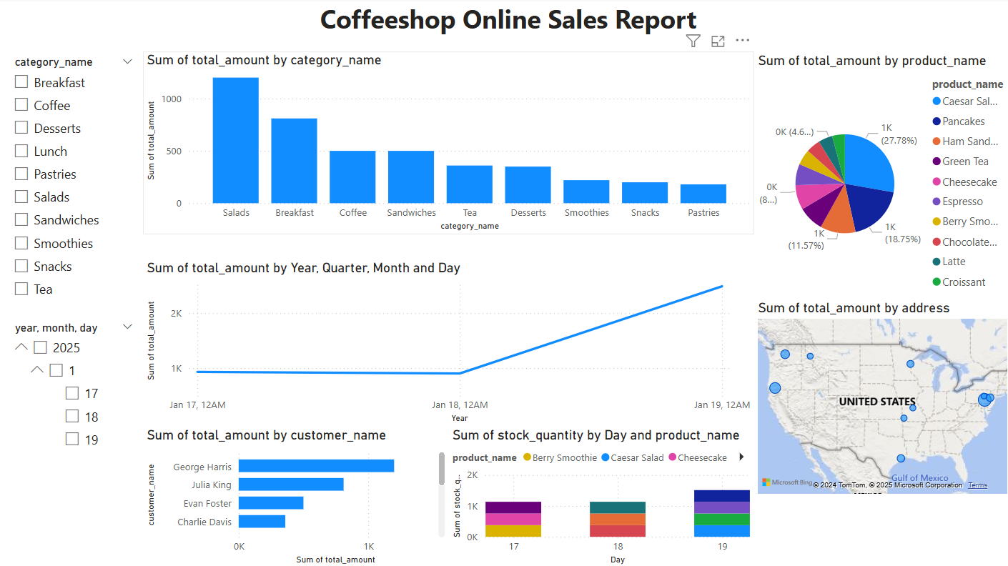

## Technologies Used

• Database: PostgreSQL  
• Visualization: Power BI (Windows)  
• ETL Process: SQL-based scripts

## Project Components

### 1. OLTP Database

The OLTP database is designed to handle the transactional operations for the coffeeshop:

- `users`: Customer information  
- `products`: Product details  
- `categories`: Product categories  
- `orders`: Customer orders  
- `order_details`: Details of each order  
- `cart`: Temporary cart information  
- `payments`: Payment records  
- `reviews`: Customer reviews

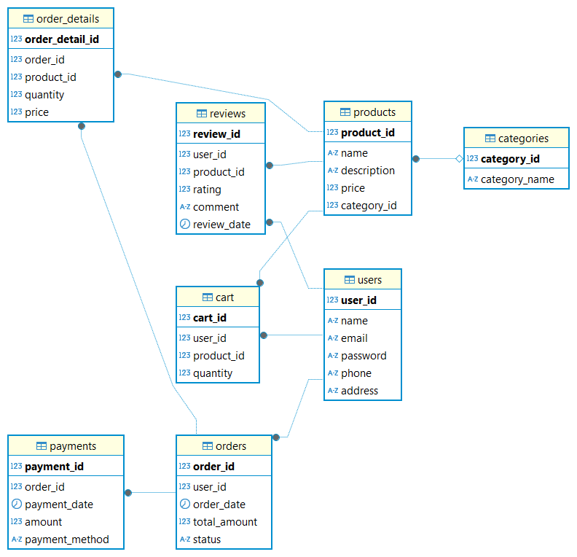

### 2. OLAP Database

• Fact tables:  
 - `fact_sales`: Sales data  
 - `fact_inventory`: Inventory data  
• Dimension tables:  
 - `dim_product`: Product information  
 - `dim_category`: Product categories  
 - `dim_customer`: Customer information  
 - `dim_date`: Calendar data  
 - `dim_employee`: Employee information

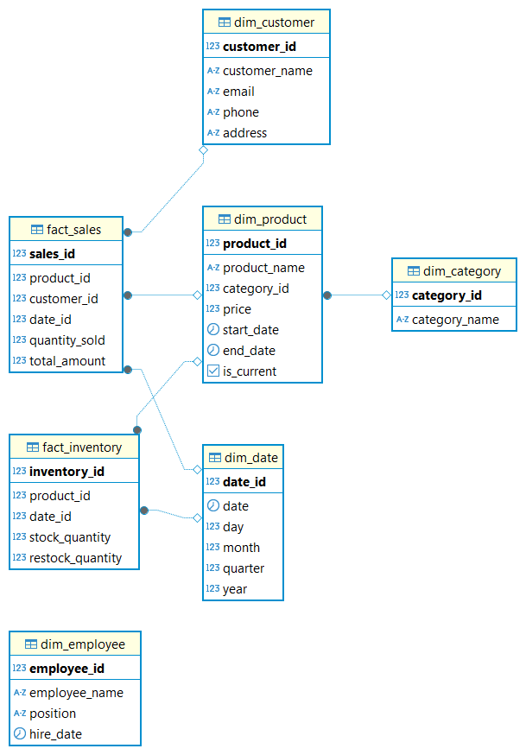

### 4. Visual Reports

Using Power BI, visual reports provide the following information:  
- Sales by category, product, and date  
- Top customers, and their map location  
- Inventory

## How to run

### Prerequisites

• PostgreSQL installed and configured  
• Power BI Desktop installed  
• OTLP and OLAP databases are created:  
 - coffeeshop_online_otlp  
 - coffeeshop_online_olap

### Steps

1. Setup Databases:  
 - Execute SQL script to create tables for OTLP database: `create_tables_otlp.sql` and populate data `insert_data_otlp_reusable.sql`  
 - Execute SQL script to creates tables for OLAP database: `create_tables_olap.sql`  
2. Run ETL Process:  
 - In this work ETL process is simulated via SQL script: `insert_data_olap.sql`  
3. Connect Power BI to PostgreSQL and generate report  
 - Use Power BI to connect to OLAP database  
 - Import tables and create reports  
 - See report example in `coffeesop_online_sales_report.pbix`