

Deutsche Bank

EXPERIENCE

Senior Java/Scala/Kotlin developer (Kotlin preferred) with experience in Spring/Spring Boot, BigData stack like Spark/Hadoop. Experienced in invest banking (middle/back office) and development tools (compilers/static analyzers). Organizer and speaker at [conferences](https://www.youtube.com/watch?v=jpYwx_XKS8o) and meetups: [OT](https://www.meetup.com/Object-Thinking/), [KaiCode](https://kaicode.timepad.ru/event/1340101/). Github: [akuleshov7](https://github.com/akuleshov7)

C/C++ Compiler Engineer

Intel Corporation 

Prepared tools to support development of Intel C/C++ compiler and Intel specific fork of Clang compiler. Including: CI/CD tools, testing framework and performance analysis tools. Worked with Intel LLVM-based compiler and open-source Clang community. Was awarded by Intel recognition award for innovative solution in cross-compilation of c/c++ code by clang and icc.

CERTIFICATES

**Certificates:**  
[Kotlin for Java Developers](https://www.coursera.org/account/accomplishments/certificate/6TV8393X4SX4)  
[Machine Learning](https://www.coursera.org/account/accomplishments/verify/P4X8Y38TEDYF)  
[Design Patterns](https://www.coursera.org/account/accomplishments/verify/NU83JM69V3J2)

**Patents:**[Recognition of objects by their image in realtime](https://www.fips.ru/registers-doc-view/fips_servlet?DB=EVM&DocNumber=2015613471&TypeFile=html)  
[Calculation of reduced binary decision trees with generalized vertices](https://www.fips.ru/registers-doc-view/fips_servlet?DB=EVM&DocNumber=2015611202&TypeFile=html)

Specialist's degree (5-year academic program in Russia, the degree is equivalent to MS). Department of Mathematical Cybernetics of [Moscow State University](https://www.msu.ru/en/). Specialization: minimizing disjunctive normal forms.

2010 - 2015

Moscow State University

**Master of Science in Computer Science**

EDUCATION

Jul 2016 - Nov 2019  
 

Jul 2014 – Jul 2016  
 

Java/Scala Senior Developer, AVP

Nov 2019 – Present  
 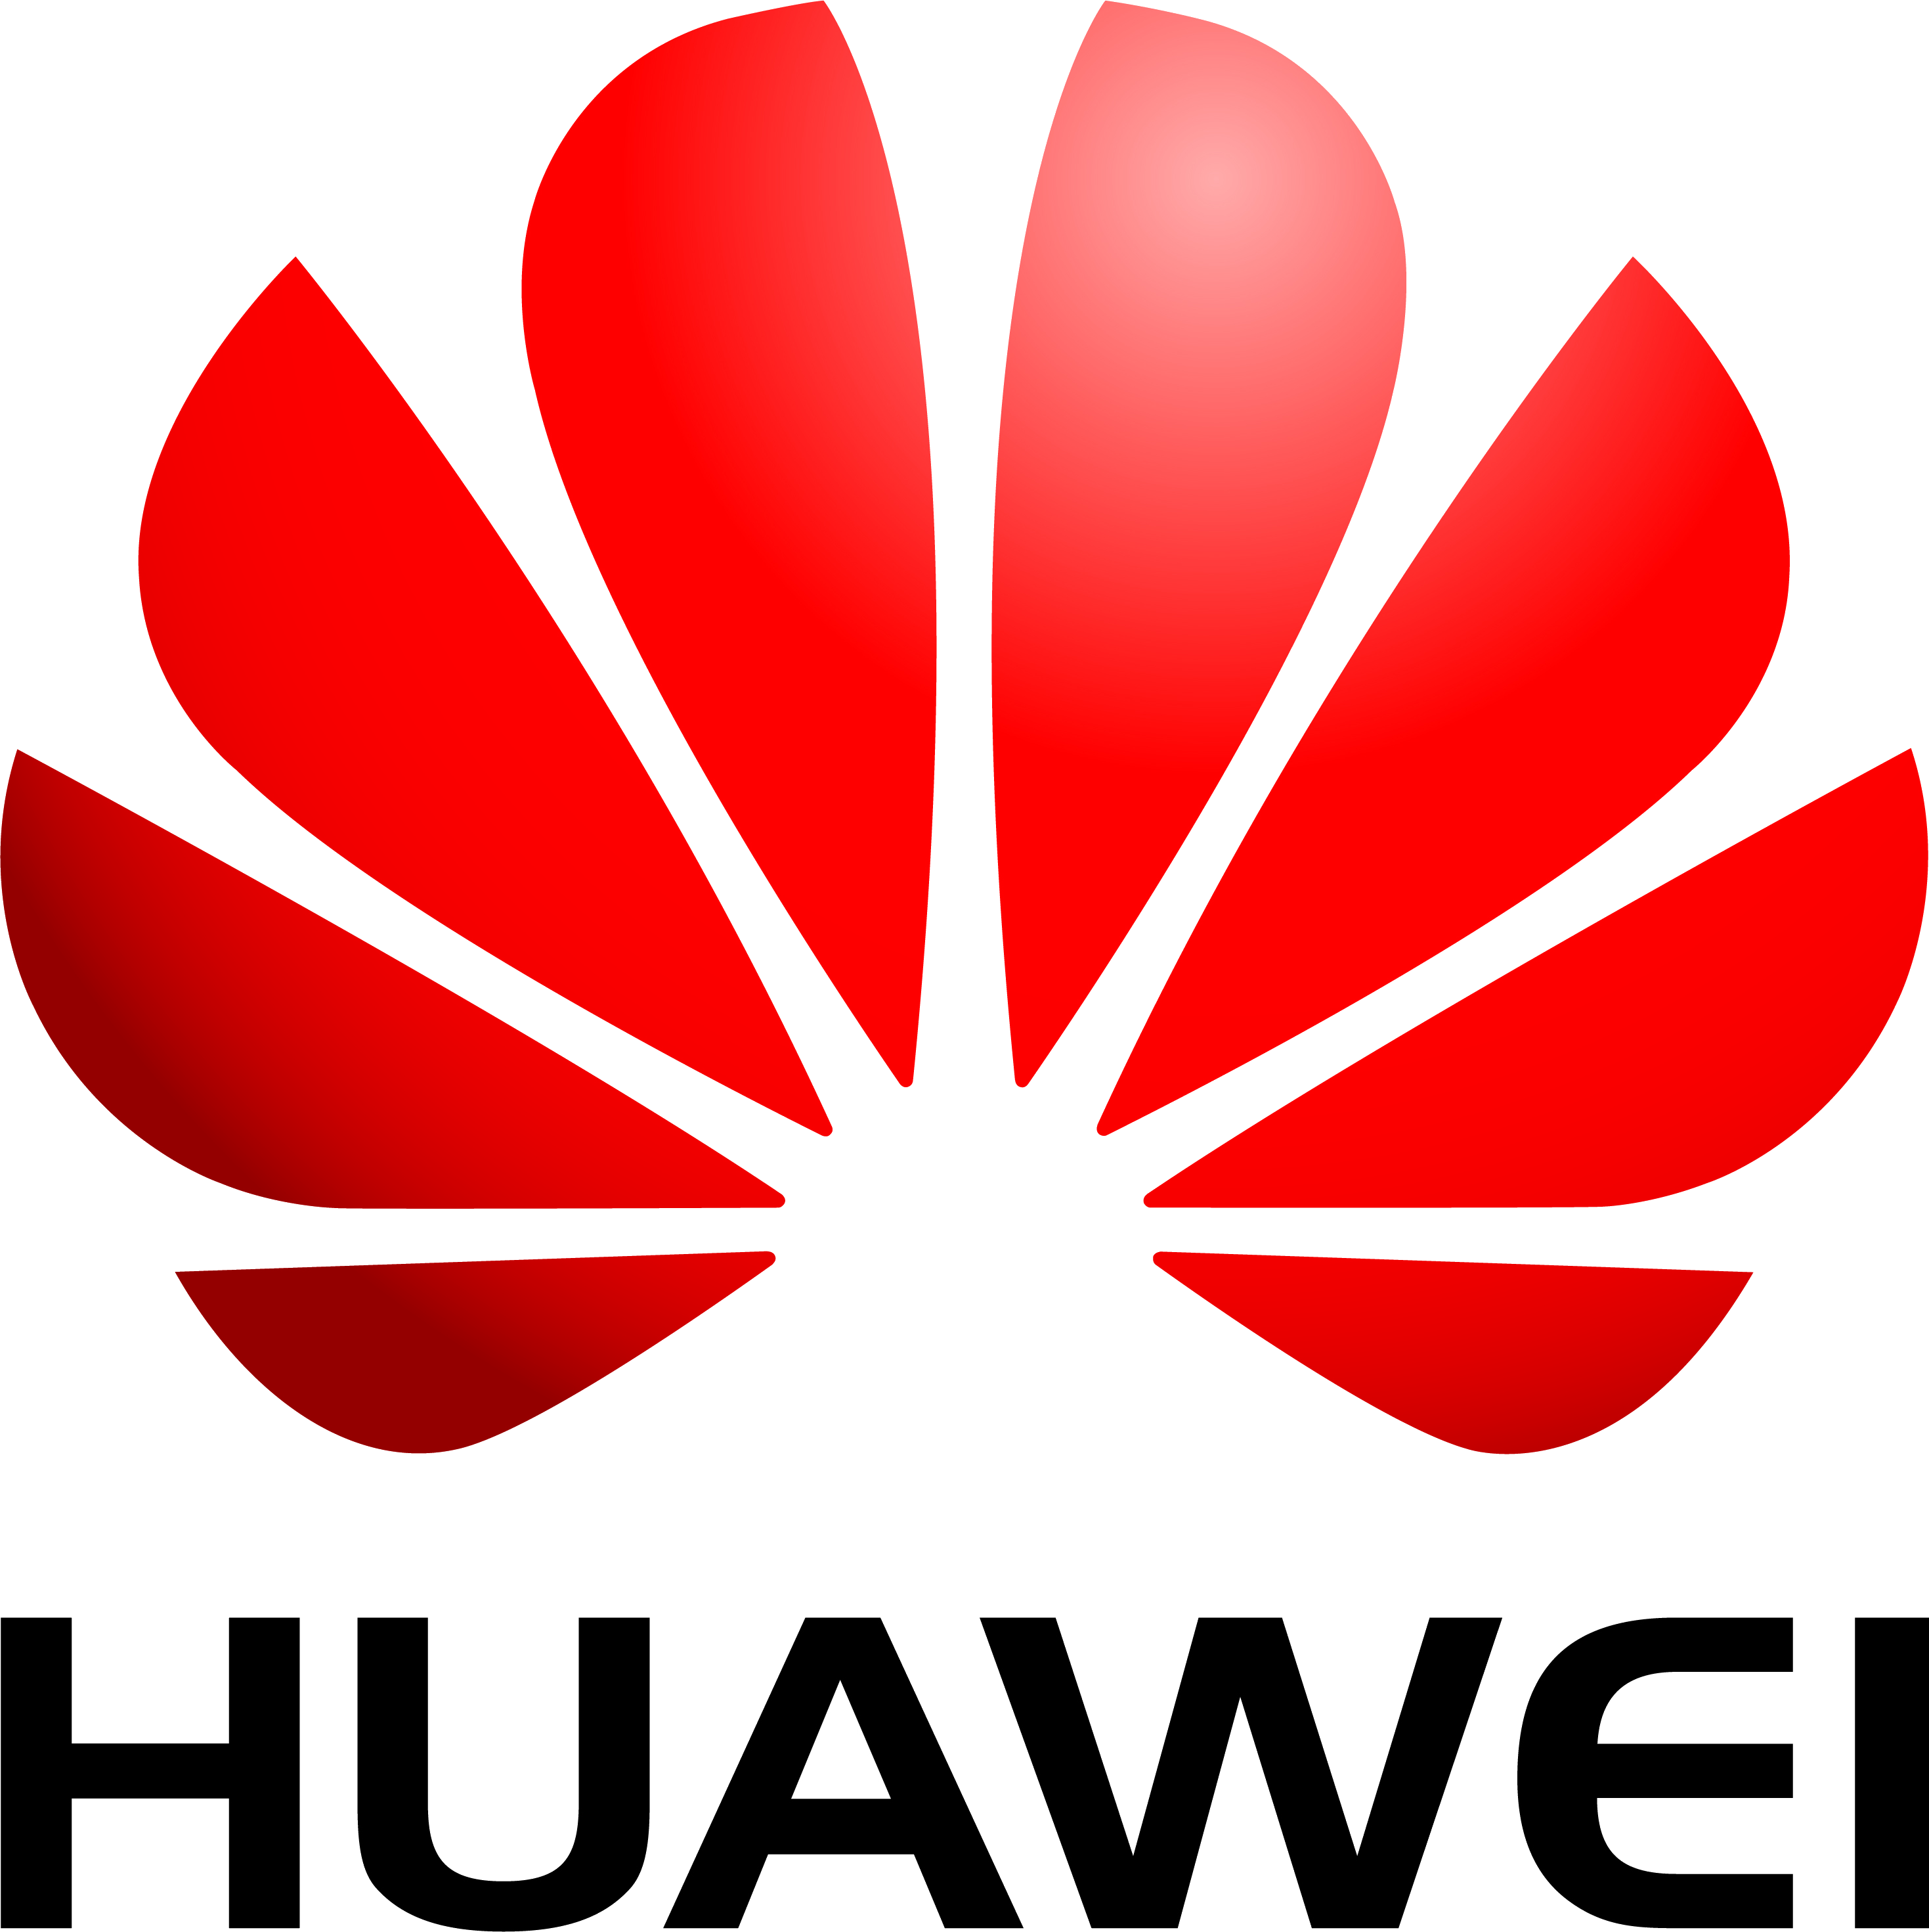

Huawei Technologies Co. Ltd.

**[Equities]** Development of High-Loaded Server side application (Java/Spring) that provides normalized (~FIX protocol) trading data from a Front Office to Middle Office.  
**[Global Prime Finance]** Development of Big Data (Spark/Hadoop) application for storing data from different global prime financing applications and feeds. Ownership of TriParty feed (JPM Chase/BoNY) and Static Data Providers.

Java/Kotlin Senior Engineer, TechLead

[Cloud Business Unit] Development of static code analyzer (based on Java and Kotlin) for Java, Python and Kotlin source code:  
 1) [Huawei-yapf](https://github.com/akuleshov7/huawei-yapf), python codestyle analyzer  
 2) diKTat, kotlin codestyle analyzer&fixer

Jury in Huawei CleanCode Audit. Member of Innovative Laboratory management board (work with vendors and institutes).

+7 965 340 45 95

andrewkuleshov7@gmail.com

Moscow, Russia

Andrey Kuleshov

PROFILE

SENIOR SOFTWARE ENGINEER