**PART – A – SINGLE ROW FUNCTIONS**

1. Produce a list of all customer names in which the first letter of the first and last names is in uppercase and the rest are in lowercase.

SELECT INITCAP(FIRSTNAME), INITCAP(LASTNAME)

FROM CUSTOMERS;

2. Create a list of all customer numbers along with text indicating whether the customer has been referred by another customer. Display the text “NOT REFERRED” if the customer wasn’t referred to JustLee Books by another customer or “REFERRED” if the customer was referred.

SELECT CUSTOMER#, FIRSTNAME, LASTNAME, NVL2(REFERRED, 'REFERRED','NOT REFERRED')

FROM CUSTOMERS;

3. Display a list of all book titles and the percentage of markup for each book. The percentage of markup should be displayed as a whole number (that is, multiplied by 100) with no decimal position, followed by a percent sign (for example, .2793 = 28%). (The percentage of markup should reflect the difference between the retail and cost amounts as a percent of the cost.)

SELECT TITLE, CONCAT(ROUND((RETAIL-COST)/COST*100, 0), '%')

FROM BOOKS;

4. Display the current day of the week, hour, minutes, and seconds of the current date setting on the computer you’re using.

SELECT TO_CHAR(CURRENT_DATE, 'DAY, HH:MI:SS')

FROM dual;

5. Create a list of all book titles and costs. Precede each book’s cost with asterisks so that the width of the displayed Cost field is 12.

SELECT TITLE, LPAD(COST, 12, '*')

FROM BOOKS;

6. Determine the length of data stored in the ISBN field of the BOOKS table. Make sure each different length value is displayed only once (not once for each book).

SELECT DISTINCT LENGTH(ISBN)

FROM BOOKS;

7. Using today’s date, determine the age (in months) of each book that JustLee sells. Make sure only whole months are displayed; ignore any portions of months. Display the book title, publication date, current date, and age.

SELECT TITLE, PUBDATE, SYSDATE, TRUNC(MONTHS_BETWEEN(SYSDATE,PUBDATE), 0) AGE

FROM BOOKS;

8. Determine the calendar date of the next occurrence of Wednesday, based on today’s date.

SELECT NEXT_DAY(SYSDATE, 'WEDNESDAY')

FROM DUAL;

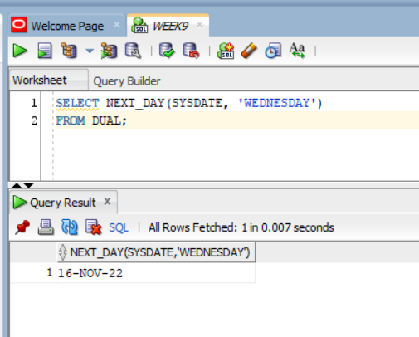

9. Produce a list of each customer number and the third and fourth digits of his or her zip code. The query should also display the position of the first occurrence of a 3 in the customer number, if it exists.

SELECT CUSTOMER#, SUBSTR(ZIP, 3, 2), INSTR(CUSTOMER#, 3)

FROM CUSTOMERS;

10. Management is proposing to increase the price of each book. The amount of the increase will be based on each book’s category, according to the following scale: Computer books, 10%; Fitness books, 15%; Self-Help books, 25%; all other categories, 3%. Create a list that displays each book’s title, category, current retail price, and revised retail price. The prices should be displayed with two decimal places. The column headings for the output should be as follows: Title, Category, Current Price, and Revised Price. Sort the results by category. If there’s more than one book in a category, a secondary sort should be performed on the book’s title.

SELECT title "Title", category "Category", retail "Current Price",

ROUND(DECODE(category, 'COMPUTER', retail*1.1, 'FITNESS', retail*1.15, 'SELF HELP', retail*1.25, retail*1.03), 2) "Revised price"

FROM books ORDER BY category, title;

**PART B: GROUP FUNCITONS**

1. Determine how many books are in the Cooking category.

SELECT COUNT(*)FROM books

WHERE category = 'COOKING';

2. Display the number of books with a retail price of more than $30.00.

SELECT COUNT(*)FROM BOOKS

WHERE RETAIL > 30;

3. Display the most recent publication date of all books sold by JustLee Books.

SELECT MAX(PUBDATE)

FROM BOOKS;

4. List the retail price of the least expensive book in the Computer category.

SELECT MIN(retail)FROM books

WHERE category = 'COMPUTER';

5. Determine how many orders have been placed by each customer. Do not include in the results any customer who hasn’t recently placed an order with JustLee Books.

SELECT customer#, COUNT(*)

FROM orders

GROUP BY customer#;

